Vehicle Standard (Australian Design Rule 81/02 — Fuel Consumption Labelling for Light Vehicles) 2008 Amendment 4
I, ANTHONY NORMAN ALBANESE, Minister for Infrastructure and Transport, determine this vehicle standard under subsection 7 of the Motor Vehicle Standards Act 1989.
Dated 24 December 2010

ANTHONY NORMAN ALBANESE
Minister for Infrastructure and Transport

CONTENTS

1 LEGISLATIVE PROVISIONS 2
2 AMENDMENT OF VEHICLE STANDARD 2
3 SCHEDULE 1 2

1 LEGISLATIVE PROVISIONS

  - NAME OF LEGISLATIVE INSTRUMENT

    - This instrument is the Vehicle Standard (Australian Design Rule 81/02 – Fuel Consumption Labelling for Light Vehicles) 2008 Amendment 4.
    - This instrument may also be cited as ADR 81/02 Amendment 4.

  - COMMENCEMENT

    - This instrument commences the day after it is registered.

2 AMENDMENT OF VEHICLE STANDARD

    - The changes specified in Schedule 1 amend Vehicle Standard (Australian Design Rule 81/02 – Fuel Consumption Labelling for Light Vehicles) 2008.

SCHEDULE 1

[1] Replace Figure 1 of Appendix A with following figure:
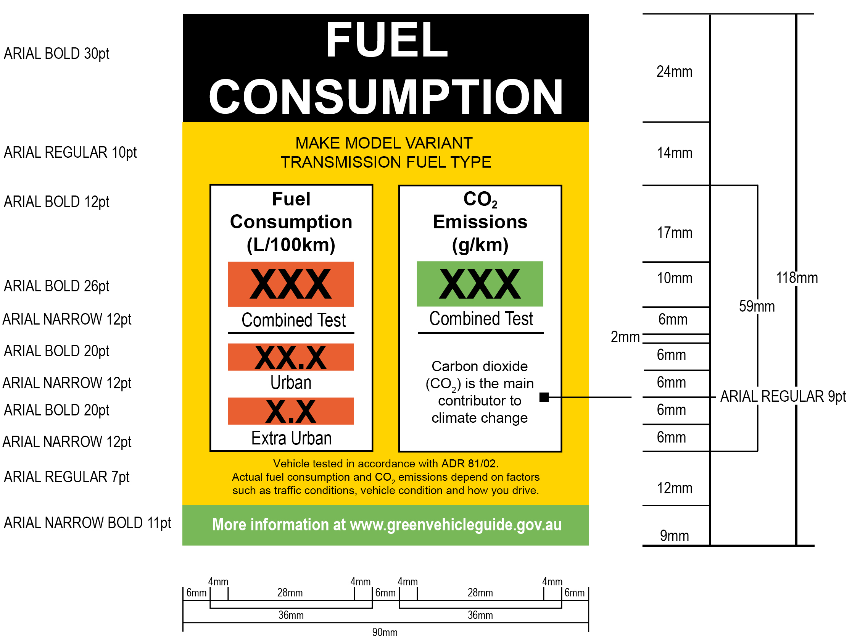
Figure 1: Illustration of Fuel Consumption Label with fonts and dimensions

