Instrument Number 11/1198
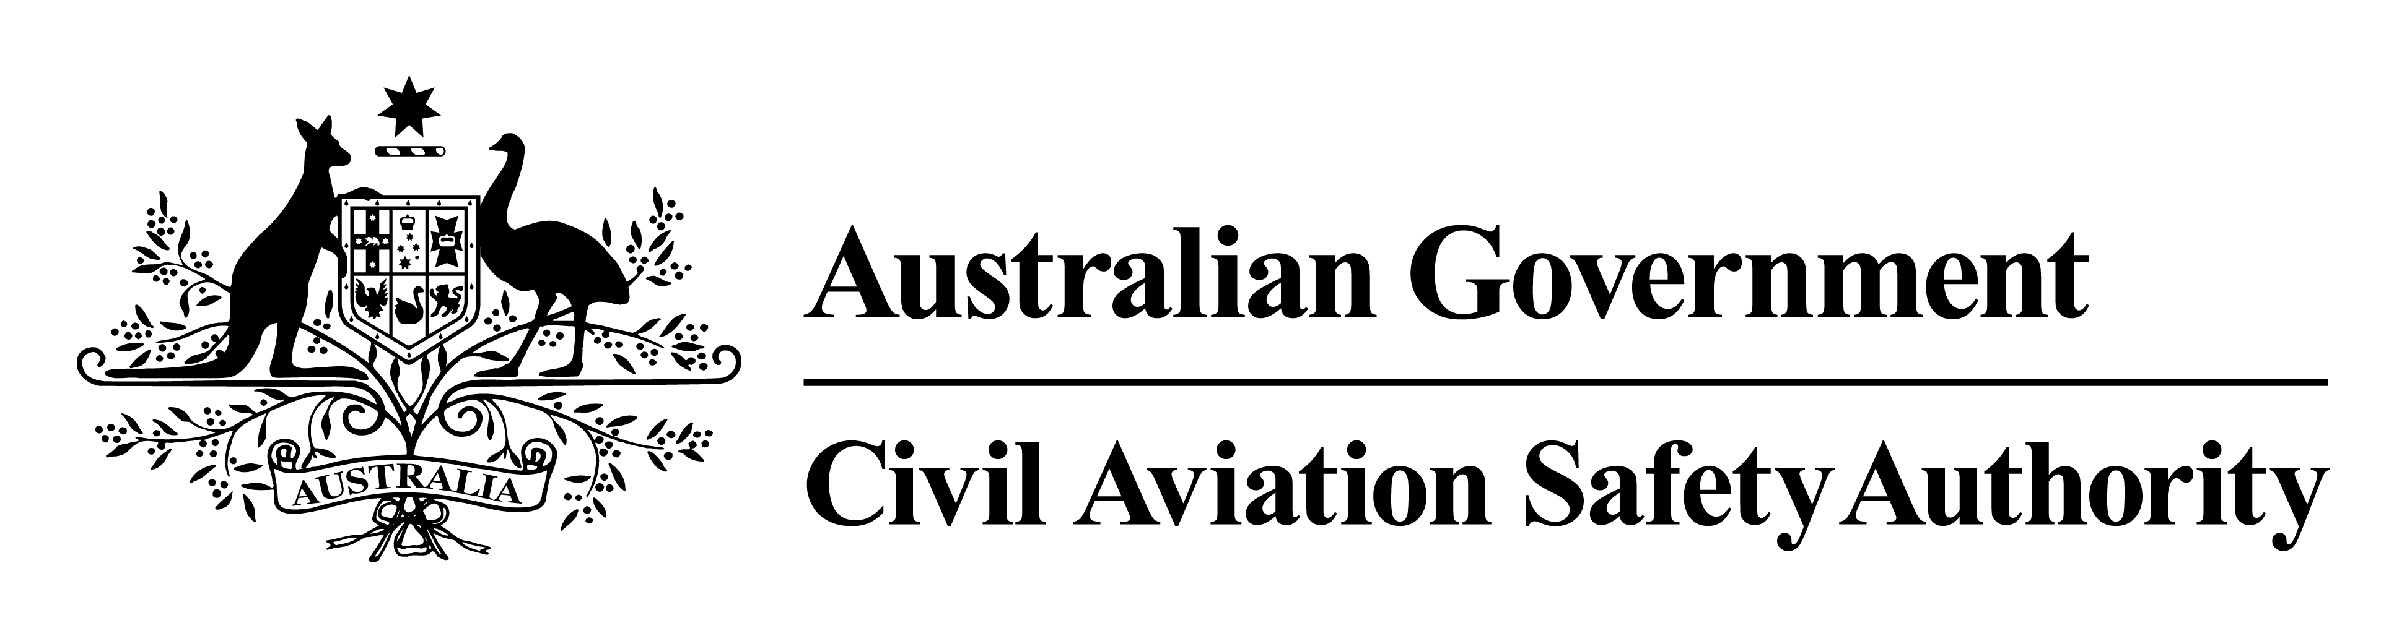
I, David Villiers, manager INITIAL Airworthiness, a delegate of CASA, make this instrument under regulation 39.004 (3) (a) of the Civil Aviation Safety Regulations 1998.

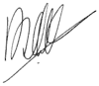
David Villiers
Manager, Initial Airworthiness
Standards Development and Future Technology Division

17 February 2011
Alternative Means of Compliance to FAA Airworthiness Directive 2009-26-11
1 Duration
This instrument:
(a) commences on the day of registration; and
(b) stops having effect if FAA AD 2009-26-11, issued by the FAA, is amended or cancelled.
2 Application
This instrument applies to a registered operator who operates an Ayres S2R series aircraft mentioned in FAA AD 2009-26-11.
3 Approved Means of Compliance
I approve, as an alternative means of compliance to FAA AD 2009-26-11, other than that set out in the AD, “Eddy Current Testing Procedure Ayres S2R Lower Spar Caps QP.97.21 (E) Issue 5, dated 4 February 2011”.

End

