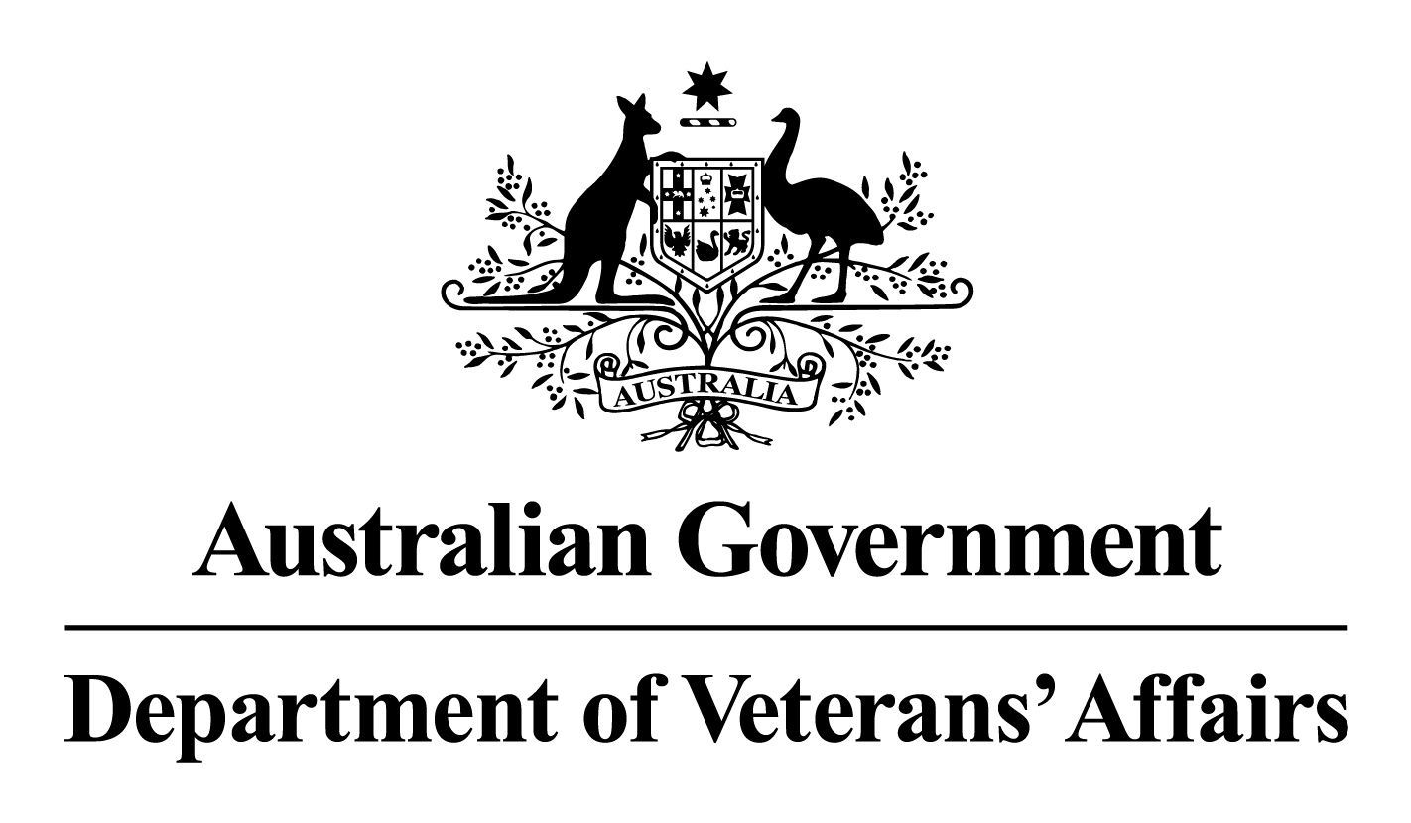

NOTES FOR
ALLIED HEALTH PROVIDERS

SECTION 2(a)

NOTES FOR
ALLIED MENTAL HEALTH CARE PROVIDERS

1 November 2010

Introduction 3
Eligibility to provide allied mental health care services 4
Neuropsychologists 4
Referrals 5
Care plans 5
Service location 5
Public Hospitals 5
Private Hospitals 5
Residential Aged Care Facilities (RACFs) 5
Services to be provided 6
Trauma focussed therapy 6
Neuropsychology 7
Number of services 7
Group Therapy 7
Trauma Focussed Therapy 7
Course of treatment and reporting back to the referring health provider 8
Fees 8
Prior financial authorisation 9
Related DVA services 9
VVCS – Veterans and Veterans Families Counselling Service (VVCS) 9
Veterans line (after hours crisis counselling) 10
Resources for mental health providers 10

I, Ian Campbell, President of the Repatriation Commission, Chair of the Military Rehabilitation and Compensation Commission and Secretary of the Department of Veterans’ Affairs hereby approve these Notes on behalf of the Repatriation Commission, the Military Rehabilitation and Compensation Commission and the Department of Veterans’ Affairs.
Ian Campbell
……………………………………………………………………
IAN CAMPBELL

Dated this …21st…………….. day of ……February……… 2011

These Notes take effect on 1 November 2010

Notes For Allied Mental Health Care Providers

Introduction

- The purpose of the Notes for Allied Mental Health Care Providers is to outline the policy and procedures for the provision of allied mental health care services to entitled persons.

- The Notes for Allied Mental Health Care Providers should be read in conjunction with the Notes for Allied Health Providers which set out the general requirements and parameters for providing health care treatment to the veteran community.

Eligibility to provide allied mental health care services

- Under DVA statutory registration arrangements, to provide allied mental health care services to entitled persons a provider must be currently registered with Medicare Australia under the Medicare Scheme as one of the following providers:
- Clinical psychologist;
- Psychologist;
- Social worker (mental health); or
- Occupational therapist (mental health).

For information on Medicare Australia’s registration requirements contact 132 150.

Neuropsychologists
- Neuropsychologists are not included in DVA’s statutory registration arrangements and must register with DVA directly before providing services to entitled persons.

- To be eligible to provide neuropsychology services to entitled persons of the veteran community a provider must:
- be registered with the Psychology Board of Australia; and
- hold an endorsement in clinical neuropsychology from the Psychology Board of Australia; or
- show evidence of their qualifications in neuropsychology including:
- an accredited doctorate in neuropsychology and at least one year of approved, supervised, full time equivalent practice; or
- an accredited masters in neuropsychology and a minimum of two years of approved, supervised, full time equivalent practice.

For more information on registering with DVA as a neuropsychologist contact:

Postal: Medicare Australia Liaison and Contract Management Section
Department of Veterans’ Affairs
GPO Box 9998
CANBERRA CITY ACT 2601

Phone: 1300 550 457 – (option 3, then option 2) Facsimile: (02) 6289 6764

Referrals

- A referral is required for a provider to deliver mental health care treatment to an entitled person. A referral can be from the following:
- Local Medical Officer (LMO);
- General Practitioner (GP);
- medical specialist;
- hospital discharge planner;
- another mental health care provider with a current referral who is transferring the entitled person; or
- VVCS - Veterans and Veterans Families Counselling Service (VVCS).

- In an emergency situation, where an entitled person seeks psychological treatment without a referral, a mental health care provider may treat the person but they must contact DVA on 1300 550 457 (metro) and 1800 550 457 (non-metro) for special approval prior to claiming payment from Medicare Australia. A referral from the veteran’s GP, LMO or treating health care provider, will be required for treatment to continue.

Care plans

- The allied mental health care provider must formulate a written care plan during the first consultation with the entitled person. The care plan should be discussed with the entitled person. The care plan does not have to be sent to the referring LMO or GP but a copy must be provided if requested.

Service location

Public Hospitals
- DVA will only pay for health care services carried out in public hospitals in exceptional circumstances and when DVA has given prior financial authorisation.

Private Hospitals
- DVA will only pay for health care services carried out by providers in private hospitals when the contract between DVA and the hospital does not already cover these services. It is the provider’s responsibility to determine whether or not health care services are included in the bed-day rate under the DVA contract, before providing services, by contacting the Veteran Liaison Officer at the hospital or DVA.

Residential Aged Care Facilities (RACFs)
- The level of care (high or low) refers to the health status of the entitled person, not the facility in which they reside. If a provider is in doubt about the level of care an entitled person who has been referred to them is receiving in a RACF, they must contact the care facility. It is the provider’s responsibility to ascertain the assessed care level of an entitled person before they provide treatment.

High Care
- Once a person has been assessed as a high level care (formerly nursing home level of care) patient the responsibility for maintenance health care services passes from DVA to the RACF. All treatment provided to entitled persons receiving high level care requires prior financial authorisation from DVA. Authorisation will only be given in exceptional circumstances such as where intensive long-term rehabilitation services are required.

Low Care
- Prior financial authorisation is not required for health care services provided to entitled persons living in RACFs who are receiving Low Level Care (formerly hostel level of care).

Services to be provided

- Eligible allied mental health care providers are responsible for determining the type, frequency and duration of services to be provided to meet the clinical need of the entitled person. The exception to this is group therapy and trauma focussed therapy services (refer to paragraphs 22-25).

- Services provided by eligible allied mental health care providers must be within the specified time period within the item descriptors as listed in the DVA fee schedules (refer to paragraph 30). The mental health care provider must personally attend the entitled person.

- It is expected that professional attendance at places other than consulting rooms would be provided where treatment in other environments is necessary to achieve therapeutic outcomes.

- Services provided by eligible allied mental health care providers may include but are not limited to:
- assessment
- psycho-education
- cognitive-behavioural therapy
- relaxation strategies
- skills training
- interpersonal therapy
- counselling.

Trauma focussed therapy

- There are four items for the provision of trauma focussed therapy by clinical psychologists (US50, US51) and psychologists (US52, US53). These items have been included in the DVA fee schedules to allow for extended consultations to meet the needs of veterans with posttraumatic stress disorder (PTSD).

- Trauma-focussed therapy should only be provided by clinical psychologists and psychologists who are adequately trained, competent and supported to provide this type of therapy. Trauma focussed therapy should be provided in accordance with the Australian Guidelines for the Treatment of Adults with Acute Stress Disorder and Posttraumatic Stress Disorder (2007).

Neuropsychology

- There are three items (CL20, CL25, CL30) for the provision of neuropsychological assessments. Assessments up to four hours can be claimed directly from Medicare Australia. Assessments over four hours require prior financial authorisation from DVA. This can be sought by contacting DVA as listed in paragraph 32.

Number of services

- The number of services provided is determined by the mental health care provider based on the assessed clinical needs of the entitled person. The exception to this is group therapy and trauma focussed therapy services (refer to paragraphs 22-26). The number of services provided to entitled persons is not limited to 12 per year and there is no requirement for a review after six consultations as required by under the Better Access to Psychiatrists, Psychologists and General Practitioners through the Medicare Benefits Schedule (MBS) initiative (Better Access).

Group Therapy
- Group therapy services are limited to 12 services per calendar year. Groups may consist of approximately six to ten participants. While it is not required that all participants in the group be entitled persons, providers can only claim from DVA for these participants. Should participant numbers reduce over the course of the group, the group may continue if clinically appropriate.

Trauma Focussed Therapy
- Up to eight sessions of trauma focussed therapy sessions can be provided. If treatment is to continue past eight sessions the clinical psychologist or psychologist must submit a Case Review to DVA and seek prior financial authorisation for further sessions.

- Case Reviews will be assessed by the appropriate DVA delegate with reference to the relevant professional DVA advisor as required. There is no set format for the case review but it should include the following information as a minimum:
- a summary of the major presenting problems and their immediate effects on the entitled person;
- an explanation of treatment provided and outcomes to date;
- a summary of the proposed treatment plan for further sessions including the number of further treatments required; and
- the provider’s opinion regarding the effects that no further treatment would have on this person.

- A copy of the case review should also be sent to the entitled person’s LMO or GP, as the coordinator of the veteran’s health care. If appropriate, a copy may also be forwarded to the referring health care provider.

- Case reviews should be sent to the DVA Health Care Providers Section as indicated below. Claims for payment for case reviews should be sent directly to Medicare Australia.

Postal: Medical and Allied Health
Department of Veterans’ Affairs
GPO Box 9998
ADELAIDE SA 5001

Phone: Metro 1300 550 457 – (option 3, then option 1)
Non-metro 1800 550 457 - (option 3, then option 1)

Facsimile: (08) 8290 0422 (for all States and Territories)

Course of treatment and reporting back to the referring health provider

- At the end of the 12 month referral period or as clinically appropriate, the allied mental health care provider should provide a report to the referring health provider. The report should include information on:
- any assessments conducted;
- treatment provided; and
- recommendations on future management of the client’s disorder.

- Following receipt of this report the referring health provider will consider the need for further treatment before providing a referral for the provision of further mental health care.

- A written report should also be provided to the referring health provider at the completion of any subsequent course(s) of treatment provided to the entitled person. This report may include information on:
- the reason for closure - for example, did the provider or person terminate treatment; had desired outcomes been achieved; and
- the mental health care provider’s overall opinion of treatment outcomes.

Fees

- Payment for services is based on the following fee schedules:
- DVA Schedule of Fees for Clinical Psychologists
- DVA Schedule of Fees for Psychologists
- DVA Schedule of Fees for Social Workers (mental health)
- DVA Schedule of Fees for Occupational Therapists (mental health)

DVA fee schedules are available at www.dva.gov.au/Service
www.dva.gov.au/service_providers/Fee_schedules/Pages/Dental_and_Allied_Health.aspx

- Under DVA arrangements a gap fee or co-payment cannot be charged for the provision of allied mental health care services to an entitled person. The Notes for Allied Health Providers state that by accepting an entitled person’s Gold or White Card and billing Medicare Australia, a health care provider agrees to accept the DVA fees as full payment for health care services without making any additional charges to the entitled person.

Prior financial authorisation

- Prior financial authorisation from DVA is required in the following cases:
- treatment to be provided to an entitled person who is a high level care resident of a RACF;
- treatment to be provided to an entitled person who is an in-patient of a public hospital;
- neuropsychology assessments over four hours; or
- after eight sessions of trauma focussed therapy sessions.

For information on requests for prior financial authorisation contact DVA on:

Phone: Metro 1300 550 457 – (option 3, then option 1)
Non-metro 1800 550 457 - (option 3, then option 1)

Facsimile: (08) 8290 0422 (for all States and Territories)

Related DVA services

- The families of entitled persons are unable to access the services of an eligible allied mental health care provider unless they themselves are a Gold or White Card holder (see Notes for Allied Health Providers). Therefore allied mental health care providers are encouraged to increase entitled persons’ awareness of the services provided by DVA that are designed to assist them and their families seeking counselling. See below for information on VVCS and the Veterans Line.

VVCS – Veterans and Veterans Families Counselling Service (VVCS)

- VVCS provides counselling and group programs to Australian veterans, peacekeepers and their families. It is a specialised, free and confidential Australia-wide service. Veterans, peacekeepers and their families can refer themselves to VVCS. Other current serving ADF members can request a formal referral from the ADF. Individuals do not need to be DVA health card holders to access the services provided by the VVCS. VVCS can be contacted on
1800 011 046.

- VVCS provides:
- individual, couple and family counselling after-hours crisis telephone counselling via Veterans Line;
- case management services;
- group programs for common mental health issues including anxiety, depression, sleep and anger;
- psycho-educational programs for couples including a residential lifestyle management program;
- Stepping Out, a 2-day transition program for ADF members and their partners preparing to leave the military;
- Changing the Mix – a self-paced alcohol reduction correspondence program. To register call 1800 1808 68;
- Operation Life suicide prevention workshops; and
- Resources – information, education and self-help resources.

Veterans line (after hours crisis counselling)

- Veterans Line – phone 1800 011 046 - is the after hours crisis counselling service provided by the VVCS. The service assists veterans and their families in coping with crisis situations outside of VVCS office hours. Counselling is provided free of charge.

Resources for allied mental health providers

DVA Factsheets for mental health providers can be accessed at: www.dva.gov.au/service_providers/Pages/factsheets.aspx.
- HIP14 Information for Psychologists
- HIP86 Information for Mental Health Occupational Therapists
- HIP87 Information for Mental Health Social Workers
- HIP88 Information for Neuropsychologists

Mental Health Advice Book – information for providers helping veterans with common mental health problems available online at:
www.at-ease.dva.gov.au/www/html/251-contents.asp?intSiteID=1

- At Ease website (www.at-ease.dva.gov.au) to improve veterans' mental health by raising awareness and understanding of how and where to seek help, and encouraging veterans to take action to optimise their health and wellbeing. A range of factsheets and products are available for providers to use with veterans.
- Australian Guidelines for the Treatment of Adults with Acute Stress Disorder and Posttraumatic Stress Disorder (Australian Centre for Posttraumatic Mental Health 2007). Available online or to order at: www.acpmh.unimelb.edu.au/resources/resources-guidelines.html

- Treatment Algorithm for PTSD: developed by Australian Centre for Posttraumatic Mental Health. Available online at:
www.at-ease.dva.gov.au/www/html/654-asd--ptsd-treatment-algorithm.asp

