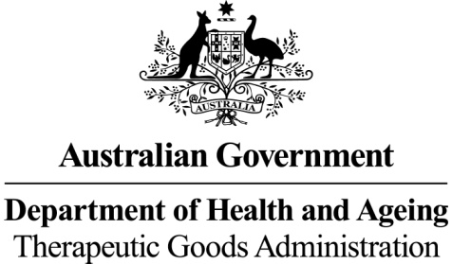

Therapeutic Goods Act 1989

Therapeutic Goods (Things that are not Biologicals)

Determination No. 1 of 2011

I, ROHAN HAMMETT, the delegate of the Secretary of the Department of Health and Ageing for the purposes of subsection 32A(3) of the Therapeutic Goods Act 1989 (the Act), determine that the things specified below are not, for the purposes of the Act, biologicals.

31 May 2011

(signed by)

Dr Rohan Hammett
Delegate of the Secretary of the
Department of Health and Ageing

Citation

- This Determination may be cited as the Therapeutic Goods (Things that are not Biologicals) Determination No.1 of 2011.

Commencement

- This Determination commences on the day it is registered in the Federal Register of Legislative Instruments.

- For the purposes of subsection 32A(3) of the Act, the following things are declared not to be biologicals:
- haematopoietic progenitor cells (HPC) used for haematopoietic reconstitution;
- in-vitro diagnostic devices (IVDs);
- samples of human cell or tissue that are solely for diagnostic purposes in the same individual;
- blood, blood components; and
- biological medicines including:
  - vaccines (that do not contain viable human cells);
  - recombinant products; and
  - plasma derived products (or that contain plasma derived products).

