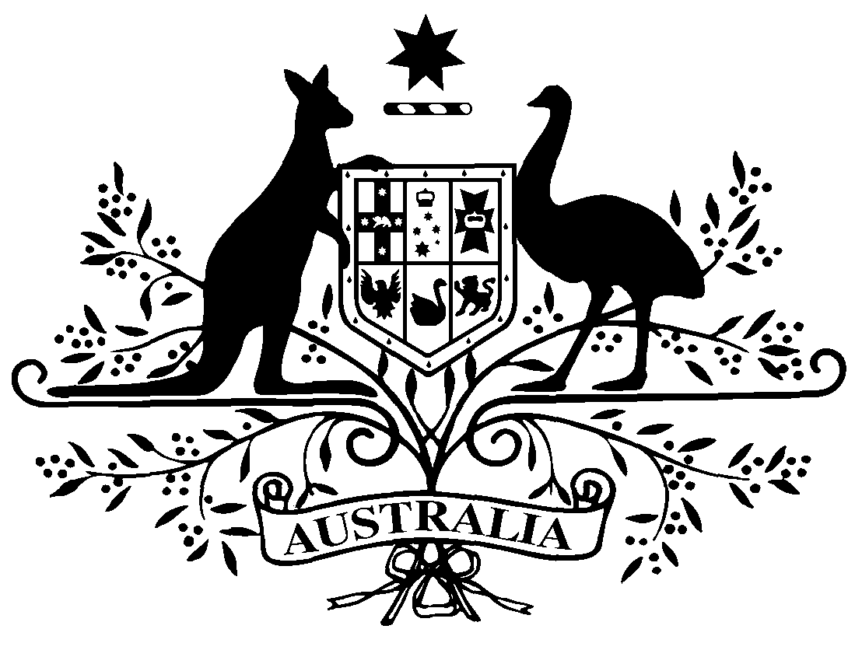

PB 48 of 2011
National Health (Remote Aboriginal Health Services Program) Special Arrangements Amendment Instrument 2011 (No. 1)

National Health Act 1953
___________________________________________________________________________

I, FELICITY MCNEILL, Acting First Assistant Secretary, Pharmaceutical Benefits Division, Department of Health and Ageing, delegate of the Minister for Health and Ageing, make this Amendment Instrument under subsections 100(1) and 100(2) of the National Health Act 1953.
Dated 16 June 2011

FELICITY MCNEILL
Acting First Assistant Secretary
Pharmaceutical Benefits Division
Department of Health and Ageing

___________________________________________________________________________

1 Name of Instrument

- This Instrument is the National Health (Remote Aboriginal Health Services Program) Special Arrangements Amendment Instrument 2011 (No. 1).

- This Instrument may also be cited as PB 48 of 2011.

2 Commencement
This Instrument commences on 1 July 2011.
3 Amendment to PB 65 of 2010
Schedule 1 amends the National Health (Remote Aboriginal Health Services Program) Special Arrangements Instrument (PB 65 of 2010).

Schedule 1 Amendment
- Paragraph 9(h), after “a handling fee of”
Omit:
$2.74
and substitute:
$ 2.79

___________________________________________________________________________

Note
All legislative instruments and compilations are registered on the Federal Register of Legislative Instruments kept under the Legislative Instruments Act 2003.
See http://www.frli.gov.au.

