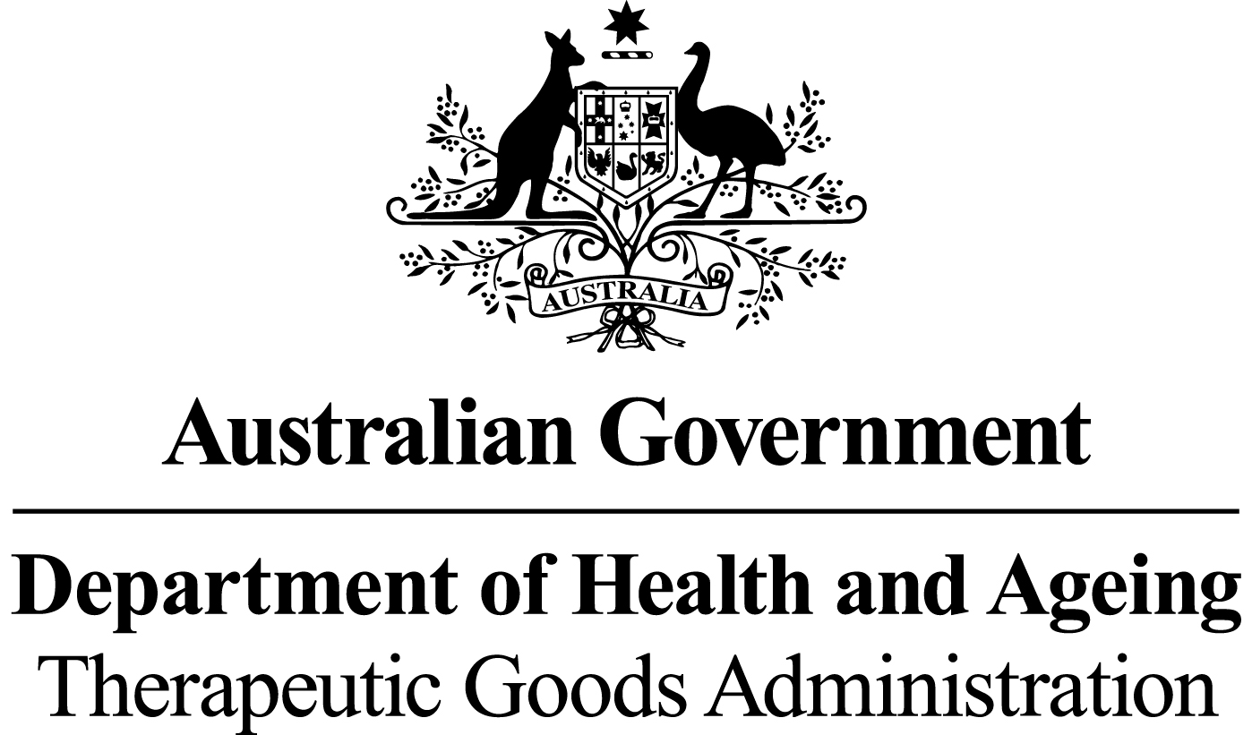

# *THERAPEUTIC GOODS ACT 1989*

### Section 10

# THERAPEUTIC GOODS ORDER NO. 84

# *Standards for human cardiovascular tissue*

I, Jenny Hefford, delegate of the Minister for Health and Ageing for the purposes of section 10 of the *Therapeutic Goods Act 1989* (the Act) and acting under that section, having consulted with the Therapeutic Goods Committee in accordance with subsection 10(4) of the Act, HEREBY:

DETERMINE that the matters specified in this Order shall constitute a standard for biologicals that are human cardiovascular tissue.

Dated this 8 day of July 2011

*(signed by)*

Jenny Hefford

Delegate of the Minister for Health and Ageing

### Name of Order

This Order may be cited as *Therapeutic Goods Order No. 84* *Standards for human cardiovascular tissue.*

### Commencement

This Order commences on 31 May 2012.

### Purpose of the Order

The purpose of this Order is to specify the minimum technical requirements with which a biological that is a human cardiovascular tissue must comply.

### Interpretation

1. In this Order:

***Act*** means the*Therapeutic Goods Act 1989.*

***allogeneic use*** means the use of a biological that is removed from one person and applied to another.

***antimicrobial*** means the ability of a substance to kill or inhibit growth of microorganisms.

***asystole*** means the reference time for cardiac death. A documented pronounced time of death is used as asystole when life-saving procedures have been attempted and there were signs of, or documentation of, recent life (e.g. agonal respirations, pulse-less electrical activity). If death was not witnessed, ‘asystole’ must be determined by reference to the last time that the person was known to be alive. Asystole will be ‘cross clamp time’ if the tissue donor was also a solid organ donor.

***bioburden*** has the same meaning as in the Act.

***biological*** has the same meaning as in the Act.

***cell(s)*** means individual cells, or a collection of cells when not bound by any form of connective tissue.

***collection*** means removing a biological or a source of a biological from a donor.

***competent valve*** means a dissected valve that is capable of functioning in a defined effective manner.

***container*** has the same meaning as in the Act.

***critical material*** means all materials or supplies used in the manufacture of therapeutic goods which could have a direct impact on the quality, safety or function of the final goods.

***cryopreserved*** means suspended in a medium containing a suitable cryoprotectant and cooled according to a method which has been validated to allow maintenance for long periods.

***domino donor*** means a person who by receiving an organ transplant donates the removed organ or tissue for allogeneic use.

***donor*** means any source, whether living or deceased, of blood, blood components, cells or tissues.

***manufacture*** has the same meaning as in the Act.

***microbial*** means microorganisms including, but not limited to, bacteria, fungi, Mycoplasma and Rickettsia but does not include viruses or prions.

***minimal manipulation***has the same meaning as in the Regulations.

***processing*** means any activity involved in the preparation, manipulation, preservation for storage and packaging of a biological.

***recipient*** means a person who receives blood, blood components, cells or tissues by infusion or implantation.

***Regulations*** means the Therapeutic Goods Regulations 1990.

***storage*** means maintaining a substance, material or product under appropriate controlled conditions.

***tissue*** means all constituent parts of the body formed by cells.

***transport*** means the transfer within or between premises of a substance, material or product under appropriate controlled conditions.

### Application of this Order

(1) Subject to section 6, the requirements of this Order apply to biologicals that are human cardiovascular tissue, including aortic, pulmonary, mitral and tricuspid heart valves or any part of such valves and vascular tissue (such as conduit or greater vessel graft, peripheral vascular tissue graft and pericardial graft) collected from:

* + 1. living human donors, including domino donors, for allogeneic use; or
    2. deceased human donors for allogeneic use.

### Exemptions

1. The following biologicals that are human cardiovascular tissue are exempt from the requirements set out under this Order:
2. cardiovascular cells and tissue biopsied for the purpose of an *in vitro* diagnosis and that are not for manufacture and/or reintroduction or transplant to a recipient; and
3. human cardiovascular tissue that is processed beyond minimal manipulation.

### General Requirements

1. In relation to manufacturing procedures relating to human cardiovascular tissue, any critical materials used in the collection and manufacture of such tissue must be of a design and quality that will not adversely affect the quality and condition of the cardiovascular tissue.
2. Human cardiovascular tissue that will not be subjected to a bioburden reduction process must be:
3. collected, manufactured, sampled for bioburden using a validated sampling technique, packaged in an operating theatre, transported to a manufacturing facility and cryopreserved. Cryopreservation must commence:
4. within 48 hours of asystole; or
5. within 48 hours of collection from a living donor; and
6. tested for bioburden using a validated method and, when tested, must:
   1. demonstrate no microbial growth; or
   2. if microbial growth is demonstrated be rejected for therapeutic use.
7. Human cardiovascular tissue that is subjected to a bioburden reduction process must be:
   * 1. subjected to processing and treatment with antimicrobial agents, which must commence:
        1. within 36 hours of asystole; or
        2. within 36 hours of collection from a living donor; and
     2. exposed, between dissection of the tissue from its surrounding tissue and the time of its cryopreservation, to conditions of antimicrobial treatment at:
8. 34°C to 39°C for 6 to 12 hours; or
9. 2°C to 8°C for 18 to 24 hours; and
   * 1. sampled using a validated sampling technique and tested for bioburden using a validated test method before addition of cryopreservative and, when tested, must either:
        1. demonstrate no microbial growth; or
        2. if microbial growth is demonstrated, be rejected for therapeutic use.
10. Where human cardiovascular tissue has been subjected to a terminal sterilisation process, the sterilisation process must be qualified to ensure that a sterility assurance level of 10-6 is achieved for the tissue.
11. Human cardiovascular tissue that is a heart valve must be determined to be a competent valve prior to cryopreservation.
12. Human cardiovascular tissue must be sealed within a sterile container and at least double packaged so as to:
13. prevent ingress/egress of material (other than gas sterilant if applicable); and
14. ensure that any breach of integrity will be evident.
15. Storage conditions for cryopreserved cardiovascular tissue must be:
16. at or below minus 100°C for no more than 5 years; or
17. in accordance with conditions and duration specified and justified by validation data or documented evidence from the relevant scientific literature; and
18. when transported, in a manner that ensures that whichever of the conditions set out at paragraph (7) (a) or (b) applies, are maintained during transport.