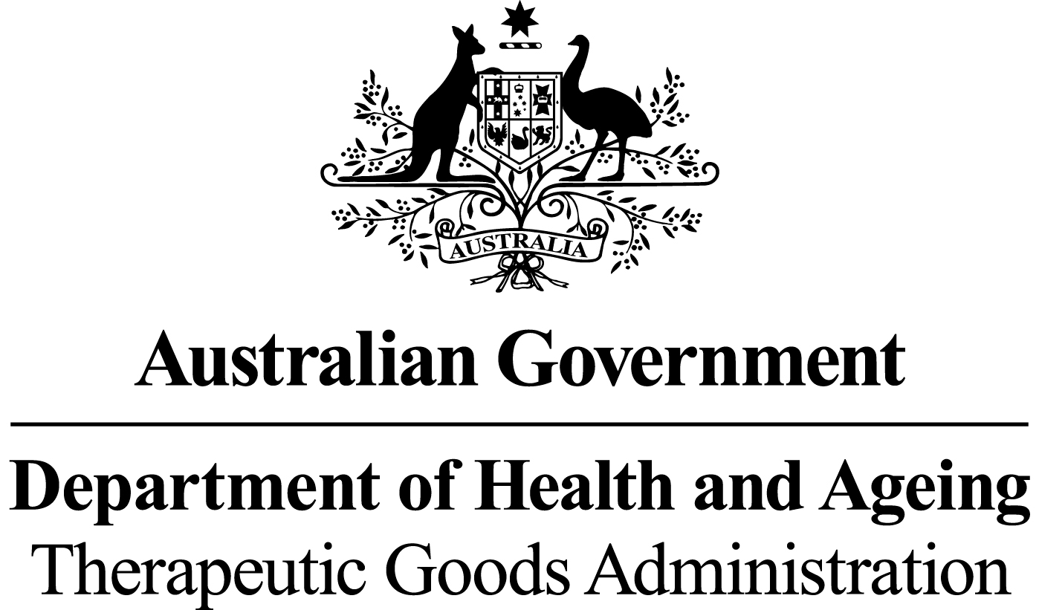

# *THERAPEUTIC GOODS ACT 1989*

### Section 10

# THERAPEUTIC GOODS ORDER NO. 85

# *Standards for human ocular tissue*

I, Jenny Hefford, delegate of the Minister for Health and Ageing for the purposes of section 10 of the *Therapeutic Goods Act 1989* (the Act) and acting under that section, having consulted with the Therapeutic Goods Committee in accordance with subsection 10(4) of that Act, HEREBY:

DETERMINE that the matters specified in this Order shall constitute a standard for biologicals that are human ocular tissue.

Dated this 8 day of July 2011

*(signed by)*

Jenny Hefford

Delegate of the Minister for Health and Ageing

### Name of Order

This Order may be cited as Therapeutic Goods Order No. 85 Standards for human ocular tissue.

### Commencement

This Order commences on 31 May 2012.

### Purpose of this Order

The purpose of this Order is to specify the minimum technical requirements with which a biological that is a human ocular tissue must comply.

### Interpretation

* 1. In this Order:

***Act*** means the*Therapeutic Goods Act 1989.*

***allogeneic use*** means use of a biological that is removed from one person and applied to another.

***asystole*** means the reference time for cardiac death. A documented pronounced time of death is used as asystole when life-saving procedures have been attempted and there were signs of, or documentation of, recent life (e.g. agonal respirations, pulse-less electrical activity). If death was not witnessed, ‘asystole’ must be determined by reference to the last time that the person was known to be alive. Asystole will be ‘cross clamp time’ if the tissue donor was also a solid organ donor.

***bioburden*** has the same meaning as in the Act.

***biological*** has the same meaning as in the Act.

***cell(s)*** means individual cells, or a collection of cells when not bound by any form of connective tissue.

***collection*** means removing a biological or a source of a biological from a donor.

***container*** has the same meaning as in the Act.

***critical material*** means all materials or supplies used in the manufacture of therapeutic goods which could have a direct impact on the quality, safety or function of the final goods.

***cryopreserved*** means suspended in a medium containing a suitable cryoprotectant and cooled according to a method which has been validated to allow maintenance for long periods.

***donor*** means any source, whether living or deceased, of blood, blood components, cells or tissues.

***manufacture*** has the same meaning as in the Act.

***microbial*** means microorganisms including, but not limited to, bacteria, fungi, Mycoplasma and Rickettsia, but does not include viruses or prions.

***minimal manipulation*** has the same meaning as in the Regulations.

***recipient*** means a person who receives blood, blood components, cells or tissues by infusion or implantation.

***Regulations*** means the Therapeutic Goods Regulations 1990.

***storage*** means maintaining a substance, material or product under appropriate controlled conditions.

***tissue*** means all constituent parts of the body formed by cells.

***transport*** means the transfer within or between premises of a substance, material or product under appropriate controlled conditions.

### Application of this Order

* 1. Subject to section 6, the requirements of this Order apply to biologicals that are human ocular tissue, including the eye globe, cornea or sclera, collected from:
     1. living human donor(s) for allogeneic use; or
     2. deceased human donor(s) for allogeneic use.

### Exemptions

1. The following biologicals that are human ocular tissue are exempt from the requirements set out under this Order:
2. human ocular cells and tissue samples that are biopsied for the purpose of an *in vitro* diagnosis and that are not for manufacture and/or reintroduction or transplant to a recipient;
3. human ocular tissue that is processed beyond minimal manipulation; and
4. amniotic membrane that may be used for therapeutic ocular procedures.

### General requirements

* 1. In relation to manufacturing procedures relating to human ocular tissue, any critical materials used in the collection and manufacture of such tissue must be of a design and quality that will not adversely affect the quality and condition of the ocular tissue.
  2. Collection of human ocular tissue from a deceased donor must commence no more than 48 hours after asystole and the time intervals between death, enucleation, preservation and/or corneal excision must be recorded.
  3. Human ocular tissue collected between 24 and 48 hours after asystole must be evaluated for quality and suitability for therapeutic use by the medical director and transplanting surgeon prior to release.
  4. Human ocular tissue must be stored as follows:

1. an eye globe in a moist chamber system at 0°C to 10°C for no more than 48 hours; or
2. excised cornea in a corneal storage medium at 0°C to 10°C for no more than 14 days; or
3. excised cornea maintained in a storage medium at 28°C to 37°C for no more than 30 days; or
4. excised cornea maintained in a cryopreservation medium between minus 75°C to minus 196°C for up to 2 years; or
5. in accordance with conditions and duration specified and justified by validation data or documented evidence from the relevant scientific literature.
   1. For human ocular tissue that is excised cornea preserved according to paragraph 7(4)(c):
      1. subsequent exposure to a transport medium at a temperature validated to maintain tissue quality must not exceed 5 days; and
      2. the storage medium must be tested for microbial contamination using a validated test method prior to transfer of the tissue to the transport medium; and
      3. evidence of any microbial contamination after testing of the storage medium under paragraph 7(5)(b) must result in rejection of the tissue for therapeutic use where the tissue has not been released for supply to a recipient; or
      4. for human ocular tissue that has already been released and supplied to a recipient, and where there is evidence of microbial contamination, results of the microbial tests must be reported to the transplanting surgeon in accordance with the manufacturer’s documented procedure.
   2. Human ocular tissue must be sealed within a sterile container and packaged and sealed so as to:
6. prevent ingress/egress of material (other than for a gas sterilant if applicable); and
7. ensure that any breach of integrity will be evident.
   1. If human ocular tissue has been subjected to a terminal sterilisation process, the sterilisation process must be qualified to ensure that a sterility assurance level of 10-6 is achieved for the tissue.

### Examination and evaluation of ocular tissue

1. Examination and evaluation of human ocular tissue must be in accordance with the requirements of Section 10 of the ‘*Eye Bank Association of Australia and New Zealand (EBAANZ). EBAANZ Medical and Quality Standards for Eye Donation and Eye Tissue Banking. Edition 2, April 2009*’, available through the EBAANZ website < <http://ebaanz.org/page_9.html>>.