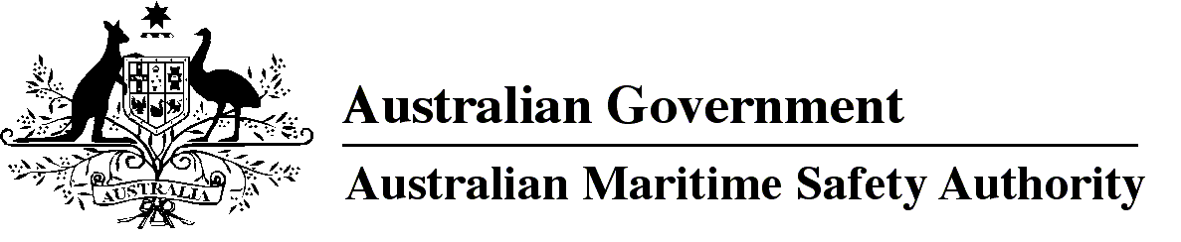
AMSA MO 2011/7
Marine Order 59, issue 2 (Off-shore industry vessel operations)
I, Mick Kinley, Acting Chief Executive Officer of the Australian Maritime Safety Authority, make this Order under subsection 425 (1AA) of the Navigation Act 1912.
Mick Kinley
Acting Chief Executive Officer
4 October 2011
1 Name of Order 3
2 Commencement 3
3 Repeal of Marine Orders Part 59, issue 1 3
4 Purpose 3
5 Application 3
6 Definitions 3
7 Requirement for safety arrangements — emergencies 4
8 Requirement for safety arrangements — generally 5
9 Applying for approval of equivalent guideline 5
10 Crew members’ responsibility 6
1 Name of Order
This Order is Marine Order 59, issue 2.
2 Commencement
This Order commences on 8 October 2011.
3 Repeal of Marine Orders Part 59, issue 1
Marine Orders Part 59, issue 1 is repealed.
4 Purpose
For section 425 of the Act, this Order makes provision about:
(a) safety of people engaged in loading or unloading off-shore industry vessels; and
(b) safe navigation and operation of off-shore industry vessels; and
(c) safety of people, including pilots, going on or coming from, or on board, off-shore industry vessels.
5 Application
This Order applies to the following (whether registered in Australia or not):
(a) an off-shore industry vessel for which a declaration under subsection 8A(2) of the Act is in force;
(b) an off-shore industry vessel that is engaged in an overseas or interstate voyage;
(c) an off-shore industry vessel that:
(i) is engaged in a voyage other than an overseas or interstate voyage; and
(ii) is affected by a provision of the Act that overrides section 2 of the Act.
Note 1 For a statement about application of the Act to off-shore industry vessels not registered in Australia, see s 283G(1) of the Act.
Note 2 This Order will affect an off-shore industry vessel not registered in Australia only to the extent that it engages in operations, as defined in this Order.
Note 3 The Offshore Petroleum and Greenhouse Gas Storage Act 2006, s 640 provides that the Navigation Act 1912 does not apply on, and in relation to, facilities to which that Act applies (except to the extent that it relates to the transfer of persons or goods between a ship and a facility).
Note 4 For paragraph (c)(ii), provisions of the Act that override s 2 of the Act include ss 186A, 187, 266, 267M, 267ZB, 267ZE, 284 and 317.
6 Definitions
In this Order:
Act means the Navigation Act 1912.
approved equivalent guideline means an equivalent guideline approved under section 9.
NWEA Guidelines means the document known as NWEA (North West European Area) Guidelines for the Safe Management of Offshore Supply and Rig Move Operations (Version 2), read together with edition 1 of the Australian Supplement published by AMSA, both as in force on 1 October 2011.
Note When this Order was made, the NWEA Guidelines were available at http://www.nwea.info. The Australian Supplement is available at http://www.amsa.gov.au.
off-shore industry vessel — see the Act, s 8(4).
operations, for an off-shore industry vessel, means the activities associated with or incidental to exploring or exploiting the natural resources of any of the following:
(a) the continental shelf of Australia;
(b) the seabed of the Australian coastal sea;
(c) the subsoil of that seabed.
Note 1 Some terms used in this Order are defined in Marine Order 1, issue 2 (Administration). For example:
- Manager, Ship Operations and Qualifications.
Note 2 Terms used in this Order have the same meaning that they have in the Act. For example, the following terms are defined in the Act:
- Australian coastal sea
- equipment
- ship.
7 Requirement for safety arrangements — emergencies
The master of an off-shore industry vessel must ensure that:
(a) the following arrangements are in place in anticipation of an emergency during operations of the vessel:
(i) safety procedures for emergencies involving the vessel are established for the vessel;
(ii) equipment, in good working order, appropriate to handling emergencies involving the vessel is on board the vessel;
(iii) instruction in emergency procedures for people involved in operation of the vessel is available and provided to the people;
(iv) training in safe operations onboard the vessel (commonly called ship specific induction) for people, including pilots, boarding or leaving the vessel is available and provided to the people to the level necessary for their safety while onboard; and
(b) the arrangements are made in accordance with:
(i) any applicable NWEA Guidelines; or
(ii) an approved equivalent guideline.
This is a penal provision.
Note equipment includes every thing or article belonging to or to be used in connexion with, or necessary for, the navigation and safety of, the ship — see the Act, s 6, definition of equipment.
8 Requirement for safety arrangements — generally
The master of an off-shore industry vessel must ensure that:
(a) the following arrangements are in place for operations of the vessel:
(i) safety procedures for the normal operation of the vessel are established for the vessel;
(ii) equipment, in good working order, appropriate to the operation of the vessel is on board the vessel;
(iii) instruction in safe operations for people involved in operation of the vessel is available and provided to the people;
(iv) training in safe operations onboard the vessel (commonly called ship specific induction) for people, including pilots, boarding or leaving the vessel is available and provided to the people to the level necessary for their safety while onboard; and
(b) the arrangements are made in accordance with:
(i) any applicable NWEA Guidelines; or
(ii) an approved equivalent guideline.
This is a penal provision.
9 Applying for approval of an equivalent guideline
9.1 The operator of an off-shore industry vessel may apply for approval of an equivalent guideline for section 7 or section 8, in accordance with the application process set out in Marine Order 1, issue 2 (Administration).
9.2 The decision maker for an application made under subsection 9.1 is the Manager, Ship Operations and Qualifications.
9.3 The Manager, Ship Operations and Qualifications may approve the equivalent guideline only if satisfied that arrangements in accordance with the equivalent guideline would be at least as effective as arrangements in accordance with the NWEA Guidelines in ensuring arrangements are safe for the safety of operations on board an off-shore industry vessel.
Note Marine Order 1, issue 2 deals with the following:
- making an application
- seeking further information about an application
- the time allowed for consideration of an application
- notification of a decision on an application
- review of decisions.
10 Crew members’ responsibility
A person who is a crew member of an off-shore industry vessel must:
(a) follow any instructions given as part of the safety arrangements mentioned in this Order by the master of the vessel or another person designated under the arrangements to give the instruction; and
(b) perform duties in a way that ensures operations of the vessel are carried out safely; and
(c) take any reasonable action (in the course of performing duties or otherwise) to ensure operations of the vessel are carried out safely.

Note
1. All legislative instruments and compilations are registered on the Federal Register of Legislative Instruments kept under the Legislative Instruments Act 2003. See http://www.frli.gov.au.

