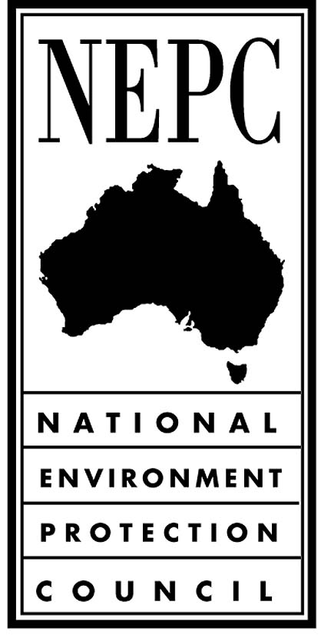

**Summary of Submissions received in relation to the Draft National Environment Protection (Used Packaging Materials) Measure and the National Environment Protection Council’s Responses to Submissions**

**SEPTEMBER 2011**

**Introduction**

The goal of the National Environment Protection (Used Packaging Materials) Measure (NEPM) is to reduce environmental degradation arising from the disposal of used packaging and conserve virgin materials through the encouragement of waste avoidance and the re-use and recycling of used packaging materials by supporting and complementing the voluntary strategies in the Australian Packaging Covenant (the Covenant) and by assisting the assessment of the performance of the Covenant.

Late in 2010, administrative issues were identified with the registration of the 2005 and 2010 Minor Variations to the Used Packaging Materials NEPM which could call into question the validity of the NEPM. In order to put the question of validity beyond doubt and provide certainty to the packaging industry the NEPM is being re-made.

In accordance with the *National Environment Protection Council Act 1994*, a notice of intention to prepare a draft NEPM was published in the *Commonwealth Government Notices Gazette* (Gazette) on Wednesday 23 February 2011 and in *The Australian* on Wednesday 23 February 2011 and Friday 25 February 2011.

The draft NEPM and an Impact Statement were subsequently released for public consultation in June 2011. A notice of public consultation was published in the Gazette on Wednesday 15 June 2011 and in *The Australian* on Wednesday 15 June 2011 and Friday 17 June 2011. The closing date for submissions was Monday 22 August 2011.

Two submissions were received in response to the release of the draft NEPM and Impact Statement: one from the West Australian Municipal Waste Advisory Council; the other from the New South Wales Office of Environment and Heritage (NSW OEH). Both submissions were supportive of the Covenant and NEPM arrangement and of remaking the NEPM.

**Key Issue**

In the NSW OEH submission an objection is made regarding the terminology used to define ‘consumer packaging’ in the draft NEPM. NSW OEH request that the definition in the NEPM aligns with the Covenant definition. In particular, NSW OEH’s objection relates to the use of the word ‘retail’, as it creates ambiguity about the scope of the ‘consumer packaging’ definition. NEPC Committee has advised NEPC that this change should be agreed to.

**Summary of submissions and responses**

|  |  |
| --- | --- |
| **Definition of ‘consumer packaging’** | |
| Submission | Response |
| There is a variation between the draft NEPM and the Covenant definition of ‘consumer packaging’. This will have a direct negative impact on the consistency of enforcement provided by jurisdictions and on the compliance messages given to industry. The NEPM-based co-regulatory scheme to enforce the Covenant is only effective if there is consistency between all jurisdictions, and between the Covenant and the NEPM. | Agree. The NEPM definition of ‘consumer packaging’ has been aligned with the Covenant definition. |

|  |  |
| --- | --- |
| **Desired environmental outcomes** | |
| Submission | Response |
| Support for the objective of reducing the environmental impacts of packaging. Local governments hold significant concerns for a progressive increase in the amount of packaging disposed to landfill and subsequent greenhouse gas emissions and consumption of resources if the NEPM was to be terminated. | Noted. |

|  |  |
| --- | --- |
| **Reasons for the proposed measure and the environmental impact of not making the measure** | |
| Submission | Response |
| Local governments have significant investment in resource recovery and their role as waste service providers will be impacted by developments in this area. It is in both local governments and the community’s best interests that the increasing amount of waste be addressed. | Noted. |

|  |  |
| --- | --- |
| **Statement of the alternative methods of achieving the desired environmental outcomes and the reasons why those alternatives have not been adopted** | |
| Submission | Response |
| Support for the decision made by Ministers to select option four as the agreed option. The Western Australian Local Government Association (WALGA) recommends that adding ‘administrative simplicity’ as an additional criterion would strengthen the options analysis. WALGA rank option four as having medium to high administrative simplicity which strengthens its position as the first preferred option. | Noted. |

|  |  |
| --- | --- |
| **Identification and assessment of the economic and social impact on the community (including industry) of making the proposed measure** | |
| Submission | Response |
| Agree that the benefits of continuing the current co-regulatory arrangement outweigh the costs. | Noted. |

|  |  |
| --- | --- |
| **Statement of the manner in which any regional environmental differences in Australia have been addressed in the development of the proposed measure** | |
| Submission | Response |
| Highlight the importance of addressing issues specific to metropolitan and regional areas in the implementation of any national scheme. | Addressed in chapter 2.2 of the 18 June 2010 Used Packaging Materials Decision Regulation Impact Statement as per schedule 17 (v) of the *National Environment Protection Council Act 1994*. |