A1047

Food Standards (Application A1047 – Sodium Carboxymethylcellulose as a Food Additive in Wine) Variation

The Board of Food Standards Australia New Zealand gives notice of the making of this variation under section 92 of the Food Standards Australia New Zealand Act 1991. The Standard commences on the date specified in clause 3 of this variation.

Dated 11 November 2011

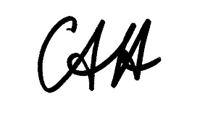
Standards Management Officer
Delegate of the Board of Food Standards Australia New Zealand

1 Name

This instrument is the Food Standards (Application A1047 – Sodium Carboxymethylcellulose as a Food Additive in Wine) Variation.

2 Variation to Standards in the Australia New Zealand Food Standards Code

The Schedule varies the Standards in the Australia New Zealand Food Standards Code.

3 Commencement

This variation commences on 17 November 2011.

SCHEDULE

[1] Standard 1.3.1 is varied by inserting the following entry in numerical order under item 14.2.2 Wine, sparkling wine and fortified wine of Schedule 1 –

 | 466 | Sodium carboxymethylcellulose | GMP |  |  | Wine and sparkling wine only

[2] Standard 4.5.1 is varied by inserting in alphabetical order in the Table to clause 3 –

Sodium carboxymethylcellulose

