HAZARDOUS WORK

Managing Noise and
Preventing Hearing Loss

Hazardous Manual Tasks

Confined Spaces

Managing the Risk
of Falls at Workplaces
TABLE OF CONTENTS
MANAGING NOISE AND PREVENTING HEARING LOSS AT WORK

Code of Practice

 | FOREWORD
 | SCOPE AND APPLICATION
1. | INTRODUCTION
1.1 | Who has health and safety duties in relation to noise?
1.2 | The meaning of key terms
1.3 | What is required to manage the risks of hearing loss?
2. | NOISE AND ITS EFFECT ON HEALTH AND SAFETY
2.1 | How does hearing loss occur?
2.2 | How much noise is too much?
2.3 | Other effects of noise
3. | HOW TO IDENTIFY THE HAZARDS
3.1 | How to find noise hazards
3.2 | What happens next?
4. | HOW TO ASSESS THE RISKS
4.1 | When should a risk assessment be conducted?
4.2 | Who can do a noise assessment?
4.3 | How should a noise assessment be done?
4.4 | What information should be included in a noise assessment?
5. | HOW TO CONTROL THE RISKS
5.1 | The hierarchy of risk control
5.2 | Substituting plant or processes to reduce noise
5.3 | Using engineering controls
5.4 | Isolating the source of noise
5.5 | Using administrative controls
5.6 | Using personal hearing protectors
5.7 | Audiometric testing
5.8 | Information, training and instruction
5.9 | Implementing and maintaining control measures
6. | HOW TO REVIEW CONTROL MEASURES
7. | ROLE OF DESIGNERS, MANUFACTURERS, SUPPLIERS AND INSTALLERS
7.1 | Designers
7.2 | Manufacturers
7.3 | Suppliers and importers
7.4 | Installers
7.5 | What information should be provided to potential users?
 | APPENDIX A – OTHER CAUSES OF HEARING LOSS IN THE WORKPLACE
 | APPENDIX B – NOISE HAZARD IDENTIFICATION CHECKLIST
 | APPENDIX C - READY RECKONER
 | APPENDIX D - CONTENTS OF A NOISE ASSESSMENT REPORT
 | APPENDIX E - ENGINEERING CONTROL MEASURES

FOREWORD
This Code of Practice for managing noise and preventing hearing loss at work is an approved code of practice under section 274 of the Work Health and Safety Act (the WHS Act).
An approved code of practice is a practical guide to achieving the standards of health, safety and welfare required under the WHS Act and the Work Health and Safety Regulations 2011 (the WHS Regulations).
A code of practice applies to anyone who has a duty of care in the circumstances described in the code. In most cases, following an approved code of practice would achieve compliance with the health and safety duties in the WHS Act, in relation to the subject matter of the code. Like regulations, codes of practice deal with particular issues and do not cover all hazards or risks that may arise. The health and safety duties require duty holders to consider all risks associated with work, not only those for which regulations and codes of practice exist.
Codes of practice are admissible in court proceedings under the WHS Act and Regulations. Courts may regard a code of practice as evidence of what is known about a hazard, risk or control and may rely on the code in determining what is reasonably practicable in the circumstances to which the code relates.
Compliance with the WHS Act and Regulations may be achieved by following another method, such as a technical or an industry standard, if it provides an equivalent or higher standard of work health and safety than the code.
An inspector may refer to an approved code of practice when issuing an improvement or prohibition notice.
This Code of Practice is based on the draft code of practice developed by Safe Work Australia as a model code of practice under the Council of Australian Governments’ Inter-Governmental Agreement for Regulatory and Operational Reform in Occupational Health and Safety for adoption by the Commonwealth, state and territory governments.
A draft of that model code of practice was released for public consultation on 7 December 2010 and was endorsed by the Workplace Relations Ministers’ Council on 10 August 2011.

SCOPE AND APPLICATION
This Code of Practice applies to all types of work and all workplaces covered by the WHS Act where there is the potential for exposure to noise that can contribute to hearing loss. It provides practical guidance to persons conducting a business or undertaking on how noise affects hearing, how to identify and assess exposure to noise and how to control health and safety risks arising from hazardous noise.
Although the WHS Regulations for noise are limited to managing the risks of hearing loss, the duties in the WHS Act extend to all health and safety risks arising from the conduct of a business or undertaking and therefore this Code also includes information about other agents that may contribute to hearing loss in Appendix A.
How to use this Code of Practice
In providing guidance, the word ‘should’ is used in this Code of Practice to indicate a recommended course of action, while ‘may’ is used to indicate an optional course of action.
This Code of Practice also includes various references to sections of the WHS Act and Regulations which set out the legal requirements. These references are not exhaustive. The words ‘must’, ‘requires’ or ‘mandatory’ indicate that a legal requirement exists and must be complied with.

1. INTRODUCTION
Hazardous noise can destroy the ability to hear clearly and can also make it more difficult to hear sounds necessary for working safely, such as instructions or warning signals.
Managing the risks related to noise will assist in:
- protecting workers from hearing loss and disabling tinnitus (ringing in the ears or head)
- improving the conditions for communication and hearing warning sounds
- creating a less stressful and more productive work environment.

1.1 WHO HAS HEALTH AND SAFETY DUTIES IN RELATION TO NOISE?
A person conducting a business or undertaking has the primary duty under the WHS Act to ensure, so far as is reasonably practicable, that workers and other persons are not exposed to health and safety risks arising from the business or undertaking.
A person conducting a business or undertaking has more specific obligations under the WHS Regulations to manage the risks of hearing loss associated with noise at the workplace, including:
- ensuring that the noise a worker is exposed to at the workplace does not exceed the exposure standard for noise
- providing audiometric testing to a worker who is frequently required to use personal hearing protectors to protect the worker from hearing loss associated with noise that exceeds the exposure standard.
Designers, manufacturers, suppliers, importers and installers of plant or structures that could be used for work must ensure, so far as is reasonably practicable, that the plant or structure is without risks to health and safety. Designers and manufacturers of plant must ensure the plant is designed and manufactured so that its noise emission is as low as reasonably practicable.
Designers, manufacturers, suppliers and importers must also provide information about the noise emission values of the plant and any conditions necessary for minimising the risk of hearing loss and other harm (see Chapter 7 of this Code).
Officers, such as company directors, have a duty to exercise due diligence to ensure that the business or undertaking complies with the WHS Act and Regulations. This includes taking reasonable steps to ensure that the business or undertaking has and uses appropriate resources and processes to eliminate or minimise risks that arise from noise.
Workers have a duty to take reasonable care for their own health and safety and that they do not adversely affect the health and safety of other persons. Workers must comply with any reasonable instruction and cooperate with any reasonable policy or procedure relating to health and safety at the workplace. For example, if personal hearing protectors are provided by the person conducting the business or undertaking, the worker must use them in accordance with the information, instruction and training provided on their use.

1.2 THE MEANING OF KEY TERMS
Decibel (dB) is the unit for measuring sound levels.
Exposure standard for noise is defined in the WHS Regulations as an LAeq,8h of 85 dB(A) or an LC,peak of 140 dB(C). There are two parts to the exposure standard for noise because noise can either cause gradual hearing loss over a period of time or be so loud that it causes immediate hearing loss.
LAeq,8h means the eight-hour equivalent continuous A-weighted sound pressure level in decibels, referenced to 20 micropascals, determined in accordance with AS/NZS 1269.1:2005. This is related to the total amount of noise energy a person is exposed to in the course of their working day. It takes account of both the noise level and the length of time the person is exposed to it. An unacceptable risk of hearing loss occurs at LAeq,8h values above 85 dB(A).
LC,peak means the C-weighted peak sound pressure level in decibels, referenced to 20 micropascals, determined in accordance with AS/NZS 1269.1:2005. It usually relates to loud, sudden noises such as a gunshot or hammering. LC,peak values above 140 dB(C) can cause immediate damage to hearing.
Hazardous noise in relation to hearing loss means noise that exceeds the exposure standard for noise in the workplace.
Risk control means taking action to first eliminate health and safety risks so far as is reasonably practicable, and if that is not possible, minimising the risks so far as is reasonably practicable. Eliminating a hazard will also eliminate any risks associated with that hazard.

1.3 What is required to manage the risks of hearing loss?
Regulation 34-38: In order to manage risk under the WHS Regulations, a duty holder must:
a) identify reasonably foreseeable hazards that could give rise to the risk
b) eliminate the risk so far as is reasonably practicable
c) if it is not reasonably practicable to eliminate the risk – minimise the risk so far as is reasonably practicable by implementing control measures in accordance with the hierarchy of control
d) maintain the implemented control measure so that it remains effective
d) review, and if necessary revise, risk control measures so as to maintain, so far as is reasonably practicable, a work environment that is without risks to health and safety.
This Code provides guidance on how to manage the risks of hearing loss associated with noise by following a systematic process that involves:
- identifying sources of noise that may cause or contribute to hearing loss,
- if necessary, assessing the risks associated with these hazards,
- implementing risk control measures
- reviewing risk control measures.
Guidance on the general risk management process is available in the Code of Practice: How to Manage Work Health and Safety Risks.
Consulting your workers
Consultation involves sharing of information, giving workers a reasonable opportunity to express views and taking those views into account before making decisions on health and safety matters.
Section 47: The WHS Act requires that you consult, so far as is reasonably practicable, with workers who carry out work for you who are (or are likely to be) directly affected by a work health and safety matter.
Section 48: If the workers are represented by a health and safety representative, the consultation must involve that representative.
Consultation with workers and their health and safety representatives is required at each step of the risk management process. By drawing on the experience, knowledge and ideas of your workers you are more likely to identify all hazards and choose effective control measures.
You must also consult your workers when proposing to make any changes that may affect their health and safety, for example when planning to buy new machinery or equipment.
Health and safety representatives must have access to relevant information such as noise exposure data and potential control options. If you have a health and safety committee, you should engage the committee in the process as well.
Consulting, co-operating and co-ordinating activities with other duty holders
Section 46: The WHS Act requires that you consult, co-operate and co-ordinate activities with all other persons who have a work health or safety duty in relation to the same matter, so far as is reasonably practicable.
Sometimes you may share responsibility for a health and safety matter with other business operators who are involved in the same activities or who share the same workplace. In these situations, you should exchange information to find out who is doing what and work together in a co-operative and co-ordinated way so that all risks are eliminated or minimised as far as reasonably practicable.
For example, if you own or manage an on-hire business and your workers work at other workplaces then you must consult the host business so far as is reasonably practicable to determine if your workers could be exposed to hazardous noise and agree on what you each will do to control any associated risks.
Further guidance is available in the Code of Practice: Work Health and Safety Consultation, Co-operation and Co-ordination.

2. NOISE AND ITS EFFECT ON HEALTH AND SAFETY

2.1 HOW DOES HEARING LOSS OCCUR?
Hazardous noise affects the functioning of the inner ear, which may cause temporary hearing loss. After a period of time away from noise, hearing may be restored. With further exposure to hazardous noise, the ear will gradually lose its ability to recover and the hearing loss will become permanent.
Permanent hearing loss can also occur suddenly if a person is exposed to very loud impact or explosive sounds. This type of damage is known as acoustic trauma.
Permanent hearing loss results from the destruction of hair cells in the inner ear. These cells cannot be replaced or repaired by any presently known medical treatments or technology.
Usually, hazardous noise first affects the ability to hear high-frequency (high-pitched) sounds. This means that even though a person can still hear some sounds, conversation will start to sound ‘muffled’ and a person may find it difficult to understand what is being said.
Communication difficulties occur especially when there are competing background noises. Modern hearing aids may improve the ability to hear speech but they are unable to completely restore the clarity of the full hearing function.
Workers exposed to hazardous noise may also experience tinnitus, which could become permanent. When severe, it may disrupt sleep, reduce concentration, make people extremely irritable and lead to depression.
The degree of hearing loss that occurs is dependent on how loud the noise is, how long someone is exposed to it and, to some extent, individual susceptibility. The frequency or pitch can also have some effect on hearing loss, since high-pitched sounds are more damaging than low-pitched ones.
Exposure to a number of common industrial chemicals and some medications can also cause hearing loss or exacerbate the effects of noise on hearing. These substances are called ototoxic substances.
Ototoxic substances absorbed into the bloodstream may damage the cochlea in the inner ear and/or the auditory pathways to the brain, leading to hearing loss and tinnitus. Hearing loss is more likely if exposure is to a combination of substances or a combination of the substance and noise.
There is also some evidence that exposure to hand transmitted vibrations can exacerbate the effects of noise on hearing.
Further information on these other causes of hearing loss is provided in Appendix A.

2.2 HOW MUCH NOISE IS TOO MUCH?
Whether the exposure standard of 85 dB(A) averaged over eight hours is exceeded depends on the level of noise involved and how long workers are exposed to it.
Peak noise levels greater than 140 dB(C) usually occur with impact or explosive noise such as sledge-hammering or a gun shot. Any exposure above this peak can create almost instant damage to hearing.
Decibels are not like normal numbers. They can’t be added or subtracted in the normal way. The decibel scale is logarithmic. On this scale, an increase of 3 dB therefore represents a doubling or twice as much sound energy. This means that the length of time a worker could be exposed to the noise is reduced by half for every 3 dB increase in noise level if the same noise energy is to be received.
Table 1 below demonstrates the length of time a person without hearing protectors can be exposed before the standard is exceeded.
Table 1: Equivalent Noise Exposures
LAeq,8h = 85 dB(A)
Noise Level dB(A) | Exposure Time
80 | 16 hours
82 | 12hours1
85 | 8 hours
88 | 4 hours
91 | 2 hours
94 | 1 hour
97 | 30 minutes
100 | 15 minutes
103 | 7.5 minutes
106 | 3.8 minutes
109 | 1.9 minutes
112 | 57 seconds
115 | 28.8 seconds
118 | 14.4 seconds
121 | 7.2 seconds
Table 1 continued

Noise Level dB(A) | Exposure Time
124 | 3.6 seconds
127 | 1.8 seconds
130 | 0.9 seconds
Essentially, a worker who is exposed to 85 dB(A) for 8 hours receives the same noise energy as someone exposed to 88 dB(A) for 4 hours, with the balance of the day in a very quiet environment. In both cases the exposure standard is not being exceeded. However, being exposed to 88 dB(A) for more than 4 hours would mean that the standard is exceeded. Similarly, if a worker is using a machine that generates 121 dB(A) then the exposure standard would be exceeded after only 7.2 seconds.
There is a big range in different people’s susceptibility to hearing loss from noise. Research shows that 8-hour average daily noise exposure levels below 75 dB(A) or instantaneous peak noise levels below 130 dB(C) are unlikely to cause hearing loss. With progressively increasing levels, the risk becomes greater.
The WHS Regulations set the exposure standard for noise at an LAeq,8h of 85 dB(A) and a peak noise level at 140 dB(C), which protects most but not all people. Therefore, workplace noise should be kept lower than the exposure standard for noise if reasonably practicable.

2.3 Other effects of noise
Noise at levels that do not damage hearing can have other adverse health effects. This can arise when noise chronically interferes with concentration and communication. Persistent noise stress can increase the risk of fatigue and cardiovascular disorders including high blood pressure and heart disease.
Although safe levels to guard against these effects have not yet been fully determined, as a guide, the risk of adverse health effects can be minimised by keeping noise levels below:
- 50 dB(A) where work is being carried out that requires high concentration or effortless conversation
- 70 dB(A) where more routine work is being carried out that requires speed or attentiveness or where it is important to carry on conversations.
These levels include the noise from other work being carried out within the workplace.
To work safely, workers must be able to hear warning signals above any other noise (ambient noise) at the workplace. For reversing alarms on mobile plant, the guidance in ISO:9533: 2010 Earth-moving machinery – Machine-mounted audible travel alarms and forward horns – Test methods and performance criteria should be followed. This requires the noise level of the alarm at potential reception points to be at least as high as the noise from the engine under high idle.
For other situations, the levels needed are higher – at least 65 dB(A) and more than 15 dB(A) greater than the ambient noise level at any position in the signal reception area. More detailed guidance on assessing the audibility of warning signals can be found in ISO 7731:2003 Ergonomics – Danger signals for public and work areas – Auditory danger signals.

3. How to identify the hazards
The potential for noise to be hazardous is not always obvious. Hazard identification is a way of finding out which work activities have the potential to contribute to hearing loss or other harm caused by noise.
Exposure to noise is cumulative and a worker may perform a number of noisy work activities over time which, in combination, may expose the worker to hazardous noise.

3.1 HOW TO FIND NOISE HAZARDS
You may not need specialist skills to identify sources of hazardous noise, but you must undertake the process in consultation with your workers and their health and safety representatives. As a guide, if you need to raise your voice to communicate with someone about one metre away, the noise is likely to be hazardous to hearing.
A checklist is provided in Appendix B to help you further with this process.
Inspect the workplace
Regularly walking around the workplace, talking to workers and observing how things are done can help you identify noise hazards. Find out where noise is coming from and which tasks or processes produce noise. Take immediate action to control noise where this is possible, for example fix loose panels that are vibrating and rattling during machine operation.
Review available information
Information regarding noise levels from the manufacturers or suppliers of plant and equipment used at the workplace should be obtained.
Information and advice about hazards and risks relevant to particular industries and work activities is also available from regulators, industry associations, unions, technical specialists and safety consultants.
You should check whether any workers’ compensation claims have been made for hearing loss and if any hearing loss or tinnitus has been found during repeat audiometric testing. If a worker’s hearing has been affected and has been attributed to a particular task, then a hazard may exist that could affect other workers.
Table 2 below lists common noise sources and their typical sound levels which can be used to compare whether noise in the workplace sounds as loud as or louder than 85 dB(A).

Table 2: Common noise sources and their typical sound levels
Typical sound level in dB | Sound source
140 | Jet engine at 30m
130 | Rivet hammer (pain can be felt at this threshold)
120 | Rock drill
110 | Chain saw
100 | Sheet-metal workshop
90 | Lawn-mower
85 | Front-end loader
80 | Kerbside Heavy traffic
80 | Lathe
70 | Loud conversation
60 | Normal conversation
40 | Quiet radio music
30 | Whispering
0 | Hearing threshold

3.2 WHAT HAPPENS NEXT?
In consultation with your workers and health and safety representatives, make a list of all noisy activities that may pose a risk to the health and safety of persons at the workplace. If you have answered ‘yes’ to any of the questions in Appendix B, it is likely that your workers are being exposed to hazardous noise. If you are unsure about the level of exposure or how to eliminate or minimise the risks effectively, you should take the next step to assess the risks of hearing loss.

4. HOW TO ASSESS THE RISKS

4.1 WHEN SHOULD A RISK ASSESSMENT BE CONDUCTED?
If you have identified any noisy activities that may expose your workers or other people at your workplace to hazardous noise then, unless you can reduce the exposures to below the standard immediately, you should assess the risks by carrying out a noise assessment.
A noise assessment will help you:
- identify which workers are at risk of hearing loss
- determine what noise sources and processes are causing that risk
- identify if and what kind of noise control measures could be implemented
- check the effectiveness of existing control measures.
A noise assessment may not always need measurement. For example, if only one activity at the workplace – the use of a single machine – involves noise above 85 dB(A) and the manufacturer has provided information about the machine’s noise levels when it is operated in particular ways, then a sufficient assessment can be made without measurement. More complex situations may require measurement to accurately determine a worker’s exposure to noise, such as workplaces with variable noise levels over a shift and jobs where workers move in and out of noisy areas.

4.2 WHO CAN DO A NOISE ASSESSMENT?
A noise assessment should be done by a competent person in accordance with the procedures in AS/NZS 1269.1:2005 Measurement and assessment of noise immission and exposure. The more complex the situation, the more knowledgeable and experienced the person needs to be.
A competent person is one who has accurately calibrated noise measuring instruments and, through training and experience:
- understands what is required by the WHS Regulations for noise
- knows how to check the performance of the instruments
- knows how to take the measurements properly
- can interpret the results of the noise measurements.

4.3 HOW SHOULD A NOISE ASSESSMENT BE DONE?
The way a noise assessment is done will depend upon:
- the type of workplace
- the number of persons potentially at risk from exposure to hazardous noise
- the information already available on noise at the workplace.
A noise assessment should be done during a typical working shift and should determine:
- the noise levels produced during various tasks carried out during the shift
- how long your workers are exposed to noise during each of these tasks.
An assessment should take into account:
- plant, equipment and other sources of noise in operation at the workplace
- how work activities are carried out
- the length of the shift
- environmental factors (e.g. types of walls, surfaces, layout of work stations).
This means that adequate information about the tasks and their frequency is needed, so consultation with workers and their supervisors is essential.
Noise measurements should be taken at 0.1 to 0.2 metres from the worker’s ear canal entrance over a period of time that is representative of the noise produced during the tasks.
In most situations the use of a hand-held integrating sound level meter will produce the most useful information for choosing appropriate noise control measures. In situations where workers are highly mobile or access for the person taking the measurement is difficult or unsafe, it may be more appropriate to use personal sound exposure meters (dose meters).
Noise measurements should include the combined noise levels of all the tools, machines and processes present as well as the background noise from ventilation systems, cooling compressors, circulation pumps, etc. To identify which noise sources contribute most to workers’ exposures, the noise from each source or work activity should also be measured separately.
The Ready Reckoner in Appendix C may be used to work out the total LAeq,8h for combinations of noise levels and exposure duration for each work activity and the relative importance of each.
If a group of workers is exposed to identical sources of noise and their exposure is likely to be the same, then you do not need a separate assessment for each worker. A representative assessment can be done for one or more of the workers.
Extended work shifts
Shift durations of 10 hours or longer involve a degree of risk greater than that indicated by the 8 hour measurement LAeq,8h. This increase in risk arises because of the additional damaging effect of continuous exposure to noise after 10 hours. The risk may be further increased if there is reduced recovery time between successive shifts.
If workers work shifts of 10 hours or more, the adjustment factor for extended shifts as set out in AS/NZS 1269.1:2005 (see Table 3) should be added to the measured LAeq,8h before comparing it with the 85 dB(A) exposure standard for noise.
Table 3: Adjustments to LAeq,8h for extended work shifts
Shift length | Adjustment added to measured LAeq,8h dB(A)
10 hrs or more to less than 14 hrs | + 1
14 hrs or more to less than 20 hrs | + 2
20 hrs or more | + 3
For example, if a worker works 12-hour shifts and the typical LAeq,8h has been determined to be 93 dB(A), an additional one decibel is added to give an adjusted LAeq,8h of 94 dB(A). Hence the worker‘s LAeq,8h exceeds the exposure standard for noise by 9 dB(A). For a fully worked example see Appendix C.
If workers work more than five days per week, the weekly averaging procedure of AS/NZS 1269.1:2005 should be used.

4.4 WHAT INFORMATION SHOULD BE INCLUDED IN A NOISE ASSESSMENT REPORT?
Noise assessment reports should show that the assessment was done properly and that all factors were taken into account. An assessment report should contain all the information shown in Appendix D. Noise assessment reports should be used to select appropriate control measures. The main findings should be included in training for all workers. The reports should be made available to managers, health and safety representatives and regulators.

5. HOW TO CONTROL THE RISKS
The most important step in the risk management process involves eliminating the risks, or if that is not reasonably practicable, minimising the risks so far as is reasonably practicable.

5.1 THE HIERARCHY OF RISK CONTROL
The WHS Regulations require duty holders to work through a hierarchy of control to choose the control measure that most effectively eliminates or minimises the risk in the circumstances. The hierarchy ranks the ways of controlling the risk of hearing loss from noise from the highest level of protection and reliability to the lowest so that the most effective controls are considered first.
Effective risk control may involve a single control measure or a combination of two or more different controls.
Eliminate the risk
The most effective control measure is to eliminate the source of noise completely, for example by ceasing to use a noisy machine, changing the way work is carried out so hazardous noise is not produced or by not introducing the hazard into the workplace.
Minimise the risk
If it is not reasonably practicable to eliminate the source of noise, you must minimise the risk associated with hearing loss so far as is reasonably practicable. This includes ensuring that the noise does not exceed the exposure standard by choosing one or more of the following measures:
- substitute the hazard with plant or processes that are quieter
- modify plant and processes to reduce the noise using engineering controls
- isolate the source of noise from people by using distance, barriers, enclosures and sound-absorbing surfaces.

If there is a remaining risk, it must be minimised so far as is reasonably practicable by implementing administrative controls, and if a risk still remains, then suitable personal protective equipment must be provided and used. These two types of control measures, when used on their own, tend to be least effective in minimising risks because they rely on human behaviour and supervision.

5.2 SUBSTITUTING PLANT OR PROCESSES TO REDUCE NOISE
Buy ‘quiet’
One of the most cost-effective and long-term ways of reducing noise at work is to introduce a purchasing and hiring policy to choose the quietest plant for the job. This can be done by obtaining information on noise emission (for example, data on sound power level or sound pressure level at the operator position) from the manufacturer, importer or supplier of plant and comparing it to determine the quietest plant.
Ask the suppliers about the likely noise emission under the particular conditions in which you will operate the machinery, as well as under standard test conditions. If you ask the same question to all suppliers you can compare information. Sound power level data will only ever be a guide as many factors affect the actual noise levels experienced by your workers, but it will help you buy quieter machines.
You should purchase or hire only from suppliers who can demonstrate a low noise design, with noise control as a standard part of the machine, not as an optional extra.
Change the way you do the job
A different way of doing the job may provide the same result with a lot less noise. For example, bending metal in a vice or a press is quieter than hammering it into shape, welding is generally quieter than riveting, gluing is quieter than hammering in nails, clipping is quieter than stapling, and lowering materials in a controlled manner is quieter than dropping them on hard surfaces.

5.3 USING ENGINEERING CONTROLS
A good understanding of the operation of the plant or process is necessary when considering ways of minimising noise at its source.
Examples of engineering control measures include:
- eliminating impacts between hard objects or surfaces
- minimising the drop height of objects or the angle that they fall onto hard surfaces
- using absorbent lining on surfaces to cushion the fall or impact of objects
- fitting exhaust mufflers on internal combustion engines
- fitting silencers to compressed air exhausts and blowing nozzles
- isolating a vibrating noise source to separate it from the surface on which it is mounted using rubber mounts and flexible connections
- ensuring gears mesh together better
- fixing damping materials (such as rubber) or stiffening to panels to reduce vibration
- fitting sound-absorbing materials to hard reflective surfaces
- turning down volume controls
- changing fan speeds or the speeds of particular components
- changing the material the equipment or its parts are made of (change metal components to plastic components).
Further information on using engineering controls is at Appendix E.

5.4 ISOLATING THE SOURCE OF NOISE
Examples of isolating the source of noise from workers include:
- building enclosures or sound proof covers around noise sources
- using barriers or screens to block the direct path of sound
- locating noise sources further away from workers (see Figure 1)
- using remote controls to operate noisy plant from a distance.
Figure 1: Sound spreading in an open space away from reflecting surfaces and measured at a certain distance from the source is reduced by about 6 dB for each doubling of that distance. Sound is reduced less when spreading inside an enclosed space.

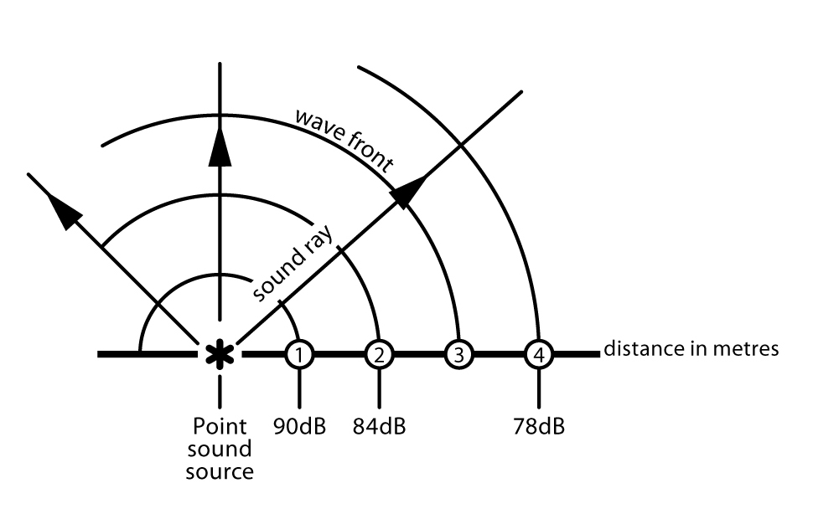
If a small sound source produces a sound level of 90 dB(A) at a distance of 1 metre, the sound level at 2 metres distance is 84 dB(A), and at 4 metres is 78 dB(A), etc.
Maintenance
Regular maintenance of plant and equipment is essential as it will deteriorate with age and can become noisier. Check for changes in noise levels – badly worn bearings and gears, poor lubrication, blunt blades, loose parts, unbalanced rotating parts and steam or air leaks all create noise that can be reduced with good maintenance. Engineering controls such as vibration mountings, impact absorbers, gaskets, seals, silencers, barriers and other equipment should be regularly inspected and maintained.

5.5 USING ADMINISTRATIVE CONTROLS
Administrative noise control measures reduce the amount of noise to which a person is exposed by reducing the time they are exposed to it. Examples include:
- organising schedules so that noisy work is done when only a few workers are present
- notifying workers and others in advance of noisy work so they can limit their exposure to it
- keeping workers out of noisy areas if their work does not require them to be there
- sign-posting noisy areas and restricting access
- providing quiet areas for rest breaks for workers exposed to noisy work
- limiting the time workers spend in noisy areas by moving them to quiet work before their daily noise exposure levels exceed the exposure standard.
If you rely on administrative controls, you should conduct regular checks to ensure that they are being complied with.

5.6 USING PERSONAL HEARING PROTECTORS

Regulation 44: If personal protective equipment (PPE) is to be used at the workplace, the person conducting the business or undertaking must ensure that the equipment is:
- selected to minimise risk to health and safety
- suitable for the nature of the work and any hazard associated with the work
- a suitable size and fit and reasonably comfortable for the person wearing it
- maintained, repaired or replaced so it continues to minimise the risk
- used or worn by the worker, so far as is reasonably practicable.
Regulation 46: A worker must, so far as reasonably able, wear the PPE in accordance with any information, training or reasonable instruction.
Personal hearing protectors, such as ear-muffs or ear-plugs, should be used in the following circumstances:
- when the risks arising from exposure to noise cannot be eliminated or minimised by other more effective control measures,
- as an interim measure until other control measures are implemented
- where extra protection is needed above what has been achieved using other noise control measures.
If the use of personal hearing protectors is necessary, it is important that the hearing protectors are worn throughout the period of exposure to noise. Removing personal hearing protectors for even short periods significantly reduces the effective attenuation (noise reduction) and might provide inadequate protection. For example, a worker wearing a hearing protector for a full 8-hour day will receive the 30 dB maximum protection level. However, one hour without wearing the hearing protector causes the maximum protection level to fall to 9 dB.
Areas where people may be exposed to hazardous noise should be sign-posted as hearing protector areas and the boundaries of these areas should be clearly defined. Workers and other persons, including managers and visitors, should not enter these areas without wearing appropriate personal hearing protectors, regardless of how short the time they stay in the hearing protector area.
Where sign-posting is not practicable, you should make other arrangements to ensure that workers and others know when personal hearing protectors are required. For example:
- attach prominent warning notices to tools and equipment indicating that personal hearing protectors should be worn when operating them
- provide written and verbal instructions on how to recognise circumstances in which personal hearing protectors are needed
- ensure effective supervision of identified hazardous tasks.
Personal hearing protectors should be selected and maintained in accordance with AS/NZS 1269.3 Occupational noise management – hearing protector program. Involve your workers in the selection process and offer a reasonable choice from a range of types.
Suppliers of hearing protectors should provide the full information on the attenuation likely to be provided including the SLC80 ratings, class and octave band attenuation values. The attenuation values should be derived from attenuation measurements made in accordance with AS/NZS 1270 Acoustics – hearing protectors.
Selection
When selecting personal hearing protectors you should consider:
- the degree of attenuation required in the worker’s environment (see Table 4). Do not provide protectors that overprotect by cutting out too much sound – this can cause difficulties hearing verbal instructions and other sounds needed to work safely
- the suitability for the type of working environment and the work tasks. For example, ear-plugs are difficult to use hygienically for work that requires them to be inserted with dirty hands and in these circumstances, ear-muffs are more appropriate, but ear-muffs can be uncomfortable to wear in hot environments and can make it difficult for the wearer to enter a confined space or to wear a helmet
- the comfort, weight and clamping force of the personal hearing protector.
Table 4: Recommended Class of hearing protector
Measured exposure LAeq,8h dB(A) | Class
Less than 90 | 1
90 to less than 95 | 2
95 to less than 100 | 3
100 to less than 105 | 4
105 to less than 110 | 5
Individual fit of personal hearing protectors is critical for optimum protection. Several devices are available to assist with this. Wearing work equipment—such as hard hats, dust masks and eye protection—may affect the performance of the protector. The fit of hearing protectors should be checked while the user is wearing regular work equipment. Workers wearing spectacles should be fitted with hearing protectors while wearing the spectacles.
Maintenance
Personal hearing protectors must be regularly inspected and maintained to ensure they remain in good, clean condition. The inspections should check that:
- ear-muff seals are undamaged
- the tension of headbands is not reduced
- there are no unofficial modifications
- compressible ear-plugs are soft, pliable and clean.
If disposable ear-plugs are used, they should only be worn once.
You must provide your workers with training, information and instruction in the proper use, fit, care and maintenance of personal hearing protectors. You should also:
- include the need to wear hearing protectors in your safety procedures
- place someone in charge of issuing and making sure replacements are readily available
- carry out spot checks to ensure that workers are wearing their hearing protectors when required and are using them correctly
- ensure all managers and supervisors set a good example and wear personal hearing protectors at all times when in hearing protector areas.

5.7 AUDIOMETRIC TESTING
Regulation 58: A person conducting a business or undertaking must provide audiometric testing for a worker who is carrying out work for the business or undertaking if the worker is required to frequently use personal hearing protectors as a control measure for noise that exceeds the exposure standard.
Audiometric testing must be provided within three months of the worker commencing work. Starting the audiometric testing before people are exposed to hazardous noise (such as new starters or those changing jobs) provides a baseline as a reference for future audiometric test results. Regular follow-up tests must be carried out at least every two years. These should be undertaken well into the work shift so that any temporary hearing loss can be picked up.
More frequent audiometric testing (e.g. every six months) may be needed if exposures are at a high LAeq,8h, which is equal or greater than 100 dB(A).
Before introducing an audiometric testing program, you must consult with your workers and their health and safety representatives. It is important that your workers understand that the aim of the testing is to evaluate the effectiveness of control measures to protect their hearing.
Audiometric testing and assessment of audiograms should be carried out by competent persons in accordance with the procedures in AS/NZS 1269.4:2005 - Occupational noise management - Auditory assessment.
Workers should be given the results of audiometric testing accompanied by a written explanation of the meaning and implications. Only with the consent of the worker should you provide their results to other parties. Unidentifiable individual results and group data should be made available to health and safety representatives of the worker’s work group.
The reasons for any changes in hearing levels over time should be thoroughly investigated.
When temporary or permanent threshold shifts are revealed through audiometric assessments or a worker reports a recent diagnosis of tinnitus, you must review your control measures to determine whether more effective control measures can be implemented so that your workers do not have to rely on personal hearing protectors.
If the worker is to continue using personal hearing protectors, you should:
- verify that the nominal performance of the worker’s personal hearing protector is adequate for the level of exposure to noise
- examine the protector carefully and ensure it is not damaged
- check the protector fits the worker closely with no leakage paths for noise
- ask the worker if they have any difficulty using the protector
- check the worker uses the protector correctly and consistently whilst performing their work.
If workers are found to have sufficient hearing loss to interfere with the safe performance of their work, all reasonably practicable steps should be taken to modify the work environment. This may include providing:
- volume control on equipment such as telephones
- acoustically treated meeting areas with low noise and low sound reflections
- supplementary visual warning signals
- alternative work for the worker if other measures do not remedy the situation.
Monitoring hearing with regular audiometric testing is recommended in situations where workers are exposed to:
- any of the ototoxic substances listed in Appendix A where the airborne exposure (without regard to respiratory protection worn) is greater than 50 per cent of the national exposure standard for the substance, regardless of the noise level
- ototoxic substances at any level and noise with LAeq,8h greater than 80 dB(A) or LC,peak greater than 135 dB(C)
- hand-arm vibration at any level and noise with LAeq,8h greater than 80 dB(A) or LC,peak greater than 135 dB(C).

5.8 INFORMATION, TRAINING AND INSTRUCTION
Section 19: A person conducting a business or undertaking must ensure, so far as is reasonably practicable, that information, training and instruction is provided to workers and others at the workplace to protect them from health and safety risks.
Regulation 39: The information, training and instruction must, so far as is reasonably practicable, be provided in a way that can be easily understood by any person to whom it is provided.
Training should be provided to:
- those workers who may be exposed to hazardous noise or other agents that may contribute to hearing loss
- their managers and supervisors
- workplace health and safety committees and health and safety representatives
- those responsible for the purchase of plant, noise control equipment, personal hearing protectors and for the design, scheduling, organisation and layout of work.
The contents of the training program should include:
- the health and safety responsibilities of each party at the workplace
- how hearing can be affected by exposure to noise
- the detrimental effects hearing loss and tinnitus have on the quality of life, both at work and socially
- the tasks at the workplace that have the potential to give rise to hearing loss and the likely noise exposure level
- how to use noise control measures
- how to select, fit, wear, maintain and store personal hearing protectors
- how to report defects in hearing protectors and noise control equipment or raise any concerns regarding hazardous noise
- the purpose and nature of audiometric testing.

5.9 IMPLEMENTING AND MAINTAINING CONTROL MEASURES
A noise management plan may help implement the chosen noise control measures effectively. It should identify what action needs to be taken, who will be responsible for taking the action and by when.
The plan should be based on the results of any noise assessment and should also include:
- measuring noise levels to confirm that control measures are achieving expected attenuation
- specifications for purchasing or hiring plant
- a description of any training and supervision that may be needed
- control measures for temporary work areas and situations
- timeframes for reviewing noise assessments and control measures.
Regulation 37: You must ensure that the control measures you implement remain effective. This includes checking that the control measures are suitable for the nature and duration of the work, are installed, maintained and used correctly.

6. HOW TO REVIEW CONTROL MEASURES
Any noise control measures that are implemented must be reviewed, and if necessary revised, to make sure they work as planned and to maintain, so far as is reasonably practicable, a work environment that is without risks to health and safety.
Regulation 38: A person conducting a business or undertaking must review and as necessary revise noise control measures:
- when the control measure does not control the risk so far as is reasonably practicable
- before a change at the workplace that is likely to give rise to a new or different health and safety risk that the control measure may not effectively control
- if a new hazard or risk is identified
- if the results of consultation indicate that a review is necessary
- if a health and safety representative requests a review.
Control measures may be reviewed using the same methods as the initial hazard identification step.
Consult your workers and their health and safety representatives and consider the following:
- Are the control measures working effectively in both their design and operation?
- How accurate is the risk assessment process? Are all noisy activities being identified?
- Have new work methods or new plant made the work quieter?
- Has instruction and training provided to workers been successful?
- Have new requirements or information indicated that current controls are no longer the most effective?
- Is an alteration planned to any structure, plant or process that is likely to result in a worker being exposed to hazardous noise?
- Has an incident occurred as a result of a worker being exposed to hazardous noise?
- Have any audiometric tests revealed changes in hearing threshold levels?
You should decide on the time interval between noise assessments by consulting with your workers. Assessment should be repeated whenever there is:
  - installation or removal of machinery or other noise sources likely to cause a significant change in noise levels
  - a change in workload or equipment operating conditions likely to cause a significant change in noise levels or exposure times
  - a change in building structure likely to affect noise levels
  - a change to working arrangements affecting the length of time workers spend in noisy work areas.
If you design, manufacture or supply products used for work you should check that the product effectively eliminates or minimises exposure to noise by obtaining feedback from users. This can help in determining whether any improvements can be made.

7. ROLE OF DESIGNERS, MANUFACTURERS, SUPPLIERS AND INSTALLERS
Eliminating noise in the early stages of product planning (at the source) is more effective and usually cheaper than making changes after noise hazards are introduced into the workplace.

7.1 DESIGNERS
Designers of plant or structures used for work must ensure so far as is reasonably practicable that the plant or structure is designed to be without risks to the health and safety of persons.
Design of plant
Regulation 59: A designer of plant must design the plant so that its noise emission is as low as reasonably practicable.
Designers must provide information on the noise emission values of the plant (for example, data on sound power level or sound pressure level), the operating conditions of the plant when the noise emission is measured and the methods used to measure the noise emission. They must also provide information on any conditions required for safe use.
This information must be provided to manufacturers, importers and suppliers.
If you design plant you should consider:
- preventing or reducing the impact between machine parts
- replacing metal parts with quieter plastic parts
- combining machine guards with acoustic treatment
- enclosing particularly noisy machine parts
- selecting power transmission which permits the quietest speed regulation; for example, rotation-speed-controlled electric motors
- isolating vibration-related noise sources within machines.
You should also design:
- good seals for doors for machines
- machines with effective cooling flanges that reduce the need for air jet cooling
- quieter types of fans or placing mufflers in the ducts of ventilation systems
- quiet electric motors and transmissions
- pipelines for low flow speeds (maximum 5m/sec.)
- ventilation ducts with fan inlet mufflers and other mufflers to prevent noise transfer in the duct between noisy and quiet rooms.
Methods of maintenance and servicing should be taken into account in noise control design.
Design of buildings and structures
Designers of buildings and structures must take noise control into account from the beginning of the planning process and minimise the noise transmitted through the structure to the lowest level that is reasonably practicable.
For new buildings designers should consider:
- the effect on noise levels of building reverberation, the building layout and location of workstations relative to any plant
- selecting the frame, floor and machine bases so that all sources of disturbance can be provided with effective vibration isolation. Heavy, noisy equipment requires rigid, heavy bases. It is also possible to isolate machine bases from direct contact with the rest of the building frame (see Figure 2)
- isolating noise sources such as plant rooms
- designing acoustic treatments for noisy areas, for example, cover ceilings (and walls in the case of very high ceilings) with sound-absorbing material, use floating floors
- using flexible construction joints as building elements
- designing walls, floors, windows and doors to provide the necessary sound transmission loss
- covering floors of office areas with carpets.
Figure 2: The vibrations of an elevator drive are isolated from the building structure.
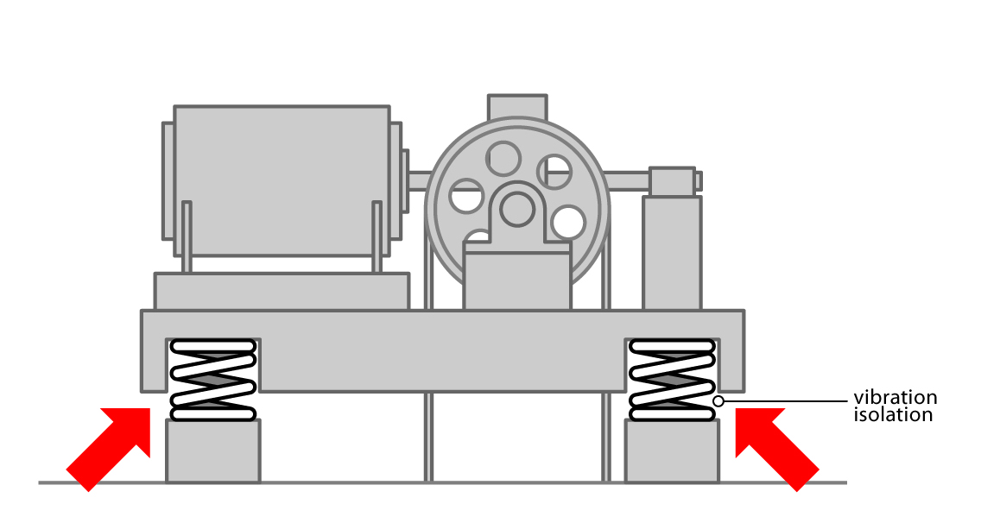
Sound insulating separate rooms
With automation of processes, remote control from a separate room may be possible. Some control measures may include:
- designing control rooms with materials having adequate transmission loss
- providing good sealing around doors and windows
- providing openings for ventilation with passages for cables and piping equipped with good seals.
Control rooms should be adequately ventilated with air-conditioning in hot working areas. Otherwise, there is a risk that the doors will be opened for ventilation, which would spoil the effectiveness of the room in reducing the noise level.
Figure 3: Examples of noise control measures in an industrial building

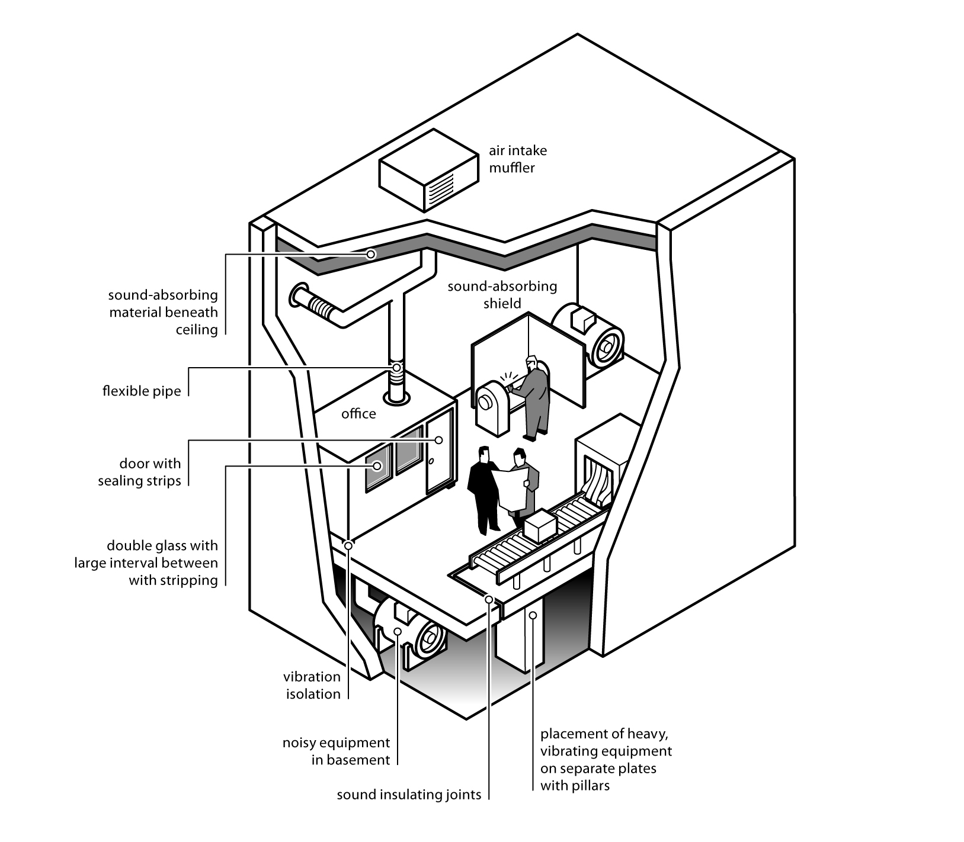

7.2 MANUFACTURERS
Regulation 59: A manufacturer of plant must manufacture the plant so that its noise emission is as low as reasonably practicable.
Manufacturers of plant or structures used for work must ensure, so far as is reasonably practicable, that the plant or structure is manufactured without risks to the health and safety of persons. If noise cannot be eliminated, manufacturers must ensure the plant is manufactured so that its noise emission is as low as reasonably practicable and that the manufacturing process does not introduce new or additional noise hazards.
Manufacturers should manufacture plant:
- using and testing the safety measures specified by the designer
- using materials and techniques that minimise the risk of hearing loss by reducing noise to the lowest level reasonably practicable.
Manufacturers must provide information to an importer or supplier on the noise emission values of the plant, the operating conditions of the plant when the noise emission is measured and the methods used to measure the noise emission. They must also provide information on any conditions required for safe use.

7.3 SUPPLIERS AND IMPORTERS
Suppliers or importers must ensure so far as is reasonably practicable that the plant is without risks to the health and safety of persons at the time of supply.
Suppliers and importers must take all reasonable steps to obtain the information that the manufacturer is required to provide on noise emission values and provide it to any person to whom the plant is supplied.
Suppliers and importers should:
- provide all noise control measures with the product as per the setup recorded on the noise test results
- provide maintenance information to ensure safe use and operation.

7.4 INSTALLERS
Installers must ensure so far as is reasonably practicable that the plant or structure is installed in such a way that it is without risks to the health and safety of persons. For example, installers should ensure that the installation is undertaken according to the designer’s specifications. Isolating vibrating sources of noise may involve installing large heavy machines on separate bases or in such a way that they do not directly contact the remainder of the building structure.
Installers should also provide information to potential users about the conditions required for safe use, including maintenance requirements.

7.5 WHAT INFORMATION SHOULD BE PROVIDED TO POTENTIAL USERS?
Designers, manufacturers, suppliers and importers must give purchasers and other potential users the information they need to safely use the plant, including the results of any calculations, analysis or testing carried out.
Information must include the noise emission values of the plant, the operating conditions of the plant when the noise emission is measured and the methods used to measure the noise emission. This information will help purchasers choose plant with low noise levels.
The testing information that should be supplied to the purchaser is listed in Table 5 below. Where relevant information on test procedures is contained in a test standard or a test report, reference to the standard or the report should be included. Information should be provided on peak noise levels, where relevant, as well as on continuous noise levels.
Where there is a selection of noise measurement results available, the preferred measurement is the sound pressure level at the operator's position.
Instructions for safe use should be communicated in a way that can be easily understood by users.

Table 5: Minimum noise testing information
Supplier's details | For example, name, local address, telephone and/or facsimile number , email
Manufacturer's details | For example, name, address, telephone and/or facsimile number ,email
Details of the plant tested | Including any noise controls, for example, make, model, serial number, relevant capacity/rating
Title or number of specific test standard or code followed | Including details of any departures from the standard. For example, if a machine needed to be mounted differently to the method given in the standard, the alternative mounting should be described
Details of operating conditions | If not specified in the standard, or if no specific test standard is available for the type of plant being tested. For example, test machine load, speed, type of material processed, details of installation and mounting of test machine, details of test environment, description of measurement instrumentation and procedure. Reference to a test report containing this information will suffice
Measurement position(s) | For example, operator’s ear or 1 metre from machines
Index measured | For example, sound pressure level or sound power level
Frequency weighting | For example, A, C or linear
Time weighting | For example, slow, fast or peak, or Leq
Sound level or levels determined in testing.
Units of measurement | For example, dB re: 20 micropascals
Details of tester | For example, name, address, telephone and/or facsimile number ,email, accreditation
Date issued

Appendix A – other Causes OF Hearing Loss in the workplace
Vibration
Studies have indicated that there is a link between exposure to hand-arm vibration and hearing loss. Workers who use equipment such as chainsaws that subject the worker to both hand-arm vibrations and to noise may be more likely to suffer from hearing loss. Tools that may expose workers to both noise and hand-arm vibration include:
- pneumatic and electrical rotary tools such as concrete breakers, grinders, sanders and drills
- percussive tools such as chippers and riveters
- petrol-powered tools such as lawn-mowers, brush-cutters and chainsaws.
Control measures to reduce exposure to hand-arm vibration may involve finding alternative ways to do the work that eliminates the need to use vibrating equipment or to purchase tools that produce less vibration.
Ototoxic substances
Exposure to some chemicals can result in hearing loss. These chemicals are known as ototoxic substances. Hearing loss is more likely to occur if a worker is exposed to both noise and ototoxic substances than if exposure is just to noise or ototoxic substances alone.
There are three major classes of ototoxic substances: solvents, heavy metals and asphyxiants. Work activities that commonly combine noise and ototoxic substances include:
- painting  - printing  - boat building  - construction  - furniture making  - fuelling vehicles and aircraft | - manufacturing, particularly of metal, leather and petroleum products  - degreasing  - fire-fighting  - weapons firing
Some medications have also been identified as ototoxic substances. These include some anti-cancer, anti-inflammatory, anti-thrombotic, anti-malarial, anti-rheumatic and antibiotic drugs. Quinine and salicylic acids (such as aspirin) are also considered to be ototoxic substances.
Table A1 below lists those ototoxic substances most commonly used in workplaces. Some of these can be absorbed through the skin and are considered particularly hazardous.

Exposure standards for chemicals and noise have not yet been altered to take account of increased risk to hearing. Until revised standards are established, it is recommended that the daily noise exposure of workers exposed to any of the substances listed in Table A1 be reduced to 80 dB(A) or below. They should also undergo audiometric testing and be given information on ototoxic substances.
Control measures such as substitution, isolation and local ventilation should be implemented to eliminate or reduce chemical exposures. Personal protective equipment should be used to prevent skin and respiratory absorption when other controls are insufficient.
Table A1: Some common ototoxic substances
Type | Name | Skin Absorption
Solvents | Butanol | √
Solvents | Carbon disulphide | √
Solvents | Ethanol
Solvents | Ethyl benzene
Solvents | n-heptane
Solvents | n-hexane
Solvents | Perchloroethylene
Solvents | Solvent mixtures and fuels Stoddard solvent (white spirits) | √
Solvents | Styrene
Solvents | Toluene | √
Solvents | Trichloroethylene | √
Solvents | Xylenes
Metals | Arsenic
Metals | Lead
Metals | Manganese
Metals | Mercury | √
Metals | Organic tin | √
Table A1: continued
Type | Name | Skin Absorption
Others | Acrylonitrile | √
Others | Carbon monoxide
Others | Hydrogen cyanide | √
Others | Organophosphates | √
Others | Paraquat
Acoustic Shock
Acoustic incidents are sudden, unexpected loud noises occurring during telephone headset use, including crackles, hisses, whistles, shrieks or high-pitched noises. Acoustic shock is not caused by the loudness of a telephone, as all phone noise is electronically limited to a peak noise level of 123 decibels, but by a sudden rise in noise levels.
The noises can come from a wide variety of sources, either within the transmission system or from the customer end. Sources of acoustic incidents include those outlined in Table A2:
Table A2: Sources of acoustic incidents
Sources within the transmission system | Sources from the customer end
- faulty or damaged networks, telephones and headset equipment  - broadband and narrowband interference  - mobile phones or fax machines used in call centres | - feedback oscillation from some cordless phones  - alarm signals  - phone receivers slammed down or dropped  - tones from misdirected facsimiles and modems  - noises made close to the receiver (e.g.. whistling)
Although acoustic incidents occur in workplaces (mainly call centres), only a very small proportion cause the symptoms known as ‘acoustic shock’ in workers.
High background noise levels at the workplace can increase the risk of acoustic shock occurring from an acoustic incident. For example, operators may raise the volume in their headsets to improve hearing thereby increasing the impact of any sudden, loud telephone noise. When an acoustic incident occurs, the operator’s automatic reaction may be to remove the headset or receiver as quickly as possible and, in some cases, this may help prevent or reduce the effects of acoustic shock.
Other factors, such as a middle ear inflammation and feelings of tension, may increase the likelihood of an acoustic shock resulting from an acoustic incident.
Acoustic shock symptoms
The effect on individuals can vary greatly for the same increase in sound level. Only a small number of people develop symptoms from an acoustic incident. Why a person experiences symptoms after an acoustic incident is not known with certainty and is still being researched.
Some researchers believe that a combination of stress and sudden loud noise causes excessive contraction of the middle ear muscles, triggering the acoustic shock symptoms.
- Audiologists have grouped symptoms into three categories: Primary (immediate) symptoms, which include but are not limited to:
  - a feeling of fullness in the ear
  - burning sensations or sharp pain around or in the ear
  - numbness, tingling or soreness down the side of face, neck or shoulder
  - nausea or vomiting
  - dizziness
  - tinnitus and other head noises such as eardrum fluttering.
- Secondary symptoms, which include but are not limited to:
  - headaches
  - fatigue
  - a feeling of being off-balance
  - anxiety
- Tertiary symptoms, which include but are not limited to:
  - hypersensitivity (sensitivity to previously tolerated sounds such as loud voices, television and radio)
  - hyper vigilance i.e. being overly alert.
People experiencing such symptoms will respond in different ways. As with other workplace injuries and ill health, some may experience further effects, including anger, anxiety, social isolation and other psychological problems.
Few people suffer hearing loss from acoustic shock. To assist in the diagnosis where this may occur, consideration should be given to baseline audiometric testing of all operators’ hearing by a specialist when they commence work to establish their baseline hearing ability.
Control measures
Control measures to eliminate or minimise the risk of acoustic shock include:
- providing high quality headsets with acoustic shock protection devices
- giving prompt attention to damaged equipment and network faults – the equipment or network supplier or an acoustic specialist should be contacted if necessary
- ensuring the proper fitting, use and maintenance of headsets
- reducing background noise in the room
- providing information and training on how to detect warning sounds for example, cordless phones being used too close to the base station at the customer end. Training on warning sounds should also prepare operators to know when to remove headsets as quickly as possible, where necessary
- with hotdesking work, ensuring workers turn the headset volume down as soon as possible after a changeover
- considering work organisation issues, such as unreasonable or unrealistic performance pressures or demands, which may cause tension and distress
- preventing mobile phones from being used in call centres.
Control of background noise in call centres
Possible control measures to implement include:
- reviewing the design and layout of the room and workstations:
  - reducing external and building service noise
  - reducing reverberation within the room by using sound absorbing materials
  - placing acoustic barriers around/between workstations and other call centre areas
- encouraging people to not talk loudly or hold discussions near operators
- locating fax machines, photocopiers and printers away from operators
- controlling radio noise and use of mobile telephones
- with hotdesking, ensuring changeovers are smoothly managed and quiet
- providing sufficient room for workers to move around at changeover times without crowding.
Managing acoustic incidents
After an acoustic incident, the worker should:
- remove the headset immediately
- in some circumstances, move to the ‘break out’ area
- report the incident and any symptoms to the supervisor
- discuss with the supervisor their ability to continue work and, where appropriate, relocate to another workstation.
After an acoustic incident, you should:
- ensure the event is recorded and logged
- discuss the incident and ability to continue work with the worker
- where symptoms are persistent or severe, refer the worker to a general practitioner and/or an audiologist for assessment and treatment of possible injury
- enquire into the cause of the noise, including whether it is from an internal or external source
- ensure the headset and other equipment is checked for clarity of sound and possible damage and faults
- remove damaged or faulty equipment from service
- review the adequacy of the noise control measures and general working environment.

APPENDIX B – NOISE HAZARD IDENTIFICATION CHECKLIST
Description of work
location:
Activities at
workstation:
Assessed by:
Date:
‘Yes’ to any of the following indicates the need to carry out a noise assessment if exposure to the noise cannot be immediately controlled.
Hazard identification questions | Yes | No
1. Is a raised voice needed to communicate with someone about one metre away?
2. Do your workers notice a reduction in hearing over the course of the day? (This may only become noticeable after work, for example, needing to turn up the radio on the way home)
3. Are your workers using noisy powered tools or machinery?
4. Are there noises due to impacts (such as hammering, pneumatic impact tools) or explosive sources (such as explosive powered tools, detonators)?
5. Are personal hearing protectors used for some work?
6. Do your workers complain that there is too much noise or that they can’t clearly hear instructions or warning signals?
7. Do your workers experience ringing in the ears or a noise sounding different in each ear?
8. Do any long-term workers appear to be hard of hearing?
9. Have there been any workers’ compensation claims for noise-induced hearing loss?
10. Does any equipment have manufacturer’s information (including labels) indicating noise levels equal or greater than any of the following:
(a) 80 dB(A) LAeq,T (T= time period over which noise is measured)?
(b) 130 dB(C) peak noise level?

(c) 88 dB(A) sound power level?

11. Do the results of audiometry tests indicate that past or present workers have hearing loss?
13. Are any workers exposed to noise and ototoxins in the workplace?
14. Are any workers exposed to noise and hand-arm vibration?

APPENDIX C – READY RECKONER
Tables C1 to C3 provide a simple way of working out a worker’s LAeq,8h (eight-hour equivalent continuous sound pressure level) if you know the noise level and duration of each of the noisy tasks carried out by the worker during the work shift.
From Tables C1 or C2 you read off the number of “noise exposure points” that correspond to a particular task’s noise level and exposure duration. Table C1 is for noise levels between 75 and 105 dB(A) and Table C2 is for higher noise levels between 95 and 125 dB(A).
For example, a task producing a noise level at the worker’s ear of 93 dB(A) that is done for two lots of 30 minutes in a shift (i.e. one hour total) produces 80 noise exposure points. Another task with a noise level of 120 dB(A) for one minute during the shift produces 670 points.
These points can be added (in the normal arithmetic way) to give the total exposure points for the shift. Table C3 is then used to convert the total points to the LAeq,8h.
In the example above, if these were the only noisy tasks carried out by the worker, the points total is 750 and (from Table C3, rounding to the nearest whole decibel) the LAeq,8h for the worker is 94 dB(A).
This calculated LAeq,8h value can be compared with the exposure standard for noise i.e. LAeq,8h = 85 dB(A). Additionally, noise exposure points can be used to prioritise the noise control program by showing which tasks make the greatest contribution to the total noise exposure.
In the example above the worker’s LAeq,8h is greater than the standard, so noise control action is needed. Although it only lasts for one minute, the 120 dB(A) task contributes more than eight times as much as the other task to the total exposure and so should be the first one tackled.
In this scheme the exposure standard for noise – LAeq,8h = 85 dB(A) – is 100 points.
Table C1: Exposure points for 75-105 dB(A)/15minutes – 12 hours
Sound Level  LAeq,T dB(A) | Duration of exposure per shift
Sound Level  LAeq,T dB(A) | 15 min | 30 min | 1 h | 2 h | 4 h | 8 h | 10 h* | 12 h*
105 | 320 | 640 | 1270 | 2530 | 5060 | 10120 | 12650 | 15180
104 | 250 | 500 | 1000 | 2010 | 4020 | 8040 | 10050 | 12060
103 | 200 | 400 | 800 | 1600 | 3200 | 6400 | 8000 | 9600
102 | 160 | 320 | 640 | 1270 | 2540 | 5070 | 6340 | 7600
101 | 130 | 250 | 500 | 1010 | 2010 | 4030 | 5040 | 6040
100 | 100 | 200 | 400 | 800 | 1600 | 3200 | 4000 | 4800
99 | 80 | 160 | 320 | 640 | 1270 | 2540 | 3180 | 3810
98 | 63 | 130 | 250 | 500 | 1010 | 2020 | 2520 | 3030
97 | 50 | 100 | 200 | 400 | 800 | 1600 | 2000 | 2410
96 | 40 | 80 | 160 | 320 | 640 | 1270 | 1590 | 1910
95 | 32 | 63 | 130 | 250 | 510 | 1010 | 1260 | 1520
94 | 25 | 50 | 100 | 200 | 400 | 800 | 1000 | 1210
93 | 20 | 40 | 80 | 160 | 320 | 640 | 800 | 960
92 | 16 | 32 | 63 | 130 | 250 | 510 | 630 | 760
91 | 13 | 25 | 50 | 100 | 200 | 400 | 500 | 600
90 | 10 | 20 | 40 | 80 | 160 | 320 | 400 | 480
89 | 7.9 | 16 | 32 | 64 | 130 | 250 | 320 | 380
88 | 6.3 | 13 | 25 | 50 | 100 | 200 | 250 | 300
87 | 5.0 | 10 | 20 | 40 | 80 | 160 | 200 | 240
86 | 4.0 | 8.0 | 16 | 32 | 64 | 130 | 160 | 190
85 | 3.2 | 6.3 | 13 | 25 | 50 | 100 | 130 | 150
84 | 2.5 | 5.0 | 10 | 20 | 40 | 80 | 100 | 120
83 | 2.0 | 4.0 | 8.0 | 16 | 32 | 64 | 80 | 96
82 | 1.6 | 3.2 | 6.3 | 13 | 25 | 51 | 63 | 76
81 | 1.3 | 2.5 | 5.0 | 10 | 20 | 40 | 50 | 60
80 | 1.0 | 2.0 | 4.0 | 8.0 | 16 | 32 | 40 | 48
79 | 0.8 | 1.6 | 3.2 | 6.4 | 13 | 25 | 32 | 38
78 | 0.6 | 1.3 | 2.5 | 5.0 | 10 | 20 | 25 | 30
77 | 0.5 | 1.0 | 2.0 | 4.0 | 8.0 | 16 | 20 | 24
76 | 0.4 | 0.8 | 1.6 | 3.2 | 6.4 | 13 | 16 | 19
75 | 0.3 | 0.6 | 1.3 | 2.5 | 5.1 | 10 | 13 | 15

NOTE:
In colour, this table would be reproduced as follows:
- White text on dark background = red background
- White text on medium background = amber background
- Black text on pale background = green background

Table C2: Exposure points for 95-125 dB(A)/5 seconds – 10 minutes
Sound Level  LAeq,T dB(A) | Duration of exposure per shift
Sound Level  LAeq,T dB(A) | 5 sec | 10 sec | 15 sec | 30 sec | 1 min | 2 min | 5 min | 10 min
125 | 180 | 360 | 530 | 1050 | 2110 | 4220 | 10540 | 21080
124 | 140 | 280 | 420 | 840 | 1680 | 3350 | 8370 | 16750
123 | 110 | 220 | 330 | 670 | 1330 | 2660 | 6650 | 13300
122 | 90 | 180 | 260 | 530 | 1060 | 2110 | 5280 | 10570
121 | 70 | 140 | 210 | 420 | 840 | 1680 | 4200 | 8390
120 | 56 | 110 | 170 | 330 | 670 | 1330 | 3330 | 6670
119 | 44 | 88 | 130 | 270 | 530 | 1060 | 2650 | 5300
118 | 35 | 70 | 110 | 210 | 420 | 840 | 2100 | 4210
117 | 28 | 56 | 84 | 170 | 330 | 670 | 1670 | 3340
116 | 22 | 44 | 66 | 130 | 270 | 530 | 1330 | 2650
115 | 18 | 35 | 53 | 110 | 210 | 420 | 1050 | 2110
114 | 14 | 28 | 42 | 84 | 170 | 330 | 840 | 1680
113 | 11 | 22 | 33 | 67 | 130 | 270 | 670 | 1330
112 | 8.8 | 18 | 26 | 53 | 110 | 210 | 530 | 1060
111 | 7.0 | 14 | 21 | 42 | 84 | 170 | 420 | 840
110 | 5.6 | 11 | 17 | 33 | 67 | 130 | 330 | 670
109 | 4.4 | 8.8 | 13 | 26 | 53 | 110 | 270 | 530
108 | 3.5 | 7.0 | 11 | 21 | 42 | 84 | 210 | 420
107 | 2.8 | 5.6 | 8.4 | 17 | 33 | 67 | 170 | 330
106 | 2.2 | 4.4 | 6.6 | 13 | 27 | 53 | 130 | 270
105 | 1.8 | 3.5 | 5.3 | 11 | 21 | 42 | 110 | 210
104 | 1.4 | 2.8 | 4.2 | 8.4 | 17 | 33 | 84 | 170
103 | 1.1 | 2.2 | 3.3 | 6.7 | 13 | 27 | 67 | 130
102 | 0.9 | 1.8 | 2.6 | 5.3 | 11 | 21 | 53 | 110
101 | 0.7 | 1.4 | 2.1 | 4.2 | 8.4 | 17 | 42 | 84
100 | 0.6 | 1.1 | 1.7 | 3.3 | 6.7 | 13 | 33 | 67
99 | 0.5 | 0.9 | 1.3 | 2.7 | 5.3 | 11 | 27 | 53
98 | 0.4 | 0.7 | 1.1 | 2.1 | 4.2 | 8.4 | 21 | 42
97 | 0.3 | 0.6 | 0.8 | 1.7 | 3.3 | 6.7 | 17 | 33
96 | 0.2 | 0.5 | 0.7 | 1.3 | 2.7 | 5.3 | 13 | 27
95 | 0.2 | 0.4 | 0.5 | 1.1 | 2.1 | 4.2 | 11 | 21

NOTE:
In colour, this table would be reproduced as follows:
- White text on dark background = red background
- White text on medium background = amber background
- Black text on pale background = green background

Notes:
- If there is only one source of noise exposure, a quick glance at the background colour of the table cell corresponding to the sound level and duration of exposure will tell you if the worker is:
(a) above the LAeq,8h 85 dB(A) exposure standard - Red
(b) well below the LAeq,8h 85 dB(A) standard - Green
(c) marginal (between LAeq,8h 80 and 85 dB(A)) – Yellow
- For durations of exposure not listed in the table, add together the points from two durations that together give the same duration. For example, for five hours at 95 dB(A), add together the points for four hours at 95 dB(A) and one hour at 95 dB(A), i.e. 510 + 130, giving a total of 640 points.
- The tables can be extended to include both higher and lower sound levels. A change of 10 dB(A) results in a tenfold change in the points. For example, one hour exposure at 108 dB(A) will give 10 times the points for one hour at 98 dB(A), that is, 2500 points.
- For shift lengths of 10 hours or more (*), the adjustments listed in Table 3 should be added to the LAeq,8h before comparing the result with the exposure standard for noise.
Table C3: Conversion
Total exposure points | L_{Aeq,8h}  dB(A)
32000 | 110
25420 | 109
20190 | 108
16040 | 107
12740 | 106
10120 | 105
8040 | 104
6400 | 103
5070 | 102
4030 | 101
3200 | 100
2540 | 99
2020 | 98
1600 | 97
1270 | 96
1010 | 95
800 | 94
640 | 93
510 | 92
400 | 91
320 | 90
250 | 89
200 | 88
160 | 87
130 | 86
100 | 85
80 | 84
64 | 83
51 | 82
40 | 81
32 | 80
25 | 79
20 | 78
16 | 77
13 | 76
10 | 75
NOTE:
In colour, this table would be reproduced as follows:
- White text on dark background = red background
- White text on medium background = amber background
- Black text on pale background = green background

Example: Carpenter working a 10.5-hour shift using tools and machines listed below.
Machine/Process | Measured Sound Level  LAeq,T dB(A) | Duration per shift
Circular Saw – cutting hardwood | 94 | 2 h
Planer – planing hardwood | 100 | 3 h
Power Drill – drilling hardwood | 87 | 4 h
Hammering nails into wood | 98 | 10 min
Background | 70 | 1 h 20 min
If you want to just quickly see if the carpenter is exposed above the L_{Aeq,8h} = 85 dB(A) noise standard, look up points for 94 dB(A) and 2 h in Table C1. You will see that the cell is red, so you know without going any further that the carpenter is exposed to noise above the standard.
If you want to actually work out the carpenter’s 8h-equivalent continuous noise level, LAeq,8h, then use Tables C1, C2 and C3 as below:
Machine/Process | Sound Level  LAeq,T dB(A) | Duration per shift | Points
Circular Saw – cutting hardwood | 94 | 2 h | 200
Planer – planing hardwood | 100 | 3 h | 2 h 800  1 h 400
Power Drill – drilling hardwood | 87 | 4 h | 80
Hammering nails into wood | 98 | 10 min | 42
Background | 70 | 1 h 20 min | 1 h 0.4  20 m 0.1
 |  | Total 10.5 h | Total 1522.5

From Table C3: LAeq,8h = 97 dB(A), but as the shift is 10.5 hours, an adjustment of +1 dB(A) is needed, hence the adjusted LAeq,8h = 98 dB(A).

Appendix D – Contents of a noise assessment report
Checklist: What should be included in a noise assessment report? | If present
When
Date of Assessment
Who
Name of Assessor
Information (background/qualifications) of assessor
Equipment used
Type of equipment used to take measurements
Calibration details for equipment
How the noise measurements were taken
Where measurements were taken (general area or operator ear position)
Period of time over which the measurements were taken
What was assessed
The area, plant, process, activity and workers that were assessed
Source of noise
The sources (plant/process/jobs) of the noise
Whether all the noise sources that may be operating at the time were taken into account
Whether there were any significant noise sources that were not operating during the assessment
Systems of work
Brief description of the work activity (how it’s done; plant/process/activity/operating conditions/duration of process etc)
Hours of workshift (e.g. 8-hour or 12-hour shift)
Whether assessment is for a normal/typical day or for a worst case scenario
Results
The results of measurements in terms of levels and durations
Interpretation of the results, (i.e. compared to exposure standards; what do the results mean etc.; ranking of noise sources)
Action Required
Any obvious noise controls that could be implemented, or the need for more detailed noise control study

control study.
Other relevant factors
Information on and adequacy of any control measures already in place and hearing protectors used during the assessment
Where relevant, information about the environment (types of walls, surfaces, buildings, operational state of machinery, etc.)

Appendix E– engineering CONTROL MEASURES
The following are 10 simple noise control techniques that have wide application across industry. In many cases they will produce substantial noise reductions quickly and cheaply, with little or no effect on normal operation or use of plant.
1. DAMPING
Typical applications - Chutes, hoppers, machine guards, panels, conveyors, tanks
Technique
There are 2 basic techniques:-
- unconstrained layer damping where a layer of bitumastic (or similar) high damping material is stuck to the surface
- constrained layer damping where a laminate is constructed
Constrained layer damping is more rugged and generally more effective. Either re-manufacture guards, panels or other components from commercially available sound deadened steel or buy self-adhesive steel sheet.
The latter can simply be stuck on to existing components (inside or outside) covering about 80% of the flat surface area to give a 5 - 25 dB reduction in the noise radiated (use a thickness that is 40 per cent to 100 per cent of the thickness of the panel to be treated).
Limitations: the efficiency falls off for thicker sheets. Above about 3mm sheet thickness it becomes increasingly difficult to achieve a substantial noise reduction.

2. FAN INSTALLATIONS
Typical applications - Axial flow or centrifugal fans.
Technique
Maximum fan efficiency coincides with minimum noise. Any fan installation feature that tends to reduce fan efficiency is therefore likely to increase noise. Two of the most common examples are bends close to the fan (intake side in particular) and dampers close to the fan intake or exhaust.

Ideally, for maximum fan efficiency and minimum noise, make sure there is at least 2 - 3 duct diameters of straight duct between any feature that may disturb the flow and the fan itself.
Noise reductions of 3 -12 dB are often possible.
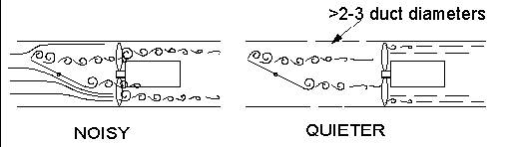
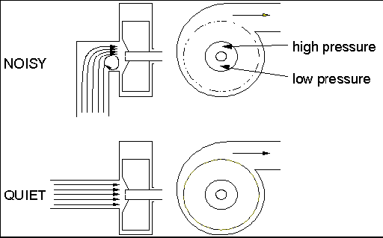

3. DUCTWORK
Typical applications - Extraction, ventilation, cooling, openings in walls and enclosures.
Technique
Instead of fitting silencers, it is often possible to achieve a 10 - 20 dB reduction in airborne noise from a duct or opening by lining the last bend in the ductwork with acoustic absorbent (foam or rockwool / fibreglass). Alternatively, construct a simple absorbent lined right-angled bend to fit on the opening. Ideally, either side of the bend should be lined along a length equivalent to twice the duct diameter. Where flow velocities are high (> 3m/s), consider using cloth faced absorbent. Duct vibration can usually be treated by damping (as above).

4. FAN SPEED
Typical applications - Axial or centrifugal flow fans.
Technique
Fan noise is roughly proportional to the 5th power of fan speed. So in many cases it is possible to achieve a large noise reduction from a small drop in fan speed by changing control systems or pulley sizes and re-setting dampers. The following table provides a guide to the trade-off that can be expected.
FAN SPEED REDUCTION | NOISE REDUCTION
10% | 2 dB
20% | 5 dB
30% | 8 dB
40% | 11 dB
50% | 15 dB

5. PNEUMATIC EXHAUSTS
Technique
Almost invariably it is possible to reduce pneumatic exhaust noise permanently by 10 - 30 dB by fitting effective silencers. The following are the practical points that can make the difference between success and failure:-
— back pressure : fit a larger coupling and silencer
— clogging : fit a straight-through silencer that cannot clog (and has no back pressure)
— multiple exhausts : manifold them into a single, larger diameter pipe fitted with the rear silencer from virtually any make of car (from your local tyre and exhaust fitter). Typically 25 dB reduction.
Note : a well designed silencer will not increase system back pressure.

6. PNEUMATIC NOZZLES
Typical applications - Cooling, drying, blowing
Technique
In most cases, it is possible to replace existing nozzles (usually simple copper pipe outlets) for quiet, high efficiency units. These not only reduce noise levels by up to 10 dB, but also use less compressed air. The types of nozzle to look out for are entraining units (schematic at right) from various manufacturers and in a variety of sizes.

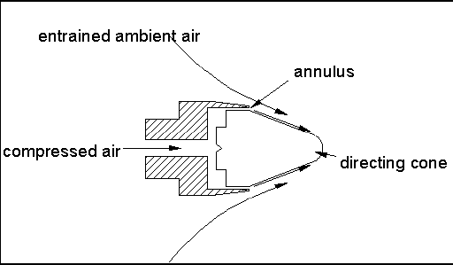

7. VIBRATION ISOLATION PADS
Typical applications - Machine feet, pumps, mezzanine installations
Technique
Mounting motors, pumps, gearboxes and other items of plant on rubber bonded cork (or similar) pads can be a very effective way of reducing transmission of vibration and therefore noise radiated by the rest of the structure. This is particularly the case where vibrating units are bolted to steel supports or floors. However, a common error with the use of these pads is for the bolt to ”short-circuit” the pad, resulting in no isolation. Additional pads should be fitted under the bolt heads as shown.
There are many types of off-the-shelf anti-vibration mounts available, for instance rubber/neoprene or spring types. The type of isolator that is most appropriate will depend on, among other factors, the mass of the plant and the frequency of vibration to be isolated. Any supplier of anti-vibration mounts will be able to advise you on this.

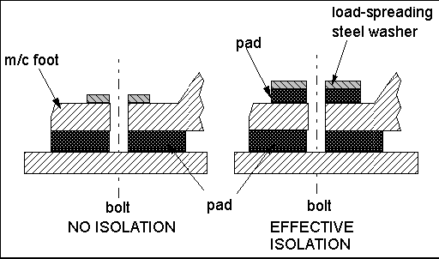

8. EXISTING MACHINE GUARDS
Technique
The existing guards on many machines can often be improved to provide a significant noise reduction. The two principles involved, which must be used in combination, are:-
(i) Minimise gaps
Reducing by half the “gap” open area in a set of guards can reduce the noise by 3 dB. If you can reduce the openings (flexible seals, additional close fitting panels etc) by 90 per cent, then a 10 dB noise reduction is possible.
(ii) Acoustic absorbent
Lining a significant proportion of the inside of the guards with acoustic absorbent (foam, rockwool / fibreglass) will reduce the noise “trapped” by the guards.
Consequently, less noise will escape through any gaps. Failure to line the inside of the guards could result in an increase in noise at the operator’s position if the gaps have been minimised as in (i) above.
In most cases, both sets of modifications can be tested in mock-up form using cardboard (and wide tape) to extend the guarding and temporarily fitting areas of acoustic foam inside. Not only does this process help with the practical aspects (access, visibility etc), but it usually also provides a very good indication of the noise reduction that can be expected. Guard vibration radiated as noise can also be treated via damping (as above).

9. CHAIN & TIMING BELT DRIVES

Technique
Noisy chain drives can often be replaced directly with quieter timing belts. Within the range of timing belts available, there are also quiet designs that use different tooth profiles to minimise noise. There is also a new design of belt for applications where noise is critical which uses a chevron tooth pattern to provide very quiet running. Noise reductions in the range of 6 - 20 dB are often possible using this approach.

10. ELECTRIC MOTORS
Technique
Most companies have large numbers of electric motors used on anything from fans to pumps to machine tools. However, it is not very common knowledge that general duty motors are available (at little or no cost premium) that are up to 10 dB(A) or more quieter than typical units as direct replacements. The best approach is to feed these motors into the system over a period of time so that all replacement motors are quiet motors.

HAZARDOUS MANUAL TASKS

Code of Practice
TABLE OF CONTENTS

 | FOREWORD
 | SCOPE AND APPLICATION
1. | INTRODUCTION
1.1 | What is a musculoskeletal disorder (MSD)?
1.2 | What is a hazardous manual task?
1.3 | Who has health and safety duties in relation to hazardous manual tasks?
1.4 | What is required to manage the risk of musculoskeletal disorders?
2. | IDENTIFYING HAZARDOUS MANUAL TASKS
2.1 | How to identify hazardous manual tasks
2.2 | Characteristics of hazardous manual tasks
3. | ASSESSING THE RISKS
3.1 | When should a risk assessment be conducted?
3.2 | How to do a risk assessment for hazardous manual tasks
3.3 | What are the risk factors?
3.4 | What are the sources of the risk?
4. | CONTROLLING THE RISKS
4.1 | The hierarchy of control
4.2 | Purchasing to eliminate or minimise risks
4.3 | Changing the design or layout of work areas
4.4 | Changing the nature, size, weight or number of items handled
4.5 | Using mechanical aids
4.6 | Handling people and animals
4.7 | Changing the system of work
4.8 | Changing the work environment
4.9 | Using administrative control measures
4.10 | Implementing control measures
5. | REVIEWING CONTROL MEASURES
6. | ROLE OF DESIGNERS, MANUFACTURERS, IMPORTERS AND SUPPLIERS
6.1 | Designers
6.2 | Manufacturers, importers and suppliers
 | APPENDIX A – THE RISK MANAGEMENT PROCESS FOR MANAL TASKS
 | APPENDIX B – HAZARDOUS MANUAL TASK IDENTIFICATION WORKSHEET
 | APPENDIX C - DISCOMFORT SURVEY
 | APPENDIX D - RISK ASSESSMENT WORKSHEET
 | APPENDIX E - CONTROLLING MSD RISKS THROUGH DESIGN
 | APPENDIX F - REFERENCES FOR FURTHER RISK ASSESSMENT METHODS

FOREWORD
This Code of Practice on how to identify hazardous manual tasks and control the risks of workers being affected by musculoskeletal disorders is an approved code of practice under section 274 of the Work Health and Safety Act (the WHS Act).
An approved code of practice is a practical guide to achieving the standards of health, safety and welfare required under the WHS Act and the Work Health and Safety Regulations 2011 (the WHS Regulations).
A code of practice applies to anyone who has a duty of care in the circumstances described in the code. In most cases, following an approved code of practice would achieve compliance with the health and safety duties in the WHS Act, in relation to the subject matter of the code. Like regulations, codes of practice deal with particular issues and do not cover all hazards or risks that may arise. The health and safety duties require duty holders to consider all risks associated with work, not only those for which regulations and codes of practice exist.
Codes of practice are admissible in court proceedings under the WHS Act and Regulations. Courts may regard a code of practice as evidence of what is known about a hazard, risk or control and may rely on the code in determining what is reasonably practicable in the circumstances to which the code relates.
Compliance with the WHS Act and Regulations may be achieved by following another method, such as a technical or an industry standard, if it provides an equivalent or higher standard of work health and safety than the code.
An inspector may refer to an approved code of practice when issuing an improvement or prohibition notice.
This Code of Practice is based on the draft code of practice developed by Safe Work Australia as a model code of practice under the Council of Australian Governments’ Inter-Governmental Agreement for Regulatory and Operational Reform in Occupational Health and Safety for adoption by the Commonwealth, state and territory governments.
A draft of that model code of practice was released for public consultation on 7 December 2010 and was endorsed by the Workplace Relations Ministers Council on 10 August 2011.

SCOPE AND APPLICATION
This Code of Practice provides practical guidance to persons conducting a business or undertaking on how to manage the risk of musculoskeletal disorders arising from hazardous manual tasks in the workplace. It applies to all types of work and all workplaces where manual tasks are carried out.
This Code of Practice explains how to identify hazardous manual tasks, assess the risks of musculoskeletal disorders and eliminate or minimise those risks. This guidance is also relevant for designers, manufacturers, importers or suppliers of equipment, materials and tools used for work, as well as designers of workplaces where manual tasks are carried out.
How to use this Code of Practice
In providing guidance, the word ‘should’ is used in this Code of Practice to indicate a recommended course of action, while ‘may’ is used to indicate an optional course of action.
This Code of Practice also includes various references to provisions of the WHS Act and Regulations which set out the legal requirements. These references are not exhaustive. The words ‘must’, ‘requires’ or ‘mandatory’ indicate that a legal requirement exists and must be complied with.

1. Introduction
Most jobs involve carrying out some type of manual task using the body to move or hold an object, people or animals. Manual tasks cover a wide range of activities including stacking shelves, working on a conveyor line and entering data into a computer.
Some manual tasks are hazardous and may cause musculoskeletal disorders. These are the most common workplace injuries across Australia.
  - WHAT IS A MUSCULOSKELETAL DISORDER (MSD)?
A musculoskeletal disorder, as defined in the WHS Regulations, means an injury to, or a disease of, the musculoskeletal system, whether occurring suddenly or over time. It does not include an injury caused by crushing, entrapment (such as fractures and dislocations) or cutting resulting from the mechanical operation of plant.
MSDs may include conditions such as:
- sprains and strains of muscles, ligaments and tendons
- back injuries, including damage to the muscles, tendons, ligaments, spinal discs, nerves, joints and bones
- joint and bone injuries or degeneration, including injuries to the shoulder, elbow, wrist, hip, knee, ankle, hands and feet
- nerve injuries or compression (e.g. carpal tunnel syndrome)
- muscular and vascular disorders as a result of hand-arm vibration
- soft tissue hernias
- chronic pain.
MSDs occur in two ways:
- gradual wear and tear to joints, ligaments, muscles and inter-vertebral discs caused by repeated or continuous use of the same body parts, including static body positions
- sudden damage caused by strenuous activity, or unexpected movements such as when loads being handled move or change position suddenly.
Injuries can also occur due to a combination of these mechanisms, for example, body tissue that has been weakened by cumulative damage may be vulnerable to sudden injury by lower forces.
  - WHAT IS A HAZARDOUS MANUAL TASK?
A hazardous manual task, as defined in the WHS Regulations, means a task that requires a person to lift, lower, push, pull, carry or otherwise move, hold or restrain any person, animal or thing involving one or more of the following:
- repetitive or sustained force
- high or sudden force
- repetitive movement
- sustained or awkward posture
- exposure to vibration.
These factors (known as characteristics of a hazardous manual task) directly stress the body and can lead to injury.
  - WHO HAS HEALTH AND SAFETY DUTIES IN RELATION TO HAZARDOUS MANUAL TASKS?
A person conducting a business or undertaking has the primary duty to ensure, so far as is reasonably practicable, that workers and other persons are not exposed to health and safety risks arising from the business or undertaking.
The WHS Regulations include specific obligations for persons conducting a business or undertaking to manage the risk of a musculoskeletal disorder associated with a hazardous manual task.
Designers, manufacturers, importers and suppliers of plant and structures that are likely to be handled or used during or as part of a manual task have an important role in eliminating or minimising the risks of MSDs, which are often associated with the poor design and layout of work areas as well as the design of equipment, tools, packaging and materials. They must ensure, so far as is reasonably practicable, that the plant or structure they design, manufacture, import or supply is without risks to health and safety (see Chapter 6 of this Code for further guidance).
Officers, such as company directors, have a duty to exercise due diligence to ensure that the business or undertaking complies with the WHS Act and Regulations. This includes taking reasonable steps to ensure that the business or undertaking has and uses appropriate resources and processes to eliminate or minimise risks that arise from hazardous manual tasks.

Workers have a duty to take reasonable care for their own health and safety and that they do not adversely affect the health and safety of other persons. Workers must comply with any reasonable instruction and cooperate with any reasonable policy or procedure relating to health and safety at the workplace.
  - WHAT IS REQUIRED TO MANAGE THE RISK OF MUSCULOSKELETAL DISORDERS?
Regulation 60: A person conducting a business or undertaking must manage risks to health and safety relating to a musculoskeletal disorder associated with a hazardous manual task.

Regulation 34-38: In order to manage risk under the WHS Regulations, a duty holder must:
• identify reasonably foreseeable hazards that could give rise to the risk
• eliminate the risk so far as is reasonably practicable
• if it is not reasonably practicable to eliminate the risk – minimise the risk so far as is reasonably practicable by implementing control measures in accordance with the hierarchy of control
• maintain the implemented control measure so that it remains effective
• review, and if necessary revise, risk control measures so as to maintain, so far as is reasonably practicable, a work environment that is without risks to health and safety.
This Code provides guidance on how to manage the risks associated with those manual tasks that have the potential to cause MSDs by following a systematic process that involves:
- identifying manual tasks that are hazardous
- if necessary, assessing the risks of MSDs associated with the hazardous manual task
- implementing suitable risk control measures
- reviewing the effectiveness of control measures.
A summary of this process in relation to manual tasks is at Appendix A. Guidance on the general risk management process is available in the Code of Practice: How to Manage Work Health and Safety Risks.

Consulting your workers
Section 47: The person conducting the business or undertaking must consult, so far as is reasonably practicable, with workers who carry out work for the business or undertaking who are (or are likely to be) directly affected by a work health and safety matter.
Section 48: If the workers are represented by a health and safety representative, the consultation must involve that representative.
Consultation involves sharing of information, giving workers a reasonable opportunity to express views and taking those views into account before making decisions on health and safety matters.
Consultation with workers and their health and safety representatives is necessary at each step of the risk management process. Your workers know which tools and activities contribute to their discomfort and may have practical suggestions or potential solutions.
It is important to consult your workers as early as possible when planning to:
- introduce new tasks or change existing tasks
- select new equipment
- refurbish, renovate or redesign existing workplaces
- carry out work in new environments.
You should also encourage your workers to report problems with manual tasks and signs of discomfort immediately so that risks can be managed before an injury occurs.
Consulting, co-operating and co-ordinating activities with other duty holders
Section 46: If more than one person has a duty in relation to the same matter, each person with the duty must, so far as is reasonably practicable, consult, co-operate and co-ordinate activities with all other persons who have a work health or safety duty in relation to the same matter.
Sometimes you may share responsibility for a health and safety matter with other business operators who are involved in the same activities or who share the same workplace. In these situations, you must exchange information to find out who is doing what and work together in a co-operative and co-ordinated way so that all risks are eliminated or minimised so far as is reasonably practicable.
For example, if a supplier visits your workplace to deliver goods, you should discuss with the supplier how the goods will be handled at your workplace, whether there are any environmental or other factors that may increase the risk (for example, using a flight of stairs while handling large boxes) and what you each will do to control any risk of injury.
Further guidance is available in the Code of Practice: Work Health and Safety Consultation, Co-operation and Co-ordination.

2. Identifying hazardous manual tasks
The first step in managing risks from carrying out manual tasks is to identify those tasks that have the potential to cause MSDs. Hazards that arise from manual tasks generally involve interaction between a worker and:
- the work tasks and how they are performed
- the tools, equipment and objects handled
- the physical work environment.
  - HOW TO IDENTIFY HAZARDOUS MANUAL TASKS
Consult your workers
Workers who perform manual tasks can provide valuable information about discomfort, muscular aches and pains that can signal potential hazards. For example, you could ask workers to identify tasks that:
- are difficult to do (or appear harder than they should be)
- are very tiring (muscle fatigue reduces work capacity)
- are awkward or dangerous (for example, difficulty controlling loads)
- cause discomfort.
A discomfort survey that may be used is at Appendix B.
Review available information
Records of workplace injuries and incidents, inspection reports and any workers compensation claims made for MSDs should be reviewed to help identify which manual tasks may cause harm. However, not all hazardous manual tasks will be associated with reported incidents, therefore it is important to gather additional information.
Information and advice about hazardous manual tasks and risks relevant to particular industries and work activities is available from regulators, industry associations, unions, technical specialists and safety consultants.
Look for trends
You may be able to identify trends or common problems from the information you collect. Trends may show that certain tasks have more characteristics that make them hazardous or that some characteristics are more common in certain jobs. Trends may also show that workers in a particular location are exposed to more hazardous manual tasks than in other areas and this could indicate a problem with the design and layout of that work area or the way work is carried out there.
These trends may help in deciding which manual tasks should be addressed as a priority.
Observe manual tasks
Hazardous manual tasks can also be identified by looking at how people actually work and focussing on their postures and movements. A manual task is hazardous if it involves any of the following characteristics (described in Section 2.2):
- repetitive or sustained force
- high or sudden force
- repetitive movement
- sustained and/or awkward posture
- exposure to vibration.
Things to look out for include:
- any changes that have resulted in new manual tasks or a changed environment
- tasks involving tools, machinery or equipment that do not work properly or are difficult to use, and
- if workers have made improvisations to tasks to avoid discomfort (such as stacking mats or flattened cartons to stand on).
The hazard identification worksheet in Appendix C may be used to record your findings.
  - CHARACTERISTICS OF HAZARDOUS MANUAL TASKS

Force is the amount of muscular effort required to perform a movement or task. Forceful muscular exertions overload muscles, tendons, joints and discs and are associated with most MSDs.
Repetitive force - using force repeatedly over a period of time to move or support an object | - lifting and stacking goods onto a pallet  - gripping and handling bricks when bricklaying  - repetitively pressing components with the thumbs or other part of the hand to assemble an item  - prolonged application of therapeutic massage treatments  - removing splinting material from patients using shears. | 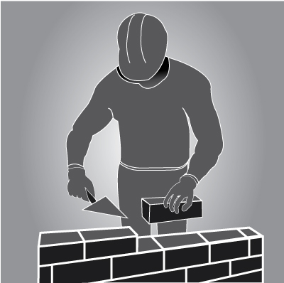
Sustained force - occurs when force is applied continually over a period of time. | - pushing or pulling a trolley around hospital wards  - holding down a trigger to operate a power tool  - supporting a plaster sheet while fixing it to a ceiling  - carrying objects over long distances  - supporting, positioning or stabilising a patient’s limb during surgery or when applying splinting or casting material | 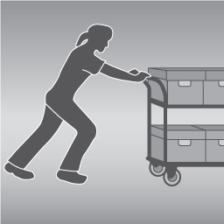

High force – may be exerted by the back, arm or leg muscles or by the hands and fingers.  High force occurs in any tasks that:  - a worker describes as very demanding physically  - a worker needs help to do because of the effort it requires  - require a stronger person or two persons to do the task. | - Lifting, lowering or carrying a heavy object  - Lifting, lowering or carrying an object that cannot be positioned close to the body  - pushing or pulling an object that is hard to move or stop  - restraining a person or animal.  Examples of high force using the hands and fingers include:  - using a finger-grip, a pinch-grip or an open-handed grip to handle a heavy or large load  - operating hand tools with tight squeeze grips  - gripping small instruments with high force, for example, a dental hygienist cleaning teeth. | 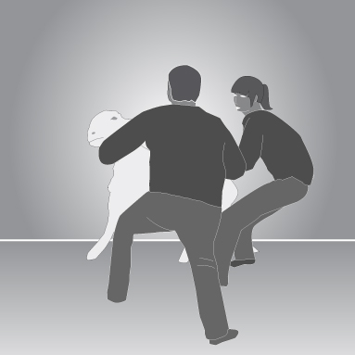  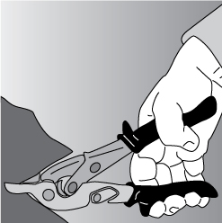
Sudden force – jerky or unexpected movements while handling an item or load are particularly hazardous because the body must suddenly adapt to the changing force.  Tasks where force is applied suddenly and with speed also generates high force. | - impact recoil of a large nail gun  - throwing or catching objects  - cutting reinforcement steel with large bolt cutters  - carrying an unbalanced or unstable load such as bagged stock feed pellets that suddenly moves  - handling frightened or resistant animals  - handling patients who suddenly resist or no longer assist during the handling procedure. | 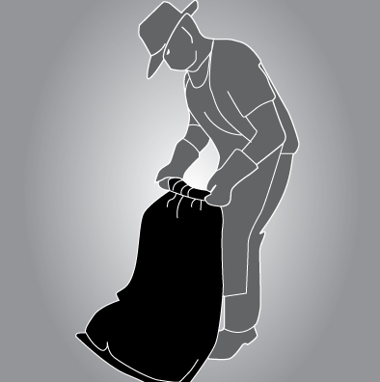
Movement
Repetitive movement – using the same parts of the body to repeat similar movements over a period of time. | - painting  - lifting goods from a conveyor belt and packing them in a carton  - typing and other keyboard tasks  - repeatedly reaching for and assembling components in electronics manufacturing  - using a socket and ratchet or spanner to unscrew long bolts. | 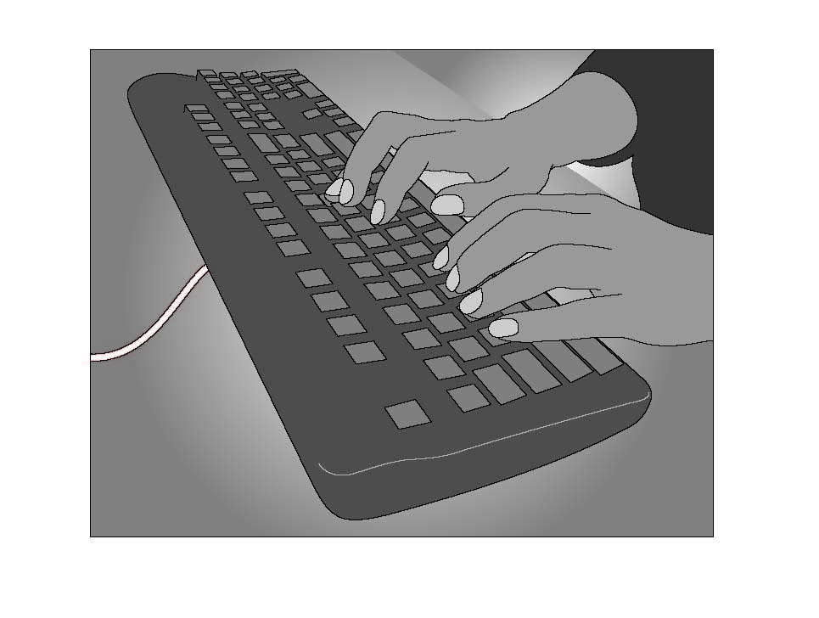

Posture
An ideal posture is one where the trunk and head are upright and forward facing, the arms are by the side of the body, the forearms are either hanging straight or at right angles to the upper arm, and the hand is in the handshake position.
Postures that are both awkward and sustained are particularly hazardous.
Sustained posture – where part of or the whole body is kept in the same position for a prolonged period. | - supporting plasterboard sheeting while it is nailed into place  - continually standing with weight mainly on one leg while operating a power press with foot pedal controls. | 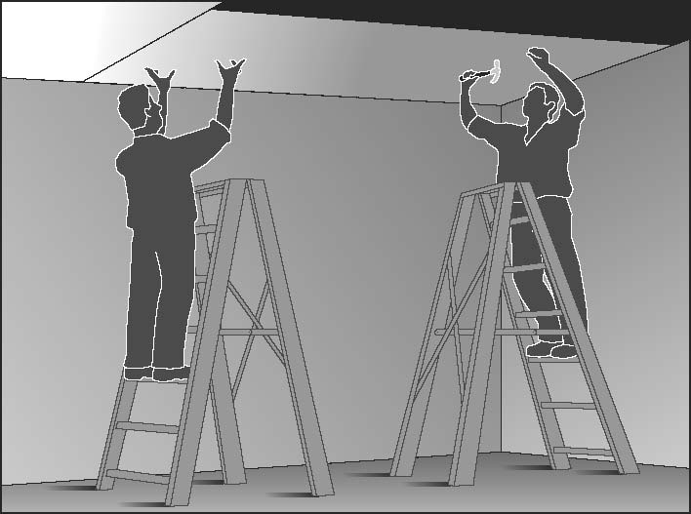
Awkward posture – where any part of the body is in an uncomfortable or unnatural position, such as:  - postures that are unbalanced or asymmetrical  - postures that require extreme joint angles or bending and twisting. | - squatting while servicing plant or a vehicle  - working with arms overhead  - bending over a desk or table  - using a hand tool that causes the wrist to be bent to the side  - kneeling while trowelling concrete or laying carpet  - bending the neck or back to the side to see around bulky items pushed on a trolley. | 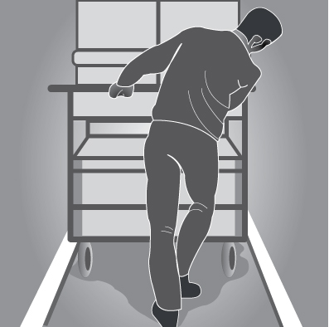

Vibration There are two common forms of vibration according to contact points between the body and the source:
Whole body vibration occurs when vibration is transmitted through the whole body, usually via a supporting surface, such as a seat or the floor in heavy vehicles or machinery. This may result in lower back pain, degeneration of the lumbar vertebrae and disc herniation. | - operating mobile plant such as heavy earth moving machinery  - driving a vehicle over rough terrain. | 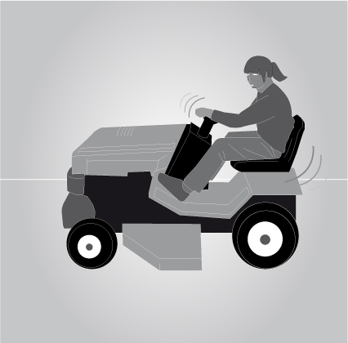
Hand-arm vibration occurs when vibration is transferred through a vibrating tool, steering wheel or controls in heavy machinery to the hand and arm. This can disrupt blood circulation in the hand and forearm and damage nerves and tendons. Localised vibration contributes to ‘vibration-induced white finger’ and ‘carpal tunnel syndrome’ through the gripping force needed to hold the vibrating tools (the tighter the grip, the more vibration is absorbed) and the repetitive shock loads of some tools. | - using impact wrenches, chainsaws, jackhammers, grinders, drills or vibrating compacting plates  - using needle guns in de-rusting metal. | 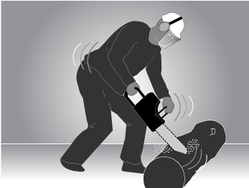  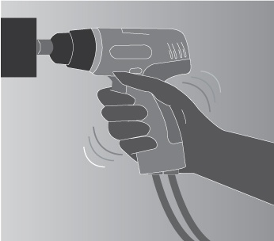

3. Assessing the Risks
A risk assessment involves examining the characteristics of the hazardous manual task in more detail to assess whether the forces, movements and postures are undertaken in such a way that they give rise to the risk of MSDs.
  - WHEN SHOULD A RISK ASSESSMENT BE CONDUCTED?
You should carry out a risk assessment for any manual tasks that you have identified as being hazardous, unless the risk is well-known and you know how to control it. A risk assessment can help you determine:
- which postures, movements and forces of the task pose a risk
- where during the task they pose a risk
- why they are occurring
- what needs to be fixed.
  - HOW TO DO A RISK ASSESSMENT FOR HAZARDOUS MANUAL TASKS
Identify who should participate in the risk assessment, for example those workers who do the task or their health and safety representative, and management who have control over how the task is done. Describe the task and area where the manual task is performed. Note which body parts are likely to be at risk of injury, then work through the assessment together to determine which risk factors pose a risk and why the risk exists.
The whole task should be examined, although it may help to look at the task in stages to identify all of the risk factors. For example, the task of putting stationery items away in a storage cabinet may involve the following steps:
- collecting boxes of stationery supplies from the delivery dock – handling boxes that are bulky may increase the risks associated with this task
- transporting stationery supplies to the storage area – using a trolley with poorly maintained wheels may increase effort
- unpacking boxes of stationery supplies – unpacking boxes from the floor may increase awkward postures
- placing supplies on storage shelves – shelving heights that are too high or too low may increase awkward postures.
Looking at each of the steps identifies the different sources of risk, which are the things that should be changed to control the risks.
For some complex situations, expert or specialist advice may be useful when conducting a risk assessment. There are a range of risk assessment tools that may be used. Further information is in Appendix F.
Assessing similar tasks
If a number of your workers carry out very similar hazardous manual tasks, you may assess these tasks together as a group instead of assessing each task individually. However, you should only do a group risk assessment if all the tasks are sufficiently similar and do not expose a worker to a different risk than if individual assessments were carried out.
  - WHAT ARE THE RISK FACTORS?
Working through the following questions will assist in determining which postures, movements and forces of the task pose a risk. The Risk Assessment Worksheet at Appendix D may be used to record the findings.
Question 1: Does the task involve any of the following:
- repetitive movement?
- sustained or awkward postures?
- repetitive or sustained forces?
As a general guideline, ‘repetitive’ means that a movement or force is performed more than twice a minute and ‘sustained’ means a posture or force is held for more than 30 seconds at a time.
Examples of postures and movements that pose a risk if they are repetitive or sustained are:

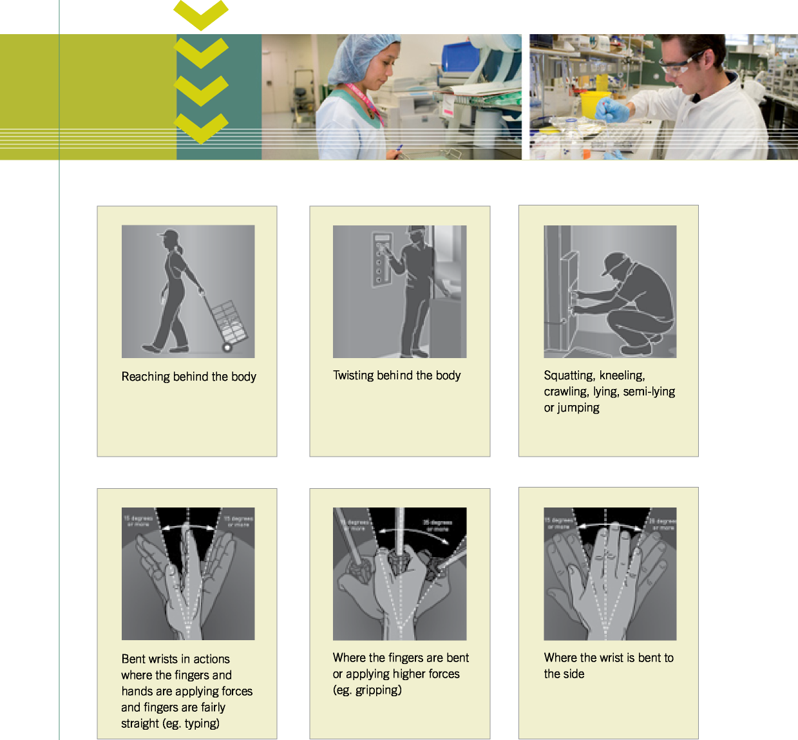

Bending the back or head forwards or sideways more than 20 degrees | 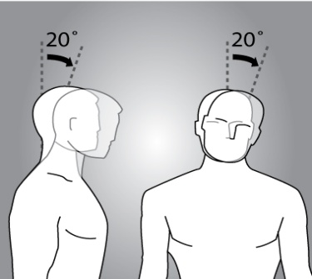 |  | 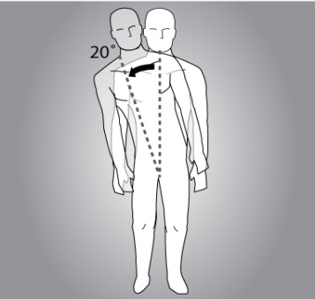
Bending the back or head backwards more than 5 degrees or looking up | 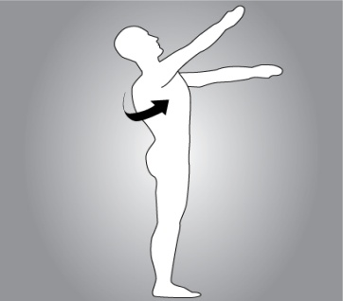
Twisting the back or neck more than 20 degrees | 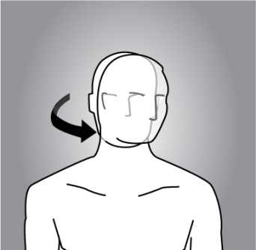 |  | 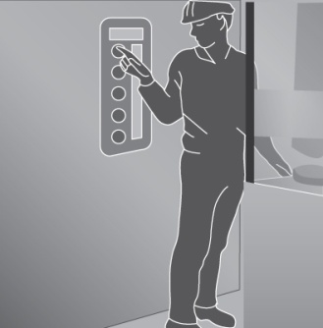
Working with one or both hands above shoulder height | 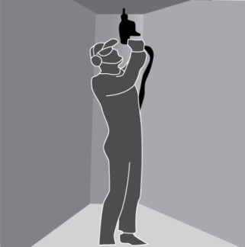
Reaching forward or sideways more than 30cm from the body | 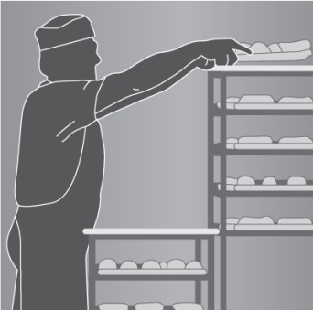 | 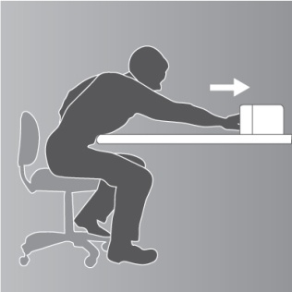
Reaching behind the body | 
Standing with most of the body’s weight on one leg | 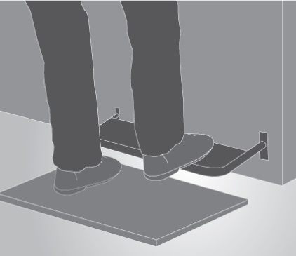
Twisting, turning, grabbing, picking or wringing actions with the fingers, hands or arms that includes excessive bending of the wrist | 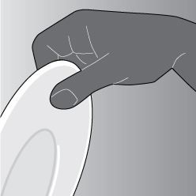
Working with the fingers close together or wide apart | 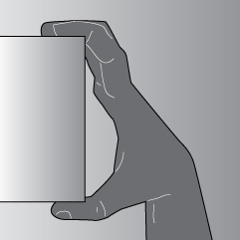
Squatting, kneeling, crawling, lying, semi-lying or jumping. | 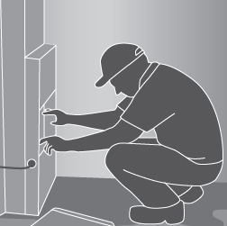
Very fast movements. | 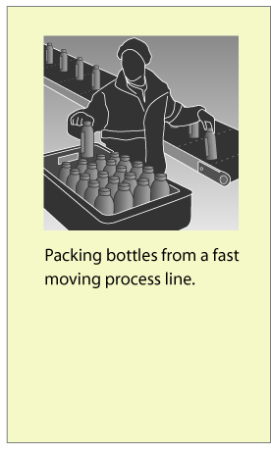

The risk increases as the degree of bending and twisting increases. The risk is greatest when the postures and movements are extreme, that is, toward the end of the movement range, and when they feel uncomfortable for the worker.
Question 2: Does the task involve long duration?
If you have assessed a task as involving postures, movements or forces that are also repetitive (more than two per minute) and/or sustained (held for more than 30 seconds), you should determine the duration of the task.
The duration of the task is how long the task is carried out over a whole shift or continually at any time during a shift. Tasks that continue over a long period or are repeated over the work day increase the risk of injury.
As a general guideline, long duration means the task is done for more than a total of 2 hours over a whole shift or continuously for more than 30 minutes at a time.
Keep in mind that workers may use the same parts of the body to repeat similar movements when carrying out various tasks that are similar in nature over time.
Question 3: Does the task involve high or sudden force?
High forces can cause MSDs even if they are not repetitive or sustained. This means that any task involving high force may be a risk, even if it is only done occasionally or for short periods. The longer and more often force is applied and the higher the force, the greater the risk.
The risk in tasks involving high force is related to:
- the intensity of the force needed - forceful muscular exertions place high stress on the muscles, tendons, joints, ligaments and vertebral discs.
- the speed involved - fast movements (particularly if repeated) can injure muscles, tendons and ligaments. The rapid or sudden speed changes caused by sudden or unexpected movements are high risk.
- whether the force is jerky or sudden - forces suddenly applied or stopped can overload the muscles, tendons, joints, ligaments and vertebral discs. This can occur when throwing or catching loads, or when the load or item worked on moves unexpectedly (for example, when pulling up a fence post that suddenly comes free, or assisting and holding a walking patient who suddenly falls).
High and sudden forces are commonly associated with the handling of live persons or animals and loads that are unstable, unbalanced or difficult to hold.
Question 4: Does the task involve vibration?
Prolonged exposure to whole-body or hand-arm vibration increases the risk of MSDs and other health problems. The degree of risk increases as the duration of exposure increases and when the amplitude of vibration is high.
Some examples of sources of vibration are:
- driving, particularly on rough roads
- frequent or prolonged use of hand powered tools
- use of machines or tools where the manufacturer’s handbook warns of vibration
- workers being jolted or continuously shaken
- use of a vehicle or tool not suitable for the environment or task.
Question 5: Is there a risk?
The task involves a risk of MSD if you have answered ‘yes’ to either:
- Question 1 and Question 2 | The task involves repetitive or sustained postures, movements or forces, and it involves long duration.
- Question 3 | The task involves high force or sudden force.
- Question 4 | The task involves vibration
A task may involve more than one risk factor. Where a number of risk factors are present and interact within a task, the risk of MSD increases significantly.
  - WHAT ARE THE SOURCES OF THE RISK?
When conducting the assessment, think about the sources of any risks that are present in the task. These will be the things that you may be able to change to eliminate or reduce the risk of MSD. For example, poor postures and movements may be due to the layout of the workplace, high forces may be due to the loads being handled, and the frequency and duration of the task may be due to the work organisation, limited staff numbers or increased work pace to meet tight deadlines.
The main sources of risk are:
- work area design and layout
- the nature, size, weight or number of things handled in performing the manual task,
- systems of work
- the environment in which the manual task is performed.
These sources of risk can also make the task more difficult to perform and therefore increase the risk of MSD.
For each risk factor, you should ask:
- where in the task are they occurring
- why each of these actions is occurring (source of the risk).
The answers to these questions will provide the information on how to fix the source of the risk and hence control the risk of MSD.
Consider the work area design and layout
A work area includes work benches, conveyors, furniture and fittings and the equipment used by workers doing that job. The positioning and relationship of the different elements in a work area to each other and to the worker are important because of the effect on working postures.
A work area that is designed without consideration of the risks that arise from hazardous manual tasks may impose awkward postures on workers undertaking manual tasks, for example, bent and twisted positions with shoulders raised and the need to reach for items or carry loads over long distances.
Consider the nature, size, weight or number of persons, animals or things handled
Loads
Loads can be a source of risk due to the amount of muscular effort needed to handle them. The harder to grip and control a person, animal or thing, the greater the force required to handle them.
The risk can arise from:
- size, shape and weight of load – loads that are large, bulky, or heavy and cannot be held close to the body or are asymmetric and put uneven forces on the spine
- loads that are difficult to grip through unsuitable handles, handholds or surface textures
- unstable or unwieldy loads can create sudden high muscle forces and result in overloading of muscles, tendons or discs
- handling people or animals – both the physical and behavioural nature of people or animals can be a source of risk, for example unpredictable movements requiring sudden forces to control.
Tools
Tools that are unsuitable for the task can be a source of risk by increasing the force required, or by promoting sustained or awkward postures. Risks can arise from:
Weight – heavy hand tools, particularly if held for long periods of time, increase the force and effort required to perform a task, for example, a 3kg power drill used on an assembly line.
Balance – if the heaviest part of the tool is in front of the wrist, the force required to grip the tool and stop it tilting forward is increased.
Handle design – if the handle diameter is too large or too small, the grip span of the hand will create awkward postures and greater force will be required to control the tool. A handle that is too short or has prominent edges, can result in damaging compression of the palm.
Handle orientation – if the handle design does not place the wrist in a handshake position, the worker will need to use an awkward posture to operate the tool. Tools that cannot be adapted for use by both hands or are designed for right-handed use only can result in awkward postures and increased force.
Shock loading and impact – tools that deliver impacts such as hammers, hammer drills, and nail guns transmit impact forces to various ligaments and can require the use of a firmer grip to maintain control. They are a particular source of risk if used repetitively and for long periods.
Prolonged use – continued use of any hand tool (even tools that are well suited to the user and designed for the task) without adequate time to recover will increase risk of injury due to the sustained force to support it. In particular, vibrating tools increase risk.
Maintenance – poorly maintained or irregular service of tools and equipment may increase the effort needed to use them. For example, an unsharpened knife will increase the force required to bone and slice meat.
Consider the systems of work
Systems of work, or the way work is organised, can influence the physical and mental demands that a manual task places on a worker. The fatigue and strain (physical and mental) that may arise from the aspects of work (task demands, task control and resources and support provided) bring on physiological responses such as increased muscular tension and affect the function of muscles, nerves and blood vessels, increasing the risk of the worker developing an MSD.
The sources of risk include:
- time constraints
- pace and flow of work across the working day or shift
- ability for workers to influence workload or work methods and changes in the workplace
- the level of resources and guidance
- consultation processes
- work roles and performance requirements or processes for dealing with conflicts
- staffing levels, skill mix and shift arrangements.
Remember that workers will also have different physical and psychological characteristics and these individual factors may increase the risk, for example:
- Skills and experience – being inexperienced in a job may increase the risk
- Physical characteristics – an overload situation may result from a mismatch between the worker and the task
- Unaccustomed work – workers who are new, have transferred from another job or are returning from extended leave and whose muscles are not conditioned to the work.
Consider the workplace environment
The sources of risk in the work environment include:
- Cold environments such as in cool rooms, freezers, cold stores or working outside in cold and/or wet weather can lower body and hand temperature and make handling and gripping objects more difficult. Increased grip force can also result from reduced sensitivity in cold hands or from wearing gloves. Cold can also significantly increase the risk of hand-arm vibration. Working in a cold environment requires thick or heavy protective clothing that restricts movement which can increase the risk of MSD. It can also cause overheating of the body as the clothing does not allow heat or sweat to dissipate and may decrease the blood flow to muscles, increasing fatigue.
- High temperatures - (including radiant heat), for example, in foundries, laundries, bakeries, kitchens, or working in hot weather can make handling and gripping objects more difficult. Workers may have difficulty grasping objects due to perspiration on the hands or there may be sudden or unexpected forces due to loads slipping.
- Humid environments - caused by processes such as steam cleaning, cooking or the weather can also increase the risk of developing MSD. Handling wet or damp objects may require increased force. Humidity may also increase discomfort and fatigue.
- Wind - may increase the force required to handle items and reduce control while handling large objects, especially those that are flexible and have a large surface area. When working in windy conditions and in low temperatures that are also windy, the resultant wind chill may lower the body temperature further.
- Slippery and uneven floor surfaces - may increase the exertion required to perform manual tasks due to difficulty maintaining stability. Unsuitable floor coverings (for example carpet) may increase friction when moving objects such as trolleys
- Obstructions – caused by poor housekeeping and cleaning can lead to awkward postures such as reaching or bending over obstacles
- Lighting - low or high levels of lighting, as well as glare and reflection, may lead to awkward or sustained postures to either improve vision or to avoid glare.

4. CONTROLLING THE RISKS
Now you know which risk factors are present, where they are present and why they are present (sources of the risk), you are in a position to know what must be controlled and work out how to do it.
  - THE HIERARCHY OF CONTROL
The ways of controlling the risk of MSDs are ranked from the highest level of protection and reliability to the lowest. This ranking is known as the hierarchy of risk control. The WHS Regulations require duty holders to work through this hierarchy to choose the control that most effectively eliminates or minimises the risk in the circumstances. This may involve a single control measure or a combination of two or more different controls.
Eliminate the risk
The most effective control measure involves eliminating the hazardous manual task and its associated risk. Eliminating hazards and risks is usually easier and cheaper to achieve in the planning or design stage of an item, process or place used for work.
Minimise the risk
If it is not reasonably practicable to eliminate the risk, then you must minimise the risks so far as is reasonably practicable by:
- substituting the hazard with something that gives rise to a lesser risk
- isolating the hazard from any person exposed to it
- implementing engineering controls.
If there is a remaining risk, it must be minimised so far as is reasonably practicable by implementing administrative controls, and if a risk still remains, then suitable personal protective equipment must be provided and used. These two types of control measures, when used on their own, tend to be least effective in minimising risks because they rely on human behaviour and supervision.
Control measures should be aimed at eliminating or minimising the frequency, magnitude and duration of movements, forces and postures by changing the source of risk: the work area, tool, load, environment, method of handling and/or the way work is organised.

Hierarchy of control |  | Examples of control measures
Level 1 | Elimination | - Automate the manual task (such as using remote controls)  - Deliver goods directly to the point of use to eliminate multiple handling
Level 2 | Substitution | - Replace heavy items with those that are lighter, smaller and/or easier to handle  - Replace hand tools with power tools to reduce the level of force required to do the task
Level 2 | Isolation | - Isolate vibrating machinery from the user, for example by providing fully independent seating on mobile plant
Level 2 | Engineering | - Use mechanical lifting aids  - Provide workstations that are height adjustable
Level 3 | Administrative | - Rotate workers between different tasks  - Arrange workflows to avoid peak physical and mental demands towards the end of a shift
Level 3 | Personal protective equipment | - Heat resistant gloves for handling hot items  - Shock absorbent shoes for work on hard concrete floors

Purchasing to eliminate or minimise risks
Before purchasing equipment, such as tools, containers, workstations, machinery and vehicles, you should always check whether the item has been designed so that it can be used safely and best matches the needs of your workers. Where possible, you should:
- brief designers and engineers so that consideration can be given to the design implications on the manual tasks performed
- liaise with manufacturers and suppliers about handling, delivery and storage requirements
- purchase ergonomically designed tools and equipment that suit the work being carried out and the physical characteristics of the workers
- check any vibration specifications.
  - CHANGING THE DESIGN OR LAYOUT OF WORK AREAS
A well-designed work area will assist in eliminating or reducing the risk factors associated with a hazardous manual task, such as the degree of reaching, twisting or bending.
Workstation design
Workstations should be designed to allow workers to work in an upright position, shoulders in a natural position (not elevated) and upper arms close to the trunk most of the time without large reaches to perform the task. Work surfaces should be easily adjustable to suit a range of workers and the tasks they perform.
Where it is not possible to provide adjustable workstations consider altering the design so that:
- the workstation height suits the widest range of physical characteristics of workers
- reaching distances suit shorter workers
- knee and leg clearances suit larger workers.
Working heights
Tasks with high visual demands should be performed above elbow height and work surfaces may need to be tilted, for example, for tasks involving delicate or precise manipulation.
Tasks where the hands make a narrow range of movements and can rest on the work surface should be performed at, or just above, elbow height. A sloping surface may reduce the amount of neck flexion required to perform desk-based tasks, such as drafting.
Light manipulative tasks or tasks involving the use of a keyboard should be performed at just below elbow height.
Tasks incorporating a range of arm movements using the shoulder should be performed at between hip and shoulder height, for example taking items from a stack and placing them on a conveyor.
Tasks requiring considerable muscular effort or use of the body for leverage, for example, drilling at a workbench, should be performed at hip height and no higher.
Where possible, place items used in manual tasks so they are:
- in front of the worker
- between waist and shoulder height
- close to the midline of workers and orientated towards the worker
- on the worker’s preferred side
- positioned within comfortable reaching distance
- positioned to avoid double handling and to avoid moving loads manually over long distances.
Displays and controls should be positioned to encourage comfortable head and neck postures, comfortable hand and arm reach and efficient use. You should:
- place frequently used displays and controls, including keyboards and other input devices, directly in front of the worker
- position controls at comfortable elbow height
- select electronic or foot controls rather than hand controls if high force is required
- place pedals so that workers can operate them from a comfortable seated position.
Working position
Workers should not remain in a seated, standing or otherwise static posture for prolonged periods. Design the workstation to provide opportunities for workers performing seated or standing tasks to vary their postures and movements
For seated tasks, seating should have the following features:
- adjustable seat height and angle
- a contoured backrest with a lumbar curve except those where the backrest would interfere with the actions to be performed
- a swivel action to prevent the worker from twisting to reach workstation components
- rounded seat edges
- a five-point base with casters to allow movement on carpet, and gliders fitted to the base for low-resistance flooring, where access to work items located beyond normal reach is required
- a footrest or foot ring fitted on drafting or higher chairs to support the feet.
A seated work position is best for:
- work that requires fine manipulation, accurate control or placement of small objects
- close visual work that requires prolonged attention
- work that involves operating a foot pedal.
Workers carrying out standing tasks should be provided with:
- a chair, stool or support so that the worker can alternate between sitting and standing
- a footrest (large enough for the whole foot) to allow the worker to stand with either foot raised
- where possible, suitable floor covering to cushion concrete and other hard floors.
A standing work position is best when:
- large, heavy or bulky loads are handled
- forceful movements are required
- reaching is required
- movements away from the working position are frequent
- there is no knee room
- there is limited space.
Work space
Work areas should have enough space to accommodate the number of workers and other people involved in the task, any equipment that might be required and space to operate the equipment safely. For example, when observing workers of an aged care facility assisting an infirm person to bathe, the bathroom may need to accommodate two workers, the client and a mobile hoist with space to manoeuvre a person in the hoist over the toilet and bath or into a shower area.
  - CHANGING THE NATURE, SIZE, WEIGHT OR NUMBER OF ITEMS HANDLED
Handling loads
Examples of control measures that should be considered when handling loads include:
- purchasing products in smaller loads for manual handling or larger loads to be shifted mechanically
- reducing the size or capacity of containers
- using handheld hooks or suction pads to move loads such as sheet materials
- using grip devices adapted to the particular object to be carried.
Tools and equipment
Hand tools should be designed to:
- be held in a neutral wrist or handshake position
- allow the hand to retain a comfortable grip span
- be well-balanced (the heaviest part of the tool needs to be behind the wrist)
- be suitable for use by either hand
- provide a good grip surface
- prevent a worker from adopting a pinch grip with high force or for prolonged periods.
Minimise the level of muscular effort, particularly of the shoulder and wrist, needed to use hand tools by:
- using power tools where possible
- suspending or supporting heavy tools where they are used repetitively and in the same place
- counterbalancing heavy tools that are used repetitively and need to be kept away from the body
- using trigger locks where the grip has to be sustained for more than 30 seconds
- holding the work piece in place with either jigs or fixtures selecting tools that produce the least amount of vibration
- reducing impact shocks
- limiting torque or ‘kick back’ reactions.
Maintenance
Tools and equipment should be well maintained by carrying out regular inspections and servicing in accordance with the manufacturer’s specifications.

  - USING MECHANICAL AIDS
Mechanical equipment may eliminate or reduce the need for workers to lift, carry or support items, animals or people. A wide range of mechanical aids is available for various industries, for example:
- conveyors such as roller conveyors, elevating conveyors, belt conveyors, screw conveyors, chutes, monorails or trolley conveyors
- cranes such as overhead travelling cranes, gantry cranes or jib cranes, stacker cranes, industrial manipulators and articulating arms
- lifting hoists
- loading dock levellers
- turntables
- springs or gas struts, mechanical devices such as hand winches, hydraulic pumps, and battery powered motors
- forklifts, platforms trucks, tractor-trailer trains, tugs and pallet trucks
- lift tables, mechanical and hand stackers, lift trolleys, two-wheel elevating hand trucks, and vacuum or magnet assisted lifters
- glass panel, duct and plaster lifters.

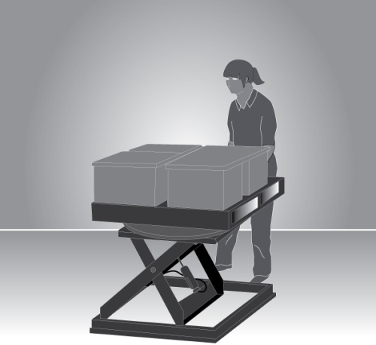 | 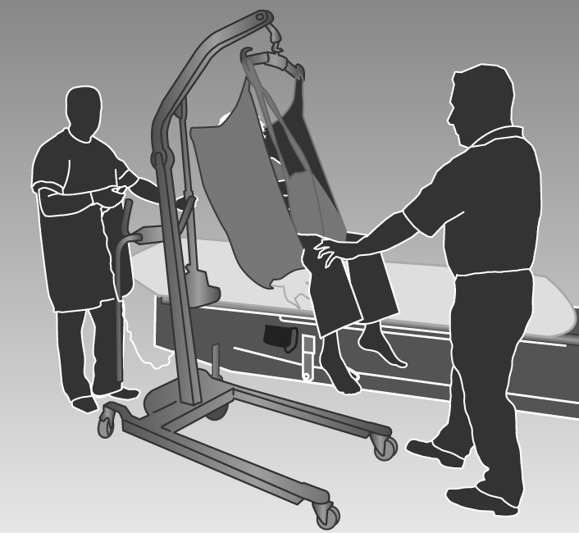
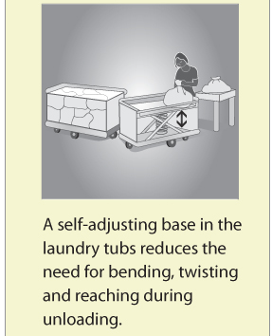
Mechanical aids should be:
- designed to suit the load and the work being done
- as light as their function will allow
- adjustable to accommodate a range of users
- easy to use
- suited to the environment in which the task is performed
- located close to the work area so they are readily available but do not cause an obstruction
- supported by a maintenance program to ensure they are safe and that the required effort to use them is kept at the lowest possible level
- introduced with suitable instruction and training in their use.
When you introduce a mechanical aid into the workplace, you must provide adequate information, instruction, training and supervision to ensure that new arrangements do not introduce any additional risks to workers, for example, a forklift operated in the same workspace used by other workers.
Pushing and pulling loads
Pushing loads is preferable to pulling because it involves less work by the muscles of the lower back, allows maximum use of body weight, less awkward postures and generally allows workers to adopt a forward facing posture, providing better vision in the direction of travel.
Reduce the effort required to start the load in motion by:
- using motorised push/pull equipment such as tugs or electric pallet jacks
- using slide sheets to reduce friction when moving patients
- positioning trolleys with wheels in the direction of travel
- using large power muscles of the legs and whole body momentum to initiate the push or pull of a load.
Reduce the effort to keep the load moving by:
- using motorised hand trucks and trolleys that are as lightly constructed as possible and have large wheels or castors that are sized correctly and roll freely
- using hand trucks or trolleys that have vertical handles, or handles at a height of approximately one metre
- ensuring that hand trucks and trolleys are well maintained
- treating surfaces to reduce resistance when sliding loads
- for pushing, ensuring handles allow the hands to be positioned above waist height and with elbows bent close to the body
- for pulling, ensuring handles allow the hands to be positioned below waist height allowing workers to adopt a standing position rather than being seated so the whole body can be used.
Reduce the effort needed to stop the load by:
- indicating the place where loads need to be delivered
- planning the flow of work
- encouraging workers to slow down gradually
- fitting brakes and speed limiters so speed can be controlled, particularly if there is a need to stop quickly so as to avoid other traffic.

  - HANDLING PEOPLE AND ANIMALS
Handling people
No worker should fully lift a person (other than a small infant) unaided, that is without assistance from, for example, mechanical aids, assistive devices or another worker. All people handling activities are a potential source of injury and the risks associated with this hazardous manual task must be eliminated or minimised so far as is reasonably practicable.
With people handling, the health and safety of the person being handled needs to be considered as well as the health and safety of the worker/s and others involved in the task. The physical condition of the person being handled as well as their non-physical characteristics, for example their ability to understand and communicate and their behaviour, will affect how the people handling activity is undertaken and the risks involved.
When people are being handled, the controls selected and applied should take into account all of the sources of risks. Controls may include the following:
- a mobility risk assessment: maximise the person’s ability to assist in the move through the use of appropriate advice, mechanical and/or assistive devices.
- moving the person to a place that does not constrain the movement of the worker performing the task, for example, using a shower trolley to bathe a patient
- where handling is required, assessing the needs of the task including the specific type of mechanical aids and personnel needed, and planning it in a manner that avoids the hazardous manual task
- where the use of a hoist requires two or more people provide adequate supervision and resources to eliminate the risk of workers being under time pressure and attempting the task on their own
- planning how to handle a person attached to medical or other equipment
- ensuring the location and storage of mechanical aids and assistive devices allows easy access
- providing training for the safe use of mechanical aids and assistive devices.
Handling animals
Supporting or restraining animals should only be carried out by people with the necessary skills and experience. When animals are being handled consider the following:
- using mechanical devices or other restraining aids for lifting, transporting or restraining animals
- moving the animal to a place that constrains or minimises the movement of the animal before commencing the task
- where handling is required, assessing the needs of the task including the specific type of mechanical aids and personnel, and planning it in a manner that avoids double-handling
- where the use of a mechanical aid or assistive device requires two or more people, providing adequate resources so that workers under time pressure don’t try to complete the task on their own.
  - CHANGING THE SYSTEM OF WORK
Workload and pace of work
The workload and pace should accommodate the physical demands of the manual task. Where possible, work should be organised to minimise multiple handling and improve the flow of work by:
- having raw materials delivered, located or transferred mechanically to the location or work area where they will be used. For example, building supplies can be delivered by truck or crane to the on-site location where they will be used or to the external lift, rather than being delivered to the front gate
- delivering materials, tools and items on mobile systems, for example, on roller pallets
- processing and packaging items in the same location or on the same workbench
- locating storage areas close to distribution areas
- changing the distribution of work across the work day or week to avoid high peak workloads
- using systems that minimise the need for storage and additional handling
- asking suppliers to deliver products, items or tools in a way that allows them to be used without the need for additional handling, for example, flat packs delivered on a vertical frame or table tops facing the right way up for use.
Workers should not have to work at a rate that is at the limit of their ability. When you establish a work rate, you should consult with the workers affected and their health and safety representatives. Set realistic work rates by:
- allowing workers to control the pace for critical or physically demanding tasks
- providing adjustability in the line speed, for example, reduce the speed when conditions are altered, such as when new products are introduced or poor quality materials are used
- providing buffers to allow material to be taken off-line, for example, ‘holding’ bins or benches off the main processing conveyor.
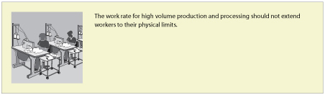
Design tasks for the working population
Task design should take account of the range of human dimensions and capabilities such as height, reach and weight. Adapt work systems to accommodate the health/fitness status of a worker. If this is not reasonably practicable, allocate the worker to other tasks. In designing work systems, considerations also include:
- the capacity of workers who have not reached physical maturity for physically demanding work
- the possibility that older workers may have a decreased physical capacity for physically demanding or fast work
- the need for gradual adjustment to physically demanding work activities during recovery from injury or illness
- pregnancy which affects the risk of back pain because of the changing shape of the body.
Provide transition arrangements for workers undertaking unaccustomed work by:
- reducing the pace of work or workloads
- providing more frequent breaks
- job rotation.
Resources and support
When introducing risk control measures that involve plant, tools or equipment, ensure that:
- it is the right equipment for the task
- there is sufficient, available equipment
- plant, tools and equipment are checked and maintained on a regular basis.
To allow for adequate recovery time and to reduce exposure to risks of MSD, arrange to have the right staffing levels, skill mix and shift arrangements considering:
- shift lengths
- the levels of overtime
- placement of rostered days off
- the numbers of workers during peak periods
Communicate and consult with workers about the way work is organised and allow workers to seek assistance from another person when necessary.
  - CHANGING THE WORK ENVIRONMENT
Vibration
Whole-body vibration – the design of vibration damped equipment and engine mountings are the most effective methods of controlling vibration exposure. Other strategies to reduce exposure include:
- improving vehicle suspension and installation of operator seats mounted on suspension systems which incorporate spring and damper elements
- ensuring that equipment and control measures implemented to reduce vibration are well maintained
- ensuring workers adjust their seats appropriately and equipment is operated within the speed suggested by the manufacturer or to a speed that reduces vibration levels
- training workers about the risks associated with whole-body vibration, the controls that have been implemented and how they should be used.
Hand-arm vibration – substitute alternative manufacturing methods or processes to eliminate the need for vibrating equipment Where this is not possible, the best strategy is to purchase tools and equipment that produce less vibration.
Cold conditions
To control exposure to cold conditions you should:
- ensure your workers take regular rest breaks in a warm place
- ensure your workers wear non-slip footwear and clothing that is fitted and not too bulky or restrictive
- provide personal protective equipment suitable for the task (for example, gloves to provide protection from the cold and also allow a good grip of the objects being handled).
Heat and humidity
For workers in hot and humid conditions, reduce temperature and humidity during manual tasks where possible by:
- relocating work away from sources of heat
- providing fans or air-conditioning
- using screens, awnings and clothing to shield workers from radiant heat sources such as ovens, furnaces and the sun
- enclosing hot processes and increasing ventilation
- altering work schedules so that work is done at cooler times
- providing a cool, well-ventilated area where workers can take rest breaks
- ensuring that workers work at a sensible pace
- providing a supply of cool drinking water.

Windy conditions
Consider minimising the risk of exposure to windy conditions by:
- planning the route of work through protected pathways
- using vehicles to transport items in outdoor conditions
- co-ordinating tasks during low wind conditions.
Floors and surfaces
Keeping work areas clean, tidy and free of clutter or obstacles prevents workers from adopting awkward postures and reduces the level of exertion that may be required to reach over or around obstacles. Clean, smooth and flat surfaces can also reduce forces required to push and pull objects and prevent slips, trips and falls.
Lighting
Select lighting to suit the task performed. To prevent awkward or sustained postures that may arise from low or excessive levels of lighting, glare or reflection:
- provide additional lighting, such as a lamp on a movable arm, where required
- improve the layout of existing lights by lowering or raising them or changing their position in the work area
- increase or decrease the number of lights
- change the diffusers or reflectors on existing lights
- change the lights to improve light levels or improve colour perception
- change the orientation or position of the item to avoid shadows, glare or reflections
- clean lights and light fittings regularly
- use screens, visors, shields, hoods, curtains, blinds or external louvers to reduce reflections, shadows and glare
- control natural light sources (particularly bright sunshine) on work pieces, screens and work surfaces by orientation and placement at 90 degrees to the source and/or by providing screening and louvers.
  - USING ADMINISTRATIVE CONTROL MEASURES
Administrative control measures do not address the risk factors or source of the risk – they only attempt to reduce risk by reducing exposure to those risk factors.
Job rotation
The risk of MSDs may be minimised by rotating staff between different tasks to increase task variety. Job rotation requires the tasks to be sufficiently different to ensure that different muscle groups are used in different ways so they have a chance to recover. To increase task variety, you should consider:
- combining two or more tasks so both are done by one worker and alter the workstation and items used accordingly
- providing breaks doing another task when the job is monotonous.
Rest breaks
Regular rest breaks provide opportunities for workers to prevent the build-up of, or recover from the effects of, fatigue in muscle groups used during hazardous manual tasks that involve:
- repetitive awkward postures or sustained postures
- application of high force
- vibration
- long duration
- high levels of mental demand combined with hazardous manual tasks, for example inspection work.
The frequency and duration of rest breaks will be dependent on the nature of the task. Generally, the greater the force required, or the longer a posture is sustained, the greater the recovery time.
More frequent and shorter rest breaks are better for rest and recovery than fewer, longer breaks. Build short breaks into task rotation arrangements where work is of a similar nature, for example process production or hand tool use. Micro-pauses (very short intermittent breaks) in physical activity are also beneficial. Build these into the design of tasks and methods of work, for example:
- workers put down hand tools or release them (suspension) between operations
- keyboard operators remove hands from keyboards during natural keying breaks
- stagger manual tasks over the full work shift.
Team handling
Team handling is manual handling of a load by two or more workers. Team handling brings its own risks and requires coordination. It should only be used as an interim control measure. You should redesign manual tasks to allow the use of mechanical equipment, or eliminate the need to lift, if there is a regular need for team handling. Team lifting can increase the risk of MSD if:
- the load is not shared equally
- workers do not exert force simultaneously
- individual workers need to make foot or hand adjustments to accommodate other team members, reducing the force each can exert
- performed on steps or on a slope where most of the weight will be borne by handlers at the lower end
- individual workers unexpectedly lose their grip, increasing or changing the balance of the load on other team members.
Whenever team handling is used it is essential to match workers, co-ordinate and carefully plan the lift. You should ensure that:
- the number of workers in the team is in proportion to the weight of the load and the difficulty of the lift
- one person is appointed to plan and take charge of the operation
- enough space is available for the handlers to manoeuvre as a group
- team members are of similar height and capability, where possible
- team members know their responsibilities during the lift
- training in team lifting has been provided and the lift rehearsed, including what to do in case of an emergency
- aids to assist with handling (a stretcher, slings, straps, lifting bars, lifting tongs, trolleys, hoists) are used where possible and training is provided in their use.
Information, training and instruction
If a risk of MSDs remains after implementing higher level control measures, then the risk must be minimised by providing information, training and instruction. Training in lifting techniques must not be used as the sole or primary means to control the risk of MSDs.
  - IMPLEMENTING CONTROL MEASURES
Risk control may initially involve using short term, interim measures while a long term solution is developed. For example, temporarily raise the bench until it can be replaced or altered permanently, or rotate employees through a production line to reduce the time spent working at a low bench until it can be changed.
To implement the most effective risk controls, you should:
- allow workers to trial solutions before decisions are made to make the solution permanent
- review controls after an initial testing period, as they may need modification
- develop work procedures to ensure that controls are understood and responsibilities are clear
- communicate the reasons for the change to workers and others
- provide training to ensure workers can implement the risk controls for the task competently
- ensure that any equipment used in the manual task is properly maintained.
You should not make final decisions on the effectiveness of the control measures that you have implemented until enough time has passed for your workers to adjust to the changes. Workers should be given a chance to practice using the new workstation, tool, mechanical device or new work method. Some modifications may require workers to use new muscle groups or different parts of the body and they may initially feel some discomfort. At this stage, you should frequently check with your workers how they feel the improvements are working.
Training
Training in the type of control measures implemented should be provided during induction into a new job and as part of an on-going manual task risk control program. Training should be provided to:
- workers required to carry out, supervise or manage hazardous manual tasks
- in-house designers, engineers and officers responsible for the selection and maintenance of plant and/or the design and organisation of the job/task
- any health and safety representatives.
The training should include information on:
- manual task risk management, including the characteristics of hazardous manual tasks
- specific manual task risks and the measures in place to control them
- how to perform manual tasks safely, including the use of mechanical aids, tools, equipment and safe work procedures
- how to report a problem or maintenance issues.
You should review your training program regularly and also when there is change to work processes, plant or equipment, implementation of new control measures, relevant legislation or other issues that may impact on the way the task is performed.
You should keep records of induction and training given to your workers. The records can include information such as the date of the session, the topics dealt with, and the name and signature of the trainer and each of the workers who attended the session.

5. Reviewing control measures
Control measures that have been implemented must be reviewed and, if necessary, revised to make sure they work as planned and to maintain a work environment that is without risks to health and safety.
Regulation 38: A person conducting a business or undertaking must review and as necessary revise risk control measures:
- when the control measure does not minimise the risk so far as is reasonably practicable
- before a change at the workplace that is likely to give rise to a new or different health and safety risk that the control measure may not effectively control
- if a new hazard or risk is identified
- if the results of consultation indicate that a review is necessary
- if a health and safety representative requests a review.
Control measures may be reviewed using the same methods as the initial hazard identification step. Consult your workers involved in the manual task and their health and safety representatives and consider the following:
- Are the control measures working effectively in both their design and operation, without creating new risks?
- Are workers actively involved in the risk management process? Are they openly raising health and safety concerns and reporting problems promptly?
- Have new work methods or new equipment reduced physical strain or difficulty?
- Has instruction and training on hazardous manual tasks and the implemented control measures been successful?
- Is the frequency and severity of MSDs reducing over time?
- Is an alteration planned to any structure, plant or process that is likely to result in a worker being exposed to a hazardous manual task?
- Has an incident occurred as a result of a worker being exposed to a hazardous manual task?
- If new information becomes available, does it indicate current controls may no longer be the most effective?

If problems are found, go back through the risk management steps, review your information and make further decisions about risk control.

6. Role of designers, manufacturers, importers and suppliers
The best time to eliminate or minimise the risk of MSDs is in the design and planning stage – when hazards and risks can be ‘designed out’ before they are introduced into a workplace.
Designers, manufacturers, importers and suppliers of plant and structures have duties under the WHS Act to ensure, so far as is reasonably practicable, that these products are without risks to health and safety when used for a purpose for which they were designed or manufactured.
  - DESIGNERS
Regulation 61: Designers of plant or structures used for work must:
• ensure the plant or structure is designed to eliminate the need to carry out a hazardous manual task in connection with the plant or structure
• where this is not reasonably practicable, minimise the need to carry out a hazardous manual task in connection with the plant or structure so far as is reasonably practicable
• give each person who is provided with the design for the purpose of giving effect to it adequate information about the features of the plant or structure that eliminate or minimise the need for any hazardous manual task to be carried out..
Ergonomic principles should be applied in the design stage. This means that a manual task should be designed to fit the people doing the task, not the reverse. Ergonomics involves consideration of the variability in human capability and an understanding of how people interact with the work environment, tools and equipment.
If you provide your design to another person (for example, a manufacturer) then you must provide certain information, including:
- the purpose for which the plant or structure was designed
- how you have dealt with hazards that may impact on manual tasks in your design, and whether there are any residual risks
- how to handle the product safely, including during its transportation, installation, operation, maintenance and disposal.
Quality assurance processes can be used to check that the product effectively minimises the risk of MSDs. When modifying a design, take into account feedback from purchasers and users of your product.
Design of workplaces
Designers of buildings used as workplaces should consider the manual tasks that may be performed throughout the lifecycle of the building, from construction through to use, maintenance, refurbishment and potential demolition. For example, design:
- building materials that are strong yet light-weight
- large structural components with suitable lifting points to enable lifting by crane
- spaces large enough to accommodate or incorporate mechanical devices
- minimal distances for pushing, pulling, lifting or carrying loads
- materials handling devices into the building, such as lifts and chutes
- floor surfaces to enable wheeled equipment to be pushed or pulled easily.
Some types of workplaces, such as hospitals, nursing homes, warehouses and distribution centres that carry out a high level of manual tasks will have particular design requirements to eliminate or minimise the risk of MSDs.
Design of plant
The safe design of plant can play a critical role in reducing the risk of MSD for workers. When designing plant, consider all phases of its life, including manufacture, cleaning and servicing.
If practicable, trial a prototype in a range of operating conditions and think about how the plant will be used. Change any aspects of the design that increase the risk of injury, for example:
- eliminate or reduce the number of repetitive actions, postures and movements required to operate the plant
- design handles on tools and controls to allow normal wrist postures
- reduce the forces required to operate the plant
- provide instructions, signs or symbols to help people use the plant properly
- take into account the range of physical characteristics of those who use the plant, such as size and strength
- ensure that the plant operates at a speed or rate that would suit most users
- ensure that regular maintenance points are easily accessible.
Appendix E lists some examples of design-related MSD risks for plant, and shows how to control the risks through safe design.
  - MANUFACTURERS, IMPORTERS AND SUPPLIERS

Regulation 61: Manufacturers of plant or structures must:

• ensure the plant or structure is manufactured designed to eliminate the need to carry out a hazardous manual task in connection with the plant or structure

• where this is not reasonably practicable, minimise the need to carry out a hazardous manual task in connection with the plant or structure so far as is reasonably practicable

• give each person to whom the manufacturer provides the plant or structure adequate information about the features of the plant or structure that eliminate or minimise the need for any hazardous manual task to be carried out.
Importers and suppliers must take all reasonable steps to obtain that information the designer or manufacturer is required to give and provide it to any person to whom the plant or structure is supplied.
Manufacturers, importers and suppliers should consider the way their products are packaged and delivered to workplaces to eliminate or minimise the risk of MSDs, for example:
- provide lifting aids or lifting points so mechanical aids can be used
- provide two handles or handholds to prevent one-handed lifting, particularly where the load is heavy or needs to be moved frequently
- repackage the load into a different weight, size or shape:
  - Large and bulky loads are difficult to handle, promote awkward postures, increased muscular exertion and are difficult to hold close to the body
  - Heavy loads generally require greater force to handle.
  - Loads that are unwieldy, unstable or move unpredictably increase risk by creating sudden high forces
- label loads to indicate any MSD risks, and where appropriate, any necessary precautions when handling the load
- deliver goods in sturdy boxes or containers with handles or handholds. Handholds on cardboard boxes should be reinforced so that it does not rip when the box is picked up.
Packaged items should be arranged so the package is well balanced and the contents will not shift unexpectedly while being handled, for example:
- use slings or other aids to maintain effective control when handling loads that lack rigidity
- fill containers holding liquids or free-moving powder so that there is only a small amount of free space at the top of individual containers
- use baffles, dividers or packing materials to keep the contents stable in partly-filled packages
- secure loads that may move during handling, for example animals in slings, fertiliser bags inside sturdy boxes
- shrink wrapping loads on pallets.
Providing information
Manufacturers, importers and suppliers must also give purchasers and users the information they need to use the product safely, including during its transportation, operation and maintenance. This information may be provided in user manuals, brochures or on the product itself (for example, labelling cartons). The information should be accurate, clear and easy to understand.
Loads should be labelled to indicate any MSD risks, and where appropriate, any necessary precautions when handling the load. This information should indicate:
- the heaviest side of an off-centred load, for example, with an arrow drawn on the packing carton
- the weight of the load
- whether the load is fragile
- the stability of the load, for example a label saying that the contents of a package may move while being transported or handled
- any specific handling or unpacking instructions.
Information provided by the designer to the manufacturer should be passed on to the supplier and then to the purchaser. Importers should obtain the information from their suppliers.
If you are an importer or a supplier and you cannot get this information from the designer or manufacturer, you should obtain information from other sources or develop it yourself.

Appendix A – The risk management process for manual tasks
REVIEW CONTROL ASSESS IDENTIFY
CONSULTCONSULTCONSULTCONSULT
What is the manual task?
Using the body to lift, lower, push, pull, carry or otherwise move, hold or restrain any person, animal or thing.

Is the manual task hazardous?
Application of force:
- Repetitive
- Sustained
- High
- Sudden
Posture:
- Sustained
- Awkward
Movement:
- Repetitive
Exposure to vibration
What is the risk of MSD?
- How often and how long are specific postures, movement or forces performed or held?
- What is the duration of the task?
- Does the task involve high or sudden force?
- Does the task involve vibration?
What is the source of risk?
Work area design and layout
Systems of work
Nature, size, weight and number of persons, animals or things handled

Work environment

- Is the task necessary?
- Can the source of risk (work area layout, environment, etc) be changed?
- Can mechanical aids be used to perform the task?
- What training is needed to support the control measures?
- when the control measure is no longer effective
- before a change at the workplace that is likely to give rise to a new or different health and safety risk that the control measure may not effectively control
- if a new hazard or risk is identified
- if the results of consultation indicate that a review is necessary
- if a health and safety representative at the workplace requests a review.

Appendix b – HazaRdous manual task identification worksheeT

Appendix c – discomfort survey
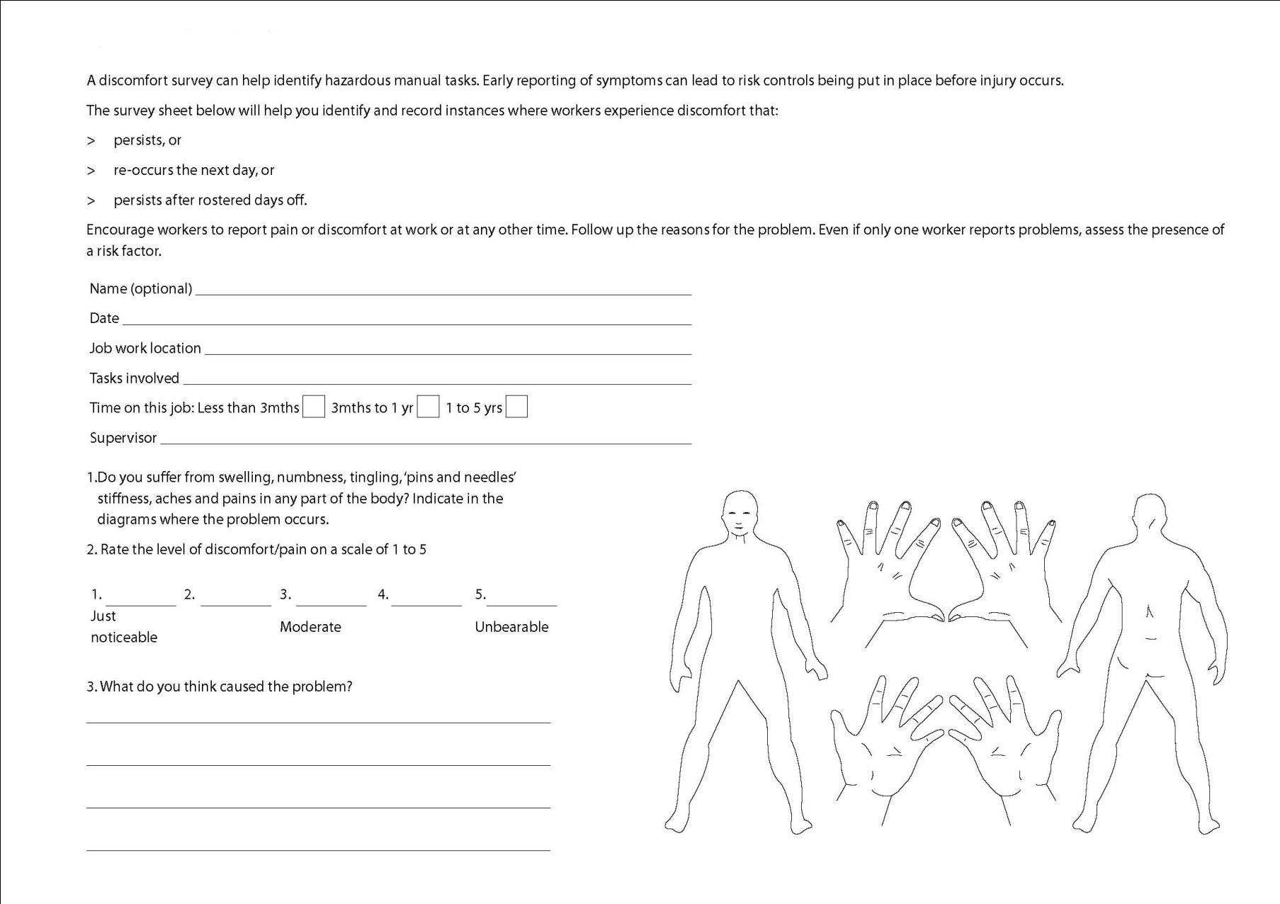

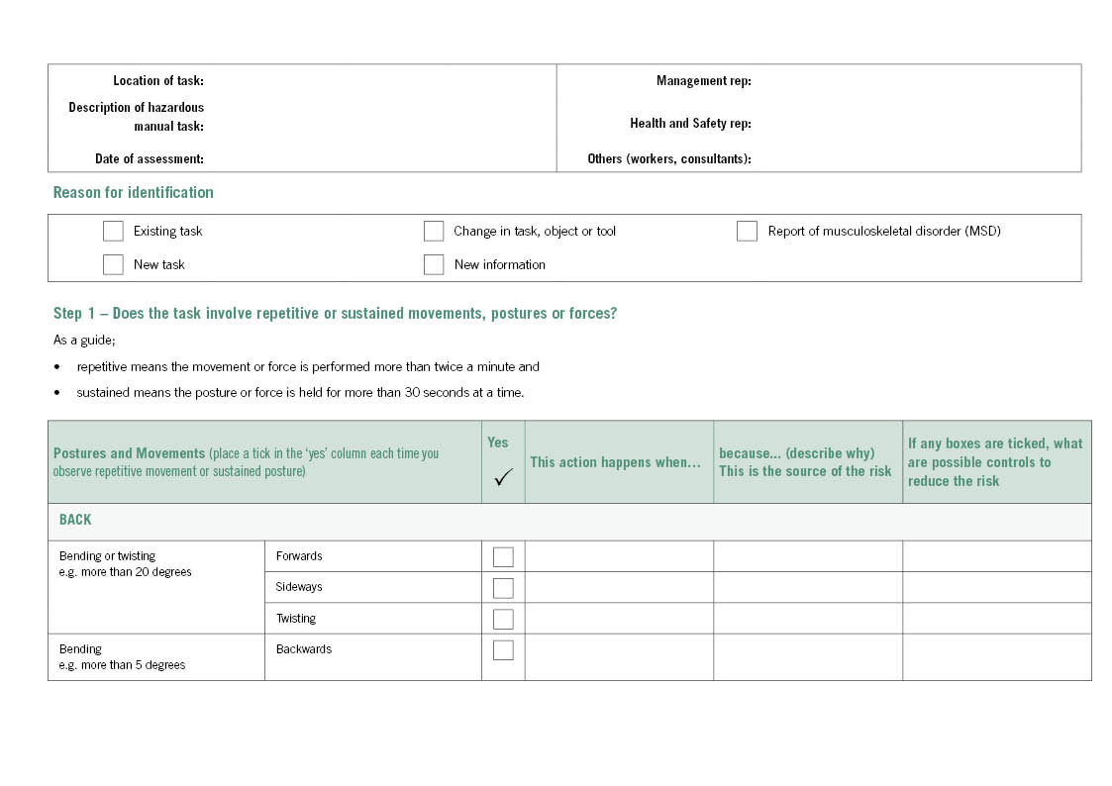
APPENDIX D – RISK Assessment WoRKSHEET
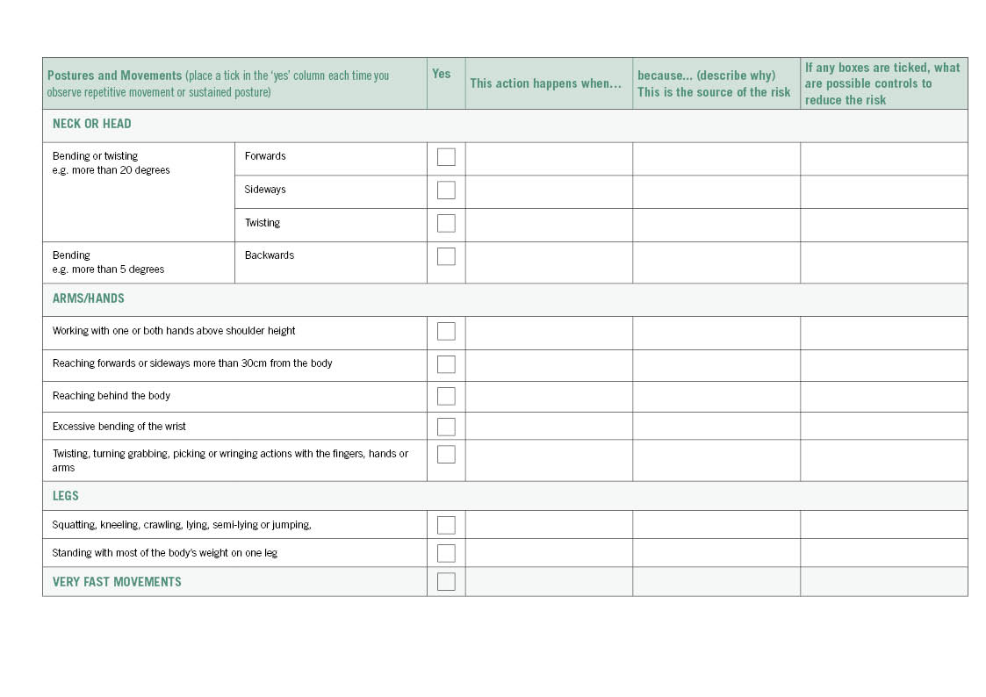

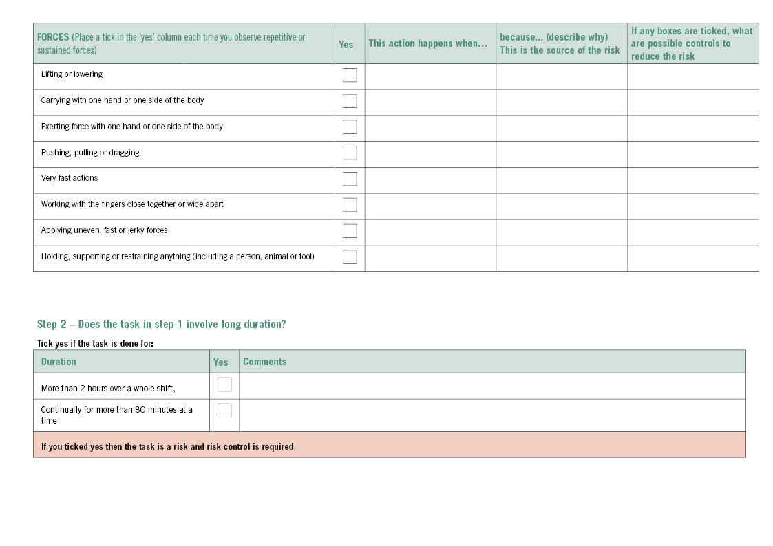
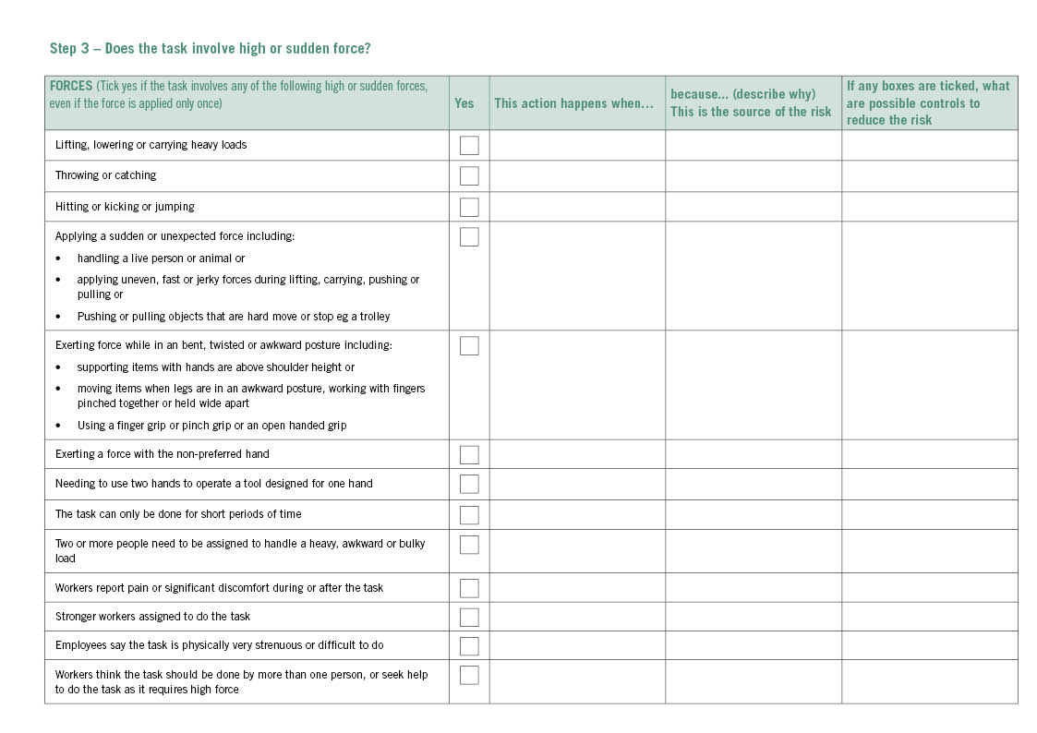
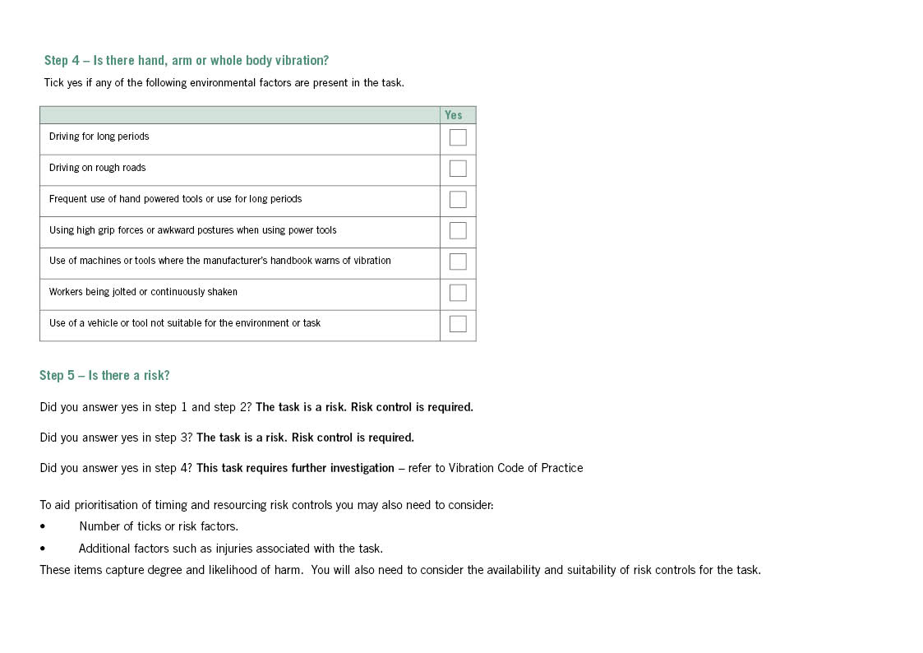
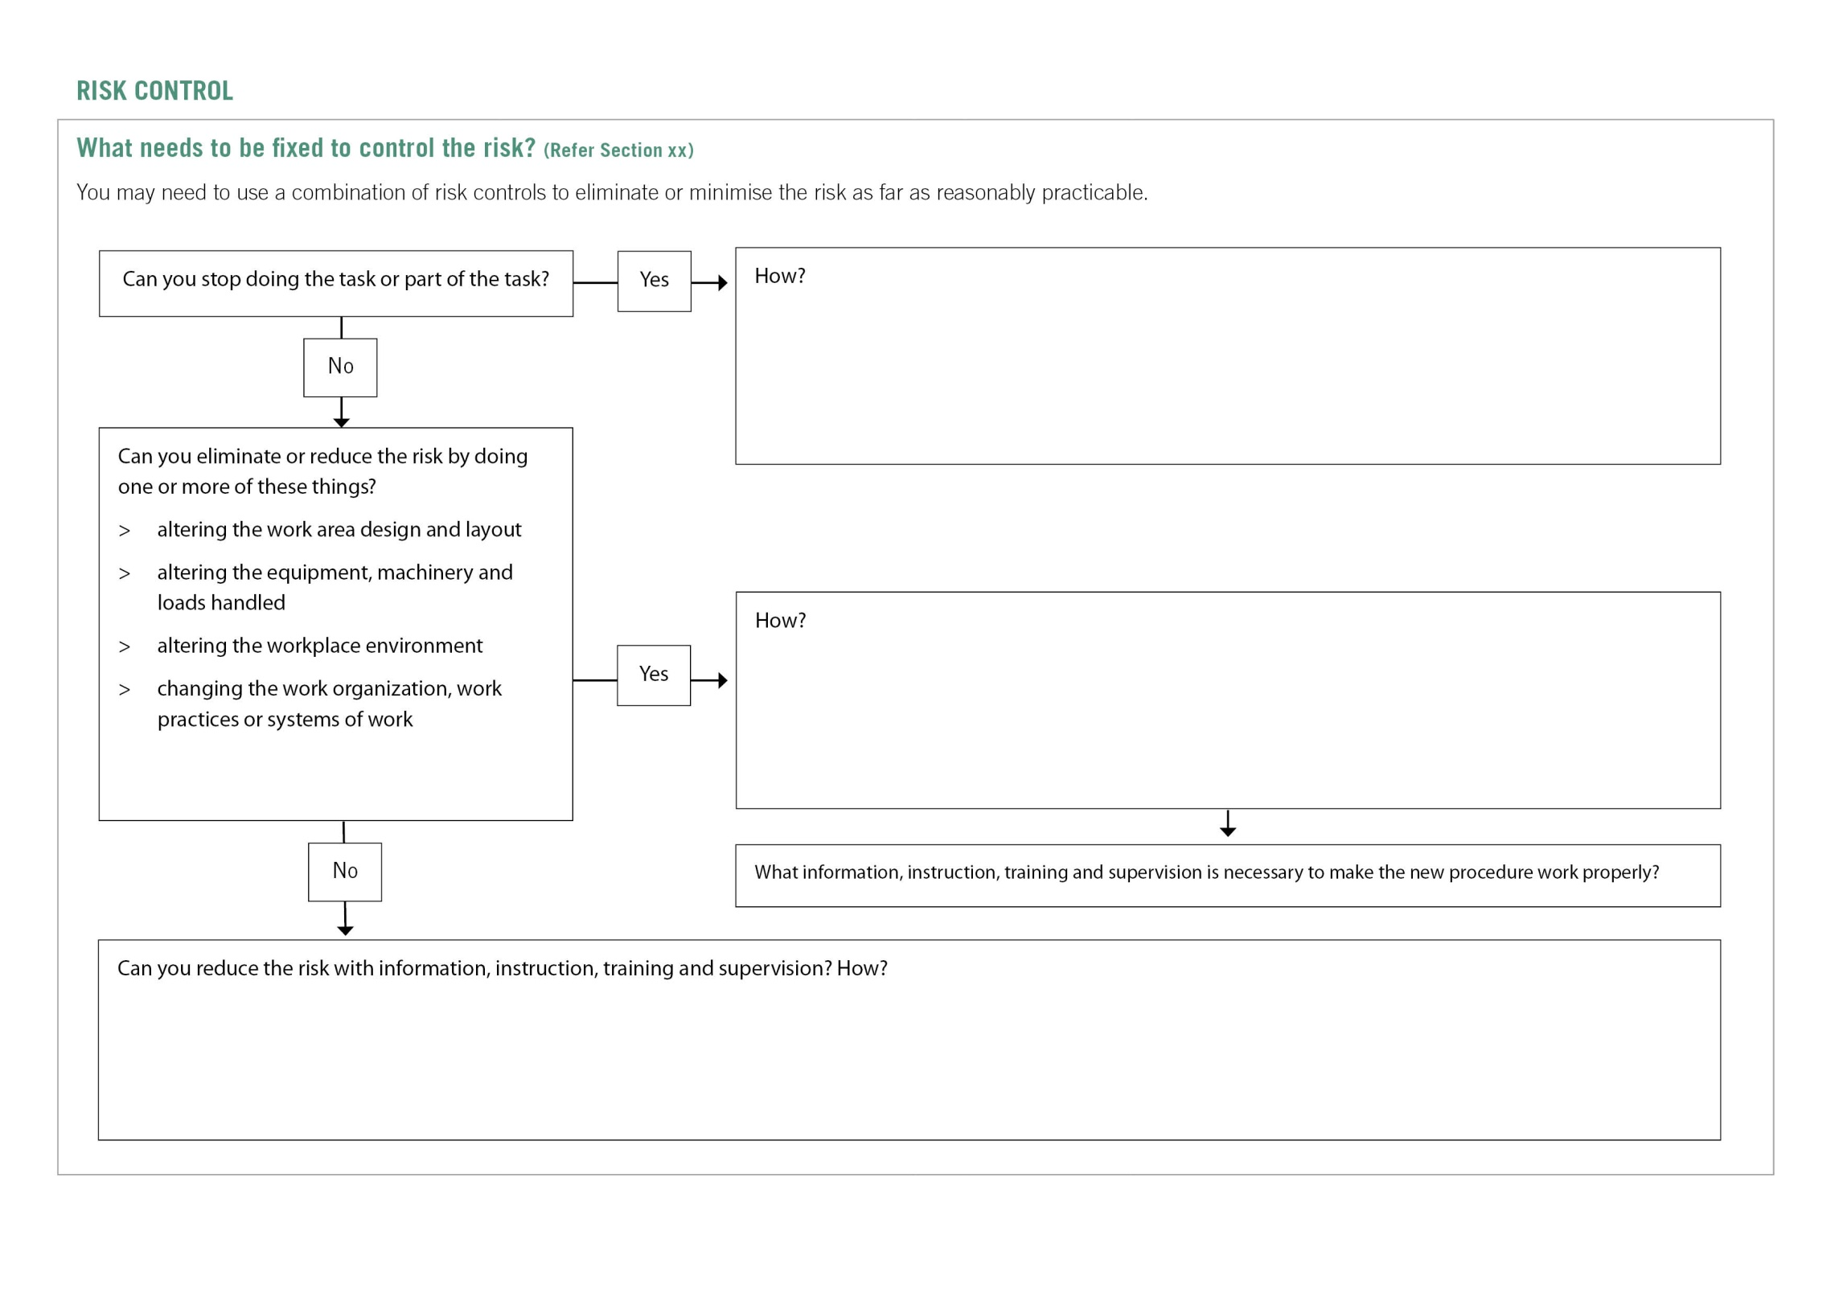

Appendix e – Controlling MSD risks through design
Type of plant | MSD risk | Possible design solution
Road-making machinery | Repetitive or sustained twisting of the neck and body while reversing. This is caused by the seat being fixed in a forward-facing position. | Design a swivel seat-mount together with two sets of controls, or controls that move with seat rotation.
Forklifts | Sustained exposure to whole-body vibration transferred through the seat.  Repetitive or sustained bending of the neck and back to see the work properly (for example, continually looking up to place loads on high shelves). | Install damping mechanisms in the seat, cabin and vehicle suspension.  Install visual aids such as mirrors or a video camera and screen.
Wrapping machines on process lines | Strain on the lower back when handling heavy rolls of plastic wrapping in awkward and twisted postures, often above shoulder height. This is caused by inappropriate design and positioning of the roll spindle and by restricted access. | Design the spindle to be adjustable. This allows the rolls to be loaded at a suitable height and orientation, and eliminates the need to lift them.  Design equipment to help worker load rolls.  Locate the spindle in an accessible place on the plant.  Provide information about how to install the plant in a way that allows adequate access.
Power drills | Prolonged use of the forearm muscles and wrist caused by a heavy or poorly balanced drill.  Exposure to vibration or impact shock recoil from hammer drills.  Excessive force needed to grip and control the tool to counter the effect of vibration and impact shocks. | Design drills to be as light as possible.  Design drills with the handle under the drill’s centre of gravity.  Design plant to reduce shock and vibration.  Provide a suitable way of holding the tool with both hands.
Pliers | Pressure to the palm of the hand caused by handles that are too short.  Prolonged use of the forearm muscles and compression of the wrist caused by using pliers with straight handles. | Design pliers with handles that extend beyond the palm.  Design pliers with bent handles so that the user can maintain a straight wrist.
Crimping, clamping and cutting tools | Excessive force with outstretched fingers required to grip handles that are too wide apart. | Design handles with a grip span of 10 cm or less.
Chainsaws | Excessive vibration.  High force required to handle the chainsaw. | Design to reduce vibration.  Design the chainsaw to be as light as possible, and provide well-placed handles.
Chairs | Poorly designed chairs that cannot be adjusted provide little back support and cause workers to adopt poor postures and movements. | Follow existing design guidelines for chairs, and consider how the chair will be used in the workplace.
Work-benches, workstations and other work surfaces | Workstations that cannot be adjusted result in unnecessary reaching, bending and exertion of force. | Design workstations to be adjustable.  Alternatively, dimensions should suit as many workers as possible.

Appendix F – references for further risk assessment methods
Method | More information
University of Michigan 3 Dimensional Static Strength Prediction Program Computer Software OR University of Michigan 2 Dimensional Static Strength Prediction Computer Software | www.umich.edu
1991 NIOSH Lifting Equation (National Institute of Occupational Safety and Health – USA) | USA National Institute of Occupational Safety and Health  http://www.cdc.gov/niosh/docs/94-110/pdfs/94-110.pdf  http://www.cdc.gov/niosh/docs/94-110/pdfs/94-110.pdf
Snook and Ciriello’s Tables of Maximum Acceptable Weights and Forces | Snook and Ciriello, “The design of manual handling tasks: revised tables of maximum acceptable weights and forces”, in Ergonomics, 1991, vol. 34, no. 9, pp. 1197-1213.
Rapid Entire Body Assessment (REBA) | Hignett, S and McAtamney, L., Applied Ergonomics, 2000, vol. 31, pp. 201-205
Posture, Activity, Tools, Handling (PATH) | PATH : A work sampling-based approach to ergonomic job analysis for construction and other non-repetitive work. Applied Ergonomics 1996, vol. 27, no. 3, pp. 177-187
Manual Tasks Risk Assessment Tool (ManTRA) V2.0 | Burgess-Limerick, L., Straker, L., Pollock, C., Egeskov, R. 2004. Manual Risk Assessment Tool (ManTRA) V2.0. School of Human Movement Studies, The University of Queensland, Australia.  http://ergonomics.uq.edu.au/download/mantra2.pdf
PErforM | Burgess-Limerick, R. (2004): PErforM and ManTRA. Ergonomics Australia, 18(4), 10-13.
OCRA Index and Checklist | Colombini, D., Occhipinti, E., & Grieco, A. (2002). Risk assessment and management of repetitive movements and exertions of upper limbs : job analysis, OCRA risk indices, prevention strategies and design principles. Oxford: Elsevier.
The Work Organisation Assessment Questionnaire (WOAQ) | EEF (2004). Work Organisation Assessment Questionnaire: A tool for the risk management of stress. London: EEF.
MSD risk assessment questionnaire | Wendy Macdonald, Owen Evans and Ross Armstrong, 2007, Centre for Ergonomics & Human Factors, Faculty of Health Sciences, La Trobe University. Research on the Prevention of Work-Related Musculoskeletal Disorders – Stage 2  A study of a small sample of workplaces in high risk industries. Department of Employment and Workplace Relations. OHS EXPERT RESEARCH PANEL. Project No. CIR 1001439-07

The adjustment factor for extended work shifts shown in Table 3 of this Code is taken into account.
Guidance for designers of buildings on recommended background sound levels (i.e. noise coming from outside the room or from building services) for different types of workplaces can be found in AS/NZS 2107:2000 Acoustics – Recommended design sound levels and reverberation times for building interiors.
Morata T.C. (2007) Promoting hearing health and the combined risk of noise-induced hearing loss and ototoxicity, Audiological Medicine, Vol.5, Issue 1, pp33-40.
Based on Health and Safety Executive UK guidance material with the points used in the tables derived from procedures in AS/NZS1269.1
Source Health and Safety Executive UK

