Private Health Insurance (Incentives) Rules 2012

I, RICHARD MAGOR, delegate of the Minister for Health, make these Rules under item 1 of the table in section 333-20 of the Private Health Insurance Act 2007.
Dated 17 May 2012

____________________________________

Richard Magor

Assistant Secretary

Private Health Insurance Branch

Medical Benefits Division
Department of Health and Ageing

Contents

Part 1 Preliminary 3
1. Name of Rules 3
2. Commencement 3
3. Revocation 3
4. Definitions 3

Part 2 Premiums reduction scheme 4
5. Application 4
6. Registration as a participant 4
7. Entitlement to incentive payment 4
8. Conditions of participation 4
9. Requirments for statements to participants 5
10. Rebate logo 6

Part 1 Preliminary

1. Name of Rules
These Rules are the Private Health Insurance (Incentives) Rules 2012.

2. Commencement
These Rules commence on the day after registration.

3. Revocation
These Rules revoke and replace the Private Health Insurance (Incentives) Rules 2007.

4. Definitions
Note: Terms used in these Rules have the same meaning as in the Act―see section 13 of the Legislative Instruments Act 2003. These terms include:
complying health insurance policy
incentive payments scheme
participant
participating insurer
premiums reduction scheme
private health insurer
standard information statement
In these rules:
30% Rebate logo means the logo that insurers were required to use under the Private Health Insurance (Incentives) Rules 2007.
Act means the Private Health Insurance Act 2007.
Australian Government Rebate on private health insurance means:
    - the incentive payments scheme; or
(b) the premiums reduction scheme; or
(c) the private health insurance tax offset.
eligible person has the same meaning as in subsection 3 (1) of the Health Insurance Act 1973 and includes a person who is treated as an eligible person under sections 6, 6A or 7 of that Act.
private health insurance tax offset means a tax offset, under the Income Tax Assessment Act 1997, for a premium, or in respect of a premium, paid under a complying health insurance policy.
Rebate logo means the logo described in rule 10.

Part 2 Premiums reduction scheme

5. Application
This Part applies in relation to financial years beginning on or after 1 July 2007.

6. Registration as a participant
For the purposes of paragraph 23-15 (1) (c) of the Act, the requirements for a person applying to a private health insurer to become a participant in the premiums reduction scheme are:
    - the person is an individual; and
    - the person is applying in respect of a complying health insurance policy under which each person covered by the policy is an eligible person.

Note: Division 23 provides for reductions in premiums paid by a person to an insurer. The insurer may claim reimbursement of such reductions under Division 279.

7. Entitlement to incentive payment
For the purposes of paragraph 26-1 (1) (c) of the Act, the requirements for a person to be entitled to a payment are:
    - the person is an individual; and
    - the person is applying in respect of a complying health insurance policy under which each person covered by the policy is an eligible person.

Note: Division 26 provides for a payment to the person if the person's premium has not been reduced under Division 23.

8. Conditions of participation
          - For the purposes of paragraph 206-1 (1) (b) of the Act, the following conditions are specified as conditions of participation in the premiums reduction scheme:
    - on or before 15 July of each year after the commencement of the Act, the participating insurer must issue to each person who was a participant in respect of a complying health insurance policy on issue from the insurer during any time in the previous financial year, a written statement in accordance with rule 9, setting out:
      - the amount of the premium paid for the policy during that financial year; and
      - the amount of the reduction, under the premiums reduction scheme, for the premium; and
    - before the participating insurer increases the amount of the premium, the insurer must issue to each participant affected by the increase written notice of:

      - the amount of the premium; and
      - the increase in the amount of the premium; and
      - the date when the increase takes effect; and
      - the fact that the dollar value of the reduction under the Australian Government Rebate on private health insurance has increased; and
      - the new amount of the reduction; and
      - the new amount of the premium; and
    - the insurer must use the phrase “Australian Government Rebate on private health insurance” or the Rebate logo in:
      - advertisements for the Australian Government Rebate on private health insurance; and
      - annual statements under paragraph (a); and
      - written notices under paragraph (b); and
      - forms that are given in relation to the premiums reduction scheme; and
      - correspondence relating to the premiums reduction scheme.
    - notwithstanding paragraph (c), for any items listed under subparagraphs (i) to (v), an insurer may use any material containing the phrase ‘Federal Government 30% Rebate’ or the 30% Rebate logo until one year after the date of commencement of these Rules.

Note: Rule 1 sets out the details of the Rebate logo.

9. Requirements for statements to participants
          - A statement under paragraph 8 (1) (a) must not include, be included with or accompany:
    - information, other than information permitted under subrule 9 (2); or
    - a written notice of increase of premium under paragraph 8 (1) (b).
          - For paragraph 1 (a), information which is permitted to be included in a statement under paragraph 8 (1) (a) is all or any of the following:
    - information that relates directly to the Australian Government Rebate on private health insurance;
    - information provided in accordance with rule 6 of the Private Health Insurance (Lifetime Health Cover) Rules 2007;
    - information about the medicare levy surcharge imposed under the Medicare Levy Act 1986 or the A New Tax System (Medicare Levy Surcharge — Fringe Benefits) Act 1999;
    - a standard information statement;
    - information that the Department:
      - has provided to a participating insurer; and
      - has identified as being available to be included with, or to accompany, a statement under paragraph 8 (1) (a);
    - information required to be provided by the Act or any of the Rules made under the Act.

10. Rebate logo
          - The logo for the Australian Government Rebate on private health insurance is:

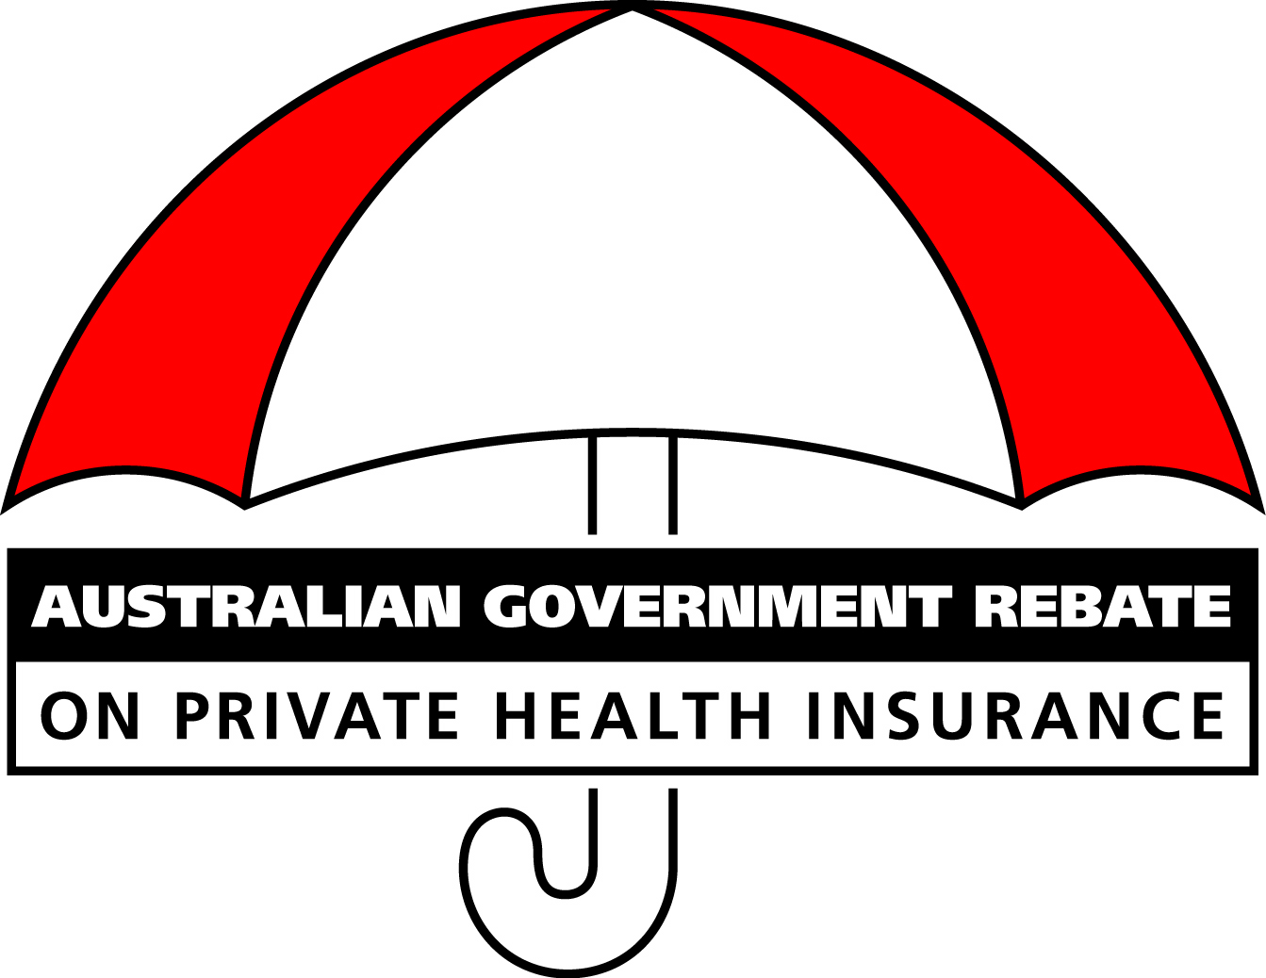
          - In any reproduction of the logo:
    - the portions other than the shaded areas of the umbrella must be black and white, as shown in subrule ; and
    - the shaded areas of the umbrella must be:
      - in the case of monochrome reproduction — 60% black; and in any other case — red (PMS 032).

Note
- All legislative instruments and compilations are registered on the Federal Register of Legislative Instruments kept under the Legislative Instruments Act 2003. See www.frli.gov.au

