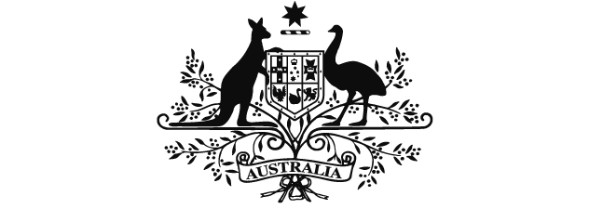
TERRORISM INSURANCE ACT 2003
Minister to Australian Reinsurance Pool Corporation (Payments to the Commonwealth) Direction
2012
I, BILL SHORTEN, Minister for Financial Services & Superannuation, give this written direction to the Australian Reinsurance Pool Corporation under s.38 of the Terrorism Insurance Act 2003.

Dated 21 / 6 /2012

BILL SHORTEN
Minister for Financial Services & Superannuation

1. Name of Direction
Minister to Australian Reinsurance Pool Corporation (Payments to the Commonwealth) Direction 2012.
2. Commencement
This Direction commences when it is made.
3. Payments to be made
The following payments are to be made by the Australian Reinsurance Pool Corporation to the Commonwealth:
a one-off payment of $100 million to be made in January 2013;
a payment of $75 million to be made in January 2013;
a payment of $75 million to be made in January 2014;
a payment of $75 million to be made in January 2015; and
a payment of $75 million to be made in January 2016.
The payments are to be made to:
Department of Treasury Official Administered Receipts Account
BSB: 009
Account Number: 918 379

