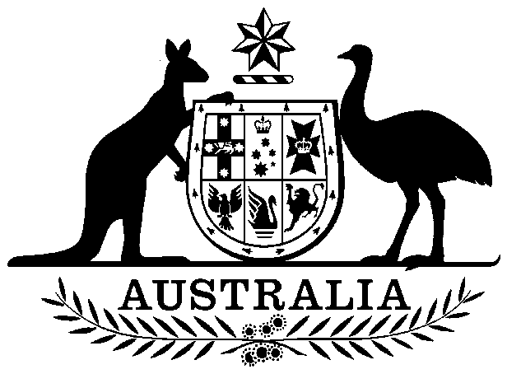
COMMONWEALTH OF AUSTRALIA

Environment Protection and Biodiversity Conservation Act 1999

Amendment of List of Exempt Native Specimens

I, GEOFF RICHARDSON, Assistant Secretary, Marine Biodiversity and Biosecurity Branch, as Delegate of the Minister for Sustainability, Environment, Water, Population and Communities, pursuant to subsection 303DC(1) of the Environment Protection and Biodiversity Conservation Act 1999 (EPBC Act), hereby amend the list of exempt native specimens established under section 303DB of the EPBC Act by revoking the conditions to which the inclusion of the following item in the list on 1 December 2004 is subject:

- Specimens that are or are derived from fish or invertebrates, other than specimens that belong to species listed under Part 13 of the Act, taken in the Western Deepwater Trawl Fishery and North West Slope Trawl Fishery.

and imposing the following conditions to which inclusion of the specimens in the list is subject:

- the specimen, or the fish or invertebrate from which it is derived, was taken lawfully

- the specimens are included in the list until 12 December 2012

- the Australian Fisheries Management Authority to inform the Department of Sustainability, Environment, Water, Population and Communities of any intended amendments to the management arrangements that may affect the assessment against the criteria on which EPBC Act decisions are based, and

- the Australian Fisheries Management Authority to ensure that management arrangements in the Western Deepwater Trawl Fishery are complementary to the Australian Fisheries Management Authority’s School Shark Stock Rebuilding Strategy 2008.

Dated this 28th day of September 2012

…………………Geoff Richardson…………………
Delegate of the Minister for Sustainability, Environment, Water, Population and Communities

