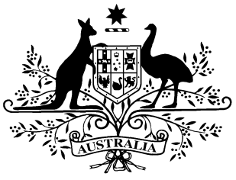

PB 102 of 2012

**National Health (Remote Aboriginal Health Services Program) Special Arrangements Amendment Instrument 2012 (No. 3)**[1]

*National Health Act 1953*

I, KIM BESSELL, Assistant Secretary, Pharmaceutical Access Branch, Pharmaceutical Benefits Division, Department of Health and Ageing, delegate of the Minister for Health, make this Amendment Instrument under subsections 100(1) and 100(2) of the *National Health Act 1953*.

Dated 05 November 2012

**KIM BESSELL**

Assistant Secretary

Pharmaceutical Access Branch

Principal Pharmacy Advisor

Pharmaceutical Benefits Division

1 Name of Instrument

(1) This Instrument is the *National Health (Remote Aboriginal Health Services Program) Special Arrangements Amendment Instrument 2012 (No. 3).*

(2) This Instrument may also be cited as PB 102 of 2012.

2 Commencement

This Instrument commences upon registration.

3 Amendment of the *National Health (Remote Aboriginal Health Services Program) Special Arrangements Instrument 2010* (PB 65 of 2010)

Schedule 1 amends the *National Health (Remote Aboriginal Health Services Program) Special Arrangements Instrument 2010* (PB 65 of 2010).

Schedule 1 Amendments

[1] After subparagraph 4. e) (iii)

Insert (as a heading):

5. Scope

[2] Section 8, Claims system

After:

and will provide this information to MA as the basis for reimbursement.

Insert (as a heading):

9. Remuneration

1. **Note** All legislative instruments and compilations are registered on the Federal Register of Legislative Instruments kept under the *Legislative Instruments Act 2003.* See <http://www.frli.gov.au>