COMMONWEALTH OF AUSTRALIA

COMPETITION AND CONSUMER ACT 2010

Consumer Protection Notice No. 5 of 2012

IMPOSITION OF PERMANENT BAN ON SMALL, HIGH POWERED MAGNETS

I, DAVID BRADBURY, Assistant Treasurer:

pursuant to section 114(1) of the Australian Consumer Law, IMPOSE a permanent ban on consumer goods of a kind specified below. This permanent ban comes into force on the day after this Notice is registered on the Federal Register of Legislative Instruments.

Particulars of Consumer Goods

Separable or loose magnetic objects that are supplied in multiples of two or more where:
a. at least two of those magnetic objects are each separately able to fit entirely, in any orientation, into the small parts cylinder as provided by clause 5.2 and figure 15 of the Australian / New Zealand Standard, Safety of toys – Part 1: Safety aspects related to mechanical and physical properties (AS/NZS ISO 8124.1:2010) and
b. at least two of those magnetic objects each separately have a magnetic flux index greater than 50 (kG)² mm², determined as per clause 5.31 of AS/NZS 8124.1:2010 and
c. the magnetic objects are marketed by the supplier as, or supplied for use as,
i. a toy, game or puzzle (including but not limited to an adult desk toy, an educational toy or game, a toy, game or puzzle for mental stimulation or stress relief); or
ii. a construction or modelling kit; or
iii. jewellery to be worn in or around the mouth or nose.

Interpretation

Construction or modelling kit
This ban is subject to the definition of consumer goods provided in section 2 of the Australian Consumer Law. This means that a construction or modelling kit containing small high powered magnets which is not used, or likely to be used, for personal, domestic or household use will not be subject to this permanent ban.

Magnetic flux index
50 (kG)² mm² is equivalent to 0.5 T²m². This measure is determined as per clause 5.31 of AS/NZS 8124.1:2010. In clause 5.31.3, omit “kG²mm²” and replace with (kG)² mm².

Small parts cylinder
The small parts cylinder is a test apparatus taken from the Australian, International and other national toy standards (for example the Australian / New Zealand Standard, Safety of toys – Part 1: Safety aspects related to mechanical and physical properties (AS/NZS ISO 8124.1:2010)) designed to identify parts which are small enough to pose an ingestion or inhalation hazard for children under 3 years of age.

Dimensions in the figure below are in mm.

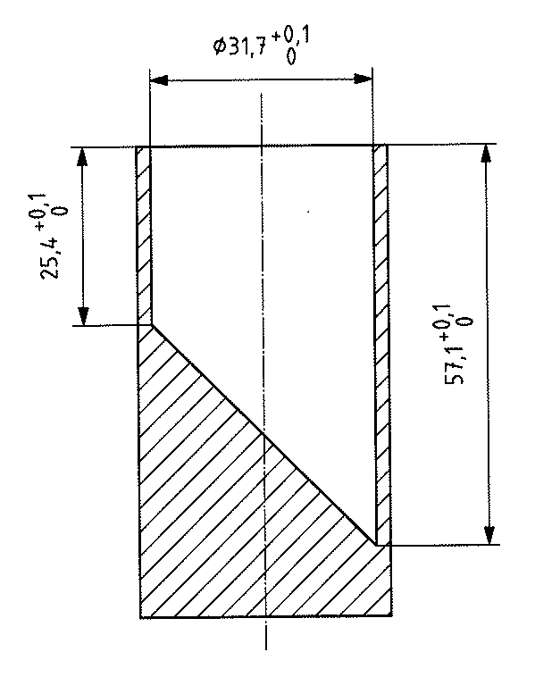
Small parts test
Place the test object, without compressing it and in any orientation, into the cylinder. If the object fits entirely within the cylinder, it fails the test.

Note: Goods subject to this Notice and which fail to comply may be subject to compulsory recall.

Dated this 9 day of November 2012

DAVID BRADBURY
Assistant Treasurer

