

**Food Standards (Application A1068 – Hydrogen Peroxide as a Processing Aid) Variation**

The Board of Food Standards Australia New Zealand gives notice of the making of this variation under section 92 of the *Food Standards Australia New Zealand Act 1991*. The Standard commences on the date specified in clause 3 of this variation.

Dated 23 November 2012

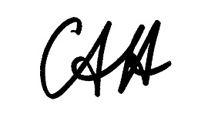

Standards Management Officer

Delegate of the Board of Food Standards Australia New Zealand

**1 Name**

This instrument is the *Food Standards (Application A1068 – Hydrogen Peroxide as a Processing Aid) Variation*.

**2 Variation to Standards in the *Australia New Zealand Food Standards Code***

The Schedule varies the Standards in the *Australia New Zealand Food Standards Code*.

**3 Commencement**

This variation commences on 29 November 2012.

**SCHEDULE**

**[1] Standard 1.3.3** is varied by inserting in columns 2 (Function) and 3 (Maximum permitted level) of the Table to clause 14, for the processing aid Hydrogen peroxide

“

|  |  |  |
| --- | --- | --- |
|  | Control of lactic acid producing microorganisms to stabilise the pH during the manufacture of –  (a) fermented milk;  (b) fermented milk products;  (c) cheese made using lactic acid producing microorganisms; and  (d) cheese products made using lactic acid producing microorganisms. | 5 |

”