

Radiocommunications Spectrum Marketing Plan (2.5 GHz Band) 2012

*Radiocommunications Act 1992*

The AUSTRALIAN COMMUNICATIONS AND MEDIA AUTHORITY makes this Marketing Plan under section 39A of the *Radiocommunications Act 1992*.

Dated *19th December* 2012

*Chris Chapman*   
[signed]  
 Member

*Richard Bean*   
[signed]   
Member/~~General Manager~~

Australian Communications and Media Authority

Contents

Part 1 Introduction 4

1.1 Name of Plan 4

1.2 Commencement 4

1.3 Purpose of this Plan 4

1.4 Definitions 4

Part 2 Allocation of spectrum licences 7

2.1 Purpose of this Part 7

2.2 Parts of the spectrum 7

2.3 How licences will be allocated 7

2.4 The auction 7

2.5 Advertising the auction 9

2.6 Taking part in the auction 9

Part 3 Spectrum licences to be issued 10

3.1 Purpose of this Part 10

3.2 Issue of Licences 10

3.3 Duration of licences 10

3.4 Commencement of licences 11

3.5 Core licence conditions 11

3.6 Determining core licence conditions 12

3.7 Other licence conditions 12

3.8 Registration of transmitters 13

3.9 Draft sample licence 13

3.10 Compatibility requirements 13

Part 4 After allocation 14

4.1 Purpose of this Part 14

4.2 Registration of licences 14

4.3 Third party use 14

4.4 Trading in licences 14

4.5 Trading Rules 14

4.6 Agreements about emission limits 14

4.7 Spectrum licences that are about to expire 15

4.8 Re‑issue of licences 15

Schedule 1 Category 16

Schedule 2 Products 17

Schedule 3 Regions 18

1 Metro ACT region 19

2 Metro Adelaide region 21

3 Metro Brisbane Region 22

4 Metro Darwin region 24

5 Metro Hobart region 25

6 Metro Melbourne region 27

7 Metro Perth Region 29

8 Metro Sydney region 31

9 Regional East Australia Region 33

10 Regional Western Australia region 37

11 Remote Australia Region 39

Schedule 4 Emission limits outside the area 41

Schedule 5 Emission limits outside the band 43

Schedule 6 Sample spectrum licence 47

Part 1 Introduction

1.1 Name of Plan

This Plan is the *Radiocommunications Spectrum Marketing Plan (2.5 GHz Band) 2012.*

1.2 Commencement

This Plan commences on the day after it is registered.

*Note* All legislative instruments and compilations are registered on the Federal Register of Legislative Instruments kept under the *Legislative Instruments Act 2003*. See http://www.frli.gov.au.

1.3 Purpose of this Plan

This Plan describes:

(a) the procedures and timetable for issuing spectrum licences in the 2.5 GHz band;

(b) the spectrum licences that will be allocated by the ACMA in accordance with this Plan;

(c) some of the matters a licensee must take into account when operating devices under a spectrum licence allocated in accordance with this Plan; and

(d) other matters which a person should take into account when deciding whether to apply for a spectrum licence under the allocation determination.

1.4 Definitions

(1) In this Plan:

***2*.*5 GHz band*** means the following spectrum, in the geographic areas specified in the re‑allocation declaration:

(a) 2500 MHz to 2570 MHz (***the 2*.*5 GHz lower band***); and

(b) 2620 MHz to 2690 MHz (***the 2*.*5 GHz upper band***).

***Act*** means the *Radiocommunications Act 1992*.

***advisory guidelines*** means the following documents made by the ACMA under section 262 of the Act, as in force from time to time:

(a) *Radiocommunications Advisory Guidelines (Managing Interference from Transmitters — 2*.*5 GHz Band) 2012*; and

(b) *Radiocommunications Advisory Guidelines (Managing Interference to Receivers — 2*.*5 GHz Band) 2012*.

***allocation determination*** means the *Radiocommunications (Spectrum Licence Allocation  — Combinatorial Clock Auction) Determination 2012*.

***allocation stage*** has the meaning given by paragraph 2.4(7)(a).

***applicant*** has the meaning given by subsection 1.4(1) of the allocation determination.

***applicant information package*** has the meaning given by subsection 1.4(1) of the allocation determination.

***assignment stage*** has the meaning given by paragraph 2.4(7)(b).

***auction*** has the meaning given by subsection 2.3(1).

***Australian spectrum map grid (ASMG)*** means the Australian Spectrum Map Grid 2012.

***category*** has the meaning given by subsection 2.4(1).

***harmful interference*** means interference that:

(a) endangers the functioning of a radio‑navigation service or other safety services; or

(b) seriously degrades, obstructs, or repeatedly interrupts a radiocommunications service.

***HCIS identifier*** means an identifier used to describe a geographic area in the HCIS.

***hierarchical cell identifier scheme (HCIS)*** means the cell grouping hierarchy scheme used to describe geographic areas in the Australian spectrum map grid (ASMG).

***horizontally radiated power,*** for a radiocommunications device, means the sum of:

(a) the maximum true mean power, in dBm per specified rectangular bandwidth at the antenna connector that is located within the frequency band of the licence authorising the operation of the radiocommunications device; and

(b) the antenna gain relative to an isotropic antenna in a specified direction in the horizontal plane containing the phase centre of the antenna used with the device, in dBi.

***in‑band*** means:

(a) for a radiocommunications transmitter or radiocommunications receiver operated under a spectrum licence, the frequencies within the frequency band to which the licence relates; and

(b) for a radiocommunications transmitter or radiocommunications receiver operating under an apparatus licence, the frequencies within the lower frequency limit and the upper frequency limit of that licence.

***licence schedule*** means a schedule to the sample spectrum licence.

***lot*** has the meaning given by subsection 2.4(3).

***lot rating***,for a lot, has the meaning given by subsection 1.4(1) of the allocation determination.

***maximum true mean power*** means the true mean power measured in a specified rectangular bandwidth that is located within a specified frequency band such that the true mean power is the maximum of true mean powers produced.

*Note*   The power within the specified rectangular bandwidth is normally established by taking measurements using either an adjacent channel power meter or a spectrum analyser. Estimation of the accuracy of the measuring equipment, measurement procedure and any adjustments made to measurements to take account of practical filter shape factors should be in accordance with good engineering practice.

***mean power*** means the average power measured during an interval of time that is at least 10 times the period of the lowest modulation frequency.

***peak power*** means the average power measured within a specified bandwidth during 1 radio frequency cycle at the crest of the signal envelope.

***product***has the meaning given by subsection 2.4(2).

***re‑allocation*** means the re‑allocation of spectrum by the issue of spectrum licences in accordance with the re‑allocation declaration.

***re‑allocation declaration*** means the *Radiocommunications (Spectrum Re‑allocation) Declaration No. 2 of 2011* made by the Minister under section 153B of the Act in relation to the spectrum in the 2.5 GHz band on 1 November 2011.

***region*** has the meaning given by Schedule 3.

***sample spectrum licence*** has the meaning given by section 3.9.

***spurious emission*** means emissions that are not:

(a) modulation products; or

(b) wide band noise; or

(c) emissions caused by switching transients.

***true mean power*** means:

(a) if an unmodulated carrier is present — the mean power measured while the unmodulated carrier is present; and

(b) if an unmodulated carrier is not present — the mean power measured while transmitted information is present.

*Note*   Terms and expressions used in this Plan have the meanings given by section 5 of the Act. For example:

* core condition
* frequency band
* Register
* spectrum licence.

(2)In this Plan, the range of numbers that identifies a frequency band or frequency range includes the higher, but not the lower, number.

Part 2 Allocation of spectrum licences

2.1 Purpose of this Part

This Part describes the procedures and timetable for allocating spectrum licences that authorise the operation of radiocommunications devices in the 2.5 GHz band.

2.2 Parts of the spectrum

(1) The ACMA will allocate and issue spectrum licences for spectrum in the 2.5 GHz band in the manner described in this Plan and the allocation determination.

(2) This Plan will have no effect if the re‑allocation declaration is revoked in accordance with the Act.

(3) No part of the spectrum in the 2.5 GHz band is reserved for public or community services.

2.3 How licences will be allocated

(1) Initially, spectrum licences for spectrum in the 2.5 GHz band will be allocated by combinatorial clock auction in accordance with the procedures set out in the allocation determination (***auction***).

*Note*   Neither the ACMA nor the Commonwealth accepts any liability for any loss or damage suffered by any person participating in the auction. Any person intending to participate in the auction should obtain their own legal, technical and financial advice before applying.

(2) The ACMA may make further allocations of spectrum in the 2.5 GHz band by any means, and in any configuration, in accordance with section 7.1 of the allocation determination.

*Note*   Section 7.1 of the allocation determination states that the ACMA may later allocate spectrum licences by a procedure to be determined by the ACMA. This may apply if any spectrum is not part of a spectrum licence allocated by the auction.

2.4 The auction

(1) There is one ***category*** for the 2.5 GHz band. The category is characterised by:

(a) the frequencies set out in columns 3 and 4 of Schedule 1; and

(b) the bandwidth described in column 5 of Schedule 1.

(2) The ACMA has divided up the 2.5 GHz band into the ***products*** described in Schedule 2. Each product is characterised by:

(a) the region for the product, specified in an item of column 3 of Schedule 2; and

(b) the category to which the product belongs, set out in an item of column 2 of Schedule 2.

(3) The number of units of each product that will be available at the auction is set out in column 4 of Schedule 2. A unit of a product is referred to in this Plan as a ‘***lot***’. The size of each lot in each product is 2 x 5 MHz, being 5 MHz in the 2.5 GHz lower band paired with 5 MHz in the 2.5 GHz upper band.

(4) The ACMA will notify applicants of the lot rating for each lot set under subsection 4.6(4) of the allocation determination. All lots of the same product must have the same lot rating.

(5) The lot rating will be used as the basis for calculating the amount of an applicant’s eligibility payment or deed of financial security. Details of this are in section 4.14(2) of the allocation determination.

(6) The auction will be held in accordance with the procedures set out in the allocation determination. All lots of each product will be available for allocation at the auction.

*Note*   The allocation determination sets out the procedures for allocating spectrum licences by a combinatorial clock auction.

(7) The auction will be carried out in two stages:

(a) the ***allocation stage***, which determines the number and type of lots allocated to, and the allocation price to be paid by, each winning bidder in accordance with the allocation determination; and

(b) the ***assignment stage***, which determines the frequencies that will apply to each lot of each product allocated to each winning bidder and any additional price that must be paid in accordance with the allocation determination.

*Note*   The allocation determination sets out the detailed rules and procedures for each stage of the auction.

(8) Subject to subsection (9), the requirements of the Act, any other relevant laws and the allocation determination, the ACMA will issue a spectrum licence to each person allocated a product in the auction. The spectrum licence will be for the number and type of lots allocated to that person during the allocation stage, at the frequencies assigned to that person for those lots during the assignment stage of the auction.

(9) If, as a result of the auction, a person is allocated:

1. a lot in:

(i) the Metro Perth region; or

(ii) the Regional Western Australia region; or

(iii) both the Metro Perth and Regional Western Australia regions; and

1. a lot in a region other than the Metro Perth region and the Regional Western Australia region;

the ACMA will issue spectrum licences to that person in accordance with subsection (10).

(10) If subsection (9) applies, the ACMA will issue to the person one spectrum licence for the number and type of lots allocated to that person in:

(a) the Metro Perth region; or

(b) the Regional Western Australia region; or

(c) both the Metro Perth and Regional Western Australia regions;

during the allocation stage, at the frequencies assigned to that person for those lots during the assignment stage of the auction. The ACMA will issue another spectrum licence for the number and type of lots allocated to that person in all regions other than the Metro Perth region and the Regional Western Australia region during the allocation stage, at the frequencies assigned to that person for those lots during the assignment stage of the auction.

(11) For the purposes of this section, ***Metro Perth region*** and ***Regional Western Australia region*** each have the meaning given by Schedule 3.

2.5 Advertising the auction

(1) The ACMA will publish details of the auction and invite persons to apply to take part in the auction, in accordance with the allocation determination.

2.6 Taking part in the auction

(1) The ACMA will make available an applicant information package that contains more detail about application requirements and the auction process in accordance with the allocation determination. Details of what must be in the applicant information package are in subsection 4.5(1) of the allocation determination.

(2) Details of how to apply to take part in the auction are in Part 4 of the allocation determination.

Part 3 Spectrum licences to be issued

3.1 Purpose of this Part

This Part describes:

(a) the spectrum licences that will be issued in accordance with this Plan;

(b) some of the matters a licensee must take into account when operating devices under a spectrum licence issued in accordance with this Plan;

(c) conditions to be included in spectrum licences issued in accordance with this Plan; and

(d) other matters which a person should take into account when deciding whether to apply for a spectrum licence under this Plan.

3.2 Issue of licences

Subject to the Act, the allocation determination and other relevant law, the ACMA will issue a spectrum licence to the person to which it is allocated as soon as practicable after the person pays to the ACMA the balance of the winning price in accordance with Division 2 of Part 6 of the allocation determination.

3.3 Duration of licences

(1) Subject to subsection (2), a licence issued to a person who has been allocated a product as a result of the auction will be for a period of 15 years starting on the date set out in section 3.4.

*Note* The licences issued as a result of the auction will be for a period of 15 years. However, a spectrum licence that authorises the operation of radiocommunications devices only in:

(a) the Metro Perth region; or

(b) the Regional Western Australia region; or

(c) both the Metro Perth and Regional Western Australia region

as those regions are defined in Schedule 3, will have a duration of less than 15 years. The duration of the licence will be such as to allow the licence to expire at the same time as other licences issued as a result of the auction.

(2) If a licence mentioned in subsection (1) is issued to a person and authorises the operation of radiocommunications devices only in:

(a) the Metro Perth region; or

(b) the Regional Western Australia region; or

(c) both the Metro Perth region and Regional Western Australia region;

the licence will be for a period of 13 years and 8 months starting on the date set out in section 3.4.

(3) For the purposes of this section, ***Metro Perth region*** and ***Regional Western Australia region*** each have the meaning given by Schedule 3.

(4) Where allocation occurs otherwise than as a result of the auction (because of unallocated lots at the auction), the licence will have a commencement date and a duration that will result in it expiring at the same time as licences issued to a person who has been allocated a product as a result of the auction. Accordingly, licences issued to a person who has been allocated a product otherwise than as a result of the auction will be for a period of less than 15 years, starting on a date to be specified by the ACMA.

3.4 Commencement of licences

(1) Subject to subsection (2), a licence issued to a person who has been allocated a product as a result of the auction will come into force on 1 October 2014.

(2) If a licence mentioned in subsection (1) is issued to a person and authorises the operation of radiocommunications devices only in:

(a) the Metro Perth region; or

(b) the Regional Western Australia region; or

(c) both the Metro Perth region and Regional Western Australia region;

the licence will come into force on 1 February 2016.

(3) For the purposes of this section, ***Metro Perth region*** and ***Regional Western Australia region*** each have the meaning given by Schedule 3.

3.5 Core licence conditions

(1) Section 66 of the Act requires spectrum licences to include the following core conditions:

(a) a condition specifying the part or parts of the spectrum in which operation of radiocommunications devices is authorised under the licence;

(b) a condition specifying the maximum permitted level of radio emission, in parts of the spectrum outside such a part, that may be caused by operation of radiocommunications devices under the licence;

(c) a condition specifying the area within which operation of radiocommunications devices is authorised under the licence; and

(d) a condition specifying the maximum permitted level of radio emission, outside that area, that may be caused by operation of radiocommunications devices under the licence.

(2) These conditions will be included in the spectrum licences issued in accordance with this Plan.

*Note*   These core conditions may be varied by the ACMA, with the licensee’s agreement, under section 72 of the Act.

3.6 Determining core licence conditions

(1) For each spectrum licence issued to a person as a result of the auction:

(a) the licence will be for the frequencies, or the aggregation of the frequencies, assigned to the lots allocated to the person in accordance with the allocation determination; and

(b) the geographic area of a licence will be the region, or the aggregation of regions, described in Schedule 3 that is for the lots allocated to the person in accordance with the allocation determination.

(2) For spectrum licences mentioned in subsection 2.3 (2) of this Plan, the frequency band and geographic area of the licence will be determined by the ACMA in accordance with the instrument that deals with the allocation of those licences.

*Note*   The ACMA may make a separate instrument for the allocation of those licences. They may otherwise be allocated by a second auction held under the allocation determination.

(3) The emission limits outside the area for all licences issued in accordance with this Plan will be calculated in accordance with Schedule 4.

(4) The emission limits outside the band for all licences issued in accordance with this Plan will be calculated in accordance with Schedule 5.

3.7 Other licence conditions

(1) Each spectrum licence will also include conditions about:

(a) payment of charges (section 67 of the Act);

(b) use by third parties (section 68 of the Act);

(c) registration of transmitters (section 69 of the Act); and

(d) residency (section 69A of the Act).

(2) Under section 71 of the Act, the ACMA may also include conditions about other matters as it thinks fit.

(3) Other conditions likely to be imposed are included in the sample spectrum licence at Schedule 6.

*Note*  The ACMA may include conditions in a spectrum licence that are not included in the sample spectrum licence.

3.8 Registration of transmitters

(1) Each spectrum licence will include a condition that prohibits operation of a radiocommunications transmitter unless the requirements under Part 3.5 of the Act to have the transmitter registered have been met.

*Note 1* Under subsection 145(1) of the Act, the ACMA may refuse to include in the Register details of a radiocommunications transmitter that is proposed to be operated under a spectrum licence if the ACMA is satisfied that operation of the transmitter could cause an unacceptable level of interference to the operation of other radiocommunications devices under that or any other licence.

*Note 2* Subsection 145(4) of the Act states that the ACMA may determine, by written instrument, what are unacceptable levels of interference for the purposes of section 145 of the Act.

*Note 3* The *Radiocommunications (Unacceptable Levels of Interference — 2.5 GHz Band) Determination 2012* sets out what are the unacceptable levels of interference for the purpose of registering devices to be operated under a licence issued in accordance with this Plan, and is to be used for the issue of certificates by accredited persons under subsection 145(3) of the Act.

(2) Transmitters that are part of a group of transmitters may be registered individually or as a group.

(3) The ACMA does not propose to register a transmitter that operates in the 2.5 GHz band with a radiated maximum true mean power of less than or equal to 35 dBm per 5 MHz.

3.9 Draft sample licence

Schedule 6 sets out:

(a) a sample spectrum licence (***sample spectrum licence***); and

(b) the conditions that may be included in each spectrum licence that is issued in a part of the spectrum referred to in the re‑allocation declaration.

*Note* The sample spectrum licence may not reflect the conditions included in a spectrum licence issued to a winning bidder.

3.10 Compatibility requirements

The advisory guidelines provide a means of coordinating services operating under spectrum licences with other services.

Part 4 After allocation

4.1 Purpose of this Part

This Part describes various matters that apply after licences are issued in accordance with this Plan.

4.2 Registration of licences

The ACMA will register all spectrum licences in accordance with Part 3.5 of the Act.

*Note*   Details about registration are in the *Radiocommunications (Register of Radiocommunications Licences) Determination 1997*.

4.3 Third party use

A licensee may authorise other persons to operate radiocommunications devices under any licence issued to it, provided it does this in accordance with Division 1 of Part 3.2 of the Act.

4.4 Trading in licences

A licensee may assign, or otherwise deal with, the whole or any part of a licence provided it does this in accordance with Division 5 of Part 3.2 of the Act.

4.5 Trading rules

The ACMA has made rules under section 88 of the Act to regulate trading in spectrum licences. Section 85 of the Act requires assignments of the whole or part of any licence to comply with these rules.

*Note*   The rules are described in the *Radiocommunications (Trading Rules for Spectrum Licences) Determination 2012*.

4.6 Agreements about emission limits

A licensee may enter into an agreement for the purpose of one or more of the following:

(a) paragraph 3 of Part 2 of Schedule 4 (about emission limits outside the geographic area of the licence); or

(b) paragraph 3 of Part 2 of Schedule 5 (about emission limits outside the band of the licence).

4.7 Spectrum licences that are about to expire

(1) As required by section 78 of the Act, the ACMA must, from time to time, cause to be published in the *Gazette* notices that:

(a) state where information may be obtained about the spectrum licences that will expire during the period specified in the notice and the parts of the spectrum to which they relate (***expiring spectrum licences***); and

(b) invite expressions of interest from persons who wish to have spectrum licences issued to them for those same parts of the spectrum.

(2) The information will also be available from the ACMA’s website.

4.8 Re‑issue of licences

(1) The ACMA must re‑issue licences, in accordance with Division 4 of Part 3.2 of the Act.

(2) Spectrum licences that are re‑issued are unlikely to take the same form as originally issued as the spectrum lots may be divided and distributed differently. Conditions on the spectrum licences may also change. Licensees should not assume that they will be re‑issued with their existing licence.

Schedule 1 Category

(subsection 2.4(1))

|  |  |  |  |  |  |
| --- | --- | --- | --- | --- | --- |
| Column 1  Category No. | Column 2  Category name | Column 3  Lower frequency range | Column 4  Upper frequency range | Column 5  Bandwidth |  |
| 1 | 2.5 GHz band | 2500 MHz – 2570 MHz | 2620MHz – 2690 MHz | 2 x 5 MHz |  |

*Note*The bandwidth in column 5 refers to a 5 MHz pair, that is, 5 MHz in the lower frequency range set out in column 3 and 5 MHz in the upper frequency range set out in column 4, with a duplex separation of 120 MHz.

Schedule 2 Products

(subsection 2.4(2))

|  |  |  |  |  |
| --- | --- | --- | --- | --- |
| Column 1  Product | Column 2  Category No | Column 3  Region | Column 4  No. of lots |  |
| 2.5 ACT | 1 | Metro ACT | 14 |  |
| 2.5 ADE | 1 | Metro Adelaide | 14 |  |
| 2.5 BRI | 1 | Metro Brisbane | 14 |  |
| 2.5 DAR | 1 | Metro Darwin | 14 |  |
| 2.5 HOB | 1 | Metro Hobart | 14 |  |
| 2.5 MEL | 1 | Metro Melbourne | 14 |  |
| 2.5 PER | 1 | Metro Perth | 14 |  |
| 2.5 SYD  2.5 EAS | 1  1 | Metro Sydney  Regional East Australia | 14  14 |  |
| 2.5 WES | 1 | Regional Western Australia | 14 |  |
| 2.5 RTA | 1 | Remote Australia | 14 |  |

*Note 1* The category no. in column 2 indicates the category to which a product belongs.

*Note 2* The region in column 3 indicates the geographical area in which radiocommunications devices may be operated using the product. Each region is defined by reference to its HCIS identifiers in Schedule 3.

*Note 3* The no. of lots in column 4 indicates the number of lots of the product available at the auction.

*Note 4* The size of each lot in column 4 is 2 x 5 MHz, being 5 MHz in the 2.5 GHz lower band and 5 MHz in the 2.5 GHz upper band.

Schedule 3 Regions

(subsection 1.4(1))

Each of the following areas is a ***region***:

(a) ***Metro ACT***, which is the area described by the HCIS identifiers specified in item 1.2;

(b) ***Metro Adelaide***, which is the area described by the HCIS identifiers specified in item 2.2;

(c) ***Metro Brisbane***, which is the area described by the HCIS identifiers specified in item 3.2;

(d) ***Metro Darwin***, which is the area described by the HCIS identifiers specified in item 4.2;

(e) ***Metro Hobart***, which is the area described by the HCIS identifiers specified in item 5.2;

(f) ***Metro Melbourne***, which is the area described by the HCIS identifiers specified in item 6.2;

(g) ***Metro Perth***, which is the area described by the HCIS identifiers specified in item 7.2;

(h) ***Metro Sydney***, which is the area described by the HCIS identifiers specified in item 8.2;

(i) ***Regional East Australia***, which is the area described by the HCIS identifiers specified in item 9.2;

(j) ***Regional Western Australia***, which is the area described by the HCIS identifiers specified in item 10.2;

(k) ***Remote Australia***, which is the area described by the HCIS identifiers specified in item 11.2.

*Description*   The geographic area of a region is the area of land described in this Schedule. Each region is described using the hierarchical cell identifier scheme (HCIS) in the *Australian Spectrum Map Grid 2012* (ASMG). There are four levels to the HCIS corresponding to 3 degree, 1 degree, 15 minute and 5 minute cells of the ASMG.

The geographic area of a region can be determined by the aggregation of block areas referenced by HCIS identifiers used to describe it. Refer to the ASMG for a complete description of the naming convention referred to as the HCIS as published by the ACMA.

*Note*   The map of each region are included for information only. The ACMA does not accept responsibility for the accuracy of that information. Potential participants in the allocation should obtain their own advice and make their own inquiries into pictorial representations of the regions.

1 Metro ACT region

1.1 Indicative Pictorial Representation

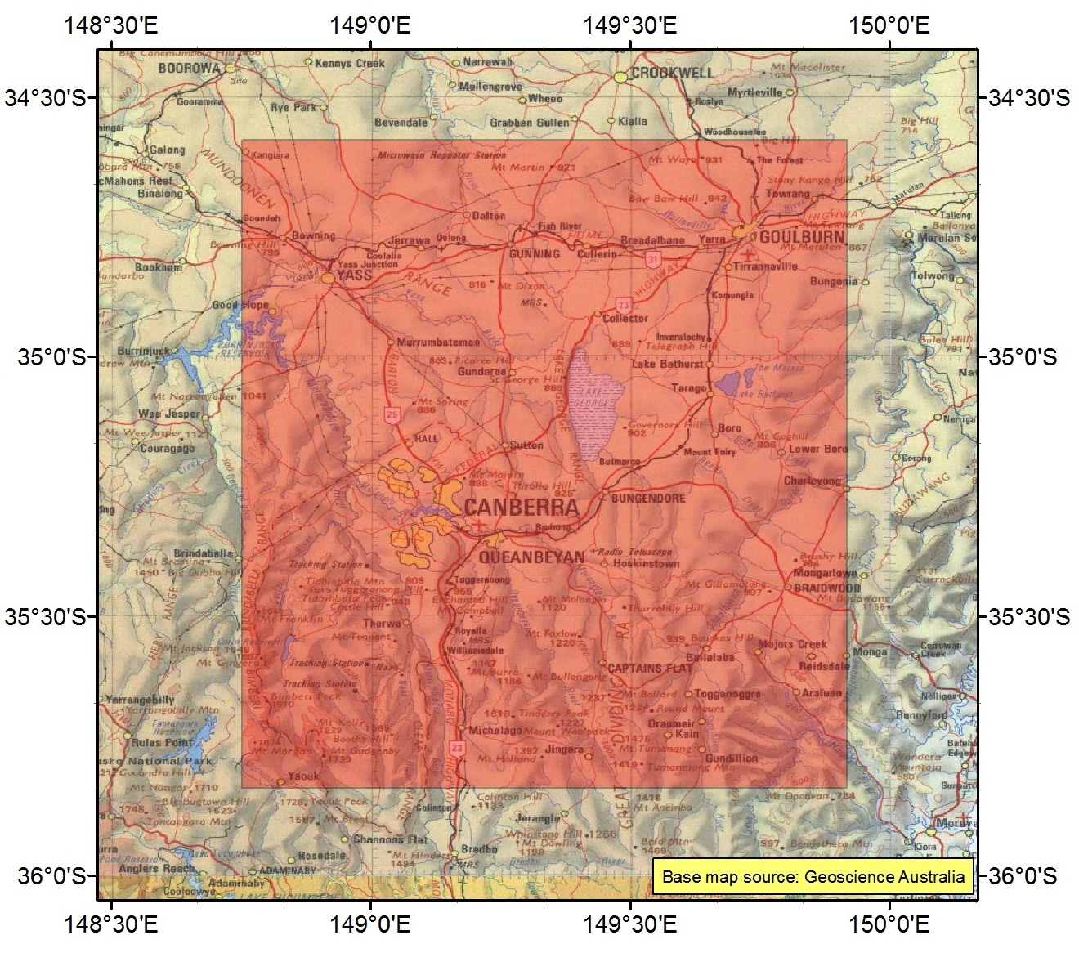

The area shaded in red is only an indicative pictorial representation of the region. Refer to the HCIS identifiers specified in item 1.2 for a description of the Metro ACT region.

1.2 HCIS identifiers for the region

MW1P, MW2M, MW2N, MW2O, MW4D, MW4H, MW4L, MW5A, MW5B, MW5C, MW5E, MW5F, MW5G, MW5I, MW5J, MW5K, MW1L4, MW1L5, MW1L6, MW1L7, MW1L8, MW1L9, MW2I4, MW2I5, MW2I6, MW2I7, MW2I8, MW2I9, MW2J4, MW2J5, MW2J6, MW2J7, MW2J8, MW2J9, MW2K4, MW2K5, MW2K6, MW2K7, MW2K8, MW2K9, MW2L4, MW2L5, MW2L7, MW2L8, MW2P1, MW2P2, MW2P4, MW2P5, MW2P7, MW2P8, MW4P1, MW4P2, MW4P3, MW5D1, MW5D2, MW5D4, MW5D5, MW5D7, MW5D8, MW5H1, MW5H2, MW5H4, MW5H5, MW5H7, MW5H8, MW5L1, MW5L2, MW5L4, MW5L5, MW5L7, MW5L8, MW5M1, MW5M2, MW5M3, MW5N1, MW5N2, MW5N3, MW5O1, MW5O2, MW5O3, MW5P1, MW5P2.

2 Metro Adelaide region

2.1 Indicative Pictorial Representation

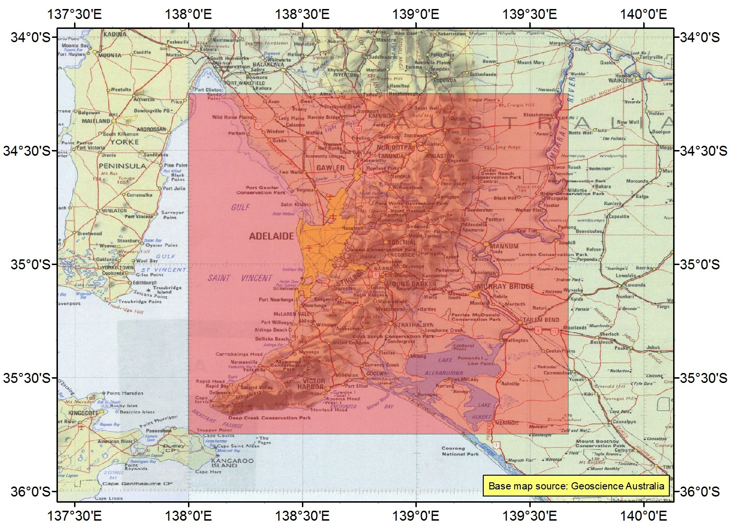

The area shaded in red is only an indicative pictorial representation of the region. Refer to the HCIS identifiers specified in item 2.2 for a description of the Metro Adelaide region.

2.2 HCIS identifiers for the region

IW3E, IW3F, IW3G, IW3H, IW3I, IW3J, IW3K, IW3L, IW3M, IW3N, IW3O, IW3P, IW6A, IW6B, IW6C, IW6D, IW6E, IW6F, IW6G, IW6H, IW6I, IW6J, IW6K, IW6L, JW1E, JW1F, JW1I, JW1J, JW1M, JW1N, JW4A, JW4B, JW4E, JW4F, JW4I, JW4J, JW1G1, JW1G2, JW1G4, JW1G5, JW1G7, JW1G8, JW1K1, JW1K2, JW1K4, JW1K5, JW1K7, JW1K8, JW1O1, JW1O2, JW1O4, JW1O5, JW1O7, JW1O8, JW4C1, JW4C2, JW4C4, JW4C5, JW4C7, JW4C8, JW4G1, JW4G2, JW4G4, JW4G5, JW4G7, JW4G8, JW4K1, JW4K2, JW4K4, JW4K5, JW4K7, JW4K8.

3 Metro Brisbane region

3.1 Indicative Pictorial Representation

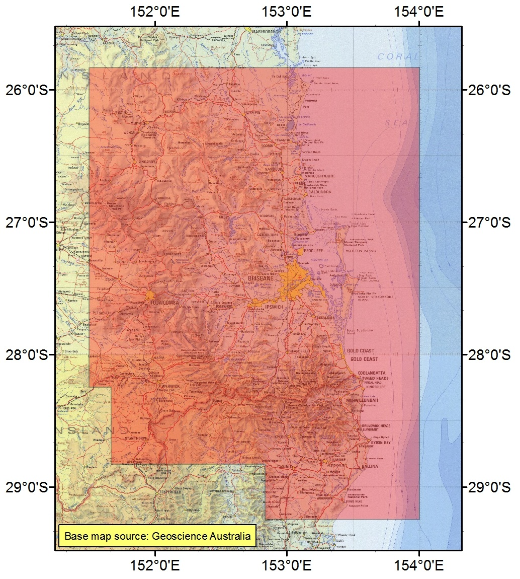

The area shaded in red is only an indicative pictorial representation of the region. Refer to the HCIS identifiers specified in item 3.2 for a description of the Metro Brisbane region.

3.2 HCIS identifiers for the region

NT5, NT6, NT8, NT9, NU3, NT4C, NT4D, NT4G, NT4H, NT4K, NT4L, NT4O, NT4P, NT7C, NT7D, NT7G, NT7H, NT7K, NT7L, NT7O, NT7P, NU1C, NU1D, NU1H, NU1L, NU2A, NU2B, NU2C, NU2D, NU2E, NU2F, NU2G, NU2H, NU2I, NU2J, NU2K, NU2L, NU6A, NU6B, NU6C, NU6D, NT1O4, NT1O5, NT1O6, NT1O7, NT1O8, NT1O9, NT1P4, NT1P5, NT1P6, NT1P7, NT1P8, NT1P9, NT2M4, NT2M5, NT2M6, NT2M7, NT2M8, NT2M9, NT2N4, NT2N5, NT2N6, NT2N7, NT2N8, NT2N9, NT2O4, NT2O5, NT2O6, NT2O7, NT2O8, NT2O9, NT2P4, NT2P5, NT2P6, NT2P7, NT2P8, NT2P9, NT3M4, NT3M5, NT3M6, NT3M7, NT3M8, NT3M9, NT3N4, NT3N5, NT3N6, NT3N7, NT3N8, NT3N9, NT3O4, NT3O5, NT3O6, NT3O7, NT3O8, NT3O9, NT3P4, NT3P5, NT3P6, NT3P7, NT3P8, NT3P9, NU1G3, NU1G6, NU1G9, NU1K3, NU1K6, NU1K9, NU1O3, NU1P1, NU1P2, NU1P3, NU2M1, NU2M2, NU2M3, NU2N1, NU2N2, NU2N3, NU2O1, NU2O2, NU2O3, NU2P1, NU2P2, NU2P3, NU2P5, NU2P6, NU2P8, NU2P9, NU5D2, NU5D3, NU5D5, NU5D6, NU5D8, NU5D9.

4 Metro Darwin region

4.1 Indicative Pictorial Representation

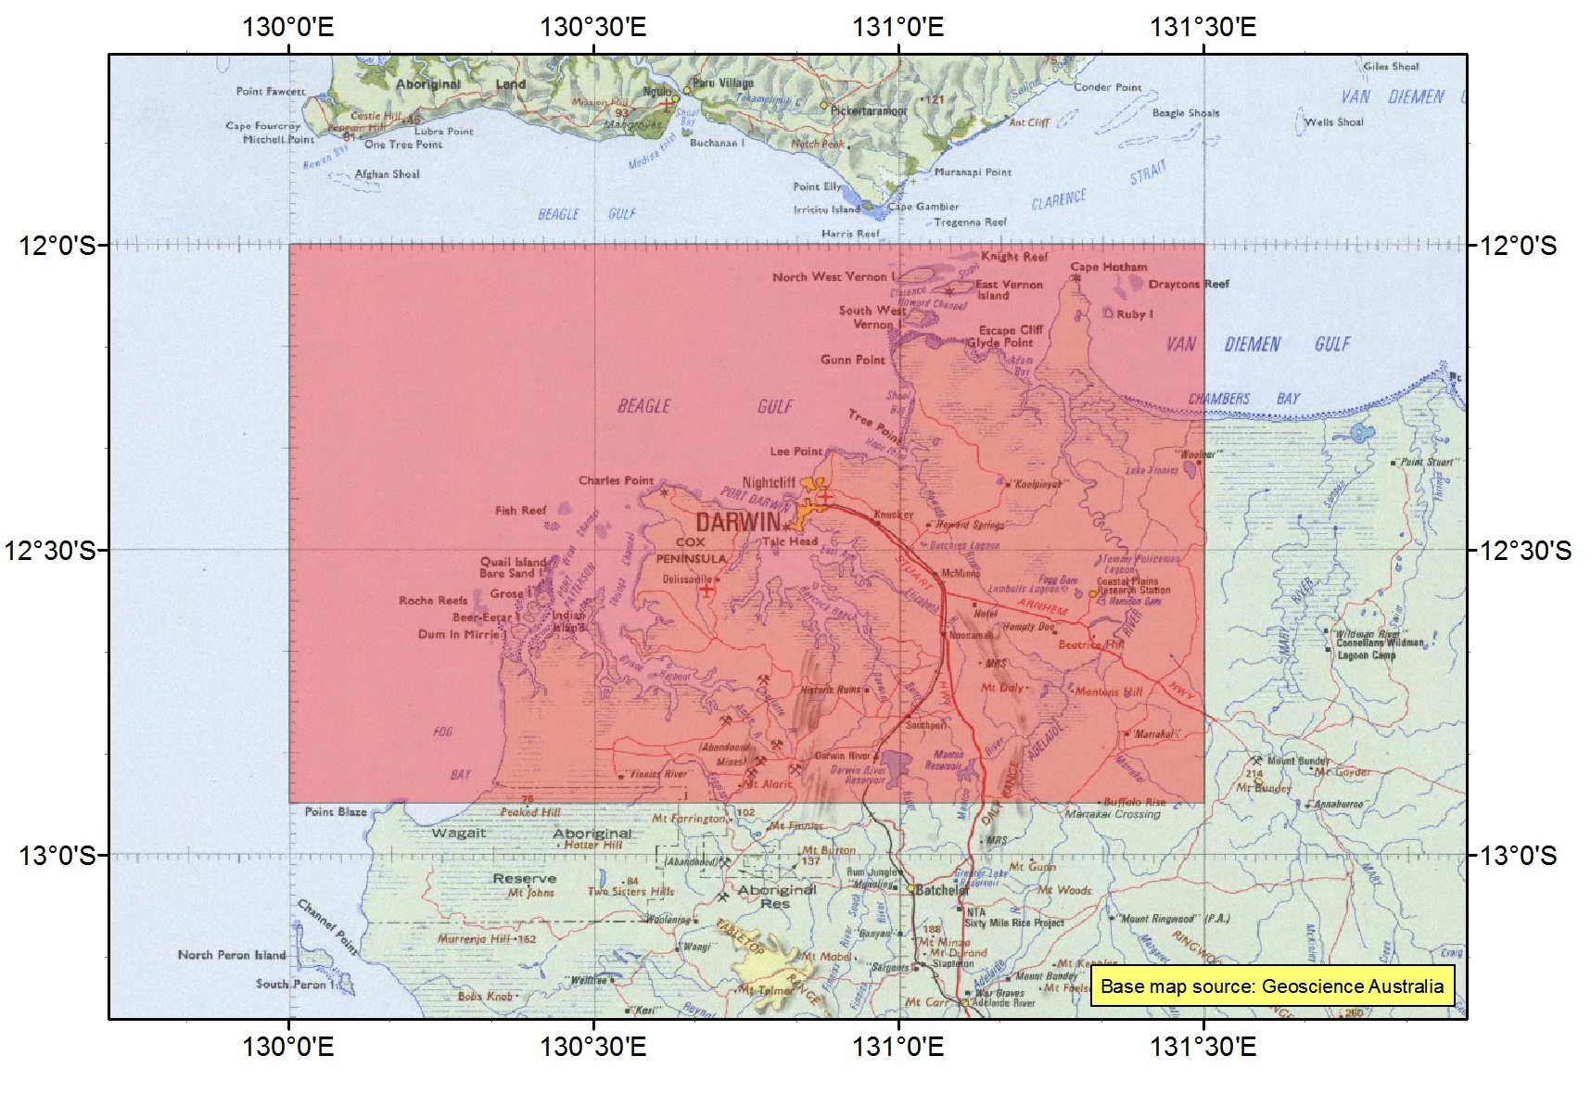

The area shaded in red is only an indicative pictorial representation of the region. Refer to the HCIS identifiers specified in item 4.2 for a description of the Metro Darwin region.

4.2 HCIS identifiers for the region

GO7A, GO7B, GO7C, GO7D, GO7E, GO7F, GO7G, GO7H, GO7I, GO7J, GO7K, GO7L, GO8A, GO8B, GO8E, GO8F, GO8I, GO8J, GO7M1, GO7M2, GO7M3, GO7M4, GO7M5, GO7M6, GO7N1, GO7N2, GO7N3, GO7N4, GO7N5, GO7N6, GO7O1, GO7O2, GO7O3, GO7O4, GO7O5, GO7O6, GO7P1, GO7P2, GO7P3, GO7P4, GO7P5, GO7P6, GO8M1, GO8M2, GO8M3, GO8M4, GO8M5, GO8M6, GO8N1, GO8N2, GO8N3, GO8N4, GO8N5, GO8N6.

5 Metro Hobart region

5.1 Indicative Pictorial Representation

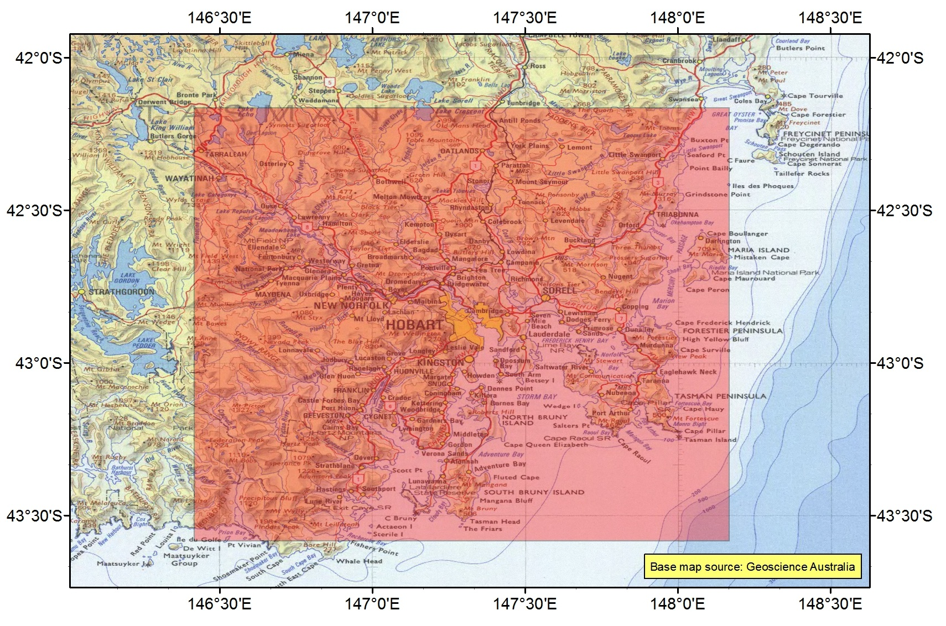

The area shaded in red is only an indicative pictorial representation of the region. Refer to the HCIS identifiers specified in item 5.2 for a description of the Metro Hobart region.

5.2 HCIS identifiers for the region

LY8G, LY8H, LY8K, LY8L, LY8O, LY8P, LY9E, LY9F, LY9G, LY9H, LY9I, LY9J, LY9K, LY9L, LY9M, LY9N, LY9O, LY9P, LZ2C, LZ2D, LZ2G, LZ2H, LZ3A, LZ3B, LZ3C, LZ3D, LZ3E, LZ3F, LZ3G, LZ3H, LY8B9, LY8C7, LY8C8, LY8C9, LY8D7, LY8D8, LY8D9, LY8F3, LY8F6, LY8F9, LY8J3, LY8J6, LY8J9, LY8N3, LY8N6, LY8N9, LY9A7, LY9A8, LY9A9, LY9B7, LY9B8, LY9B9, LY9C7, LY9C8, LY9C9, LY9D7, LY9D8, LY9D9, LZ2B3, LZ2B6, LZ2B9, LZ2F3, LZ2F6, LZ2F9, LZ2J3, LZ2K1, LZ2K2, LZ2K3, LZ2L1, LZ2L2, LZ2L3, LZ3I1, LZ3I2, LZ3I3, LZ3J1, LZ3J2, LZ3J3, LZ3K1, LZ3K2, LZ3K3, LZ3L1, LZ3L2, LZ3L3, MY7A7, MY7A8, MY7E1, MY7E2, MY7E4, MY7E5, MY7E7, MY7E8, MY7I1, MY7I2, MY7I4, MY7I5, MY7I7, MY7I8, MY7M1, MY7M2, MY7M4, MY7M5, MY7M7, MY7M8, MZ1A1, MZ1A2, MZ1A4, MZ1A5, MZ1A7, MZ1A8, MZ1E1, MZ1E2, MZ1E4, MZ1E5, MZ1E7, MZ1E8, MZ1I1, MZ1I2.

6 Metro Melbourne region

6.1 Indicative Pictorial Representation

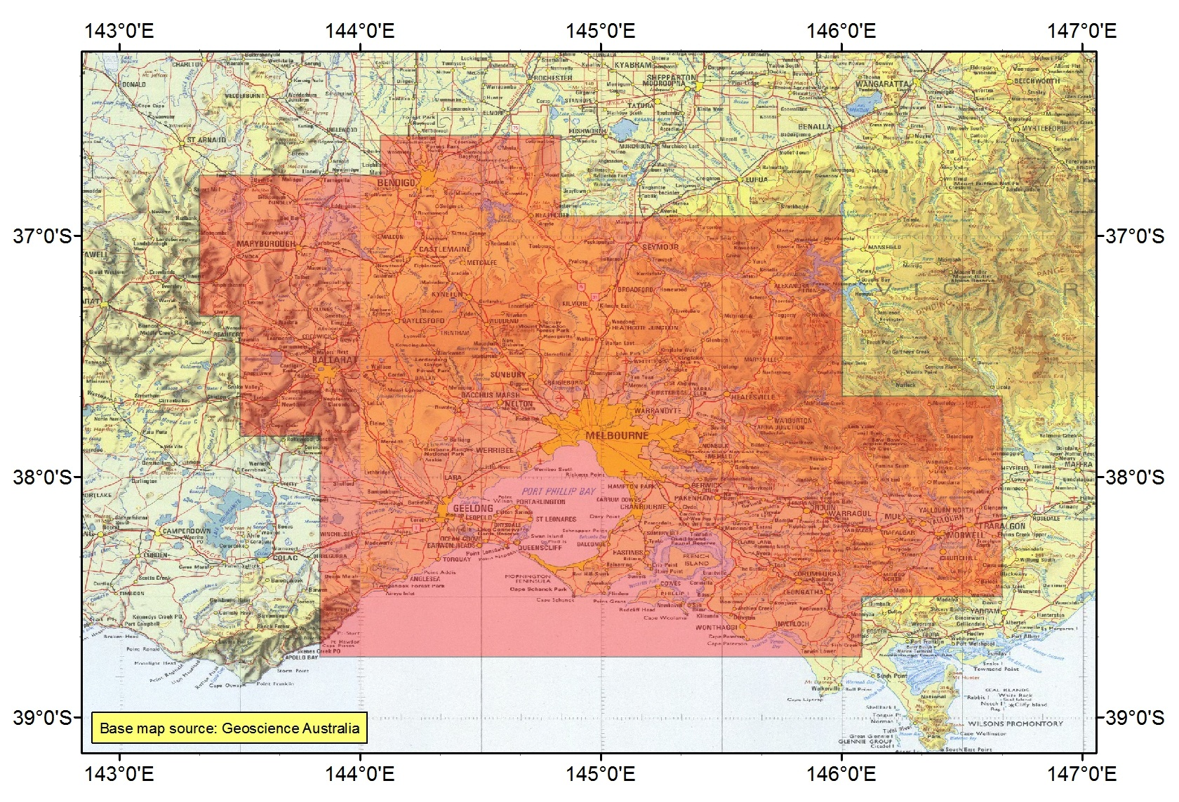

The area shaded in red is only an indicative pictorial representation of the region. Refer to the HCIS identifiers specified in item 6.2 for a description of the Metro Melbourne region.

6.2 HCIS identifiers for the region

KX3, LX1, KW8O, KW8P, KW9M, KW9N, KW9O, KX2C, KX2D, KX2G, KX2H, KX2K, KX2L, KX6A, KX6B, KX6C, KX6D, KX6E, KX6F, KX6G, KX6H, KX6I, KX6J, KX6K, KX6L, LX2M, LX2N, LX4A, LX4B, LX4C, LX4D, LX4E, LX4F, LX4G, LX4H, LX4I, LX4J, LX4K, LX4L, LX5A, LX5B, LX5E, LX5F, KW8N2, KW8N3, KW8N5, KW8N6, KW8N8, KW8N9, KW9I5, KW9I6, KW9I8, KW9I9, KW9J4, KW9J5, KW9J6, KW9J7, KW9J8, KW9J9, KW9K4, KW9K5, KW9K6, KW9K7, KW9K8, KW9K9, KW9L4, KW9L7, KW9P1, KW9P4, KW9P7, KW9P8, KW9P9, KX2B2, KX2B3, KX2B5, KX2B6, KX2B8, KX2B9, KX2F2, KX2F3, KX2O1, KX2O2, KX2O3, KX2P1, KX2P2, KX2P3, KX2P5, KX2P6, KX2P8, KX2P9, KX5D2, KX5D3, KX5D5, KX5D6, KX5D8, KX5D9, KX5H2, KX5H3, KX5H5, KX5H6, KX5H8, KX5H9, KX5L2, KX5L3, KX5L5, KX5L6, KX5L8, KX5L9, LW7M7, LW7M8, LW7M9, LW7N7, LW7N8, LW7N9, LW7O7, LW7O8, LW7O9, LW7P7, LW7P8, LW7P9, LX2I7, LX2I8, LX2I9, LX2J7, LX2J8, LX2J9, LX2K7, LX2K8, LX2O1, LX2O2, LX2O4, LX2O5, LX2O7, LX2O8, LX5C1, LX5C2, LX5C4, LX5C5, LX5C7, LX5C8, LX5G1, LX5G2, LX5G4, LX5G5, LX5G7, LX5G8, LX5I1, LX5I4, LX5I7.

7 Metro Perth region

7.1 Indicative Pictorial Representation

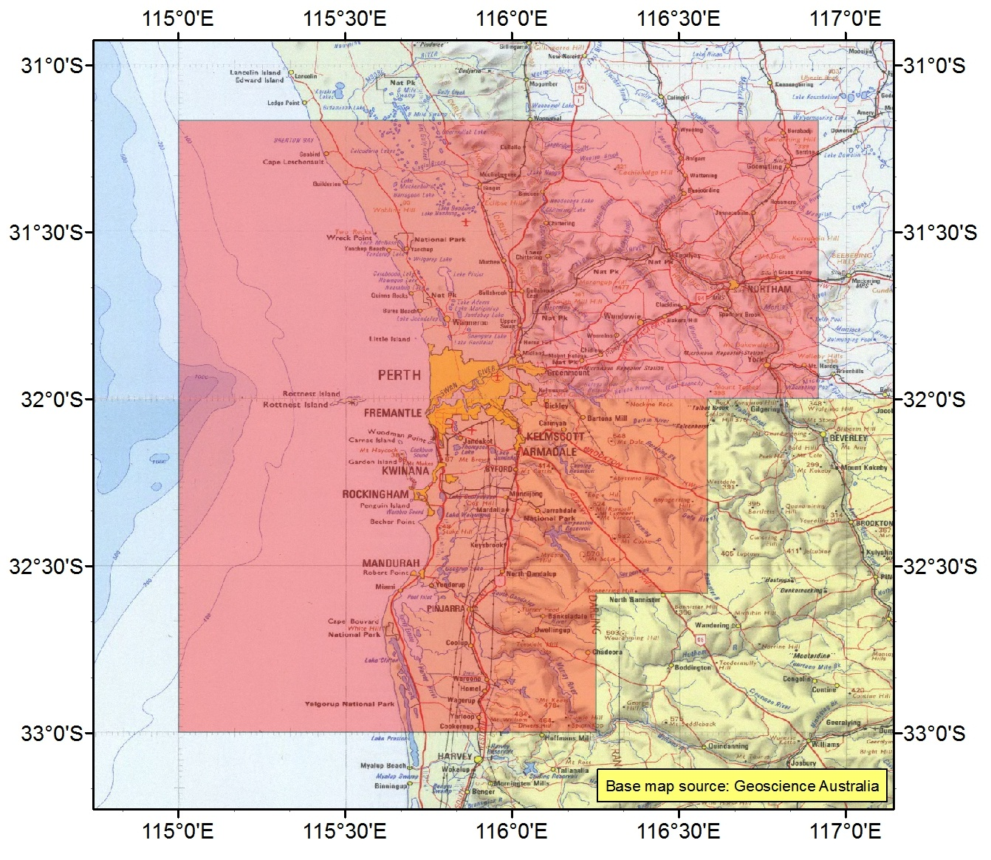

The area shaded in red is only an indicative pictorial representation of the region. Refer to the HCIS identifiers specified in item 7.2 for a description of the Metro Perth region.

7.2 HCIS identifiers for the region

BV4, BV1E, BV1F, BV1G, BV1H, BV1I, BV1J, BV1K, BV1L, BV1M, BV1N, BV1O, BV1P, BV2E, BV2F, BV2G, BV2I, BV2J, BV2K, BV2M, BV2N, BV2O, BV5A, BV5B, BV5E, BV5F, BV5I, BV5M, BV1A7, BV1A8, BV1A9, BV1B7, BV1B8, BV1B9, BV1C7, BV1C8, BV1C9, BV1D7, BV1D8, BV1D9, BV2A7, BV2A8, BV2A9, BV2B7, BV2B8, BV2B9, BV2C7, BV2C8, BV2C9, BV2D7, BV2D8, BV2H1, BV2H2, BV2H4, BV2H5, BV2H7, BV2H8, BV2L1, BV2L2, BV2L4, BV2L5, BV2L7, BV2L8, BV2P1, BV2P2, BV2P4, BV2P5, BV2P7, BV2P8, BV5C1, BV5C4, BV5C7, BV5G1, BV5G4, BV5G7, BV5J1, BV5J2, BV5J3, BV5K1.

8 Metro Sydney region

8.1 Indicative Pictorial Representation

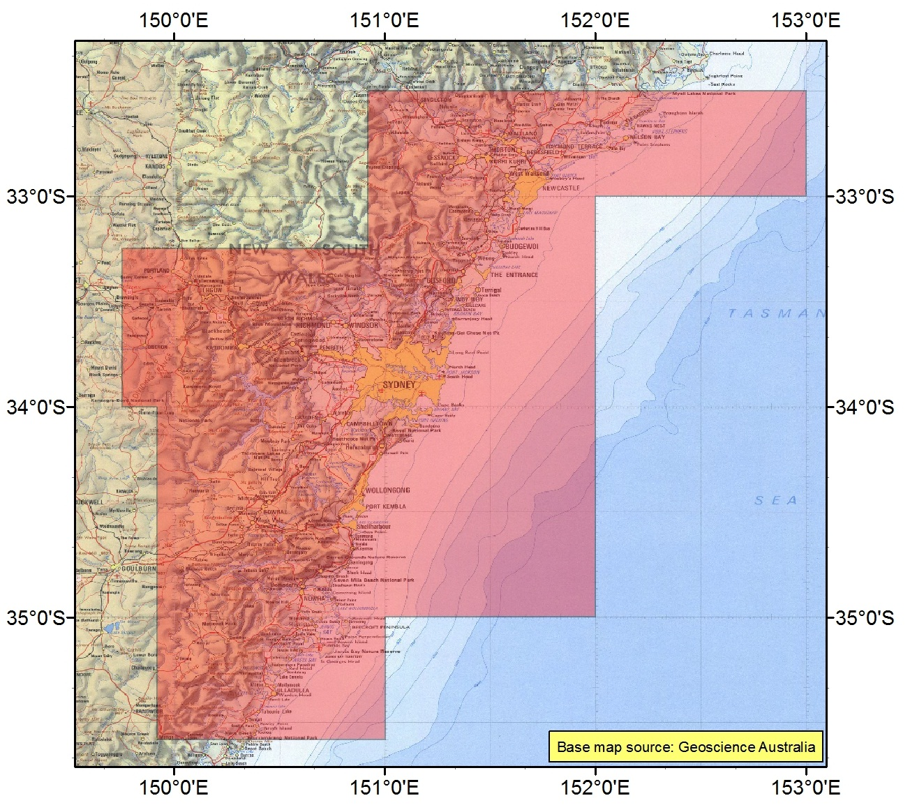

The area shaded in red is only an indicative pictorial representation of the region. Refer to the HCIS identifiers specified in item 8.2 for a description of the Metro Sydney region.

8.2 HCIS identifiers for the region

MW3, NV7, NW1, MV8H, MV8L, MV8P, MV9E, MV9F, MV9G, MV9H, MV9I, MV9J, MV9K, MV9L, MV9M, MV9N, MV9O, MV9P, MW6A, MW6B, MW6C, MW6D, MW6E, MW6F, MW6G, MW6H, NV4I, NV4J, NV4K, NV4L, NV4M, NV4N, NV4O, NV4P, NV5I, NV5J, NV5K, NV5L, NV5M, NV5N, NV5O, NV5P, MV6L3, MV6L6, MV6L9, MV6P3, MV6P6, MV6P9, MV9D3, MV9D6, MV9D9, MW2D3, MW2D6, MW2D9, MW2H3, MW2H6, MW2H9, MW2L3, MW2L6, MW2L9, MW2P3, MW2P6, MW2P9, MW5D3, MW5D6, MW5D9, MW5H3, MW5H6, MW5H9, MW5L3, MW6I1, MW6I2, MW6I3, MW6J1, MW6J2, MW6J3, MW6K1, MW6K2, MW6K3, MW6L1, MW6L2, MW6L3.

9 Regional East Australia region

9.1 Indicative Pictorial Representation

The area shaded in red is only an indicative pictorial representation of the region. Refer to the HCIS identifiers specified in item 9.2 for a description of the Regional East Australia region.

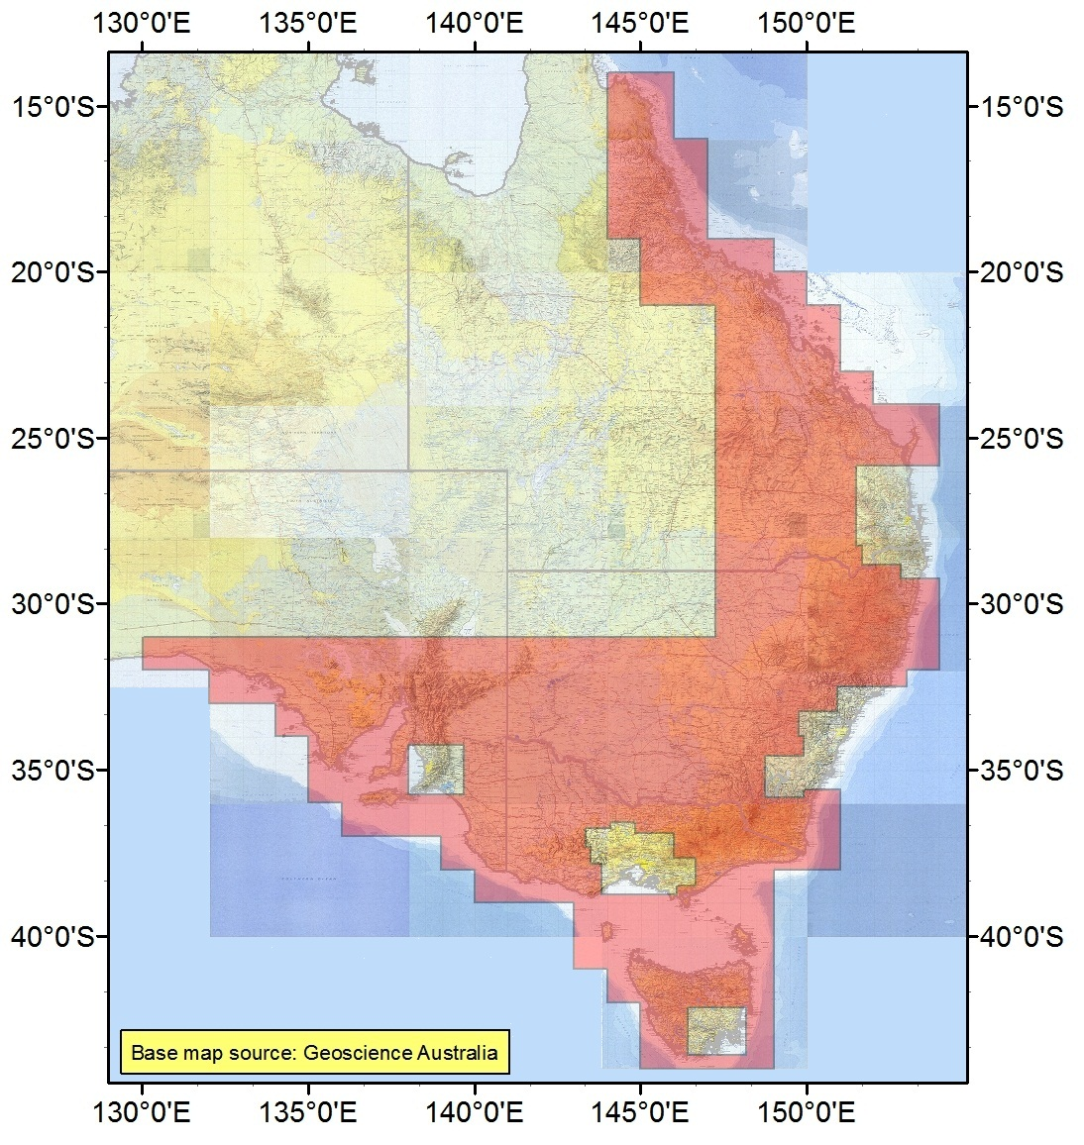

9.2 HCIS identifiers for the region

IV, JV, KV, LV, MS, MT, MU, GV1, GV2, GV3, GV6, HV1, HV2, HV3, HV4, HV5, HV6, HV8, HV9, HW3, HW6, IW1, IW2, IW4, IW5, IW7, IW8, IW9, JW2, JW3, JW5, JW6, JW7, JW8, JW9, JX1, JX2, JX3, JX5, JX6, KP6, KP9, KQ3, KQ6, KQ9, KW1, KW2, KW3, KW4, KW5, KW6, KW7, KX1, KX4, KX8, KX9, KY2, KY3, KY6, LP4, LP7, LQ1, LQ2, LQ4, LQ5, LQ7, LQ8, LR1, LR2, LR3, LR4, LR5, LR6, LW1, LW2, LW3, LW4, LW5, LW6, LW8, LW9, LX3, LX6, LX7, LX8, LX9, LY1, LY2, LY3, LY4, LY5, LY6, LY7, LZ1, MR1, MR4, MR5, MR7, MR8, MR9, MV1, MV2, MV3, MV4, MV5, MV7, MW7, MW8, MW9, MX1, MX2, MX3, MX4, MX7, MY1, MY4, NS4, NS7, NS8, NS9, NU4, NU7, NU8, NU9, NV1, NV2, NV3, IW3A, IW3B, IW3C, IW3D, IW6M, IW6N, IW6O, IW6P, JW1A, JW1B, JW1C, JW1D, JW1H, JW1L, JW1P, JW4D, JW4H, JW4L, JW4M, JW4N, JW4O, JW4P, KW8A, KW8B, KW8C, KW8D, KW8E, KW8F, KW8G, KW8H, KW8I, KW8J, KW8K, KW8L, KW8M, KW9A, KW9B, KW9C, KW9D, KW9E, KW9F, KW9G, KW9H, KX2A, KX2E, KX2I, KX2J, KX2M, KX2N, KX5A, KX5B, KX5C, KX5E, KX5F, KX5G, KX5I, KX5J, KX5K, KX5M, KX5N, KX5O, KX5P, KX6M, KX6N, KX6O, KX6P, LR9B, LR9C, LR9D, LR9F, LR9G, LR9H, LR9J, LR9K, LR9L, LR9N, LR9O, LR9P, LS3B, LS3C, LS3D, LS3F, LS3G, LS3H, LS3J, LS3K, LS3L, LS3N, LS3O, LS3P, LS6B, LS6C, LS6D, LS6F, LS6G, LS6H, LS6J, LS6K, LS6L, LS6N, LS6O, LS6P, LS9B, LS9C, LS9D, LS9F, LS9G, LS9H, LS9J, LS9K, LS9L, LS9N, LS9O, LS9P, LT3B, LT3C, LT3D, LT3F, LT3G, LT3H, LT3J, LT3K, LT3L, LT3N, LT3O, LT3P, LT6B, LT6C, LT6D, LT6F, LT6G, LT6H, LT6J, LT6K, LT6L, LT6N, LT6O, LT6P, LT9B, LT9C, LT9D, LT9F, LT9G, LT9H, LT9J, LT9K, LT9L, LT9N, LT9O, LT9P, LU3B, LU3C, LU3D, LU3F, LU3G, LU3H, LU3J, LU3K, LU3L, LU3N, LU3O, LU3P, LU6B, LU6C, LU6D, LU6F, LU6G, LU6H, LU6J, LU6K, LU6L, LU6N, LU6O, LU6P, LU9B, LU9C, LU9D, LU9F, LU9G, LU9H, LU9J, LU9K, LU9L, LU9N, LU9O, LU9P, LW7A, LW7B, LW7C, LW7D, LW7E, LW7F, LW7G, LW7H, LW7I, LW7J, LW7K, LW7L, LX2A, LX2B, LX2C, LX2D, LX2E, LX2F, LX2G, LX2H, LX2L, LX2P, LX4M, LX4N, LX4O, LX4P, LX5D, LX5H, LX5J, LX5K, LX5L, LX5M, LX5N, LX5O, LX5P, LY8A, LY8E, LY8I, LY8M, LZ2A, LZ2E, LZ2I, LZ2M, LZ2N, LZ2O, LZ2P, LZ3M, LZ3N, LZ3O, LZ3P, MV6A, MV6B, MV6C, MV6D, MV6E, MV6F, MV6G, MV6H, MV6I, MV6J, MV6K, MV6M, MV6N, MV6O, MV8A, MV8B, MV8C, MV8D, MV8E, MV8F, MV8G, MV8I, MV8J, MV8K, MV8M, MV8N, MV8O, MV9A, MV9B, MV9C, MW1A, MW1B, MW1C, MW1D, MW1E, MW1F, MW1G, MW1H, MW1I, MW1J, MW1K, MW1M, MW1N, MW1O, MW2A, MW2B, MW2C, MW2E, MW2F, MW2G, MW4A, MW4B, MW4C, MW4E, MW4F, MW4G, MW4I, MW4J, MW4K, MW4M, MW4N, MW4O, MW6M, MW6N, MW6O, MW6P, MY7B, MY7C, MY7D, MY7F, MY7G, MY7H, MY7J, MY7K, MY7L, MY7N, MY7O, MY7P, MZ1B, MZ1C, MZ1D, MZ1F, MZ1G, MZ1H, MZ1J, MZ1K, MZ1L, MZ1M, MZ1N, MZ1O, MZ1P, NT1A, NT1B, NT1C, NT1D, NT1E, NT1F, NT1G, NT1H, NT1I, NT1J, NT1K, NT1L, NT1M, NT1N, NT2A, NT2B, NT2C, NT2D, NT2E, NT2F, NT2G, NT2H, NT2I, NT2J, NT2K, NT2L, NT3A, NT3B, NT3C, NT3D, NT3E, NT3F, NT3G, NT3H, NT3I, NT3J, NT3K, NT3L, NT4A, NT4B, NT4E, NT4F, NT4I, NT4J, NT4M, NT4N, NT7A, NT7B, NT7E, NT7F, NT7I, NT7J, NT7M, NT7N, NU1A, NU1B, NU1E, NU1F, NU1I, NU1J, NU1M, NU1N, NU5A, NU5B, NU5C, NU5E, NU5F, NU5G, NU5H, NU5I, NU5J, NU5K, NU5L, NU5M, NU5N, NU5O, NU5P, NU6E, NU6F, NU6G, NU6H, NU6I, NU6J, NU6K, NU6L, NU6M, NU6N, NU6O, NU6P, NV4A, NV4B, NV4C, NV4D, NV4E, NV4F, NV4G, NV4H, NV5A, NV5B, NV5C, NV5D, NV5E, NV5F, NV5G, NV5H, JW1G3, JW1G6, JW1G9, JW1K3, JW1K6, JW1K9, JW1O3, JW1O6, JW1O9, JW4C3, JW4C6, JW4C9, JW4G3, JW4G6, JW4G9, JW4K3, JW4K6, JW4K9, KW8N1, KW8N4, KW8N7, KW9I1, KW9I2, KW9I3, KW9I4, KW9I7, KW9J1, KW9J2, KW9J3, KW9K1, KW9K2, KW9K3, KW9L1, KW9L2, KW9L3, KW9L5, KW9L6, KW9L8, KW9L9, KW9P2, KW9P3, KW9P5, KW9P6, KX2B1, KX2B4, KX2B7, KX2F1, KX2F4, KX2F5, KX2F6, KX2F7, KX2F8, KX2F9, KX2O4, KX2O5, KX2O6, KX2O7, KX2O8, KX2O9, KX2P4, KX2P7, KX5D1, KX5D4, KX5D7, KX5H1, KX5H4, KX5H7, KX5L1, KX5L4, KX5L7, LW7M1, LW7M2, LW7M3, LW7M4, LW7M5, LW7M6, LW7N1, LW7N2, LW7N3, LW7N4, LW7N5, LW7N6, LW7O1, LW7O2, LW7O3, LW7O4, LW7O5, LW7O6, LW7P1, LW7P2, LW7P3, LW7P4, LW7P5, LW7P6, LX2I1, LX2I2, LX2I3, LX2I4, LX2I5, LX2I6, LX2J1, LX2J2, LX2J3, LX2J4, LX2J5, LX2J6, LX2K1, LX2K2, LX2K3, LX2K4, LX2K5, LX2K6, LX2K9, LX2O3, LX2O6, LX2O9, LX5C3, LX5C6, LX5C9, LX5G3, LX5G6, LX5G9, LX5I2, LX5I3, LX5I5, LX5I6, LX5I8, LX5I9, LY8B1, LY8B2, LY8B3, LY8B4, LY8B5, LY8B6, LY8B7, LY8B8, LY8C1, LY8C2, LY8C3, LY8C4, LY8C5, LY8C6, LY8D1, LY8D2, LY8D3, LY8D4, LY8D5, LY8D6, LY8F1, LY8F2, LY8F4, LY8F5, LY8F7, LY8F8, LY8J1, LY8J2, LY8J4, LY8J5, LY8J7, LY8J8, LY8N1, LY8N2, LY8N4, LY8N5, LY8N7, LY8N8, LY9A1, LY9A2, LY9A3, LY9A4, LY9A5, LY9A6, LY9B1, LY9B2, LY9B3, LY9B4, LY9B5, LY9B6, LY9C1, LY9C2, LY9C3, LY9C4, LY9C5, LY9C6, LY9D1, LY9D2, LY9D3, LY9D4, LY9D5, LY9D6, LZ2B1, LZ2B2, LZ2B4, LZ2B5, LZ2B7, LZ2B8, LZ2F1, LZ2F2, LZ2F4, LZ2F5, LZ2F7, LZ2F8, LZ2J1, LZ2J2, LZ2J4, LZ2J5, LZ2J6, LZ2J7, LZ2J8, LZ2J9, LZ2K4, LZ2K5, LZ2K6, LZ2K7, LZ2K8, LZ2K9, LZ2L4, LZ2L5, LZ2L6, LZ2L7, LZ2L8, LZ2L9, LZ3I4, LZ3I5, LZ3I6, LZ3I7, LZ3I8, LZ3I9, LZ3J4, LZ3J5, LZ3J6, LZ3J7, LZ3J8, LZ3J9, LZ3K4, LZ3K5, LZ3K6, LZ3K7, LZ3K8, LZ3K9, LZ3L4, LZ3L5, LZ3L6, LZ3L7, LZ3L8, LZ3L9, MV6L1, MV6L2, MV6L4, MV6L5, MV6L7, MV6L8, MV6P1, MV6P2, MV6P4, MV6P5, MV6P7, MV6P8, MV9D1, MV9D2, MV9D4, MV9D5, MV9D7, MV9D8, MW1L1, MW1L2, MW1L3, MW2D1, MW2D2, MW2D4, MW2D5, MW2D7, MW2D8, MW2H1, MW2H2, MW2H4, MW2H5, MW2H7, MW2H8, MW2I1, MW2I2, MW2I3, MW2J1, MW2J2, MW2J3, MW2K1, MW2K2, MW2K3, MW2L1, MW2L2, MW4P4, MW4P5, MW4P6, MW4P7, MW4P8, MW4P9, MW5L6, MW5L9, MW5M4, MW5M5, MW5M6, MW5M7, MW5M8, MW5M9, MW5N4, MW5N5, MW5N6, MW5N7, MW5N8, MW5N9, MW5O4, MW5O5, MW5O6, MW5O7, MW5O8, MW5O9, MW5P3, MW5P4, MW5P5, MW5P6, MW5P7, MW5P8, MW5P9, MW6I4, MW6I5, MW6I6, MW6I7, MW6I8, MW6I9, MW6J4, MW6J5, MW6J6, MW6J7, MW6J8, MW6J9, MW6K4, MW6K5, MW6K6, MW6K7, MW6K8, MW6K9, MW6L4, MW6L5, MW6L6, MW6L7, MW6L8, MW6L9, MY7A1, MY7A2, MY7A3, MY7A4, MY7A5, MY7A6, MY7A9, MY7E3, MY7E6, MY7E9, MY7I3, MY7I6, MY7I9, MY7M3, MY7M6, MY7M9, MZ1A3, MZ1A6, MZ1A9, MZ1E3, MZ1E6, MZ1E9, MZ1I3, MZ1I4, MZ1I5, MZ1I6, MZ1I7, MZ1I8, MZ1I9, NT1O1, NT1O2, NT1O3, NT1P1, NT1P2, NT1P3, NT2M1, NT2M2, NT2M3, NT2N1, NT2N2, NT2N3, NT2O1, NT2O2, NT2O3, NT2P1, NT2P2, NT2P3, NT3M1, NT3M2, NT3M3, NT3N1, NT3N2, NT3N3, NT3O1, NT3O2, NT3O3, NT3P1, NT3P2, NT3P3, NU1G1, NU1G2, NU1G4, NU1G5, NU1G7, NU1G8, NU1K1, NU1K2, NU1K4, NU1K5, NU1K7, NU1K8, NU1O1, NU1O2, NU1O4, NU1O5, NU1O6, NU1O7, NU1O8, NU1O9, NU1P4, NU1P5, NU1P6, NU1P7, NU1P8, NU1P9, NU2M4, NU2M5, NU2M6, NU2M7, NU2M8, NU2M9, NU2N4, NU2N5, NU2N6, NU2N7, NU2N8, NU2N9, NU2O4, NU2O5, NU2O6, NU2O7, NU2O8, NU2O9, NU2P4, NU2P7, NU5D1, NU5D4, NU5D7.

10 Regional Western Australia region

10.1 Indicative Pictorial Representation

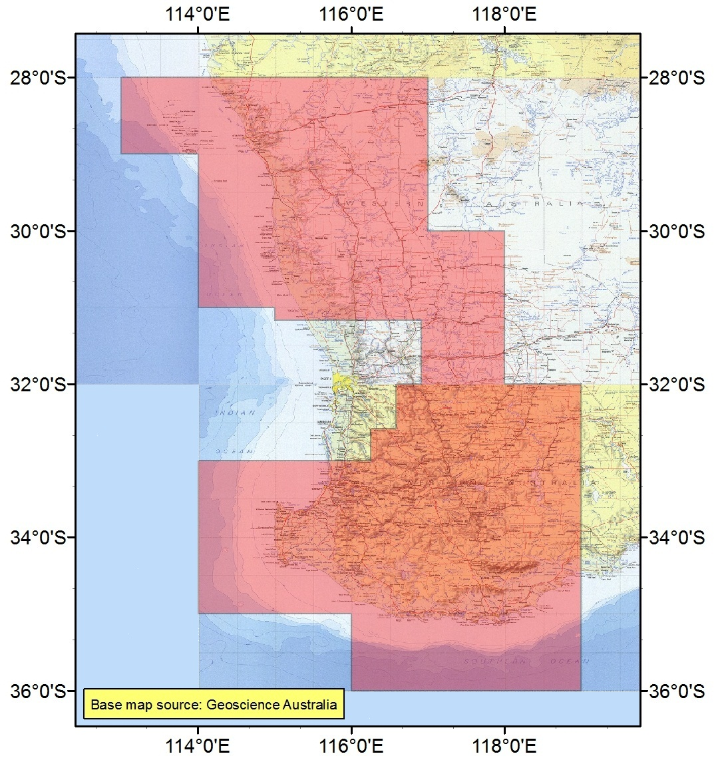

The area shaded in red is only an indicative pictorial representation of the region. Refer to the HCIS identifiers specified in item 10.2 for a description of the Regional Western Australia region.

10.2 HCIS identifiers for the region

AU2, AU3, AU6, AU9, AV9, AW3, BU1, BU2, BU4, BU5, BU7, BU8, BU9, BV3, BV6, BV7, BV8, BV9, BW1, BW2, BW3, BW5, BW6, CV4, CV7, CW1, CW4, BV5D, BV5H, BV5L, BV5N, BV5O, BV5P, BV1A1, BV1A2, BV1A3, BV1A4, BV1A5, BV1A6, BV1B1, BV1B2, BV1B3, BV1B4, BV1B5, BV1B6, BV1C1, BV1C2, BV1C3, BV1C4, BV1C5, BV1C6, BV1D1, BV1D2, BV1D3, BV1D4, BV1D5, BV1D6, BV2A1, BV2A2, BV2A3, BV2A4, BV2A5, BV2A6, BV2B1, BV2B2, BV2B3, BV2B4, BV2B5, BV2B6, BV2C1, BV2C2, BV2C3, BV2C4, BV2C5, BV2C6, BV2D1, BV2D2, BV2D3, BV2D4, BV2D5, BV2D6, BV2D9, BV2H3, BV2H6, BV2H9, BV2L3, BV2L6, BV2L9, BV2P3, BV2P6, BV2P9, BV5C2, BV5C3, BV5C5, BV5C6, BV5C8, BV5C9, BV5G2, BV5G3, BV5G5, BV5G6, BV5G8, BV5G9, BV5J4, BV5J5, BV5J6, BV5J7, BV5J8, BV5J9, BV5K2, BV5K3, BV5K4, BV5K5, BV5K6, BV5K7, BV5K8, BV5K9.

11 Remote Australia region

11.1 Indicative Pictorial Representation

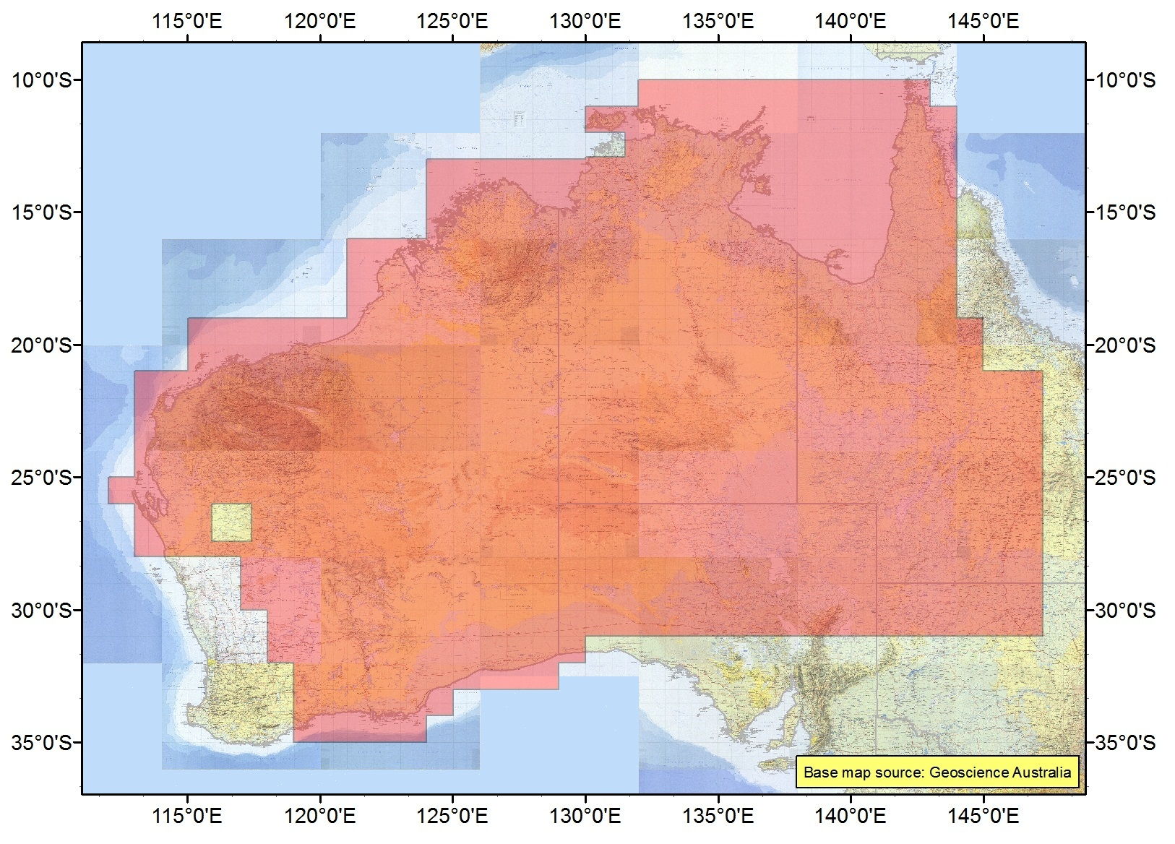

The area shaded in red is only an indicative pictorial representation of the region. Refer to the HCIS identifiers specified in item 11.2 for a description of the Remote Australia region.

11.2 HCIS identifiers for the region

BR, BS, CR, CS, CT, CU, DQ, DR, DS, DT, DU, DV, EP, EQ, ER, ES, ET, EU, FP, FQ, FR, FS, FT, FU, GP, GQ, GR, GS, GT, GU, HO, HP, HQ, HR, HS, HT, HU, IO, IP, IQ, IR, IS, IT, IU, JO, JP, JQ, JR, JS, JT, JU, KR, KS, KT, KU, AR8, AR9, AS2, AS3, AS5, AS6, AS8, AS9, AT1, AT2, AT3, AT5, AT6, AT8, AT9, BT1, BT2, BT3, BU3, BU6, CV1, CV2, CV3, CV5, CV6, CV8, CV9, CW2, CW3, DW1, DW2, DW3, EV1, EV2, EV3, EV4, EV5, EV6, EV7, FV1, FV2, FV3, FV4, FV5, GO3, GO4, GO5, GO6, GO9, KO1, KO4, KO5, KO7, KO8, KP1, KP2, KP4, KP5, KP7, KP8, KQ1, KQ2, KQ4, KQ5, KQ7, KQ8, LR7, LR8, LS1, LS2, LS4, LS5, LS7, LS8, LT1, LT2, LT4, LT5, LT7, LT8, LU1, LU2, LU4, LU5, LU7, LU8, BT4A, BT4B, BT4C, BT4E, BT4F, BT4G, BT4I, BT4J, BT4K, BT4M, BT4N, BT4O, BT6C, BT6D, BT6G, BT6H, BT6K, BT6L, BT6O, BT6P, BT7A, BT7B, BT7C, BT7E, BT7F, BT7G, BT7I, BT7J, BT7K, BT7L, BT7M, BT7N, BT7O, BT7P, BT8I, BT8J, BT8K, BT8L, BT8M, BT8N, BT8O, BT8P, BT9C, BT9D, BT9G, BT9H, BT9I, BT9J, BT9K, BT9L, BT9M, BT9N, BT9O, BT9P, GO8C, GO8D, GO8G, GO8H, GO8K, GO8L, GO8O, GO8P, LR9A, LR9E, LR9I, LR9M, LS3A, LS3E, LS3I, LS3M, LS6A, LS6E, LS6I, LS6M, LS9A, LS9E, LS9I, LS9M, LT3A, LT3E, LT3I, LT3M, LT6A, LT6E, LT6I, LT6M, LT9A, LT9E, LT9I, LT9M, LU3A, LU3E, LU3I, LU3M, LU6A, LU6E, LU6I, LU6M, LU9A, LU9E, LU9I, LU9M, BT4D1, BT4D2, BT4D4, BT4D5, BT4D7, BT4D8, BT4H1, BT4H2, BT4H4, BT4H5, BT4H7, BT4H8, BT4L1, BT4L2, BT4L4, BT4L5, BT4L7, BT4L8, BT4P1, BT4P2, BT4P4, BT4P5, BT4P7, BT4P8, BT6B3, BT6B6, BT6B9, BT6F3, BT6F6, BT6F9, BT6J3, BT6J6, BT6J9, BT6N3, BT6N6, BT6N9, BT7D1, BT7D2, BT7D4, BT7D5, BT7D7, BT7D8, BT7H1, BT7H2, BT7H4, BT7H5, BT7H7, BT7H8, BT7H9, BT8E7, BT8E8, BT8E9, BT8F7, BT8F8, BT8F9, BT8G7, BT8G8, BT8G9, BT8H7, BT8H8, BT8H9, BT9B3, BT9B6, BT9B9, BT9E7, BT9E8, BT9E9, BT9F3, BT9F6, BT9F7, BT9F8, BT9F9, GO7M7, GO7M8, GO7M9, GO7N7, GO7N8, GO7N9, GO7O7, GO7O8, GO7O9, GO7P7, GO7P8, GO7P9, GO8M7, GO8M8, GO8M9, GO8N7, GO8N8, GO8N9

Schedule 4 Emission limits outside the area

(subsection 3.6 (3))

Part 1 Base emission limits

1. This Part applies in those parts of the spectrum for which there is no agreement for the purposes paragraph 3 of Part 2 of this Schedule in force.

2. The maximum permitted level of radio emission outside the area of a licence, caused by operation of radiocommunications devices, must not exceed a horizontally radiated power of:

45 dBm EIRP per 30 kHz.

3. For this Part, the maximum permitted level of radio emission is to be determinedwith a level of confidence not less than 95 percent that the true level of emission will always remain below the requirement specified.

4. The licensee complies with paragraph 2 by ensuring that no radiocommunications device is operated under this licence in excess of a horizontally radiated power of:

45 dBm EIRP per 30 kHz.

5. For the purposes of paragraphs 2 and 4, the level of emission is to be estimated after taking into account:

(a) the kind of antenna; and

(b) the kind of equipment used with the antenna; and

(c) the location and immediate physical environment in which the antenna operates.

Part 2 Other emission limits

1. This Part applies in the parts of the spectrum for which there is an agreement in force for the purposes of paragraph 3.
2. For this Part, the maximum permitted level of radio emission is to be determined with a level of confidence not less than 95 percent that the true level of emission will always remain below the requirement specified.

3. Where a written agreement exists between:

(a) the licensee; and

(b) all the affected licensees of frequency‑adjacent and area‑adjacent spectrum licences;

specifying the maximum permitted level of radio emission, the licensee must comply with that specified maximum permitted level of radio emission.

4. For the purposes of paragraph 3, the specified maximum permitted level of radio emission cannot exceed the base emission limits of Part 1 of this Schedule.

**_______________________**

Schedule 5 Emission limits outside the band

(subsection 3.6 (4))

Part 1 Base emission limits

1.This Part applies in those parts of the spectrum for which there is no agreement in force for the purposes of paragraph 3 of Part 2 of this Schedule.

*Note*   Emission limits outside the band manage levels of:

(a) modulation and intermodulation products outside the frequency band of the licence associated with:

(i) the transmitted information; and

(ii) switching transient emissions (carrier rise times); and

(iii) where applicable, multicarrier transmitters; and

(b) transmitter wide band noise; and

(c) transmitter spurious signals from frequency combining processes, including   
multicoupling of transmitters into an antenna; and

(d) receiver emissions.

2. For this Schedule, the maximum permitted level of radio emission is to be determinedwith a level of confidence not less than 95 percent that the true level of emission will always remain below the requirement specified.

Non‑spurious emission – 2.5 GHz lower band transmitters

3. The non spurious emission limits in Table 1 apply:

1. to a radiocommunications transmitter operating within the band 2500 MHz to 2570 MHz; and
2. under a 2.5 GHz band spectrum licence; and
3. at frequencies outside the licence frequency band; and
4. within the band 2490 MHz to 2700 MHz; and
5. offset from the upper and lower limits of the licence frequency band.

where:

foffset: is the frequency offset from the upper or lower frequency limits set out in the Part 2 of Licence Schedule 1.

**Table 1 Non spurious emission limits at frequencies outside the band**

| Frequency offset, foffset | Radiated maximum true mean power (dBm EIRP) | Bandwidth |
| --- | --- | --- |
| 0 Hz ≤ foffset <1 MHz | ‑15 | 30 kHz |
| 1 MHz ≤ foffset <5 MHz | ‑10 | 1 MHz |
| 5 MHz≤ foffset <6 MHz | ‑13 | 1 MHz |
| foffset ≥6 MHz | ‑19 | 1 MHz |

Non‑spurious emission – 2.5 GHz upper band transmitters

1. The non spurious emission limits in Table 2 apply:
2. to a radiocommunications transmitter operating within the band 2620 MHz to 2690 MHz; and
3. under a 2.5 GHz band spectrum licence; and
4. at frequencies outside the licence frequency band; and
5. within the band 2615 MHz to 2700 MHz; and
6. offset from the upper and lower limits of the licence frequency band.

where:

foffset: is the frequency offset from the upper or lower frequency limits set out in the Part 2 of Licence Schedule 1.

**Table 2 Non-spurious emissions limits at frequencies outside the band**

|  |  |  |
| --- | --- | --- |
| Frequency offset, foffset | Radiated maximum true mean power (dBm EIRP) | Bandwidth |
| 0 Hz ≤ foffset <1 MHz | 3 | 30 kHz |
| foffset ≥1 MHz | 4 | 1 MHz |

1. The non spurious emission limits in Table 3 apply:
2. to a radiocommunications transmitter operating within the band 2620 MHz to 2690 MHz; and
3. under a 2.5 GHz band spectrum licence; and
4. at frequencies outside the band 2615 MHz to 2700 MHz; and
5. and within the band 2490 MHz to 2800 MHz.

where:

foffset: is the frequency offset from the upper or lower frequency limits of the band in (c).

**Table 3 Non spurious emission limits at frequencies outside the band**

|  |  |  |
| --- | --- | --- |
| Frequency offset, foffset | Radiated maximum true mean power (dBm EIRP) | Bandwidth |
| foffset ≥0 Hz | ‑45 | 1 MHz |

Spurious emission limits

1. The licensee must ensure that radiocommunications devices operated under the licence do not exceed the spurious emission limits in paragraphs 7 and 8.
2. For radiocommunications transmitters operated under the licence, the spurious emissions limits in Table 4 apply at frequencies outside the 2490 MHz to 2700 MHz frequency band.

**Table 4 Radiocommunications transmitter spurious emission limits**

|  |  |  |
| --- | --- | --- |
| Frequency (f) | Radiated mean power (dBm EIRP) | Bandwidth |
| 9 kHz ≤ f <150 kHz | ‑36 | 1 kHz |
| 150 kHz ≤ f <30 MHz | ‑36 | 10 kHz |
| 30 MHz≤ f <1GHz | ‑36 | 100 kHz |
| 1 GHz≤ f <12.75 GHz | ‑30 | 1 MHz |

1. For radiocommunications receivers operated under the licence, the spurious emissions limits in Table 5 apply at frequencies outside the 2490 MHz to 2700 MHz frequency band.

**Table 5 Radiocommunications receiver spurious emission limits**

|  |  |  |
| --- | --- | --- |
| Frequency (f) | Radiated mean power (dBm EIRP) | Bandwidth |
| 30 MHz ≤ f <1 GHz | ‑57 | 100 kHz |
| 1GHz≤ f <12.75 GHz | ‑47 | 1 MHz |

Part 2 Other emission limits

1. This Part applies in that part of the spectrum for which there is an agreement in force for the purposes of paragraph 3.

2. For this Schedule, the maximum permitted level of radio emission is to be determinedwith a level of confidence not less than 95 percent that the true level of emission will always remain below the requirement specified.

3. Where a written agreement exists between:

(a) the licensee; and

(b) all the affected licensees of frequency‑adjacent and area‑adjacent spectrum licences;

specifying the maximum permitted level of radio emission, the licensee must comply with that specified maximum permitted level of radio emission.

4. For the purposes of paragraph 3, the specified maximum permitted level of radio emission cannot exceed the base emission limits of Part 1 of this Schedule.

**__________________________________**

Schedule 6 Sample spectrum licence

(section 3.9)

This Schedule sets out a sample spectrum licence, and the conditions that may be included in a spectrum licence, issued in the 2.5 GHz band, in accordance with this Plan.



**COMMONWEALTH OF AUSTRALIA**

**AUSTRALIAN COMMUNICATIONS AND MEDIA AUTHORITY**

***Radiocommunications Act 1992***

**Sample Spectrum Licence for the 2.5 GHz Band**

Prepared under section 61 of the Radiocommunications Act 1992 (‘the Act’) in accordance with the

*Radiocommunications Spectrum Marketing Plan (2*.*5 GHz Band) 2012*

This licence is issued under section 62 of the Act to the person named at Item 1 of Licence Schedule 1 of this licence.

1. The person named at Item 1 of Licence Schedule 1 of this licence (the licensee), or a person authorised under subsection 68 (1) of the Act, is authorised to operate radiocommunications devices in accordance with:

(a) the Act;

(b) the core conditions set out in Licence Schedule 2;

(c) the statutory conditions set out in Licence Schedule 3; and

(d) the other conditions set out in Licence Schedule 4.

2. This licence comes into force on the date shown at Item 5 of Licence Schedule 1 and remains in force until the end of the date shown at Item 6 of Licence Schedule 1.

3. Unless the contrary intention appears, terms and expressions used in this licence have the meaning given to them by the *Radiocommunications Spectrum Marketing Plan (2*.*5 GHz Band) 2012*.

4. Unless the contrary intention appears, in this licence:

(a) the value of a parameter in Licence Schedules 2 and 3, must be estimated with a level of confidence not less than 95% that the true value of the parameter will always remain below the requirement specified; and

(b) the range of numbers that identify a frequency band includes the higher, but not the lower, number

**Licence Schedule 1 Licence details, bands and areas**

**Part 1 Licence Details**

|  |  |  |
| --- | --- | --- |
| Item | Details  Licensee Details |  |
| 1 | Name of licensee | TBD |
| 2 | Address of licensee | TBD |
| 3 | Client number | TBD |
| 4 | Band release | 2.5 GHz band |
| 5 | Date of licence effect | TBD |
| 6 | Date of licence expiry | TBD |
| 7 | Licence number | TBD |
| 8 | Date of licence issue | dd/mm/yyyy |

**Part 2 Frequency bands and geographic areas**

For core condition 1, this licence authorises the operation of radiocommunications devices in the frequency bands specified in column 3 and within the corresponding geographic areas specified in column 2 of Table 1.

The frequency band consists of the lower and upper frequencies, where the lower frequency limit is exclusive and upper frequency limit is inclusive. The geographic areas in column 2 of Table 1 are described by the sequence of HCIS identifiers in Table 2.

Table 1: Frequency bands and geographic areas of this licence

| **Identifier (column 1)** | **Geographic areas (column 2)** | **Frequency bands (column 3)** | | | |
| --- | --- | --- | --- | --- | --- |
| **Lower band (MHz)** | | **Upper band (MHz)** | |
| **Lower limit** | **Upper limit** | **Lower limit** | **Upper limit** |
| A | 1 | 2500 | 2505 | 2620 | 2625 |

Table 2: Description of the geographic areas of this licence

| **Geographic areas**  **(column 1)** | **HCIS identifiers**  **(column 2)** |
| --- | --- |
| 1 | IW3J, IW3K, IW3L, IW3N, IW3O, IW3P, IW6B, IW6C, IW6D, IW6F, IW6G, IW6H, IW3E5, IW3E6, IW3E8,IW3E9, IW3F4, IW3F5, IW3F6, IW3F7, IW3F8, IW3F9, IW3G4, IW3G5, IW3G6, IW3G7, IW3G8, IW3G9, IW3H4, IW3H5, IW3H6, IW3H7, IW3H8, IW3H9, IW3I2, IW3I3, IW3I5, IW3I6, IW3I8, IW3I9, IW3M2, IW3M3, IW3M5, IW3M6, IW3M8, IW3M9, IW6A2, IW6A3, IW6A5, IW6A6, IW6A8, IW6A9, IW6E2, IW6E3, IW6E5, IW6E6, IW6E8, IW6E9, JW1E4, JW1E7, JW1I1, JW1I4, JW1I7, JW1M1, JW1M4. |

Note: The HCIS is described in the *Australian Spectrum Map Grid 2012* and referenced to the Geocentric Datum of Australian 1994 (GDA94). The *Australian Spectrum Map Grid 2012* is available on the ACMA website at: [www.acma.gov.au](http://www.acma.gov.au). Copies are also available from the ACMA.

**Licence Schedule 2 Core Conditions**

**Frequency band and geographic areas**

1. This licence authorises the operation of radiocommunications devices in the frequency bands and within the geographic areas set out at Part 2 of Licence Schedule 1.

**Emission limits outside the band**

2. Core conditions 3 to 11 apply in relation to those frequencies that are outside the frequency bands set out in Part 2 of Licence Schedule 1.

3. Where a written agreement specifying the maximum permitted level of radio emission for frequencies described in core condition 2 exists between:

(a) the licensee; and

(b) all the affected licensees of frequency‑adjacent and area‑adjacent spectrum licences;

the licensee must comply with that specified maximum permitted level of radio emission.

4. Where there is no written agreement for the purposes of core condition 3 in force, the licensee must comply with core conditions 5 to 11.

**Non spurious emission limits**

5. The licensee must ensure that radiocommunications devices operated under the licence do not exceed the non spurious emission limits in core conditions 6, 7 and 8.

6. The non spurious emission limits in Table 1 apply:

(a) to a radiocommunications transmitter operating in the band 2500 to 2570 MHz;

(b) under a 2.5 GHz band spectrum licence;

(c) at frequencies outside the frequency band of the licence;

(d) within the band 2490 MHz to 2700 MHz; and

(e) offset from the upper and lower limits of the frequency band of the licence.

where:

**foffset** is the frequency offset from the upper or lower frequency limits set out in Part 2 of Licence Schedule 1.

**Licence Schedule 2 Core Conditions (cont)**

**Table 1 Non spurious emission limits at frequencies outside the band**

| Frequency offset, foffset | Radiated maximum true mean power (dBm EIRP) | Bandwidth |
| --- | --- | --- |
| 0 Hz ≤ foffset <1 MHz | ‑15 | 30 kHz |
| 1 MHz ≤ foffset <5 MHz | ‑10 | 1 MHz |
| 5 MHz≤ foffset <6 MHz | ‑13 | 1 MHz |
| foffset ≥6 MHz | ‑19 | 1 MHz |

7. The non spurious emission limits in Table 2 apply:

(a) to a radiocommunications transmitter operating in the band 2620 MHz to 2690 MHz;

(b) under a 2.5 GHz band spectrum licence;

(c) at frequencies outside the frequency band of the licence;

(d) within the band 2615 to 2700 MHz; and

(e) offset from the upper and lower limits of the frequency band of the licence.

where:

**foffset** is the frequency offset from the upper or lower frequency limits set out in Part 2 of Licence Schedule 1.

**Table 2 Non spurious emission limits at frequencies outside the band**

|  |  |  |
| --- | --- | --- |
| Frequency offset, foffset | Radiated maximum true mean power (dBm EIRP) | Bandwidth |
| 0 Hz ≤ foffset <1 MHz | 3 | 30 kHz |
| foffset ≥1 MHz | 4 | 1 MHz |

8. The non spurious emission limits in Table 3 apply:

(a) to a radiocommunications transmitter operating in the band 2620 MHz to 2690 MHz;

(b) under a 2.5 GHz band spectrum licence;

(c) at frequencies outside the band 2615 MHz to 2700 MHz; and

(d) within the band 2490 MHz to 2800 MHz.

where:

**Licence Schedule 2 Core Conditions (cont)**

**foffset** is the frequency offset from the upper or lower frequency limits of the band in (c).

**Table 3 Non spurious emission limits at frequencies outside the band**

|  |  |  |
| --- | --- | --- |
| Frequency offset, foffset | Radiated maximum true mean power (dBm EIRP) | Bandwidth |
| foffset ≥0 Hz | ‑45 | 1 MHz |

**Spurious emission limits**

9. The licensee must ensure that radiocommunications devices operated under the licence do not exceed the spurious emission limits in core conditions 10 and 11.

10. For radiocommunications transmitters operated under the licence, the spurious emission limits in Table 4 apply at frequencies outside the 2490 MHz to 2700 MHz frequency band.

**Table 4 Radiocommunications transmitter spurious emission limits**

|  |  |  |
| --- | --- | --- |
| Frequency (f) | Radiated mean power (dBm EIRP) | Bandwidth |
| 9 kHz ≤ f <150 kHz | ‑36 | 1 kHz |
| 150 kHz ≤ f <30 MHz | ‑36 | 10 kHz |
| 30 MHz≤ f <1GHz | ‑36 | 100 kHz |
| 1 GHz≤ f <12.75 GHz | ‑30 | 1 MHz |

11. For radiocommunications receivers operated under the licence, the spurious emission limits in Table 5 apply at frequencies outside the 2490 MHz and 2700 MHz frequency band.

**Table 5 Radiocommunications receiver spurious emission limits**

|  |  |  |
| --- | --- | --- |
| Frequency (f) | Radiated mean power (dBm EIRP) | Bandwidth |
| 30 MHz ≤ f <1 GHz | ‑57 | 100 kHz |
| 1GHz≤ f <12.75 GHz | ‑47 | 1 MHz |

**Licence Schedule 2 Core Conditions (cont)**

**Emission limits outside the geographic area**

12. Core conditions 13 to 15 apply in relation to those areas that are outside the geographic areas set out at Part 2 of Licence Schedule 1.

13. Where a written agreement specifying the maximum permitted level of radio emission for areas described in core condition 12 exists between:

(a) the licensee; and

(b) all the affected licensees of frequency‑adjacent and area‑adjacent spectrum licences;

the licensee must comply with that specified maximum permitted level of radio emission.

14. Where there is no written agreement for the purposes of core condition 13 in force, core condition 15 applies.

15. (a) The maximum permitted level of radio emission for an area described in core condition 12 caused by operation of a radiocommunications transmitter under the licence must not exceed a horizontally radiated power of 45 dBm EIRP per 30 kHz.

(b) The licensee complies with sub-condition 15(a) by ensuring that no radiocommunications device is operated under the licence in excess of a horizontally radiated power of 45 dBm EIRP per 30 kHz.

**__________________________________**

**Licence Schedule 3 Statutory Conditions**

**Liability to pay charges**

1. The licensee must comply with all its obligations to pay:

(a) charges fixed by determinations made under section 60 of the *Australian Communications and Media Authority Act 2005*;

(b) the spectrum access charges fixed by determinations made under section 294 of the Act; and

(c) amounts of spectrum licence tax.

**Third party use**

2.

(a) The licensee must notify any person authorised to operate radiocommunications devices under the licence of that person’s obligations under the Act, in particular of any registration requirements under Part 3.5 of the Act for operation of radiocommunications devices under the licence, and any rules made under subsection 68(3) of the Act.

(b) Any person other than the licensee who operates a radiocommunications device under the licence must comply with rules made by the ACMA under subsection 68(3) of the Act.

**Radiocommunications transmitter registration requirements**

3. The licensee must not operate a radiocommunications transmitter under this licence unless:

(a) the radiocommunications transmitter has been exempted from the registration requirements under statutory condition 4 below, or:

(b) both:

(i) the requirements of the ACMA under Part 3.5 of the Act relating to registration of the radiocommunications transmitter have been met; and

(ii) the radiocommunications transmitter complies with the details about it that have been entered in the Register.

**Exemption from registration requirements**

4. The following kinds of radiocommunications transmitters are exempt from the registration requirement in statutory condition 3:

(a) a radiocommunications transmitter that operates in the 2.5 GHz band with a radiated maximum true mean power of less than or equal to 35 dBm EIRP per 5 MHz.

**Licence Schedule 3 Statutory Conditions (cont)**

**Determination of Unacceptable Interference**

5. The ACMA has made *Radiocommunications (Unacceptable Levels of Interference – 2*.*5 GHz Band) Determination 2012* which sets out the unacceptable levels of interference for the purpose of registering radiocommunications transmitters to be operated under this licence, and which is to be used for the issuing of certificates by accredited persons under subsection 145(3) of the Act.

*Note*   Although not mandatory, the registration of receivers is advised because one of the matters ACMA will take into account in settling interference is the time of registration of the receiver involved in the interference.

**Residency etc**

6. (1) A licensee must not derive any income, profits or gains from operating radiocommunications devices under this licence or authorise any authorised person to do so unless:

(a) the licensee is an Australian resident; or

(b) the income, profits or gains are attributable to a permanent establishment in Australia through which the licensee carries on business.

(2) An authorised person must not derive income, profits or gains from allowing third parties to operate radiocommunications devices under the licence, unless:

(a) the authorised person is an Australian resident; or

(b) the income, profits or gains are attributable to a permanent establishment in Australia through which the authorised person carries on business.

(3) In this condition:

***Australian resident*** has the same meaning as in the *Income Tax Assessment Act 1997*.

***authorised person*** means a person authorised under section 68 of the Actby the licensee to operate radiocommunications devices under this licence.

***permanent establishment*** has the same meaning as in:

(a) if the licensee or authorised person (as appropriate) is a resident of a country or other jurisdiction with which Australia has an agreement, within the meaning of the *International Tax Agreements Act 1953*—that agreement; or

(b) in any other case—the *Income Tax Assessment Act 1997*.

**Licence Schedule 4 Other Conditions**

**Interference management**

1. In this licence:

***manage interference*** includes but is not limited to:

(a) investigating the possible causes of the interference;

(b) taking all steps reasonably necessary to resolve disputes about interference;

(c) taking steps (or requiring persons authorised to operate devices under this licence to take steps) reasonably likely to reduce interference to acceptable levels; and

(d) negotiating with other persons to reduce interference to acceptable levels.

**Responsibility to manage interference**

2. The licensee must manage:

(a) interference between radiocommunications devices operated under this licence; and

(b) interference between radiocommunications devices operated under this licence and under each other spectrum licence held by the licensee.

**Co‑sited devices**

3. If:

(a) interference occurs between a radiocommunications device:

(i) operated under this spectrum licence; and

(ii) operated under another licence

when the measured separation between the phase centre of the antenna used with each device is less than 200 metres; and

(b) that interference is not the result of operation of a radiocommunications device in a manner that does not comply with the conditions of the relevant licence; and

(c) either the licensee or the holder (or authorised third party) of the other licence wishes to resolve the interference;

the licensee must manage interference with:

(d) the holder of the other licence; or

(e) if a site manager is responsible for managing interference at that location, that site manager.

**Information for register**

4. The licensee must give the ACMA all information as required by the ACMA from time to time for inclusion in the Register.

**International coordination**

5. A licensee must ensure that operation of a radiocommunications transmitter under this licence does not cause harmful interference to a receiver that operates in accordance with International Telecommunication Union Radio Regulations and is located in a country other than Australia.

**Electromagnetic Energy Requirements (EME)**

6. The licensee must comply with Parts 2, 3 and 4 of the *Radiocommunications Licence Conditions (Apparatus Licence) Determination 2003*, as in force from time to time. For the purpose of compliance with this condition, the definition of licence in subsection 4(1) of the *Radiocommunications Licence Conditions (Apparatus Licence) Determination 2003* should be read as if it means a spectrum licence.

**Protection of the Mid West Radio Quiet Zone**

7. Before seeking to register a radiocommunications transmitter for use in or around the RQZ and supplementary RQZ, as defined by the *Radiocommunications (Mid‑West Radio Quiet Zone) Frequency Band Plan 2011*, the licensee must follow the procedures set out in *Radiocommunications Assignment and Licensing Instruction (RALI) MS 32* as in force from time to time.

*Note*   RALI MS 32 is available on the ACMA website.

**Licence Schedule 5 Licence Notes**

**Variation to licence conditions**

1. The ACMA may, with the written agreement of the licensee, vary a licence by including one or more further conditions, or revoking or varying any conditions of the licence, provided that the conditions, as varied, still comply with the requirements of Subdivision C of Division 1 of Part 3.2 of the Act.

2. The ACMA may, by written notice given to the licensee, vary a licence by including one or more further conditions or revoking or varying any non core conditions of the licence provided that the licence, as varied, complies with the requirements of Subdivision C of Division 1 of Part 3.2 of the Act.

**Guidelines**

3. The ACMA has issued written Radiocommunications Advisory Guidelines under section 262 of the Act about:

(a) co‑ordinating the operation of transmitters under this licence with radiocommunications receivers operated under other licences:

* *Radiocommunications Advisory Guidelines (Managing Interference from Transmitters ⎯ 2*.*5 GHz Band) 2012*;

(b) co‑ordinating the operation of receivers operated under this licence with transmitters operated under other radiocommunications licences:

* *Radiocommunications Advisory Guidelines (Managing Interference to Receivers – 2*.*5 GHz Band) 2012*.

4. The guidelines should be read in conjunction with the *Radiocommunications (Unacceptable Levels of Interference – 2*.*5 GHz Band) Determination 2012* made under subsection 145(4) of the Act. This determination sets out the unacceptable levels of interference for the purpose of the registration of transmitters to be operated under this licence. The guidelines should be followed by licensees (and accredited persons) in the planning of services and in the resolution of interference cases.   The Advisory Guidelines do not prevent a licensee negotiating other protection requirements with another licensee.  The ACMA will consider these guidelines during the settlement of interference disputes.  Each case will be assessed on its merits. Copies of the guidelines are available from the ACMA

**The suspension and cancellation of spectrum licences**

5. The ACMA may by written notice given to a licensee, suspend or cancel a spectrum licence in accordance with Division 3 of Part 3.2 of the Act.

**Reissue**

6. A spectrum licence will not be reissued to the same licensee without a price based allocation procedure unless:

(a) the ACMA is satisfied under subsection 82 (1) of the Act that special circumstances exist as a result of which it would in the public interest for that licensee to continue to hold that licence; or

(b) the licence was used to provide a service of a kind determined by the Minister under subsection 82 (3) of the Act for which reissuing licences to the same licensees would be in the public interest.

**Trading**

7. (a) A licensee may assign or otherwise deal with the whole or any part of a spectrum licence provided that this is done in accordance with any rules determined by the ACMA under section 88 of the Act and Division 5 of Part 3.2 of the Act.

(b) An assignment under section 85 of the Act of the whole or any part of a licence that involves any change to a licence does not take effect until the Register has been amended to take it into account.

**Appeals**

8. An application may be made to the ACMA for re‑consideration of the ACMA’s decisions listed under section 285 of the Act. A person affected by and dissatisfied with an ACMA decision may seek a re‑consideration of the decision by the ACMA under subsection 288(1) of the Act. This decision can be subject to further re‑consideration by the Administrative Appeals Tribunal, subject to the provisions of the *Administrative Appeals Tribunal Act 1975*.

**Labelling of transmitters**

9. Transmitters operated under this licence must be labelled in accordance   
with the *Radiocommunications (Labelling) Determination 1997*.