

**Standard 2.9.5 – Food for Special Medical Purposes** **Notice Amendment 2012 (No. 1)**

The Board of Food Standards Australia New Zealand gives notice of the making of this variation under section 92 of the *Food Standards Australia New Zealand Act 1991*. This variation commences on the date specified in clause 2 of this instrument.

Dated 15 February 2013

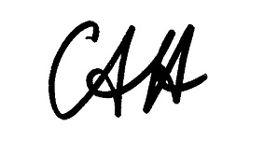

Standards Management Officer

Delegate of the Board of Food Standards Australia New Zealand

1 Name

This instrument is the *Standard 2.9.5 – Food for Special Medical Purposes Notice Amendment 2012 (No.1).*

2. Commencement

This instrument commences on 21 February 2013.

3. Variation to instrument

The Schedule varies the notice given under section 92 of the *Food Standards Australia New Zealand Act 1991* for *Standard 2.9.5 – Food for Special Medical Purposes* (Federal Register of Legislative Instruments (*FRLI*) No. F2012L01347).

SCHEDULE

[1] The notice given under section 92 of the *Food Standards Australia New Zealand Act 1991* for ***Standard 2.9.5 – Food for Special Medical Purposes*** (Federal Register of Legislative Instruments (*FRLI*) No. F2012L01347) is varied by omitting the sentence “The Standard commences on 28 June 2014.” and substituting “The Standard commences on the date of gazettal of *Food Standards (Proposal 1023 – Tutin, Tocopherols & Food for Special Medical Purposes Standards Amendments) Variation*.”