For Official Use Only



PARLIAMENTARY SECRETARY TO THE PRIME MINISTER

Reference: B13/2317

25 NOV 2013

Chair

Senate Standing Committee on Regulations and Ordinances

Room S1.111

Parliament House

Canberra ACT 2600

Dear Chair

Thank you for your Committee's letter dated 25 October 2013 regarding the Explanatory Statement for the *Royal Commission Amendment Regulation 2013 (No. 1),* tabled by the previous Government.

I have approved an updated version of the Explanatory Statement to include an explanation of why no consultation was undertaken in accordance with the requirements of the *Legislative Instruments Act 2003.* A copy is attached for your information. For ease of reference the amendment to the Explanatory Statement is marked up.

I intend to table the updated Explanatory Statement in the House of Representatives and the Senate shortly. Once it is tabled the updated Explanatory Statement will also be registered on the Federal Register of Legislative Instruments.

Yours sincerely

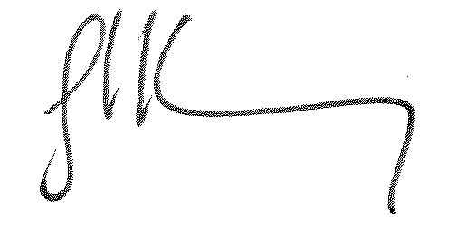

JOSH FRYDENBERG

Parliament House CANBERRA ACT 2600

For Official Use Only