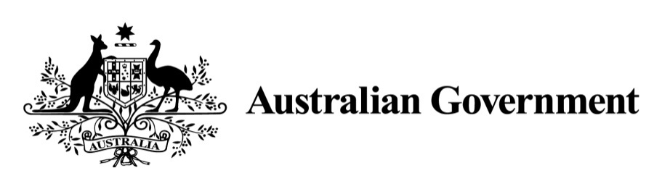

***Shipping Reform (Tax Incentives) Act 2012***

**Subsection 10 (5) specification of kinds of vessels**

I, ANTHONY NORMAN ALBANESE, Minister for Infrastructure and Transport, in the exercise of the power conferred by subsection 10(5) of the *Shipping Reform (Tax Incentives) Act 2012* (the Act)*,* specify that the following kinds of vessels are not to be excluded vessels for the purposes of the Act:

* LNG tankers or gas carriers operating solely on international routes; and
* Ro Ro ferries operating solely on interstate routes.

In this instrument:

* ***LNG tanker*** means a [tanker ship](http://en.wikipedia.org/wiki/Tank_ship) designed to transport [liquefied natural gas](http://en.wikipedia.org/wiki/Liquefied_natural_gas).
* ***Gas carrier*** means a [ship](http://en.wikipedia.org/wiki/Ship) designed to transport liquefied petroleum gas, liquefied natural gas, or liquefied chemical gasses in [bulk](http://en.wikipedia.org/wiki/Bulk_liquids).
* ***Ro Ro ferry*** means a vessel designed to carry wheeled [cargo](http://en.wikipedia.org/wiki/Cargo) such as [automobiles](http://en.wikipedia.org/wiki/Automobiles), [trucks](http://en.wikipedia.org/wiki/Truck), [semi-trailer trucks](http://en.wikipedia.org/wiki/Semi-trailer_truck), [trailers](http://en.wikipedia.org/wiki/Trailer_(vehicle)) or [railroad cars](http://en.wikipedia.org/wiki/Railroad_car) that are driven on and off the ship on their own wheels.
* ***Inter-State route*** means a route between two States or between a State and a Territory.

This instrument shall be taken to have come into effect on and from 1 July 2012.

ANTHONY ALBANESE

Minister for Infrastructure and Transport

Dated 6 May 2013