

**Food Standards (Application A1069 – Irradiation of Tomatoes and Capsicums) Variation**

The Board of Food Standards Australia New Zealand gives notice of the making of this variation under section 92 of the *Food Standards Australia New Zealand Act 1991*. The Standard commences on the date specified in clause 3 of this variation.

Dated 17 May 2013

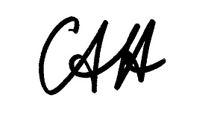

Standards Management Officer

Delegate of the Board of Food Standards Australia New Zealand

**Note:**

This variation will be published in the Commonwealth of Australia Gazette No. FSC 83 on 23 May 2013. This means that this date is the gazettal date for the purposes of clause 3 of the variation.

1 Name

This instrument is the *Food Standards (Application A1069 – Irradiation of Tomatoes and Capsicums) Variation.*

2 Variation to a Standard in the *Australia New Zealand Food Standards Code*

The Schedule varies a Standard in the *Australia New Zealand Food Standards Code*.

3 Commencement

The variation commences on the date of gazettal.

**SCHEDULE**

[1] Standard 1.5.3 is varied by –

[1.1] omitting from the Table to clause 4 “Bread fruit” and substituting

“Bread fruit

Capsicum”

[1.2] omitting from the Table to clause 4 “Rambutan” and substituting

“Rambutan

Tomato”