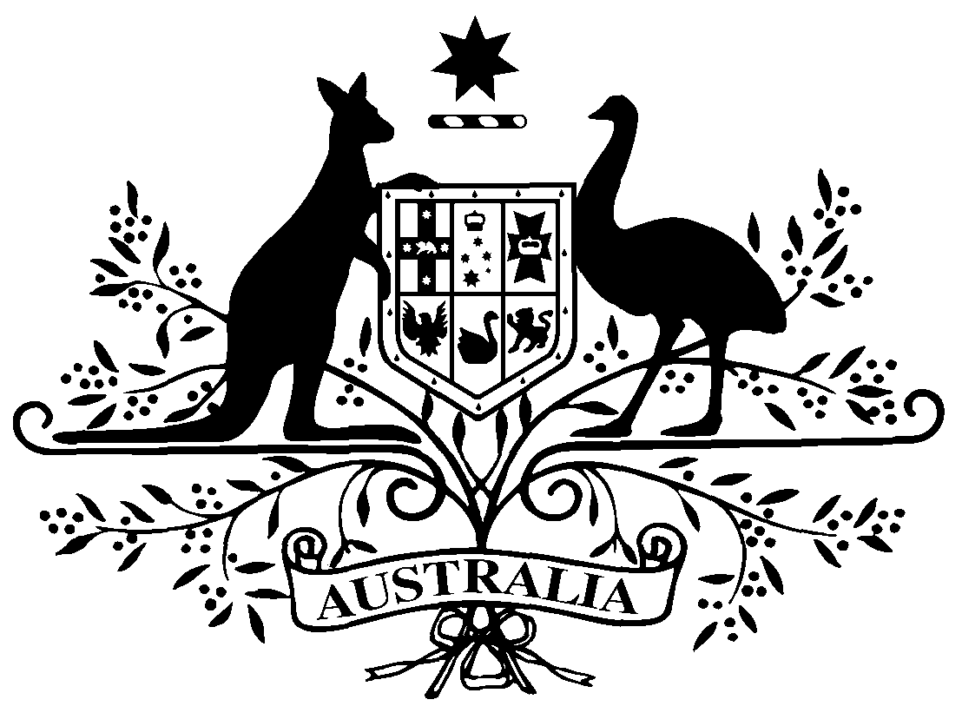

PB 34 of 2013
National Health (Remote Aboriginal Health Services Program) Special Arrangements Amendment Instrument 2013 (No. 1)

National Health Act 1953
___________________________________________________________________________

I, STEVE DUNLOP, A/g Assistant Secretary, Pharmaceutical Access Branch, Department of Health and Ageing, delegate of the Minister for Health, make this Amendment Instrument under subsections 100(1) and 100(2) of the National Health Act 1953.
Dated 13 June 2013

STEVE DUNLOP
A/g Assistant Secretary
Pharmaceutical Access Branch
Department of Health and Ageing

___________________________________________________________________________

1 Name of Instrument

- This Instrument is the National Health (Remote Aboriginal Health Services Program) Special Arrangements Amendment Instrument 2013 (No. 1).

- This Instrument may also be cited as PB 34 of 2013.

2 Commencement
This Instrument commences on 1 July 2013.
3 Amendment to PB 65 of 2010
Schedule 1 amends the National Health (Remote Aboriginal Health Services Program) Special Arrangements Instrument (PB 65 of 2010).

Schedule 1 Amendment
- Paragraph 9(c)
omit:
$2.82
substitute:
$2.83

Note
All legislative instruments and compilations are registered on the Federal Register of Legislative Instruments kept under the Legislative Instruments Act 2003. See http://www.comlaw.gov.au.

