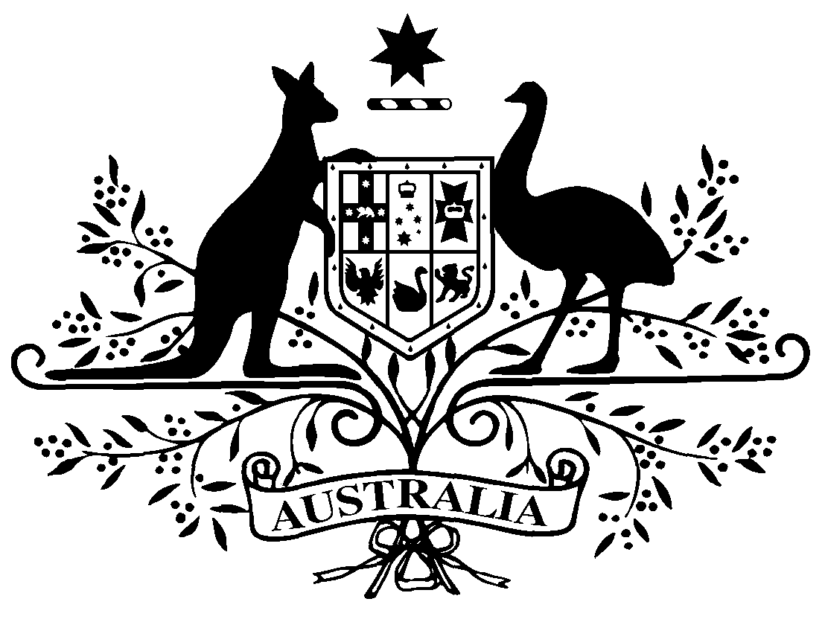

PB 45 of 2013
National Health (Continued Dispensing) Amendment Determination 2013 (No. 1)

National Health Act 1953
___________________________________________________________________________

I, Steve Dunlop, Acting Assistant Secretary, Pharmaceutical Access Branch, Pharmaceutical Benefits Division, Department of Health and Ageing, delegate of the Minister for Health and Medical Research, make the following determination under subsection 89A(3) of the National Health Act 1953.
Dated 2 August 2013

Steve Dunlop
Acting Assistant Secretary
Pharmaceutical Access Branch
Pharmaceutical Benefits Division
Department of Health and Ageing
___________________________________________________________________________

1 Name of Instrument

- This Instrument is the National Health (Continued Dispensing) Amendment Instrument 2013 (No.1).

- This Instrument may also be cited as PB 45 of 2013.

2 Commencement
This Instrument commences on the day after registration.
3 Amendments to National Health (Continued Dispensing) Determination 2012
Schedule 1 amends the National Health (Continued Dispensing) Determination 2012.

Schedule 1 Amendments
- Subsection 1.03(2)
insert in alphabetical order:
- listed brand
- Schedule equivalent

- after Paragraph 2.01(3)(b)
insert:
(c) a reference to “the pharmaceutical benefit” in sections 2.03, 2.05, 2.06 and 2.07 includes a pharmaceutical benefit that is Schedule equivalent.

- Section 3.01
omit:
3.01 Pharmaceutical benefits
For paragraph 89A (3) (a) of the Act, Schedule 1 sets out the pharmaceutical benefits that may be supplied by an approved pharmacist without a prescription for that supply under subsection 89A (1) of the Act.
insert:
3.01 Pharmaceutical benefits
- For subsection 89A (3) (a) of the Act, an approved pharmacist may supply without a prescription a pharmaceutical benefit, being any listed brand of a pharmaceutical item mentioned in Schedule 1.
- For subsection (1), the pharmaceutical item is the listed drug mentioned in Schedule 1:
(a) in the form mentioned in Schedule 1 for the listed drug; and
(b) with the manner of administration mentioned in Schedule 1 for the form of the listed drug.

- Schedule 1
omit:

insert:
Schedule 1 Pharmaceutical benefits
(sections 3.01)
Part 1 Oral hormonal contraceptives
Listed Drug | Form | Manner of Administration
Levonorgestrel | Tablets 30 micrograms, 28 | Oral
Levonorgestrel with Ethinyloestradiol | Pack containing 21 tablets 100 micrograms-20 micrograms and 7 inert tablets | Oral
 | Pack containing 21 tablets 125 micrograms-50 micrograms and 7 inert tablets | Oral
 | Pack containing 21 tablets 150 micrograms-30 micrograms and 7 inert tablets | Oral
 | Pack containing 6 tablets 50 micrograms-30 micrograms, 5 tablets 75 micrograms-40 micrograms, 10 tablets 125 micrograms-30 micrograms and 7 inert tablets | Oral
Norethisterone | Tablets 350 micrograms, 28 | Oral
Norethisterone with Ethinyloestradiol | Pack containing 21 tablets 500 micrograms-35 micrograms and 7 inert tablets | Oral
 | Pack containing 21 tablets 1 mg-35 micrograms and 7 inert tablets | Oral
 | Pack containing 12 tablets 500 micrograms-35 micrograms, 9 tablets 1 mg-35 micrograms and 7 inert tablets | Oral
Norethisterone with Mestranol | Pack containing 21 tablets 1 mg-50 micrograms and 7 inert tablets | Oral

Part 2 Lipid modifying agents
Listed Drug | Form | Manner of Administration
Atorvastatin | Tablet 10 mg (as calcium) | Oral
 | Tablet 20 mg (as calcium) | Oral
 | Tablet 40 mg (as calcium) | Oral
 | Tablet 80 mg (as calcium) | Oral
Fluvastatin | Capsule 20 mg (as sodium) | Oral
 | Capsule 40 mg (as sodium) | Oral
 | Tablet (prolonged release) 80 mg (as sodium) | Oral
Pravastatin | Tablet containing pravastatin sodium 10 mg | Oral
 | Tablet containing pravastatin sodium 20 mg | Oral
 | Tablet containing pravastatin sodium 40 mg | Oral
 | Tablet containing pravastatin sodium 80 mg | Oral
Rosuvastatin | Tablet 5 mg (as calcium) | Oral
 | Tablet 10 mg (as calcium) | Oral
 | Tablet 20 mg (as calcium) | Oral
 | Tablet 40 mg (as calcium) | Oral
Simvastatin | Tablet 5 mg | Oral
 | Tablet 10 mg | Oral
 | Tablet 20 mg | Oral
 | Tablet 40 mg | Oral
 | Tablet 80 mg | Oral

Note
All legislative instruments and compilations are registered on the Federal Register of Legislative Instruments kept under the Legislative Instruments Act 2003. See http://www.frli.gov.au.

