Commonwealth of Australia

Telecommunications Act 1997

Carrier Licence Conditions

(Pivit Pty Ltd) Declaration 2013

I, MALCOLM BLIGH TURNBULL, Minister for Communications, make the following declaration under subsection 63(2) of the Telecommunications Act 1997.

Dated 14 October 2013

MALCOLM BLIGH TURNBULL
Minister for Communications
_________________________________________________________
- Name of Declaration
This Declaration is the Carrier Licence Conditions (Pivit Pty Ltd)
Declaration 2013.
- Commencement
This Declaration commences on the day after it is registered on the Federal Register of Legislative Instruments.
- Definitions
In this Declaration:
Act means the Telecommunications Act 1997.
development area means a real estate development specified in column 1 of the table at Schedule 1 to this Declaration that occupies the corresponding area of land depicted in the relevant map at Annexure A to Schedule 1 (refer to columns 2 and 3 of the table at Schedule 1 to this Declaration).
Licensee means Pivit Pty Ltd (ACN 109 578 752), as the company exists from time to time (even if its name is later changed).

relevant premises means premises that are:
- occupied or used by an end-user; and
- situated in a development area.
Specified Pivit Network means a telecommunications network:
- that is owned by the Licensee; and
- which is located in a development area; and
- which uses fibre-to-the-premises architecture.

Note The following expressions have the meaning given by the Act (see subsection 13(1) of the Legislative Instruments Act 2003):
- carriage service
- carriage service provider
- telecommunications network
4 Obligation to connect relevant premises

(1) Upon reasonable request by an end-user at relevant premises, the Licensee must:
- connect; or
- arrange for another person on its behalf to connect;
the relevant premises to the Specified Pivit Network in order that a carriage service provider can provide carriage services to the end-user at the relevant premises.

(2) For the purposes of subclause (1), a request may be made directly by an end-user to the Licensee or by a carriage service provider to the Licensee on behalf of an end-user.

Schedule 1 – Specified Pivit Networks
(clauses 3 and 4)

Item number | Name and location of real estate development project | Area of project (map number)
1. | Coomera Waters  Serenity Bay Coomera QLD 4209 | Map 1 at Annexure A
2. | Elements Retirement Living  Dennis Road,  Springwood QLD 4127 | Map 2 at Annexure A
3. | Kelvin Grove Urban Village  Kelvin Grove QLD 4059 | Map 3 at Annexure A
4. | Little Bay Estate  Little Bay NSW 2036 | Map 4 at Annexure A
ANNEXURE A

Map 1 – Coomera Waters, Coomera QLD

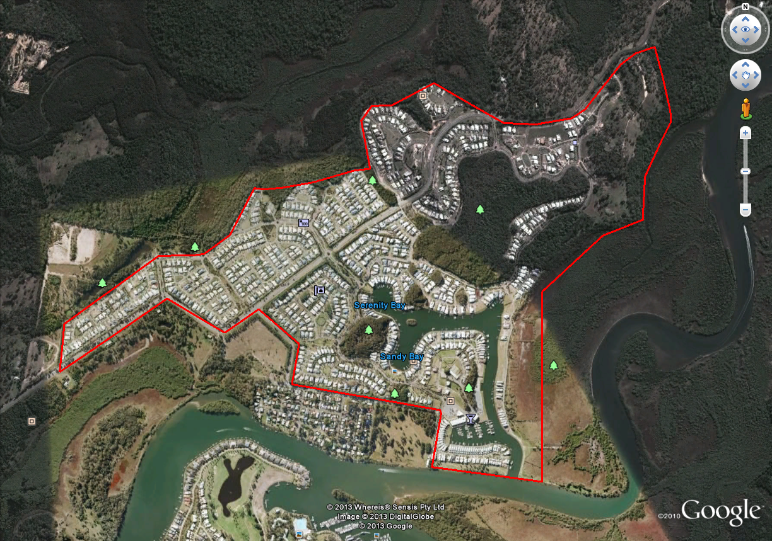

Map 2 – Elements Retirement Living, Springwood QLD

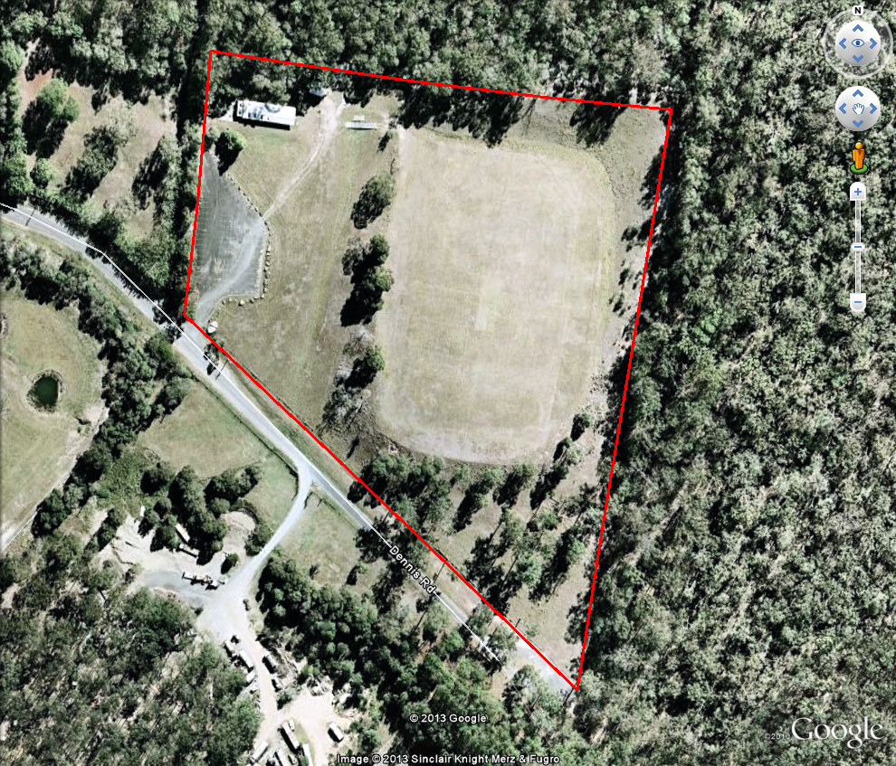

Map 3 – Kelvin Grove Urban Village, Kelvin Grove QLD

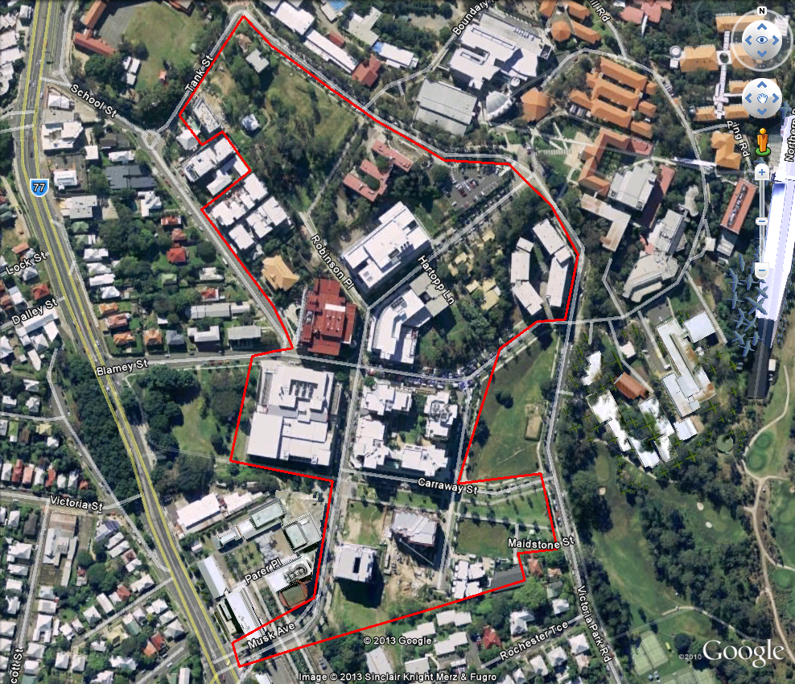

Map 4 – Little Bay Estate, Little Bay NSW

