EXPLANATORY STATEMENT

Issued by the Authority of the Minister for the Environment

Carbon Credits (Carbon Farming Initiative) Act 2011
Carbon Credits (Carbon Farming Initiative) (Native Forest from Managed Regrowth) Methodology Determination 2013
Background
The Carbon Credits (Carbon Farming Initiative) Act 2011 (the Act) enables the crediting of greenhouse gas abatement in the land sector. Greenhouse gas abatement is achieved either by reducing or avoiding emissions or by removing carbon from the atmosphere and storing it in soil or trees.
Carbon sequestration and emissions reduction activities are undertaken as offsets projects. The process involved in establishing an offsets project is set out in Part 3 of the Act. An offsets project must be covered by, and undertaken in accordance with, a methodology determination.
Subsection 106(1) of the Act empowers the Minister to make, by legislative instrument, a methodology determination. The purpose of a methodology determination is to establish procedures for estimating abatement (emissions reductions and sequestration) and project rules for monitoring, record keeping and reporting on abatement.
A methodology determination must meet the offsets integrity standards set out in section 133 of the Act and the other eligibility criteria set out in section 106 of the Act. The Minister cannot make a methodology determination unless the Domestic Offsets Integrity Committee (DOIC) has endorsed the proposal for the methodology determination under section 112 of the Act and advised the Minister of the endorsement under section 113 of the Act. The DOIC is an independent expert panel established to evaluate proposals for methodology determinations.
Application of the Determination
The Carbon Credits (Carbon Farming Initiative) (Native Forest from Managed Regrowth) Methodology Determination 2013 (the Determination) sets out the detailed rules for implementing and monitoring offsets projects that sequester carbon by establishing a native forest from in-situ seed sources, including rootstock and lignotubers. The projects will involve a change in land management practice that leads to the development of a native forest. The Determination applies to projects in which land has been cleared of forest cover where regrowth has begun but has not attained forest cover and would be cleared to maintain pastoral use unless a project is implemented.
The Determination differs from the Carbon Credits (Carbon Farming Initiative) (Human-Induced Regeneration of a Permanent Even-Aged Native Forest—1.1) Methodology Determination 2013 by using the Full Carbon Accounting Model, rather than the Reforestation Modelling Tool, to calculate abatement, and by accommodating baseline scenarios that allow for fluctuations in carbon stocks.
A project proponent wishing to implement the Determination must make an application to the Clean Energy Regulator (the Regulator) and meet the general eligibility requirements for an offsets project set out in subsection 27(4) of the Act. These requirements include compliance with the rules set out in the Determination.
Offsets projects that are undertaken in accordance with the Determination and approved by the Regulator can generate Australian carbon credit units (ACCUs) that can be sold to:
- Australian companies that pay the carbon price established under the Clean Energy Act 2011; and
- businesses in Australia wanting to offset their own carbon pollution.
As they are sequestration offsets projects under section 54 of the Act, projects undertaken in accordance with the Determination are subject to a risk of reversal buffer, as provided by section 16 of the Act.
Public Consultation
The methodology determination proposal for Native forests from managed regrowth (the proposal) was developed by the Queensland Department of Science, Information Technology, Innovation and the Arts (the applicant), in consultation with the former Department of Industry, Innovation, Climate Change, Science, Research and Tertiary Education (the Department).
The proposal was published on the website of the former Department of Climate Change and Energy Efficiency from 13 July to 22 August 2012 for public comment. Four public submissions relating to the proposal were received.
The DOIC considered the issues raised in the public submissions during its assessment of the proposal as required under subsection 112(5) of the Act, and requested further information from the applicant. The Department assisted the applicant in the subsequent revision of the proposal.
The proposal was endorsed by the DOIC on 25 July 2013, subject to certain amendments being made to the proposal. The final amended proposal was submitted on 1 September 2013 and was published on the Department’s website on 23 September 2013.
The Department consulted with the applicant, the Regulator, and key stakeholders The Carbon Store and Devine Agribusiness in the development of the Determination.
Determination Details
The Determination is a legislative instrument within the meaning of the Legislative Instruments Act 2003.
The Determination commences on the day after it is registered on the Federal Register of Legislative Instruments (FRLI).
The Determination expires when it is either revoked under section 123 of the Act, or on the day before it would otherwise be repealed under the Legislative Instruments Act 2003, whichever happens first. Under subsection 50(1) of that Act, a legislative instrument such as the Determination is repealed on the first 1 April or 1 October falling on or after the tenth anniversary of registration of the instrument on FRLI. For example, if the Determination is registered before 1 April 2014, it would expire on 31 March 2024.
Details of the Determination are at Attachment A.
A Statement of Compatibility prepared in accordance with the Human Rights (Parliamentary Scrutiny) Act 2011 is at Attachment B.

Attachment A

Details of the Methodology Determination

Part 1 Preliminary
1.1 Name of Determination
Section 1.1 sets out the full name of the Determination, which is the Carbon Credits (Carbon Farming Initiative) (Native Forest from Managed Regrowth) Methodology Determination 2013.
1.2. Duration
Section 1.2 sets out when the Determination commences and expires.
Paragraph 1.2(a) provides that the Determination commences on the day after it is registered on the Federal Register of Legislative Instruments (FRLI).
Under subparagraph 122(1)(b)(i) of the Act, a methodology determination remains in force for the period specified in the determination.
Paragraph 1.2(b) of the Determination specifies that the Determination expires the day before it would otherwise be repealed under the Legislative Instruments Act 2003. Instruments are repealed under that provision in the first 1 April or 1 October following the tenth anniversary of registration on FRLI. Paragraph 1.2(b) ensures that the Determination will expire in accordance with the Act, shortly before it would be repealed under the Legislative Instruments Act 2003.
If the Determination expires or is revoked during a crediting period for a project to which the Determination applies, the Determination will continue to apply to the project during the remainder of the crediting period under subsections 125(2) and 127(2) of the Act. Project proponents may apply to the Regulator during a reporting period to have a different methodology determination apply to their projects from the start of that reporting period (subsection 128(1) of the Act).
1.3 Definitions
Section 1.3 defines a number of terms used in the Determination.
Key definitions include those set out below.
baseline forecast period refers to a period of 100 years during which carbon stocks in the carbon estimation area are modelled, or forecast, based on a sequence of certain land management events, for projects that cannot use a zero baseline. The sequence of management events depicted by the model may reflect documented past practice or planned management, or may follow a conservative default description of common management practice.
baseline model refers to the simulation in FullCAM used to estimate long-term average carbons stocks in the absence of an offsets project. The model is used to estimate the average stock of carbon in above ground and below ground tree and debris pools, with a regime of management events scheduled in FullCAM as a default scenario of cyclic re-clearing on a 15-year cycle, or according to documented evidence of past historic practice. The Determination provides the project proponent with a choice as to which kind of baseline to apply (see section 4.12).
C mass of biomass on-site refers to the sum of C mass of trees and debris, including dead standing trees, in a carbon estimation area.
C mass of trees refers to the sum of carbon in live tree above and below ground biomass.
carbon estimation area refers to a stratum of the project area that is land which is deemed to be homogenous for the purposes of abatement calculations, and has broadly consistent physical characteristics as is determined in accordance with section 3.3.
carbon pool refers to a reservoir which has the capacity to accumulate or release carbon. The only carbon pools dealt with by the Determination relate to trees, and consist of tree above-ground biomass, tree below-ground biomass, and tree debris.
CFI Mapping Guidelines refers to the guidelines of the same name, as published from time to time on the website of the Department administering the Act. The guidelines are used for mapping project areas and carbon estimation areas.
comprehensive clearing refers to the complete destruction of vegetation by mechanical or chemical means. Comprehensive clearing leaves the land in a non-forested state for pastoral land use only. Comprehensive clearing may be accompanied by associated practices such as burning or establishment of pastures. For modelling purposes, all live tree biomass is converted to debris by this type of clearing.
disturbance event refers to an event that has a negative effect on the survival and/or growth of trees, and includes natural disturbances such as fire, storms, and pest or disease attacks, as well as human interventions.
event queue refers to a series of management activities, and the times at which they occur, as modelled in FullCAM.
exclusion area refers to land that is in the project area but that is excluded from abatement estimates and crediting.
forest potential refers to the capacity of vegetation on land to become trees that reach 2 metres or more in height and that provide crown cover of at least 20% of the land.
In practice, the potential of vegetation to achieve forest cover is dependent on land management practices. Land which is managed to suppress regrowth, including periodic re-clearing, may have the potential to achieve forest cover but will not have forest cover while such land management practices are in place.
Forest potential may be demonstrated by geo-referenced descriptions of vegetation structure and composition (such as plots or landscape photographs) or reference to remote sensing, such as woody cover mapping.
implementation date refers to the first time the project mechanism is implemented in a carbon estimation area.
initial clearing refers to the first time the land was converted from a forested state to a non-forested state for pastoral land use.
project commencement refers to the first time when management on land on which the project mechanism will be implemented changed to allow forest potential to be realised—that is, to allow regrowth with forest potential to develop forest cover.
project model refers to the simulation in FullCAM used to estimate project carbon stocks that reflects the age of regrowth within the project area, observed climate, as well as real activities and disturbances subsequent to the establishment of the project such as thinning and fire. The difference between the average baseline and total project models forms the basis of abatement calculations and claims for ACCUs.
regeneration refers to the regrowing of stems (or trees) originating from growth of in-situ seed, lignotubers or rootstock sources. The stems will be comprised of Australian native plant species that are indigenous to the local area and which can consist of a mix of tree and understory species, or a single species if monocultures naturally occur in the area. In the Determination regeneration is taken to occur simultaneously within a single carbon estimation area.
tree refers to a perennial plant that has primary supporting structures consisting of secondary xylem, as defined in the Carbon Credits (Carbon Farming Initiative) Regulations 2011 (the Regulations).
Note In accordance with section 23 of the Acts Interpretation Act 1901, words in the Determination in the singular number include the plural and words in the plural number include the singular.
1.4 Type of project to which this Determination applies
The effect of paragraphs 27(4)(b) and 106(1)(a) of the Act is that a project must be covered by a methodology determination, and that the methodology determination must specify the kind of offsets project to which it applies.
The Determination applies to the type of project specified in subparagraph 3.28(1)(c)(v) of the Regulations. In particular, the Determination applies to a project that consists of:
- a change in land management on or after 1 July 2007; and
- regrowth that will achieve forest cover as a direct result of the change in land management.

Part 2 Requirements for declaration as eligible project
2.1 Eligible projects
The effect of paragraph 106(1)(b) of the Act is that a methodology determination must set out requirements that must be met for a project to be an eligible offsets project. Under paragraph 27(4)(c) of the Act, the Regulator must not declare that an offsets project is an eligible offsets project unless the Regulator is satisfied that the project meets these requirements.
Part 2 of the Determination specifies a number of requirements that must be met in order for a project to which the Determination applies to be declared an eligible offsets project.
The note to section 2.1 refers to regulatory requirements for applications for declarations. In particular, the note refers to regulation 3.36 of the Regulations. This regulation sets out the types of projects that are excluded offsets projects. Under paragraph 27(4)(m) of the Act excluded projects cannot be declared as eligible offsets projects.
2.2 Project mechanism
Section 2.2 specifies that the project must consist of a change in land management which allows native vegetation to achieve forest cover, thereby realising forest potential. The project mechanism, or activity, is the promotion or management of regeneration from sources including in-situ seeds and lignotubers.
The Determination does not apply to projects that involve direct seeding or planting.
2.3 Decision to implement project mechanism
The effect of subsection 2.3(1) is that the project proponent must be able to provide evidence of a decision to implement the project mechanism. The project proponent must decide to move away from pasture maintenance practices that suppress or destroy regeneration, to a new management regime that facilitates native tree regeneration and growth.
Subsection 2.3(2) specifies the date when the decision is taken to be made. This will be determined by the type of evidence provided to support the claim that a decision to implement the project mechanism has been made.
2.4 Land on which project mechanism is implemented
Section 2.4 sets out the requirements for land where project activities may occur and, as a consequence, where project abatement will be estimated.
Subsection 2.4(2) specifies the area where a project to which the Determination applies may be located. This must be an area for which FullCAM data exists. FullCAM data currently exists for land areas within a latitude of -9 to -44 degrees and longitude of 112 to 154 degrees.
Subsections 2.4(3) and (4) require that the project area must include land that has been converted from forest to pastoral use.
Subsection 2.4(5) specifies that at the time of the decision to change land management, the land must have forest potential and native vegetation, but not forest cover.
The Determination uses the term ‘forest cover’ to distinguish between trees that have actually reached a state of forest cover, and the Kyoto definition of ‘forest’ which includes trees that have the potential to achieve forest cover.
If the land contains forest cover at the date when the project mechanism was implemented in a carbon estimation area, then the regrowth is taken to have occurred independently of a decision to change land management and is not covered by the Determination.
2.5 Evidentiary requirements
Section 2.5 sets out the types of evidence that may be required to demonstrate that the requirements in Part 2 are met.
Subsection 2.5(1) sets out evidence that may be provided to demonstrate that there has been a decision to implement the project mechanism.
Subsections 2.5(2) and (3) set out the evidence that may be provided to the Regulator to demonstrate that the land has been subject to initial clearing and that the clearing was for the purpose of maintaining pasture.
Subsection 2.5(4) specifies that evidence of forest cover may include the 1990 forest extent layer, which is a derived vegetation cover map used in Australia’s national inventory accounting under the National Greenhouse and Energy Reporting Act 2007.

Part 3 Requirements for operation of eligible projects
Division 3.1 Operation of eligible projects
3.1 Operation of eligible projects
Section 3.1 specifies that the rules for operating a project under the Determination are set out in Part 3.

Division 3.2 Stratification of the project area
3.2 Initial stratification of project area
The effect of section 3.2 of the Determination is that a project area must be stratified into at least one carbon estimation area in accordance with both the CFI Mapping Guidelines and with Division 3.2 before submitting the first offsets report for the project.
The project area must be stratified according to the site characteristics and management practices that affect the growth rate of trees in the area.
The project area may include one or more exclusion areas.
The project area, or part of the project area, may only be re-stratified as provided for in Division 3.2.
3.3 Requirements for a carbon estimation area
Section 3.3 sets out the required characteristics for a carbon estimation area.
Paragraph 3.3(1)(a) provides that a carbon estimation area must consist of land on which the project mechanism, or activities, will be carried out.
Under the CFI Mapping Guidelines, a carbon estimation area must be a single area with an unbroken perimeter (paragraph 3.3(1)(b)).
Each carbon estimation area must contain a static ‘model point’ location (latitude and longitude) which must be located at the approximate centre of the carbon estimation area for the purpose of estimation with FullCAM (paragraph 3.3(1)(c)). Subsection 3.3(2) specifies that points may not change over time unless the carbon estimation area is re-stratified.
Paragraph 3.3(1)(d) provides that a carbon estimation area must contain regrowth of the same forest type or vegetation community, in terms of likely mature structure and dominant tree species.
The note following paragraph 3.3(1)(d) indicates that a carbon estimation area should be selected according to actual and consistent site characteristics. This is because managed regrowth occurring on sites with different characteristics is likely to sequester carbon at different rates and must be modelled separately.
For the purposes of modelling carbon stocks, regeneration is assumed to occur simultaneously within a carbon estimation area.
Subsection 3.3(3) provides that all regeneration that occurs within a carbon estimation area must be subject to the same change in land management, and have commenced after the last comprehensive clearing but not have attained forest cover (paragraphs 3.3(3)(a) and (b)). Regrowth in the carbon estimation area must be subject to the same land management events (paragraph 3.3(3)(c)).
The effect of section 3.3 is that if the entire project area is homogenous both in site characteristics and management activities, then the project area may also be a single carbon estimation area.
3.4 Carbon estimation area boundaries
The boundaries of a carbon estimation area must be identified before the first offsets report for the project is submitted to the Regulator, and in accordance with the requirements set out in the CFI Mapping Guidelines.
A project proponent may use a range of approaches to determine the boundaries of a carbon estimation area, but must include at least one of the following:
- field surveys;
- aerial photographs;
- satellite imagery including derived vegetation cover data; or
- soil, vegetation or landform maps.
If a carbon estimation area is re-stratified, the new boundaries must be identified in the next offsets report submitted to the Regulator after the re-stratification (subsection 3.6(2)).
3.5 Requirements for an exclusion area
An area of land must be defined as an exclusion area, in accordance with the CFI Mapping Guidelines, if it is an area of land within the project area which will not be subject to the project mechanism. An exclusion area may adjoin, or be contained within the boundaries of, a carbon estimation area. If an area is defined as an exclusion area, it is excluded as a source of abatement for the project.
Examples of when land in the project area may be defined as an exclusion area include if:
- the land has forest cover immediately before the implementation date;
- the project mechanism cannot occur on the land, such as where the area is a road, water course or large rock outcrop which materially affects the abatement calculation; or
- the land fails to maintain or realise forest potential after undertaking the project mechanism.
3.6 Re-stratification of project area
A carbon estimation area may only be re-stratified as provided for in Division 3.2 of the Determination.
An example of when a carbon estimation area may need to be re-stratified is if the occurrence of regrowth is determined to be patchy, inconsistent, irregular or absent. This can be determined on a case-by-case basis by visual confirmation, including from aerial maps or spatial images.
A carbon estimation area may also need to be re-stratified to isolate areas that are subject to changed land management practices, and if it is found that site characteristics are not uniform. This may occur if, for example, there is a large salinity-affected part of the project area which was not obvious when the project area was stratified.
A carbon estimation area does not have to be re-stratified to account for natural disturbance as this can be modelled by FullCAM as a proportion of the carbon estimation area affected. The exception to this is a disturbance event causing more than 5% of the trees in a carbon estimation area to die. Re-stratification after such an event may be required.
If the project mechanism causes regeneration to occur in an exclusion area, the area may be re-stratified as a carbon estimation area in accordance with Division 3.2.
Mandatory re-stratification
An area of land on which the project mechanism is implemented must be re-stratified if it loses forest potential or if regeneration fails to occur in a reporting period in any area greater than 0.2 of a hectare. This requirement ensures that FullCAM is not used to model regeneration that is not actually occurring.

Division 3.3 Restricted activities
Division 3.3 restricts certain activities which may have an impact on carbon stocks in the project area.
3.7 Harvesting
Section 3.7 specifies that no more than 10% of fallen timber from a carbon estimation area may be removed for personal use each calendar year. No other removal of biomass is permitted.
The effect of section 3.7 is that commercial harvesting is not permitted under the Determination.
Any emissions associated with the removal of biomass in accordance with section 3.7 are considered immaterial to project abatement. The removal of the biomass therefore does not need to be modelled in FullCAM.
3.8 Grazing
Section 3.8 provides that if livestock graze in a carbon estimation area, the Regulator may request evidence that the grazing has not prevented the growth of native forest. This requirement is designed to ensure that grazing of livestock does not prevent regrowth from achieving forest cover.
The note to the section provides an example of the type of evidence that may be provided to demonstrate that forest cover has not been affected by grazing. Imagery that shows that the regrowth has achieved forest cover will provide sufficient evidence that the presence of livestock has not had a material impact on the regeneration.
The effect of the restriction in section 3.8 is that livestock may graze in a carbon estimation area provided the grazing has only a minor or insignificant impact on regrowth in the area.
3.9 Thinning
Under section 3.9, trees in a carbon estimation area may be thinned for ecological purposes, provided that the biomass resulting from thinning remains in the carbon estimation area.
3.10 Use of lime or fertiliser
Section 3.10 provides that lime or fertiliser must not be used in a carbon estimation area.
Part 4 The net abatement amount
Division 4.1 The net abatement amount
4.1 The net abatement amount
Under the Determination, the carbon dioxide equivalent net abatement amount is calculated as the change in the amount of carbon stored in carbon estimation areas (through the combined effect of tree growth, natural decay and disturbance events such as fire, pest, disease and storm), minus emissions resulting from fire and from fuel used to establish and maintain the project.

To calculate this amount under the Determination, project proponents must undertake the general steps outlined below for each carbon estimation area.
Step 1—the baseline for the area must be determined in accordance with Division 4.3. If a non-zero baseline is applied to the area, FullCAM must be used to determine the average baseline carbon stock in accordance with Equation 4 in section 4.24.
Step 2—FullCAM must be used to determine the C mass of biomass on-site for the month ending the current reporting period, in accordance with Equation 3 in section 4.23.
Step 3—FullCAM must be used in accordance with Equation 5 in section 4.25 to determine the change in C mass of biomass on-site since:
- for the first reporting period—the start of the project; or
- at all other times—the previous offsets report.
Step 4—FullCAM must be used to determine the total emissions from trees and debris due to fire, in accordance with Equation 9 in subsection 4.27(3).
Step 5—total emissions from fuel use must be calculated in accordance with Equation 11 in subsection 4.28(3) and based on data collected in accordance with Division 4.8.
After these steps the total net abatement for a project must be calculated in accordance with Equation 12 in section 4.29.

Division 4.2 Calculations—Preliminary
Subdivision 4.2.1 General
4.2 General
Section 4.2 refers to factors or parameters that are used in a calculation and derived from either the National Greenhouse and Energy Reporting Regulations 2008 (the NGER Regulations) or the determination made under subsection 10(3) of the National Greenhouse and Energy Reporting Act 2007 (the NGER Measurement Determination).
The effect of section 4.2 is that if those legislative instruments are amended during a project’s reporting period, then the project proponent is required to use the factor or parameter prescribed in the instrument that is in force at the time the report is submitted, or required to be submitted, whichever is earlier.
The table below sets out the factors or parameters that are current at 1 January 2013.

Table 1—Factors or Parameters found in the NGER Regulations to be used in the calculation of abatement
Factor or Parameter | Reference | Value of Factor or Parameter at 1 January 2013
$${GWP}_{{CO}_{2}}$$ | The global warming potential of carbon dioxide as specified in regulation 2.02 of the NGER Regulations | 1
$${GWP}_{{CH}_{4}}$$ | The global warming potential of methane as specified in regulation 2.02 of the NGER Regulations | 21
$${GWP}_{N_{2}O}$$ | The global warming potential of nitrous oxide as specified in regulation 2.02 of the NGER Regulations | 310

4.3 Greenhouse gas assessment boundary
Section 4.3 describes the greenhouse gas sources and relevant carbon pools that need to be assessed in order to determine the amount of carbon dioxide removed from the atmosphere when undertaking the project activity. The greenhouse gas assessment boundary includes the tree and debris carbon pools within the project area and the emission of greenhouse gases from establishing and managing the project.
The carbon pools and emission sources which need to be taken into account when calculating abatement for the project are set out in the following table.
Table 2—Greenhouse gas assessment boundary
Emissions from and removals to the above and below ground tree and debris pools
- Increases in carbon stocks relating to tree growth
- Reductions in carbon stocks relating to biomass decay
- Reductions in carbon stocks relating to disturbance—fire or management events
Emissions from fire
- Methane emissions from fire—planned and unplanned
- Nitrous oxide emissions from fire—planned and unplanned
- Carbon dioxide emissions from fire—planned and unplanned
Emissions from project activities
- Emissions from use of fuel to power vehicles and machinery for planning and site selection
- Emissions from use of fuel to power vehicles and machinery for management operations, including thinning of trees and fire control (planned and unplanned)
- Emissions from use of fuel to power vehicles and machinery for transportation and travel (of people or supplies)
A number of emission sources are excluded from the abatement calculations for the following reasons:
- emissions from soils are excluded as these are not a net source of emissions over the life of the project;
- emissions from site preparation are excluded as the preparation of the site will involve little to no disturbance;
- ongoing emissions from dead plant material remaining after past clearing are excluded as they will not be materially affected by the project;
- emissions from domestic fires that may occur using the 10% of fallen timber that can be taken for personal use are excluded as the emissions are considered to be negligible;
- emissions from fertiliser use or lime application are excluded on the grounds that the application of fertiliser is prohibited under the Determination;
- emissions from grazing of livestock in the project area are excluded as grazing must not prevent or inhibit tree regeneration or growth in the project area. It is therefore unlikely that the project would result in production of enough feed to lead to significant increased emissions (including that the project is unlikely to lead to an increase in livestock numbers).
4.4 FullCAM modelling—calculating carbon stocks
Section 4.4 specifies the circumstances in which FullCAM must be used for the purposes of calculating carbon stocks in a carbon estimation area.

Division 4.3 Baseline
Division 4.3 sets out the requirements for the two baseline scenarios covered by the Determination, referred to as the zero and non-zero baselines.
Both baseline scenarios involve the ongoing, active management of a carbon estimation area for pastoral use, including mechanical or chemical treatment to supress regrowth.
The regrowth may be suppressed through fire, the application of chemicals, or mechanical suppression such as bulldozing.
The timing and nature of actual past land management practices will determine whether a zero or non-zero (‘average’) baseline applies to a carbon estimation area.

Subdivision 4.3.1 Baseline—general
4.5 Baseline—general
Section 4.5 specifies the two possible baseline scenarios that may be applied to a carbon estimation area.
A zero baseline exists if there has been ongoing and active suppression of regrowth in the carbon estimation area such that the C mass of trees has been immaterial for the 10 years before the project mechanism is implemented in the area.
A non-zero baseline exists if the C mass of trees has reached a material level from time to time during the 10 years before the project mechanism is implemented in the carbon estimation area. In these circumstances a long-term average of carbon stocks in the area must be calculated.
Material level refers to a threshold test for the C mass of trees in a carbon estimation area. FullCAM is used to model the C mass of trees in the carbon estimation area over 100 years. If the level of C mass of trees is ever greater than 5% of the amount of C mass of trees at the end of the modelled period, then the C mass of trees has reached a material level during the 100 years.
4.6 Baseline—establishing forest potential date
Land on which the project mechanism will be implemented must have forest potential. This means it is likely to have or develop sufficient density of regenerating woody plants (or regrowth) to be capable of developing into a forest given a change in land management.
Under the Determination, forest potential exists when the carbon estimation area supports enough stems of appropriate tree species to have the potential to achieve 20% crown cover and minimum 2 metres height.
The table below sets out the minimum stem density required to achieve 20% crown cover for a given crown diameter, assuming a circular crown area. Failure to meet these assumptions—such as where the distribution of trees in a stand is clumped or widely spaced—will increase the tree density required. Project proponents are encouraged to ensure that there is sufficient regrowth at the implementation date to allow for some variation from these assumptions and a buffer for mortality, and to ensure that greater than 20% crown cover can be achieved and maintained.
Table 3—Minimum number of trees per hectare to achieve 20% crown cover in a stand of trees
Mature crown diameter per tree (m) | Crown area per tree at maturity (m²) | Crown area per tree at maturity (ha) | Minimum number of trees per hectare required for 20% crown cover  (Crown cover of 20% divided by crown area per tree at maturity)
5.0 | 19.63 | 0.00196 | 102
4.5 | 15.90 | 0.00159 | 126
4.0 | 12.57 | 0.00126 | 160
3.5 | 9.62 | 0.00096 | 208
3.0 | 7.07 | 0.00071 | 283
2.5 | 4.91 | 0.00049 | 408
2.0 | 3.14 | 0.00031 | 637

Section 4.6 sets out the two possible times when forest potential may occur under the Determination.
Subsection 4.6(1) specifies the default forest potential date, which is 12 months after the last comprehensive clearing in the carbon estimation area.
Subsection 4.6(2) specifies that if there is evidence that forest potential arose at another time, then that other time is the forest potential date.
Evidence of forest potential may include current or past field observations, or date-stamped geo-referenced remotely sensed imagery such as attributed satellite data, aerial photographs, satellite imagery or derived vegetation cover data.
4.7 Baseline—materiality test
Section 4.7 sets out the test for determining whether the C mass of trees in a carbon estimation area reached a material level in the 10 years before the project mechanism was implemented in the area.
To determine whether or not the C mass of trees reached a material level, the following needs to be modelled in FullCAM:
- the maximum C mass of trees reached during the 10 years before the project mechanism was implemented in the carbon estimation area (section 4.8); and
- the C mass of trees in the carbon estimation area 100 years after the project mechanism was implemented in the carbon estimation area (section 4.9).
If the total in (a) is less than or equal to 5% of the total in (b), then the C mass of trees did not reach a material level.
4.8 FullCAM modelling—C mass of trees 10 years before implementation date
Section 4.8 sets out the requirements for using FullCAM to model the C mass of trees in a carbon estimation area in the 10 years before the project mechanism is implemented in the area.
Project proponents must comply with the relevant part of the FullCAM Guidelines when modelling the C mass of trees specified in subsection 4.8(1).
Subsection 4.8(2) clarifies that the appropriate default values in FullCAM or the FullCAM Guidelines must be used to model the C mass of trees specified in subsection 4.8(1), except where the FullCAM Guidelines specify that project-specific inputs must be used.
Subsection 4.8(3) specifies when modelling must commence. In order to determine when modelling commences, a project proponent must determine the following:
- the date when the project mechanism was implemented in the carbon estimation area;
- ten years before the date in (a); and
- the date, before the start of the 10 year period referred to in (b), when the last comprehensive clearing ended.
The FullCAM model must commence on the day after the date in (c). This is an appropriate starting point for modelling the C mass of trees.
There must be documentary evidence for the management events in the FullCAM event queue that are used to establish the C mass of trees in the carbon estimation area.
Subsection 4.8(6) provides a non-exhaustive list of the documentary evidence that may be provided to the Regulator.
4.9 FullCAM modelling—C mass of trees 100 years after implementation date
Section 4.9 sets out the requirements for using FullCAM to model the C mass of trees in a carbon estimation area 100 years after the project mechanism is implemented in the area.
Project proponents must comply with the relevant sections of the FullCAM Guidelines when establishing the C mass of trees at the end of the 100-year period.
Subsection 4.9(2) clarifies that the appropriate default values in FullCAM or the FullCAM Guidelines must be used to model the C mass of trees specified in subsection 4.9(1), except where the FullCAM Guidelines specify that project-specific inputs must be used.
Modelling must begin on the implementation date, which is when the project mechanism is implemented in the carbon estimation area. It must end on the last day of the 100-year period that follows the implementation date.
Once the C mass of trees in a carbon estimation area 100 years after the implementation date is modelled, 5% of the total must be calculated in accordance with the FullCAM Guidelines. This allows the materiality test set out in section 4.7 to be used to determine whether the C mass of trees in a carbon estimation area reached a material level in the specified period.

Subdivision 4.3.2 Zero baseline
Subdivision 4.3.2 sets out the requirements for determining whether a zero baseline applies to a carbon estimation area.
4.10 Zero baseline scenario
Section 4.10 sets out the circumstances in which the baseline for a carbon estimation area in the project area is taken to be zero.
A carbon estimation area will have a zero baseline if the C mass of trees did not reach a material level in the 10 years before the date on which the project mechanism was implemented in the area. C mass of trees includes only carbon in above ground and below ground tree biomass.
Subsection 4.10(2) specifies that the C mass of trees is taken to have been immaterial if:
- the C mass of trees has not reached a material level during the 10 years before the project mechanism was implemented in the carbon estimation area; and

- there is evidence that regrowth in the carbon estimation area has not exceeded 2 metres in height and 20% crown cover during that 10 year period.
In a zero baseline scenario the baseline amount will not in fact normally be precisely zero for land that has forest potential. Ongoing suppression activities will, however, result in the baseline amount being small enough to be taken to be zero for the purposes of the Determination.
Subdivision 4.3.3 Non-zero baseline
Subdivision 4.3.3 sets out the requirements for determining whether a non-zero, or ‘average’, baseline applies to a carbon estimation area.
4.11 Non-zero baseline scenario
If a zero baseline does not apply to a carbon estimation area, the project proponent will need to calculate the long-term average baseline level of carbon for the area. This is calculated as the average carbon on site (being the sum of above and below ground tree biomass and debris) during a 100-year FullCAM event queue based on the repetition of a scenario of baseline management events. The various baseline management event scenarios are set out in section 4.12.
4.12 Baseline management event scenarios—general
Section 4.12 details the requirements for the different types of baseline management event scenarios that can be used in the 100-year FullCAM event queue.
It is open to project proponents to select their preferred scenario for each carbon estimation area, provided the relevant evidentiary requirements outlined in section 4.13 can be met for that scenario.
See Appendix A for more information about the baseline management event scenarios including diagrams of key management events.
Default baseline management event scenario
Baseline events may be scheduled to follow a default scenario of a clearing every 15 years, and forest potential occurring 12 months after each clearing. This scenario is referred to in the Determination as the default baseline management event scenario.
Subsection 4.12(5) specifies that the default baseline event scenario may include a fire event after each comprehensive clearing if the project proponent can provide evidence, to the satisfaction of the Regulator, that fire was used to suppress regrowth on land that is part of the same pastoral property as the carbon estimation area. The fire events may be included in the default baseline management event scenario only in accordance with the FullCAM Guidelines.
‘Pastoral property’ is defined in subsection 4.12(16). A pastoral property may be larger than the project area, and encompass more than one land title.
Hybrid baseline management event scenario
If there is documented evidence for specified management events that occurred before the implementation date, then the baseline scenario may consist of intervals defined by those historic management events and certain other default events.
This scenario is referred to in the Determination as the hybrid baseline management event scenario. The requirements for this type of scenario are set out in subsections 4.12(7) to (11).
The hybrid baseline management event scenario comprises two intervals.
The first interval is defined by a default comprehensive clearing and the earlier of the two comprehensive clearings that define the second interval (see below). The length of the first interval is always 15 years.
The second interval is defined by the two most recent comprehensive clearings to have occurred in the carbon estimation area before the implementation date. Project proponents must be able to provide documentary evidence satisfying the Regulator that these comprehensive clearings occurred. The length of the second interval is the period of time equivalent to the time between the two comprehensive clearings. For example, if the comprehensive clearings occurred eight years apart, the interval is eight years.
Subsection 4.12(10) specifies that the hybrid baseline management event scenario may include a fire event in the first, default interval if the project proponent can provide evidence, to the satisfaction of the Regulator, that fire was used to suppress growth on land that is part of the same pastoral property as the carbon estimation area. The fire event may be included in the interval only in accordance with the FullCAM Guidelines.
Subsection 4.12(11) specifies that the hybrid baseline management event scenario may include a management event (including fire) other than a comprehensive clearing in the second interval if documentary evidence shows, to the satisfaction of the Regulator, that the management event occurred in the carbon estimation area.
Historic baseline management event scenario
If there is documented evidence of at least the three most recent comprehensive clearings that occurred before the project mechanism was implemented in the carbon estimation area, then the baseline scenario may be based on those comprehensive clearings. This scenario is referred to in the Determination as the historic baseline management event scenario.
The requirements for this scenario are set out in subsections 4.12(12) to (15). Project proponents must have evidence for each event in the historic baseline management event scenario (except for default forest establishment).
The scenario consists of the intervals between the demonstrated consecutive comprehensive clearings. The comprehensive clearings must occur consecutively and include the most recent comprehensive clearing.
Subsection 4.12(14) specifies that the scenario may also include any other management event, including fires, that occurred in the intervals.
In both the hybrid and historic management event scenarios, forest establishment occurs either on a default date of 12 months after the last clearing, or on an actual date if evidence can be provided to demonstrate it occurred on that date.
4.13 Baseline management event scenarios—evidentiary requirements
Section 4.13 sets out the types of evidence required to demonstrate the occurrence of events used in the baseline management event scenarios.
Evidence to demonstrate the timing and extent of the clearings may include date-stamped geo-referenced remote sensing data such as imagery or forest cover mapping, and fire scar maps (paragraph 4.13(2)(a)).
Evidence to demonstrate the occurrence of comprehensive clearings may include records of fuel used, herbicide used or labour employed (paragraph 4.13(2)(b)).

Subdivision 4.3.4 FullCAM modelling—non-zero baseline model
4.14 FullCAM modelling—non-zero baseline model
Section 4.14 sets out general requirements for modelling a non-zero baseline model using FullCAM.
4.15 FullCAM modelling—baseline forecast period
Section 4.15 sets out the general rules for modelling the baseline forecast period in FullCAM.
The event queue for the model of the baseline forecast period for each carbon estimation area must consist of a cycle of regeneration events (‘tree planting’), clearing events (‘100% thinning’) and, if relevant, fire events.
The intervals between events are determined by the type of baseline event scenario used.
4.16 FullCAM modelling—fires in baseline model
Section 4.16 clarifies that a fire may be included in the baseline model only in accordance with the FullCAM Guidelines and Subdivision 4.3.4.
4.17 FullCAM modelling—estimating carbon stocks in baseline forecast period
Subsection 4.17(1) provides that FullCAM must be run to provide monthly estimates of carbon stocks (carbon in trees and debris) for the baseline forecast period. These must be averaged to calculate a long-term average baseline carbon stock for each carbon estimation area.
Subsection 4.17(2) requires that the model for the baseline forecast period must be re-run for each project report to calculate baseline stocks that reflect changes in data (such as observed climate) and modelling techniques.

Subdivision 4.3.5 FullCAM modelling—project model
The most recent public release version of FullCAM must be used to develop a project model for each carbon estimation area in the project area. The instructions for setting up simulations in the FullCAM Guidelines for the Determination must also be followed.
4.18 FullCAM modelling—project model
Section 4.18 sets out general requirements for modelling a project model using FullCAM.
4.19 FullCAM modelling—project period
Section 4.19 sets out the general rules for modelling the project period in FullCAM.
4.20 FullCAM modelling—estimating carbon stocks in project period
Subsection 4.20(1) provides that FullCAM must be run to provide monthly estimates of carbon stocks (carbon in trees and debris) for the project period of 100 years after the date the project mechanism is implemented in the carbon estimation area.
Subsection 4.20(2) requires that the estimates of carbon stocks for the project period must be re-run for each offsets report.

Division 4.4 Calculation of carbon stock change
4.21 Calculating long-term average baseline carbon stock for project area
The long-term average baseline carbon stock for a project area is the sum of the average baseline carbon stock of all carbon estimation areas in the project area, and must be calculated using Equation 1.
Unless applying a zero baseline to all carbon estimation areas the calculation of the long-term average baseline carbon stock for a project must be done each time a report is submitted to the Regulator to ensure the modelling for project and baseline scenarios is based on consistent, actual data.
4.22 Calculating project area carbon stock at end of reporting period
The C mass of biomass on-site for the project area must be calculated at the end of a reporting period using Equation 2.
4.23 Calculating carbon stock for carbon estimation area
The C mass of biomass on-site for a carbon estimation area is to be calculated as the sum of FullCAM outputs for carbon in tree and debris pools, in accordance with Equation 3.
The FullCAM output for C mass in debris pools is: ‘Whole / Debris / C mass of debris’.
The FullCAM output for C mass of trees is: ‘Whole / Plant / C mass of plants’.
4.24 Calculating average baseline carbon stock for carbon estimation area
The average baseline carbon stock for each carbon estimation area must be calculated in accordance with Equation 4.
The average baseline carbon stock for each carbon estimation area is calculated as the average of monthly values for C mass of biomass on-site (trees plus debris) for 100 years (100 x 12 months) from the date the project mechanism was implemented in the area, multiplied by the area of the carbon estimation area.
For carbon estimation areas where a zero baseline is applied, the average baseline carbon stock is zero and is not recalculated during the project (see section 4.10).
4.25 Calculating carbon stock change for project area
The change in C mass of biomass on-site for the project area must be calculated using Equation 5.
Recalculating the baseline before calculating carbon stock change for the project for each report enables changes to the underlying datasets of FullCAM to be incorporated into the carbon stock change calculation. It also adjusts the baseline to reflect observed weather rather than average climate. This ensures project proponents are credited according to estimates generated using the most recent data.
If Equation 5 results in a negative value, the project carbon stock is less than the long term average baseline carbon stock, and ACCUs cannot be issued.
4.26 Converting carbon stock change to carbon dioxide equivalent (CO₂-e)
FullCAM provides cumulative monthly time step outputs in mass of carbon (C) which must be converted to carbon dioxide equivalent (CO₂-e) using Equation 6 for use in subsequent equations.

Division 4.5 Calculation of project emissions
4.27 Calculating methane and nitrous oxide emissions from biomass burning
The emissions of methane due to biomass burning for the baseline forecast period must be calculated using Equation 7.
The relevant FullCAM output is: ‘Whole / Emissions / CH4 emitted due to fire’.
The emissions of nitrous oxide due to biomass burning for the baseline forecast period must be calculated using Equation 8.
The relevant FullCAM output is: ‘Whole / Emissions / N2O emitted due to fire’.
The outcomes from Equations 7 and 8 are then added together to determine total emissions due to biomass burning for the baseline forecast period. This is calculated using Equation 9.
4.28 Calculating emissions from fuel use
Emissions from fuel use from the previous reporting period to the last month of the current reporting period must be calculated from raw data or from estimates for quantities and types of fuel used. The relevant calculations are set out in section 4.28 and the relevant data collection rules are set out in Division 4.7.
The project emissions in tonnes of CO₂-e for the project for a reporting period is the sum of the total emissions due to biomass burning (calculated using Equation 9) and the total emissions from fuel use (calculated using Equation 11).

Division 4.6 Calculation of the carbon dioxide equivalent net abatement amount
4.29 Calculating the carbon dioxide equivalent net abatement amount for a project
The carbon dioxide equivalent net abatement amount for an offsets project to which the Determination applies must be calculated using Equation 12.
If Equation 12 results in a negative value for a reporting period, the net abatement from the project will be insufficient for further ACCUs to be issued.

Division 4.7 Data collection
4.30 FullCAM inputs
Project proponents must collect area and point location (latitude and longitude) data for each carbon estimation area as specified in subsection 4.30(1).
Data and information regarding management and disturbance events must be entered into FullCAM to generate estimates for each carbon estimation area. Further guidance on how FullCAM should be used for the Determination is provided in the FullCAM Guidelines.
4.31 FullCAM outputs
FullCAM generates output data for emissions and removals from tree and debris pools, as set out in Table 2.
The Equations in Part 4 take account of the form of FullCAM outputs, including that:
- carbon stock is the cumulative total, while emissions due to fire are presented as per month estimates; and
- FullCAM outputs are presented in masses of carbon, methane or nitrous oxide per hectare and must be converted to tonnes of CO₂-e.
Under the Determination project proponents are required to estimate fuel use for the purpose of calculating project emissions. The following table may be used as a guide for data collection and monitoring purposes.
Table 4—Form for use in monitoring fuel use
Date | Fuel Type | Quantity (kL) | Project/CEA Name | Purpose

Part 5 Monitoring, record-keeping and reporting requirements

Division 5.1 General
5.1 Application
Subsection 106(3) of the Act provides that a methodology determination may require the project proponent of an eligible offsets project to comply with specified monitoring, record-keeping and reporting requirements.
Under Parts 17 and 21 of the Act, a failure to comply with these requirements may constitute a breach of a civil penalty provision, and a financial penalty may be payable.
The monitoring, record-keeping and reporting requirements specified in Part 5 of the Determination are in addition to any requirements specified in the Regulations.
5.2 Geospatial information requirements
Section 5.2 specifies that a project proponent must use either the CFI Mapping Tool or an alternative geographic information system to monitor and report on geospatial information concerning the offsets project. The boundaries of the project area, and the carbon estimation areas and exclusion areas within the project area, must be defined in accordance with the CFI Mapping Guidelines.

Division 5.2 Monitoring requirements
5.3 Project monitoring
A project proponent must monitor the project area and, in accordance with Part 3 of the Determination, adjust the boundaries of areas within the project area if the areas no longer meet the requirements of the Determination or require further stratification.
A project proponent must monitor disturbances in the project area and enter this information into the FullCAM event queue.
On-ground observation or remotely-sensed imagery, or both, must be used to monitor projects.

Division 5.3 Record-keeping requirements
5.4 Records that must be kept
Section 5.4 specifies the records that must be created and maintained in relation to the project.
Other sections of the Determination also specify particular information which must be kept in relation to those sections.
Paragraph 5.4(c) requires evidence that the land on which the project mechanism is implemented was cleared from forest so as to be used for pasture. Evidence that could be provided to meet this requirement may include:
- clearing permits;
- farm management records of forest clearance or the chemical or mechanical suppression of regrowth;
- aerial photography or other date stamped remote sensing showing changes from forest; or
- published vegetation mapping indicating the presence of forest vegetation on the land prior to clearing.
Paragraph 5.4(d) requires evidence that comprehensive clearing of regrowth on land in the project area was authorised by law. Examples of evidence that could be provided to meet this requirement include:
- Property Map of Assessable Vegetation (Queensland);
- Regional Ecosystem and Remnant Map (Queensland); or
- Property Vegetation Management Plan (NSW).
Paragraph 5.4(o) specifies the records that must be kept in relation to fires occurring in the project area. The information that must be kept includes the carbon estimation area affected by the fire, the timing of the event, the area affected (proportion of carbon estimation areas), and the extent to which trees in the affected area have been killed.
5.5 Forest management information
Section 5.5 specifies the records that constitute forest management information.
5.6 Project area information
Section 5.6 specifies the records that constitute project area information.

Division 5.2 Offsets report requirements
5.7 Information in first offsets report
Section 5.7 sets out the information that must be included in an offsets report for the first reporting period for the project.
5.8 Information in subsequent offsets reports
Section 5.8 sets out information that must be included in the second and subsequent offsets reports for the project.

Appendix A Baseline management event scenarios

Default baseline management event scenario

The default baseline management event scenario is suitable for project proponents who have evidence of only one comprehensive clearing before the implementation date (as required by subsection 2.4(3) for project eligibility).
Figure 1—default baseline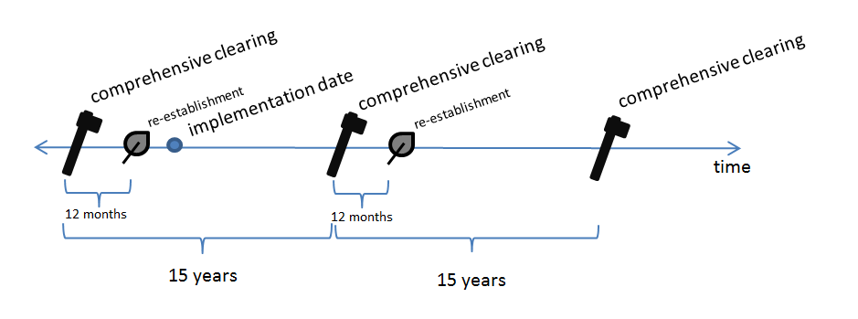

Hybrid baseline management event scenario

The hybrid baseline management event scenario is suitable for project proponents who have evidence of two comprehensive clearings that occurred less than 15 years apart before the implementation date.

Example A—Figure 2

Alice has evidence of two comprehensive clearings, in 1999 and 2006. The two comprehensive clearings define only one interval, so the first interval in Alice’s hybrid baseline management event scenario is the ‘default’ period of 15 years. The second interval is seven years, being the period between 1999 and 2006.

Figure 2—hybrid baseline (re-establishment not shown)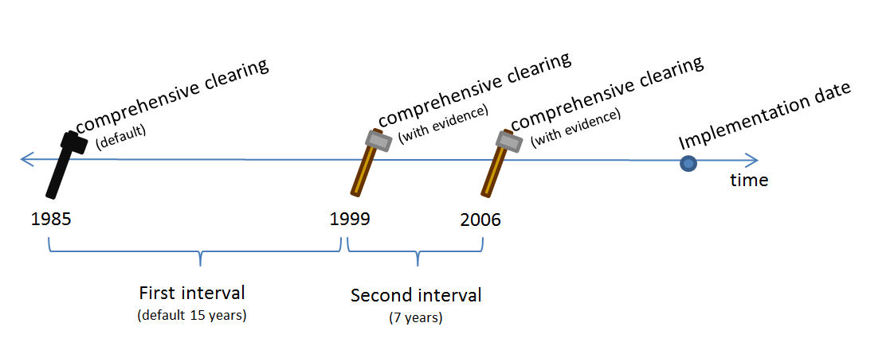
Historic baseline management event scenario
Defining intervals—three comprehensive clearings
Project proponents wishing to use an historic baseline management event scenario must have evidence for at least three comprehensive clearings that occurred in the carbon estimation area before the implementation date.
Example B
Brian has evidence of three comprehensive clearings. The most recent comprehensive clearing occurred in 2006. The others occurred in 1998 and 1992.
These three comprehensive clearings define two intervals. The first interval is 6 years (being the period between 1992 and 1998), and the second interval is 8 years (being the period between 1998 and 2006).
Brian can use these two intervals in the historic baseline management event scenario (Figure 3).
Figure 3—historic baseline with two intervals (re-establishment not shown)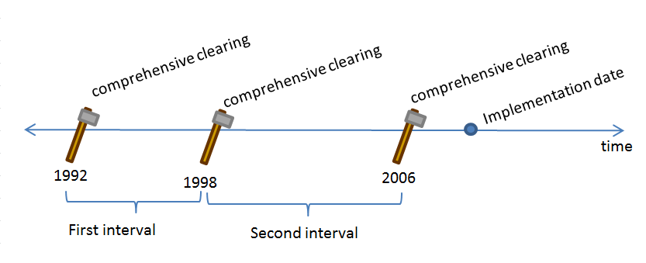

Defining intervals—more than three comprehensive clearings
If they have evidence for more than three comprehensive clearings, project proponents may add intervals to the baseline management event scenario.
Example C
Colin has evidence of four comprehensive clearings.
The most recent comprehensive clearing occurred in 2006. The three earlier comprehensive clearings occurred in 1998, 1992, and 1987.
These comprehensive clearings define three intervals.
The first interval is five years (being the period between 1987 and 1992). The second interval is six years (being the period between 1992 and 1998). The third interval is eight years (being the period between 1998 and 2006).
Colin can use either the second and third intervals, or the first, second and third intervals in the historic baseline management event scenario (Figure 4).
Colin cannot ‘cherry pick’ intervals. For example, Colin cannot use only the first and second intervals (Figure 5). This is because the most recent comprehensive clearing must be used as an endpoint to one of the intervals.
In addition, the comprehensive clearings used to define the intervals must be consecutive. In other words, there cannot be a ‘gap’ between intervals. Colin could not use only the first interval and the third interval (Figure 6).

Figure 4—more than three comprehensive clearings with evidence (re-establishment not shown)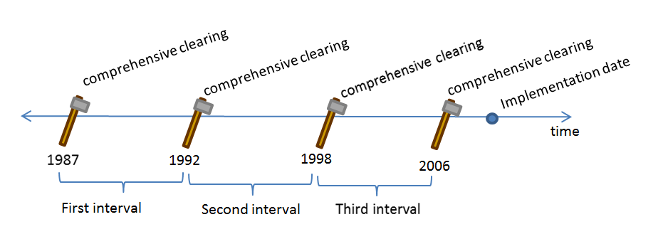

Figure 5—the comprehensive clearing immediately before the implementation date must be used to define an interval (re-establishment not shown)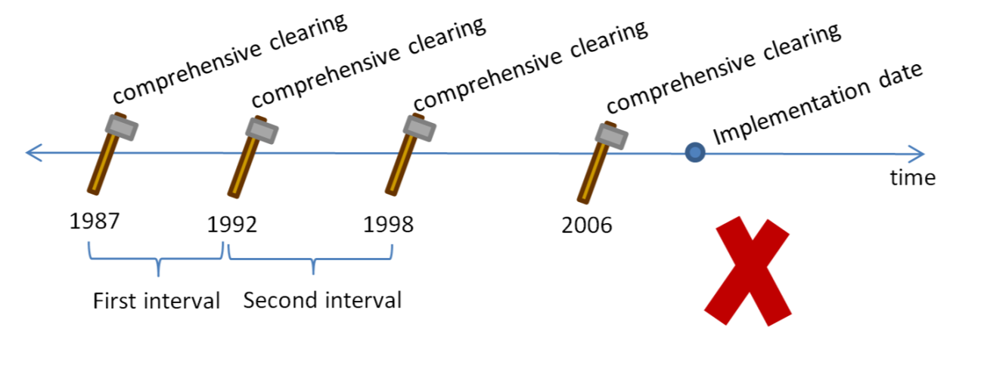

Figure 6—non-consecutive intervals are not allowed (re-establishment not shown)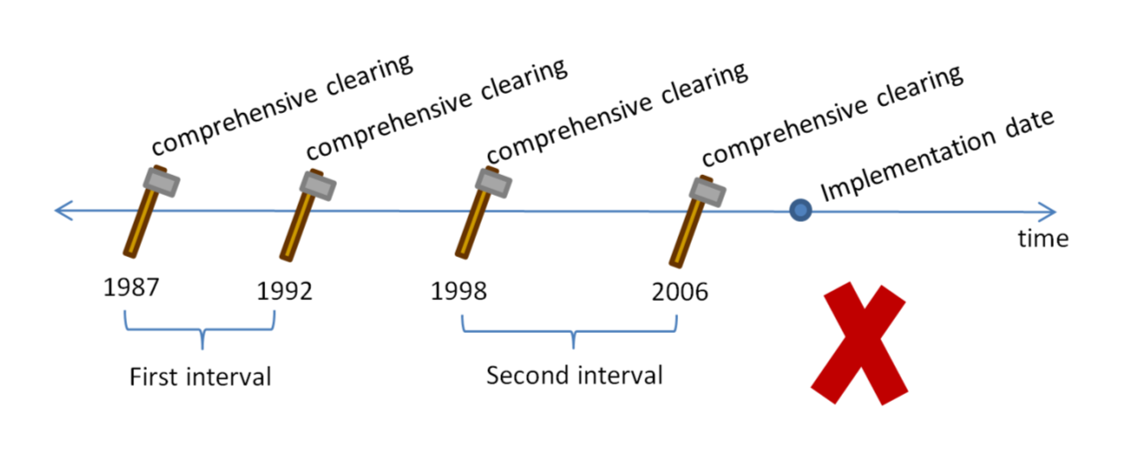

Adding management events
Project proponents may add documented management events other than comprehensive clearings in the intervals.
Example D
Dorothy has evidence of three comprehensive clearings.
The most recent comprehensive clearing occurred in 2006. Two earlier comprehensive clearings occurred in 1998 and 1992.
These comprehensive clearings define two intervals. The first interval is 6 years (being the period between 1992 and 1998). The second interval is 8 years (being the period between 1998 and 2006).
Dorothy also has evidence of fires used for land management in 1995 and 2002. Dorothy may add these additional management events to the baseline management event scenario (Figure 7).
Figure 7—historic baseline with fires (re-establishment not shown)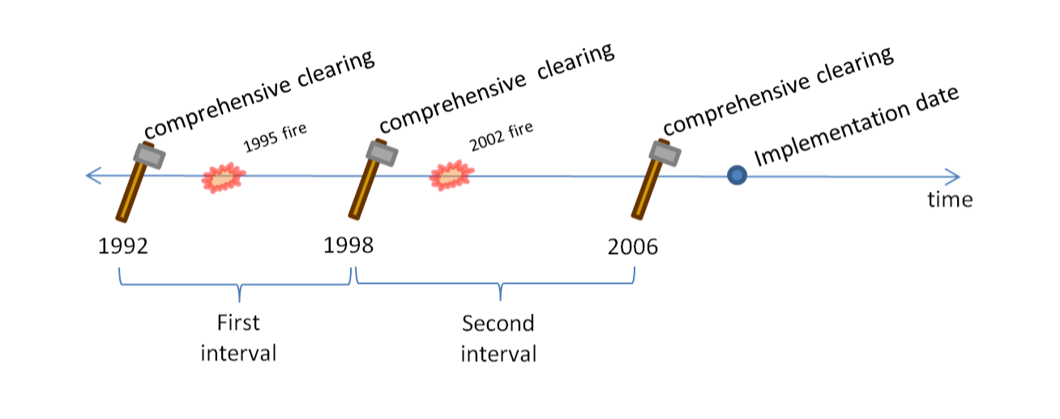

When Dorothy’s baseline management event scenario is modelled in the baseline forecast period, one fire will occur in the first interval three years after the comprehensive clearing at the start of the interval (being the number of years between 1992 and 1995). The other fire will occur in the second interval four years after the comprehensive clearing at the start of that interval (being the number of years between 1998 and 2002).

Attachment B
Statement of Compatibility with Human Rights
Prepared in accordance with Part 3 of the Human Rights (Parliamentary Scrutiny) Act 2011
Carbon Credits (Carbon Farming Initiative) (Native Forest from Managed Regrowth) Methodology Determination 2013

This legislative instrument is compatible with the human rights and freedoms recognised or declared in the international instruments listed in section 3 of the Human Rights (Parliamentary Scrutiny) Act 2011.
Overview of the Legislative Instrument
The Carbon Credits (Carbon Farming Initiative) (Native Forest from Managed Regrowth) Methodology Determination 2013 (the Determination) sets out the detailed rules for implementing and monitoring offsets projects that sequester carbon by establishing permanent native forests from in situ seed sources, including rootstock and lignotubers. The project activities, or ‘mechanism’, involve the management or removal of external pressures that prevent regrowth from occurring. The Determination applies to projects in which land has been cleared of native vegetation and regrowth suppressed.
Project proponents wishing to implement the Determination must make an application to the Clean Energy Regulator (the Regulator) and meet the eligibility requirements set out under the Carbon Credits (Carbon Farming Initiative) Act 2011. Offsets projects that are approved by the Regulator can generate Australian carbon credit units that can be sold to:
- Australian companies that pay the carbon price established under the Clean Energy Act 2011; and
- businesses in Australia wanting to offset their own carbon pollution.
Human rights implications
This legislative instrument does not engage any of the applicable rights or freedoms.
Conclusion
This legislative instrument is compatible with human rights as it does not raise any human rights issues.

Greg Hunt, Minister for the Environment

