Broadcasting Services (Additional Television Licence Condition) Notice 2014
Broadcasting Services Act 1992
The AUSTRALIAN COMMUNICATIONS AND MEDIA AUTHORITY makes this Notice under subsection 43(1) of the Broadcasting Services Act 1992.
Dated 24th September 2014
Chris Chapman Richard Bean
[signed] [signed]
Chair Member/General Manager

Australian Communications and Media Authority

Part 1 Preliminary

1 Name of Notice
This Notice is the Broadcasting Services (Additional Television Licence Condition) Notice 2014.
2 Commencement
This Notice commences on 1 October 2014.
3 Revocation
Under subsection 43(1) of the Act, the Broadcasting Services (Additional Television Licence Condition) Notice 8 November 2007 is revoked.
4 Transitional
An obligation to make or keep records arising under subsections 10(1) 10(2), 10(6) and 10(7) of the Broadcasting Services (Additional Television Licence Condition) Notice 8 November 2007 is taken to be an obligation in relation to those records arising under section 10 of this Notice as applicable.
5 Interpretation
(1) In this Notice:
Act means the Broadcasting Services Act 1992.
eligible periods is defined in item 2.1 of Schedule 2.
licensee, for a commercial television broadcasting licence to which this Notice relates, means the holder of the licence.
local area means an area described in that way in section 7.
material of local significance has the meaning given by section 8.
regional licence area has the meaning given by the Commercial Television Conversion Scheme 1999.
reportable week, in relation to a licensee, means a week for which the licensee has an obligation under this Notice to accumulate points.
timing periods is defined in item 2.2 of Schedule 2.
week means a period of 7 days starting on a Sunday.
Note Other terms defined or used in the Act have the same meaning in this Notice. These include the following:
• ACMA
• licence
• licence area
(2) This Notice includes explanatory comments in Schedule 3, which form part of the Notice.
6 Purpose of Notice
For subsection 43 (1) of the Act, this Notice imposes an additional condition on:
(a) service licence number 85;
(b) service licence number 90;
(c) service licence number 94;
(d) service licence number 95;
(e) service licence number 96;
(f) service licence number 99;
(g) service licence number 103;
(h) service licence number 104;
(i) service licence number 106;
(j) service licence number 107;
(k) service licence number 113;
(l) service licence number 115;
(m) service licence number 116;
(n) service licence number 132;
(o) service licence number 133; and
(p) service licence number 1150806.
7 Local areas
(1) The areas of the commercial television broadcasting licences to which this Notice relates are set out in Parts 1, 2, 3, 4 and 5 of Schedule 1.
(2) For a service licence number mentioned in an item in the following table, the local areas are the areas mentioned in the item.
Item | For the service licence number … | the local areas are …
1 | 113, 115 or 116 | 5 of the 7 areas set out in Part 1 of Schedule 1, chosen by the licensee
2 | 94, 95 or 96 | 4 of the 5 areas set out in Part 2 of Schedule 1, chosen by the licensee
3 | 85, 90 or 99 | all of the areas set out in Part 3 of Schedule 1
4 | 103 or 107 | all of the areas set out in Part 4 of Schedule 1
5 | 104 | the areas set out in Part 4 of Schedule 1 and entitled ‘North Central Victoria’ and ‘South West Victoria’
6 | 106 | the areas set out in Part 4 of Schedule 1 and entitled ‘Upper Murray & Goulburn Valley’ and ‘Gippsland’
7 | 132, 133 or 1150806 | the area set out in Part 5 of Schedule 1
8 Material of local significance
(1) Material that is broadcast to a local area is material of local significance if it relates directly to:
(a) the local area; or
(b) the licensee’s licence area.
Note 1 Not all material of local significance described in subsection (1) will accumulate points in the same way — see Schedule 2.
Note 2 The local area of Tasmania is equal to the licence area for Tasmania.
(2) However:
(a) material in the form of advertising or sponsorship matter, whether or not of a commercial kind, is not material of local significance unless it is a community service announcement; and
(b) material (including a station promotion) that constitutes an announcement that material of local significance will appear later is not material of local significance.
Part 2 Licence conditions

9 Licensee must broadcast material of local significance
A licensee who is the holder of a service licence number mentioned in the table in section 7 must broadcast to each local area for the service licence number, material of local significance in order to accumulate the number of points required in accordance with Schedule 2.

Note Section 9 does not prevent the broadcasting of material of local significance at times outside the eligible periods mentioned in Schedule 2.
10 Records and reporting to the ACMA
(1) A licensee to whom this Notice relates must make a record, in audiovisual form, of material of local significance it has broadcast in its local areas.
(2) A record made under subsection (1) must be:
(a) retained for:
(i) 30 days after the end of the timing period to which the record relates; or
(ii) a longer period specified by the ACMA in a direction under paragraph (3) (c); and
(b) sufficient to verify the times, and the content, of broadcast material that the licensee claims accumulated points.
Note Timing periods are explained in Schedule 2.
(3) The licensee must comply with any directions by the ACMA about:
(a) what a record made under subsection (1) must cover; or
(b) how the record must be made or kept; or
(c) how long the record must be kept.
(4) On request by the ACMA, the licensee must provide the ACMA with access to a record required to be made in accordance with this section.

Note
1. All legislative instruments and compilations are registered on the Federal Register of Legislative Instruments kept under the Legislative Instruments Act 2003. See http://www.frli.gov.au.

Schedule 1 Areas of commercial television broadcasting licences
(section 7)
Part 1 Regional Queensland Licence Area
(service licence numbers 113, 115 and 116)

101 Local Area — Far North Queensland
The Area, in terms of areas defined by the Australian Bureau of Statistics at the Census of 7 August 2001, is:
the Local Government Areas of Atherton (S); Cairns (C); Cardwell (S); Eacham (S) and Johnstone (S); Collection District Numbers 010805, 010806, 010810, 010901, 010902, 010903, 010904, 010905, 010906, 010907, 010908, 010909, 010910, 010911, 010912, 010913, 010914, 010915, 010916, 010917 and 010918 within the Local Government Area of Douglas (S); Collection District Numbers 030801, 030802, 030803, 030806, 030807, 030809, 030810 and 030811 within the Local Government Area of Herberton (S); Collection District Numbers 030303, 030304, 030305, 030306, 030307, 030308, 030309, 030311, 030312, 030313, 030314, 030316, 030317, 030318, 030401, 030402, 030403, 030404, 030405, 030406, 030407, 030408, 030409, 030410, 030411 and 030412 within the Local Government Area of Mareeba (S) in the State of Queensland.

102 Local Area — North Queensland
The Area, in terms of areas defined by the Australian Bureau of Statistics at the Census of 7 August 2001, is:
the Local Government Areas of Burdekin (S); Charters Towers (C); Hinchinbrook (S); Thuringowa (C) and Townsville (C); Collection District Numbers 050401, 050402, 050403, 050404, 050405, 050406, 050407, 050408, 050409, 050410, 050501, 050502, 050503, 050504, 050505, 050506, 050507, 050508, 050509, 050510, 050511 and 050512 within the Local Government Area of Bowen (S); Collection District Numbers 040109, 040111, 040205, 040206 and 040207 within the Local Government Area of Cardwell (S); Collection District Number 031305 within the Local Government Area of Dalrymple (S) in the State of Queensland.

103 Local Area — Capricornia
The Area, in terms of areas defined by the Australian Bureau of Statistics at the Census of 7 August 2001, is:
the Local Government Areas of Calliope (S); Fitzroy (S); Gladstone (C); Mount Morgan (S) and Rockhampton (C); Collection District Numbers 061701, 061702, 061703, 061704, 061705, 061706, 061707, 061708, 061801, 061803, 061804, 061805, 061808, 061809, 061811, 061812, 061901, 061902, 061903, 061904, 061905, 061906, 061907, 061908, 061909, 061910, 061911, 061912, 061913 and 061914 within the Local Government Area of Banana (S); Collection District Numbers 080603, 080604, 080605, 080606 and 080607 within the Local Government Area of Bauhinia (S); Collection District Numbers 080402, 080403, 080404, 080405, 080406, 080407, 080408, 080409, 080410, 080411, 080502, 080503, 080504, 080505, 080506, 080507, 080508, 080509 and 080512 within the Local Government Area of Duaringa (S); Collection District Numbers 080201, 080203, 080204, 080205, 080206, 080207, 080208, 080209, 080210, 080211, 080212, 080213, 080214, 080215, 080216, 080217, 080301, 080302, 080303, 080306, 080307, 080308 and 080310 within the Local Government Area of Emerald (S); Collection District Numbers 060102, 060103, 060104, 060105, 060106, 060107, 060108, 060109, 060110, 060201, 060202, 060203, 060204, 060205, 060206, 060207, 060208, 060209, 060210, 060211, 060212, 060213, 060214, 060215, 060301, 060302, 060303, 060304, 060305, 060306, 060307, 060308, 060309, 060310, 060311, 060312, 060313, 060314, 060315, 060316, 060317, 060318, 062001, 062002, 062003, 062004, 062005, 062006, 062007, 062008, 062009, 062010, 062011 and 062012 within the Local Government Area of Livingstone (S); Collection District Numbers 070701, 070703, 070708, 070709, 070710, 070713, 070714 and 070715 within the Local Government Area of Miriam Vale (S); Collection District Numbers 080102 and 080104 within the Local Government Area of Peak Downs (S) in the State of Queensland.

104 Local Area — Central Coast & Whitsundays
The Area, in terms of areas defined by the Australian Bureau of Statistics at the Census of 7 August 2001, is:
the Local Government Areas of Mackay (C); Mirani (S); Sarina (S) and Whitsunday (S); Collection District Numbers 031502, 031503, 031504, 031505, 031506, 031507, 031508, 031509, 031601, 031604, 031605, 031606, 031607, 031608, 031609, 031610, 031611, 031612 and 031613 within the Local Government Area of Belyando (S); Collection District Numbers 050602, 050603, 050604, 050605, 050606 and 050607 within the Local Government Area of Bowen (S); Collection District Numbers 052301, 052302, 052303, 052304, 052305, 052306, 052308, 052309, 052310 and 052311 within the Local Government Area of Broadsound (S); Collection District Numbers 052001, 052003, 052004, 052005 and 052006 within the Local Government Area of Nebo (S); Collection District Numbers 080101, 080103, 080105 and 080106 within the Local Government Area of Peak Downs (S) in the State of Queensland.

105 Local Area — Wide Bay
The Area, in terms of areas defined by the Australian Bureau of Statistics at the Census of 7 August 2001, is:
the Local Government Areas of Biggenden (S); Bundaberg (C); Burnett (S); Gayndah (S); Hervey Bay (C); Isis (S); Kilkivan (S); Kolan (S); Maryborough (C); Perry (S); Tiaro (S) and Woocoo (S); Collection District Numbers 101101, 101102, 101103, 101104, 101105, 101106, 101107, 101108, 101109, 101110, 101111, 101113, 101114, 101115, 101117, 101118 and 101201 within the Local Government Area of Cooloola (S); Collection District Numbers 072103 and 072104 within the Local Government Area of Eidsvold (S); Collection District Numbers 070702, 070704, 070705, 070706, 070707, 070711, 070712, 070716, 070717 and 070811 within the Local Government Area of Miriam Vale (S); Collection District Numbers 071802, 071803, 071804, 071805, 071806, 071807, 071808 and 071809 within the Local Government Area of Monto (S); Collection District Numbers 072002, 072003 and 072008 within the Local Government Area of Mundubbera (S); Collection District Numbers 101601, 101602 and 101603 within the Local Government Area of Murgon (S); Collection District Number 101703 within the Local Government Area of Wondai (S) in the State of Queensland.

106 Local Area — Sunshine Coast
The Area, in terms of areas defined by the Australian Bureau of Statistics at the Census of 7 August 2001, is:
the Local Government Areas of Maroochy (S) and Noosa (S); Collection District Numbers 111301, 111302, 111303, 111304, 111305, 111306, 111307, 111308, 111309, 111310, 111311, 111312, 111313, 111314, 111315, 111316, 111317, 111318, 111319, 111320, 111321, 111322, 111323, 111324, 111325, 111326, 111327, 111328, 111329, 111401, 111402, 111403, 111404, 111405, 111406, 111407, 111408, 111409, 111410, 111411, 111412, 111413, 111414, 111415, 111501, 111502, 111503, 111504, 111505, 111506, 111507, 111508, 111509, 111510, 111511, 111512, 111513, 111514, 111515, 111516, 111601, 111602, 111603, 111604, 111605, 111606, 111607, 111608, 111609, 111610, 111611, 111612, 111613, 111614, 111615, 111616, 111617, 111618, 111619, 111620, 111701, 111702, 111703, 111704, 111705, 111706, 111707, 111708, 111709, 111710, 111711, 111712, 111713, 111714, 111715, 111801, 111802, 111803, 111804, 111805, 111806, 111807, 111808, 111809, 111810, 111811, 111812, 111813, 111814, 120301, 120302, 120303, 120304, 120305, 120306, 120308, 120309, 120310, 120311, 120312 and 120313 within the Local Government Area of Caloundra (C); Collection District Numbers 100901, 100902, 100903, 100904, 100905, 100906, 100907, 100908, 100909, 100910, 101001, 101002, 101003, 101004, 101005, 101006, 101007, 101008, 101009, 101010, 101011, 101112, 101116, 101202, 101203, 101204, 101205, 101206, 101207, 101208, 101209, 101210, 101211, 101212, 101213, 101214, 101301, 101302, 101303, 101304, 101305, 101306, 101307, 101308, 101309, 101310, 101311, 101312 and 101313 within the Local Government Area of Cooloola (S) in the State of Queensland.

107 Local Area — Darling Downs
The Area, in terms of areas defined by the Australian Bureau of Statistics at the Census of 7 August 2001, is:
Collection District Numbers 050102, 050103 and 050105 within the Local Government Area of Inverell (A); Collection District Number 041509 within the Local Government Area of Moree Plains (A); Collection District Numbers 052501, 052505, 052506 and 052511 within the Local Government Area of Tenterfield (A) in the State of New South Wales; the Local Government Areas of Cambooya (S); Clifton (S); Crow's Nest (S); Dalby (T); Gatton (S); Goondiwindi (T); Inglewood (S); Jondaryan (S); Kingaroy (S); Laidley (S); Millmerran (S); Murgon (S); Nanango (S); Pittsworth (S); Rosalie (S); Stanthorpe (S); Toowoomba (C); Wambo (S) and Warwick (S); Collection District Numbers 081001, 081002, 081003, 081004, 081005, 081006, 081007, 081008, 081009, 081012, 081013, 081014 and 081015 within the Local Government Area of Chinchilla (S); Collection District Numbers 081103, 081104, 081105, 081106, 081107, 081108, 081111 and 081112 within the Local Government Area of Murilla (S); Collection District Numbers 081404, 081405, 081406, 081411, 081412, 081413 and 081414 within the Local Government Area of Tara (S); Collection District Numbers 081809, 081810 and 081811 within the Local Government Area of Waggamba (S); Collection District Numbers 101701, 101702, 101704, 101705, 101706, 101707, 101708, 101709, 101710 and 101711 within the Local Government Area of Wondai (S) in the State of Queensland.

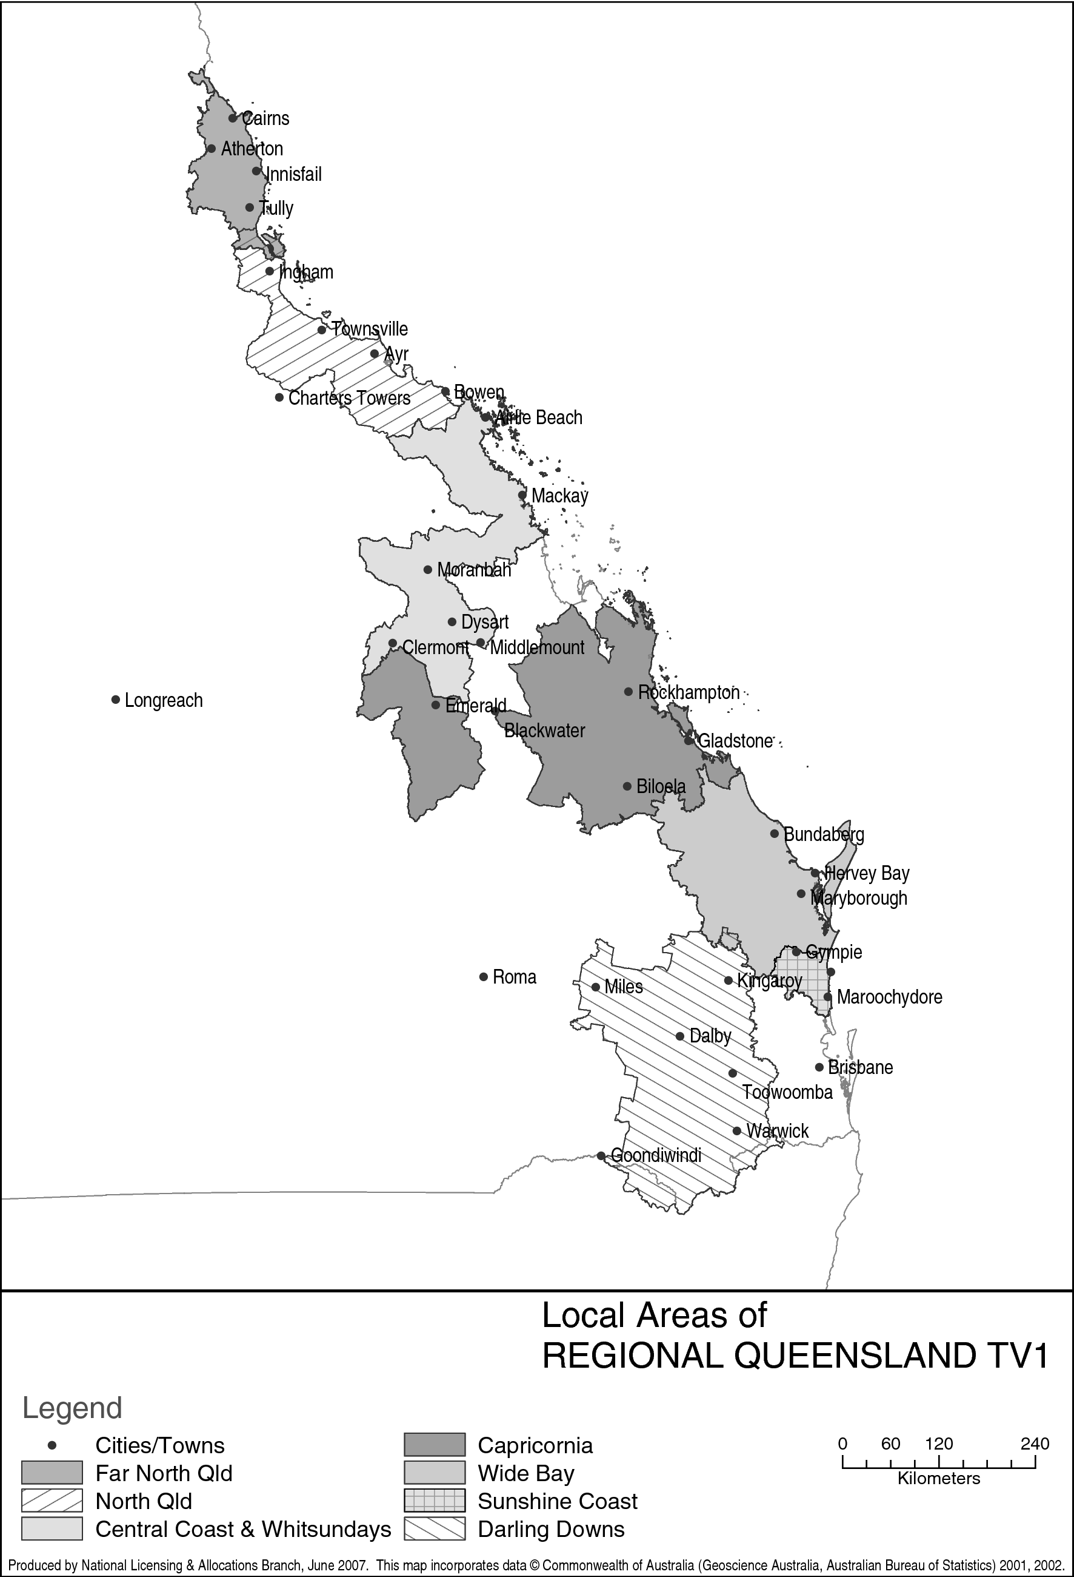
Part 2 Northern NSW Licence Area
(service licence numbers 94, 95 and 96)

201 Local Area — Richmond/Tweed
The Area, in terms of areas defined by the Australian Bureau of Statistics at the Census of 7 August 2001, is:
the Local Government Areas of Ballina (A); Byron (A); Kyogle (A); Lismore (C); Richmond Valley (A) and Tweed (A); Collection District Numbers 052404, 052405, 052406, 052503, 052507, 052510, 052511, 052601, 052602, 052603, 052604, 052605, 052606 and 052607 within the Local Government Area of Tenterfield (A) in the State of New South Wales; Collection District Numbers 160105, 160106, 160107, 160108, 160111, 160113, 160114, 160115, 160116, 160305, 160311, 160312, 160324, 160325, 160401, 160402, 160403, 160404, 160405, 160406, 160407, 160408, 160409, 160410, 160411, 160412, 160413, 160414, 160415, 160416, 160417, 160418, 160419, 160420, 160501, 160502, 160503, 160504, 160505, 160506, 160507, 160508, 160509, 160510, 160511, 160512, 160513, 160514, 160515, 160601, 160602, 160603, 160604, 160605, 160606, 160607, 160608, 160609, 160610, 160611, 160612, 160613, 160614, 160615, 160616, 160617, 160701, 160702, 160703, 160704, 160705, 160706, 160707, 160708, 160709, 160710, 160711, 160712, 160713, 160714, 160715, 160716, 160717, 160801, 160802, 160803, 160804, 160805, 160806, 160807, 160808, 160809, 160810, 160811, 160812, 160813, 160814, 160815, 160816, 160817, 160901, 160902, 160903, 160904, 160905, 160906, 160907, 160908, 160909, 160910, 160911, 160912, 160913, 160914, 160915, 160916, 160917, 160918, 160919, 161001, 161002, 161003, 161004, 161005, 161006, 161007, 161008, 161009, 161010, 161011, 161012, 161013, 161101, 161102, 161103, 161104, 161105, 161106, 161107, 161108, 161109, 161110, 161111, 161201, 161202, 161203, 161204, 161205, 161206, 161207, 161208, 161209, 161210, 161211, 161212, 161213, 161214, 161215, 161301, 161302, 161303, 161304, 161305, 161306, 161307, 161308, 161309, 161310, 161311, 161312, 161313, 161401, 161402, 161403, 161404, 161405, 161406, 161407, 161408, 161409, 161410, 161501, 161502, 161503, 161504, 161505, 161506, 161507, 161508, 161509, 161510, 161511, 161512, 161513, 161514, 161601, 161602, 161603, 161604, 161605, 161606, 161607, 161608, 161609, 161610, 161611, 161612, 161613, 161701, 161702, 161703, 161704, 161705, 161706, 161707, 161708, 161709, 161710, 161711, 161712, 161713, 161714, 161715, 161716, 161717, 161718, 161801, 161802, 161803, 161804, 161805, 161806, 161807, 161808, 161809, 161810, 161811, 161812, 161813, 161814, 161901, 161902, 161903, 161904, 161905, 161906, 161907, 161908, 161909, 161910, 161911, 161912, 162001, 162002, 162003, 162004, 162005, 162006, 162007, 162008, 162009, 162010, 162011, 162101, 162102, 162103, 162104, 162105, 162106, 162107, 162108, 162109, 162110, 162111, 162112, 162113, 162114, 162201, 162202, 162203, 162204, 162205, 162206, 162207, 162208, 162209, 162210, 162211, 162212, 162213, 162214, 162215, 162216, 162301, 162302, 162303, 162304, 162305, 162306, 162307, 162308, 162309, 162310, 162311, 162312, 162313, 162314, 162315, 162401, 162402, 162403, 162404, 162405, 162406, 162407, 162408, 162409, 162410, 162411, 162412, 162413, 162414, 162415, 162416, 162417, 162501, 162502, 162503, 162504, 162505, 162506, 162507, 162508, 162509, 162510, 162511, 162512, 162513, 162514, 162515, 162601, 162602, 162603, 162604, 162605, 162606, 162607, 162608, 162609, 162610, 162611, 162612, 162613, 162614, 162615, 170101, 170102, 170103, 170104, 170105, 170106, 170107, 170108, 170109, 170110, 170111, 170112, 170113, 170201, 170202, 170203, 170204, 170205, 170206, 170207, 170208, 170209, 170210, 170211, 170212, 170213, 170214, 170215, 170216, 170217, 170218, 170219, 170220, 170221, 170222, 170223, 170301, 170302, 170303, 170304, 170305, 170306, 170307, 170308, 170309, 170310, 170311, 170312, 170313, 170314, 170315, 170316, 170317, 170401, 170402, 170403, 170404, 170405, 170406, 170407, 170408, 170409, 170410, 170411, 170412, 170413, 170414, 170415, 170416, 170417, 170418, 170419, 170420, 170421, 170422, 170423, 170424, 170425, 170426, 170427, 170428, 170429, 170501, 170502, 170503, 170504, 170505, 170506, 170507, 170508, 170509, 170510, 170511, 170512, 170513, 170601, 170602, 170603, 170604, 170605, 170606, 170607, 170608, 170609, 170610, 170611, 170612, 170613, 170614, 170615, 170616, 170701, 170702, 170703, 170704, 170705, 170706, 170707, 170708, 170709, 170710, 170711, 170712, 170713, 170714, 170715, 170801, 170802, 170803, 170804, 170805, 170806, 170807, 170808, 170809, 170810, 170811, 170812, 170813, 170901, 170902, 170903, 170904, 170905, 170906, 170907, 170908, 170909, 170910, 170911, 170912, 170913, 170914, 170915, 171001, 171002, 171003, 171004, 171005, 171006, 171007, 171008, 171009, 171010, 171011, 171012, 171013, 171014, 171101, 171102, 171103, 171104, 171105, 171106, 171107, 171108, 171109, 171110, 171111, 171112, 171113, 171114, 171115, 171201, 171202, 171203, 171204, 171205, 171206, 171207, 171208, 171209, 171210, 171211, 171212, 171213, 171214, 171301, 171302, 171303, 171304, 171305, 171306, 171307, 171308, 171309, 171310, 171311, 171312, 171313, 171314, 171315, 171401, 171402, 171403, 171404, 171405, 171406, 171407, 171408, 171409, 171410, 171411, 171412, 171413, 171414, 171415, 171416, 171501, 171502, 171503, 171504, 171505, 171506, 171507, 171508, 171509, 171510, 171511, 171512, 171513, 171514, 171601, 171602, 171603, 171604, 171605, 171606, 171607, 171608, 171609, 171610, 171611, 171612, 171613, 171701, 171702, 171703, 171704, 171705, 171706, 171707, 171708, 171709, 171710, 171711, 171712, 171713, 171801, 171802, 171803, 171804, 171805, 171806, 171807, 171808, 171809, 171810, 171811, 171812, 171813, 171814, 171815, 171816, 171901, 171902, 171903, 171904, 171905, 171906, 171907, 171908, 171909, 171910, 171911, 171912, 171913, 171914, 171915, 171916, 171917, 171918, 172001, 172002, 172003, 172004, 172005, 172006, 172007, 172008, 172009, 172010, 172011, 172012, 172013, 172014, 172015, 172101, 172102, 172103, 172104, 172105, 172106, 172107, 172108, 172109, 172110, 172111, 172112, 172113, 172114, 172115, 172116, 172117, 172118, 172119, 172120 and 172121 within the Local Government Area of Gold Coast (C) in the State of Queensland.

202 Local Area — North West Slopes & Plains
The Area, in terms of areas defined by the Australian Bureau of Statistics at the Census of 7 August 2001, is:
the Local Government Areas of Barraba (A); Bingara (A); Glen Innes (A); Manilla (A); Narrabri (A); Nundle (A); Parry (A); Tamworth (C) and Uralla (A); Collection District Numbers 051701, 051702, 051705, 051706, 051707, 051801, 051802, 051803, 051804, 051805, 051806, 051807, 051808, 051809, 051810, 051901, 051902, 051903, 051904, 051905, 051906, 051907, 051908, 051909, 051910, 051911, 051912, 052001, 052002, 052003, 052004, 052005, 052006, 052007, 052008, 052009, 052010, 052011, 052012, 052013 and 052014 within the Local Government Area of Armidale Dumaresq (A); Collection District Numbers 042301, 042302, 042303, 042304, 042305, 042306, 042307, 042308, 042309, 042310, 042401, 042402, 042403, 042404, 042408, 042501, 042502, 042503, 042504, 042505, 042506, 042507, 042508, 042509, 042510, 042511, 042512, 042601, 042602, 042603, 042604 and 042605 within the Local Government Area of Gunnedah (A); Collection District Numbers 050501, 050502, 050503, 050504, 050505, 050506, 050604, 050606 and 050607 within the Local Government Area of Guyra (A); Collection District Numbers 050101, 050104, 050107, 050109, 050201, 050202, 050203, 050204, 050205, 050206, 050207, 050208, 050209, 050301, 050302, 050303, 050304, 050305, 050306, 050307, 050308, 050401, 050402, 050403, 050404, 050405, 050406, 050407, 050408, 050409, 050410, 050411, 050412, 050413, 050414, 050415 and 050416 within the Local Government Area of Inverell (A); Collection District Numbers 041402, 041403, 041404, 041405, 041406, 041407, 041504, 041505, 041506, 041507, 041508, 041601, 041602, 041603, 041604, 041605, 041606, 041607, 041608, 041801, 041802, 041803, 041804, 041805, 041806, 041807, 041808, 041809, 041810, 041811, 042801, 042802, 042803, 042804, 042805, 042806 and 042807 within the Local Government Area of Moree Plains (A); Collection District Numbers 130101, 130102 and 130104 within the Local Government Area of Murrurundi (A); Collection District Numbers 041701, 041702, 041703, 041704, 041705, 041706, 042703, 042704, 042705, 042706, 042707, 042708 and 042709 within the Local Government Area of Quirindi (A); Collection District Numbers 052205, 052206 and 052207 within the Local Government Area of Severn (A); Collection District Numbers 051601, 051602, 051604, 051606, 051607, 051608 and 051609 within the Local Government Area of Walcha (A); Collection District Numbers 040302, 040304, 040305 and 040309 within the Local Government Area of Walgett (A); Collection District Numbers 041901, 041903, 041904, 041905, 041906, 041907, 041908, 041909, 041910, 041911, 041912, 041913 and 041914 within the Local Government Area of Yallaroi (A) in the State of New South Wales.

203 Local Area — Northern Rivers & Mid North Coast
The Area, in terms of areas defined by the Australian Bureau of Statistics at the Census of 7 August 2001, is:
the Local Government Areas of Bellingen (A); Coffs Harbour (C); Grafton (C); Kempsey (A); Maclean (A); Nambucca (A) and Pristine Waters (A); Collection District Numbers 060403, 060405, 060406, 060407, 060408, 060409, 060410, 060411, 060412 and 060413 within the Local Government Area of Copmanhurst (A); Collection District Numbers 110103, 110104, 110105, 110106, 110107, 110108, 110109, 110110, 110111, 110112, 110113 and 110114 within the Local Government Area of Gloucester (A); Collection District Numbers 091601, 091602, 091603, 091604, 091605, 091606, 091607, 091608, 091609, 091610, 091611, 091701, 091702, 091703, 091704, 091705, 091706, 091707, 091708, 091709, 091710, 091801, 091802, 091803, 091804, 091805, 091806, 091807, 091808, 091809, 091810, 091811, 091903, 092006, 092013, 092401, 092402, 092403, 092404, 092405, 092406, 092407, 092408, 092409, 092410, 092411, 092412, 092601, 092602, 092603, 092604, 092605, 092606, 092607, 092608, 092609 and 092610 within the Local Government Area of Great Lakes (A); Collection District Numbers 090903, 090904, 090905, 090906, 090907, 090908, 090909, 090910, 090911, 090913, 091001, 091002, 091003, 091004, 091005, 091006, 091007, 091008, 091009, 091010, 091011, 091012, 091013, 091101, 091102, 091103, 091104, 091105, 091106, 091107, 091108, 091109, 091110, 091111, 091112, 091201, 091202, 091203, 091204, 091205, 091206, 091207, 091208, 091209, 091210, 091211, 091212, 091213, 091301, 091302, 091303, 091304, 091305, 091306, 091307, 091401, 091402, 091403, 091404, 091405, 091406, 091407, 091408, 091409, 091410, 091411, 091501, 091502, 091503, 091504, 091505, 091506, 091507, 091508, 091509, 091510, 091511, 091512, 092301, 092302, 092303, 092304, 092305, 092306, 092307, 092308, 092309 and 092310 within the Local Government Area of Greater Taree (C); Collection District Numbers 090101, 090104, 090105, 090106, 090107, 090108, 090109, 090110, 090111, 090201, 090202, 090203, 090204, 090205, 090206, 090207, 090208, 090209, 090210, 090211, 090212, 090213, 090301, 090302, 090303, 090304, 090305, 090306, 090307, 090308, 090309, 090310, 090311, 090312, 090313, 090401, 090402, 090403, 090404, 090405, 090406, 090407, 090408, 090409, 090410, 090411, 090501, 090502, 090503, 090504, 090505, 090506, 090507, 090508, 090509, 090510, 090511, 090512, 090601, 090602, 090603, 090604, 090605, 090606, 090607, 090608, 090609, 090610, 090611, 090612, 090701, 090702, 090703, 090704, 090705, 090706, 090707, 090708, 090709, 090710, 090711, 090712, 090713, 090714, 090715, 090716, 090802, 090805, 090806, 090807, 090809, 090810, 092201, 092202, 092203, 092204, 092205, 092206, 092207, 092208, 092209, 092501, 092502, 092503, 092504, 092505, 092506, 092507, 092508, 092509, 092510 and 092511 within the Local Government Area of Hastings (A) in the State of New South Wales.

204 Local Area — Hunter
The Area, in terms of areas defined by the Australian Bureau of Statistics at the Census of 7 August 2001, is:
the Local Government Areas of Cessnock (C); Dungog (A); Lake Macquarie (C); Maitland (C); Muswellbrook (A); Newcastle (C); Port Stephens (A); Scone (A) and Singleton (A); Collection District Numbers 091901, 091902, 091904, 091905, 091906, 091907, 091908, 091909, 091910, 091911, 092001, 092002, 092003, 092004, 092005, 092007, 092008, 092009, 092010, 092011, 092012 and 092014 within the Local Government Area of Great Lakes (A); Collection District Numbers 130201, 130202, 130203, 130204, 130205, 130206, 130207 and 130209 within the Local Government Area of Merriwa (A); Collection District Numbers 130103, 130105, 130106, 130107 and 130108 within the Local Government Area of Murrurundi (A) in the State of New South Wales.

205 Local Area — Central Coast
The Area, in terms of areas defined by the Australian Bureau of Statistics at the Census of 7 August 2001, is:
the Local Government Areas of Gosford (C) and Wyong (A) in the State of New South Wales.

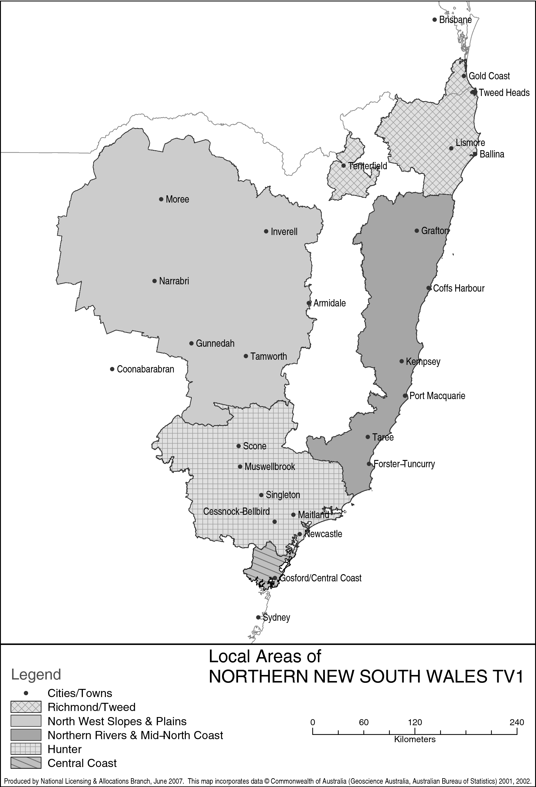
Part 3 Southern NSW Licence Area
(service licence numbers 85, 90 and 99)

301 Local Area — Central Tablelands & Central Western Slopes
The Area, in terms of areas defined by the Australian Bureau of Statistics at the Census of 7 August 2001, is:
the Local Government Areas of Bathurst (C); Blayney (A); Cabonne (A); Coolah (A); Coonabarabran (A); Coonamble (A); Cowra (A); Dubbo (C); Evans (A); Forbes (A); Gilgandra (A); Narromine (A); Orange (C); Parkes (A); Weddin (A) and Wellington (A); Collection District Numbers 150104, 150201, 150202, 150301, 150302, 150303, 150304, 150305, 150306, 150307, 150308, 150309 and 150310 within the Local Government Area of Bland (A); Collection District Numbers 030102, 030103, 030109 and 030110 within the Local Government Area of Bogan (A); Collection District Numbers 151601, 151602, 151603, 151605, 151606, 151607, 151608 and 151610 within the Local Government Area of Boorowa (A); Collection District Numbers 021201, 021203, 021204, 021205, 021206, 021207, 021208 and 021209 within the Local Government Area of Cobar (A); Collection District Numbers 151901, 151902, 151903, 151904, 151906, 151907 and 151908 within the Local Government Area of Crookwell (A); Collection District Numbers 142101, 142102, 142103, 142104, 142105, 142108, 142109, 142201, 142202, 142204, 142205, 142207, 142208, 142209, 142210, 142211, 142212, 142301, 142302, 142303, 142304, 142305, 142306, 142307, 142308, 142309, 142310, 142311, 142312, 142313, 142401, 142402, 142403, 142404, 142405, 142406, 142407, 142408, 142409, 142410 and 142411 within the Local Government Area of Greater Lithgow (C); Collection District Numbers 030205, 030303, 030304, 030305, 030306, 030401, 030402, 030403, 030404, 030405 and 030406 within the Local Government Area of Lachlan (A); Collection District Number 130208 within the Local Government Area of Merriwa (A); Collection District Numbers 032401, 032402, 032403, 032404, 032405, 032406, 032407, 032408, 032409, 032501, 032502, 032503, 032504, 032505, 032506, 032507, 032508, 032509, 032510, 032511, 032512, 032513, 032514, 032515, 032516, 032601, 032604, 032605, 032608, 032609, 032801, 032802, 032803, 032804, 032805, 032806, 032807, 032808 and 032809 within the Local Government Area of Mudgee (A); Collection District Numbers 142001, 142002, 142003, 142004, 142005, 142006, 142007, 142010 and 142011 within the Local Government Area of Oberon (A); Collection District Numbers 142504, 142507, 142508, 142509, 142510, 142511, 142512 and 142513 within the Local Government Area of Rylstone (A); Collection District Numbers 031401, 031403, 031404, 031405, 031501, 031502, 031503, 031504, 031505, 031506 and 031507 within the Local Government Area of Warren (A); Collection District Numbers 150603, 150604, 150605, 150607, 150608, 150609 and 150610 within the Local Government Area of Young (A) in the State of New South Wales.

302 Local Area — South Western Slopes & Eastern Riverina
The Area, in terms of areas defined by the Australian Bureau of Statistics at the Census of 7 August 2001, is:
the Local Government Areas of Coolamon (A); Cootamundra (A); Gundagai (A); Harden (A); Junee (A); Lockhart (A); Temora (A); Tumut (A); Wagga Wagga (C) and Weddin (A); Collection District Numbers 150104, 150106, 150107, 150201, 150202, 150203, 150204, 150205, 150206, 150302, 150303, 150304, 150305, 150306, 150307, 150308, 150309 and 150310 within the Local Government Area of Bland (A); Collection District Numbers 151604, 151606, 151607, 151608 and 151609 within the Local Government Area of Boorowa (A); Collection District Numbers 012001, 012002, 012003, 012004, 012005, 012006, 012007, 012008, 012009, 012101, 012102, 012104, 012105 and 012106 within the Local Government Area of Narrandera (A); Collection District Numbers 152801, 152802, 152901, 152902 and 152903 within the Local Government Area of Tumbarumba (A); Collection District Numbers 160102 and 160108 within the Local Government Area of Urana (A); Collection District Numbers 152201, 152202, 152203, 152204, 152205, 152206, 152207, 152208, 152301, 152302, 152303, 152304, 152305, 152306, 152307 and 152308 within the Local Government Area of Yass (A); Collection District Numbers 150601, 150602, 150603, 150604, 150605, 150606, 150608, 150609, 150610, 150611, 150612, 150613, 150701, 150702, 150703, 150704, 150705, 150706, 150707, 150708, 150709, 150710, 150711 and 150712 within the Local Government Area of Young (A) in the State of New South Wales.

303 Local Area — Illawarra & South Coast
The Area, in terms of areas defined by the Australian Bureau of Statistics at the Census of 7 August 2001, is:
the Local Government Areas of Bega Valley (A); Eurobodalla (A); Kiama (A); Shellharbour (C); Shoalhaven (C) and Wollongong (C); Collection District Numbers 200101 and 200102 within the Local Government Area of Mulwaree (A); Collection District Number 170703 within the Local Government Area of Tallaganda (A); Collection District Numbers 200601, 200602, 200605, 200606, 200607, 200608, 200609, 200610, 200611, 200612, 200613, 200614, 200701, 200702, 200704, 200705, 200706, 200707, 200708, 200709, 200710, 200711, 200712, 200713, 200714, 200715, 200801, 200802, 200803, 200804, 200805, 200806, 200807, 200808, 200809, 200810, 200811, 200812, 200813, 200814, 200815, 200816, 200817, 200901, 200902, 200903, 200904, 200905, 200906, 200907, 200908, 200909, 201001, 201002, 201003, 201004, 201005, 201006, 201007, 201008, 201009, 201010, 201011, 201012, 201013, 201014, 201101, 201102, 201103, 201104, 201105, 201106, 201107, 201108, 201109, 201110, 201111 and 201112 within the Local Government Area of Wingecarribee (A) in the State of New South Wales; Collection District Numbers 030101, 030102 and 030103 within the Local Government Area of Unincorp. Other Territories in Australia's Other Territories.

304 Local Area — ACT & Southern Tablelands
The Area, in terms of areas defined by the Australian Bureau of Statistics at the Census of 7 August 2001, is:
the Local Government Areas of Bombala (A); Cooma-Monaro (A); Goulburn (C); Gunning (A); Queanbeyan (C); Snowy River (A); Yarrowlumla (A) and Yass (A); Collection District Numbers 200105, 200106, 200107, 200108, 200207 and 200208 within the Local Government Area of Mulwaree (A); Collection District Numbers 170701, 170702, 170704, 170708 and 170709 within the Local Government Area of Tallaganda (A) in the State of New South Wales; the Local Government Area of Unincorporated ACT in the Australian Capital Territory.

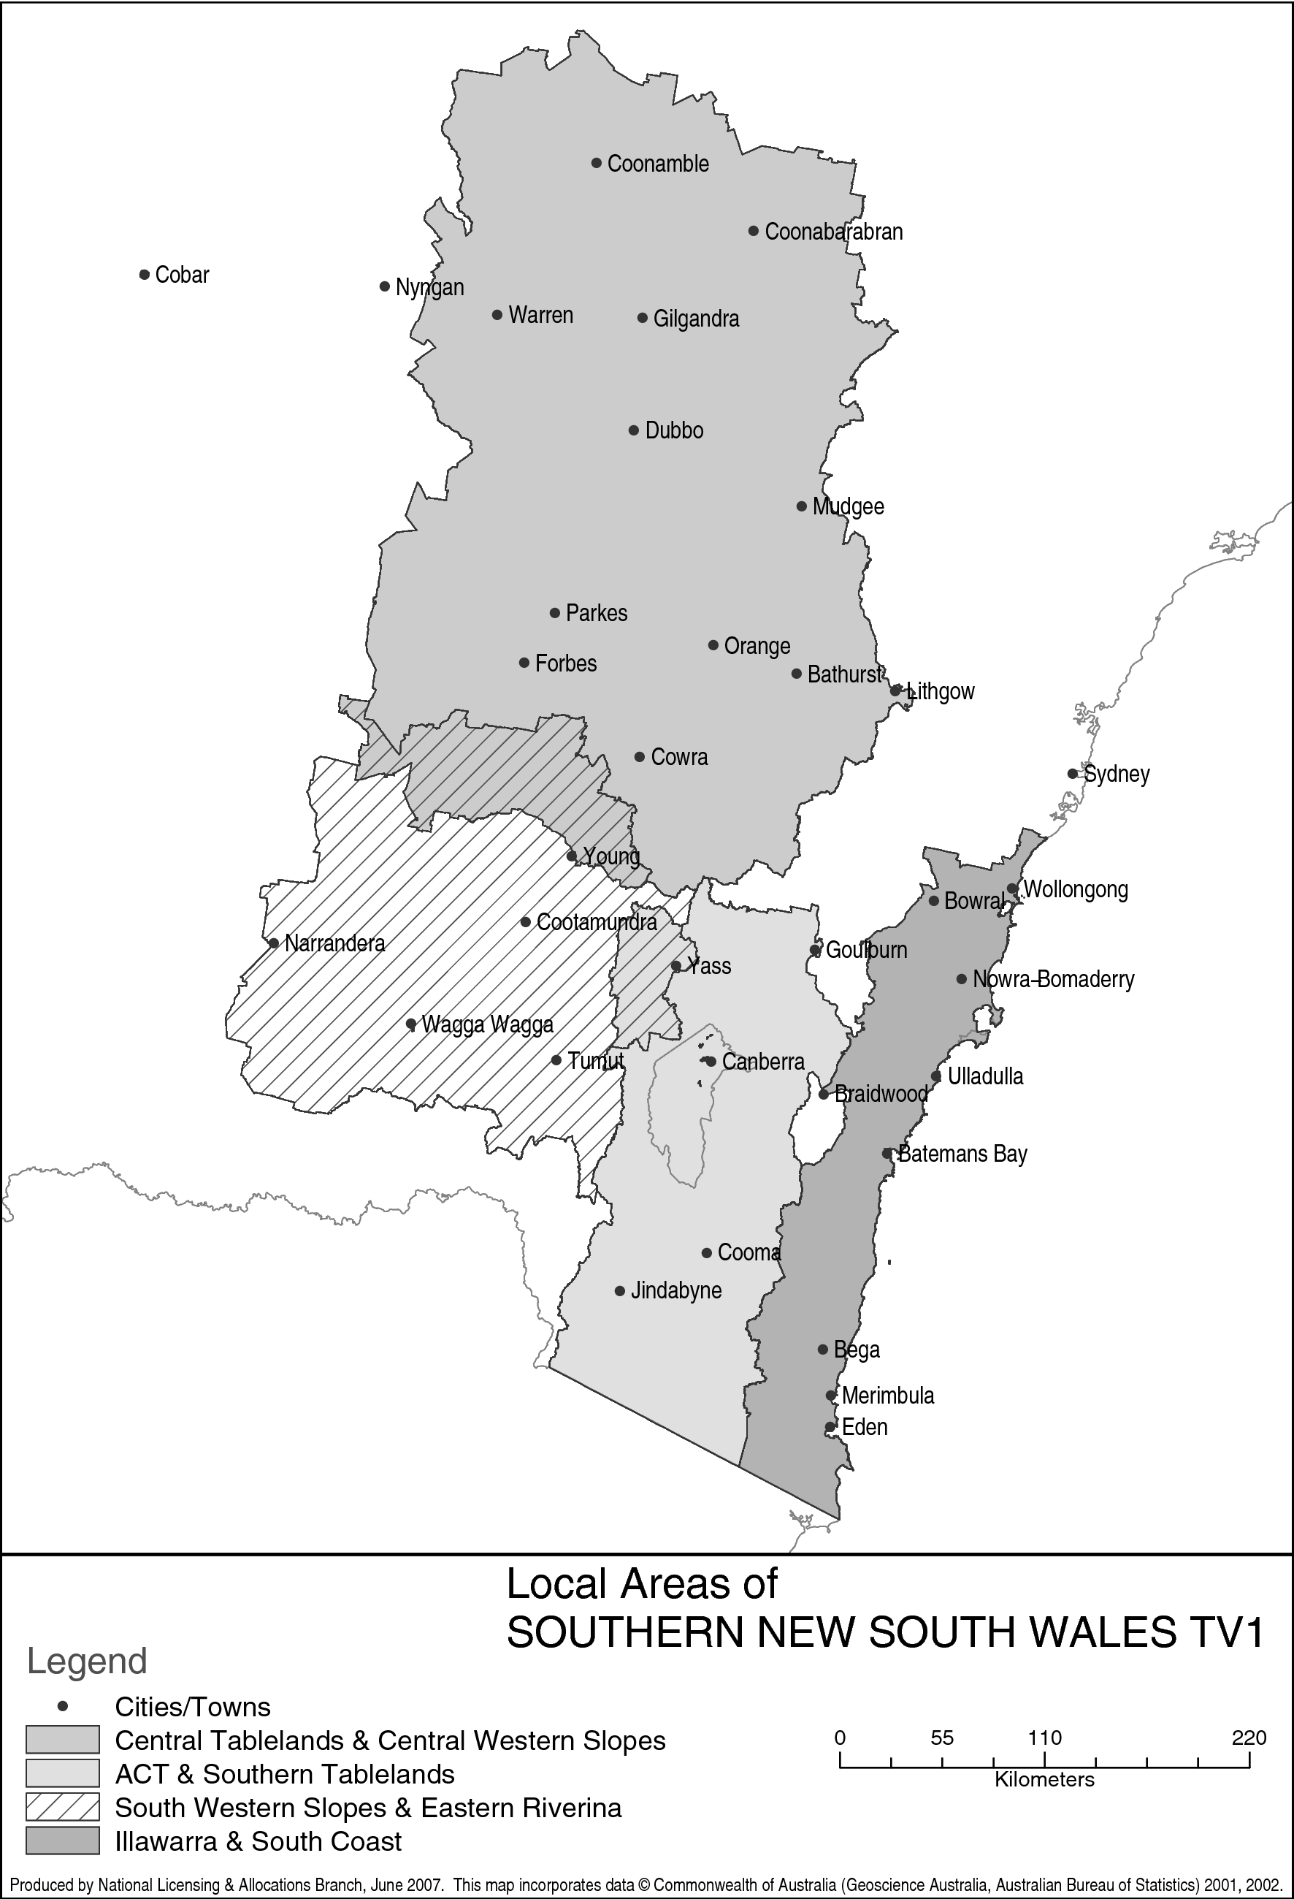
Part 4 Regional Victoria Licence Area
(service licence numbers 103, 104, 106 and 107)

401 Local Area — Upper Murray & Goulburn Valley
The Area, in terms of areas defined by the Australian Bureau of Statistics at the Census of 7 August 2001, is:
the Local Government Areas of Albury (C); Berrigan (A); Corowa (A); Culcairn (A); Deniliquin (A); Holbrook (A) and Hume (A); Collection District Numbers 010902, 010903, 010904 and 010905 within the Local Government Area of Conargo (A); Collection District Numbers 011203, 011204 and 011205 within the Local Government Area of Jerilderie (A); Collection District Number 152907 within the Local Government Area of Tumbarumba (A); Collection District Numbers 160105, 160106 and 160107 within the Local Government Area of Urana (A) in the State of New South Wales; the Local Government Areas of Indigo (S); Towong (S); Wangaratta (RC) and Wodonga (RC); Collection District Numbers 032001, 032002, 032003, 032004, 032005, 032006, 032007, 032008, 032009, 032010, 032011, 032012, 032013, 032101, 032102, 032103, 032104, 032105, 032106, 032107, 032108, 032109, 032110, 032111, 032201, 032202, 032203, 032204, 032205, 032206, 032208, 032209 and 032210 within the Local Government Area of Alpine (S); Collection District Numbers 050401, 050402, 050403, 050404, 050405, 050406, 050407, 050408, 050409, 050410, 050411, 050412, 050413, 050501, 050502, 050503, 050504, 050505, 050506, 050507, 050508, 050509, 050510, 050511, 050512, 050513, 050701, 050702, 050703, 050704, 050705, 050706, 050707, 050708, 050709, 050710, 050711, 050801, 050802, 050804, 050805, 050806, 050807, 050808, 050809, 050810, 050811 and 050812 within the Local Government Area of Delatite (S); Collection District Numbers 021214, 021301, 021302, 021303, 021304, 021305, 021306, 021307, 021308, 021309, 021310, 021401, 021402, 021403, 021404, 021405, 021406, 021407, 021408, 021409, 021410, 021411, 021412, 021413, 021414, 021501, 021502, 021503, 021504, 021505, 021506, 021507, 021508, 021509, 021510, 021601, 021602, 021603, 021604, 021605, 021606, 021607, 021608, 021609, 021610, 021701, 021702, 021703, 021704, 021705, 021706, 021707, 021708, 021709, 021710, 021711, 021712, 021801, 021802, 021803, 021804, 021805, 021806, 021807, 021808, 021809, 021810, 021811 and 021812 within the Local Government Area of Greater Shepparton (C); Collection District Numbers 030101, 030102, 030103, 030104, 030105, 030106, 030107, 030108, 030109, 030201, 030202, 030203, 030204, 030205, 030206, 030207, 030208, 030209, 030210, 030301, 030302, 030303, 030304, 030305, 030306, 030307, 030308, 030309, 030310, 030311, 030312, 030313, 031201, 031202, 031203, 031204, 031205, 031206, 031207, 031208, 031209, 031210, 031211, 032310, 032311 and 032312 within the Local Government Area of Moira (S); Collection District Numbers 050206, 050901, 050903, 050904, 050905, 050907, 050908, 050909, 050911, 051001, 051002, 051003, 051004, 051005, 051006, 051007, 051008, 051009, 051010, 051101, 051102, 051103, 051104, 051105, 051106, 051107, 051108, 051109, 051110, 051111, 051112, 051113 and 051114 within the Local Government Area of Murrindindi (S); Collection District Numbers 050105, 050207, 050208, 050209, 050302, 050303, 050304, 050305 and 050308 within the Local Government Area of Strathbogie (S) in the State of Victoria.

402 Local Area — North Central Victoria
The Area, in terms of areas defined by the Australian Bureau of Statistics at the Census of 7 August 2001, is:
the Local Government Area of Wakool (A); Collection District Numbers 010101, 010102 and 010109 within the Local Government Area of Balranald (A); Collection District Numbers 010702, 010703, 010704, 010705, 010706, 010707, 010708, 010709, 010710, 010711, 010712, 010713, 010714, 010715 and 010716 within the Local Government Area of Murray (A) in the State of New South Wales; the Local Government Areas of Buloke (S); Campaspe (S); Central Goldfields (S); Gannawarra (S); Greater Bendigo (C); Hepburn (S); Loddon (S) and Mount Alexander (S); Collection District Numbers 020411, 020412, 021101, 021102, 021103, 021104, 021105, 021106, 021107, 021108, 021109, 021110, 021111, 021112, 021113, 021114, 021201, 021202, 021203, 021204, 021205, 021206, 021207, 021208, 021209, 021210, 021211, 021212, 021213 and 021215 within the Local Government Area of Greater Shepparton (C); Collection District Numbers 060301, 060302, 060303, 060304, 060305, 060306, 060307, 060308, 060309, 060310, 060311, 060401, 060403, 060404, 060405, 060406, 060410, 060801, 060802, 060803, 060804, 060805, 060806, 060807 and 060808 within the Local Government Area of Macedon Ranges (S); Collection District Numbers 050602, 050604, 050606, 050607, 050611, 051201, 051202, 051203, 051204, 051205, 051206, 051207, 051208, 051301, 051302, 051303, 051304, 051305, 051306, 051307, 051308, 051309, 051401, 051403, 051404, 051405 and 051407 within the Local Government Area of Mitchell (S); Collection District Numbers 032301, 032302, 032303, 032304, 032305, 032306, 032307, 032308 and 032309 within the Local Government Area of Moira (S); Collection District Numbers 071901, 071902, 071903, 071904, 071905, 072001, 072002, 072003, 072004 and 072005 within the Local Government Area of Northern Grampians (S); Collection District Numbers 082301, 082302, 082303, 082304, 082305, 082306 and 082307 within the Local Government Area of Pyrenees (S); Collection District Numbers 050101, 050102, 050103, 050104, 050106, 050107, 050108, 050109, 050201, 050202, 050203, 050204, 050205, 050301, 050306 and 050307 within the Local Government Area of Strathbogie (S); Collection District Numbers 010707, 010801, 010802, 010803, 010804, 010805, 010806, 010807, 010808, 010809, 010810, 010901, 010902, 010903, 010904, 010905, 010906, 010907, 010908, 010909, 010910, 010911, 010912, 011001, 011002, 011003, 011004, 011005, 011006, 011007, 011008, 012201, 012202, 012203, 012204, 012205, 012206, 012207 and 012208 within the Local Government Area of Swan Hill (RC); Collection District Numbers 011302, 011304, 011306, 011307 and 011309 within the Local Government Area of Yarriambiack (S) in the State of Victoria.

403 Local Area — South West Victoria
The Area, in terms of areas defined by the Australian Bureau of Statistics at the Census of 7 August 2001, is:
the Local Government Areas of Ararat (RC); Ballarat (C); Colac-Otway (S); Corangamite (S); Golden Plains (S); Hindmarsh (S); Horsham (RC); Moyne (S); Southern Grampians (S) and Warrnambool (C); Collection District Numbers 091101, 091102, 091103, 091104, 091105, 091106, 091107, 091108, 091202, 091203, 091204, 091205, 091301, 091302, 091303, 091305, 091306, 091307, 091308, 091309, 091310, 091311, 091312, 091313, 091314, 091401, 091402, 091403, 091404, 091405, 091406, 091407, 091408, 091501, 091502, 091503, 091504, 091505, 091506, 091507, 091508 and 091509 within the Local Government Area of Glenelg (S); Collection District Number 111301 within the Local Government Area of Greater Geelong (C); Collection District Numbers 080501, 080502, 080503, 080504, 080505, 080506, 080507, 080508, 080509, 080510, 080511, 080512, 081101, 081102, 081103, 081104, 081105, 081106, 081107, 081108, 081109, 081110, 081111 and 081112 within the Local Government Area of Moorabool (S); Collection District Numbers 070201, 070202, 070203, 070204, 070205, 070206, 070207, 070208, 070209, 070210, 070211, 070212, 070801, 070802, 070803, 070804, 070805, 070806, 070807, 070808, 070809, 070810 and 070811 within the Local Government Area of Northern Grampians (S); Collection District Numbers 080401, 080402, 080403, 080404, 080405, 080406, 080407, 080408, 080409, 082308, 082309, 082310 and 082311 within the Local Government Area of Pyrenees (S); Collection District Numbers 100104, 100105, 100106, 100107, 100108, 100109, 100112, 101401, 101402, 101403, 101404, 101406 and 101407 within the Local Government Area of Surf Coast (S); Collection District Number 091808 within the Local Government Area of Unincorporated Vic; Collection District Numbers 090101, 090103, 090105, 090106, 090107, 090108, 090109, 090110, 090111, 090201, 090202, 090203, 090204, 090205, 090206, 090207, 090208, 090209, 090210 and 090211 within the Local Government Area of West Wimmera (S); Collection District Numbers 012003, 012004, 012005, 012006, 012007, 012008, 012009, 012010, 012011, 012012, 012101, 012102, 012103, 012104, 012105, 012106, 012107 and 012108 within the Local Government Area of Yarriambiack (S) in the State of Victoria.

404 Local Area — Gippsland
The Area, in terms of areas defined by the Australian Bureau of Statistics at the Census of 7 August 2001, is:
the Local Government Area of Latrobe (C); Collection District Numbers 200201, 200205, 200206, 200207, 200208, 200209, 200210, 200211, 200212 and 200213 within the Local Government Area of Bass Coast (S); Collection District Numbers 180201, 180202, 180203, 180204, 180205, 180206, 180207, 180208, 180209, 180402, 180403, 180404, 180405, 180406, 180407, 180408, 180409, 180410, 180411, 180501, 180502, 180503, 180504, 180505, 180506, 180507, 180508, 180509, 180510, 180511, 180512, 180513, 180801, 180802, 180803, 180804, 180805, 180806, 180807, 180808, 180809, 180810, 180811, 180901, 180902, 180903, 180904, 180905, 180906, 180907, 180908, 180909 and 180910 within the Local Government Area of Baw Baw (S); Collection District Numbers 040202, 040205, 040206, 040207, 040208, 040209, 040210, 040211, 040301, 040302, 040303, 040304, 040305, 040306, 040307, 040308, 040309, 040310, 040311, 040312, 040313, 040314, 040315, 040401, 040402, 040403, 040404, 040405, 040406, 040407, 040408, 040501, 040502, 040503, 040504, 040505, 040506, 040601, 040602, 040603, 040604, 040605, 040606, 040607, 040608, 040609, 040610, 040701, 040702, 040703, 040704, 040705, 040706, 040707, 040708, 040709, 040710, 040801, 040802, 040803, 040804, 040805, 040806, 040807, 040808, 040809, 040901, 040902, 040903, 040904, 040905, 040906, 040907, 040908, 040909, 040910 and 040911 within the Local Government Area of East Gippsland (S); Collection District Numbers 200202, 200203, 200204, 200214, 200215, 200301, 200302, 200304, 200305, 200306, 200307, 200308, 200309, 200310, 200311, 200312, 200401, 200402, 200403, 200404, 200405, 200406, 200407, 200408, 200409, 200410, 200411, 200412, 200413, 200501, 200502, 200503, 200504, 200505, 200506, 200507, 200508, 200509, 200601, 200602, 200603, 200604, 200605, 200606, 200607, 200608, 200609 and 200610 within the Local Government Area of South Gippsland (S); Collection District Numbers 041001, 041002, 041003, 041004, 041005, 041006, 041007, 041008, 041101, 041102, 041103, 041104, 041105, 041106, 041107, 041108, 041109, 041110, 041111, 041202, 041204, 041205, 041206, 041207, 041208, 041209, 041210, 041301, 041302, 041303, 041304, 041305, 041306, 041307, 041308, 041309, 041310, 041311, 041312, 041401, 041402, 041403, 041404, 041405, 041406, 041407, 041408, 041409, 041410, 041411, 041412, 041413, 041501, 041502, 041503, 041504, 041505, 041506, 041507, 041508, 041509, 041601, 041602, 041603, 041604, 041605, 041606, 041607, 041608, 041609, 041610, 041611, 041612, 041613, 041701, 041702, 041703, 041704, 041705, 041706, 041707, 041708, 041709, 041710, 041711, 041712 and 041713 within the Local Government Area of Wellington (S) in the State of Victoria.

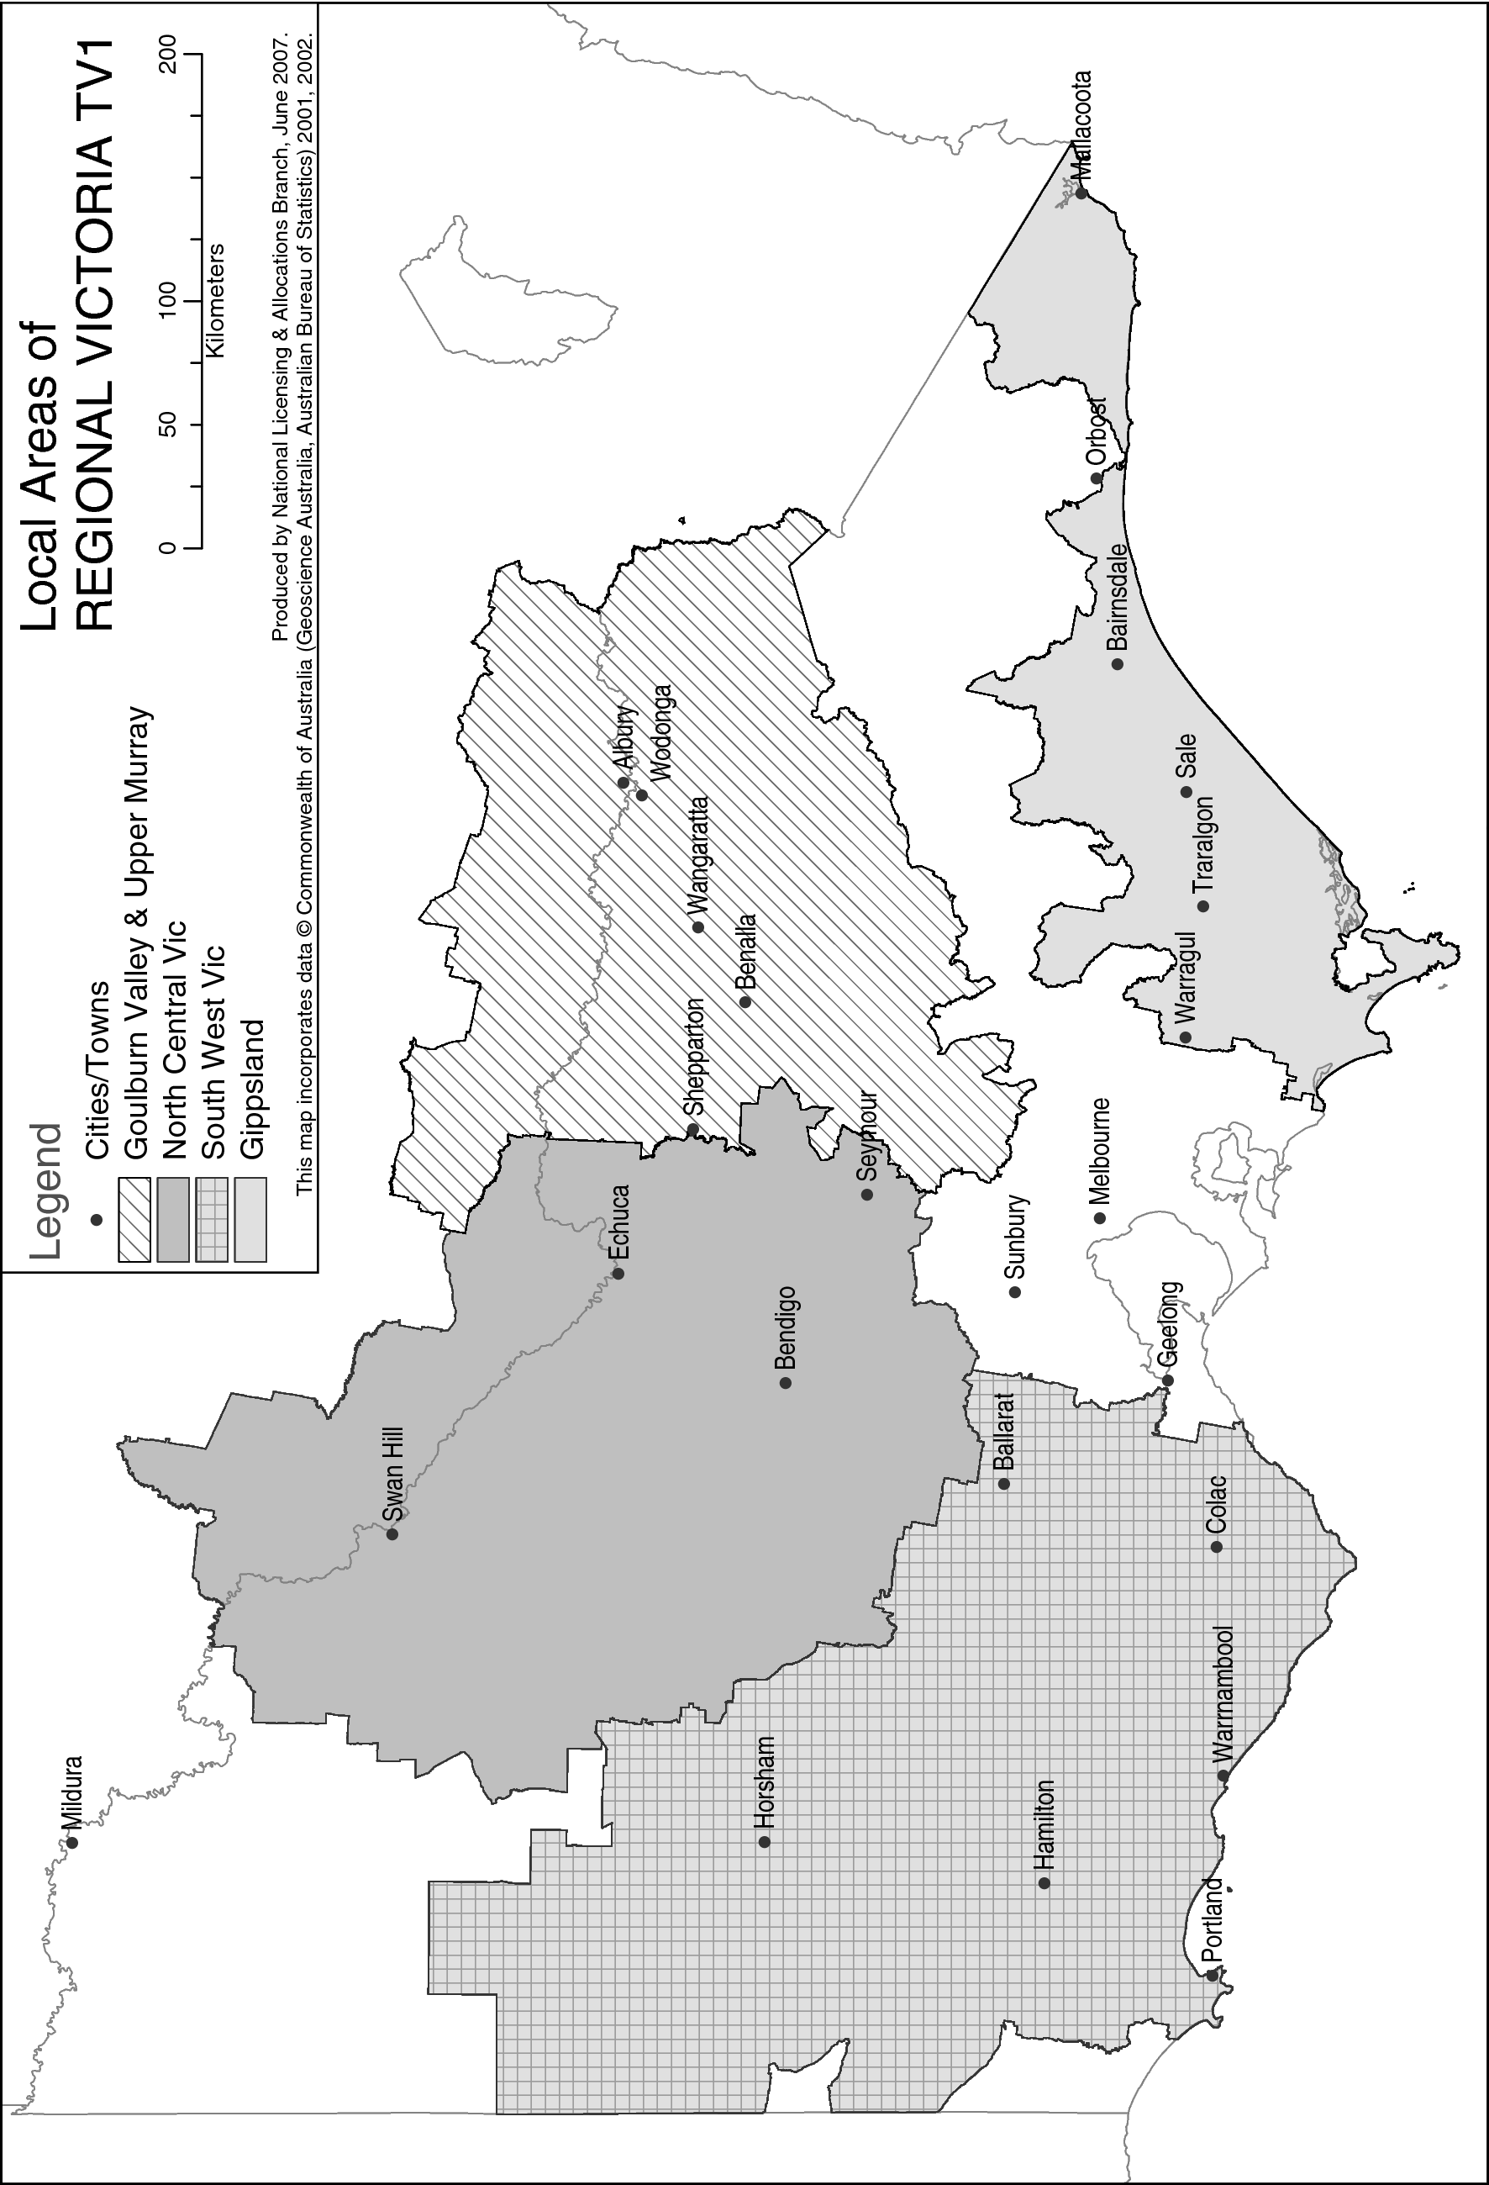

Part 5 Tasmania Licence Area
(service licence numbers 132, 133 and 1150806)

501 Local Area — Tasmania
The Area, in terms of areas defined by the Australian Bureau of Statistics at the Census of 7 August 2001, is:
the Statistical Division of Greater Hobart; the Local Government Areas of Break O'Day (M), Burnie (C), Central Coast (M), Devonport (C), Dorset (M), Flinders (M), George Town (M), Glamorgan/Spring Bay (M), Kentish (M), King Island (M), Latrobe (M), Launceston (C), Meander Valley (M), Southern Midlands (M), Tasman (M), Waratah/Wynyard (M) and West Tamar (M); Collection District Numbers 031301, 031303, 031304, 031305, 031306, 031307, 031308, 031402, 031404, 031405, 031407 and 031408 within the Local Government Area of Central Highlands (M); Collection District Numbers 010201, 010202, 010203, 010205, 010206, 010207, 010208, 010209, 010301, 010302, 010303, 010304, 010306, 010307, 010308, 010309 and 010310 within the Local Government Area of Circular Head (M); Collection District Numbers 040201, 040202, 040203, 040204, 040205, 040206, 040207, 040209, 040210, 040211 and 040212 within the Local Government Area of Derwent Valley (M); Collection District Numbers 040102, 040103, 040104, 040105, 040106, 040107, 041001, 041002, 041003, 041004, 041005, 041006, 041007, 041008, 041009, 041010, 041011, 041012, 041501, 041502, 041503, 041504, 041505, 041506, 041507, 041508, 041509, 041510 and 041511 within the Local Government Area of Huon Valley (M); Collection District Numbers 041401, 041402, 041403, 041404, 041601, 041602 and 041603 within the Local Government Area of Kingborough (M); Collection District Numbers 030701, 030702, 030703, 030704, 030705, 030706, 030707, 030708, 030801, 030802, 030803, 030804, 030805, 030806, 030807, 030901, 030902, 030903, 030904, 031001, 031002, 031201, 031202, 031203, 031204, 031501 and 031502 within the Local Government Area of Northern Midlands (M); Collection District Numbers 052002, 052003 and 052007 within the Local Government Area of Sorell (M); Collection District Numbers 012102, 012103, 012104, 012105, 012106, 012107, 012108, 012109, 012201, 012202, 012203, 012204, 012205, 012206, 012207, 012208, 012209, 012302 and 012303 within the Local Government Area of West Coast (M) in the State of Tasmania.

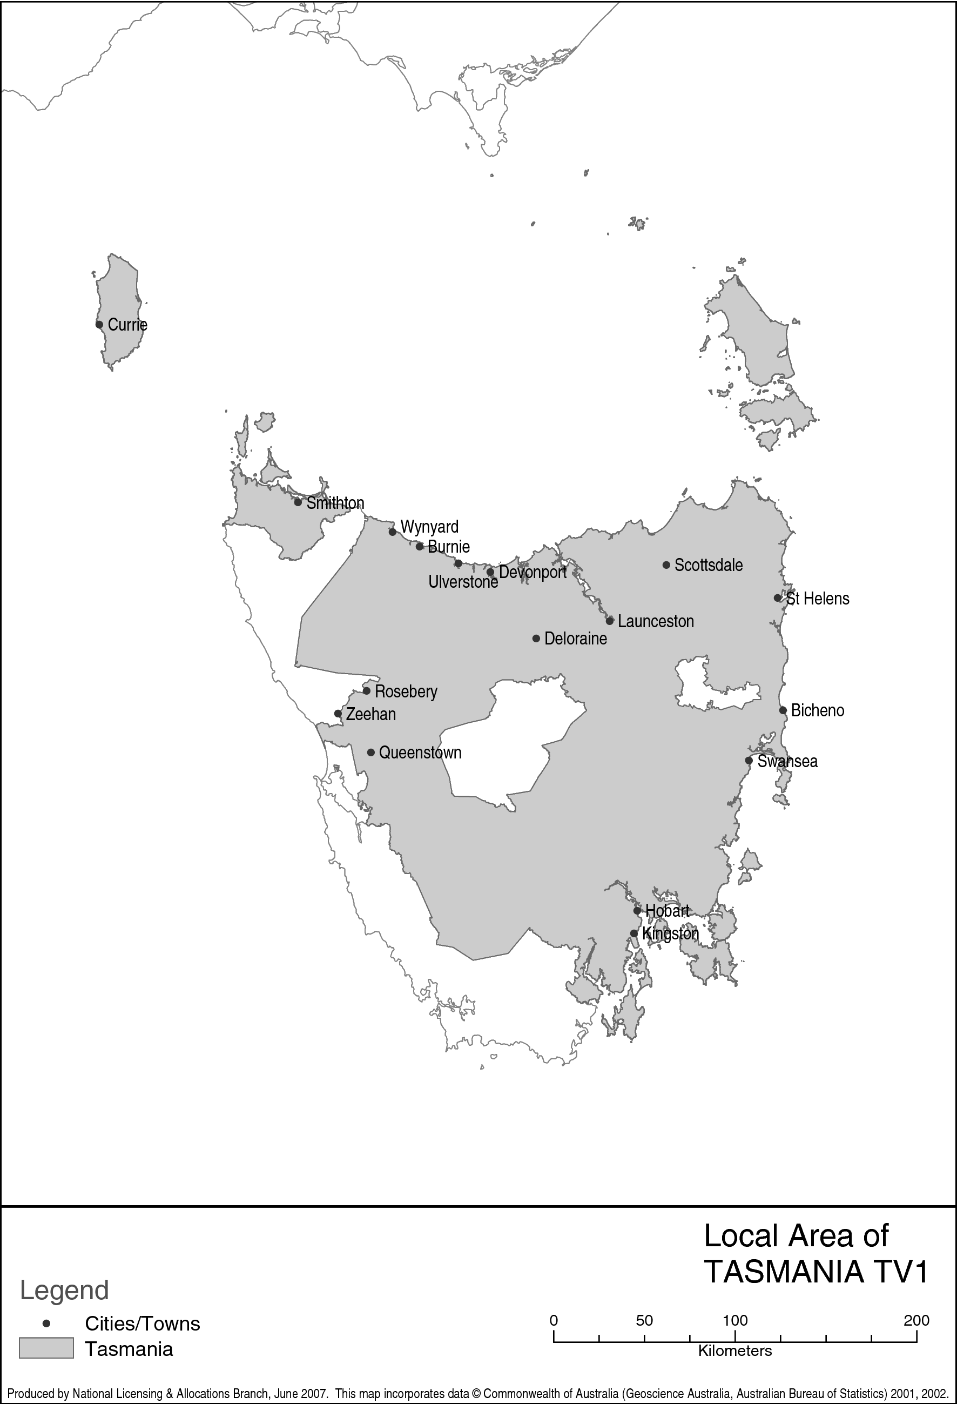
Keith
Schedule 2 The points system
(section 9)

Eligible periods
2.1 Points are accumulated during the following eligible periods:
(a) from 6:30 am to midnight (inclusive) on Monday to Friday;
(b) from 8:00 am to midnight (inclusive) on Saturday and Sunday.
Timing periods
2.2 Points are calculated during the following timing periods:
(a) the period of 6 weeks starting on the first Sunday in February in a year;
(b) each subsequent period of 6 weeks until the end of the 42nd week after the first Sunday in February;
(c) the period starting at the end of the 42nd week after the first Sunday in February and ending immediately before the first Sunday in February in the following year.
Note A licensee is not able to accumulate points during the timing period specified in item 2.5.
Points for material of local significance
2.3 Subject to items 2.4 to 2.9, material of local significance accumulates points in a local area according to the following table.
Note See items 3.10 and 3.11 of Schedule 3.

Item | Material | Points for each minute of material
1 | Material that is not broadcast during an eligible period  This item takes precedence over the other items in this table | 0
2 | Material (other than a community service announcement) that has previously been broadcast to a local area during an eligible period  This item takes precedence over items 3, 4, 5 and 6 | 0
3 | News that relates directly to the local area | 2
4 | Other material that relates directly to the local area | 1
5 | News that relates directly to a licensee’s licence area | 1
6 | Other material that relates directly to a licensee’s licence area | 1
Minimum total of points
2.4 For material of local significance broadcast in a local area during the eligible periods, the licensee must accumulate at least:
(a) 90 points each week; and
(b) 720 points in each timing period.
Limits on material in the timing period starting at the end of the 42nd week
2.5 For the timing period mentioned in paragraph 2.2 (c), points cannot be accumulated:
(a) for 4 weeks from and including the week of the timing period that includes 15 December; and
(b) for any week between the end of the 10th week of the timing period mentioned in paragraph 2.2 (c) and the beginning of the timing period mentioned in paragraph 2.2 (a).
Limits on material that relates directly to the licensee’s licence area
2.6 Except for service licence numbers 104 and 106, not more than 50% of the points accumulated in a local area during a timing period is to be attributable to material that relates directly to the licensee’s licence area.
2.7 For service licence numbers 104 and 106, not more than 50% of the points accumulated in a local area during a timing period is to be attributable to material that relates directly to the combined licence areas of the licensees for service licence numbers 104 and 106.
Limits on community service announcements
2.8 Points may be accumulated in a local area for:
(a) the first broadcast of a community service announcement in the area; and
(b) not more than 4 repeats of the community service announcement in the area.
2.9 Despite item 2.8, not more than 10% of the points accumulated for a local area during a timing period is to be attributable to material of local significance in the form of community service announcements.
Schedule 3 Explanatory comments
(subsection 5 (2))

Comments on section 7 (Local areas)
3.1 The areas set out in Parts 1 to 4 of Schedule 1 are based on the pre-aggregation service areas, but may have been adjusted to take into account matters such as:
(a) more recent Census data; or
(b) the level of diversity within the areas; or
(c) evidence of the way in which the licensee provides commercial television broadcasting services.
The local area set out in Part 5 of Schedule 1 is not based on pre-aggregation service areas, but on the current licence area. Account has been taken of the way in which the licensees in Tasmania are providing local content on commercial television broadcasting services.
Comments on section 8 (Material of local significance)
Subsection 8 (1)
3.2 The test of whether material is of local significance combines the subject and the way in which the subject is presented. Under this Notice, material that interests people in a particular area is not automatically ‘material of local significance’.
For example, a report about ‘drought in Australia’ can emphasise the effect of the drought on the Australian economy, or on a local area, or on both. The effect on the Australian economy is likely to be of interest to people in the local area, but the absence of a local emphasis means that it would not be ‘material of local significance’.
Material can have both a national and a local element, and can have more or less local significance depending on how much emphasis is given to its relevance to the local area. Presentation and emphasis have a significant effect on whether the ACMA will treat the material as being of local significance.
3.3 Most material of local significance is likely to be collected and prepared in the local area, using reporters and other resources located in the area. It is less likely that material prepared outside the local area, and distributed in a similar generic form to several licensees, will have an adequate local emphasis for this Notice.
3.4 The following are examples of material that relates directly to a local area:
(a) material that relates to people or organisations in the area;
(b) material that relates to the activities of people or organisations in the area;
(c) material that relates to issues that arise in the area;
(d) material that deals with the effects in the area of an event that occurs elsewhere;
(e) material that deals with people, organisations, events or issues that are of particular interest to people in the area, in a way that focuses on the interests of people in the area;
(f) material that:
(i) relates to a political matter or a matter of current affairs; and
(ii) is in the form of discussion by, or statements or commentary from, people in the area;
(g) material about a sporting event that involves a person or team from the area;
(h) material about a sporting event that involves a person or team from a nearby area, whose principal support base includes the area, or a significant part of the area;
(i) material about market conditions that closely affect a major business activity in the area, such as prices of a commodity in an area where that commodity is produced on a significant scale;
(j) material about an individual in whom people in the area are particularly interested because of an association with the area, such as the individual’s having grown up, or lived, in the area.
The examples are not exhaustive.
3.5 Material that relates to events that occur in a local area, but is not material of the kind described in item 3.4, may still be material of local significance. However, material that deals with the event itself (or with its effects generally), without relating the event to the local area, will not be treated as material of local significance.
Paragraph 8 (1) (b)
3.6 Material of local significance may relate directly to the licensee’s licence area rather than relating directly to any particular local area within the licence area. Similar to paragraph 8 (1) (a), the test of whether material relates directly to the licence area combines the subject and the way in which the subject is presented.
In considering whether material relates directly to the licence area, the material is to be treated in the same way as the consideration of whether material relates directly to a local area, applying items 3.2, 3.4 and 3.5 to the licence area as a whole.
3.7 The following are examples of material that relates directly to a licence area:
(a) material that relates to economic affairs in the area;
(b) material that relates to government in the area;
(c) material that relates to social issues that affect the area.
The examples are not exhaustive.
Subsection 8 (2)
3.8 An announcement of information about a person or organisation that provides a service to the community in a local area is an example of a community service announcement.
Comments on Schedule 1 (Areas of commercial television broadcasting licences)
Abbreviations used in descriptions of local areas
3.9 The abbreviations refer to standard terminology used by the Australian Bureau of Statistics, as follows:

(C) = City
(A) = Local Government Area (excluding Cities)
(M) = Municipality or Municipal Council
(RC) = Rural City
(S) = Shire
(T) = Town
Comments on item 2.3 of Schedule 2 (Points for material of local significance)
Item 2 of the table
3.10 If material of local significance is repeated within an eligible period, the material will not accumulate points when it is repeated. An example is a news bulletin broadcast at 6:00 pm and replayed at 10:00 pm.
However, 2 or more broadcasts of material of local significance in an eligible period will accumulate points if each broadcast forms a fresh editorial compilation.
Item 3 of the table
3.11 If material that relates directly to a local area is presented in a news bulletin or a news update in the form of a report about sport, business, weather, science, medicine or other specific subjects, the material will accumulate points as news that relates directly to the local area.
The traditional format of a ‘news bulletin’ is a program of 30 or 60 minutes, including advertisements. The traditional format of a ‘news update’ is a program of not more than 2 minutes that does not include advertisements. However, if other forms of news include material, in the form of a report about sport, business, weather, science, medicine or other specific subjects, that relates directly to a local area, the material may accumulate points as news that relates directly to the local area.

