***Australian Film, Television and Radio School Act 1973***

# DETERMINATION OF DEGREES, DIPLOMAS AND CERTIFICATES No. 2014/3

I, **Julianne Schultz,** Chair of the Council of the Australian Film, Television and Radio School, on behalf of the Australian Film, Television and Radio School, make a determination under section 6A of the *Australian Film, Television and Radio School Act 1973* (the Act) specifying the following degrees, diplomas and certificates for the purposes of paragraph 5(1)(g) of the Act.

* Diploma in Directing Comedy

This Determination comes into effect on the day after it is registered on the Federal Register of Legislative Instruments.

Dated: 31 October 2014 Signed:

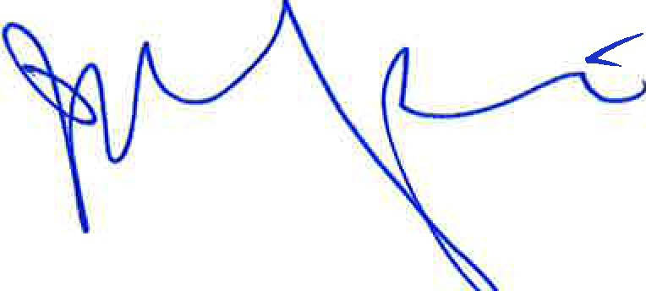

# Professor Julianne Schultz AM FAHA

Chair of Council, Australian Film, Television and Radio School

*)*