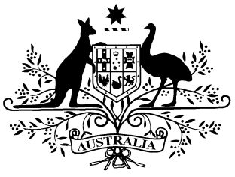

**PB 107 of 2014**

**National Health (Prescriber bag supplies) Amendment Determination 2014 (No. 2)**

_____________________________________________________________________

I, FELICITY McNEILL, First Assistant Secretary, Pharmaceutical Benefits Division, Department of Health, delegate of the Minister for Health, make this Instrument under sections 93 and 93AB of the *National Health Act 1953*.

Dated 17 December 2014

**FELICITY McNEILL**

First Assistant Secretary

Pharmaceutical Benefits Division

Department of Health

**1 Name of Determination**

1. This Determination is the *National Health (Prescriber bag supplies) Amendment Determination 2015 (No. 2).*
2. This Determination may also be cited as PB 107 of 2014.

2 Commencement

This Determination commences on 1 January 2015.

3 Amendment of *National Health (Prescriber bag supplies) Determination 2012*

Schedule 1 amends the National Health (Prescriber bag supplies) Determination*2012* (PB 73 of 2012).

Schedule 1 Amendments

[1] The Schedule

omit:

|  |  |  |  |  |
| --- | --- | --- | --- | --- |
| **15** | Lignocaine | Injection containing lignocaine hydrochloride 100 mg in 5 mL | MP, NP | 5 |

*[subsequent Groups are not renumbered]*