

Family Law Amendment (2014 Measures No. 1) Rules 2014

Select Legislative Instrument No. 213, 2014

We, Judges of the Family Court of Australia, make the following Rules.

Dated

D Bryant CJ

J Faulkes J

M May J

A Ainslie-Wallace J

J Ryan J

J Stevenson J

M Le Poer Trench J

R Benjamin J

J Crisford J

S Austin J

S Moncrieff J

M Cleary J

W Johnston J

I Loughnan J

C Forrest J

M Kent J

K Macmillan J

M Aldridge J

J Walters J

S Duncanson J

P Tree J

J Hogan J

D Berman J

G Foster J

C Thornton J

H Hannam J

Judges of the Family Court  
of Australia

Contents

1 Name 1

2 Commencement 1

3 Authority 1

4 Schedules 1

Schedule 1—Amendments 2

Family Law Rules 2004 2

1 Name

These are the *Family Law Amendment (2014 Measures No. 1) Rules 2014*.

2 Commencement

These Rules commence on 1 January 2015.

3 Authority

These Rules are made under the *Family Law Act 1975.*

4 Schedules

Each instrument that is specified in a Schedule to these Rules is amended or repealed as set out in the applicable items in the Schedule concerned, and any other item in a Schedule to these Rules has effect according to its terms.

Schedule 1—Amendments

Family Law Rules 2004

1 At the end of Part 1.4

Add:

1.22 Methods of attaching the seal of the Court

The seal of the Court may be attached to a document:

(a) by hand; or

(b) by electronic means; or

(c) in any other way.

2 Subrule 2.04D(1)

Omit “A Notice of Child Abuse or Family Violence (Form 4)”, substitute “Form 4”.

3 Paragraph 2.04E(1)(c)

Omit “Notice of Child Abuse or Family Violence (Form 4)”, substitute “Form 4”.

4 After rule 11.03

Insert:

11.04 Certificate of vexatious proceedings order

(1) A request under subsection 102QC(1) of the Act for a certificate relating to a vexatious proceedings order must:

(a) be in writing; and

(b) include the following:

(i) the name and address of the person making the request;

(ii) the person’s interest in making the request.

(2) The request must be lodged in the Registry in which the vexatious proceedings order was made.

(3) For the purposes of paragraph 102QC(2)(b) of the Act, the certificate must specify the following information:

(a) the name of the person subject to the vexatious proceedings order;

(b) if applicable, the name of the person who applied for the vexatious proceedings order;

(c) the orders made by the court under subsection 102QB(2) of the Act.

Note: The certificate must also specify the date of the vexatious proceedings order: see paragraph 102QC(2)(a) of the Act.

5 Division 15.3.4

Repeal the Division.

6 Paragraph 16.06(1)(a)

Repeal the paragraph.

7 Paragraph 16.06(1)(b)

Repeal the paragraph, substitute:

(b) that the party has made appropriate inquiries to determine the attitude of the foreign country’s government to the taking of evidence by electronic communication; and

8 At the end of paragraphs 16.06(1)(c) and (d)

Add “and”.

9 Rule 17.03

Omit “87(11)(b) and 90KA(b)”, substitute “87(11)(b), 90KA(b) and 90UN(b),”.

10 Subrule 18.06(2) (at the end of table 18.5)

Add:

|  |  |
| --- | --- |
| 44 | Chapter 26A |

11 At the end of paragraph 20.04(d)

Add “or the Assessment Act”.

12 Rule 20.04 (at the end of the note)

Add “and section 79 of the Assessment Act”.

13 Rule 22.02 (note 3)

Omit “For the number of copies of a document to file, see rule 24.08.”.

14 Subrule 22.22(2) (note)

Repeal the note.

15 Rule 22.36 (note 2)

Repeal the note.

16 Rule 22.36 (note 3)

Omit “Note 3”, substitute “Note 2”.

17 Paragraph 24.01(1)(g)

Omit “include the following on the first page”, substitute “have a coversheet, in a form approved by the Principal Registrar, that includes the following”.

18 Subparagraph 24.01(1)(g)(iv)

Omit “document; and”, substitute “document.”.

19 Paragraph 24.01(1)(h)

Repeal the paragraph.

20 Rule 24.06 (note 1)

Omit “Note 1”, substitute “Note”.

21 Rule 24.06 (note 2)

Repeal the note.

22 Rule 24.08

Repeal the rule.

23 After paragraph 24.13(1)(b)

Insert:

(ba) if the case affects, or may affect, the welfare of a child—a child welfare officer of a State or Territory;

24 After Chapter 26

Insert:

Chapter 26A—Cases to which the Trans‑Tasman Proceedings Act 2010 applies

*Summary of Chapter 26A*

Chapter 26A sets out the rules about a case in a Family Court to which the *Trans‑Tasman Proceedings Act 2010* applies. Delegation of the Family Court’s power in such cases is set out in Chapter 18 of these Rules.

***The rules in Chapter 1 relating to the court’s general powers apply in all cases and override all other provisions in these Rules.***

***A word or expression used in this Chapter may be defined in the dictionary at the end of these Rules.***

26A.01 Application of Division 34.4 of the *Federal Court Rules 2011*

Division 34.4 of the *Federal Court Rules 2011*, as modified by rule 26A.02 or an order, applies to a proceeding in a Family Court as if the rules in that Division were provisions of these Rules.

26A.02 Modification of the *Federal Court Rules 2011*

(1) For the purposes of rule 26A.01, Division 34.4 of the *Federal Court Rules 2011* is modified as follows:

(a) a reference to an originating application is taken to be a reference to an Initiating Application;

(b) a reference to an interlocutory application is taken to be a reference to an Application in a Case;

(c) a reference to an application or subpoena being in accordance with a Form is to be disregarded.

(2) For the purposes of rule 26A.01, Division 34.4 of the *Federal Court Rules 2011* is also modified in accordance with Table 26A.1.

| Table 26A.1—Additional modifications of the *Federal Court Rules 2011* | | | |
| --- | --- | --- | --- |
| Item | Provision | Omit | Substitute |
| 1 | Paragraph 34.63(1)(b) | rules 8.01 and 8.03 | rule 2.01 |
| 2 | Subparagraph 34.64(a)(ii) | rule 17.01 | rule 5.01 |
| 3 | Subrule 34.68(2) | the whole of the subrule |  |

26A.03 Service of subpoena

A subpoena to which Division 2 of Part 5 of the *Trans‑Tasman Proceedings Act 2010* applies must also be accompanied by an information sheet in a form approved by the Principal Registrar.

Note 1: Subsection 32(2) of the *Trans‑Tasman Proceedings Act 2010* requires the subpoena to be accompanied by a copy of the order giving leave for service and a notice in the prescribed form.

Note 2: Section 33 of the *Trans‑Tasman Proceedings Act 2010* requires the reasonable expenses of complying with the subpoena to be paid at the time of service of the subpoena or at some other reasonable time before compliance with the subpoena is required.

25 At the end of Chapter 27

Add:

Part 2—Transitional provisions relating to the Family Law Amendment (2014 Measures No. 1) Rules 2014

27.02 Application of Schedule 3 (itemised scale of costs)

Schedule 3, as substituted by the *Family Law Amendment (2014 Measures No. 1) Rules 2014*, applies to work done on or after 1 January 2015.

26 Schedule 2

Repeal the Schedule, substitute:

Schedule 2—Forms

Note: See subrule 24.04(2).

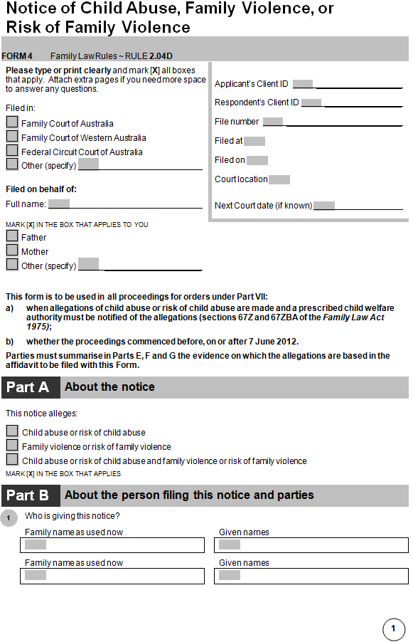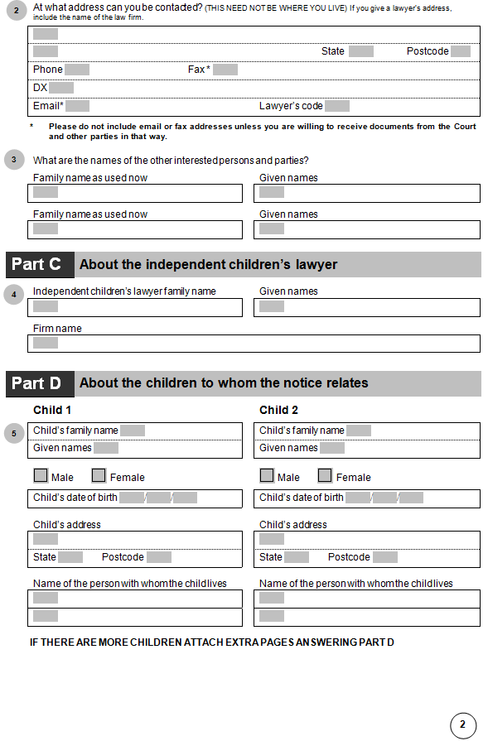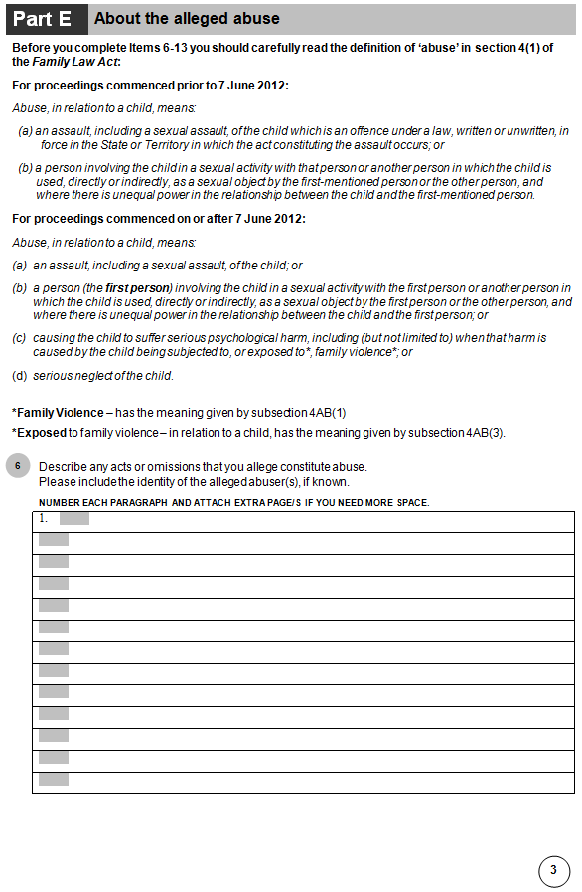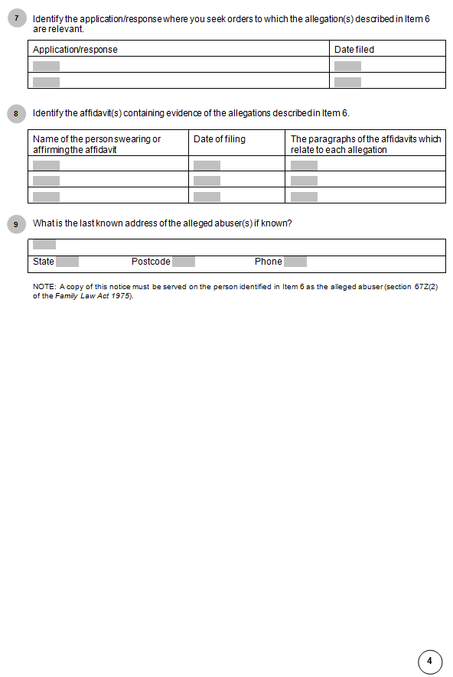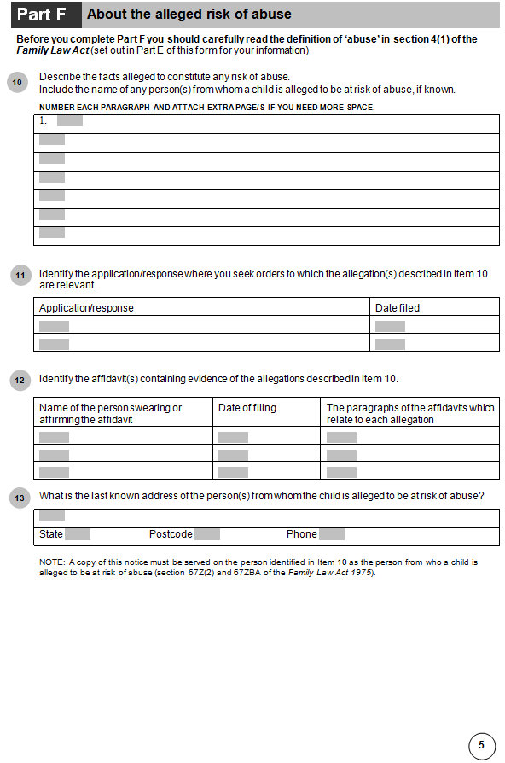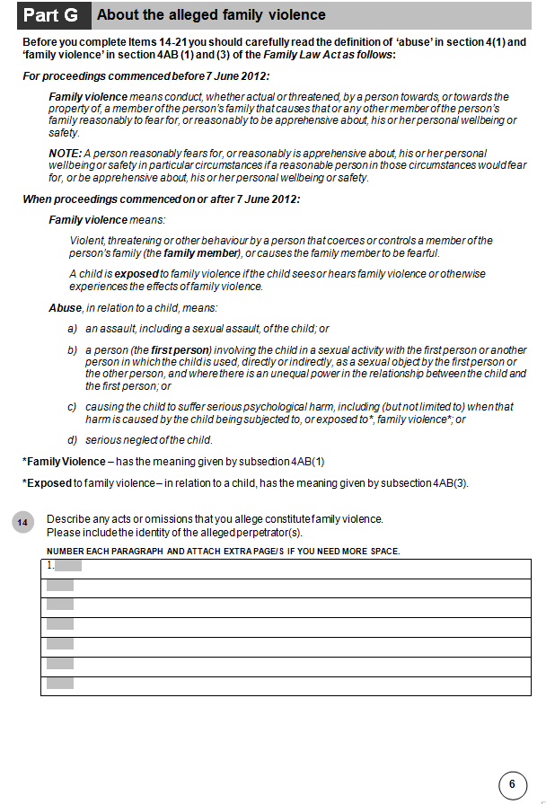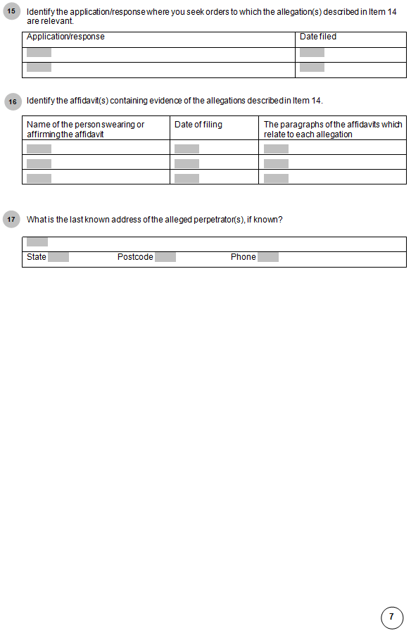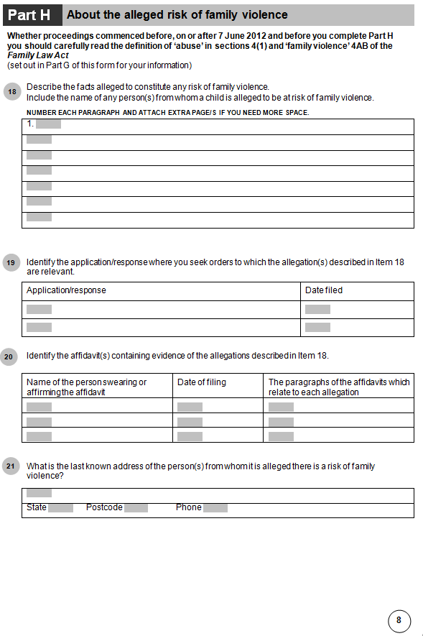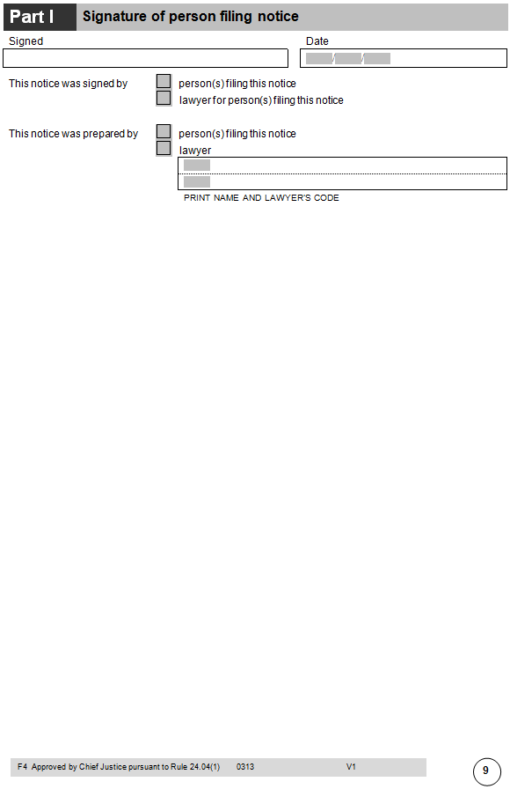

27 Schedule 3

Repeal the Schedule, substitute:

Schedule 3—Itemised scale of costs

Note 1: See rule 19.18 and clause 6.19 of Schedule 6.

Note 2: This Schedule applies generally to work done on or after 1 January 2015 (see rule 27.02). Different amounts, set out in superseded versions of this Schedule, may continue to apply to work done before that date.

Part 1—Costs allowable for lawyer’s work done and services performed

| Costs—lawyer’s work | | |
| --- | --- | --- |
| Item | Matter for which charge is made | Amount (including GST) |
| 101 | Drafting a document (other than a letter) | $19.67 per 100 words |
| 102 | Producing a document (other than a letter) in printed form | $6.72 per 100 words |
| 103 | Drafting and producing a letter (including a fax or an email) | $22.60 per 100 words |
| 104 | Reading a document | $9.21 per 100 words |
| 105 | Scanning a document (where reading is not necessary) | $3.62 per 100 words |
| 106 | For a document or letter mentioned in item 101, 102, 103, 104 or 105 containing more than 3 000 words | The amount allowed by the Registrar |
| 107 | Photocopy or other reproduction of a document | 78 cents per page |
| 108 | Time reasonably spent by a lawyer on work requiring the skill of a lawyer (except work to which any other item in this Part applies) | $230.78 per hour |
| 109 | Time reasonably spent by a lawyer, or by a clerk of a lawyer, on work (except work to which any other item in this Part applies) | $149.63 per hour |

Note: See rule 19.43 in relation to item 104.

Part 2—Costs allowable for counsel’s work done and services performed

| Costs—counsel’s work | | | |
| --- | --- | --- | --- |
| Item | Matter for which charge is made | Amount (including GST)—senior counsel | Amount (including GST)—junior counsel |
| 201 | Chamber work (including preparing or settling any necessary document, opinion, advice or evidence, and any reading fee (if allowed)) | $443.84–$760.88 per hour | $264.99–$377.92 per hour |
| 202 | Attendance at a conference (including a court‑appointed conference), if necessary | $443.84–$760.88 per hour | $264.99–$377.92 per hour |
| 203 | Attendance of less than 3 hours (for example, a procedural hearing or a summary hearing) | $443.84–$3 170.16 | $237.06–$1 110.82 |
| 204 | A hearing or trial taking at least 3 hours but not more than 1 day | $824.25–$6 340.92 | $785.92–$1 816.68 |
| 205 | Other hearings or trials | $2 092.40–$6 340.92 per day | $1 873–$2 753.04 per day |
| 206 | Reserved judgment | $443.84–$760.88 per hour | $264.99–$377.92 per hour |

Part 3—Basic composite amount for undefended divorce

| Costs—undefended divorce | | |
| --- | --- | --- |
| Item | Matter for which charge is made | Amount (including GST) |
| 301 | If the lawyer employed another lawyer to attend at court for the applicant and there is a child of the marriage under 18 | $974.74 |
| 302 | If the lawyer employed another lawyer to attend at court for the applicant and there is no child of the marriage under 18 | $725.21 |
| 303 | If the lawyer did not employ another lawyer to attend at court for the applicant and there is a child of the marriage under 18 | $915.11 |
| 304 | If the lawyer did not employ another lawyer to attend at court for the applicant and there is no child of the marriage under 18 | $684.76 |
| 305 | If the lawyer did not attend at court for the hearing under section 98A of the Act | $589.18 |

Part 4—Basic composite amount for request for Enforcement Warrant or Third Party Debt Notice

|  |  |  |
| --- | --- | --- |
| Costs—Enforcement Warrant or Third Party Debt Notice | | |
| Item | Matter for which charge is made | Amount (including GST) |
| 401 | An Enforcement Warrant under rule 20.16 | $589.18 |
| 402 | A Third Party Debt Notice under rule 20.32 | $589.18 |

28 Dictionary (definition of *Federal Magistrates Court*)

Repeal the definition.

29 Amendments of listed provisions relating to the Federal Magistrates Court of Australia

| Amendments relating to the Federal Magistrates Court of Australia | | | |
| --- | --- | --- | --- |
| Item | Provision | Omit | Substitute |
| 1 | Division 4.2.4 (note to Division heading) | Federal Magistrates Court (wherever occurring) | Federal Circuit Court |
| 2 | Division 4.2.5 (overview of Division 4.2.5) | Federal Magistrates Court (wherever occurring) | Federal Circuit Court |
| 3 | Rule 6.16 (definition of ***bankruptcy proceedings***) | Federal Magistrates Court | Federal Circuit Court |
| 4 | Subrule 11.18(1) (note) | Federal Magistrates Court (wherever occurring) | Federal Circuit Court |
| 5 | Chapter 21 (summary of Chapter 21) | Federal Magistrates Court (wherever occurring) | Federal Circuit Court |
| 6 | Paragraph 22.01(1)(b) | a Federal Magistrates Court | the Federal Circuit Court |
| 7 | Part 22.2 (note to Part heading) | Federal Magistrates Court | Federal Circuit Court |
| 8 | Subrule 22.11(3) | Judge, Federal Magistrate | Judge of the Family Court, Judge of the Federal Circuit Court |
| 9 | Rule 22.14 | Federal Magistrates Court (wherever occurring) | Federal Circuit Court |
| 10 | Part 22.4 (heading) | **Federal Magistrates Court** | **Federal Circuit Court** |
| 11 | Rule 22.23 | Federal Magistrates Court (wherever occurring) | Federal Circuit Court |
| 12 | Subparagraph 22.26(1)(c)(i) | Federal Magistrate | Judge of the Federal Circuit Court |
| 13 | Rule 22.27 | Federal Magistrate (wherever occurring) | Judge of the Federal Circuit Court |
| 14 | Subrule 24.04(4) | Federal Magistrates Court | Federal Circuit Court |
| 15 | Dictionary (paragraph (a) of the definition of ***appeal***) | Federal Magistrates Court | Federal Circuit Court |
| 16 | Dictionary (paragraph (a) of the definition of ***Appeal Registry***) | Federal Magistrates Court | Federal Circuit Court |