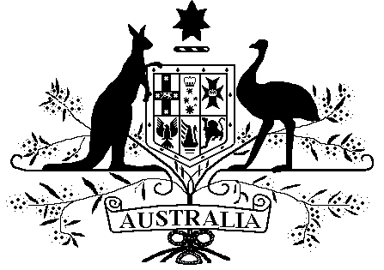

Veterans’ Entitlements Act 1986

Veterans’ Entitlements (Income Exempt Lump Sum — Government of South Australia Energy Concession Bonus) Determination 2015
Instrument 2015 No. R19
I, MARK HARRIGAN, delegate of the Repatriation Commission, hereby determine under paragraph 5H(12)(c) of the Veterans’ Entitlements Act 1986 (VEA) that an amount specified in Part 2 is an exempt lump sum for the purposes of the definition of “ordinary income” in subsection 5H(1) of the VEA.
Dated this 2nd day of February 2015
Mark Harrigan………………………………………………………….
MARK HARRIGAN

Part 1: Preliminary and Interpretation

1.1 Name of determination
This determination is the Veterans’ Entitlements (Income Exempt Lump Sum - Government of South Australia Energy Concession Bonus) Determination 2015.

Commencement of determination
This Determination commences on the day after registration.
1.3 Revocation
The Veterans’ Entitlements Income (Government of South Australia Energy Concession Bonus) Determination No. R14 of 2005 is revoked.

1.4 Definition
In this Determination:
energy concession bonus means a one-off annual payment paid by the State Government of South Australia to people eligible for the South Australia Energy Concession to assist with their energy bills.

Part 2: Exempt Lump Sum

If a person has received an energy concession bonus from the South Australian Government, then the amount is an exempt lump sum.

