Explanatory Statement

Accounting Standard AASB 2015-5  
*Amendments to Australian Accounting Standards – Investment Entities: Applying the Consolidation Exception*

**January 2015**

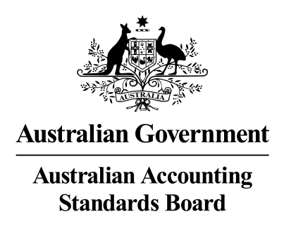

# EXPLANATORY STATEMENT

## Reasons for Issuing AASB 2015-5

This Standard makes amendments to Australian Accounting Standards AASB 10 *Consolidated Financial Statements,* AASB 12 *Disclosure of Interests in Other Entities* and AASB 128 *Investments in Associates and Joint Ventures*.

These amendments arise from the issuance of International Financial Reporting Standard *Investment Entities: Applying the Consolidation Exception* (Amendments to IFRS 10, IFRS 12 and IAS 28) by the International Accounting Standards Board in December 2014.

## Main Features of AASB 2015-5

### Main Requirements

This Standard amends AASB 10, AASB 12 and AASB 128:

1. to confirm that the exemption from preparing consolidated financial statements set out in paragraph 4(a) of AASB 10 is available to a parent entity that is a subsidiary of an investment entity;
2. to clarify the applicability of AASB 12 to the financial statements of an investment entity; and
3. to introduce relief in AASB 128 to permit a non-investment entity investor in an associate or joint venture that is an investment entity to retain the fair value through profit or loss measurement applied by the associate or joint venture to its subsidiaries.

### Application Date

This Standard applies to annual reporting periods beginning on or after 1 January 2016.

This Standard may be applied by:

(a) for-profit entities to annual reporting periods beginning on or after 1 January 2005 but before 1 January 2016 and

(b) not-for-profit entities to annual reporting periods beginning on or after 1 January 2013 but before 1 January 2016.

## Consultation Prior to Issuing this Standard

The AASB issued Exposure Draft ED 250 *Investment Entities: Applying the Consolidation Exception* in June 2014 for comment by 15 August 2014.

Five submissions were received by the AASB in respect of the proposals in ED 250 and there was general support for adopting the proposals in Australian Accounting Standards. The AASB considered the comments it received in making its submission to the IASB and in finalising AASB 2015‑5.

A Regulation Impact Statement (RIS) has not been prepared in connection with the issue of AASB 2015-5 as the amendments made are minor in nature.

**Statement of Compatibility with Human Rights**

Prepared in accordance with Part 3 of the   
*Human Rights (Parliamentary Scrutiny) Act 2011*

**Accounting Standard AASB 2015-5  
*Amendments to Australian Accounting Standards – Investment Entities: Applying the Consolidation Exception***

**Overview of the Accounting Standard**

AASB 2015-5 *Amendments to Australian Accounting Standards – Investment Entities: Applying the Consolidation Exception* amends AASB 10, AASB 12 and AASB 128:

(a) to confirm that the exemption from preparing consolidated financial statements set out in paragraph 4(a) of AASB 10 is available to a parent entity that is a subsidiary of an investment entity;

(b) to clarify the applicability of AASB 12 to the financial statements of an investment entity; and

(c) to introduce relief in AASB 128 to permit a non-investment entity investor in an associate or joint venture that is an investment entity to retain the fair value through profit or loss measurement applied by the associate or joint venture to its subsidiaries.

**Human Rights Implications**

This Standard is issued by the AASB in furtherance of the objective of facilitating the Australian economy. It does not diminish or limit any of the applicable human rights or freedoms, and thus does not raise any human rights issues.

**Conclusion**

This Standard is compatible with the human rights and freedoms recognised or declared in the international instruments listed in section 3 of the *Human Rights (Parliamentary Scrutiny) Act 2011*.