**EXPLANATORY STATEMENT**

Issued by the Authority of the Minister for the Environment

# *Carbon Credits (Carbon Farming Initiative) Act 2011*

*Carbon Credits (Carbon Farming Initiative—Designated Verified Carbon Standard Projects) Methodology Determination 2015*

**Background**

The *Carbon Credits (Carbon* Farming *Initiative) Act 2011* (the Act) enables the crediting of greenhouse gas abatement from emissions reduction activities across the economy. Greenhouse gas abatement is achieved either by reducing or avoiding emissions or by removing carbon from the atmosphere and storing it in soil or trees.

In 2014, the Australian Parliament passed the *Carbon Farming Initiative Amendment Act 2014*, which establishes the Emissions Reduction Fund (ERF). The ERF has three elements: crediting emissions reductions, purchasing emissions reductions, and safeguarding emissions reductions.

Emissions reduction activities are undertaken as offsets projects. The process involved in establishing an offsets project is set out in Part 3 of the Act. An offsets project must be covered by, and undertaken in accordance with, a methodology determination.

Subsection 106(1) of theAct empowers the Minister to make, by legislative instrument, a methodology determination. The purpose of a methodology determination is to establish procedures for estimating abatement (emissions reduction and sequestration) from eligible projects and rules for monitoring, record keeping and reporting. These methodologies will ensure that emissions reductions are genuine—that they are both real and additional to business as usual.

In deciding to make a methodology determination the Minister must have regard to the advice of the Emissions Reduction Assurance Committee (ERAC), an independent expert panel established to advise the Minister on proposals for methodology determinations. The Minister must not make or vary a methodology if the ERAC considers it inconsistent with the offsets integrity standards, which are set out in section 133 of the Act. The Minister must also consider any adverse environmental, economic or social impacts likely to arise as a result of projects to which the methodology determination applies.

Offsets projects that are undertaken in accordance with the methodology determination and approved by the Clean Energy Regulator (the Regulator) can generate Australian Carbon Credit Units (ACCUs), representing emissions reductions from the project.

Project proponents can receive funding from the ERF by submitting their projects into a competitive auction run by the Regulator. The Government will enter into contracts with successful proponents, which will guarantee the price and payment for the future delivery of emissions reductions.

Further information on the ERF is available on the Department of the Environment website at:

[www.environment.gov.au/emissions-reduction-fund](http://www.environment.gov.au/emissions-reduction-fund).

**Application of the Determination**

The *Carbon Credits (Carbon Farming Initiative—Designated Verified Carbon Standard Projects) Methodology Determination 2015* (the Determination) sets out the detailed rules for implementing and monitoring offsets projects that were previously validated under the Verified Carbon Standard (the VCS) and which implemented the *Approved VCS Methodology VM0010—Methodology for Improved Forest Management: Conversion from Logged to Protected Forest* (the VCS methodology). These projects protect native forests on private land by not harvesting. Other projects, including projects that protect native forests, that were not validated under the VCS are not eligible under the Determination.

The projects produce abatement by avoiding emissions from harvesting that would have occurred in the project area in the absence of the project, and by sequestering carbon that would not have been sequestered in the absence of the project. The project activity or ‘project mechanism’ is best described as protecting native forests by not harvesting them.

The VCS, which commenced in 2005, is the world’s largest voluntary greenhouse gas program. It is regarded by voluntary market players as a credible and robust international offsets program. In Australia, four forest management projects were approved under the VCS. No other types of projects have been approved under the VCS in Australia. Following Australia’s decision to count forest management towards its emissions reduction target under the Kyoto Protocol from 1 January 2013, these projects can no longer generate credits under the VCS.

The Act, as amended by the *Carbon Farming Initiative Amendment Act 2014*, enables Australian projects approved under the VCS to transition to the Emissions Reduction Fund. This will enable these specific projects to continue to generate credits as they would have prior to Australia accounting for emissions from forest management against its Kyoto target.

Under subitem 388A(3) of the Schedule to the *Carbon Farming Initiative Amendment Act 2014* proponents of Australian projects that were registered under the VCS before the commencement of the Bill can submit a transitional application for registration under the Emissions Reduction Fund before 30 June 2015. Like projects seeking to apply existing Carbon Farming Initiative methodology determinations before the Act’s amendment, these projects will not be subject to the requirement that projects must be new.

A project proponent wishing to implement the Determination must make an application to the Regulator under section 22 of the Act and meet the general eligibility requirements for an offsets project set out in subsection 27(4). However, paragraph 27(4)(d) and subsection 27(4A) of the Act (the additionality requirements) do not apply to projects implementing the Determination.

Projects implementing the Determination are sequestration offsets projects under section 16 of the Act.

Section 23 of the Act provides that, if a project is a sequestration offsets project, an application to the Regulator under section 22 must include a request that the project be subject to either a 100-year or 25-year permanence period. Then, if the Regulator declares that the project is an eligible offsets project, the Regulator will declare that the project is subject to a 100-year or 25-year permanence period. Once declared, the permanence period is fixed and it will not be possible for projects to ‘move between’ permanence periods.

If the project proponent elects a 25-year permanence period, the permanence discount applies in accordance with section 16 of the Act. The permanence discount is 20% of the net abatement number unless another percentage is specified in accordance with the Regulations.

As they are sequestration offsets projects under section 54 of the Act, projects undertaken in accordance with the Determination are subject to a risk of reversal buffer, as provided by section 16 of the Act.

**The Integrity of the VCS Methodology**

The Determination allows four VCS projects to transition into the ERF. The four projects implemented the VCS methodology, which comprised a set of high-level requirements including key requirements for additionality, the projected baseline and the avoided emissions estimate. Proponents were required to adopt approaches that met these requirements in ways that could be validated and verified. The requirements of the VCS methodology in combination with the VCS validation and verification process outlined below met the offsets integrity standards.

*The VCS Validation and Verification Process*

Each VCS project was validated at the beginning of the crediting period. The validations addressed all of the requirements of the VCS methodology, including additionality, the projected baseline and the avoided emissions estimate. Validations were conducted by VCS validation/verification bodies that had received international certification through the UN Clean Development Mechanism or the US International Standards (ISO 14065). To validate a project, the verification body had to be satisfied that all data, rationales, assumptions, justifications and documentation provided by the project proponent to support the selection of the baseline and to demonstrate additionality were credible. Each validation was conducted to a reasonable level of assurance and involved document reviews, interviews and site visits.

Verification reports were conducted for each project prior to the VCS issuing credits for abatement claimed. Like validation reports, the reports were conducted by verification bodies. The purpose of the reports was to ensure that the abatement claimed was genuine.

*Additionality*

The VCS methodology required proponents to set the baseline for their projects using the *VCS Tool for the Demonstration and Assessment of Additionality in VCS Agriculture, Forestry and Other Land Use Project Activities*. The tool required proponents to conduct a four-step analysis:

1. identification of alternative land use scenarios to the project activity;
2. investment analysis to determine that the proposed project activity is not the most economically or financially attractive of the identified land use scenarios; or
3. barriers analysis to determine whether there were barriers preventing the project activity in the absence of revenue from carbon credits; and
4. common practice analysis to determine whether the project activity was common practice.

*The projected baseline and the avoided emissions estimate*

The VCS methodology required proponents to develop a timber harvest plan, which set out planned harvest events in the project area. The timber harvest plan was required to be consistent with the relevant state legislation. Proponents derived their timber harvest plans from historical logging records. The timber harvest plan is a projected baseline similar to baselines in approved ERF methods such as *Avoided Deforestation* and *Avoided Clearing of Native* *Regrowth*. Proponents then estimated emissions from the planned harvest events by working out how much carbon was in the trees that would have been harvested in the absence of the project. The estimates were made using either existing forest inventory data held by the proponents or by undertaking field surveys.

**Public Consultation**

An exposure draft of the Determination was published on the Department’s website for public consultation from 10 December 2014 to 9 January 2015. Three submissions were received. Details of the non-confidential submissions are provided on the Department of the Environment website, [www.environment.gov.au](http://www.environment.gov.au).

**Determination Details**

The Determination is a legislative instrument within the meaning of the *Legislative Instruments Act 2003*.

The Determination ends when it is either revoked under section 123 of the Act, or on the day before it would otherwise be repealed under the *Legislative Instruments Act 2003*, whichever happens first. Under subsection 50(1) of that Act, a legislative instrument such as the Determination is repealed on the first 1 April or 1 October falling on or after the tenth anniversary of registration of the instrument on the Federal Register of Legislative Instruments. For example, if the Determination is registered before 1 April 2015, it would expire on 31 March 2025.

Details of the Determination are at Attachment A.

For the purpose of subsections 106(4), (4A) and (4B) of the Act, in making this Determination the Minister has had regard to, and agrees with, the advice of the Emissions Reduction Assurance Committee that the determination complies with the offsets integrity standards and that the proposed determination should be made. The Minister is satisfied that the carbon abatement used in ascertaining the carbon dioxide equivalent net abatement amount for a project is eligible carbon abatement from the project. The Minister also had regard to whether any adverse environmental, economic or social impacts are likely to arise from the carrying out of the kind of project to which the determination applies and other relevant considerations.

Subitem 393A(2) of Schedule 1 of the *Carbon Farming Initiative Amendment Act 2014* operated in relation to this Determination to deem the request to the Interim ERAC to be the relevant request to the statutory ERAC under subsection 106(10) of the Act. Subitem 393A(3) then allowed the ERAC to consider the consultation on the exposure draft which started before 13 December 2014 and not re-open consultation under section 123D of the Act.

A Statement of Compatibility prepared in accordance with the *Human Rights (Parliamentary Scrutiny) Act 2011* is at Attachment D.

Attachment A

**Details of the Methodology Determination**

**Part 1 Preliminary**

1 Name

Section 1 sets out the full name of the Determination, which is the *Carbon Credits (Carbon Farming Initiative—Designated Verified Carbon Standard Projects) Methodology Determination 2015*.

2 Commencement

Section 2 provides that the Determination is taken to have come into force on 1 January 2013. This retrospective commencement is provided for under subitem 388A(2) of the Schedule to the *Carbon Farming Initiative Amendment Act 2014*. It is of a beneficial nature and does not raise any issues for proponents.

3 Authority

Section 3 provides that the Determination is made under subsection 106(1) of the Act.

4 Duration

Paragraph 4(a) provides that the Determination begins on 1 January 2013.

Under subparagraph 122(1)(b)(i) of the Act, a methodology determination remains in force for the period specified in the Determination.

Paragraph 4(b) provides that the Determination ends on the day before it would otherwise be repealed under subsection 50(1) of the *Legislative Instruments Act 2003*.

Instruments are repealed under that provision on the first 1 April or 1 October following the tenth anniversary of registration on the Federal Register of Legislative Instruments. Paragraph 4(b) ensures that the Determination will expire in accordance with subparagraph 122(1)(b)(i) of the Act.

If the Determination expires or is revoked during a crediting period for a project to which the Determination applies, the Determination will continue to apply to the project during the remainder of the crediting period under subsections 125(2) and 127(2) of the Act. Project proponents may apply to the Regulator during a reporting period to have a different methodology determination apply to their projects from the start of that reporting period (see subsection 128(1) of the Act).

5 Definitions

Section 5 defines a number of terms used in the Determination.

The note at the bottom of section 5 lists terms that are not defined in the Determination but instead have the meaning given to them by section 5 of the Act.

Under section 23 of the *Acts Interpretation Act 1901*, words in the Determination in the singular number include the plural and words in the plural number include the singular.

**Part 2 Designated Verified Carbon Standard projects**

6 Designated Verified Carbon Standard projects

The effect of paragraphs 27(4)(b) and 106(1)(a) of the Act is that a project must be covered by a methodology determination, and that the methodology determination must specify the kind of offsets project to which it applies.

Paragraph 6(1)(a) provides that the Determination applies to sequestration offsets projects that are designated Verified Carbon Standard projects. ‘Designated Verified Carbon Standard project’ is defined in section 388A of the *Carbon Farming Initiative Amendment Act 2014* as a project that was registered under the VCS at any time before the commencement of section 388A and is, or is to be, carried on in Australia.

Paragraph 6(1)(b) provides that the project must result in ‘eligible carbon abatement’, which is defined in section 5 of the Act.

Paragraph 6(1)(c) provides that the Determination applies only to VCS projects that were registered before 18 July 2014. This is the date that item 388A of the Carbon Farming Initiative Amendment Bill 2014 was introduced to Parliament.

**Part 3 Project requirements**

**Division 1 General requirements**

7 Operation of this part

Section 7 provides that, for paragraph 106(1)(b) of the Act, Part 3 sets out requirements that must be met for a designated Verified Carbon Standard project to be an eligible offsets project.

The effect of paragraph 106(1)(b) of the Act is that a methodology determination must set out requirements that must be met for a project to be an eligible offsets project. Under paragraph 27(4)(c) of the Act, the Regulator must not declare that an offsets project is an eligible offsets project unless the Regulator is satisfied that the project meets these requirements.

The effect of section 35 of the Act is that the Regulator may, if an appropriate regulation or legislative rule is made, revoke the declaration that a project is an eligible offsets project if eligibility requirements have not been met.

Part 3 of the Determination specifies a number of requirements that must be met in order for a project to which the Determination applies to be declared and remain an eligible offsets project.

**Division 2 Information provided to Regulator**

Division 2 provides that project proponents must provide certain information to the Regulator before the Regulator can declare a project to be an eligible offsets project. The information ‘feeds into’ the baseline calculation in Part 4. All of the information has previously been gathered and verified in accordance with the VCS methodology.

8 Information supported by evidence

Subsection 8(1) provides that the information provided to the Regulator in accordance with Division 2 must be supported by evidence.

Subsection 8(2) provides that the evidence may comprise maps, spreadsheets or other documents. Such evidence will have been prepared for the project while it was operating under the VCS. Other forms of evidence may be provided so long the requirement in subsection 8(3) is met.

Subsection 8(3) provides that the evidence provided to the Regulator in accordance with Division 2 must be contained or referenced in a Validation Report or Verification Report for the project. Validation and Verification Reports are independent and publically available audit reports prepared for the VCS. The reports will either contain the evidence directly, or reference other sources for the evidence, showing that these other sources have been audited. The reports do not need to be submitted with offsets reports for the projects.

One effect of section 8 is that the baseline for projects is ‘fixed’, that is, it is not possible for proponents to add new harvest events to the baseline because these events could not meet the requirement in subsection 8(3).

The geographic boundaries of strata cannot be changed or varied. In addition, strata and land parcels cannot be added to or removed from the project. This is because project proponents could not meet the requirement in subsection 8(3) if they wanted to vary or add strata or land parcels to the project.

9 Spatial information

Section 9 lists the spatial information that the project proponent must provide to the Regulator. The spatial information is needed in Part 4 to calculate the baseline and to calculate emissions from natural disturbances including fires in the project scenario. It is expected that much of the spatial information, such as the location of each stratum in the project area, will be provided in the form of maps.

In the baseline, harvest events would have occurred in land parcels. Land parcels are areas of land in the project area that would have been harvested in the absence of the project. Each land parcel is inside, or is ‘tied to’ a specific stratum. A land parcel is defined spatially (it has a certain area) and temporally (it is scheduled for harvested in a certain year). However, a land parcel does not have a specific location. For example, a land parcel of 50 hectares in a 200-hectare stratum may represent any 50 hectares that are scheduled for harvested in, say, 2022. The concept of ‘land parcel’ has been adopted from projects previously implementing the VCS methodology.

10 Tree species information

Section 10 lists the tree species information that the project proponent must provide to the Regulator. The information relates to species that would have been harvested in the baseline. In the project scenario the species are not harvested. The tree species information is needed in Part 4 to calculate the baseline.

11 Baseline harvest information

Section 11 lists the baseline harvest information that the project proponent must provide to the Regulator. The information is needed in Part 4 to calculate the baseline.

The information relates to the harvest events that would occur in the project area in the baseline, i.e. if the project were not carried out. The project ‘avoids’ these events.

The baseline is a ‘projected’ baseline, which means that it describes what would happen in the project area if the project were not carried out. The baseline does not describe events that have actually occurred.

Note that the proportion of each harvested wood product, i.e. pulpwood or sawlog extracted from each land parcel is a proportion based on volume.

12 Project scenario information

Section 12 lists the project scenario information that the project proponent must provide to the Regulator. This information is used to calculate sequestration and emissions from natural disturbances in the project scenario.

**Division 3 Other requirements**

13 Verified Carbon Units

Paragraph 13(a) provides that the project proponent must provide the Regulator with evidence of the most recent day in respect of which Verified Carbon Units (VCUs) were issued for the project. VCUs are the units issued by the VCS to validated projects. All designated VCS projects have previously received VCUs. The note at the bottom of paragraph 13(a) provides an example:

For example, if VCUs were issued for the project for abatement occurring between 1 July 2011 and 30 June 2012, the most recent day in respect of which VCUs were issued for the project is 30 June 2012.

Paragraph 13(b) provides that the project proponent must provide the Regulator with evidence of the number of VCUs issued for the project. Paragraphs 13(c) and (d) provide that the project proponent must provide the Regulator with evidence of the VCS project start date and the VCS modelling period. These values are used in Equation 17 when calculating net baseline emissions.

The rules in section 13 help avoid double counting, ensuring that abatement that has already been credited is not credited again under the Determination.

14 No re-harvest events

Section 14 provides that in the baseline, a land parcel may be scheduled for harvest in only one year in the crediting period.

15 No land conversion events

Section 15 provides that in the baseline, a land parcel must not be scheduled for harvest with the result that the land parcel is converted to a non-forest land use. The avoidance of conversion of forest to a non-forest land use is covered by other methodology determinations.

16 No harvest events after 2028

Section 16 provides that in the baseline, a land parcel must not be scheduled for harvest after 31 December 2028.

17 No removal of live biomass

Subsection 17(1) provides that the project proponent must not remove living trees or other living biomass from the project area. This is because projects are credited for carbon stored in live trees.

Subsection 17(2) provides that dead wood may be removed from the project area. For example, dead wood may be removed from the project area and sold as firewood.

Subsection 17(3) provides that thinning is not permitted in the project area. This is because projects are credited for carbon stored in live trees.

**Part 4 Net abatement amount**

**Division 1 Operation of this Part**

18 Operation of this Part

Section 18 provides that, for paragraph 106(1)(c) of the Act, Part 4 specifies a method for working out the carbon dioxide equivalent net abatement amount for a reporting period for a designated Verified Carbon Standard project that is an eligible offsets project.

Paragraph 106(1)(c) of the Act provides that the carbon dioxide equivalent net abatement amount for a project in relation to a reporting period for the project is taken, for the purposes of the Act, to be equal to the amount ascertained using a method specified in, or ascertained in accordance with, the Determination.

A flow diagram of the method used in the Determination to ascertain the net abatement amount is at Attachment B.

19 References to factors and parameters from external sources

Section 19 is a standard provision common to several methodology determinations.

Subsection 19(1) provides that if a calculation in the Determination includes a factor or parameter that is defined or calculated by reference to another instrument or writing, the factor or parameter to be used for a reporting period is the factor or parameter referred to in, or calculated by reference to, the instrument or writing as in force at the end of the reporting period. For example, if a calculation requires a parameter from the NGER Measurement Determination, the parameter used must be from the version of the NGER Measurement Determination at the end of the reporting period.

Subsection 19(2) provides that the rule in subsection 19(1) does not apply if the Determination specifies otherwise or it is not possible to define or calculate the factor or parameter to the instrument or writing as in force at the end of the crediting period.

**Division 2 Project commencement**

20 Project commencement

Section 20 provides that projects implementing the Determination commence on the later of 1 January 2013, or the day after the most recent day in respect of which VCUs were issued for the project.

This provision is consistent with section 388A of the *Carbon Farming Initiative Amendment Act 2014* (Transitional Rules for designated Verified Carbon Standard projects). Its effect is that projects can be ‘back-dated’ to as early as 1 January 2013, when Australia began accounting for emissions from forest management against its Kyoto target. However, where the VCS credited abatement generated by projects after 1 January 2013, the project may only be ‘back-dated’ to the day after that day. This avoids the double-crediting of abatement.

The note at the bottom of the section provides an example:

For example, if VCUs were issued for the project in respect of abatement occurring until 30 March 2013, the project commences on 1 April 2013.

Under section 388A of the Amendment Act, the crediting period begins at the same time as project commencement.

**Division 3 Calculating net baseline emissions**

**Subdivision 1 General**

21 General

Subsection 21(1) provides that the project proponent must calculate the project’s baseline emissions by completing the equations in Division 3. A flow diagram of the equations used to calculate the baseline is at Attachment C.

The project’s baseline emissions are the emissions that would have occurred in the project area if the baseline harvest events had occurred. In the project scenario, neither the baseline harvest events nor the emissions associated with them occur.

Subsection 21(2) contains a table that shows where the information provided to the Regulator in accordance with Part 3 ‘feeds into’ calculating the net abatement amount.

**Subdivision 2 Carbon stock extracted from project area**

22 General

Subsection 22(1) provides that the carbon stock scheduled to be extracted from the project area in the baseline is calculated in accordance with Subdivision 2. This is the carbon stock that would have been taken from the project area in the baseline in the form of timber.

Subsection 22(2) provides that for the purposes of the calculations in Part 4, projected growth (of all species) in a land parcel before harvest is taken to be a separate species. ‘Projected growth’ is a measure of trees’ growth since the start of the VCS projects. It was calculated by proponents implementing the VCS methodology. For example, there might have been 40m3/ha of biomass in a land parcel at the start of a VCS project and (according to the project’s projections) 50m3/ha at the time of harvest. The additional 10m3/ha is ‘projected growth’.

The approach to projected growth is illustrated by the example presented in Table 1 below. ‘Species D’ in the right-hand column represents the growth of Species A to C in the 10 years since project commencement.

Table 1—Example 1

|  |  |  |  |  |  |
| --- | --- | --- | --- | --- | --- |
| Biomass at project commencement (m3/ha) | | Projected growth in biomass at 10 years (m3/ha) | | Biomass at 10 years for Part 4 (m3/ha) | |
| Species A | 10 | All species combined | 6 | Species A | 10 |
| Species B | 10 | Species B | 10 |
| Species C | 10 | Species C | 10 |
|  |  |  |  | Species D (growth) | 6 |
|  |  |  |  | Total | 36 |

The approach taken to projected growth in subsection 22(2) is consistent with the approach taken by projects implementing the VCS methodology. Projected growth was calculated by projects implementing the VCS methodology and is provided to the Regulator under Part 3. Projected growth is expressed as a volume and not as a rate, because the relevant value is the amount of biomass in a land parcel at the time of harvest.

23 Mean merchantable volume of each species in each stratum

Section 23 provides that the mean merchantable volume of each species in each stratum must be calculated using Equation 1. The merchantable volume of each species in each sample plot (*Vi,j,sp*) was calculated by projects implementing the VCS methodology and is provided to the Regulator under Part 3.

The mean merchantable volume of each species in each stratum represents the merchantable volume in the project area at the start of the Verified Carbon Standard modelling period. Because there has not yet been growth at the start of the modelling period, subsection 23(2) provides that projected growth, which is elsewhere treated as a species, is not calculated using Equation 1.

24 Mean merchantable volume in each land parcel

Subsection 24(1) provides that the mean merchantable volume of each species in each land parcel must be calculated using either:

1. Equation 2A if the mean merchantable volume of the species in the stratum was calculated using Equation 1; or
2. Equation 2B if the ‘species’ is the additional growth of all species in the stratum.

Subsection 24(2) provides that the mean merchantable volume of all species in each land parcel must be calculated using Equation 2C, which sums the results of Equations 2A and 2B. Equation 2C calculates the merchantable volume in a land parcel at the time when the land parcel would have been harvested. This value is used to determine the relevant biomass conversion and expansion factor using Table B.

25 Mean volume of extracted timber for each species in each land parcel

Section 25 provides that the mean volume of extracted timber for each species in each land parcel must be calculated using Equation 3. This value represents how much timber from the relevant species would have been taken out the land parcel in the baseline harvest event, which is avoided in the project scenario. The percentage of biomass extracted from a land parcel (*EXp*) was calculated by projects implementing the VCS methodology and is provided to the Regulator under Part 3.

26 Mean carbon stock of harvested biomass for each species in each land parcel

Section 26 provides that the mean carbon stock of harvested biomass for each species in each land parcel must be calculated using Equation 4. This value represents how much carbon, in the form of biomass, would have been harvested in the land parcel from the relevant species in the baseline harvest event, which is avoided in the project scenario. The biomass conversion and expansion factor (*BCEF*) is set out in Table B in section 27.

27 Biomass conversion factor

Section 27 provides that the biomass conversion and expansion factor for each species in each land parcel must be determined using Table B.

The left-hand column in Table B lists a range of growing stock levels, which are calculated as mean merchantable volume (*Vp|BSL*) in Equation 2C, and the right-hand column lists the relevant biomass conversion and expansion factor. Table B is derived from Table 4.5 at page 4.51 in Volume 4 of the *IPCC 2006 Guidelines for National Greenhouse Gas Inventories*. The factors used in the *IPCC Guidelines* have been adopted to maintain consistency with the VCS methodology.

28 Mean carbon stock of extracted timber for each species in each land parcel

Section 28 provides that the mean carbon stock of extracted timber for each species in each land parcel must be calculated using Equation 5. This value represents how much carbon would have been taken out the land parcel in the form of timber from that species in the baseline harvest event, which is avoided in the project scenario. The basic wood density of each species (*Di*) was calculated by projects implementing the VCS methodology and is provided to the Regulator under Part 3.

The basic wood density of projected growth in each land parcel is 0.63 tonnes of dry matter per cubic metre. This value has been used to maintain consistency with the VCS methodology. Note that, for the purposes of the calculations in Part 4, projected growth (of all species) in a land parcel is treated as a species (see subsection 22(2)).

29 Carbon stock of logging slash in each land parcel

Section 29 provides that the carbon stock of logging slash remaining as debris at the end of the crediting period must be calculated using Equation 6. This value represents how much carbon would have remained onsite as logging debris in the project area after the (avoided) baseline harvest event and after accounting for the decay that would take place until the end of the crediting period. The decay factor for debris is 0.1 per year, representing the slowest (conservative) decay rate for a debris pool published in the National Inventory Report.

30 Carbon stock of extracted timber from each land parcel

Section 30 provides that the carbon stock of all wood products extracted from each land parcel must be calculated using Equation 7. This value represents how much carbon would have been taken in the form of timber from all species within the land parcel as a result of the baseline harvest event, which is avoided in the project scenario. This value also represents how much carbon would have been stored in wood products immediately after the (avoided) baseline harvest event.

31 Carbon stock for each harvested wood product in each land parcel

Section 31 provides that the carbon stock for each harvested wood product from each land parcel must be calculated using Equation 8. This value represents how much carbon would have been stored in each harvested wood product immediately after the (avoided) baseline harvest event. Consistently with the VCS Methodology, only two harvested wood products are taken into account: sawlog and pulpwood. The percentage of each wood product extracted from a land parcel is provided to the Regulator under Part 3.

**Subdivision 3 Carbon stock in existence in harvested wood products at end of crediting period**

32 General

Subsection 32(1) provides that the carbon stock in existence in harvested wood products at the end of the crediting period is calculated in accordance with Subdivision 3.

Subsection 32(2) provides that the values in Table C must be used in Equations 9 and 10.

**Table C**

|  |  |  |  |
| --- | --- | --- | --- |
| Wood product ($k$) | Wood waste ($WW$) | Decay factor  ($DF$) | Minimum carbon stock in existence at end of crediting period ($MD$) |
| Sawlog | 0.19 | 0.033yr-1 | 0.8 |
| Pulpwood | 0.19 | 0.333yr-1 | 0.1 |

The wood waste factor, which reflects the proportion of the extracted timber lost when wood products are created, is carried over from the VCS methodology. The decay factors and the minimum carbon stock in existence at the end of the crediting period are taken from Table 7.4.2 at page 92 of the *National Inventory Report 2012 Volume 2*. Sawlog is taken to correspond to ‘Very long-term products’ and pulpwood to ‘Very short-term products’ in the National Inventory Report. The minimum carbon stock in existence at the end of the crediting period is taken to be the inverse of the ‘maximum possible loss’ included in the National Inventory Report.

33 Carbon stock in harvested wood products in existence at end of crediting period—decay factor method

Section 33 provides that, for each harvested wood product (sawlog and pulpwood), the carbon stock in the harvested wood product in existence at the end of the crediting period must be calculated using Equation 9, which uses the decay factor method. The decay factor method applies a decay factor to the carbon stock in wood products extracted from the project area and calculates how much carbon stock remains at the end of the crediting period, assuming that the wood product decays at a constant rate.

34 Carbon stock in harvested wood products in existence at end of crediting period—maximum loss method

Section 34 provides that, for each harvested wood product (sawlog and pulpwood), the carbon stock in the harvested wood product in existence at the end of the crediting period must be calculated using Equation 10, which uses the maximum loss method. The maximum loss method calculates the minimum amount of carbon that, had the baseline harvest event occurred, would have appeared in the National Inventory as being stored in harvested wood products. Accordingly, the maximum loss method calculates the greatest amount of carbon that could be recorded as an emission from harvested wood products from the project area using decay factors from the National Inventory Report.

35 Calculating carbon stock in harvested wood products in existence at end of crediting period—conservative estimate

Section 35 provides that a conservative estimate must be made of the carbon stock in each harvested wood product at the end of the crediting period by taking the higher value of the values calculated using Equations 9 and 10. It is conservative to select the higher of the two values calculated in accordance with the decay factor method and the maximum loss method because the more carbon remains in harvested wood products at the end of the crediting period, the lower the net baseline carbon stock losses and, therefore, the net avoided emission in respect of which the project is credited. This approach ensures that the amount of carbon stored in harvested wood products is not lower than what would have been recorded in the inventory.

Conservative estimates must be made because paragraph 133(1)(g) of the Act provides that any estimate, projection or assumption used to ascertain the net abatement amount in accordance with a methodology determination must be conservative.

36 Carbon stock in existence in harvested wood products at end of crediting period

Section 36 provides that, for each land parcel, the carbon stock in existence at the end of the crediting period must be calculated using Equation 11.

**Subdivision 4 Carbon stock in forest regrowth after harvest**

37 General

Section 37 provides that carbon stock in regrowth must be calculated in accordance with Subdivision 4. This is the carbon stock that would have accumulated in the baseline after the harvest events, which are avoided in the project scenario. This carbon stock is subtracted from net baseline emissions in Equation 16 because it reduces net baseline emissions and therefore the emissions that are avoided in the project scenario.

38 Carbon stock in regrowth in each land parcel

Section 38 provides that, for each land parcel, the carbon stock in regrowth after the harvesting event must be calculated using Equation 12. This value represents the amount of carbon stored in each land parcel in the baseline scenario as a result of regrowth that would have occurred after the harvest event. The average annual rate of carbon sequestration in each land parcel (${\overline{RGR}}_{p}$) was calculated by projects implementing the VCS methodology and is provided to the Regulator under Part 3.

39 Carbon stock in regrowth in all land parcels

Section 39 provides that, for each year in the crediting period, regrowth following the harvest events in all land parcels must be calculated using Equation 13.

Equation 13 sums the carbon stock from post-harvest regrowth calculated using Equation 12, and converts this number from a per hectare figure to a total carbon stock. This approach is consistent with the approach taken in the VCS Methodology.

40 Carbon stock of harvested biomass for all species in each land parcel

Section 40 provides that the mean carbon stock of harvested biomass for all species in each land parcel must be calculated using Equation 14.

Equation 14 sums the mean carbon stock of harvested biomass for each species in each land parcel, which was calculated using Equation 14. The sum is need as an input for Equation 15 and Equation 26B.

41 Loss from logging slash and harvested wood product decay across the crediting period

Section 41 provides that the loss of carbon stock in all land parcels after a harvest event must be calculated using Equation 15. This value represents the carbon stock that would have been lost (either as logging residue or through decayed wood products) from all the land parcels in the project area had the baseline harvest events not been avoided. At the end of the crediting period, the carbon stock that would have been lost is the carbon stock in harvested biomass minus: (a) the logging slash remaining in the project area at the end of the crediting period, and (b) the carbon stock existing in harvested wood products at the end of crediting period.

**Subdivision 5 Net baseline emissions**

42 General

Section 42 provides that net baseline emissions are calculated in accordance with Subdivision 5.

43 Net carbon stock change—all land parcels

Section 43 provides that the net carbon stock losses or gains in the baseline over the crediting period must be calculated using Equation 16. This value represents the change in the carbon stock in the project area over the crediting period had the baseline harvest events occurred.

44 Net baseline emissions—all land parcels

Section 44 provides that net baseline emissions must be calculated using Equation 17. Equation 17 applies a carbon to carbon dioxide equivalent conversion factor to the result of Equation 16 (net carbon stock change) and annualises this value over the crediting period. Net baseline emissions for the current reporting period are calculated by multiplying the annualised net baseline emissions by the number of years in the reporting period.

Equation 17 also takes into account the VCUs received by projects before project commencement in respect of the same harvest events that the project is avoiding. Net baseline emissions are reduced to ensure that abatement is not credited if it has already been credited under the VCS.

If there was no avoided harvest event before project commencement, Equation 17 subtracts the number of VCUs issued (*VCUissued*) for the project before project commencement from the net baseline emissions across the crediting period. This is because all of those VCUs were issued for harvest events that fall within the crediting period and that are avoided—and credited—as part of the project.

If there were avoided harvest events before project commencement, some of the VCUs would have been issued in respect of avoided harvest events that occurred before the crediting period. In this situation, the net baseline emissions are also reduced by the number of VCUs issued (*VCUissued*) for the project before project commencement. However, the deduction is reduced by net abatement (*GHGNET,bc*) relating to avoided harvest events occurring before the crediting period. This is because credits are not issued for these harvest events under the Determination (i.e. within the Determination’s crediting period) and the problem of double crediting does not arise.

45 Emissions before project commencement

Subsection 45(1) provides that section 45 applies if there is a land parcel in the project area with a harvest date earlier than project commencement.

The parameter *GHGNET,bc* represents the net abatement before project commencement from all land parcels with a harvest date earlier than project commencement. The net abatement from these land parcels is calculated in the same way as net abatement from all other land parcels in the project area. Accordingly, subsection 45(2) provides that the project proponent must use the calculations in Part 4 to calculate the net abatement from these land parcels.

Paragraph 45(3)(a) provides that, to calculate *GHGNET,bc,*where an equation contains the subscript *r*, the project proponent must substitute *bc* for *r*, where *bc*  means the period between the VCS project start date and project commencement. For example, the term *nr* in Equation 17 should be read as *nbc* and interpreted as the number of years between the Verified Carbon Standard project start date and project commencement. This rule is necessary because the calculations made in relation to avoided harvest events before the crediting period are, by definition, not made in relation to a reporting period.

Paragraph 45(3)(b) provides that references to the reporting period are taken to be references to the period between the Verified Carbon Standard project start date and project commencement. For example, if a section requires a calculation to be made for each reporting period, the section should be read as requiring the calculation to be made for the period between the Verified Carbon Standard project start date and project commencement, for example 2010–2013. To take a specific example, section 49 should be applied as follows:

49 For ~~each reporting period~~ **the period between the Verified Carbon Standard project start date and project commencement**, carbon stock increases in the project area in the project scenario must be calculated using the following equation:

|  |  |
| --- | --- |
|  | Equation 19 |

Where:

|  |  |
| --- | --- |
|  | the carbon stock increases since harvest, in tonnes CO2e, in the project scenario in ~~reporting period~~  **the period between the Verified Carbon Standard project start date and project commencement**. |
|  | the annualised growth rate after harvest, in tonnes C per hectare per year, for land parcel $p$—from Equation 18. |
| $A_{p}$ = | the area, in hectares, in land parcel $p$—provided to the Regulator in accordance with **Error! Reference source not found.**. |
| $$n_{rbc}=$$ | the number of years in ~~reporting period~~ **the period between the Verified Carbon Standard project start date and project commencement.** |

Paragraph 45(3)(c) provides that the project proponent must provide the Regulator with the information prescribed by Division 2 in relation to each land parcel with a harvest date earlier than project commencement. This information is listed in Table A in section 21.

Paragraph 45(3)(d) provides that the project proponent must not complete Equation 17. This rule avoids a circular reference, since Equation 17 requires the parameter *GHGNET,bc* but is also one of the equations used to calculate that parameter. In other words, if there is a land parcel in the project area with a harvest date earlier than project commencement, section 45 requires the project proponent to complete all of the equations in Part 4, skip Equation 17 and complete Equation 17A instead. The proponent then uses the result of Equation 17A to complete Equation 17 in accordance with section 44.

Subsection 45(4) provides that if the project proponent does not provide the Regulator with the information prescribed by Part 3 in relation to a land parcel with a harvest date earlier than project commencement, the value for *GHGNET,bc* is zero. Thus, if the project proponent does not provide evidence, the full value of *VCUissued* will be deducted from net baseline emissions calculated using Equation 17, as if all of the avoided harvest events for which VCUs had previously been issued had been scheduled to occur in the crediting period.

**Division 4 Calculating net project emissions**

46 General

Section 46 provides that the project proponent must calculate net project emissions by completing the equations in Division 4. A flow diagram showing the equations used to calculate net project emissions is at Attachment C.

**Subdivision 2 Net sequestration**

47 General

Section 47 provides that carbon stock increases in the project scenario are calculated in accordance with Subdivision 2. The carbon stock increases result from the growth of trees in the land parcels until the end of the crediting period. The land parcels would have been harvested in the baseline.

48 Average growth rate in land parcel

Section 48 provides that, for each land parcel, the annualised growth rate after the (baseline/avoided) harvest event in the land parcel to the end of the crediting period must be calculated using Equation 18. This is the growth of the trees in the land parcel that were not harvested and so are still standing in the project scenario, as opposed to the notional regrowth of the trees that would have been harvested in the baseline. This growth is credited toward the net abatement amount, unlike the baseline regrowth, which is deducted from the net abatement amount because it reduces the net avoided emission.

49 Carbon stock increases due to growth in project scenario

Section 49 provides that for each reporting period, the carbon stock increases in the project area must be calculated using Equation 19. The equation calculates the total carbon stock increase across the project area in the project scenario.

**Subdivision 3 Natural disturbances**

50 General

Subsection 50(1) provides that emissions from trees killed by natural disturbances in the project area are calculated in accordance with Subdivision 3. The requirements apply only if there has been canopy decline in the affected area and the proportion of biomass killed is not assumed to be 100%.

Subsection 50(2) provides that the project proponent must calculate the emissions from trees killed in the natural disturbance before submitting the next offsets report. This requirement ensures that emissions from natural disturbances in a reporting period are reflected in the offsets report for that reporting period.

51 Detection of natural disturbances

Section 51 applies if the project proponent has detected a natural disturbance in the project area and the natural disturbance has killed, or is likely to have killed trees, in more than 5 per cent of the project area (paragraphs 51(1)(a) and (b)).

Section 67 in Part 5 provides that the project proponent must take reasonable steps to monitor the project area for natural disturbances, and it is anticipated that any natural disturbances would be detected as a result of these steps being taken.

Subsection 51(2) provides that the project proponent must identify the natural disturbance on a map and calculate the area of each stratum affected by the natural disturbance. If there has been canopy decline, this information will be used in Equation 23 to calculate the notional area of trees killed in each land parcel in the affected stratum.

The project proponent must assess whether there has been canopy decline in the area affected by the natural disturbance. Canopy decline may present as the death of trees in the affected area or as deterioration in crown quality. The project proponent may either assume that there has been canopy decline (subsection 51(3)) or obtain ‘before and after’ remotely sensed images of the affected area and determine from them whether there has been canopy decline (subsection 51(4)). The images must show the affected area within six months of the natural disturbance so that an accurate assessment of the natural disturbance’s impact can be made (paragraph 51(4)(a)).

So that the assessment of canopy decline is accurate, paragraph 51(4)(b) provides that the resolution of the images must be greater than 30m $×$ 30m. This is consistent with the resolution used by Landsat.

Paragraph 51(5)(a) provides that if there has been no canopy decline, the proportion of trees killed by the natural disturbance is zero. If this is the case, no further action is required by the project proponent.

Paragraph 51(5)(b) provides that if there has been canopy decline—either because canopy decline has been assumed in accordance with subsection 51(3) or revealed by the assessment of the remotely sensed images in accordance with subsection 51(4)—then either the proportion of trees killed is 100% or, if the project proponent wishes a lower proportion to apply, the project proponent must sample the area affected by the natural disturbance.

Subsection 51(6) defines ‘canopy decline’ as a loss of an area of canopy cover equivalent to at least 5% of the project area. For example, if the project area is 100 hectares and in a 50 hectare area affected by a natural disturbance there has been a reduction in canopy cover from 30 hectares to 20 hectares (a loss of 10 hectares, >5% of 100 hectares), then there has been ‘canopy decline’.

52 Establishing a grid overlay

Section 52 applies if the project proponent has elected to estimate the proportion of biomass killed instead of assuming that 100% has been killed.

Section 52 sets out the requirements for establishing a grid overlay of the area affected by a natural disturbance. Sample plots are established at each grid intersect in accordance with section 53. Subsection 52(4) provides that there must be at least five grid intersects within each affected area. If re-sampling is required in accordance with subparagraph 50(2)(c)(i)—because the probable limits of error calculated using Equation 23 are equal to or greater than 50%—the number of grid intersects will have to be greater than five.

The number of plots needed is a function of inter-plot variability in the proportion of biomass killed, and the desired probable limits of error. It is anticipated that five grid intersects will not be sufficient in many cases. To reduce the risk of needing to resample, it is recommended that proponents estimate the number of plots needed to achieve the desired probable limits of error. One method for doing this is to use a formula such as:

$$n=\frac{{CV}^{2}×t^{2}}{E^{2}}$$

Where $n$ is the number of plots needed within the disturbed area, $CV$ is the coefficient of variation for the proportion of biomass killed in the disturbed area, $t$ is the student t-value calculated with the appropriate degrees of freedom, and $E$ is the desired probable limits of error.

53 Sample plots

Section 53 applies if the project proponent has elected to estimate the proportion of biomass killed instead of assuming that 100% has been killed.

Section 53 sets out the requirements for establishing sample plots at the grid intersects established in accordance with section 52.

54 Calculating biomass proportion

Section 54 applies if the project proponent has elected to estimate the proportion of biomass killed instead of assuming that 100% has been killed.

The proportion of dead trees in each sample plot established in accordance with section 53 must be calculated in accordance with section 54.

Subsection 54(2) provides that in every sample plot the project proponent must measure the diameter at breast height (DBH) of every dead tree and every living tree, and record whether the tree is alive or dead. This must be done at least six months after the natural disturbance. This is because trees that have not recovered from the disturbance after six months can be properly considered dead. However, paragraph 54(2)(b) provides that the trees must not be counted before it is safe to enter the area affected by the natural disturbance.

Subsection 54(3) provides that only trees that would have been included in the original survey carried out under VCS need to be included in the biomass survey. The note at the bottom of the subsection provides an example:

For example, if trees in a sample plot with a diameter of less than 20cm were excluded from a biomass survey of the same sample plot conducted under the Verified Carbon Standard, those trees do not have to be counted

Subsection 54(4) provides that the cross sectional area of each measured tree must be calculated using Equation 20A. The cross sectional area of a tree at this height is referred to as the tree’s basal area, and is a strong surrogate for biomass and carbon (see Torres, A.B & Lovett, J, C. (2013) *Using basal area to estimate aboveground carbon stocks in forests: La Primavera Biosphere's Reserve, Mexico,* Forestry86 (2): 267-281).

Subsection 54(5) provides that the proportion of biomass killed within each sample plot must be calculated using Equation 20B.

55 Calculating average tree proportion

The average proportion of biomass killed in the affected area in each stratum is calculated using Equation 21.

56 Calculating margin of error for tree proportion

The margin of error for the proportion of biomass killed in each stratum is calculated using Equation 22.

57 Calculating probable limits of error for tree proportion

The probable limits of error for the proportion of biomass killed in each disturbed area in each stratum in each reporting period are calculated using Equation 23.

58 Calculating conservative estimate of tree proportion

The conservative estimate of the proportion of biomass killed in each disturbed area in each stratum in each reporting period is calculated using Equation 24.

59 Proportion of biomass killed

Subsection 59(1) provides that the proportion of biomass killed in each disturbed area in each stratum in each reporting period must be determined in accordance with section 59.

Subsection 59(2) ensures a conservative approach to determining the proportion of biomass killed and the sampling process.

60 Notional area of trees killed in land parcel

Section 60 provides that the notional area of trees killed by a natural disturbance in a land parcel must be calculated using Equation 25. This equation is necessary because: (a) land parcels are not geographically explicit, so it is not possible to attribute a specific parcel to a fire event; (b) the total emissions from a natural disturbance are calculated on the basis of a notional area in which 100 per cent of the trees have been killed; and (c) the emissions must be calculated for each land parcel so that the emissions can be compared to emissions in the baseline, which are also calculated per land parcel.

For example, if there is a fire in a stratum affecting 100 hectares and killing 50 per cent of the trees in that area, and the stratum has one land parcel with an area of 50 hectares, then Equation 25 calculates the extent of the area of trees killed by the fire as 25 hectares.

61 Carbon stock in debris pool following natural disturbance

Section 61 provides that the carbon stock entering the debris pool following a natural disturbance must be calculated using either Equation 26A if the natural disturbance was a fire or Equation 26B if the natural disturbance was not a fire.

The carbon stock in the debris pool following a natural disturbance is the carbon stock that exists in the project scenario but would not have existed in the baseline, because in the baseline the carbon stock would have been removed from the project area in harvest events. This means that the carbon stock in the debris pool can be calculated using data for the amount of carbon stock removed from the project area in the baseline.

The carbon stock associated with sequestration under the project scenario in a disturbed area is also taken to reverse following a non-fire disturbance event.

The calculations must be performed for each land parcel in each stratum affected by a natural disturbance because carbon stock removed in the baseline is calculated in relation to land parcels.

Carbon dioxide emissions from the debris pool, which are subtracted from the net abatement amount, are calculated using Equations 27 to 30.

*Equation 26A—fire*

If the natural disturbance was a fire, the carbon stock that enters the debris pool in the project scenario (and which would not have entered the debris pool in the baseline) is equivalent to the carbon stock in timber removed from the project area in the baseline scenario. This reflects the fact that the stem of a tree would not typically be combusted in a fire and therefore enters the debris pool. Other tree components (for example tree crowns) are assumed to burn (see Division 3 of Part 4 below).

*Equation 26B—non-fire natural disturbance*

If the natural disturbance was not a fire, the carbon stock that enters the debris pool in the project scenario (and which would not have entered the debris pool in the baseline) is equivalent to the carbon stock in timber removed from the project area in the baseline scenario plus logging slash, which is assumed to stay in the project area.

In addition, growth in the project scenario until the start of the reporting period in which the natural disturbance occurred is added to the debris pool. Only growth occurring until the start of the reporting period is added to the debris pool because growth occurring after the start of the reporting period in which the natural disturbance occurs is accounted for in Equation 27. Accounting for all the growth up to the time of the natural disturbance would therefore result in double-counting. For example, if there is a natural disturbance in 2022 in a reporting period beginning in 2020, project scenario growth is accounted for until 2020 and not 2022, because growth from 2020 is accounted for in Equation 27.

62 Carbon dioxide emissions

The note at the top of section 62 indicates that if a natural disturbance occurs, carbon dioxide emissions from the resulting debris pool are subtracted from the net abatement amount in every reporting period for the rest of the crediting period, not only in the reporting period in which the natural disturbance occurs. This reflects the fact that carbon dioxide emissions from debris occur throughout the crediting period, unlike methane and nitrous oxide fire emissions which occur with the fire.

Carbon dioxide emissions are calculated by summing emissions from all disturbance events in the current reporting period and annualising those emissions over the years that remain in the crediting period (measured from the start of the current reporting period). The annualised emissions from each reporting period are summed, and then multiplied by the number of years in the reporting period and deducted from the net abatement amount for that reporting period.

Subsection 62(1) provides that the annualised carbon dioxide emissions from the debris pool in each land parcel in which a natural disturbance has occurred must be calculated using Equation 27.

For each land parcel in each reporting period, Equation 27 is used to calculate the land parcel’s debris pool’s annualised rate of decay over the period beginning at the start of the reporting period to the end of the crediting period. Decay has been ‘deemed’ to occur from the start of the reporting period so that emissions from different natural disturbances in different land parcels at different times can be summed relatively simply in Equations 28 to 30.

The annual project scenario growth rate for the land parcel is added to this annual rate because credits for project scenario growth have already been issued to the project in Equation 19. These credits are deducted in Equation 27 because the trees that were growing in the project scenario have been killed in the natural disturbance.

Subsection 62(2) provides that, for each reporting period, the annualised carbon dioxide emissions from all natural disturbances in the reporting period must be calculated using Equation 28.

Subsection 62(3) provides that the annualised carbon dioxide emissions from natural disturbances in all reporting periods must be calculated using Equation 29.

Subsection 62(4) provides that, for each reporting period, the total carbon dioxide emissions from all natural disturbances must be calculated using Equation 30.

63 Emissions from carbon stock burnt

Subsection 63(1) provides that section 63 applies if the natural disturbance was a fire.

Subsection 63(2) provides that, for each land parcel in a stratum affected by a natural disturbance, the amount of carbon stock burnt must be calculated using Equation 31.

Equation 31 calculates the carbon stock that was burnt in the project scenario when the fire occurred but would not have been burnt in the baseline, because in the baseline the carbon stock would have been removed from the project area in harvest events. The carbon stock burnt in the project scenario is equivalent to the amount of logging slash (non-merchantable timber, such as the crown) calculated in the baseline plus growth in the project scenario until the start of the reporting period in which the fire occurred.

Only growth occurring until the start of the reporting period is taken to burn because growth occurring after the start of the reporting period in which the fire occurs is accounted for in Equation 27. Accounting for all the growth up to the time of the fire would therefore result in double-counting. For example, if there is a fire in 2022 in a reporting period beginning in 2020, project scenario growth is accounted for until 2020 and not 2022, because growth after 2020 is accounted for in Equation 27.

Logging slash comprises mainly leaves and branches and is assumed to completely combust. Equation 31 calculates the amount of logging slash at the time of the baseline harvest event by taking the average amount of logging slash at the end of the crediting period—from Equation 6—and using the inverse decay factor to estimate the amount of logging slash present in the parcel at the time of the harvest.

Subsection 63(4) provides that emissions of methane from the burnt carbon stock must be calculated using Equation 32.

Subsection 63(5) provides that emissions of nitrous oxide from the burnt carbon stock must be calculated using Equation 33.

Equations 32 and 33 use parameters contained in the *National Inventory Report*. The project proponent must use the parameters from the most recent report. The table in the note provides references to the parameters in the *National Inventory Report 2012.*

Subsection 63(6) provides that total project area emissions from carbon stock burnt must be calculated using Equation 34.

64 Net project emissions

Section 64 provides that, for each reporting period, the net project emissions must be calculated using Equation 35. Equation 35 sums the net greenhouse gas emissions from fires in the project area in the reporting period (${GHG}_{FR,r|PRJ}$) and the total carbon dioxide emissions from the project area in the reporting period (${CO2}_{r}$) and subtracts sequestration (${GHG}_{Seq,r|PRJ}$), which can be thought of as a ‘negative emission’.

If there has been a fire in the reporting period, there will be a value for ${GHG}_{FR,r|PRJ}$ in that reporting period.

If there has been a natural disturbance (including fire) in the reporting period, there will be a value for ${CO2}_{r}$ in that reporting period—and in every subsequent reporting period in the crediting period.

**Subdivision 4 Carbon dioxide equivalent net abatement amount**

Paragraph 106(1)(c) of the Act provides that the carbon dioxide equivalent net abatement amount for a project in relation to a reporting period for the project is taken, for the purposes of the Act, to be equal to the amount ascertained using a method specified in, or ascertained in accordance with, the Determination.

65 Carbon dioxide equivalent net abatement amount

The carbon dioxide equivalent net abatement amount is calculated each reporting period.

Section 65 provides that the carbon dioxide equivalent net abatement amount must be calculated using either Equation 36A or 36B.

Equation 36B is only used when the net abatement amount for the previous reporting period was less than zero (i.e. a net emission). This could have occurred as a result of natural disturbances. Equation 36B deducts the net emission from the previous reporting period from the net abatement amount in the current reporting period.

The carbon dioxide equivalent net abatement amount is calculated in Equations 36A and 36B by subtracting net project scenario emissions (*GHGNET,r|PRJ*) from net baseline emissions (*GHGNET,r|BSL*) and applying the leakage factor. The project scenario emissions are subtracted from the baseline emissions because, unlike the baseline emissions, they were not avoided in the project scenario. The results of Equation 36A and 36B represent avoided emissions.

The leakage factor is 10 per cent based on an Australian Bureau of Agricultural and Resource Economics and Sciences (ABARES) report prepared for the Department of Industry, Innovation, Climate Change, Science, Research and Tertiary Education in August 2013 (*Leakage from avoided clearing and harvesting of native forests under the CFI: a quantitative assessment*). The report estimates that leakage rates for private native forests are between 6 and 10 per cent at a national level. The higher of the range was selected as a conservative approach.

In addition to national level estimates, the ABARES report provides high-level estimates for state-specific factors, which vary considerably between jurisdictions. While specific leakage rates may be lower or higher in any specific jurisdiction, the ABARES report considers the national level leakage rates to be more reliable (i.e. in the absence of a comprehensive regional analysis).

**Part 5 Reporting, record-keeping and monitoring requirements**

**Division 1 General**

66 Application

Subsection 106(3) of the Act provides that a methodology determination may require the project proponent of an eligible offsets project to comply with specified reporting, record-keeping and monitoring requirements.

Under Parts 17 and 21 of the Act, a failure to comply with these requirements may constitute a breach of a civil penalty provision, and a financial penalty may be payable.

The reporting, record-keeping and monitoring requirements specified in Part 5 of the Determination are in addition to any requirements specified in the legislative rules.

**Division 2 Monitoring requirements**

67 Project monitoring

Section 67 provides that the project proponent must take reasonable steps to monitor the project area for natural disturbances. No specific set of monitoring activities is prescribed.

The note at the bottom of the section says that if a natural disturbance occurs in the project area, section 81 of the Act and subregulation 6.10(1) apply. Section 81 of the Act contains notification requirements that come into effect when a natural disturbance occurs. Subregulation 6.10(1) defines ‘significant reversal’ for the purposes of section 81.

**Division 3 Record-keeping requirements**

68 Records that must be created and kept

Section 68 provides that the project proponent must create and keep records of the result of every calculation completed in accordance with Part 4, and the data used for those calculations. These records could be kept in the form of an Excel spreadsheet. It is expected that further record-keeping requirements will be prescribed in legislative rules.

Much of the data used in the calculations will be in the form of evidence provided to the Regulator in accordance with section 8. This evidence may include Verification and Validation reports.

69 Determination of certain factors and parameters

Section 69 is a standard provision that applies if it is not possible for the project proponent to define or calculate the factor or parameter by reference to the instrument or writing as in force at the end of the reporting period (see subsection 19(2)).

Attachment B

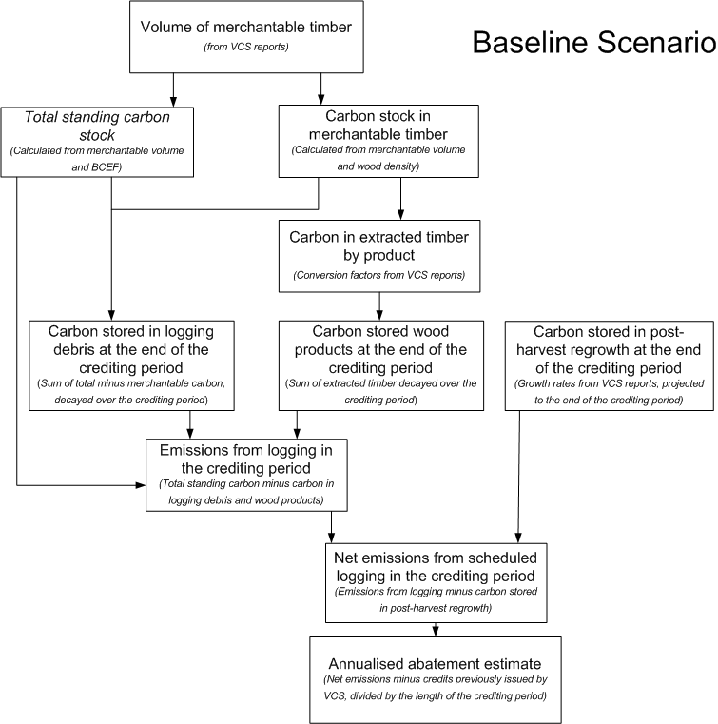

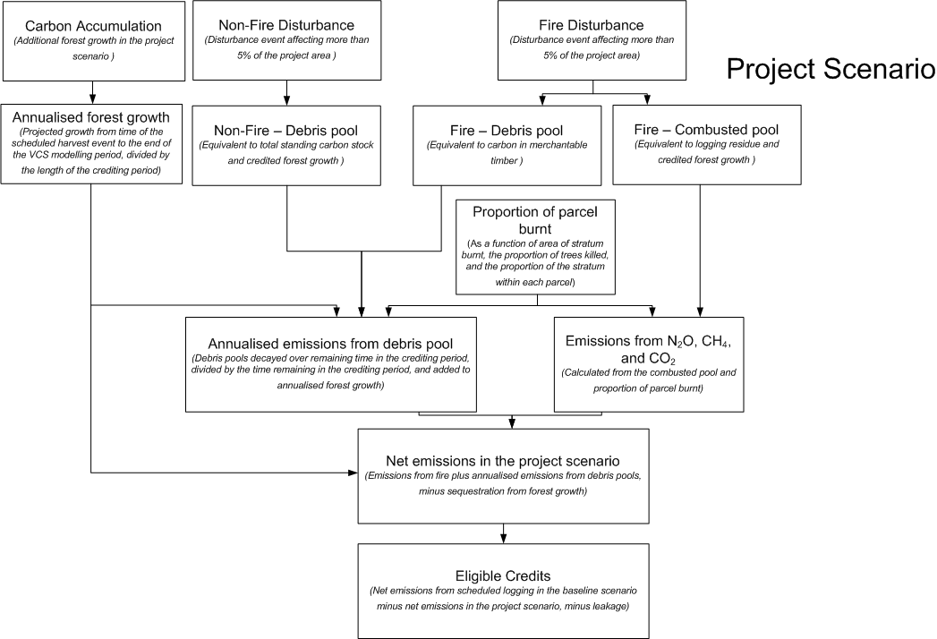

Attachment C

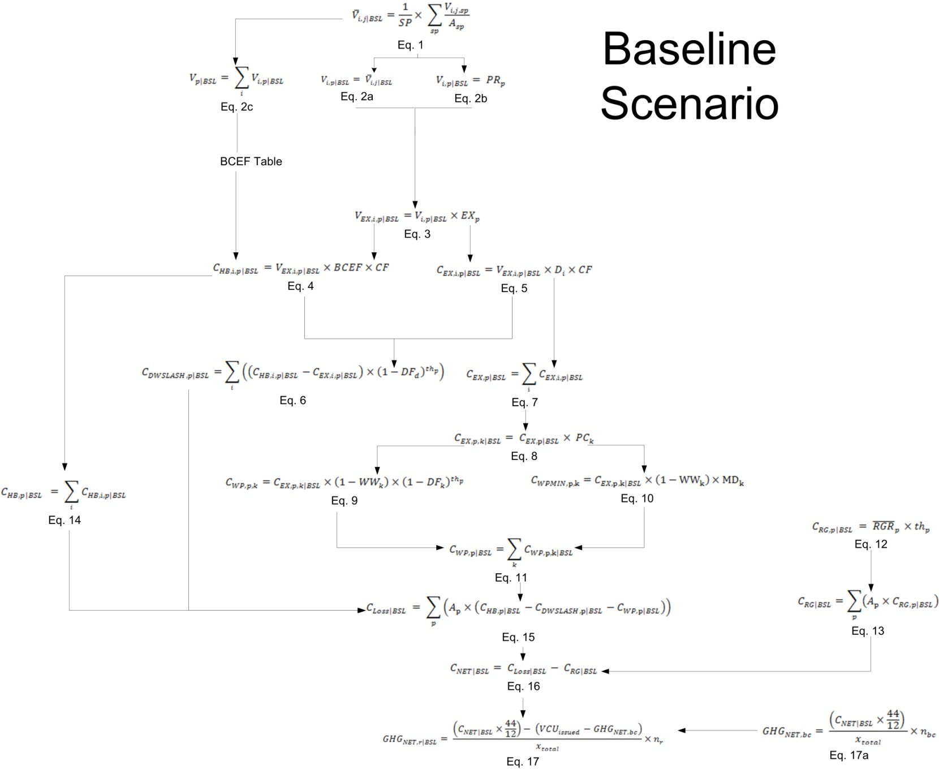

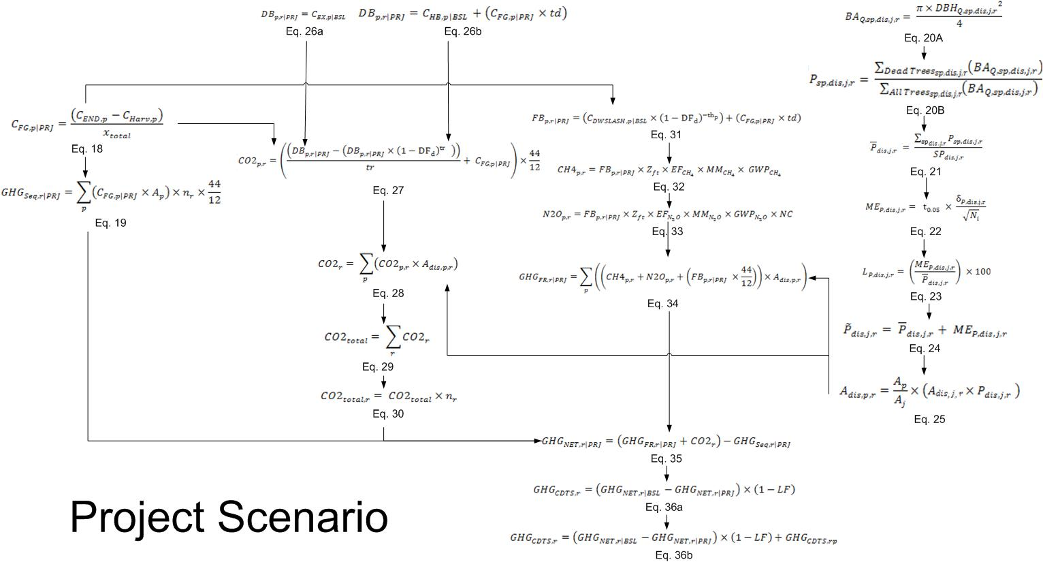

Attachment D

**Statement of Compatibility with Human Rights**

Prepared in accordance with Part 3 of the *Human Rights (Parliamentary Scrutiny) Act 2011*

*Carbon Credits (Carbon Farming Initiative—Designated Verified Carbon Standard Projects) Methodology Determination 2015*

This legislative instrument is compatible with the human rights and freedoms recognised or declared in the international instruments listed in section 3 of the *Human Rights (Parliamentary Scrutiny) Act 2011*.

**Overview of the Legislative Instrument**

The *Carbon Credits (Carbon Farming Initiative—Designated Verified Carbon Standard Projects) Methodology Determination 2015* (the Determination) sets out the detailed rules for implementing and monitoring offsets projects that avoid emissions and sequester carbon by not harvesting private native forests. The Determination applies to projects that were previously operating under the Verified Carbon Standard, a voluntary international emissions offsets program.

Project proponents wishing to implement the Determination must make an application to the Clean Energy Regulator (the Regulator) and meet the eligibility requirements set out under the *Carbon Credits (Carbon Farming Initiative) Act 2011*. Offsets projects that are approved by the Regulator can generate Australian carbon credit units.

**Human rights implications**

This legislative instrument does not engage any of the applicable rights or freedoms.

**Conclusion**

This legislative instrument is compatible with human rights as it does not raise any human rights issues.

**Greg Hunt, Minister for the Environment**