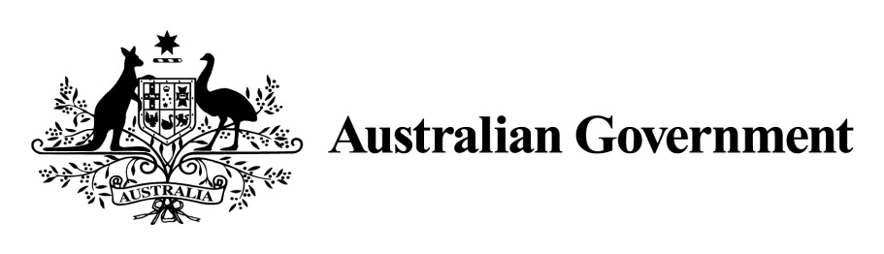

National Land Transport Act 2014

VARIATION OF THE ROADS TO RECOVERY LIST 2014

Instrument No. 2015/1
I, ALEXANDER EDWARD FOULDS, General Manager, South East Roads, Department of Infrastructure and Regional Development, under section 88(2A) of the National Land Transport Act 2014 (the Act), vary the Roads to Recovery List 2014 which was made by the Minister on 12 September 2014 as follows:

- Name of variation

This variation instrument is the Roads to Recovery List 2014 Variation Instrument No. 2015/1.

- Variation

(a) In Schedule 1 of the List, in the part relating to Western Australia:
omit the amount specified in Column 2 of Schedule 1 to the List for each applicable person or body named in Column 1 of the schedule to this instrument and replace the omitted amount with the amount specified for that person or body in Column 2 of the schedule to this instrument.
(b) In Schedule 2 of the List, in the part relating to Western Australia:
Omit the amount specified in the List for Western Australia in Column 2 of schedule 2 and replace the omitted amount with the amount $4,778,667.

- Commencement

This instrument commences on 30 April 2015.

Dated: Twenty Fourth March 2015

Alex Foulds

ALEXANDER FOULDS
Delegate of the Minister for Infrastructure and Regional Development

Schedule to Instrument 2015/1

Column 1 | Column 2
Shire of Broome | $2,665,062
Shire of Derby West Kimberley | $2,742,906
Shire of East Pilbara | $6,850,582
Shire of Halls Creek | $2,794,095
Town of Port Hedland | $1,997,551
Shire of Upper Gascoyne | $2,604,814
Shire of Wyndham East Kimberley | $3,406,002
City of Kalgoorlie-Boulder | $4,702,649
Shire of Laverton | $2,736,506
Shire of Menzies | $2,335,000
Shire of Ngaanyatjarraku | $3,364,434
Shire of Murray | $3,382,440
City of Swan | $7,263,328
City of Karratha | $2,467,954
Shire of Murchison | $2,881,635
City of Busselton | $4,936,097
Shire of Collie | $1,816,806
Shire of Donnybrook Balingup | $3,731,830
City of Gosnells | $4,821,954
City of Albany | $6,057,784
Shire of Boyup Brook | $2,133,116
Shire of Bridgetown Greenbushes | $2,164,849
Shire of Denmark | $1,367,944
Shire of Kojonup | $3,074,478
Shire of West Arthur | $1,794,120
Shire of Northam | $2,304,120

