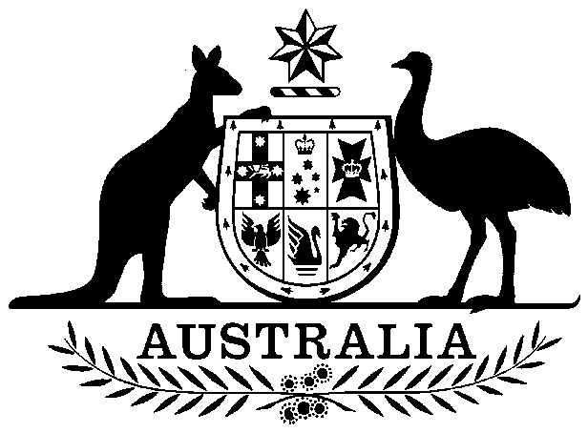

**COMMONWEALTH OF AUSTRALIA**

##### Environment Protection and Biodiversity Conservation Act 1999

**Amendment of List of Exempt Native Specimens**

I, PAUL MURPHY, Assistant Secretary, Wildlife Trade and Biosecurity Branch, as Delegate of the Minister for the Environment pursuant to subsection303DC(1) of the *Environment Protection and Biodiversity Conservation Act 1999* (EPBC Act), hereby amend the list of exempt native specimens established under section 303DB of the EPBC Act by deleting from the list the following item and any associated notations:

* Specimens that are or are derived from fish or invertebrates, other than specimens that belong to species listed under Part 13 of the EPBC Act, taken in the South Australian Blue Crab Fishery, as defined in the *Fisheries Management (Blue Crab Fishery) Regulations 1998* and the *Fisheries Management (Marine Scalefish Fisheries) Regulations 2006* in force under the *Fisheries Management Act 2007* (South Australia).

# Dated this 30th day of March 2015

……………… Paul Murphy………………..

Delegate of the Minister for the Environment