# EXPLANATORY STATEMENT

# *Carbon Credits (Carbon Farming Initiative) Act 2011*

*Carbon Credits (Carbon Farming Initiative—Reforestation and Afforestation 2.0) Methodology Determination 2015*

### Background: Emissions Reduction Fund

The *Carbon Credits (Carbon Farming Initiative) Act 2011* (the Act) enables the crediting of greenhouse gas abatement from emissions reduction activities across the economy. Greenhouse gas abatement is achieved either by reducing or avoiding emissions or by removing carbon from the atmosphere and storing it in soil or trees.

In 2014, the Act was amended by the *Carbon Farming Initiative Amendment Act 2014* to establish the Emissions Reduction Fund (ERF). The ERF expands on the Carbon Farming Initiative (CFI) by extending the scope of eligible emissions reduction activities and by streamlining existing processes. The ERF has three elements: crediting emissions reductions, purchasing emissions reductions, and safeguarding emissions reductions.

Emissions reduction activities are undertaken as offsets projects. The process involved in establishing an offsets project is set out in Part 3 of the Act. An offsets project must be covered by, and undertaken in accordance with, a methodology determination.

Subsection 106(1) of the Act empowers the Minister to make, by legislative instrument, a methodology determination. The purpose of a methodology determination is to establish procedures for estimating abatement (emissions reductions and sequestration) and rules for monitoring, record-keeping and reporting. These methodologies will ensure that emissions reductions are genuine – that they are both real and additional to business as usual.

In deciding to make a methodology determination the Minister must have regard to the advice of the Emissions Reduction Assurance Committee (ERAC), an independent expert panel established to advise the Minister on proposals for methodology determinations. The Minister will also consider any adverse environmental, economic or social impacts likely to arise as a result of projects to which the determination applies.

The ERAC must include in its advice to the Minister the Committee’s opinion on whether a proposed determination complies with the offsets integrity standards set out in section 133 of the Act. The offsets integrity standards require that an eligible project should result in carbon abatement that is unlikely to occur in the ordinary course of events and is eligible carbon abatement under the Act. In summary, the offsets integrity standards also include that:

* amounts are measurable and capable of being verified;
* the methods used are supported by clear and convincing evidence;
* material emissions which are a direct consequence of the project are deducted; and
* estimates, assumptions or projections used in the determination should be conservative.

Offsets projects that are undertaken in accordance with a methodology determination and approved by the Clean Energy Regulator (the Regulator) can generate abatement, representing emissions reductions from the project.

Project proponents can receive funding from the ERF by submitting their projects into a competitive auction run by the Regulator. The Government will enter into contracts with successful proponents, which will guarantee the price and payment for the future delivery of emissions reductions.

Further Information on the Emissions Reduction Fund is available at: www.environment.gov.au/emissions-reduction-fund.

### Application of the Determination

The *Carbon Credits (Carbon Farming Initiative—Reforestation and Afforestation 2.0) Methodology Determination 2015* (the Determination) sets out the detailed rules for implementing and monitoring offsets projects that sequester carbon by establishing and maintaining trees that have the potential to attain a height of at least 2 metres, and a crown cover of at least 20%, on land that has previously been used for agricultural purposes in any part of Australia, and that meet the eligibility requirements set out in the Determination. The rules set out in the Determination have been designed to reflect the requirements of the offsets integrity standards, and to ensure that emissions reductions are real and additional to business as usual.

A project proponent wishing to implement a project in accordance with the Determination must make an application to the Regulator under section 22 of the Act and meet the general eligibility requirements for an offsets project set out in subsection 27(4), which include compliance with the rules set out in the Determination, and the additionality requirements in subsection 27(4A) of the Act. The additionality requirements are:

* the newness requirement;
* the regulatory additionality requirement; and
* the government program requirement;

or any requirements in lieu of those requirements.

Subsection 27(4A) provides that a methodology determination may specify requirements in lieu of the newness or regulatory additionality requirements. The Determination specifies a requirement in lieu of the regulatory additionality requirement. Further, legislative rules made under the Act, the *Carbon Credits (Carbon Farming Initiative) Rule 2015*, specify a requirement in lieu of the government program requirement.

Section 23 of the Act provides that, if a project is a sequestration offsets project, an application to the Regulator under section 22 must include a request that the project be subject to either a 100-year or 25-year permanence period. Then, if the Regulator declares that the project is an eligible offsets project, the Regulator will declare that the project is subject to a 100-year or 25-year permanence period. Once declared, the permanence period is fixed and it will not be possible for projects to ‘move between’ permanence periods.

If the project proponent elects a 25-year permanence period, a permanence discount applies in accordance with section 16 of the Act. The permanence discount is 20% of the net abatement number unless another percentage is specified in legislative rules made under the Act.

As they are sequestration offsets projects under section 54 of the Act, projects undertaken in accordance with the Determination are subject to a risk of reversal buffer, as provided by section 16 of the Act.

The Determination is similar to other CFI determinations that relate to reforestation and afforestation project type. These are:

* the *Carbon Credits (Carbon Farming Initiative) (Reforestation and Afforestation) Methodology Determination 2013*;
* the *Carbon Credits (Carbon Farming Initiative) (Reforestation and Afforestation—1.1) Methodology Determination 2013*; and
* the *Carbon Credits (Carbon Farming Initiative) (Reforestation and Afforestation—1.2) Methodology Determination 2013*.

However, the Determination has been updated to meet the requirements of the Act as amended and the ERF.

The Determination provides for the calculation of the net project abatement of greenhouse gases during a reporting period by estimating the carbon dioxide stored in the biomass of project trees, litter and fallen dead wood, known as ‘project forest biomass’.

### Public Consultation

An exposure draft of the Determination was published on the Department’s website for public consultation from 16 November to 30 November 2014. One submission was received.

### Determination Details

The Determination is legislative instrument within the meaning of the *Legislative Instruments Act 2003*.

The Determination commences on the day after it is registered on the Federal Register of Legislative Instruments (the FRLI).

The Determination ceases to be in force when it is either revoked under section 123 of the Act, or on the day before it would otherwise be repealed under the *Legislative Instruments Act 2003*, whichever happens first. Under subsection 50(1) of that Act, a legislative instrument such as the Determination is repealed on the first 1 April or 1 October falling on or after the tenth anniversary of registration of the instrument on the FRLI. For example, if the Determination is registered before 1 April 2015, it would expire on 31 March 2025.

Details of the Determination are at Attachment A to Attachment F.

A statement of compatibility with human rights is set out at Attachment G.

### Note on this explanatory statement

Numbered sections in this explanatory statement align with the relevant sections of the Determination.

# Details of the Determination

## Part 1—Preliminary

#### 1 Name

This section sets out the full name of the Determination, which is the *Carbon Credits (Carbon Farming Initiative—Reforestation and Afforestation 2.0) Methodology Determination 2015*.

The Determination bears strong similarities to the *Carbon Credits (Carbon Farming Initiative) (Reforestation and Afforestation – 1.1) Methodology Determination 2013*, as well as other CFI determinations for the reforestation and afforestation project type.

#### 2 Commencement

This section provides that the Determination commences on the day after its registration on the Federal Register of Legislative Instruments (the FRLI).

#### 3 Authority

This section provides that the Determination is made under subsection 106(1) of the Act.

#### 4 Duration

Under subparagraph 122(1)(b)(i) of the Act, a methodology determination remains in force for the period specified in the determination.

This section provides that the Determination remains in force for a period that begins when the determination commences and ends on the day before it would otherwise be repealed under subsection 50(1) of the *Legislative Instruments Act 2003*.

Instruments are repealed under that provision on the first 1 April or 1 October following the tenth anniversary of registration on the FRLI. This section ensures that the Determination will expire in accordance with subparagraph 122(1)(b)(i) of the Act.

If the Determination expires or is revoked during a crediting period for a project to which the Determination applies, the Determination will continue to apply to the project during the remainder of the crediting period under subsections 125(2) and 127(2) of the Act. Project proponents may apply to the Regulator during a reporting period to have a different methodology determination apply to their projects from the start of that reporting period (see subsection 128(1) of the Act).

#### 5 Definitions

This section defines a number of terms used in the Determination.

The note at the bottom of this section lists terms that are not defined in the Determination but instead have the meaning given to them by section 5 of the Act.

Under section 23 of the *Acts Interpretation Act 1901*, words in the Determination in the singular number include the plural and words in the plural number include the singular.

#### 6 References to factors and parameters from external sources

This section refers to factors or parameters used in calculations that are derived from external sources. Most parameters are derived from the *National Greenhouse and Energy Reporting Regulations 2008* (the NGER Regulations) or the *NGER (Measurement) Determination* made under subsection 10(3) of the *National Greenhouse & Energy Reporting Act 2007* (NGER Act).

The effect of subsection (1) is that if those legislative instruments are amended during a project’s reporting period, then the project proponent will be required to use the factor or parameter prescribed in the instrument that is in force at the end of the reporting period.

Paragraph (2)(a) provides that subsection (1) does not apply if the Determination sets out other requirements.

Paragraph (2)(b) provides that subsection (1) does not apply where it is not possible to retrospectively apply a factor or parameter in an instrument that is in force at the end of the reporting period. An example of circumstances where this may occur is where the monitoring approach defined in an external source is amended to require additional or different monitoring practices after the reporting period has commenced. In this circumstance it is not possible to retrospectively undertake monitoring activities in accordance with the new requirement.

As provided for by section 10 of the *Acts Interpretation Act 1901* and section 13 of the *Legislative Instruments Act 2003*, references to external documents which are legislative instruments (such as the *NGER (Measurement) Determination*) are to versions of those instruments as in force from time to time. In circumstances where paragraph (2)(b) applies, it is expected that project proponents will use the version of legislative instruments in force at the time at which monitoring or other actions were conducted. Subsection 126(1) sets out reporting requirements to be followed when paragraph (2)(b) applies.

## Part 2—Permanent planting projects

#### 7 Permanent planting projects

The effect of paragraphs 27(4)(b) and 106(1)(a) of the Act is that a project must be covered by a methodology determination, and that the methodology determination must specify the kind of offsets project to which it applies.

This section lists the kinds of offsets projects to which the Determination applies. The kinds of project listed in this section are projects that establish a ‘permanent planting’ that can reasonably be expected to result in eligible carbon abatement. The term ‘permanent planting’ has the same meaning as it has under regulations or legislative rules made under the Act. Under the *Carbon Credits (Carbon Farming Initiative) Regulations 2011*, the term is defined as follows:

***permanent planting*** means a planting:

(a) that is not harvested other than:

(i) for thinning for ecological purposes; or

(ii) to remove debris for fire management; or

(iii) to remove firewood, fruits, nuts, seeds, or material used for fencing or as craft materials, if those things are not removed for sale; or

(iv) in accordance with traditional indigenous practices or native title rights; and

(b) that is not a landscape planting.

Projects registered under the existing suite of CFI reforestation and afforestation methodologies can transition to the Determination in accordance with the Act.

## Part 3—Project requirements

#### 8 Operation of this Part

Under paragraph 106(1)(b) of the Act, the Minister is able to make a methodology determination that sets out, among other things, requirements that must be met for a project to be an eligible offsets project. Under paragraph 27(4)(c) of the Act, the Regulator must not declare that an offsets project is an eligible offsets project unless the Regulator is satisfied that the project meets these requirements. The effect of section 35 of the Act is that the Regulator may, if an appropriate regulation or legislative rule is made, revoke the declaration that a project is an eligible offsets project if eligibility requirements have not been met.

Part 3 of the Determination specifies a number of requirements that must be met in order for a project to which the Determination applies to be an eligible offsets project.

#### 9 Location

This section provides that the project area must be located in Australia. The term ‘Australia’ is defined in the Act as including external Territories.

Project proponents of carbon sequestration projects are able to include their whole land title as their project area, even if the project is only being undertaken on a part of that land. Alternatively, the project area could be narrower than the whole land title.

#### 10 Project area to include eligible land

This section sets out the requirements for land in the project area where project activities will occur and, as a consequence, project abatement will be estimated. Subsection (1) provides that the project area is required to include at least some land that, for at least 5 years before the date of the ‘relevant application’ in relation to the project, has been used for grazing or cropping, and/or fallow between grazing or cropping activities.

Subsection (3) defines the term ‘relevant application’ for the purposes of this provision. In the situation that the land on which the project is to be carried out was part of the project at the time of the application under section 22 of the Act, the ‘relevant application’ is that made under section 22 of the Act. If the land was added later through a variation to the project under legislative rules or regulations made for the purposes of section 29 of the Act, the ‘relevant application’ is the application for the variation.

The project area is able to include areas of land which are not eligible land, such as roads, water courses, large rock outcrops and non-project forest. Such areas of land cannot be included as ‘strata’ under the project, and consequently, are not counted when abatement is calculated.

In addition, paragraphs 3.36(e) and (f) of the *Carbon Credits (Carbon Farming Initiative) Regulations 2011* provide that a project will be excluded if it involves the establishment of vegetation on land that has been subject to:

* unlawful clearing of a native forest; or
* lawful clearing of a native forest within:
  + seven years; or
  + if there is a change in ownership of the land that constitutes the project area after the clearing – five years;

of the lodgement of an application for the project to be declared an eligible offsets project.

#### 11 Project mechanisms

This section prescribes the project mechanisms of an eligible offsets project under the Determination. The project must involve establishing a ‘permanent planting’ (as defined above) of project trees that is planted with sufficient density for the trees to have the potential to achieve forest cover.

The terms ‘project trees’ and ‘forest cover’ are defined in section 5. Under this definition, land has forest cover if it has an area of at least 0.2 of a hectare, and the vegetation on the land includes trees that are 2 metres or more in height and which provide crown cover of at least 20% of the land.

The potential of the project trees to achieve forest cover can be demonstrated by reference to the growth characteristics of the species to which the project trees belong and the planting density.

Table 1 shows the minimum number of trees per hectare to achieve 20% crown cover in a stand of trees.

**Table 1**

| **Mature crown diameter per tree (m)** | **Crown area per tree at maturity (m2)** | **Crown area per tree at maturity (ha)** | **Minimum number of trees per hectare required for 20% crown cover**  (Crown cover of 20% divided by Crown area per tree at maturity) |
| --- | --- | --- | --- |
| 5.0 | 19.63 | 0.00196 | 102 |
| 4.5 | 15.90 | 0.00159 | 126 |
| 4.0 | 12.57 | 0.00126 | 159 |
| 3.5 | 9.62 | 0.00096 | 208 |
| 3.0 | 7.07 | 0.00071 | 283 |
| 2.5 | 4.91 | 0.00049 | 407 |
| 2.0 | 3.14 | 0.00031 | 637 |

Crown cover as a proportion can be estimated by multiplying planting density (trees per hectare) by crown area (in hectares). For example, a minimum density to achieve 20% crown cover with evenly distributed trees for a species with a crown diameter of 3.5 to 4 metres is about 150 – 200 trees per hectare. Table 1 provides guidance on the ratio of trees to crown cover for a given crown diameter.

Project proponents are encouraged to plant in each stratum more than the minimum number of trees to achieve greater than 20% crown cover, to allow a buffer for mortality.

The note to this section makes clear that the project trees may be planted in a belt or block configuration (or a combination of the two configurations) provided the project trees are able to achieve forest cover.

#### 12 Removal of trees

Subsection (1) sets out the general rule that native forest and other non-project trees must not be removed from the project area, or otherwise disturbed.

Subsection (2) sets out exceptions to the general rule regarding the removal of trees. Under paragraphs (2)(a) and (b), non‑project trees can be removed from the project area at any time if:

* they are prescribed weeds, or if the removal of the trees is otherwise required by law; or
* the trees do not meet the definition of ‘native forest’, and they are less than 2 metres in height at the time of their removal. Trees meeting these specifications may be removed or otherwise disturbed at any time from commencement to six months after planting, provided that the crown cover of the trees to be removed covers less than 5% of the project area; or
* they are removed for biomass sampling; or
* they are removed to manage a natural disturbance event such as disease or fire; or
* their removal is otherwise required by law or permitted by or under the Act.

Subsection (3) allows project trees to be removed from the project area in certain limited circumstances.

* Paragraph (3)(a) allows the removal of project trees for biomass sampling.
* Under paragraph (3)(b), project trees may be removed either before or after the occurrence of a natural disturbance, in order to manage that disturbance. For example, project trees could be removed as a precautionary measure during bushfire or flood seasons.
* Paragraph (3)(c) specifies that project trees may be removed where otherwise required by law or permitted by or under the Act. Relevant laws include, for example, laws that require removal of trees growing near power lines, or removal of trees for other risk management or hazard avoidance purposes.

The effect of subsection (3) is that large-scale removal of project trees such as harvesting would lead to a project not being an eligible offsets project under the Act.

#### 13 Preparation burns

This section specifies that only one preparation burn can be carried out within each stratum as part of pre-planting site preparation activities. This burn is not accounted for as part of the project emissions, as it is not expected to be a material deviation from the baseline scenario. A burn in these circumstances could be carried out to reduce the cover of competing ground‑level vegetation such as grasses, forbs and herbaceous species. Where the preparation burn is carried out as part of pre-planting preparations, the burn must comply with the restrictions on removing trees set out in section 12. Preparation burns are restricted because of their potential to affect carbon stock.

#### 14 Restrictions relating to fertiliser use

This section sets out the general rule that fertiliser application within the stratum is no more frequent than four times in a 100-year period. There is little economic incentive to exceed this threshold.

Fertiliser use is restricted under this section so that the fertiliser regime applied under the project is not more intensive than that which was likely to have been applied under the baseline scenario of cleared agricultural land. A frequency of only one application per 25 years is likely to be lower than the average frequency in the baseline scenario. This means that emissions associated with fertiliser use are likely to be equivalent under the baseline scenario and project scenario. Accounting for this emissions source is therefore not required under either scenario.

#### 15 Requirements for pre-existing project

This section deals with requirements for projects that are transitioning to the Determination from another methodology determination.

#### 16 Requirement in lieu of regulatory additionality requirement

Paragraph 27(4)(d) of the Act requires, as one of the criteria for declaration of a project as an eligible offsets project, that the project meets the additionality requirements set out in subsection 27(4A) of the Act. One of these requirement, set out in paragraph 27(4A)(b) of the Act, is either the regulatory additionality requirement set out in subparagraph 27(4A)(b)(i) of the Act, or any requirement in lieu of this that is specified in a methodology determination, for the purposes of subparagraph 27(4A)(b)(ii). The regulatory additionality requirement is that the project is not required to be carried out by or under a law of the Commonwealth, a State or a Territory.

This section sets out a requirement in lieu of the regulatory additionality requirement.

The effect of this section is that, consistently with the regulatory additionality requirement, the project must not be required to be carried out by or under a law of the Commonwealth, a State or a Territory. However, in contrast to the regulatory additionality requirement, the requirement of this section is met even if the project is being undertaken as part of a conservation covenant with the Commonwealth, a State, a Territory or a local governing body or an authority of the Commonwealth, a State or a Territory.

## Part 4—Stratification, estimating project removals and calculating project emissions

Part 4 outlines the processes of estimating the project level carbon stock through in-field sampling. This process includes stratification, undertaking an in-field sample, as well as developing and validating allometric functions. In-field sampling is required to be undertaken each time the proponents wishes to make a claim for credits.

### Division 1—Defining strata and delineating boundaries

The Determination creates sub-units of areas within a project area for the purposes of abatement calculations. These sub-units of areas are referred to in the Determination as ‘strata’. Under the Determination, a stratum is the base land unit used to calculate change in carbon stock occurring within the project area. That is, the mean carbon stock and stock change of each carbon pool will be averaged across all plots within a stratum, to arrive at a single estimate for each stratum.

The process for delineating strata is generally referred to as ‘stratification’. Stratification can be used to improve the precision of forest and forest-carbon measurements and allows project proponents to manage the measurement of the inherent variability in the project trees being sampled. This gives confidence that the samples are an accurate representation of the measured population of project trees. To achieve this result, stratification should be carried out according to actual site characteristics that affect growth rates of trees. These characteristics might include some of those set out under subsection 17(3) of the Determination.

#### 17 Defining strata in the project area

This section deals with defining strata in the project area.

Subsection (1) requires the project proponent to define one or more areas, known in the Determination as ‘strata’, in the project area, in accordance with the CFI Mapping Guidelines. Under the Determination, abatement will only be calculated in relation to such strata. At least one stratum must be defined before submission of the first offsets report (subsection (4)), and new strata can be defined at any time (subsection (5)).

Strata must consist of eligible land on which a permanent planting has been established in accordance with the project mechanism (subsections (2) and subsection (6)). A stratum cannot include land that is not eligible land.

Subsection (3) provides that strata may be selected on the basis of any characteristics that tend to make the growth characteristics of trees in a stratum more uniform. A note to that subsection lists some examples of such characteristics.

Subsection (8) provides for how strata are defined.

In some cases, a new stratum might include part of an existing stratum. Subsection (7) provides for what to do in such circumstances. In such a case:

* the existing stratum is superseded; and
* another new stratum may be defined from the remainder.

Section 21 provides for reporting on superseded strata.

Under the Determination, strata cannot overlap (see subsections 18(4) and (5)).

In the case of strata which are defined after the initial strata are defined, usually, a full inventory will be required. This is referred to in a note under subsection (6), and is discussed further below.

If re-stratification of the project area is accompanied by a change in the project area, project proponents should be aware of the provisions specified in section 29 of the Act.

Subsections (10) to (13) deal with projects that are transitioning into the Determination from other applicable methodology determinations. These subsections transition pre-existing strata into the project under the Determination, and provide for the treatment of such strata under the Determination.

#### 18 Delineating stratum boundaries

This section deals with strata boundaries.

Under subsection (1) of this section, the first step in delineating stratum boundaries is generating a set of spatial coordinates in order to determine the geographic limits of the particular land area. The spatial coordinates can be generated by conducting an on-the-ground survey with a global positioning system, or by using ortho‑rectified aerial or satellite image; or by a combination of these two methods. Ortho-rectification refers to the process of adjusting the size and shape of an aerial photograph or satellite image to account for earth’s curvature, so that the photograph can be used to develop an accurate flat-earth map.

Once the limits of the extant project forest area have been established, the project proponent must use a geographic information system to generate spatial data-files of the project boundaries.

##### Use of ortho-rectified aerial imagery

Subsection (2) sets out the requirements that ortho-rectified aerial imagery captured over the land must meet before it can be used when required under the Determination.

This imagery can also be used to:

* confirm the status or health of project trees within the stratum;
* define the boundaries of extant project forest;
* map stratum area;
* assess crown cover; and
* confirm compliance with project requirements.

##### Extant project forest boundary

Subsection (3) defines the term ‘extant project forest boundary’, which is central to the Determination. The ‘extant project forest boundary’of a stratum is the polygon that is the outer limit of the stems of the project trees that are included in the stratum.

##### Stratum boundary

Subsections (4) and (5) deal with the stratum boundary. Generally speaking, this is the outer limit of the area of land that lies within a ‘crown radius’ of the extant project forest boundary. The term ‘crown radius’ is defined in section 5 of the Determination. Under this definition of ‘stratum boundary’, there are some adjustments in the case that the stratum boundary would otherwise extend beyond the project area, or the strata boundaries of adjacent strata would otherwise overlap. In the case of the latter, this is to prevent double-counting of project trees on the ground, and ensures that measurements of abatement are conservative.

#### 19 Growth disturbances and revision of strata

This section deals with disturbance events that affect the growth characteristics of project trees in a stratum. These ‘growth disturbances’ include events such as fires and outbreaks of disease. These events are important because they will have a long-term influence on carbon stock in the stratum.

Subsection (2) defines the term ‘growth disturbance’, as being an event that is likely to affect significantly the project tree growth characteristics of the whole or part of a stratum that has been previously reported in an offsets report. Examples include floods, fires, droughts, pest attacks, diseases and natural disturbance that would be a significant reversal under legislative rules made under the Act. Subsection (1) provides that this section applies if a stratum that has been reported in an offsets report experiences a ‘growth disturbance’.

Subsection (3) requires the project proponent to delineate the boundaries of the land on which the project trees affected by the disturbance are located. The boundaries must be delineated within six months after the occurrence of the growth disturbance.

If the growth disturbance has affected more than 5% of the area in a stratum, the project proponent must revise the affected stratum in accordance with subsections (6) and (7). If no more than 5% of the stratum area has been affected, this approach is optional. Where the approach is adopted, the revision must occur before the project proponent submits the offsets report that relates to the time when the disturbance happened.

Subsection (6) provides that, if the whole stratum has been affected by the disturbance, the stratum is ‘revised’ by creating a new stratum, with new stratum identifier. Subsection (8) requires the new stratum to be labelled as either a ‘fire affected stratum’ or a ‘disturbance affected stratum’, depending on the nature of the disturbance.

Subsection (7) sets out the requirements for revising partially affected strata. This process must be applied to affected areas of more than 5% of the area within a stratum, but is optional for areas that are less than or equal to 5% of the stratum area. Under this subsection, revised strata that correspond to the area of the growth disturbance are known as an ‘affected strata’, while revised strata that correspond to the balance of the original stratum are known as ‘unaffected strata’. Subsection (8) provides that such strata must similarly be labelled as either a ‘fire affected stratum’ or ‘disturbance affected stratum’, depending on the nature of the disturbance.

The new stratum or strata that consists or consist of the affected area must meet the general requirements for strata.

Subsection (9) provides that the labels of ‘fire affected stratum’ or ‘disturbance affected stratum’ may be removed from a stratum when it is no longer significantly affected by the disturbance. That is, when the growth characteristics reflect an unaffected stratum. Stratum labelled as fire or disturbance affected cannot be amalgamated with unaffected stratum.

Subsections (10) to (12) set out the process for estimating the closing carbon stock for unaffected strata. Subsection (11) provides that a project proponent can estimate the closing carbon stock for an unaffected stratum using a PSP assessment combined with data previously collected for an offsets report. That is, where the project proponent has plot data that relates to land that was part of the original stratum, and following a disturbance event is part of an unaffected stratum, that data can be used in conjunction with PSP data to estimate the closing carbon stock.

The closing carbon stock for affected strata are calculated in accordance with subsections (13) and (14).

#### 20 Effect of change in stratum boundaries

This section sets out the consequences if a revision, or cumulative revisions across multiple reporting periods, of the boundaries of a stratum change the stratum area by more than 5% between any reporting periods, other than one that is required to be revised in accordance with section 19.

An adjustment limit of ±5% is considered adequate tolerance to account for any minor adjustments relating to, for example, amending mapping with reference to superior data sources (e.g. aerial imagery) so as to reflect stratum boundaries more accurately. If the boundary of a stratum referred to in an offsets report changes by 5% or less, this section does not apply.

Where boundaries of a stratum change and consequently change the stratum area by more than 5%, the stratum is treated as being superseded. The proponent can then opt to define one or more new strata. Superseded strata are dealt with by the following provision.

#### 21 Reporting on established and superseded strata

This section provides that stratum identifiers must continue to be reported in offsets reports even where the strata with which they are associated no longer exist because the stratum is superseded. Subsection (2) provides that the closing carbon stock and associated standard error will be zero for the strata that no longer exist, and that these zero values are to be used when calculating the carbon stock change for the strata in accordance with section 92 (see Example 1 and 2). In accordance with section 93, the initial carbon stock and standard error of any new strata are zero.

##### Example 1

Max has one stratum in his project, which he has called ‘Stratum 1’. For the first offsets report Max reports on the closing carbon stock for Stratum 1 as being 2,000 t CO2-e. After looking at the data collected for the first offsets report, Max found the sampling would be more efficient if he split Stratum 1 into two strata, called ‘Stratum 1a’ and ‘Stratum 1b’. For the second reporting period, Max estimated the closing carbon stock for Stratum 1a and Stratum 1b to be 2,000 t CO2-e and 1,000 t CO2-erespectively. Given this, in the second offsets report, Max then reports a loss 2,000 t CO2-efrom Stratum 1 (the superseded stratum), and a gain of 3,000 t CO2-e in the two ‘new’ strata.

##### Example 2

Amelie has one stratum in her project, which she has called ‘Stratum 1’. For the first offsets report Amelie reports on the closing carbon stock for Stratum 1 as being 2,000 t CO2-e. During the second reporting period, Amelie detects a fire that kills trees in half of ‘Stratum 1’. In response to the requirements in section 19, Amelie delineates Stratum 1 into ‘Stratum 1a’ and ‘Stratum 1b – Fire affected stratum’. For the second reporting period, Amelie estimated the closing carbon stock for Stratum 1a to be 1,000 t CO2-e and 200 t CO2-e for Stratum 1b – Fire affected stratum. Given this, in the second offsets report, Amelie then reports a loss 2,000 t CO2-efrom Stratum 1 (the superseded stratum), and a gain of 1,200 t CO2-e in the two ‘new’ strata.

### Division 2—Estimating project removals

Division 2 of this Part outlines the processes that must be undertaken when estimating carbon stock for a stratum at the end of a reporting period. The methods involve regularly collecting field-based measurements from strata to determine carbon stock and changes in carbon stock.

This Part allows the project proponent to choose between two measurement processes, or to apply a combination of both, for these purposes. The processes are referred to as ‘full inventory’ and ‘PSP assessment’.

* A full inventory refers to a field inventory where sufficient plots are measured within a stratum, such that the probable limit of error is equal to or less than ± 10% of the mean carbon stock of the stratum, at the 90% confidence level. A full inventory in the context of the Determination does not mean that every tree should be measured.
* A PSP assessment involves the establishment of permanently marked plots with fixed locations, at a rate that achieves a target probable limit of error of ± 20% of the estimated mean PSP carbon stock for all PSPs within the stratum, at the 90% confidence level.

Generally speaking, a full inventory is required within six months prior to the submission of the first offsets report for a particular stratum. However, there are special rules in section 19 for growth affected strata.

After that, full inventories will usually be required at least once every five years, prior to submission of offsets reports. The exception to this is in circumstances where the project forest in a particular stratum has reached a level of maturity at which it has ceased to sequester significant amounts of additional carbon in each reporting period. Although offsets reporting will still be required in such circumstances, the proponent is ordinarily able to discontinue conducting full inventories or PSP assessments. While inventories and assessments are not being conducted, proponents will not be able to generate additional Australian carbon credit units from the project, even if the project forest continues to grow and to sequester carbon. However, if there is a growth disturbance in a stratum, proponents will be required to conduct a full inventory. Even without a growth disturbance, proponents are able to conduct a full inventory at a later stage (and to conduct subsequent inventories and assessments), and are then able to obtain credit for sequestration over the period during which assessment of carbon stock did not take place.

Optionally, project proponents may supplement full inventories with PSP assessments. PSP assessments are particularly useful where the preference is to submit offsets reports more frequently than every five years. PSP assessments can be conducted in between full inventories, prior to each offsets report, to inform estimates of changes in carbon stock between reporting periods. PSP assessments might be applied in order to save costs, as they have a lower sampling frequency. If PSP assessments are conducted, full inventories will nevertheless be required every five years. A PSP assessment can only be conducted within 5 years after the most recent previous full inventory.

The following example scenarios illustrate some combinations of full inventory and PSP assessment that meet differing offsets report schedules.

##### Example scenario 1: Annual Offsets Reports from year 1.

| Year/Activity | 1 | 2 | 3 | 4 | 5 | 6 | 7 | 8 | 9 | 10 |
| --- | --- | --- | --- | --- | --- | --- | --- | --- | --- | --- |
| Full Inventory |  |  |  |  |  |  |  |  |  |  |
| PSP Assessment |  |  |  |  |  |  |  |  |  |  |

##### Example scenario 2: Offsets Reports at years 2, 5, 8 & 10.

| Year/Activity | 1 | 2 | 3 | 4 | 5 | 6 | 7 | 8 | 9 | 10 |
| --- | --- | --- | --- | --- | --- | --- | --- | --- | --- | --- |
| Full Inventory |  |  |  |  |  |  |  |  |  |  |
| PSP Assessment |  |  |  |  |  |  |  |  |  |  |

##### Example scenario 3: Offsets Reports at years 2, 5-10.

| Year/Activity | 1 | 2 | 3 | 4 | 5 | 6 | 7 | 8 | 9 | 10 |
| --- | --- | --- | --- | --- | --- | --- | --- | --- | --- | --- |
| Full Inventory |  |  |  |  |  |  |  |  |  |  |
| PSP Assessment |  |  |  |  |  |  |  |  |  |  |

##### Example scenario 4: Offsets Reports at years 5 & 10.

| Year/Activity | 1 | 2 | 3 | 4 | 5 | 6 | 7 | 8 | 9 | 10 |
| --- | --- | --- | --- | --- | --- | --- | --- | --- | --- | --- |
| Full Inventory |  |  |  |  |  |  |  |  |  |  |
| PSP Assessment |  |  |  |  |  |  |  |  |  |  |

### Subdivision 1—General

#### 22 General

This section provides that Division 1 sets out processes that must be conducted when undertaking activities in relation to estimating the carbon dioxide equivalent net abatement amount for an eligible offsets project to which this Determination applies.

### Subdivision 2—Outline—conducting full inventory or PSP assessment

A full inventory is an assessment of forest biomass for calculation of carbon amounts using plot-based assessments. Compared with PSP assessment, a full inventory is a higher intensity field-based measurement approach to carbon stock estimation that involves the establishment and assessment of temporary sampling plots (TSPs) – and, if desired, PSPs – across strata. Individual project trees are measured from within plots and allometric functions are applied to estimate carbon stock.

#### 23 Outline of steps—conducting full inventory or PSP assessment

This section sets out the processes that the project proponent must undertake when conducting a full inventory or a PSP assessment of a stratum. The purpose of this section is to outline the main steps of the methods. The details are set out in other Subdivisions in this Part.

Section 85 sets out when full inventories must be conducted. In short, a full inventory is required for a stratum:

* within 6 months before the end of the reporting period for the offsets report that first references the stratum;
* as required by section 19;
* if there has been a PSP assessment—no later than 5 years after the most recent full inventory.

The principal steps in conducting a full inventory are:

* establishing temporary sample plots and, where appropriate, permanent sample plots;
* sampling those plots, and applying allometric functions to estimate the biomass in project trees occurring in each plot within the stratum, developing and updating these functions as appropriate;
* optionally, accounting for carbon in litter and fallen dead wood pools in accordance with Subdivision 17;
* from this, working out the mean plot carbon stock for the stratum and the closing stock;
* verifying, *ex post*, that the appropriate target degree of error was achieved;
  + if it was – calculating carbon stock for the stratum; and
  + if it was not – revising the full inventory in order to ensure that the appropriate target degree of error was achieved.

The principal steps in a PSP assessment are broadly similar, but the assessment is less costly and less time-intensive.

### Subdivision 3—Sampling plans

Subdivision 3 deals with sampling plans. A sampling plan is a document that identifies the quantity and location of TSPs, PSPs, and biomass sample trees within a stratum, or the geographic limits of an allometric domain.

#### 24 Developing and documenting a sampling plan

This section requires the project proponent to develop and document a sampling plan when one or more of the following occurs:

* a full inventory is conducted;
* a PSP is established, or a PSP assessment is conducted;
* an allometric function is developed, updated, or validated.

A sampling plan can document multiple activities conducted within a single stratum, such as validating an allometric function and conducting a full inventory.

In all cases a sampling plan must include a description of the activity to which the sampling plan relates, including the dates during which the activity is to be conducted.

#### 25 Sampling plan information for full inventory and PSP assessment

This section specifies matters that must be included in a sampling plan when a full inventory or PSP assessment is being conducted.

Paragraph (2)(f) of this section requires that the number of plots be calculated in advance of the full inventory, such that the number of plots to be established meets the target probable limit of error. Following completion of the target number of field plots, the probable limit of error is re-calculated in order to determine whether the target error has been reached. If not, more plots will need to be established. In other words, plot establishment is an iterative process whereby the probable limit of error calculation, as specified in section 117, is re-visited throughout the field inventory to determine whether enough plots have been established.

Section 56 of the Determination provides that where the PSP assessment meets the requirements of a full inventory, the proponent can calculate the closing carbon stock using the full inventory procedures. Where this procedure has been used by a proponent, subparagraph (2)(f)(iii) of this section sets out an additional requirement for the sampling plan that verifies that the calculation met the applicable legislative requirements.

Paragraph (2)(l) of this section requires that a sampling plan includes details of corrective measures that were taken when the variation referred to in paragraph (2)(k) exceeds the threshold specified in Subdivision 9.

#### 26 Sampling plan information for stratum specific functions

#### 27 Sampling plan information for regional functions

Sections 26 and 27 specify the matters that the project proponent must include in a sampling plan in relation to allometric functions. The additional matters include the spatial coordinates defining the location of biomass sample sites, biomass sample plots and biomass sample trees generated both off site and on the ground. Recording the coordinates in a sample plan allows the off-site coordinates to be cross-checked with the actual location recorded in the field.

In some instances, sections 25, 26 and 27 require both *ex ante* and *ex post* information and processes. The project proponent should therefore create and maintain both *ex ante* and *ex post* versions of the sampling plans required under this Subdivision.

Other provisions specify other matters that must be included in such plans. See for example subsections 67(2), 68(1) and 70(13).

### Subdivision 4—*Ex ante* estimate of minimum number of TSPs or PSPs

#### 28 Operation of Subdivision

Subdivision 4 sets out how to estimate *ex ante* the minimum number of:

* TSPs that will be needed to conduct a full inventory; and
* PSPs that will be needed to conduct a PSP assessment

If the project proponent intends conducting a permanent sample plot (PSP) assessment in the stratum, then at the very least, sufficient PSPs must be established in order to meet the target probable limit of error for such an assessment. In any event, the project proponent must establish sufficient plots in order to meet the target probable limit of error for a full inventory.

#### 29 Target probable limits of error for full inventory and PSP assessment

This section specifies the target probable limits of error for full inventory and PSP assessment.

* The ‘target probable limit of error for a full inventory’is no more than 10% at the 90% confidence level around the estimated mean carbon stock for plots within the stratum, calculated using Equation 28.
* The ‘target probable limit of error for a PSP assessment’ is no more than 20% at the 90% confidence level around the estimated mean carbon stock for plots within the stratum, calculated using Equation 28.

#### 30 *Ex ante* estimate of minimum number of TSPs or PSPs

This section details how to make an *ex ante* estimate of minimum number of TSPs or PSPs required to meet these target probable limits of error. These are verified in accordance with the *ex* *post* analysis of Subdivision 9.

The estimate of the number of plots per stratum required to achieve the target probable limit of error must be documented in a sampling plan that has been developed in accordance with Subdivision 3. For full inventories and PSP assessments, the sampling plan must include the *ex post* analysis confirming that the target probable limit of error has been achieved in accordance with section 52.

### Subdivision 5—Determining the location of TSPs and PSPs

#### 31 Operation of Subdivision

This Subdivision sets out how to determine the intended location coordinates of:

* TSPs that will be needed to conduct a full inventory; and
* PSPs that will be needed to conduct a PSP assessment

#### 32 Determining potential plot locations

This section sets out the process of selecting potential plot locations. The process described is akin to a systematic sample, where a grid is used to determine potential plot locations. A number of different approaches are described for determining the potential plot locations. This is done to reflect the approaches described in previous Reforestation and Afforestation determinations.

#### 33 Selecting a subset from the potential plot locations

#### 34 Determining the intended location coordinates of TSPs and PSPs

These sections set out the method of determining the intended location coordinates of TSPs and PSPs. Essentially, this method consists of determining potential plot locations for TSPs and PSPs, selecting a subset of those to be TSPs and PSPs, and determining the locations of those plots as so selected.

The potential plot locations must be determined according to randomly selected points of intersection from a grid overlay as described in these provisions. Grid intersections are selected as potential plot locations.

The diagram at Attachment B represents the process for establishing a grid overlay for a stratum. The process requires that the location of a plot within a stratum be determined using a map of the stratum. The map must have been developed in accordance with Division 1 of this Part, and must reflect the current boundaries of the stratum.

The method for determining the potential plot locations within strata yields an unbiased representation of the trees being sampled. The instructions include a choice of anchor point from which to define a reference grid. The option in sub-subparagraph 32(1)(d)(ii)(A) may be more appropriate for projects located in the eastern half of Australia, while the option in sub-subparagraph 32(1)(d)(ii)(B) may be more appropriate for projects in the western half.

Paragraph 25(2)(g) provides that the number of grid intersections occurring wholly within the stratum boundary must be recorded in a sampling plan.

Section 33 specifies the steps that are to be undertaken if the number of grid intersections that occur within the stratum exceeds the desired number of plots to be established in the stratum.

Under these provisions, it is possible to select plots to be both TSPs and PSPs, so long as the selection complies with these provisions and the plots are established in accordance with Subdivision 6.

Under the Determination, the project proponent is required to record the plot layout option for plantings in each stratum. The three lay-out options permitted under the Determination are the ‘centroid’, the ‘consistent edge’, and the ‘constant position’ options.

* For the centroid method, plots are established so that the actual location coordinates are located at the centre (centroid) of the plot.
* For the consistent edge method, plots are established so that the first edge of the plot to be laid out in the field, referred to as the Starting Edge, passes through the coordinates of the actual location coordinates, and is aligned perpendicular to the orientation of the edges of a belt planting. Refer to Attachment B for more information on this plot configuration.
* For the constant position method, plots are established so that the actual location coordinates are located at a constant position on the plots (e.g. the most southern and eastern corner).

These provisions clarify which option must be used for strata containing block plantings, belt plantings, or both. ‘Belt plantings’ is a defined term and means discrete patches of project trees that have been established in a linear or curvilinear ‘belt’ pattern where width measured across the belt is no wider than 50 metres. ‘Block plantings’ is also a defined term and means discrete patches of project trees that have been established so the average minimum width is greater than 50 metres. Attachment C illustrates examples of a series of belt plantings of varying shapes.

### Subdivision 6—Establishing plots

#### 35 Operation of Subdivision

This Subdivision sets out how to establish:

* TSPs for a full inventory; and
* PSPs for a PSP assessment.

This Subdivision also sets out how to establish biomass sample plots for the purposes of section 70.

#### 36 Establishing plots

During a full inventory, the project proponent is required to establish and assess TSPs within the stratum. Additionally, where a PSP assessment is to be conducted to inform estimates of carbon stock change in between full inventory events, PSPs should also be established during a full inventory. Collectively, TSPs and PSPs are referred to in the Determination as ‘plots’.

This section details the specifications for the establishment of plots during a full inventory. Under the Determination, at least five plots will need to be established per stratum. If the project proponent wishes to conduct PSP assessments in the future, then at least five permanent sample plots must be established. As noted above, the same plots could be both TSPs and PSPs.

The intended location coordinates determined in accordance with this section must be uploaded into a geographic positioning system, which is used by field crews to navigate to these coordinates. It is important that plots are established according to the intended location coordinates as shown on the global positioning system in the field, without any deliberate positioning of plots with reference to, for example, planting lines, inter-rows, compartment breaks, unplanted land or extant project forest or stratum boundaries.

If establishing a plot according to the process outlined in this section would constitute a serious safety risk, the plot must be relocated to the nearest safe point to the intended location coordinates. In this case revised plot location is recorded in the sampling plan.

#### 37 Plot configuration

This section describes the requirements that must be met in relation to the shape of plots that are established in a stratum.

#### 38 Plot size

This section sets out the requirements that must be met in relation to the size of plots in a stratum. Plot sizes are given in area not dimensions, for example 5 square metres is the area covered by the plot, rather than a plot that is 5 metres by 5 metres (25 square metres). Plots must be established consistently to a pre-defined target plot size (which is documented in a sampling plan) to ensure that plots are all approximately equivalent in size to each other. This is necessary because of the arithmetic, rather than weighted, averaging approach that is applied in Equation 8.

#### 39 Identifying and marking plots

This section requires that the corners of a rectangular plot, or centre point of a circular plot, must be marked to allow for a return visit to the plot, including by independent verifiers.

Under subsection (3), the marking of a TSP must allow for its identification on return visits for at least 12 months after a full inventory assessment. PSPs must be able to be identified on return visits for five years from their establishment. Subsection (4) requires that the PSP boundary markers be fire and flood resistant, so that the plots can be identified in the event of any natural disturbance that occurs in the five years from establishment.

#### 40 Dealing with plots located close to stratum boundaries

This section applies if the ‘intended location coordinates’ of a plot fall close to the boundaries of a stratum, and provides for the assessment of such plots. Depending on the intended location of such a plot, a plot may or may not be established or assessed.

#### 41 Edge plots

If part of the boundary of the plot falls outside the stratum boundary, the plot is known as an ‘edge plot’.

Subsection (3) sets out the requirements for plot markers in rectangular edge plots. The minimum marker requirement for circular plots is to mark the centre (as required under paragraph 39(2)(b)). This may make it possible to establish the marker wholly within the stratum boundary in the case of circular plots. Further requirements for marking plots are set out in section 39.

Attachment E contains a diagrammatic example of the treatment of an edge plot.

### Subdivision 7—Visiting TSPs and PSPs and collecting data

#### 42 Operation of Subdivision

This Subdivision sets out how to visit TSPs and PSPs and collect data when conducting a full inventory or a PSP assessment.

#### 43 Plot visits during full inventory

This section provides that all TSPs must be visited when conducting a full inventory. The procedures set out in this Subdivision must be undertaken during those visits. Where PSPs are not a subset of TSPs, then all PSPs must also be visited if a PSP assessment is planned for the future.

#### 44 Plot visits during PSP assessment

This section provides that all PSPs must be visited during a PSP assessment.

#### 45 Collection of information during plot visits

This section specifies the minimum information that must be collected during plot visits.

Paragraph (1)(c) requires the noting of whether a plot is located completely inside the stratum, or is an edge plot that includes land that is outside the stratum. Stratum edges will not be obvious in the field in all circumstances, so this assessment can be performed *ex ante* and *ex post*, and either on or off site. Off site assessment of this matter could be conducted using a geographic information system and spatial data files showing the location of the plot relative to the stratum boundary.

Implicit within the requirements of this section is the necessity to conduct an internal audit of plot locations, where the plots are re-located by a person or field crew that did not participate in the original plot establishment process. Any discrepancy between the plot location from the original and internal audit should be documented, and should be within the location tolerance. The internal auditing program should also be documented in the sampling plan.

### Subdivision 8—Estimation of biomass

#### 46 Operation of Subdivision

This Subdivision sets out how to estimate biomass and calculate mean plot carbon stock when conducting a full inventory or a PSP assessment.

#### 47 Estimation of biomass

These sections outline the process for estimating biomass is full inventories and PSP assessments. Subsection (1) provides that biomass in project trees must be estimated using an allometric function that has been developed or validated in accordance with Subdivision 12 to Subdivision 16. Allometric functions are used to estimate biomass from one or more non-destructive predictor measures such as the diameter of the trunk at 1.3 metres (diameter at breast height). Different equations give different estimates for biomass because each one is designed for a specific range of variables including the type of forest and climate.

The project proponent is able to apply the following classes of allometric function to estimate the biomass within project trees:

* Stratum-specific functions;
* Regional functions, or
* CFI functions.

Biomass in litter and fallen dead wood plots is assessed in accordance with Subdivision 17.

#### 48 Estimation of carbon stock

These sections detail the provisions that apply when estimating biomass and carbon stock for full inventories and PSP assessments.

#### 49 Plot carbon stock for edge plots

This section clarifies how carbon stock in edge plots is to be assessed, and sets out modifications to various provisions of the Determination that apply in relation to edge plots. Essentially, only carbon stock within both the plot boundary and the stratum boundary are assessed; however the plot is assumed to be the standard size. The effect of this is a conservative estimate of abatement.

#### 50 Assessment of plots if pilot inventory was conducted

The *ex ante* estimate of the minimum required number of PSPs can be determined by conducting a field study known as a ‘pilot inventory’. This section regulates the extent to which the results of a pilot inventory may be used for the purposes of the Determination.

### Subdivision 9—*Ex post* analysis of plots

#### 51 Operation of Subdivision

This Subdivision sets out how to conduct an *ex post* analysis when conducting a full inventory or a PSP assessment.

#### 52 *Ex post* analysis—probable limit of error

The purpose of this section is to ensure that the target probable limit of error specified for a full inventory or a PSP assessment has been met or exceeded, by following an iterative process of measuring more plots and re-calculation of the probable limit of error, until the target level has been reached.

#### 53 *Ex post* analysis—plot location and size

The purpose of this section is to ensure that the plot locations and size are consistent with the requirements of the Determination.

### Subdivision 10—Proceeding when requirements of e*x post* analysis met

#### 54 Operation of Subdivision

This Subdivision sets out sets out how to proceed if the requirements of the *ex post* analysis are met.

Essentially, the project proponent is able to continue with calculations set out in Part 5 of the Determination.

#### 55 Estimation of carbon stock—full inventory

This section provides that the closing carbon stock for a stratum for which a full inventory has been conducted must be estimated using Equation 5a.

#### 56 Estimation of carbon stock—PSP assessment

This section sets out how the closing carbon stock for a stratum for which a PSP assessment has been conducted. The section provides two options for calculating this.

Subsection (1) provides that where the PSP assessment meets the requirements of a full inventory, the closing carbon stock can be calculated as though a full inventory had been conducted, that is, using Equation 5a.

Subsection (2) provides that where the PSP assessment meets the target probable limit of error for a PSP assessment and closing carbon stock has not been calculated in accordance with subsection (1), then the closing carbon stock must be calculated in accordance with Equation 6a.

### Subdivision 11—Proceeding when requirements of e*x post* analysis not met

#### 57 Operation of Subdivision

This Subdivision sets out sets out how to proceed if the requirements of the *ex post* analysis are not met.

Essentially, several of the steps will have to be re-done until the relevant requirements are met.

#### 58 How to proceed if target probable limit of error not met

This section provides the process to be followed if the target probable limit of error is not met. Subsection (1) provides that where a full inventory has been conducted and the probable limit of error is not met, the proponent can generally select additional plots and complete the full inventory. The results of the newly established and measured plots are combined to reduce the provable limit of error.

Subsection (2) provides that where a PSP assessment has been conducted and the probable limit of error is not met, the proponent must conduct a full inventory. For the purpose of conducting a full inventory, the data collected in the original PSP assessment can be combined with the data collected from TSPs during the full inventory.

#### 59 How to proceed if plot location tolerance or size requirement not met

This section provides that, where plot location tolerance or size requirements are not met, then the proponent must not use that data in any calculations in Part 5. The proponent must then re-establish any non-compliant plots in accordance with Subdivision 7. The full inventory or PSP assessment can then be completed using this revised data.

### Subdivision 12—Allometric functions

#### 60 Applying allometric functions

The use of an allometric function is only possible where the requirements detailed under Subdivisions 12 to 15 are met and the compatibility and validation tests in Subdivision 16 are applied. In summary, this involves felling and weighing a specified number of biomass sample trees in the field (a process known as ‘destructive sampling’), and calculating the dry weight of each tree via a wet weight:dry weight conversion. An allometric function is then ‘fitted’ using standard regression techniques, with the result that the equation will estimate tree biomass based on a readily measurable predictor measure, such as diameter at breast height.

If a stratum specific function is applied outside of the stratum from which the allometric dataset was collected, the allometric function must be treated as a regional function subject to the validation process set out in section 78.

In accordance with subsection (3), generally an allometric function can only be applied to project trees that have a predictor measure (such as diameter and height) that occurs within the limit of the allometric domain for that allometric function. However, if the predictor measure of the project tree exceeds the allometric domain of the allometric function, then the predictor measure for that tree must be assigned the maximum value of the allometric domain. For example, if the largest tree that was used to develop an allometric function had a diameter of 70 cm, then the upper limit of the allometric domain is 70 cm. If a project tree is measured to have a diameter of 95 cm, then that project tree is assumed to have a diameter of 70 cm. Allometric domains are dealt with in section 61.

In accordance with subsection (4), an allometric function must not be used if the species of the tree and the tree status (i.e. live, dead standing, live fire affected, or dead standing fire affected) do not match that of the trees used to develop the allometric function.

#### 61 Allometric domain

An allometric domain describes the specific conditions under which an allometric function is taken to apply. This section specifies the processes that the project proponent must undertake when determining the domain of an allometric function.

For each allometric function applied under the Determination, subsection (1) provides that the project proponent must clearly define and document the allometric domain that relates to the allometric function in an allometric report.

Procedures used to assess predictor measures for the purposes of paragraph (1)(c) include, for example, using a hypsometer or a height pole. The procedures used to collect predictor measures from trees included within plots assessed during a full inventory or PSP assessment must replicate the procedures to collect predictor measures from the biomass sample trees used to develop the applicable allometric function. This avoids introducing error and bias into carbon stock estimation processes.

#### 62 Regression fitting

This section sets out the requirements for conducting regression analyses for the purposes of developing allometric functions.

Allometric functions may only be used for the purposes of the Determination if they have been derived by using regression analyses to relate predictor measures collected from biomass sample trees to biomass estimates obtained for the same set of biomass sample trees (inclusive of both above-ground and below-ground components).

Basic concepts and approaches to performing regression analyses are detailed in the *National Carbon Accounting System* *Technical Report No. 31: Protocol for Sampling Tree and Stand Biomass,* Australian Greenhouse Office, 2002 (the Protocol for Sampling Tree and Stand Biomass).

If a single predictor measure such as tree height is to be considered, linear or non-linear regression techniques may be applied. Where multiple predictor measures such as tree height and diameter are to be considered, multiple linear or non-linear regression techniques may be applied to develop a multivariate allometric function.

The weighted least squares method must be applied to estimate the line of best fit. The weighted least squares method includes an additional weight that determines how much each observation in the data set influences the final parameter estimates.

In both cases, data must not be transformed. Instead, raw data values must be applied. While transforming data is common for developing allometric functions, some transformations such as logarithms can create bias when back-transformed. As the Determination does not provide corrections for such transformations, they cannot be used.

#### 63 Minimum data requirements

This section sets out the minimum data requirements for conducting regression analyses for the purpose of deriving allometric functions.

An allometric function can only be applied under the Determination where the regression analyses used to develop the allometric function reference data collected from at least 20 individual biomass sample trees sampled from within the geographic limits of the allometric domain.

All biomass sample trees must have had both above-ground and below-ground biomass components assessed in accordance with Subdivision 14 as part of the sampling process.

#### 64 Minimum regression fit requirements

This section specifies the requirements that must be met before an allometric function can be used to estimate biomass from project trees.

For an allometric function to be considered acceptable for estimating biomass within a given allometric domain, the requirements specified in subsection (2) must be met. The testing process involves calculating the difference between the biomass of a sample tree as estimated using the allometric function, and the biomass of the same sample tree as measured in the field through destructive sampling.

Where the requirements specified in subsection (2) are not met, one of the processes set out in subsection (3) may be applied. Paragraph (3)(a) provides that the allometric domain may be redefined *ex post* so as to reduce variability or to remove bias. This process could include separating the allometric dataset on the basis of geographic location, size, or growing conditions, and then applying regression analyses to data sub-sets. This would result in a more narrowly defined allometric domain. The minimum data requirements set out in section 63 would still need to be met in this case.

#### 65 Variance of weighted residuals

This section provides that the project proponent must calculate and report the variance of weighted residuals for an allometric function using Equation 32a. The allometric function cannot be used as part of the Determination unless this calculation has occurred.

#### 66 Allometric report

This section sets out the matters that must be documented in an allometric report for each allometric function applied to project trees in a project. The listed requirements apply to both stratum specific and regional allometric functions, and to all tree types.

### Subdivision 13—Allometric functions for live trees

#### 67 Developing allometric functions for live trees

This section provides that a project proponent must undertake the processes specified in this Subdivision when developing stratum specific functions, updating stratum specific functions, and developing regional functions for live trees. A treatment for live fire-affected, dead standing, and dead fire-affected trees is set out in Subdivision 15.

Details of all biomass sample site and tree selections must be documented in a sampling plan, including:

* the size classes applied;
* the seed value used in the pseudo random number generator;
* the TSPs within which biomass sample trees are located; and
* the spatial coordinates for the location of biomass sample trees (collected in-field using a global positioning system).

#### 68 Developing stratum specific functions

A stratum specific function is developed as part of a full inventory, where TSPs have been established and assessed in accordance with the processes set out in this Division.

This section sets out the process for selecting and assessing biomass sample trees from within TSPs for the tree type of interest.

The process set out in subsections (4) and (5) of ranking the candidate predictor measures according to size and then selecting the project trees with the highest and lowest predictor measures, ensures that the full range of project tree sizes occurring within the TSPs during the full inventory is represented in the allometric dataset.

Subsections (2) and (6) refer to the grouping of the trees being analysed into at least 5 size classes by their predictor measures. (The term ‘size class’ is defined in section 5 of the Determination.) The Determination does not stipulate how this grouping is to be undertaken. Project proponents may wish to choose the size classes based on the variation and sizes in the trees being sampled in order to optimise the process. Additional guidance on establishing size classes may be found in Snowdon, P, *et al*. (2002) *NCAS Technical Report no.31: Protocol for Sampling Tree and Stand Biomass*, Australian Greenhouse Office.

Subsection (11) deals with situations where the sampling processes, and in particular destructive sampling processes, may pose a safety, environmental, cultural or property risk.

#### 69 Updating pre-existing stratum specific functions or CFI functions

It is likely that project trees will grow beyond the allometric data range for a stratum specific function from reporting period to reporting period. For this reason, the Determination allows for an existing stratum specific function to be updated or extended in accordance with the process described in this section. The updating process ensures that the function is updated following a procedure that is analogous to the procedure that was followed when the function was originally developed, to ensure a reliable and accurate update.

Subsection (3) requires an update or extension to be done in conjunction with either a full inventory or a PSP assessment.

Subsection (6) provides the process of adding size classes to an allometric domain. The general principle is that the same number of trees should be selected from each size class. For example, if the original allometric function was developed from 5 trees per size class and two new size classes were added to expand the domain. In this case, 5 new trees would need to be selected from each of the two new size classes.

Subsection (7) provides the process of selecting trees from within the current domain of an allometric function. As with subsection (6), the same number of trees should be selected from each size class. For example, there are 5 size classes, with 5 trees per size class. To up-date the domain, at least one tree from each size class would need to be selected so that all size classes now have 6 trees.

#### 70 Regional functions

A regional function may be developed at any time from trees that occur inside or outside the project area. The development of a regional function does not need to be linked to a full inventory.

This section sets out the process for developing a regional function. The process is the same as that for developing a stratum specific function, with certain exceptions as noted in this section.

Subsection (15) states that regional functions may be up-dated in a manner similar to the process used to update stratum specific functions.

#### 71 Converting a stratum-specific function to a regional function

This section deals with converting a stratum-specific function to a regional function. Under this section, if a stratum specific function is validated in accordance with Subdivision 16 for a stratum outside the stratum from which the function was developed, then:

* the stratum specific function may be reclassified as a regional function; and
* the geographic limits of the allometric domain may be redefined so as to include the geographic limits of each stratum for which the stratum specific function has been validated in accordance with Subdivision 16.

### Subdivision 14—Assessing biomass sample trees

#### 72 Assessing above-ground biomass of biomass sample trees

This section sets out the processes that the project proponent must undertake when assessing the above-ground biomass of a biomass sample tree. These processes are based on the Protocol for Sampling Tree and Stand Biomass. When assessing the above-ground biomass of biomass sample trees, the ‘Complete Harvest Method’ outlined at pages 6-16 of the Protocol should therefore be applied.

Subsection (2) requires that measures of candidate predictor measures be collected. The predictor measures may include:

* stem diameter;
* tree height;
* crown dimensions; or
* other predictor measures that may be correlated with tree biomass.

Subsection (3) requires that the biomass sample tree be cut at ground-level and separated into biomass components. The Protocol for Sampling Tree and Stand Biomass provides a framework for separating components based on dry-wet weight ratio and carbon content. As a minimum, the biomass components must include the stem, branches, crown and attached dead material associated with the biomass sample tree.

Definitions of ‘stem’, ‘branches’ and ‘crown’ are set out in section 5.

‘Dead material’ means dead, project-tree derived material (for example, dead branches, dead stem and dead crown) that remains attached to the biomass sample tree. The dead material must be attached to the tree and suspended above the ground. It may include dead material that is merely hanging from the tree.

For the purposes of the processes outlined in this section, it is important that sub-samples are collected and weighed as soon as possible after the wet weight of each biomass component is recorded so as to ensure the wet to dry weight ratio obtained for sub-samples remains applicable to the biomass component.

For each biomass sample tree, a minimum of three sub-samples should be collected from each biomass component, so as to allow for an estimate of the level of variation between sub‑samples.

The project proponent is advised to consult Section 2.3—Complete Harvest Method—of Snowden, P*, et al* (2002) *NCAS Technical Report no.31: Protocol for Sampling Tree and Stand Biomass* (Australian Greenhouse Office) for direction on selection of a representative sample of tree components for the purpose of estimating the wet dry weight ratio.

An alternative, acceptable approach to sub-sampling is to record the wet weight and oven dry weight of the entire biomass component. This will generally only be feasible where biomass sample trees are small. Where the entire biomass component is used, there is no need to calculate the average of the dry-wet ratios as specified in subsection (10) since a single value is returned.

#### 73 Assessing below-ground biomass of biomass sample trees

This section provides that a project proponent may apply either of the following methods to estimate below ground biomass of individual trees:

* the default root:shoot biomass ratio method;
* destructive sampling.

In the case of destructive sampling, section 121 provides for how total biomass is calculated.

#### 74 Destructive sampling method for estimating below-ground biomass

This section sets out the destructive tree sampling method for section 73.

Once the above-ground biomass components of a biomass sample tree have been assessed in accordance with section 72, the processes set out in this section may be undertaken to assess the below-ground biomass of the same tree. These processes are based on ‘Section 3 – Estimating root biomass’ (pages 27- 35) in the Protocol for Sampling Tree and Stand Biomass.

Subsection (2) requires that the roots of each individual biomass sample tree be excavated using the root ‘diameter limit’ approach. Under this approach, the project proponent defines those parts of the root system that will be included in the sampling and measurement process. Subsection (3) specifies that roots of a diameter less than 2 millimetres should not be included, except where these remain attached to larger root sections.

Once the root system is excavated and cleaned, subsection (5) requires that it be divided into its separate biomass components which, at a minimum, must include the tap root or lignotuber, and the lateral roots. The project proponent may also elect to apply further separation, including into root crown, coarse lateral roots and fine lateral roots.

Subsection (7) requires that for each biomass sample tree, a minimum of three sub‑samples should be collected from each biomass component, so as to allow for an estimate of the level of variation between sub-samples.

An alternative, acceptable approach to sub-sampling is to record the wet weight and oven dry weight of the entire biomass component. Where the entire biomass component is used, there is no need to calculate the average of the dry-wet ratios as specified in subsection (12) since a single value is returned.

### Subdivision 15—Allometric functions for other trees

#### 75 Developing allometric functions for trees other than live trees

Under the Determination, project proponents can choose to account carbon stock in dead standing trees, dead standing fire-affected trees and live fire-affected trees. Where the project proponent wishes to account for carbon stock in these pools, the project proponent is required to develop allometric functions that relate to these tree types. The procedure for this is the same as that detailed in Subdivisions 12 and 13, but subject to the modifications specified in this section.

In the case of dead standing trees and dead standing fire-affected trees, only biomass contained within the stem component may be considered. This ensures that the allometric function relates the preferred predictor measure to stem biomass alone, rather than biomass for the entire tree. Biomass contained in non-stem components, such as branches, crown and below-ground biomass components, must be assumed to be zero. This approach is conservative and is applied because it obviates the need to categorise levels of degradation in trees that have died.

In the case of live fire-affected trees, the project proponent may adopt either the stem-only approach for dead tree types set out in this section, or the approach detailed in Subdivision 14 to develop allometric functions based on sampling of the whole tree.

It is likely that live fire-affected trees will recover from the fire event over time and that their form may once again approach that of live trees. Where this occurs, the project proponent may revert to use of the allometric function developed for live trees, provided that it can be demonstrated that there is no statistically significant difference in the relationships between predictor measures and above-ground biomass for live fire-affected trees and live trees. This should be demonstrated through the processes set out in Subdivision 16.

### Subdivision 16—Applicability of allometric functions

#### 76 Testing the applicability of allometric functions

Section 76 provides that project proponents must test the applicability of all allometric functions used for the project in accordance with Subdivision 16. The applicability of allometric functions is verified to minimise error in the final estimates of carbon stock.

#### 77 Compatibility checks

This section provides the initial compatibility checks for each allometric function used as part of the project. Essentially this involves checking the domain characteristics for each allometric function against the characteristics of the trees the allometric function is being applied to.

Paragraph (1)(a) provides that, subject to subsection 60(3), which allows trees that exceed the upper data range of an allometric function to be assigned the upper value of the allometric data range, the predictor measures from project trees from a full inventory or PSP assessment should not exceed the allometric data range.

The note at the end of this section reiterates that if project trees that have a predictor measure (such as diameter and height) that occurs above the upper limit of the allometric domain for that allometric function, the allometric function will still be considered compatible with the project trees as per this section, if the predictor measure for that tree is assigned the maximum value of the allometric domain, as per subsection 60(3).

An allometric function can only be applied to estimating biomass for project trees that fall within or above the upper limit of the domain of that allometric function. The project proponent is required to perform the compatibility checks set out in this section on each occasion that an allometric function is applied to project trees within a stratum. The outcomes of the checks must be documented.

#### 78 Validation test

In addition to the compatibility checks set out in section 77, the project proponent must perform a validation test at the times specified in subsection 78(1). This test must be performed during the first reporting period for a regional function, and when a stratum specific function is being converted to a regional function. The test involves destructively sampling a minimum of 10 test trees, and comparing the weighted residual biomass of the test trees, to that of the original biomass sample trees that were used to develop the allometric function. In all cases, the test must be performed as part of a full inventory and documented in an offsets report.

Subsection (6) involves grouping the trees being analysed into at least 5 size classes by their predictor measures. (The term ‘size class’ is defined in section 5 of the Determination.) The Determination does not stipulate how this grouping is to be undertaken. Project proponents may wish to choose the size classes based on the variation and sizes in the trees being sampled in order to optimise the process. Additional guidance on establishing size classes may be found in Snowdon, P, *et al*. (2002) *NCAS Technical Report no.31: Protocol for Sampling Tree and Stand Biomass*, Australian Greenhouse Office.

Subsection 78(16) provides that an upper one-tailed F-Test must be applied in accordance with the process in subsection 78(17). This is required to test for statistical difference between the variance of weighted residuals for the trees used to develop the allometric function in accordance with Subdivision 12, and the variance of weighted residuals for the test trees calculated at subsection 78(15).

The F-test statistic is used to determine whether the variance of two sample populations is statistically different. In this case, the two sample populations are the weighted residuals of the biomass sample trees selected for destructive sampling as required in Subdivision 14 of Division 2 of Part 4, and the weighted residuals of the test trees, selected for validation as required in section 78. In this context, paragraph (17)(a) is used to calculate the F-test statistic, which is the ratio between variance of weighted residuals for the test trees, and that of the biomass sample trees. The result is then compared against a table of critical F-values ($F_{∝}$) to determine if there is a statistically significant difference ($α<0.05$) between the variance of weighted residuals for test trees, and the variance of weighted residuals for the allometric function subject to the validation test (paragraph (17)(b)). That is, the test is used to determine whether the allometric function provides a good estimation of the true biomass of the test trees.

The appropriate degrees of freedom for determination of the critical F-value are calculated using paragraph (17)(c).

### Subdivision 17—Assessing carbon stock in fallen dead wood and litter

#### 79 Assessing carbon stock in litter

Litter is dead project tree-derived biomass that occurs at ground level. It can include bark, leaves, and smaller woody components such as stem and branch material with cross-sectional diameter of less than or equal to 2.5 centimetres. It is optional under the Determination for the project proponent to account for carbon in litter.

If choosing to assess the carbon stock in litter, the project proponent must undertake the processes specified in this section. This involves collecting four litter samples for assessment from within each TSP and PSP. Subsection (2) requires that the samples must be collected from a square or rectangular sampling frame placed randomly in separate, non‑overlapping locations within the plot. Care needs to be taken to ensure that litter is not collected from outside the boundaries of the sampling frame and that as little dirt or other contaminants as possible is included in the sample.

Subsections (3) and (4) require that the four samples from the plot be combined into a single bulked sample for the plot. The single bulked sample must then be weighed and its ‘wet weight’ recorded in an allometric report.

For all plots assessed on each day, or at least the first 3 plots assessed each day, subsection (5) requires that a sub-sample from the bulked sample for each plot must be collected. The wet weight of the sub‑samples must then be recorded in an allometric report. The remainder of the bulked sample may then be discarded by being scattered uniformly over the area sampled with the sampling frame.

Subsections (6) to (10) require that the sub-samples be oven dried and then weighed. This ‘dry weight’ must also be recorded in an allometric report. The dry-to-wet ratio of the sub‑samples must then be calculated and used to estimate the dry weight of the bulked samples collected each day.

#### 80 Assessing carbon stock in fallen dead wood

Fallen dead wood is dead project tree derived biomass that occurs at ground level. It includes larger woody stem and branch components with cross-sectional diameter of more than 2.5 centimetres. It is optional under the Determination for the project proponent to account for carbon in fallen dead wood.

The processes set out in this section must be applied where the project proponent chooses to assess the carbon stock in fallen dead wood. The processes involve collecting as much as possible of the fallen dead wood that occurs in the plot. Subsection (3) deals with fallen dead wood that partially extends over the boundaries of the plot. Subsection (5) specifies how to obtain sub-samples of the dead wood that has been collected from each plot. Once obtained, the sub-samples must be weighed as they are, then oven-dried and weighed again. The ratio of the two weights must be calculated for each sub-sample in accordance with subsection (10). The average of the dry-to-wet ratios of the sub-samples must then be calculated and used to estimate the dry weight of the fallen dead wood collected that day. Under subsection (12), the project proponent must ensure that the sub-samples and the fallen dead wood used in the processes set out in this section are collected on the same day. This means that sub-samples collected on one day cannot be used to estimate the dry weight of fallen dead wood collected on a different day.

### Division 3—Calculating project emissions

Division 3 specifies the parts of the Determination that must be used to calculate fire and fuel emissions that occur as a result of project activities.

#### 81 Calculating fuel emissions from project activities

Subsection (1) provides that the project proponent must calculate – in respect of each stratum – the fossil fuel emissions produced while conducting project activities in the project area.

Subsection (2) provides that the project proponent must calculate the fossil fuel emissions produced while conducting project activities for the project area outside of any actual stratum.

In respect of both subsections (1) and (2), the project proponent must use Equations 24 and 25.

For the purposes of completing Equations 24 and 25, the project proponent may determine the kilolitres of fuel to be assigned to each stratum using:

* an estimate of per-stratum fuel use based on the total quantity of fuel used divided by the number of strata in the project area; or
* an estimate of per-stratum fuel use based on the total quantity of project area fuel used multiplied by the area of the strata as a percentage of total area of all stratum; or
* an estimate based on a method provided by the Regulator.

#### 82 Calculating fire emissions from a stratum

This section provides that the project proponent must calculate the emissions of methane and nitrous oxide from any fire in the project area in accordance with section 19 and Equations 26a to 27d. Carbon dioxide emissions associated with fire events are accounted for separately through biomass surveys that will detect any decrease in carbon stock.

## Part 5—Calculating the carbon dioxide equivalent net abatement amount for a project in relation to a reporting period

Under the Determination, abatement is calculated as the change in the amount of carbon stored in a project area through the growth of trees, natural decay, and disturbance events such as fire, pest, disease and storm, minus emissions resulting from fire and from fuel used to establish and maintain the project.

### Division 1—Preliminary

#### 83 General

Subsection (1) provides that, for paragraph 106(1)(c) of the Act, this Part sets out requirements that must be met to calculate the carbon dioxide equivalent net abatement amount for a reporting period for a project to which this Determination applies.

Paragraph (2)(a) clarifies that all calculations are in respect of activities done or outcomes achieved during the reporting period for a project.

#### 84 Gases accounted for in abatement calculations

This section describes the greenhouse gas sources and sinks and relevant carbon pools that need to be assessed in order to determine the amount of carbon dioxide removed from the atmosphere when undertaking the project activity. This includes the tree and debris carbon pools within the project area and the emission of greenhouse gases from establishing and managing the project.

The carbon pools and emission sources that need to be taken into account when calculating abatement for the project are set out in Table 2.

**Table 2 – Greenhouse gas/carbon pools included in the method**

| **Carbon pool/Event** | **Greenhouse gas** |
| --- | --- |
| Above ground biomass | Carbon dioxide (CO2) |
| Below ground biomass | Carbon dioxide (CO2) |
| Debris | Carbon dioxide (CO2) |
| Fire—planned and unplanned | Methane (CH4)  Nitrous oxide (N2O)  Carbon dioxide (CO2) |
| Fossil Fuel Use | Methane (CH4)  Nitrous oxide (N2O)  Carbon dioxide (CO2) |
| Non-fire disturbances | Carbon dioxide (CO2) |

#### 85 Requirements for calculating carbon dioxide equivalent net abatement

This section sets out the general requirements and timeframes for calculating the carbon dioxide equivalent net abatement for a reporting period.

A project proponent has three options for calculating carbon stock under this provision:

* by undertaking a full inventory;
* by undertaking a PSP assessment;
* by not undertaking any assessment.

In the case of the first two options, the inventory or assessment must be conducted no later than 6 months before the end of the reporting period, and the result will determine the net abatement amount delivered by the project in the reporting period. In the case of the third option, the carbon stock change will be zero, and the project will not deliver any net abatement for the purpose of obtaining Australian carbon credit units.

This section also sets out when full inventories and PSP assessments will be required.

### Division 2—Calculations

Division 2 sets out the formulas used for calculating net greenhouse gas abatement for the project area.

### Subdivision 1—Calculating carbon dioxide equivalent net abatement amount

Subdivision 1 outlines the equations required to calculate the carbon dioxide equivalent of greenhouse gases sequestered within the project area. This is done by calculating the carbon stock change within the project area.

#### 86 General

The equations in this division are structured in a hierarchical order. The first equation in a section typically gives the overarching (or final) equation, and all other equations listed in the section below it are inputs to the overarching equation (i.e. are subordinate equations); or are uncertainty terms associated with the overarching equation. For example, Equations 1d and 1e are inputs to Equation 1c. The output of Equation 1c is the uncertainty associated with Equation 1a. This hierarchical order not only applies within sections, but also between sections. Sections occurring later in the division often provide inputs for sections in the earlier part of the division. For example, section 91 calculates project carbon stock change, which is used to calculate net project abatement in section 87. In practice, it may mean that project proponents may need to read the calculations section ‘backwards’ in order to understand all inputs contributing to the overarching equations.

The basis for the calculation of the net greenhouse gas abatement occurring within a given reporting period for the project is provided at Equation 1a. The process for calculating uncertainty for the estimate of net greenhouse gas abatement (expressed as a 90% confidence interval) is set out in Equations 1c to 1e.

To estimate net greenhouse gas abatement for a reporting period, the change in carbon stock that has occurred within the project area for the reporting period is calculated using Equation 2a and project emissions (calculated using Equation 23a) are subtracted from this figure. The standard error for changes in carbon stock within the project area is calculated in accordance with Equation 2b. The standard error for project emissions is calculated in accordance with Equation 23b.

In order to estimate the total change in carbon stock occurring across the project area within a reporting period, the change in carbon stock that has occurred within each individual stratum is calculated. Two separate calculation approaches are applied (Equation 3a or 3b) depending on whether the stratum:

* is to be referred to in an offsets report for the first time; or
* has been referred to in an offsets report previously.

##### (a) Calculating change in carbon stock for a stratum that is being referred to in an offsets report for the first time – apply Equation 3a.

Before referring to a stratum within an offsets report for the first time, a full inventory must ordinarily have been conducted within the stratum no earlier than six months before the submission of the first offsets report that refers to the stratum. This ensures that carbon stock estimates align closely with actual carbon stock at the close of the reporting period. As a consequence, the Determination does not require pro-rata adjustment from the date of the full inventory to the date of the close of the reporting period. This is a conservative way to estimate abatement because carbon stock is likely to increase from the full inventory to the close of the reporting period.

Where the project proponent wishes to utilise PSP assessment to inform future offsets reports, the project proponent must establish PSPs as part of this first full inventory.

The data collected from the full inventory is then used to estimate the total amount of carbon sequestered within the stratum at the close of the reporting period (referred to in the Determination as ‘closing carbon stock’) using Equation 5a.

Section 93 deals with initial carbon stock. This is zero, except in the case of transitioning projects.

The value for initial carbon stock is then subtracted from closing carbon stock to derive the change in carbon stock for the stratum over the reporting period using Equation 3a.

The standard error for the change in carbon stock for strata referred to for the first time must be calculated using Equation 3c. The standard error for the closing carbon stock for a stratum based on a full inventory must be calculated using Equation 5b.

##### (b) Calculating change in carbon stock for a stratum that has been referred to previously in an offsets report – apply Equation 3b

Before submitting an offsets report for a stratum that has already been referred to in an offsets report for a previous reporting period, either a full inventory or PSP assessment is to be conducted within the stratum. The assessment is to be undertaken no earlier than six months before the submission of the next offsets report to reference the stratum.

The data collected from the full inventory or PSP assessment must then be used to estimate the closing carbon stock for the stratum for the current reporting period. Where data from a full inventory is used as the basis for estimating closing carbon stock, Equation 5a is applied. Where data from a PSP assessment is used, Equation 6a is applied.

The standard error for closing carbon stock for strata must be calculated using Equation 5b if a full inventory has been undertaken, or using Equation 6b if a PSP assessment has been undertaken.

To calculate the change in carbon stock for a stratum over a reporting period, the closing carbon stock for the stratum for the previous reporting period is subtracted from the closing carbon stock estimated for the stratum for the current reporting period using Equation 3b.

The standard error for the change in carbon stock for strata that have been referred to in an offsets report must be calculated using Equation 3d.

##### Treatment of error

The Determination deals with sampling error for all influential elements of the project abatement estimation process through a variety of mechanisms, including those set out below.

* Acceptable probable limit of error thresholds are prescribed at the stratum level for carbon stock estimates generated through full inventory and PSP assessment. These are set out in Division 2 of Part 4. The project proponent must establish additional plots until these thresholds are met and cannot otherwise calculate carbon stock for the project.
* Where PSP assessment is applied, carbon stock change is estimated based on a highly conservative lower confidence bound that mitigates the influence of sampling error arising from reduced sampling intensity as compared with a full inventory (Equations 6a to 10).
* A process for calculating overall error associated with estimated carbon stock is prescribed. The process requires calculation of standard errors at key points in the carbon stock and project emissions estimation process. Key requirements include:
  + estimating and reporting the standard errors and 90% confidence intervals for estimates of net greenhouse gas abatement for the project area (Equations 1b to 1d);
  + estimating and reporting of within-stratum standard errors and probable limits of error for estimates of carbon stock derived through full inventory and PSP assessment (Equations 5b, 6b, 28); and
  + estimating and reporting the standard error for estimates of project emissions and stratum emissions (Equations 23b and 27 respectively).

The main form of modelling error referred to in the Determination is prediction error associated with the application of allometric functions to generate biomass estimates. This is dealt with through the following processes:

* prescribing minimum data and regression fit requirements (sections 63 and 64);
* requiring the performance of validation tests according to prescribed procedures and statistical tests (Subdivision 16 of Division 2 of Part 4); and
* requiring the calculation and reporting of the variance of residuals for allometric functions (Equation 32a).

Where this assumption is found to be invalid, for example if the project proponent identifies a systematic measurement bias that has a known magnitude and direction, the effect of this bias must be accounted for by applying a correction factor to affected carbon stock estimates.

#### 87 Calculating the carbon dioxide equivalent net abatement amount

The net greenhouse gas abatement amount ($A$) for a project occurring within a given reporting period is calculated using Equation 1a or Equation 1b. Where the net abatement about for the previous reporting period was equal to or greater than zero, the net abatement number for the current reporting period is calculated using Equation 1a, which deducts the net project emissions over the reporting period from the carbon stock change that occurred in the project area over the reporting period.

Where the net abatement amount for the pervious reporting period was less than zero, for example because there was a growth disturbance, the net abatement amount is calculated using Equation 1b. Equation 1b carries over any negative abatement numbers through subsequent reporting periods. This is to ensure that there is no double counting.

#### 88 Calculating uncertainty for net abatement amount

The uncertainty for the net abatement amount calculated in Equation 1a is expressed in terms of the half width of the 90% confidence interval (UA), and is calculated using Equation 1c. Equation 1b states that half width of the 90% confidence interval is equal to the standard error of the net abatement amount ($SEA$), multiplied by the students t-value for the 90% confidence interval (τ). The students t-value corresponding to a two tailed test with the appropriate degrees of freedom must be applied, where degrees of freedom is calculated using equation 1d. The SEA variable is derived from equation 1d, and τ is derived from application of Equation 1e.

#### 89 Calculating standard error for net abatement amount

The $SEA$ variable used in Equation 1c is calculated using Equation 1d. The effect of the equation is to combine the Standard Error terms for the two components of the net abatement amount (i.e. project stock change and project emissions), using a standard process for combining error terms.

#### 90 Calculating degrees of freedom for net abatement amount

Equation 1e is used to calculate the degrees of freedom which is used to determine the appropriate t-value, when calculating the uncertainty for the net greenhouse gas abatement for a project in Equation 1c. The degrees of freedom is determined by the sample size, which in this case refers to the number of plots. Because the number of plots may differ between strata, it is necessary to estimate degrees of freedom using Equation 1e (known as the Welch-Satterthwaite equation), which is used for comparison of two means with unequal sample sizes and variances.

### Subdivision 2—Calculating carbon stock change

#### 91 Calculating carbon stock change for a project

Equation 2a is the overarching equation for this section, whereby the project carbon stock change for a reporting period ($∆C$) is the sum of the carbon stock change for all strata ( ${∆S}_{j})$ that are being reported on for that reporting period.

The standard error for the change in carbon stock within the project area for a reporting period is calculated according to Equation 2b. The effect of the equation is to combine the Standard Error terms for all strata, using a standard process for combining error terms.

#### 92 Calculating carbon stock change for a stratum

This section describes how to calculate the change in carbon stock for an individual stratum over the duration of a reporting period. This is calculated as the difference in carbon stock between two points in time, being the start and end of the reporting period. Unless there has been a disturbance event, the carbon stock change reported in this equation will normally represent forest growth/sequestration. There are two separate calculation approaches for estimating the carbon stock change within a stratum (Equation 3a and Equation 3b). The approach that applies depends on whether:

* the stratum is being referred to in an offsets report for the first time; or
* the stratum has been referred to previously in an offsets report.

The two approaches differ in the way that the initial carbon stock is determined. For the first reporting period to refer to the stratum, the change in carbon stock occurring within the stratum to the end of the reporting period calculated using Equation 3a, where the initial carbon stock is determined in accordance with Subdivision 3; and the standard error associated with this term is calculated using Equation 3c. Equation 3c combines the standard error of the initial and closing carbon stock, using a standard process for combining error terms.

Where an offsets report that refers to the stratum has been submitted previously, the change in carbon stock occurring within the stratum during the reporting period is calculated using Equation 3b, where the initial carbon stock is the amount that was reported at the end of the most recent reporting period, and the standard error associated with this term is calculated using Equation 3d. Equation 3d combines the standard error of the closing carbon stock for the current reporting period, and that of the previous reporting period, using a standard process for combining error terms.

### Subdivision 3—Calculating initial carbon stock for a stratum

This Subdivision outlines the procedure for calculation of initial carbon stock for a stratum, which is used to calculate carbon stock change for a stratum.

#### 93 Calculating initial carbon stock for a stratum

Under this section, the general rule is that both the initial carbon stock for a stratum (referred to in Equation 3a) and the standard error for the initial carbon stock for a stratum (referred to in Equation 3c) are taken to be zero. As this Determination applies to projects that involve the establishment of a permanent planting, it can be assumed for the purposes of the Determination that there were no project trees within the project area at the start of the project.

The exception to this general rule is when a project is transitioning from another determination. In such a case, the initial carbon stock and standard error are taken to be the same as the closing carbon stock and the relevant standard error that applied to that project under that determination.

### Subdivision 4—Calculating closing carbon stock for a stratum

Calculation of closing carbon stock is a required input for calculation of project carbon stock change in Equation 3a or 3b. This Subdivision presents three options for calculation of closing carbon stock, depending on whether the closing carbon stock will be calculated using data from a full inventory (described in section 94), or a partial (PSP) inventory (described in section 95), or if no assessment at all has been carried out (described in section 96).

#### 94 Calculating closing carbon stock for a stratum based on full inventory

Where a full inventory has been conducted within a stratum in the six months leading up to the end of the reporting period, the closing carbon stock for the stratum ($C_{j}$) to the end of the reporting period is calculated using Equation 5a, which involves multiplication of mean carbon stock of a stratum, by the area of that stratum. The mean carbon stock of the stratum is calculated using subordinate Equation 11a. The standard error calculation associated with Equation 5a is presented in Equation 5b, whereby the standard error of mean carbon stock for each stratum is multiplied by the area of that stratum.

This section also applies in the circumstances described in subsection 56(1), that is, if a PSP assessment has been conducted, the PSP assessment meets the requirements of a full inventory, and after having conducted the PSP assessment, the target probable limit error for a full inventory is achieved. In this case, the project proponent is permitted, but not required, to calculate closing carbon stock in accordance with Equation 5a.

#### 95 Calculating closing carbon stock for a stratum based on PSP assessment

If a PSP assessment has been conducted in accordance with the Determination, the closing carbon stock for the stratum to the end of the reporting periodmust be calculated using Equation 6a (unless the project proponent is able, and elects, to calculate closing carbon stock in accordance with Equation 5a, as set out in subsection 56(1)). Equation 6a represents an alternative approach to simply reporting the carbon stock at the end of the reporting period (as provided in Equation 5a). Equation 6a provides a conservative approach designed to minimise sampling error in estimation of closing carbon stock. This conservative approach is applied to ensure carbon is not overestimated due to the lower sample size of the PSP inventory.

Closing carbon stock is calculated by applying a growth factor or ‘ratio of change’ to the lower confidence bound of the closing carbon stock from the most recent full inventory. The ratio of change is calculated using subordinate Equation 8, and is based on the amount of sequestration occurring between the most recent full inventory and the PSP assessment. Application of the ratio of change results in lower error than reporting an overall estimate of carbon stock, as error is only proportional to the *change* in carbon stock, rather than the overall carbon stock. The approach is conservative in that the ratio of change is indexed to the lower confidence bound of the closing carbon stock of the most recent full inventory. The entire equation is multiplied by the ratio of the stratum area at the end of the current reporting period, relative to the stratum area at the end of the previous reporting period where a full inventory was undertaken. This provides an adjustment to the closing carbon stock where the stratum area may have changed between inventories.

When calculating the closing carbon stock for a stratum in accordance with this section, the standard error includes both:

* the standard error for carbon stock for a full inventory assessment; and
* the standard error for the ratio between carbon stock in PSPs.

The standard error for the closing carbon stock for a stratum based on PSP assessment is calculated using Equation 6b, which uses a standard approach for estimating the variance of the product of independent variables, each of which are inputs to Equation 6a.

#### 96 Calculating closing carbon stock for a stratum with no assessment

This section applies if no assessment of carbon stock has been made in a stratum in the relevant reporting period. In such a case, the closing carbon stock and associated standard error will usually be the same as for the previous reporting period.

However, if the reporting period is the first for the stratum, and subsection 85(4) does not apply because of subsection 19(10) or (13), the closing carbon stock will be zero.

### Subdivision 5—Calculating lower confidence bound

Calculation of the lower confidence bounds ensures a conservative approach when estimating closing carbon stock based on a PSP rather than a full inventory. Lower confidence bounds must be determined for both the closing carbon stock from the most recent full carbon inventory, as well as the ratio of change.

#### 97 Calculating the lower confidence bound for mean ratio of change in PSP carbon stock

The lower confidence bound of the weighted mean ratio of change is used to determine growth since the most recent full inventory, as applied in Equation 6a. The lower confidence bound for the mean ratio of change in PSP carbon stock is calculated using Equation 8, where the half width of the 90% confidence interval is deducted from the mean ratio of change. The half width of the 90% confidence interval is determined by multiplying the standard error of the mean ratio of change by the appropriate t-value. The appropriate t-value corresponds to the degrees of freedom based on the number of plots in the most recent PSP inventory (not full inventory), minus one. The calculation is conducted separately for each stratum.

### Subdivision 6—Calculating mean ratio of change in PSP carbon stock

#### 98 Calculating the mean ratio of change in PSP carbon stock

Equation 9a is used to calculate the weighted average PSP carbon stock change ratios of each individual plot. The stock change ratios are weighted according to the carbon stock of the plot in the most recent full inventory, whereby the carbon stock of each plot is multiplied by its ratio of change, as calculated in subordinate Equation 10. This figure is then summed for all plots in the stratum, and then divided by the sum of all carbon stock in the stratum as at the most recent full inventory.

The standard error for the mean ratio of changes in PSP carbon stock is calculated using Equation 9b, using a standard method for calculation of standard error.

For the purposes of Equations 8 to 10, plots which recorded zero carbon stock are excluded from the calculations. This is because it is not possible to calculate the ratios in Equation 10 for such plots. However, such plots are included in other calculations where relevant under the Determination, for example, Equation 12.

#### 99 Calculating the ratio of change in PSP carbon stock

Equation 10 calculates the ratio between PSP carbon stock for an individual PSP (*p*) for the current report period, and the carbon stock reported for *p* in the most recent offsets report to reference a full inventory. It can be thought of as the growth rate between measurement periods for individual PSP plots.

### Subdivision 7—Calculating mean plot carbon stock for a stratum

#### 100 Calculating mean plot carbon stock for a stratum

For the purposes of Equations 5a, 26a, and 28, the mean plot carbon stock for a stratum must be calculated using Equation 11a. This involves averaging the mean carbon stock of all plots in that stratum.

When calculating the mean plot carbon stock for a stratum, the standard error is to be calculated using Equation 11b, using a standard method for calculation of standard error.

### Subdivision 8—Calculating carbon stock in a plot

#### 101 Calculating carbon stock within a plot assessed as part of full inventory or a PSP assessment

Equation 12 is used to calculate the carbon stock contained within all of the sampled project forest carbon pools within a TSP or PSP assessed as part of a full inventory or a PSP inventory. Equation 12 provides that the carbon stock of each carbon pool that was measured within the plot must be added. The equation relies in inputs from a number of subordinate equations (i.e. Equations 13 – 18). Some carbon pools noted in this Equation are optional for inclusion.

### Subdivision 9—Calculating carbon stock in trees, fallen dead wood, and litter

#### 102 Calculating carbon stock in live trees within a plot

The amount of carbon contained within the biomass of live trees within plot $p$ is calculated using Equation 13, which is a standard process for conversion of live tree biomass (expressed in kg dry matter per plot) to live tree carbon stock (expressed in t CO2-e per hectare). The calculation is conducted separately for each plot.

#### 103 Calculating carbon stock in live fire affected trees within a plot

The amount of carbon contained within the biomass of live fire affected trees within plot $p$ is calculated using Equation 14, which is a standard process for conversion of live fire-affected tree biomass (expressed in kg dry matter per plot) to live fire-affected tree carbon stock (expressed in t CO2-e per hectare). The calculation is conducted separately for each plot.

#### 104 Calculating carbon stock in dead standing trees within a plot

The amount of carbon contained within the biomass of dead standing trees within plot $p$ is calculated using Equation 15, which is a standard process for conversion of dead standing tree biomass (expressed in kg dry matter per plot) to dead standing tree carbon stock (expressed in t CO2-e per hectare). The calculation is conducted separately for each plot.

#### 105 Calculating carbon stock in dead standing fire affected trees within a plot

The amount of carbon contained within the biomass of dead standing fire affected trees within plot $p$ is calculated using Equation 16, which is a standard process for conversion of dead standing fire affected tree biomass (expressed in kg dry matter per plot) to dead standing fire-affected tree carbon stock (expressed in t CO2-e per hectare). The calculation is conducted separately for each plot.

#### 106 Calculating carbon stock in litter within a plot

Equation 17 is used to calculate the amount of carbon contained within litter occurring within a TSP or PSP , which is a standard process for conversion of wet weight of litter collected from the sampling frame (expressed in kg per plot) to dry litter carbon stock (expressed in t CO2-e per hectare). The calculation is conducted separately for each plot.

#### 107 Calculating carbon stock in fallen dead wood within a plot

Equation 18 is used to calculate the amount of carbon contained within fallen dead wood within a TSP or PSP, which is a standard process for conversion of fallen dead wood collected from the plot (expressed in kg per plot) to dry carbon stock of fallen dead wood (expressed in t CO2-e per hectare). The calculation is conducted separately for each plot.

### Subdivision 10—Calculating biomass in trees

#### 108 Calculating biomass in live trees within a plot

The total biomass contained in live trees within plot $p$ is calculated using Equation 19, by summing the live biomass of all trees in the plot. The calculation is conducted separately for each plot.

#### 109 Calculating biomass in live fire affected trees within a plot

The total biomass contained in live fire affected trees within plot $p$ is calculated using Equation 20, by summing the biomass of all live fire affected trees in the plot. The calculation is conducted separately for each plot.

#### 110 Calculating biomass in dead standing trees within a plot

The total biomass contained in dead standing trees within plot $p$ is calculated using Equation 21, by summing the biomass of all dead standing trees in the plot. The calculation is conducted separately for each plot.

#### 111 Calculating biomass in dead standing fire affected trees within a plot

The total biomass contained in dead standing fire affected trees within plot $p$ is calculated using Equation 22, by summing the biomass of all dead standing fire affected trees in the plot. The calculation is conducted separately for each plot.

### Subdivision 11—Calculating project emissions

#### 112 Calculating project emissions

The emissions for a project for a reporting period are calculated using Equation 23a, which is the summation of emissions from fuel use and fire occurring over the reporting period for all strata.

The Determination requires that emissions arising from fuel use (fuel emissions) and fire events that affect more than 5% of the stratum area (fire emissions) during a reporting period be accounted as project emissions. These project emissions must be deducted from the change in carbon stock for the project area in order to calculate net greenhouse gas abatement for the project area (refer to Equation 1a).

It is assumed that there is no error in estimated emissions from fossil fuel use and that all error is associated with estimates of carbon losses due to fire. The standard error for Project Emissions ($PE$) is calculated using Equation 23b, using a standard process of summation of standard errors.

#### 113 Calculating fuel emissions for a stratum

The Determination requires that greenhouse gas (carbon dioxide, methane and nitrous oxide) emissions arising from fossil fuel used in delivering the project activity be accounted as project emissions. Equation 24 is used to calculate fuel emissions for a stratum for a reporting period, by summing the emissions from each fossil fuel type (e.g. petrol or diesel) and for each greenhouse gas type (carbon dioxide, methane and nitrous oxide) as calculated in subordinate Equation 25.

When calculating the emissions from fuel use within a stratum for a reporting period, it is assumed that the standard error is zero.

#### 114 Calculating emissions for fossil fuel types

Equation 25 is used to calculate the greenhouse gas (carbon dioxide, methane and nitrous oxide) emissions associated with the combustion of different fossil fuel types (e.g. petrol or diesel). Equation 25 is a standard method for conversion of different fuel quantities (expressed in kilolitres) to CO2-e emissions, based on subsection 10(3) of the *National Greenhouse and Energy Reporting Act 2007*.

### Subdivision 12—Calculating emissions for newly fire affected strata

#### 115 Calculating emissions for a newly fire affected stratum

Section 19 provides that where a stratum ($y$) experiences a fire event during a reporting period ($Ri$) that exceeds the area threshold of 5% of the stratum area, the fire affected portion is subsequently separated as fire affected stratum $j$. In other words, it is excised from the main stratum, and labelled as a new ‘fire affected stratum’. In this case, the project proponent:

* may choose to treat the closing carbon stock in the fire affected stratum for the relevant reporting period as zero; or
* may conduct a full inventory in the fire affected stratum.

However, if a full inventory is not conducted in the fire-affected stratum within 5 years of the date of the fire event, the fire-affected stratum becomes a superseded stratum, and is dealt with by section 21 of the Determination. Under the Determination, a ‘newly fire affected stratum’ is a fire affected stratum that has not had the emissions from the relevant fire event included in abatement calculations. This section sets out how to calculating emissions for a newly fire affected stratum. This section is relevant regardless of whether the project proponent conducted a full inventory or chose to treat closing carbon stock in the stratum as zero.

Equation 26a is used to estimate the weight (t) of elemental carbon (C) released as a result of the fire, by calculating the difference between the mean carbon stock of plots in fire affected areas, and non-fire affected areas. The carbon stock of non-fire and fire affected areas is calculated using Equation 11a. If a full inventory of fire affected areas has not been conducted, the carbon stock of fire affected areas is assumed to be zero. This figure is multiplied by the area of the fire-affected stratum, and the molecular ratio of carbon to CO2 (i.e. 12/44) to obtain units of elemental carbon. It should be noted that by following the rules specified in section 19, the area of the fire-affected stratum is equivalent to the total area of fire that affected the original (pre-fire) stratum.

The outcome ( $W_{C,j})$ of Equation 26a is then used as the basis for calculation of the amount of methane (Equation 26b) and nitrous oxide (Equation 26c), in t CO2-e, emitted from the fire-affected stratum for a reporting period, by the application of standard conversion factors as stated in the *NGER Regulations*.

Equation 26d is then used to calculate the total emissions of methane and nitrous oxide ($E_{FR,j}$) from the fire-affected stratum for a reporting period, by summation of the methane and nitrous oxide emissions as calculated in Equations 26b and 26c.

#### 116 Calculating the standard error for fire emissions

When calculating the emissions for a fire affected stratum using Equations 26a to 26d, the standard error must be calculated using Equations 27a to 27d. Equation 27a represents the primary standard error calculation, where the standard error for the mean plot carbon stock for plots within of fire and non-fire affected strata, for the relevant reporting period, are summed using standard processes for summation of standard errors. The result of this summation is then multiplied by the molecular ratio of carbon to CO2 (i.e. 12/44) and the area of the fire affected stratum, to obtain the standard error for the weight of elemental carbon emitted from the newly fire affected stratum. The result of this equation is then input to Equations 27b and 27c to calculate the standard error for the amounts of methane and nitrous oxide respectively, using standard conversion factors as specified in the *NGER Regulations*.

These calculations result in the standard error for fire emissions for the newly fire affected stratum, given by Equation 27d.

### Subdivision 13—Calculating probable limit of error

The probable limit of error is also known as the half width of the confidence interval, expressed as a percentage of the mean. Throughout this Determination, a confidence level of 90% is specified, and therefore the probable limit of error is defined as the half width of the 90% confidence interval expressed as a percentage of the mean. This is a standard method of expressing allowable error, for example it is widely used by the Intergovernmental Panel on Climate Change (IPCC).

#### 117 Calculating probable limit of error for carbon stock estimates

Equation 28 is used to calculate the probable limit of error around mean carbon stock values for a set of plots within a stratum. This calculation uses the standard error around the mean estimate for the sample population calculated at Equation 11b.

#### 118 Calculating number of plots required for probable limit of error

Equations 29a and 29b are used to make *ex ante* (i.e. pre-inventory) estimates of the number of plots required to meet a target probable limit of error. This applies primarily when conducting a full inventory – see Subdivision 4 of Division 2 of Part 4.

Equation 29a is first used to calculate the coefficient of variation for the sample population; in this case, carbon stock estimates for a set of plots. Where this equation is used to produce an *ex ante* estimate of required plot number in Equation 29b, it will use data from a preliminary inventory or pilot sample, which will be conducted in advance of the main inventory.

The result of Equation 29a is then used in Equation 29b to calculate an estimate of the number of plots required.

### Subdivision 14—Calculating biomass for biomass sample trees and test trees

This Subdivision provides a process for calculating the biomass of trees that are destructively sampled in order to develop a stratum-specific or regional function as per section 68 and 70, or to test the validity of the allometric function, as per section 78.

#### 119 Calculating total biomass for trees—destructive sampling

This section applies if the destructive sampling option has been chosen under section 73. Equation 30 provides that the total biomass for a biomass sample tree or a test tree is equal to the sum of the dry weight of each of its biomass components (for example, stem, branch, crown, tap root or lignotuber, and lateral roots).

#### 120 Calculating total biomass for trees—default root:shoot ratio

This section applies if the default root:shoot ratio option has been chosen under section 73. Equation 30A provides that the total biomass for a biomass sample tree or test tree is equal to the sum of the dry weight of each of its aboveground biomass components, multiplied by a factor that incorporates the default root:shoot ratio.

#### 121 Calculating the dry weight of biomass components for biomass sample trees and test trees

Equation 31 is used to calculate the dry weight of biomass components for a biomass sample tree or a test tree, where the dry weight of a biomass component is equal to the wet weight of a biomass component, multiplied by a dry-wet weight ratio. This is a standard procedure for conversion of wet weights to dry weights.

This equation is applied in order to use dry weights of biomass component sub-samples to estimate the dry weight of entire biomass components for biomass sample trees or test trees.

At a minimum, the relevant biomass components are defined in section 5.

#### 122 Calculating the variance of weighted residuals for biomass sample trees and test trees

Equation 32a is the overarching equation used to calculate the variance of weighted residuals for a set of biomass sample trees that have been assessed as part of the process for developing or validating an allometric function. It draws on the input variables from subordinate Equations 32b and 32c.

Equation 32b is used in order to estimate the weighted residual in kilograms for a biomass sample tree or test tree ($R_{i}$), which is one of the inputs to Equation 32a. This involves calculating the difference between the biomass of a tree as measured during the destructive sample, and the biomass of that same tree as estimated using the allometric function. The result is then weighted according to a weighting factor ($w_{i}$), calculated in Equation 32c.

**Part 6—Monitoring and reporting requirements**

Subsection 106(3) of the Act provides that a methodology determination that applies to a particular kind of offsets project may provide that, if such a project is an eligible offsets project, the project proponent is subject to monitoring and reporting requirements that are specified in the determination.

Under Parts 17 and 21 of the Act, a failure to comply with these requirements may constitute a breach of a civil penalty provision, and a financial penalty may be payable.

The monitoring and reporting requirements specified in Part 6 of the Determination are in addition to any requirements specified in regulations or legislative rules made under the Act. The note for this part states that this determination does not contain any record-keeping requirements for the purposes of paragraph 106(3)(c) of the Act. Record-keeping requirements are set out in Part 17 of the Rule.

**Division 1—Monitoring requirements**

#### 123 Application

This section provides that this Division sets out requirements to monitor a project to which the Determination applies that is an eligible offsets project. This Division is made for the purposes of paragraph 106(3)(d) of the Act.

#### 124 Monitoring for growth disturbances

This section requires the project proponent to monitor strata for growth disturbances. This requirement applies throughout the life of the project, even if the project forest reaches the stage that the proponent is no longer generating Australian carbon credit units under this Determination. If a large growth disturbance event occurs (that is, when more than 5% of the stratum area has been affected), section 19 applies so that a new disturbance or fire affected stratum is created and referred to in the offsets report.

This monitoring activity can include in-field visits or remote monitoring approaches such as review of aerial imagery, or a combination of these activities.

### Division 2—Offsets report requirements

#### 125 Operation of this Division

This section provides that, for paragraph 106(3)(a) of the Act, this Division sets out information that must be included in an offsets report about a project to which this determination applies that is an eligible offsets project.

#### 126 Reporting when not possible to use factors or parameters as at end of reporting period

In relation to section 126, subsection (1) provides that the offsets reporting requirements in this subsection apply where it is not possible to meet the requirements of subsection 6(1), as outlined in paragraph 6(2)(b). Further explanation of these circumstances is provided in section 6. The purpose of subsection 126(1) is to provide the Regulator with information on which version of the *NGER (Measurement) Determination* or other relevant external source has been used by a project proponent to meet the monitoring requirements set out in the Determination. The proponent is required to detail in their offsets report the version of the *NGER (Measurement) Determination* or external source that was used when undertaking monitoring, the dates that the version was used and why it was not possible for the proponent to use the version that was in force at the end of the reporting period.

### Division 3—Reporting under section 77A of the Act

#### 127 No division of stratum area

Section 77A of the Act provides that a project may be divided into 2 or more specified parts for the purpose of reporting. This section specifies that if a project is divided, this cannot involve division of a stratum or the division of a superseded stratum and any strata that supersede it.

## Establishing a grid overlay to identify plot locations

Representation of the process for establishing a grid overlay for a stratum.

A: GIS software is used to place a grid over a map of the stratum (yellow rectangle), initially oriented north-south, east-west.

B: The grid is then rotated according to a randomly generated angle ($α$, value of: 0 - 89).

C: While maintaining the orientation established at B, the grid is repositioned so that an intersection is aligned with a set anchor point (red circle).

D: Randomly selected grid intersections that fall within the stratum boundary (green squares) define the spatial co-ordinates at which plots are to be established.

B

A

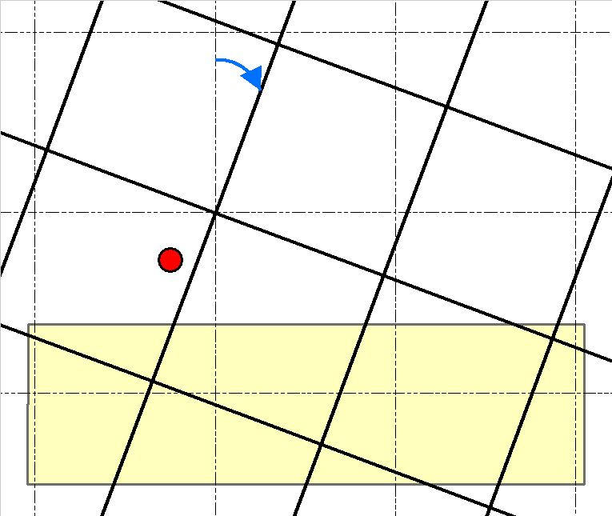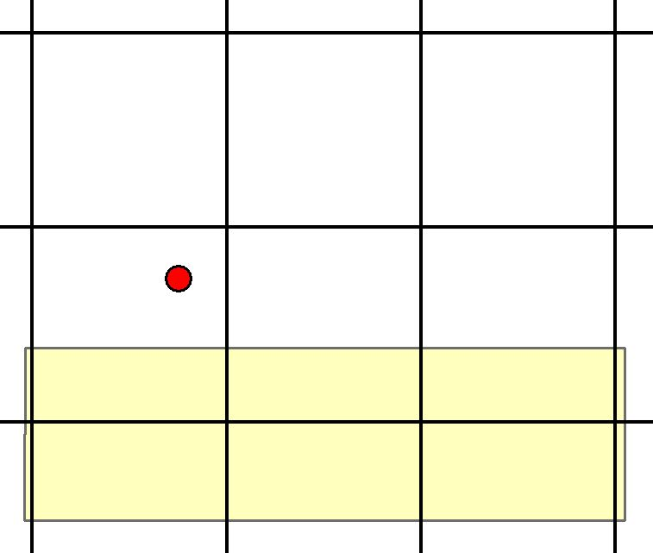

$$α$$

D

C

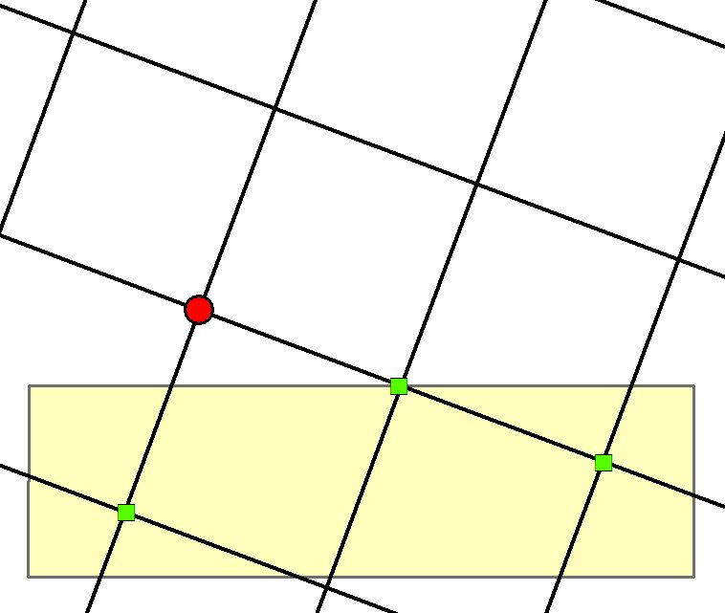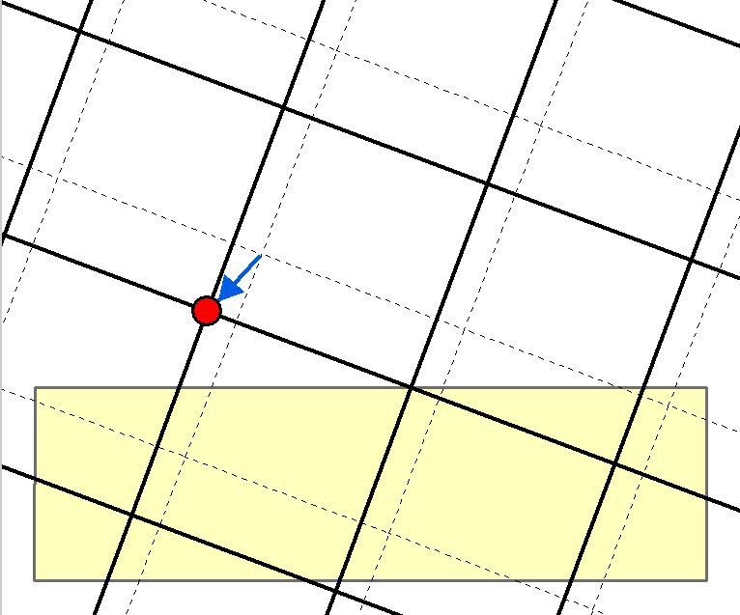

## Belt plantings

Examples of a series of belt plantings of varying shape.

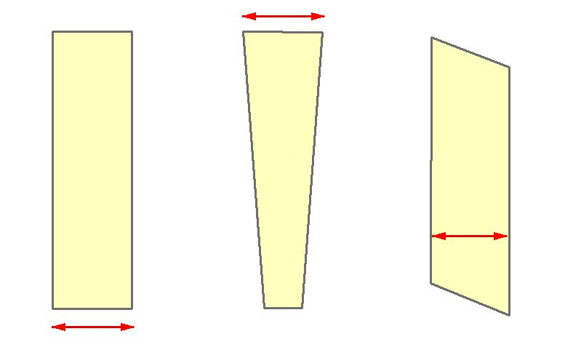Belt plantings are discrete patches of project trees that have been established in a linear ‘belt’ pattern, where width measured across the belt ($w$) is no greater than 50 metres at any point along the length of the belt.

$$w$$

$$w$$

$$w$$

$$w$$

## Plot orientation in a belt planting

Examples of plot orientation in belt plantings.

Randomly selected grid intersections (green squares) define the spatial coordinates for plot establishment. In the field, plots are established so that the starting edge passes through the spatial coordinates for the grid intersection, running perpendicular to the orientation of the belt planting. In the case of belt plantings with east-west orientation (A), the plot is laid out toward the most westerly end of the belt planting. For all other orientations (examples at B, C, D), the plot is laid out toward the most southerly end of the belt planting. In all cases, the plot must extend across the full width of belt planting.

A

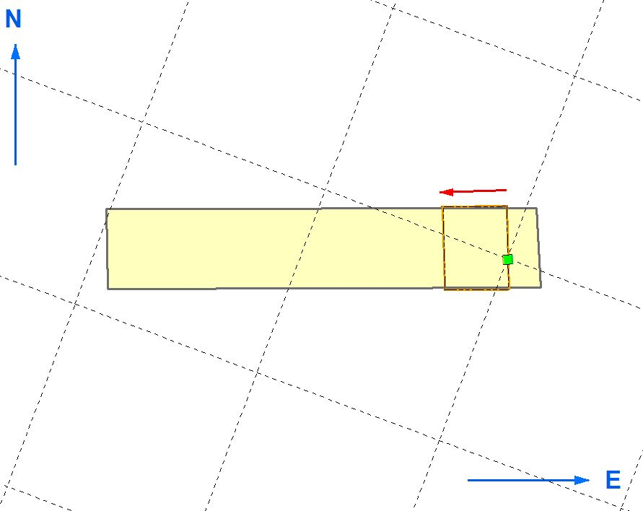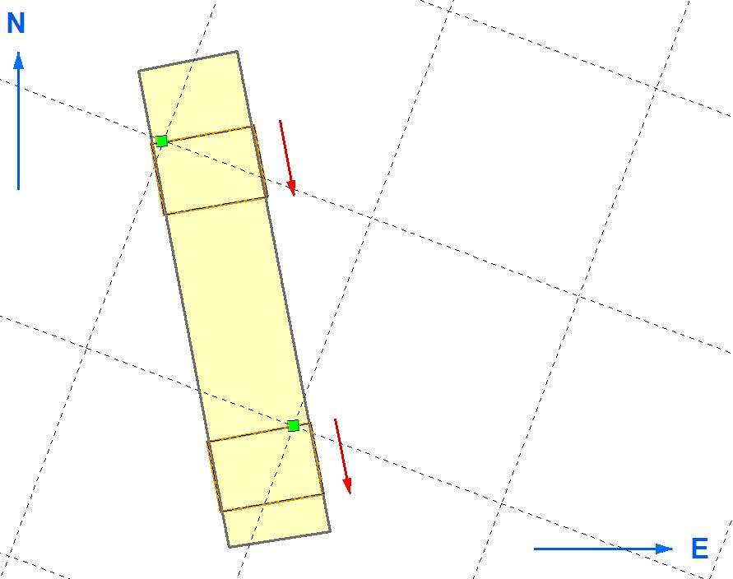

Starting edge

B

Belt Planting

Plot

Grid intersect

D

C

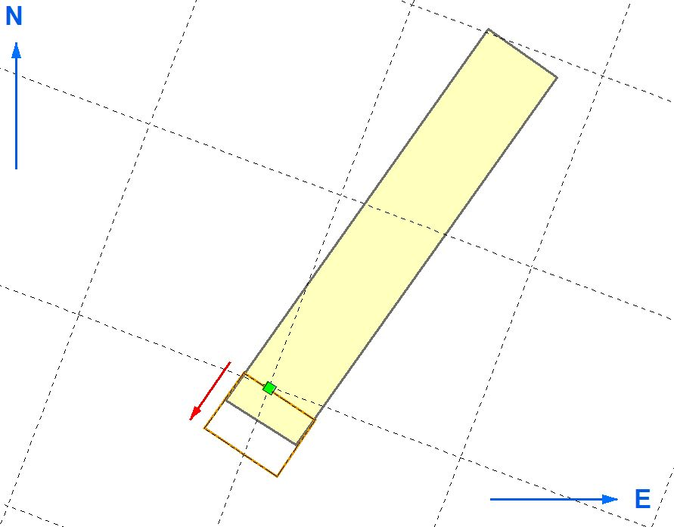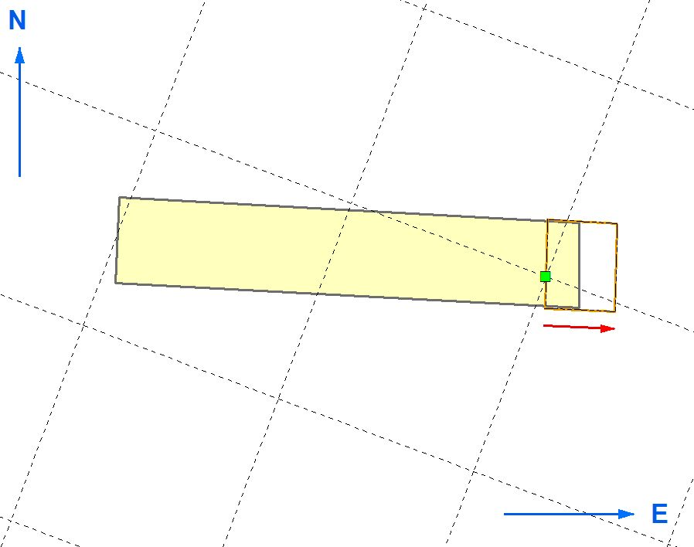

## Treatment of an edge plot located close to stratum boundary

Diagrammatic example of the treatment of an edge plot that is partially within the stratum boundary.

The centroid (centre of the plot)falls within the stratum boundary so a plot must be established at this location. Markers are placed at the limits of plot corners and at the points where the stratum boundary intersects the plot. Project trees, litter (optional) and fallen dead wood (optional) are assessed from within the stippled area (land that falls within both the plot boundary and stratum boundary). For the purposes of calculating plot carbon stock, the plot area is taken to be equivalent to the pre-defined target plot area documented in the sampling plan.

|  |
| --- |
| Stratum boundary  Plot marker  Land outside stratum boundary – not for inclusion in assessment  Land within both plot boundary & stratum boundary (stippled) – for inclusion in assessment  Centroid (within stratum boundary) |

## Location of Plots with Constant Position

Diagrammatic example of the location of plots with a constant position plot layout

The field team establishes the actual location coordinates according to the constant position nominated in the sampling plan. The team positions the two longest edges of the plot parallel with the planting lines and establish the other 3 corners of the Plot according to the length, width and area requirements specified in the sampling plan. When forests consist of project trees with a shrubby habit (typically the case with mallee eucalypt species) this method may be more efficient than utilising the centroid technique.

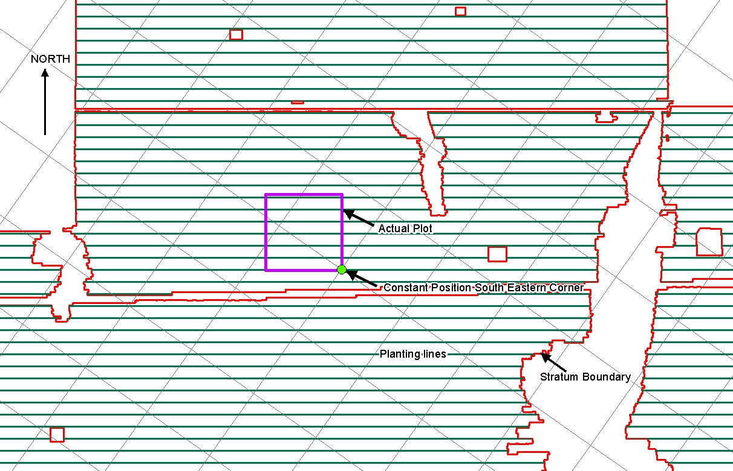

**Statement of Compatibility with Human Rights**

*Prepared in accordance with Part 3 of the Human Rights (Parliamentary Scrutiny) Act 2011*

*Carbon Credits (Carbon Farming Initiative—Reforestation and Afforestation 2.0) Methodology Determination 2015*

This Legislative Instrument is compatible with the human rights and freedoms recognised or declared in the international instruments listed in section 3 of the *Human Rights (Parliamentary Scrutiny) Act 2011*.

**Overview of the Legislative Instrument**

The *Carbon Credits (Carbon Farming Initiative—Reforestation and Afforestation 2.0) Methodology Determination 2015* (the Determination) sets out the detailed rules for implementing and monitoring offsets projects that would sequester carbon by establishing and maintaining trees that have the potential to attain a height of at least 2 metres, and a crown cover of at least 20%, on land that has previously been used for agricultural purposes in any part of Australia.

Project proponents wishing to implement the Determination must make an application to the Clean Energy Regulator (the Regulator) and meet the eligibility requirements set out under the *Carbon Credits (Carbon Farming Initiative) Act 2011*. Offsets projects that are approved by the Regulator can generate Australian carbon credit units.

**Human rights implications**

This Legislative Instrument does not engage any of the applicable rights or freedoms.

**Conclusion**

This Legislative Instrument is compatible with human rights as it does not raise any human rights issues.

**Greg Hunt, Minister for the Environment**