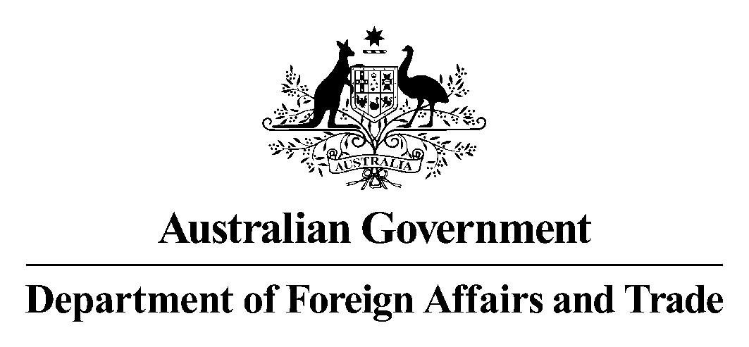

File Number: 14/29864#6

8 September 2015

Clerk of the Senate

Senate Table Office

Attention: Assistant Legislation Officer

Suite S5-25

Parliament House

CANBERRA ACT 2600

Dear Sir or Madam

**Autonomous Sanctions Amendment (Sanctioned Commercial Activity – Russia) Regulation 2015**

I am writing in relation to the Explanatory Statement for the *Autonomous Sanctions Amendment (Sanctioned Commercial Activity – Russia) Regulation 2015* (the Regulation).

On 12 August 2015, the Senate Standing Committee on Regulations and Ordinance (the Committee) noted that the Explanatory Statement does not provide information on consultation undertaken in relation to the Regulation.

The Department of Foreign Affairs and Trade has amended the Explanatory Statement to address this matter.

I have enclosed a copy of the amended Explanatory Statement. I would be grateful if you would arrange tabling.

Yours sincerely

Julie Heckscher

Assistant Secretary

Sanctions, Treaties and Transnational Crime Legal Branch