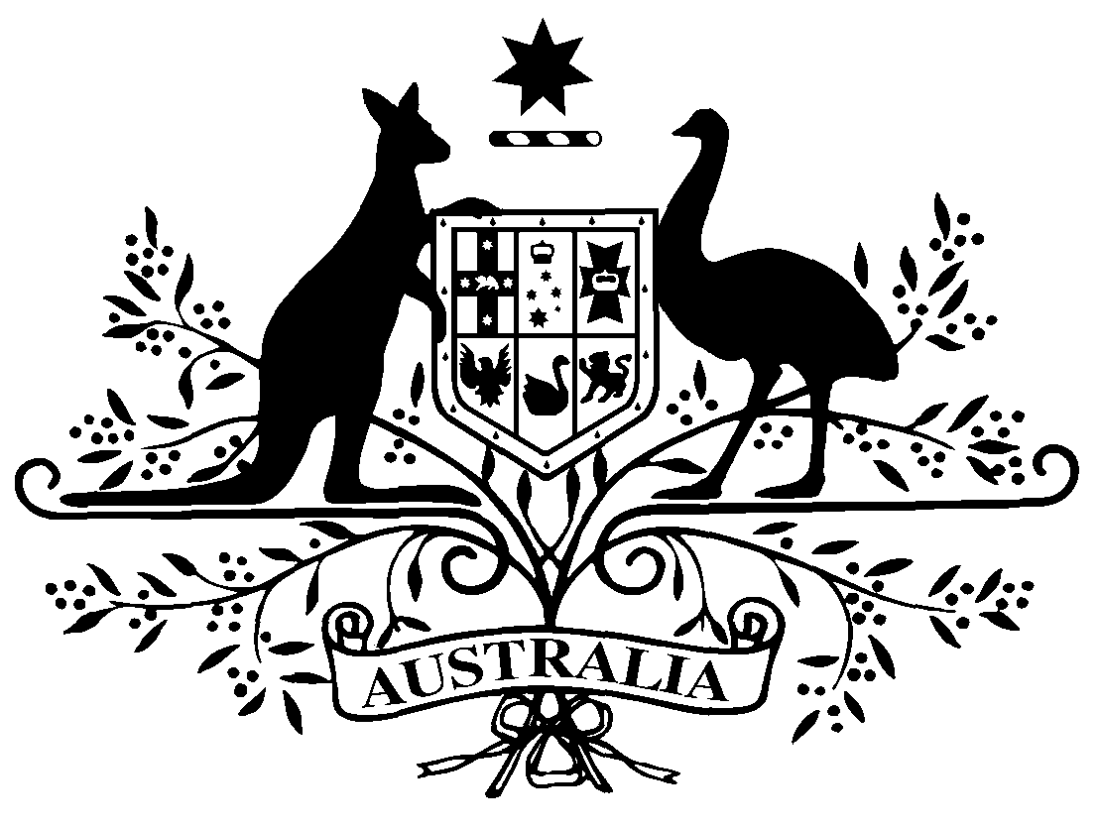

PB 65 of 2015
National Health (Remote Aboriginal Health Services Program) Special Arrangements Amendment Instrument 2015 (No. 1)

National Health Act 1953
___________________________________________________________________________

I, JULIANNE QUAINE, Assistant Secretary, Pharmaceutical Access Branch, Department of Health, delegate of the Minister for Health, make this Amendment Instrument under subsections 100(1) and 100(2) of the National Health Act 1953.
Dated 24 June 2015

JULIANNE QUAINE
Assistant Secretary
Pharmaceutical Access Branch
Pharmaceutical Benefits Division
Department of Health
___________________________________________________________________________

1 Name of Instrument

- This Instrument is the National Health (Remote Aboriginal Health Services Program) Special Arrangements Amendment Instrument 2015 (No. 1).

- This Instrument may also be cited as PB 65 of 2015.

2 Commencement
This Instrument commences on 1 July 2015.
3 Amendment to PB 65 of 2010
Schedule 1 amends the National Health (Remote Aboriginal Health Services Program) Special Arrangements Instrument (PB 65 of 2010).

Schedule 1 Amendment
- Paragraph 9(c)
omit:
$2.88
substitute:
$2.92

Note
All legislative instruments and compilations are registered on the Federal Register of Legislative Instruments kept under the Legislative Instruments Act 2003. See http://www.comlaw.gov.au.

