EXPLANATORY STATEMENT
Booderee National Park Management Plan 2015-2025
Overview of the Legislative Instrument
The Director of National Parks prepares management plans for Commonwealth reserves in accordance with Section 368 of the Environment Protection and Biodiversity Conservation Act 1999 (EPBC Act). The purpose of this management plan is to describe the philosophy and direction of management for Booderee National Park for the next 10 years in accordance with the EPBC Act. The plan enables management to proceed in an orderly way, helps to reconcile competing interests, and identifies priorities for the allocation of available resources.
The management plan for the park is an enabling document. It allows management activities to occur that would otherwise be restricted under EPBC legislation, and enables certain management, recreational and commercial activities to occur.
The first management plan for the park ceased to have effect on the 3 April 2009. Since that time Booderee National Park has been managed under s.357 of the EPBC Act, effectively guiding the interim management of the park by the actions and principles of the previous management plan until the third plan comes into effect.
About the park
Booderee National Park is located on the south-east coast of Australia, within the Jervis Bay Territory. It comprises most of the Bhewerre Peninsula on the southern side of Jervis Bay and St Georges Basin and includes part of the waters within Jervis Bay. The park covers an area of 6,379 hectares which includes 875 hectares of marine environment and the Booderee Botanic Gardens that covers 80 hectares of the park. The Booderee Botanic Gardens and Booderee National Park (which incorporates the Botanic Gardens) were first proclaimed as reserves in 1991 and 1992 respectively.
Jervis Bay is one of the major biogeographic nodes in Australia and contains a variety of relatively undisturbed marine and terrestrial habitats. The marine environment is one of the most diverse recorded in temperate Australia, with tropical and temperate species represented. The park is renowned for its exceptional water clarity, due to small intact catchments, and for its exceptionally white sands. The park has one of the largest seagrass meadows on the New South Wales coast, which maintains water quality and provides habitat to a wide variety of marine species. Terrestrial vegetation communities include relic rainforest, littoral rainforest, eucalypt forest, woodland, wet and dry heath, salt marsh and coastal wetlands and coastal scrub and grassland communities. The park is rich in flora and fauna.
Joint management arrangements
The park is jointly managed with the Aboriginal traditional owners of Booderee–the registered members of the Wreck Bay Aboriginal Community Council.
Freehold title to the park was granted to the Wreck Bay Aboriginal Community Council in 1995 and the park was subsequently leased to the Director of National Parks for the purpose of being managed as a national Park, under a 99 year lease commencing on 11 October 1995.
The Council’s vision of controlling and managing its own land and waters is strongly reflected in this management plan. Through taking greater responsibility for the management of the park, the Community aims to become self-sufficient and able to freely determine its future and lifestyle.
The Director is bound by obligations in the park lease to provide certain benefits to members of the Wreck Bay Aboriginal Community, including assisting in the maintenance of cultural traditions, providing employment opportunities, training in administrative and management skills and to protect areas and matters of significance to the Community. This plan strengthens these commitments, creating a roadmap towards sole management of the park by the Community.
Consultation
On 1 October 2008 a notice was published inviting comments on the proposal to prepare a draft management plan. This initial opportunity for public comment closed on 28 November 2008 and
25 submissions were received.
Following consideration of these submissions, the Director and the Board then prepared a draft management plan in accordance with s.368 (1) (b) of the EPBC Act, which was released for public comment on 4 May 2011, allowing 90 days for public consideration of the draft plan.
There were 29 written submissions received on the draft management plan from a range of stakeholders. Seven meetings of the Board of Management were held to discuss issues described in the submissions and an additional two day out of session meeting was held to discuss the last outstanding issues and adjustments necessary to finalise the plan.
The Board altered aspects of the plan following consideration of the submissions on the draft plan.
The final wording of the plan was cleared in September 2015, allowing finalisation of the plan and subsequent consideration and approval by the Minister.
Period of operation
This management plan will come into operation, following approval by the Minister for Cities and the Built Environment under s.370 of the EPBC Act, at the beginning of the day after it is registered under the Legislative Instruments Act 2003. The plan will cease to have effect ten years after commencement, unless revoked or amended earlier by another management plan.
Regulatory Impact
This management plan has been written to preserve the cultural heritage of the park and its traditional owners, to conserve the terrestrial and marine ecosystems of the park, and to provide rewarding and unique experiences for visitors. This management plan does not place any additional compliance burden on businesses, community organisations or individuals. Given there is no additional compliance burden no regulatory offset is required. The Office of Best Practice Regulation (OBPR) advised that a Regulatory Impact Statement was not required for this management plan (OBPR reference: ID 2011/13155).

Sally Barnes
Director of National Parks
17 November 2015
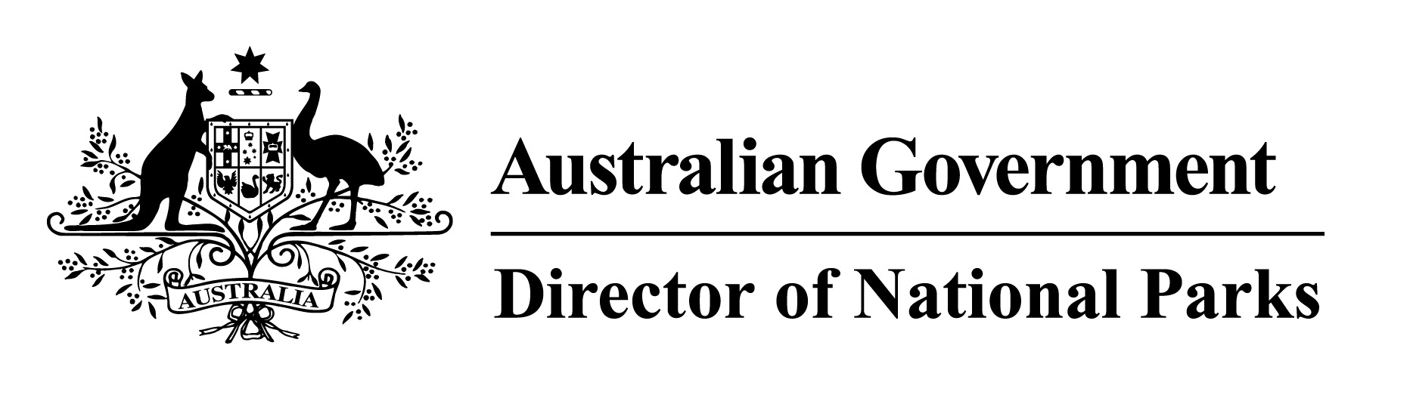
Statement of Compatibility with Human Rights
Prepared in accordance with Part 3 of the Human Rights (Parliamentary Scrutiny) Act 2011
Booderee National Park Management Plan 2015-2025
This Legislative Instrument is compatible with the human rights and freedoms recognised or declared in the international instruments listed in section 3 of the Human Rights (Parliamentary Scrutiny) Act 2011.
Overview of the Legislative Instrument
The Director of National Parks prepares management plans for Commonwealth reserves in accordance with Section 368 of the Environment Protection and Biodiversity Conservation Act 1999 (EPBC Act). The purpose of this management plan is to describe the philosophy and direction of management for Booderee National Park for the next ten years in accordance with the EPBC Act. The plan enables management to proceed in an orderly way, helps to reconcile competing interests, and identifies priorities for the allocation of available resources.
The EPBC Act and associated Regulations prohibit certain activities from occurring in Booderee National Park and other Commonwealth reserves. The management plan for the park is an enabling document. It allows management activities to occur that would otherwise be restricted under EPBC legislation, and enables certain management, recreational and commercial activities to occur.
Human rights implications
This Legislative Instrument provides benefits to Indigenous Australians to address indigenous disadvantage, assisting their
- Right to self-determination
Through encouraging the development of a road map for sole management of the park by the traditional owners of Booderee.
- Right to equality and non-discrimination
Through the use of special measures in the recruitment of staff for the park, encouraging the recruitment of Indigenous people into management and operational positions.
Conclusion
This Legislative Instrument is compatible with human rights and provides benefits to Indigenous people, striving towards the sole management of the park by the traditional owners of the land.

Sally Barnes
Director of National Parks
17 November 2015

