

Greenhouse and Energy Minimum Standards (Rotary Clothes Dryers) Determination 20151

*Greenhouse and Energy Minimum Standards Act 2012*

I, Josh Frydenberg, Minister for Resources, Energy and Northern Australia, make this replacement Determination under sections 23 and 35 of the *Greenhouse and Energy Minimum Standards Act 2012*.

Dated  30 October 2015

JOSH FRYDENBERG

Minister for Resources, Energy and Northern Australia

**COPYRIGHT**

© 2015 Commonwealth of Australia

This Determination includes material from Australian Standards and/or Australian/New Zealand Standards, which are copyright Standards Australia Ltd. Apart from reproduction for personal and non-commercial use, and uses permitted under the *Copyright Act 1968,* Standards Australia Ltd material may not be reproduced without permission or licence.

With the exception of the Commonwealth Coat of Arms, Commonwealth copyright material is licensed under a [Creative Commons Attribution-NonCommercial-ShareAlike 4.0 International License](http://creativecommons.org/licenses/by-nc-sa/4.0/).. To view a copy of this license, visit <https://creativecommons.org/licenses/by-nc-sa/4.0/>.

You are free to copy, communicate and adapt the Commonwealth copyright material, so long as you attribute the Commonwealth of Australia.

Complete Australian/New Zealand Standards are available for purchase from Standards Australia Ltd. Requests and inquiries concerning other reproduction and rights pertaining to standards should be directed to SAI Global Limited.

1. Name of Determination

This Determination is the *Greenhouse and Energy Minimum Standards (Rotary Clothes Dryers) Determination 2015.*

1. Commencement, revocation and replacement
   1. This Determination comes into force on the day after it is registered.
   2. This Determination revokes and replaces the *Greenhouse and Energy Minimum Standards (Rotary Clothes Dryer) Determination 2012* (F2012L02121).

*Note:* The revoked Determination ceases to be in force immediately before the replacement Determination comes into force (see subsection 35 (2) of the Act).

1. Definitions

In this Determination:

***Act*** means the *Greenhouse and Energy Minimum Standards Act 2012*.

***AS/NZS 2442.1:1996*** means *Australian/New Zealand Standard* *2442.1:1996 Performance of household electrical appliances – Rotary clothes dryers – Part 1: Energy consumption and performance*, as it existed on the date this Determination came into force.

*Note 1:* AS/NZS 2442.1:1996 is available from Standards Australia Limited.

*Note 2:* AS/NZS 2442.1:1996 includes all amendments up to and including AS/NZS 2442.1:1996/Amdt 4:2006 made on 8 September 2006.

***AS/NZS 2442.2:2000*** means *Australian/New Zealand Standard* *2442.2:2000**Performance of household electrical appliances – Rotary clothes dryers – Part 2: Energy labelling requirements*, as it existed on the date this Determination came into force.

*Note 1:* AS/NZS 2442.2:2000 is available from Standards Australia Limited.

*Note 2:* AS/NZS 2442.2:2000 includes all amendments up to and including AS/NZS 2442.2:2000/Amdt 2:2007 made on 30 April 2007.

***Australian Standard*** means a standard that is published by Standards Australia Limited denoted by the letters "AS" and identifying numbers and/or letters.

***Australian/New Zealand Standard*** means a standard that is jointly published by Standards Australia Limited and Standards New Zealand, is applicable in both countries and denoted by the letters “AS/NZS” and identifying numbers and/or letters.

***condenser rotary clothes dryer*** means an electric clothes dryer by which the moisture from the air within the clothes dryer is converted to a liquid and the liquid is drained or stored for later removal.

*Note:* This is the same meaning as ‘condenser electric rotary clothes dryer’ in subclause 1.4.4 (b) of AS/NZS 2442.1:1996.

***control mechanism*** means the mechanism by which the operation of a dryer is terminated, being one of the following mechanisms:

1. autosensing – the clothes drying is stopped by a system within the dryer that can determine, directly or indirectly, the moisture content of the load;
2. manual – the clothes drying must be stopped by hand; or
3. timer – the clothes drying is stopped by a timer.

*Note:*  This is the same meaning as ‘Dryer control mechanisms’ in subclause 1.4.3 of AS/NZS 2442.1:1996.

***dryer type*** means a vented rotary clothes dryer or a condenser rotary clothes dryer

*Note:* This is the same meaning as in clause 1.4.4 of AS/NZS 2442.1:1996.

***Energy Efficiency Label*** means the label described in section 5 of 2442.2:2000.

*Note:* An example of an Energy Efficiency Label is shown in Figure 5.1 of AS/NZS 2442.2:2000.

***rotary clothes dryer*** means an appliance for the tumble-drying of clothing, which is one of the following:

1. a condenser rotary clothes dryer;
2. a vented rotary clothes dryer; or
3. the drying function of an appliance which includes both washing and clothes drying functions and in which the drying function operates by the same method as a condenser rotary clothes dryer or vented rotary clothes dryer.

*Note:* This definition reflects the scope specified in clause 1.1 of AS/NZS 2442.2:2000 and clause 1.1 of AS/NZS 2442.1:1996.

***standard*** means an Australian Standard, an Australian/New Zealand Standard or any other equivalent document.

***Super-Efficiency Label*** means the label described in Part 2 of Schedule 2 of this Determination.

*Note:* An example of a Super-Efficiency Label is shown in Figure 1 of Schedule 2.

***tumble-drying*** (of clothing) means drying by passing air through an item while it is being tumbled.

*Note:* Note: This is the same meaning as in subclauses 1.4.4 (a) and 1.4.4 (b) of AS/NZS 2442.1:1996.

***vented rotary clothes dryer*** means an electric clothes dryer by which the air and accumulated moisture is discharged into the atmosphere.

*Note:* This is the same meaning as ‘vented electric rotary clothes dryer’ in subclause 1.4.4 of AS/NZS 2442.1:1996.

*Note*: Several other words and expressions used in this Determination have the meaning given by section 5 of the Act. For example:

* category A product;
* covered by;
* family of models;
* GEMS;
* GEMS labelling requirements;
* GEMS level requirements;
* model;
* product classes;
* supply

1. Interpretation

Applicable definitions of terms or phrases

* 1. If there is inconsistency in the definitions of words or expressions, words or expression will be interpreted in the following order of priority to the extent of any inconsistency:
     1. the Act;
     2. this Determination;
     3. the Standards.
  2. A word or expression defined in a standard mentioned specifically in section 4 of this Determination has the meaning given to it in the relevant standard.

Applicable version of documents incorporated into Determination and Standards

* 1. For the purposes of this Determination the applicable version of any:
     1. standard or
     2. other document that:
        1. is referred to in a standard under the heading ‘Referenced Documents’, or under an equivalent heading in a standard; and
        2. must be applied to give effect to this Determination or a standard referred to in this Determination,

is the version of the standard or other document that existed at the date this Determination came into force.

1. Specified product class covered by this Determination
   1. This Determination covers rotary clothes dryers that are ordinarily supplied and used for personal, domestic or household use, and which use a control mechanism.

*Note 1:*  This Determination covers household rotary clothes dryers irrespective of the context in which they are used. For example, this Determination covers household rotary clothes dryers used in a commercial context.

*Note 2:* This subsection reflects the scope specified in clause 1.1 of AS/NZS 2442.2:2000 and clause 1.1 of AS/NZS 2442.1:1996.

* 1. The products covered by this Determination form a single product class for the purposes of the Act.

1. GEMS level requirements

Energy use and greenhouse gas production

* 1. For paragraphs 24 (1) (a) and 25 (a) of the Act, the specified requirements for energy use are the requirements mentioned in clause 4.4 of AS/NZS 2442.1:1996.

Conducting tests

* 1. For paragraphs 24 (1) (a) and 25 (b) of the Act, the specified requirements for conducting tests are the requirements specified in section 2 of AS/NZS 2442.2:2000, as modified by subsection 6 (3) of this Determination.
  2. The requirements for conducting tests specified in subsection 6(2) are modified as follows:
     1. the garments specified in Part 1 of Schedule 1 of this Determination may be used as an alternative to the test load component items specified in Table E1 of Appendix E of AS/NZS 2442.1:1996, provided that the load make up is prepared in accordance with Table E2 of Appendix E of AS/NZS 2442.1:1996.

*Note:* The total mass of the load when using the alternative load specification in Part 1 of Schedule 1 and the load make up in accordance with this subsection is on average 3.2 percent higher than the approximate bone dry mass listed in column 2 Table E2 of Appendix E of AS/NZS 2442.1:1996. This is slightly higher than the original load specified in AS/NZS 2442.1:1996 but is considered to be within acceptable limits considering that the mass of the load items is measured when they are new and some loss of mass is expected over the life of the load items.

* + 1. where rotary clothes dryers have both timer and autosensing control mechanisms:
       1. the determination of moisture removal and energy consumption must be tested on the supplier’s nominated autosensing program not in accordance with clause 2.2 of AS/NZS 2442.1-1996; and
       2. the requirements of clause 2.3 of AS/NZS 2442.1-1996 and the test set out in clause D 2.4 of Appendix D of AS/NZS 2442.1-1996 must be met both when using the timer and the autosensing control mechanisms.
    2. where rotary clothes dryers have a mechanism that prevents access to their load for the purpose of weighing the load immediately prior to the commencement of the cool-down period (commonly called an 'interlock'), then clause B 3.2 of Appendix B of AS/NZS 2442.1:1996 does not apply, and any energy and water used up to the point where the load becomes accessible again must be included in the tests conducted in accordance with subsection 6 (2).

1. GEMS labelling requirements

Labelling and communication requirements

* 1. Subject to subsection 7 (2) of this Determination, for paragraphs 24 (1) (b), 26 (1) (a) and 26 (1) (b) of the Act, the GEMS labelling and communication requirements are the requirements mentioned in sections 2, 5 and Appendix B of AS/NZS 2442.2:2000, with the following modifications:
     1. Part 1 of Schedule 2 of this Determination applies instead of subclause 1.5.10 and clause 2.8 of AS/NZS.2:2000.
     2. Part 3 of Schedule 2 of this Determination applies instead of the requirements in clause 5.1 of AS/NZS 2442.2:2000.
  2. For subsection 7 (1) of this Determination, if a star rating of seven or more stars is derived from the star rating index in accordance with Part 1 of Schedule 2 of this Determination, the labelling requirements are either:
     1. the labelling requirements specified in sections 2, 5 and Appendix B of AS/NZS 2442.2:2000 as if the star rating were deemed to be six stars; or
     2. the requirements specified in Part 2 of Schedule 2 of this Determination (the Super-Efficiency Label).

*Note:* Where the derived star rating is one to six stars, the standard Energy Efficiency Label (that is, the labelling requirements specified in sections 2, 5 and Appendix B of AS/NZS 2442.2:2000) must still be used.

Conducting tests

* 1. For paragraph 26 (1) (c) of the Act, the specified requirements for conducting tests are the requirements mentioned in sections 2 and 4 of AS/NZS 2442.1:1996, as modified by subsection 7 (4) of this Determination.
  2. The requirements for conducting tests specified in subsection 7(3) are modified as follows:
     1. The items specified in Part 1 of Schedule 1 of this Determination can be used as alternative to the test load component items specified in Table E1 of Appendix E of AS/NZS 2442.1:1996, provided that the test load make up is prepared in accordance with Table E2 of Appendix E of AS/NZS 2442.1:1996.

*Note:* The total mass of the load when using the alternative load specifications in Part 1 of Schedule 1 is on average 3.2 percent higher than the approximate bone dry mass listed in column 2 Table E2 of Appendix E of AS/NZS 2442.1:1996. This is slightly higher than the original load specified in AS/NZS 2442.1:1996 but is considered to be within acceptable limits considering that the mass of the load items is measured when they are new and some loss of mass is expected over the life of the load items.

* + 1. Where rotary clothes dryers have both timer and autosensing control mechanisms:
       1. the determination of moisture removal and energy consumption must be tested on the supplier’s nominated autosensing program not in accordance with clause 2.2 of AS/NZS 2442.1:1996; and
       2. the requirements of clause 2.3 of AS/NZS 2442.1:1996 and the test conditions set out in clause D 2.4 of Appendix D of AS/NZS 2442.1:1996 must be met for both operation using the timer and the autosensing control mechanisms.
    2. Where rotary clothes dryers have a mechanism that prevents access to their load for the purpose of weighing the load immediately prior to the commencement of the cool-down period (commonly called an 'interlock') then clause B 3.2 of Appendix B of AS/NZS 2442.1:1996 does not apply, and any energy and water used up to the point where the load becomes accessible again must be included in the tests conducted in accordance with subsection 7(3) of this Determination.

1. Other GEMS requirements

Product performance

* 1. For subsection 24 (2) and paragraph 27 (1) (b) of the Act, the specified requirements relating to the performance are the requirements mentioned in:
     1. clause 3.2 of AS/NZS 2442.2:2000 (Drying Clothes in a Single Operation); and
     2. clause 3.3 of AS/NZS 2442.2:2000 (Maximum Fabric Temperature).

Conducting tests

* 1. For subsection 24 (2) and paragraph 27 (1) (e) of the Act, the specified requirements for conducting tests in relation are the requirements mentioned in section 2 of AS/NZS 2442.1:1996, as modified by subsection 8 (3) of this Determination.
  2. The requirements for conducting tests specified in subsection (2) are modified as follows:
     1. The garments specified in Part 1 of Schedule 1 of this Determination may be used as an alternative standard mixed cotton test load to that specified in Table E1 of Appendix E of AS/NZS 2442.1:1996, provided that the load make up is in accordance with Table E2 of Appendix E of AS/NZS 2442.1:1996.

*Note:* The total mass of the load when using the alternative load specification in Part 1 of Schedule 1 and the load make up in accordance with this subsection is on average 3.2 percent higher than the approximate bone dry mass listed in column 2 Table E2 of Appendix E of AS/NZS 2442.1:1996. This is slightly higher than the original load specified in AS/NZS 2442.1:1996 but is considered to be within acceptable limits considering that the mass of the load items is measured when they are new and some loss of mass is expected over the life of the load items.

* + 1. Where rotary clothes dryers have both timer and autosensing control mechanisms:
       1. the determination of moisture removal and energy consumption must be tested on the supplier’s nominated autosensing program and not in accordance with clause 2.2 of AS/NZS 2442.1:1996; and
       2. the requirements of clause 2.3 of the AS/NZS 2442.1:1996 and the test conditions set out in clause D 2.4 of Appendix D of AS/NZS 2442.1:1996 must be met for both operation using the timer and the autosensing control mechanisms.
    2. Where the rotary clothes dryers have a mechanism that prevents access to their load for the purpose of weighing the load immediately prior to the commencement of the cool-down period (commonly called an 'interlock') then clause B 3.2 of Appendix B of AS/NZS 2442.1:1996 does not apply, and any energy and water used up to the point where the load becomes accessible again must be included in the tests conducted in accordance with subsection 8(2).

1. Families of models

For section 28 of the Act, the specified circumstances in which 2 or more models from a single product class covered by this Determination are in the same family of models, are the circumstances mentioned in subclause 1.5.11 of AS/NZS 2442.2:2000.

1. Product categories

For subsection 29 (1) of the Act, the products covered by this Determination are category A products.

1. Registrations affected by this Determination

For paragraph 36 (1) (c) of the Act, this Determination does not affect the registration of any model registered against the *Greenhouse and Energy Minimum Standards (Rotary Clothes Dryers) Determination 2012* (F2012L02121).

*Note:* If a model’s registration is not affected the model is taken to be registered against this Determination. See subsection 36 (2) of the Act.

**Note**

1. All legislative instruments and compilations are registered on the Federal Register of Legislative Instruments kept under the *Legislative Instruments Act 2003.* See http://www.frli.gov.au.

Schedule 1 Variation to operation of AS/NZS 2442.1:2005

(paragraphs 6(3)(a), 7(4)(a) , and 8(3)(a) of this Determination)

Part 1 Alternative Test Load

For the purposes of paragraphs 6(3)(a), 7(4)(a), and 8(3)(a) of this Determination, the following requirements apply:

NOTES:

1. The mass in the table (above) is the expected nominal average mass and target bone dry mass for new items prior to any pre-conditioning runs. Individual load items may vary in mass according to slight variations in size and changes in style, e.g. shape of collar on shirts. It is expected that the actual mass of load items will decline gradually with an increase in the number of test cycles. The expected loss of mass over the life of a load item is of the order of 5 percent. The mass of each item should be checked prior to use.
2. To minimise variations in test results, it is recommended that a list of suppliers who have nominated that they can supply test materials used for evaluating machines under test to be obtained from the sources referred to at the Energy Rating website (<http://www.energyrating.gov.au>). For the purpose of check testing appliances the test materials will be obtained from those sources.

The suppliers listed on the website neither are endorsed by this Determination nor are their products certified to meet the specification requirements within this Determination. Purchasers of these materials should seek all necessary documentation from suppliers to ensure that the purchased product meets the specifications within this Determination.

Schedule 2 GEMS labelling requirements – GEMS star ratings and label requirements

(Paragraphs 7(1)(a), 7 (1) (b) and 7 (2) (b) of this Determination)

Part 1 Star Rating

For paragraph 7(1)(a) of this Determination, the following requirements in subparagraph (a) and (b) apply:

### the number of stars displayed on the Energy Efficiency Label and Super-Efficiency Label. Available stars are between a minimum of one and a maximum of ten, shown in half star intervals for an Energy Efficiency Label and one star intervals for a Super-Efficiency Label. The star rating is calculated from the star rating index (Dimensionless.).

### the table below applies instead of Table 2.1 in clause 2.8 of AS/NZS 2442.2:2000.

|  |  |
| --- | --- |
| **SRI** | **Star rating** |
| SRI < 1.5 | 1.0 |
| 1.5 ≤ SRI ≤ 2.0 | 1.5 |
| 2.0 ≤ SRI < 2.5 | 2.0 |
| 2.5 ≤ SRI < 3.0 | 2.5 |
| 3.0 ≤ SRI < 3.5 | 3.0 |
| 3.5 ≤ SRI ˂ 4.0 | 3.5 |
| 4.0 ≤ SRI ˂ 4.5 | 4.0 |
| 4.5 ≤ SRI ˂ 5.0 | 4.5 |
| 5.0 ≤ SRI ˂ 5.5 | 5.0 |
| 5.5 ≤ SRI ˂ 6.0 | 5.5 |
| 6.0 ≤ SRI < 7.0 | 6.0 |
| 7.0 ≤ SRI < 8.0 | 7.0 |
| 8.0 ≤ SRI < 9.0 | 8.0 |
| 9.0 ≤ SRI < 10.0 | 9.0 |
| 10.0 ≤ SRI | 10.0 |

Part 2 Labelling requirements

For paragraph 7(2)(b) of this Determination, the following requirements apply:

### the Super-Efficiency Label in Figure 1 , Figure 2 (Super-Efficiency Label Dimensions) and Figure 3 (Star Dimensions and Geometry) must be used; and

1. the Super-Efficiency Label must be self-adhesive;.
2. a trim or die cut margin of up to 2mm around the Super-Efficiency Label is acceptable; and
3. the Super-Efficiency Label must be printed in the following colours on a white background:

Red: Pantone Warm Red

Blue: Pantone 299

Yellow: Pantone 116

Black: Pantone Black

Green: Pantone 340

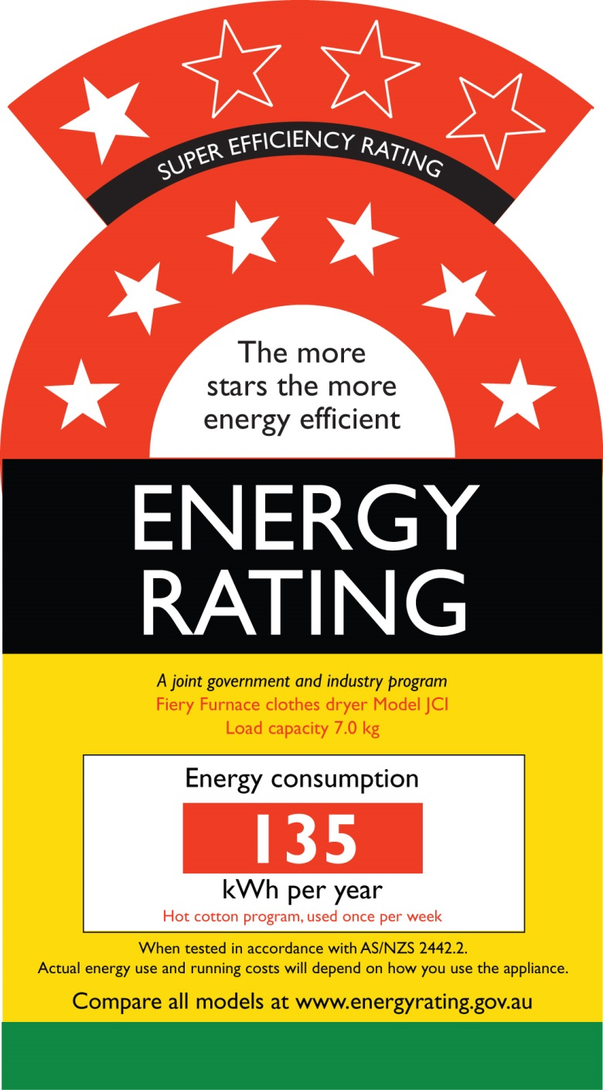

Figure 1: Super-Efficiency Label

*Note:* This example depicts 7 stars (out of a possible 10 stars).

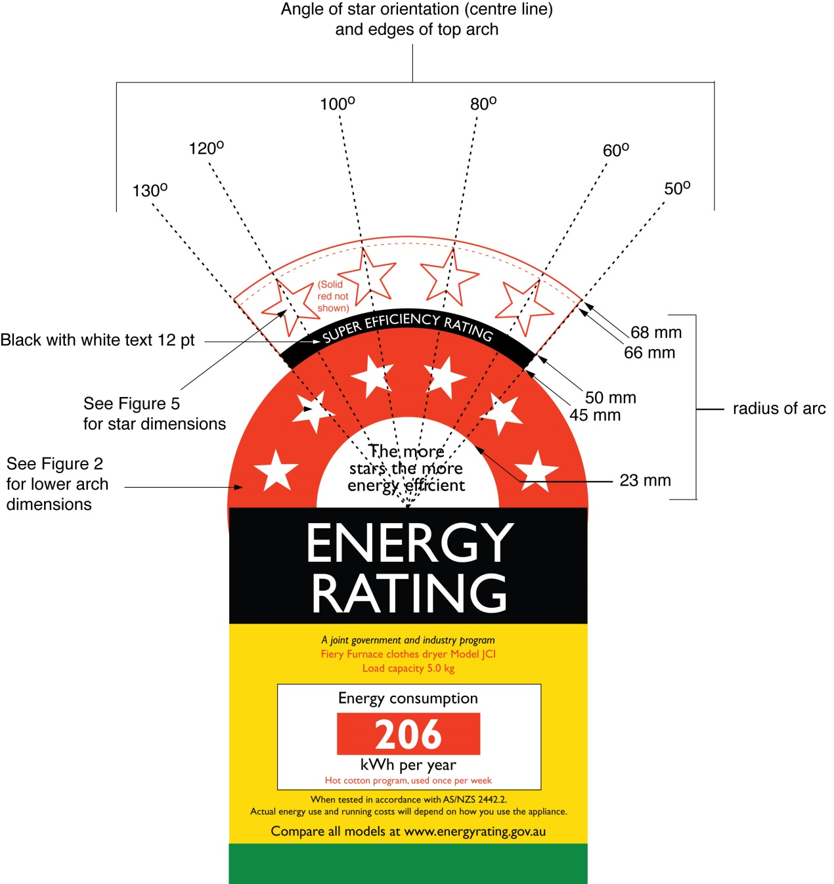

Figure 2: Super-Efficiency Label Dimensions

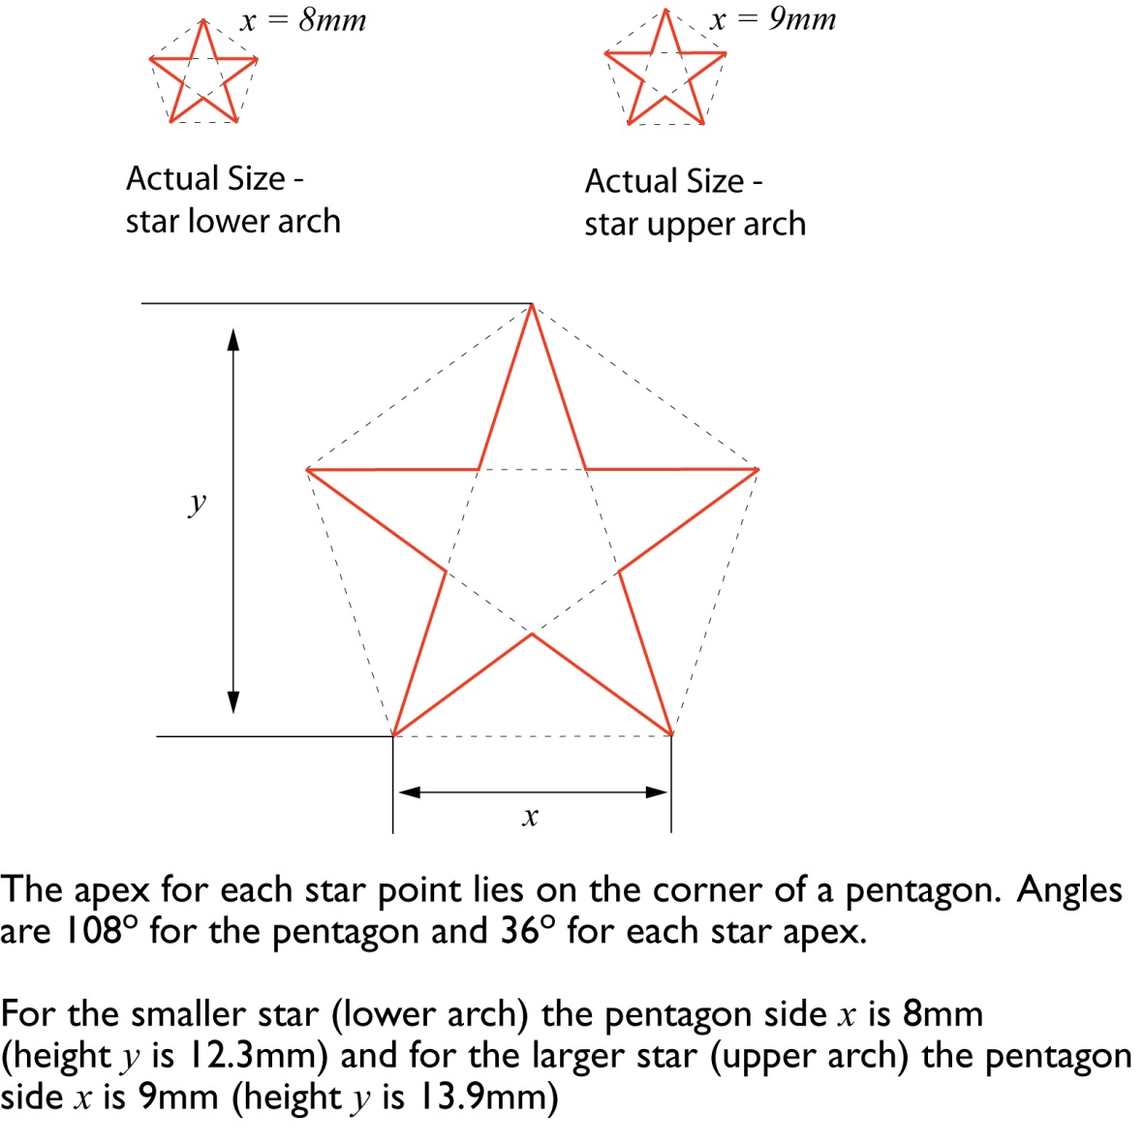

Figure 3: Star Dimensions and Geometry

**Part 3 –** **Label placement**

For paragraph 7(1)(b) of this Determination, the following requirements apply:

### the Energy Efficiency Label or Super-Efficiency Label must be adhered to the upper-front part of the rotary clothes dryer or any display front; or

### if the Energy Efficiency Label or Super-Efficiency Label cannot be adhered to the upper front part of the rotary clothes dryer because it is not feasible or practicable, then the Energy Efficiency Label or Super‑Efficiency Label must be—

1. adhered to the top of the rotary clothes dryer or on any display front of the rotary clothes dryer so that the Energy Efficiency Label or Super-Efficiency Label is not obscured when the rotary clothes dryer is on display; or
2. displayed via a swing tag with the Energy Efficiency Label or Super-Efficiency Label located at the upper-front part of the rotary clothes dryer (any single-sided swing tag shall be non-rotating and rotating swing tags shall be double-sided).

*Note:* This means that the Energy Efficiency Label or Super-Efficiency Label cannot be affixed to the side, back or base of the rotary clothes dryer.