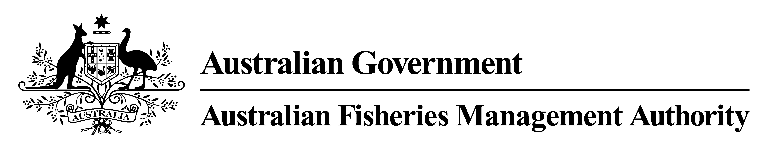

**DETERMINATION OF FISHING CAPACITY**

***Fisheries Management Act 1991***

Subsection 17(6)(aa)

***Heard Island and McDonald Islands Fishery Management Plan 2002***

Sections 11 and 11A

**HEARD ISLAND AND McDONALD ISLANDS FISHERY TOTAL ALLOWABLE CATCH AND TRAWL FISHING CAPACITY DETERMINATION 2015**

The **AUSTRALIAN FISHERIES MANAGEMENT AUTHORITY** pursuant to a resolution of the Commission performing and exercising the domestic fisheries management functions and powers of the Authority, makes the following Determination in accordance with subsection 17(6)(aa) of the *Fisheries Management Act 1991* under sections 11 and 11A of the *Heard Island and McDonald Islands Fishery Management Plan 2002*.

**Dated:** 19November 2015

In accordance with a decision taken to have been made without a meeting of the Commissioners under s25 of the *Fisheries Administration Act 1991*, this instrument is accepted on behalf of the Commission by:

**Andrew Pearson**

Executive Secretary

Australian Fisheries Management Authority

**Citation**

1. This Determination may be cited as the *Heard Island and McDonald Islands Fishery Total Allowable Catch and Trawl Fishing Capacity Determination 2015*.

**Commencement**

2. This Determination commences on the day after it is registered on the Federal Register of Legislative Instruments.

**Cessation**

3.This Determination is repealed on 30 November 2016 unless earlier revoked.

**Interpretation**

4. Terms used in this Determination that are defined for the purposes of the *Heard Island and McDonald Islands Fishery Management Plan 2002* have the same meanings in this Determination as they have in that Plan.

**Notes**: 1. Terms defined in the *Fisheries Management Act 1991* have the same meanings in this Determination.

**Determination of total allowable catch**

5. The total allowable catch for target species and catch limits for other species in the Heard Island and McDonald Islands Fishery for the 2015/2016 fishing year commencing on 1 December 2015 and ending on 30 November 2016 are:

*Target species:*

Patagonian Toothfish (*Dissostichus eleginoides)* 3,405 tonnes

Mackerel Icefish (*Champsocephalus gunnari)* 482 tonnes

*Other Species:*

*Macrourus Caml* and *M. whitsoni* 409 tonnes

*M. halotrachys and M. carinatus* 360 tonnes

Unicorn Icefish (*Channichthys rhinoceratus)* 1,663 tonnes

Skates and Rays (*Bathyraja spp.)* 120 tonnes

Grey Rockcod (*Lepidonotothen squamifrons*) 80 tonnes

All other species 50 tonnes (for each species)

**Determination of trawl fishing capacity**

6. For the purposes of Section 11A of the *Heard Island and McDonald Islands Fishery Management Plan 2002*, AFMA determines the minimum quota for trawl methods expressed as a percentage of Statutory Fishing Rights for the 2015/2016 fishing year commencing on 1 December 2015 and ending on 30 November 2016 to be 25.5% of the statutory fishing rights held in the fishery for each trawler.