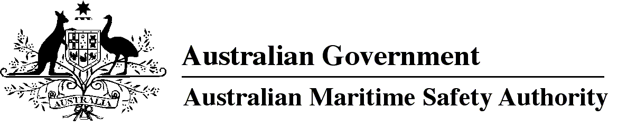

AMSA MO 2015/7

Marine Order 76 (Seafarer certification amendment) 2015

I, Gary Prosser, Acting Chief Executive Officer of the Australian Maritime Safety Authority, make this Order under subsection 342(1) of the *Navigation Act 2012*.

26 November 2015

Gary Prosser  
Acting Chief Executive Officer

1 Name of Order

This Order is *Marine Order 76 (Seafarer certification amendment) 2015*.

2 Commencement

This Order commences immediately after the commencement of *Marine Order 74 (Masters and deck officers — yachts) 2015*.

3 Amendment of Marine Orders

Each Order mentioned in the title of a Schedule to this Order is amended in accordance with the Schedule.

Schedule 1 Marine Order 70 (Seafarer certification) 2014

(section 3)

[1] After paragraph 7(1)(a)

insert

(aa) a certificate of competency as master or deck officer for a yacht;

[2] Subsection 10(1), note 1

omit

*2014* or *Marine Order 73 (Ratings) 2014*

insert

*2014, Marine Order 73 (Ratings) 2014* and *Marine Order 74 (Masters and deck officers — yachts) 2015*

[3] Section 16, note 2

omit

*2014* or *Marine Order 73 (Ratings) 2014*

insert

*2014*, *Marine Order 73 (Ratings) 2014* and *Marine Order 74 (Masters and deck officers — yachts) 2015*

[4] Subsection 31(2), note 1

omit

*2014* and *Marine Order 73 (Ratings) 2014*

insert

*2014, Marine Order 73 (Ratings) 2014* and *Marine Order 74 (Masters and deck officers — yachts) 2015*

Schedule 2 Marine Order 71 (Masters and deck officers) 2014

(section 3)

[1] Subsection 2(1), note

substitute

*Note for paragraph (a)*For alternative master or deck officer qualifications under the Navigation Act for yachts — see *Marine Order 74 (Masters and deck officers — yachts) 2015*.

*Note for paragraph (b)*   The 2011 edition of the STCW Convention and the STCW Code (including the amendments to the annex known as the 2010 Manila Amendments) can be purchased from the International Maritime Organization See the IMO website at http://www.imo.org/publications.

[2] Section 7

omit

For

insert

(1) For

[3] Section 7, after the note

insert

(2) However, a person who holds a seafarer certificate of a grade mentioned in Schedule 1 to *Marine Order 74 (Masters and deck officers* — *yachts) 2015* may perform the permitted duties or functions mentioned in that Schedule for the grade of certificate.

**Note**

1. All legislative instruments and compilations are registered on the Federal Register of Legislative Instruments kept under the *Legislative Instruments Act 2003.* See http://www.frli.gov.au.