

Family Law Amendment (Arbitration and Other Measures) Rules 2015

Select Legislative Instrument No. 255, 2015

We, Judges of the Family Court of Australia, make the following Rules.

Dated 21 December

D Bryant CJ

M May J

A Ainslie-Wallace J

J Ryan J

P Murphy J

J Stevenson J

M Le Poer Trench J

G Watts J

R Benjamin J

V Bennett J

J Crisford J

S Austin J

S Moncrieff J

M Cleary J

W Johnston J

I Loughnan J

C Forrest J

A Rees J

M Aldridge J

J Walters J

S Duncanson J

P Tree J

D Berman J

G Foster J

C Thornton J

H Hannam J

R McClelland J

Judges of the Family Court  
of Australia

Contents

1 Name 1

2 Commencement 1

3 Authority 1

4 Schedules 2

Schedule 1—Amendments relating to arbitration 3

Part 1—Main amendments 3

Family Law Rules 2004 3

Part 2—Other amendments 23

Family Law Rules 2004 23

Schedule 2—Amendments relating to subpoenas 25

Family Law Rules 2004 25

Schedule 3—Amendments relating to surrogacy 32

Family Law Rules 2004 32

Schedule 4—Costs 36

Family Law Rules 2004 36

Schedule 5—Miscellaneous amendments 39

Family Law Rules 2004 39

Schedule 6—Transitional provisions 53

Part 1—Transitional provisions commencing 1 January 2016 53

Family Law Rules 2004 53

Part 2—Transitional provisions commencing 1 April 2016 54

Family Law Rules 2004 54

1 Name

These are the *Family Law Amendment (Arbitration and Other Measures) Rules 2015*.

2 Commencement

(1) Each provision of these Rules specified in column 1 of the table commences, or is taken to have commenced, in accordance with column 2 of the table. Any other statement in column 2 has effect according to its terms.

| Commencement information | | |
| --- | --- | --- |
| Column 1 | Column 2 | Column 3 |
| Provisions | Commencement | Date/Details |
| 1. Rules 1 to 4 and anything in these Rules not elsewhere covered by this table | The day after these Rules are registered. |  |
| 2. Schedule 1 | 1 April 2016. | 1 April 2016 |
| 3. Schedules 2 to 5 | 1 January 2016. | 1 January 2016 |
| 4. Schedule 6, Part 1 | 1 January 2016. | 1 January 2016 |
| 5. Schedule 6, Part 2 | 1 April 2016. | 1 April 2016 |

Note: This table relates only to the provisions of these Rules as originally made. It will not be amended to deal with any later amendments of these Rules.

(2) Any information in column 3 of the table is not part of these Rules. Information may be inserted in this column, or information in it may be edited, in any published version of these Rules.

3 Authority

These Rules are made under the *Family Law Act 1975.*

4 Schedules

Each instrument that is specified in a Schedule to these Rules is amended or repealed as set out in the applicable items in the Schedule concerned, and any other item in a Schedule to these Rules has effect according to its terms.

Schedule 1—Amendments relating to arbitration

Part 1—Main amendments

Family Law Rules 2004

1 After Chapter 26A

Insert:

Chapter 26B—Arbitration

*Summary of Chapter 26B*

Chapter 26B sets out rules relating to arbitration. In particular, the Chapter contains rules about disclosure (Part 26B.1) and subpoenas (Part 26B.2) in arbitrations. See also Part 5 of the Regulations for additional requirements relating to arbitration. Delegation of the Family Court’s powers in relation to arbitration is set out in Chapter 18 of these Rules.

***The rules in Chapter 1 relating to the court’s general powers apply in all cases and override all other provisions in these Rules.***

***A word or expression used in this Chapter may be defined in the dictionary at the end of these Rules.***

Part 26B.1—Disclosure relating to arbitration

26B.01 General duty of disclosure

(1) Each party to an arbitration has a duty to the arbitrator and each other party to the arbitration to give full and frank disclosure of all information relevant to the arbitration, in a timely manner.

(2) Without limiting subrule (1), a party to an arbitration must make full and frank disclosure of the party’s financial circumstances, including the following:

(a) the party’s earnings, including income that is paid or assigned to another party, person or legal entity;

(b) any vested or contingent interest in property;

(c) any vested or contingent interest in property owned by a legal entity that is fully or partially owned or controlled by a party;

(d) any income earned by a legal entity fully or partially owned or controlled by a party, including income that is paid or assigned to any other party, person or legal entity;

(e) the party’s other financial resources;

(f) any trust:

(i) of which the party is the appointor or trustee; or

(ii) of which the party, or the party’s child, spouse or de facto spouse, is an eligible beneficiary as to capital or income; or

(iii) of which a corporation is an eligible beneficiary as to capital or income if the party, or the party’s child, spouse or de facto spouse, is a shareholder or director of the corporation; or

(iv) over which the party has any direct or indirect power or control; or

(v) of which the party has the direct or indirect power to remove or appoint a trustee; or

(vi) of which the party has the power (whether subject to the concurrence of another person or not) to amend the terms; or

(vii) of which the party has the power to disapprove a proposed amendment of the terms or the appointment or removal of a trustee; or

(viii) over which a corporation has a power mentioned in any of subparagraphs (iv) to (vii), if the party, or the party’s child, spouse or de facto spouse, is a director or shareholder of the corporation;

(g) any disposal of property (whether by sale, transfer, assignment or gift) made by the party, a legal entity mentioned in paragraph (c), a corporation, or a trust mentioned in paragraph (f), that may affect, defeat or deplete a claim:

(i) in the 12 months immediately before the separation of the parties; or

(ii) since the final separation of the parties;

(h) liabilities and contingent liabilities.

(3) Paragraph (2)(g) does not apply to a disposal of property made with the consent or knowledge of the other party or in the ordinary course of business.

(4) In this rule:

***legal entity*** means a corporation (other than a public company), trust, partnership, joint venture business or other commercial activity.

26B.02 Duty of disclosure—documents

(1) The duty of disclosure, under subrule 26B.01(1), of a party to an arbitration applies to each document that:

(a) is or has been in the possession, or under the control, of the party; and

(b) is relevant to an issue in dispute between the parties to the arbitration.

(2) This Part does not affect:

(a) the right of a party to an arbitration to inspect a document, if the party has a common interest in the document with the party who has possession or control of the document; or

(b) another right of access to a document other than under this Part; or

(c) an agreement between parties to an arbitration for disclosure by a procedure that is not described in this Part.

26B.03 Use of documents

A person who inspects or copies a document produced under this Chapter in relation to an arbitration:

(a) must use the document for the purposes of the arbitration only; and

(b) must not otherwise disclose the contents of the document, or give a copy of it, to any other person without the court’s permission.

26B.04 Party may require production of documents

(1) A party to an arbitration may, by written notice, require another party to the arbitration to provide a copy of, or produce for inspection, a document referred to:

(a) in a document provided by a party to the arbitration to another party to the arbitration; or

(b) in correspondence prepared and sent by or to another party to the arbitration.

(2) Subject to rule 26B.08, a party required to provide a copy of a document must provide the copy within 14 days after receiving the written notice.

26B.05 Documents that need not be produced

(1) A party to an arbitration must disclose, but need not produce:

(a) a document for which there is a claim of privilege from production; or

(b) a document a copy of which has already been provided, if the copy contains no change, obliteration or other mark or feature that may affect the outcome of the arbitration.

Note: Rule 26B.06 sets out the requirements for challenging a claim of privilege from disclosure.

(2) Subrule (1) has effect despite rules 26B.04, 26B.07 and 26B.08.

26B.06 Objection to production

(1) This rule applies if:

(a) a party to an arbitration (the ***disclosing party***) claims:

(i) privilege from production of a document under this Part; or

(ii) that the disclosing party is unable to produce a document required to be produced under this Part; and

(b) another party to the arbitration, by written notice to the disclosing party, challenges the claim.

(2) The disclosing party must, within 7 days after receiving the notice, give a statement setting out the basis of the claim to:

(a) the other party; and

(b) the arbitrator.

(3) If a statement is given to the arbitrator under subrule (2) in relation to a claim and the arbitrator considers that determining the claim would not involve determining a question of law, the arbitrator must determine the claim or terminate the arbitration.

(4) If a statement is given to the arbitrator under subrule (2) in relation to a claim and the arbitrator considers that determining the claim would involve determining a question of law, the arbitrator must notify the parties.

Note: See also rule 26B.09 (applications for orders relating to disclosure).

(5) If the arbitrator terminates a section 13E arbitration under subrule (3), the arbitrator must, within 7 days, inform the court.

26B.07 Disclosure by giving a list of documents

(1) This rule applies if:

(a) the parties to an arbitration have made an arbitration agreement in relation to the arbitration; or

(b) the parties to an arbitration have been given a notice under regulation 67G of the Regulations.

(2) A party to the arbitration (the ***requiring party***) may, by written notice, require another party to the arbitration (the ***disclosing party***) to give the requiring party a list of documents to which the duty of disclosure under subrule 26B.01(1) applies.

Note: An arbitrator may require a person to produce documents: see regulation 67N of the Regulations.

(3) The disclosing party must, within 21 days after receiving the notice, give the requiring party a list of the documents to which the disclosing party’s duty of disclosure under subrule 26B.01(1) applies.

Note: Rule 26B.02 sets out the documents to which the duty of disclosure under subrule 26B.01(1) applies.

(4) The list must identify:

(a) the documents (if any) that are no longer in the possession, or under the control, of the disclosing party (with a brief statement about the circumstances in which the documents left the party’s possession or ceased to be under the party’s control); and

(b) the documents (if any) for which privilege from production is claimed.

(5) The requiring party may, by written notice, require the disclosing party to do either of the following in relation to a document included in a list in accordance with subrule (3):

(a) produce the document for inspection;

(b) provide a copy of the document.

(6) If the disclosing party receives a notice under paragraph (5)(b) in relation to a document, the disclosing party must, within 14 days after receiving the notice, give the requiring party a copy of the document at the requiring party’s expense.

(7) Subrule (6) has effect subject to subrule (8) and rule 26B.08.

(8) Subrule (6) does not apply to a document:

(a) in relation to which privilege from production is claimed; or

(b) that is no longer in the disclosing party’s possession or control.

(9) If:

(a) the disclosing party gives the requiring party a list in accordance with subrule (3); and

(b) after doing so, a document identified in the list in accordance with paragraph (4)(a) is located by, or comes into the possession or under the control of, the disclosing party;

the disclosing party must, within 7 days, notify the requiring party of that fact.

26B.08 Disclosure by inspection of documents

(1) This rule applies if a party to an arbitration (the ***disclosing party***) receives a notice from another party to the arbitration (the ***requiring party***) under subrule 26B.04(1) or paragraph 26B.07(5)(a) requiring the disclosing party to produce a document for inspection.

(2) This rule also applies if:

(a) a party to an arbitration (the ***disclosing party***) receives a notice from another party to the arbitration (the ***requiring party***) under subrule 26B.04(1) or paragraph 26B.07(5)(b) requiring the disclosing party to provide a copy of a document; and

(b) it is not convenient for the disclosing party to provide a copy of a document required by the notice because of the number and size of the documents specified in the notice.

(3) The disclosing party must, within 14 days after receiving the notice:

(a) notify the requiring party, in writing, of a convenient place and time at which the document may be inspected; and

(b) produce the document for inspection at that place and time; and

(c) allow copies of the document to be made, at the requiring party’s expense.

(4) Unless the parties agree otherwise, the time notified under paragraph (3)(a) must not be more than 21 days after the day on which the notice referred to in subrule (1) or (2) was given.

Note: The court may shorten or extend the time for compliance with a rule (see rule 1.14).

(5) If the requiring party fails to inspect the document at the time notified under paragraph (3)(a), the requiring party is not entitled to inspect the document at a later time unless the requiring party tenders an amount to the disclosing party for the reasonable costs of providing another opportunity for inspection.

Note: The court may dispense with the obligation to tender an amount (see rule 1.12).

26B.09 Applications for orders relating to disclosure

Applications by a party to an arbitration

(1) A party to an arbitration may apply for an order that the party be partly or fully relieved of the duty of disclosure under subrule 26B.01(1).

(2) If:

(a) a party to an arbitration (the ***requiring party***) gives another party to the arbitration (the ***disclosing party***) a notice under subrule 26B.04(1), 26B.07(2) or 26B.07(5); and

(b) the disclosing party fails to comply with the notice; and

(c) either:

(i) the disclosing party has not made a claim under rule 26B.06 in relation to a document to which the notice relates; or

(ii) the disclosing party has made such a claim, and the arbitrator has determined the claim under subrule 26B.06(3) or has notified the parties under subrule 26B.06(4) in relation to the claim;

the requiring party may apply for an order under subrule (3).

(3) For subrule (2), the requiring party may apply for an order that the disclosing party:

(a) comply with a notice given by the requiring party to the disclosing party under subrule 26B.04(1), 26B.07(2) or 26B.07(5); or

(b) disclose a document or class of documents to the requiring party by providing a copy of the document or documents or producing the document or documents for inspection; or

(c) give the requiring party and the arbitrator a written statement:

(i) that a specified document, or class of documents, does not exist or has never existed; or

(ii) setting out the circumstances in which a specified document or class of documents ceased to exist or passed out of the possession or control of the disclosing party.

Applications by an arbitrator

(4) An arbitrator may apply for an order that:

(a) a party to the arbitration comply with a notice given to the party under subrule 26B.04(1), 26B.07(2) or 26B.07(5); or

(b) a party to the arbitration comply with a determination by the arbitrator under subrule 26B.06(3); or

(c) a party to the arbitration give the arbitrator and each other party to the arbitration a written statement:

(i) that a specified document, or class of documents, does not exist or has never existed; or

(ii) setting out the circumstances in which a specified document or class of documents ceased to exist or passed out of the possession or control of that party.

Note: For additional powers of the arbitrator, see subregulation 67N(1) of the Regulations.

All applications

(5) An application under this rule must be made by filing:

(a) an application in accordance with the approved form; and

(b) an affidavit stating the facts relied on in support of the application.

(6) A person making an application under this rule must satisfy the court that the order is necessary to facilitate the effective conduct of the arbitration.

Note: Before making an application under this Chapter, a party must make a reasonable and genuine attempt to settle the issue to which the application relates (see rule 5.03).

(7) In making an order under this rule, the court may consider the following:

(a) whether the disclosure sought is relevant to an issue in dispute between the parties to the arbitration;

(b) the relative importance of the issue to which the document or class of documents relates;

(c) the likely time, cost and inconvenience involved in disclosing a document or class of documents, taking into account the amount of the property, or complexity of the corporate, trust or partnership interests (if any), involved in the arbitration;

(d) the likely effect on the outcome of the arbitration of disclosing, or not disclosing, the document or class of documents.

(8) If a party to an arbitration objects to the production, in accordance with an order under this rule, of a document for inspection or copying, the court may inspect the document to decide the objection.

26B.10 Costs of compliance

If the cost of complying with the duty of disclosure under subrule 26B.01(1) would be oppressive to a party to an arbitration, the court may order another party to the arbitration to:

(a) pay the costs; or

(b) contribute to the costs; or

(c) give security for costs.

26B.11 Electronic disclosure

The court may make an order directing that documents be disclosed for the purposes of this Part by electronic communication.

Note: This rule does not limit the power of an arbitrator to require the production of documents under paragraph 67N(1)(b) of the Regulations.

Part 26B.2—Subpoenas

Division 26B.2.1—General

26B.12 Application of this Part

This Part applies in relation to subpoenas issued, or to be issued, in relation to an arbitration.

26B.13 Interpretation

(1) In this Part:

***interested person***, in relation to a subpoena, means a person who has a sufficient interest in the subpoena.

***issuing party*** means the party for whom a subpoena is issued in accordance with this Part.

***named person*** means a person required by a subpoena issued in accordance with this Part to give evidence or produce documents.

***subpoena for production*** means a subpoena mentioned in paragraph 26B.14(1)(b).

***subpoena for production and to give evidence*** means a subpoena mentioned in paragraph 26B.14(1)(c).

***subpoena to give evidence*** means a subpoena mentioned in paragraph 26B.14(1)(a).

(2) In this Part, a reference to a document includes a reference to an object.

Note: For the definition of ***document***, see the *Acts Interpretation Act 1901*.

26B.14 Issuing a subpoena

(1) The court may, on application, issue a subpoena requiring a person:

(a) to attend an arbitration to give evidence; or

(b) to produce documents to the court in relation to an arbitration; or

(c) to produce documents to the court in relation to an arbitration and attend the arbitration to give evidence.

(2) A subpoena mentioned in subrule (1) must be in the approved form.

(3) An application, under subregulation 67N(2) of the Regulations, by a party to an arbitration for the issue of a subpoena:

(a) may be made orally or in writing; and

(b) may be made without giving notice to any other party to the arbitration; and

(c) may be determined in chambers in the absence of the other parties to the arbitration.

(4) A party to an arbitration must not request the issue of a subpoena for production and to give evidence if production would be sufficient in the circumstances.

(5) A subpoena must identify the person to whom it is directed by name or description of office.

(6) A subpoena may be directed to 2 or more persons if:

(a) the subpoena is to give evidence only; or

(b) the subpoena requires each named person to produce the same document (rather than the same class of documents).

(7) A subpoena for production:

(a) must identify the document to be produced and the time and place for production; and

(b) may require the named person to produce the document before the day the arbitration is to start.

(8) A subpoena to give evidence must specify the time and place at which the person must attend the arbitration to give evidence.

(9) A subpoena for production and to give evidence must:

(a) identify the document to be produced; and

(b) specify the time and place at which the person must attend the arbitration to produce the document and give evidence.

26B.15 Subpoena not to issue in certain circumstances

The court must not issue a subpoena:

(a) on application by a self‑represented party, unless the party has first obtained the Registrar’s permission to make the application; or

(b) for production of a document in the custody of the court or another court.

Note: Rule 26B.27 sets out the procedure to be followed when a party seeks to produce to the court a document from another court.

26B.16 Amendment of subpoena

A subpoena that has been issued, but not served, may be amended by the issuing party filing the amended subpoena with the amendments clearly marked.

26B.17 Service

(1) The issuing party for a subpoena must serve the named person, by hand, with:

(a) the subpoena; and

(b) the brochure, approved by the Principal Registrar, containing information about subpoenas.

(2) The issuing party for a subpoena must serve a copy of the subpoena, by ordinary service, on:

(a) each other party to the arbitration; and

(b) each interested person in relation to the subpoena.

(3) Unless the court directs otherwise, a document required to be served under subrule (1) or (2) must be served:

(a) in relation to a subpoena for production—at least 10 days before the day on which production in accordance with the subpoena is required; and

(b) in relation to a subpoena to give evidence—at least 7 days before the day on which attendance in accordance with the subpoena is required; and

(c) in relation to a subpoena for production and to give evidence—at least 10 days before the day on which production and attendance in accordance with the subpoena is required.

(4) A subpoena must not be served on a child without the court’s permission.

Note: For service generally, see Chapter 7.

26B.18 Conduct money and witness fees

(1) A named person is entitled to be paid conduct money by the issuing party at the time of service of the subpoena, of an amount that is:

(a) sufficient to meet the reasonable expenses of complying with the subpoena; and

(b) at least equal to the minimum amount mentioned in item 101 of the table in Part 1 of Schedule 4.

(2) A named person served with a subpoena to give evidence, or a subpoena for production and to give evidence, is entitled to be paid a witness fee by the issuing party, in accordance with Part 2 of Schedule 4, immediately after attending the arbitration in compliance with the subpoena.

(3) A named person may apply to the court to be reimbursed if the named person incurs a substantial loss or expense that is greater than the amount of the conduct money or witness fee payable under this rule.

26B.19 When compliance is not required

(1) A named person does not have to comply with a subpoena if:

(a) the named person was not served in accordance with these Rules; or

(b) conduct money was not tendered to the person:

(i) at the time of service; or

(ii) at a reasonable time before the day on which attendance or production in accordance with the subpoena is required.

(2) If a named person is not to be calledto give evidence at the arbitration, or to produce a document to the court, in compliance with the subpoena, the issuing party may release the named person from the obligation to comply with the subpoena.

26B.20 Duration of subpoena

A subpoena remains in force until whichever of the following first occurs:

(a) the subpoena is complied with;

(b) the issuing party or the court releases the named person from the obligation to comply with the subpoena;

(c) the arbitration ends.

26B.21 Objection to subpoena

(1) If a named person, or an interested person, in relation to a subpoena:

(a) seeks an order that the subpoena be set aside in whole or in part; or

(b) seeks any other relief in relation to the subpoena;

the person must, before the day on which attendance or production in accordance with the subpoena is required, apply to the court, in writing, for the relevant order.

(2) If a person makes an application under subrule (1), the subpoena must be referred to the court for the hearing and determination of the application.

(3) The court may compel a person to produce a document to the court for the purpose of determining an application under subrule (1).

Division 26B.2.2—Production of documents and access by parties

26B.22 Application of Division 26B.2.2

This Division applies to a subpoena for production.

26B.23 Compliance with subpoena

(1) A named person may comply with a subpoena for production by providing the required documents and a copy of the subpoena to the court:

(a) at the place specified in the subpoena; and

(b) on or before the day on which production in accordance with the subpoena is required.

(2) The named person, when complying with the subpoena for production, must inform the Registry Manager in writing whether:

(a) the documents referred to in the subpoena are to be returned to the named person; or

(b) the Registry Manager is authorised to destroy the documents when they are no longer required by the court.

(3) In this rule:

***copy*** includes:

(a) a photocopy; and

(b) a PDF copy on a CD‑ROM; and

(c) a copy in any other electronic form that the issuing party for the subpoena has indicated is acceptable.

26B.24 Right to inspect and copy documents

(1) This rule applies if:

(a) the court issues a subpoena for production; and

(b) at least 10 days before the day (the ***production day***) on which production in accordance with the subpoena is required, the issuing party:

(i) serves the named person with the subpoena and the brochure in accordance with subrule 26B.17(1); and

(ii) serves each person mentioned in subrule 26B.17(2) with a copy of the subpoena in accordance with that subrule; and

(c) no objection under rule 26B.25 to production of a document required in accordance with the subpoena is made by the production day; and

(d) the named person complies with the subpoena; and

(e) on or after the production day, the issuing party files:

(i) a notice of request to inspect in an approved form; and

(ii) an Affidavit of Service setting out details of the service mentioned in paragraph (b).

(2) Each party to the proceedings may:

(a) inspect a document produced in accordance with the subpoena; and

(b) take copies of a document (other than a child welfare record, criminal record, medical record or police record) produced in accordance with the subpoena.

(3) Subrule (2) has effect subject to paragraph 26B.25(4)(c) (inspection of medical records).

(4) Unless the court orders otherwise, an inspection under paragraph (2)(a):

(a) must be by appointment; and

(b) may be made without an order of the court.

26B.25 Objections relating to production of documents

Objection to producing, or to inspection or copying of, a document

(1) Subrule (2) applies if a subpoena for production is issued in relation to an arbitration, and:

(a) the named person objects to producing a document in accordance with the subpoena; or

(b) the named person or an interested person in relation to the subpoena, or another party to the arbitration, objects to the inspection or copying of a document identified in the subpoena.

(2) The person or party (the ***objector***) must, before the day on which production in accordance with the subpoena is required, give written notice of the objection and the grounds for the objection, to:

(a) the Registry Manager; and

(b) if the objector is not the named person—the named person; and

(c) each party, or other party, to the arbitration; and

(d) the arbitrator.

Objection relating to inspection or copying of medical records

(3) If a subpoena for production requires the production of a person’s medical records, the person may, before the day (the ***production day***) on which production under the subpoena is required, notify the Registry Manager in writing that the person wishes to inspect the medical records for the purpose of determining whether to object to the inspection or copying of the records.

(4) If a person (the ***potential objector***) gives notice under subrule (3):

(a) the potential objector may inspect the medical records; and

(b) if the potential objector wishes to object to the inspection or copying of the records—the potential objector must, within 7 days of the production day, give written notice of the objection and the grounds for the objection, to the Registry Manager; and

(c) unless the court orders otherwise, no other person may inspect the medical records until the later of:

(i) 7 days after the production day; and

(ii) if the potential objector makes an objection under paragraph (b)—the end of the hearing and determination of the objection.

Referral of subpoena to the court

(5) If a person makes an objection under subrule (2) or paragraph (4)(b), the subpoena must be referred to the court for the hearing and determination of the objection.

(6) The court may compel a person to produce a document to the court for the purpose of ruling on an objection under subrule (2) or paragraph (4)(b).

26B.26 Court permission to inspect documents

A person may not inspect or copy a document produced in compliance with a subpoena for production unless:

(a) rule 26B.24 applies; or

(b) the court gives permission.

26B.27 Production of document from a court

(1) A party to an arbitration who seeks to produce to the court a document in the possession of the court or another court must give the Registry Manager a written notice setting out the following:

(a) the name and address of the court having possession of the document;

(b) a description of the document to be produced;

(c) the date when the document is to be produced;

(d) the reason for seeking production.

(2) If the Registry Manager receives a notice under subrule (1) in relation to a document in the possession of another court, a Registrar may ask the other court, in writing, to send the document to the Registry Manager of the filing registry by a specified date.

(3) A party may apply for permission to inspect and copy a document produced to the court under this rule.

26B.28 Return or destruction of documents produced

(1) If:

(a) a named person has informed the Registry Manager under paragraph 26B.23(2)(a) that a document produced by the person in compliance with a subpoena is to be returned to the named person; and

(b) the document is in the possession of the Registry Manager at the end of the arbitration;

the Registry Manager must return the document to the named person at least 28 days, and no later than 42 days, after the end of the arbitration.

(2) If:

(a) a named person has informed the Registry Manager under paragraph 26B.23(2)(b) that a document produced by the person in compliance with a subpoena may be destroyed; and

(b) the document is in the possession of the Registry Manager at the end of the arbitration;

the Registry Manager may destroy the document, in an appropriate way, not earlier than 42 days after the end of the arbitration.

Division 26B.2.3—Non‑compliance with subpoena

26B.29 Non‑compliance with subpoena

If:

(a) a named person does not comply with a subpoena; and

(b) the court is satisfied that the named person was served, and given conduct money, in accordance with these Rules;

the court may issue a warrant for the named person’s arrest and order the person to pay any costs caused by the non‑compliance.

Note: A person who does not comply with a subpoena may be guilty of contempt (see section 112AP of the Act).

Part 26B.3—Other rules relating to arbitration

26B.30 Referral of question of law by an arbitrator

(1) A referral of a question of law by an arbitrator under section 13G of the Act must be made by application in accordance with the approved form.

(2) The arbitrator must give each party to the arbitration a copy of the application within 7 days after making the application.

26B.31 Referral of other matters to the court by the arbitrator

(1) A referral by an arbitrator of a matter to the court under paragraph 67H(3)(b), 67K(b) or 67L(1)(b) of the Regulations must be made by written notice to the Registry Manager.

Note: Regulation 67H is about costs of arbitrations. Regulation 67K is about suspension of arbitrations for failure to comply with directions. Regulation 67L is about termination of arbitrations for lack of capacity.

(2) A referral by an arbitrator of a matter to the court under paragraph 67L(1)(b) of the Regulations must be made within 7 days after the arbitration is terminated.

26B.32 Informing the court about awards made in arbitration

An arbitrator must inform the court of the matters referred to in paragraph 67P(4)(b) of the Regulations, by written notice to the Registry Manager, within 7 days after the award is made.

26B.33 Registration of awards made in arbitration

(1) A copy of an application to register an arbitration award required to be served under subregulation 67Q(2) of the Regulations must be served within 14 days of the day on which the application is filed.

(2) The applicant must file an Affidavit of Service within 7 days of the day on which a copy of the application is so served.

26B.34 Response to applications in relation to arbitration

(1) This rule applies if:

(a) an application is made to the court in relation to an arbitration (whether the application is made under this Chapter, the Regulations, or the Act); and

(b) a respondent to the application:

(i) seeks to oppose the application; or

(ii) seeks different orders to those sought in the application.

(2) The respondent must file:

(a) a response in accordance with the approved form; and

(b) an affidavit stating the facts relied on in support of the response.

(3) The response and affidavit must be filed and served within 7 days after the day on which the application was served.

26B.35 Arbitrator to notify court when certain arbitrations end

If one or more subpoenas are issued in relation to a relevant property or financial arbitration, the arbitrator must inform the court if the arbitration is suspended, terminated or otherwise ends.

Note: See regulation 67P of the Regulations for the duty of the arbitrator to notify the court when a section 13E arbitration ends.

Part 2—Other amendments

Family Law Rules 2004

2 After subrule 5.01(4)

Insert:

(4A) This rule does not apply to restrict the filing of an application for an order in relation to an arbitration by a party to the arbitration or an arbitrator conducting the arbitration.

3 Subrule 18.06(1) (table 18.4, after item 33)

Insert:

|  |  |
| --- | --- |
| 33A | subregulation 67Q(4) |

4 Subrule 18.06(2) (at the end of table 18.5)

Add:

|  |  |
| --- | --- |
| 45 | Part 26B.1 |
| 46 | Divisions 26B.2.1 and 26B.2.2 |

5 After subrule 24.13(1)

Insert:

(1A) An arbitrator conducting an arbitration relating to a case may search the court record relating to the case, and inspect and copy a document forming part of the court record.

6 Subrule 24.13(2)

After “copied”, insert “in accordance with subrule (1) or (1A)”.

7 Schedule 4 (note to Schedule heading)

Omit “15.23 and 19.18”, substitute “15.23, 19.18 and 26B.18”.

8 Dictionary

Insert:

***arbitration agreement*** has the same meaning as in Part 5 of the Regulations.

9 Dictionary (at the end of the definition of *case*)

Add:

Note: A ***case*** does not include arbitration: see the definitions of ***arbitration*** and ***proceedings*** in the Act.

Schedule 2—Amendments relating to subpoenas

Family Law Rules 2004

1 Rule 7.03 (table 7.1, item 9)

Omit “15.28(1)”, substitute “15.22(1)”.

2 Rule 13.07 (note 4)

Repeal the note.

3 After rule 13.07

Insert:

13.07A Use of documents

A person who inspects or copies a document, in relation to a case, under these Rules or an order:

(a) must use the document for the purpose of the case only; and

(b) must not otherwise disclose the contents of the document, or give a copy of it, to any other person without the court’s permission.

4 Subrule 15.16(1) (definition of *court date*)

Repeal the definition.

5 Subrule 15.16(1)

Insert:

***interested person***, in relation to a subpoena, means a person who has a sufficient interest in the subpoena.

***subpoena for production*** means a subpoena mentioned in paragraph 15.17(1)(a).

6 Subrule 15.16(2) (note)

Repeal the note, substitute:

Note: For the definition of ***document***, see the *Acts Interpretation Act 1901*.

7 After subrule 15.17(1)

Insert:

(1A) A subpoena mentioned in subrule (1) must be in the approved form.

8 After subrule 15.17(3)

Insert:

(3A) A party must not request the issue of a subpoena for production and to give evidence if production would be sufficient in the circumstances.

9 At the end of rule 15.17

Add:

(7) A subpoena to give evidence must specify the time and place at which the person must attend court to give evidence.

(8) A subpoena for production and to give evidence must:

(a) identify the document to be produced; and

(b) specify the time and place at which the person must attend court to produce the document and give evidence.

10 Rule 15.22

Repeal the rule, substitute:

15.22 Service

(1) The issuing party for a subpoena must serve the named person, by hand, with:

(a) the subpoena; and

(b) the brochure, approved by the Principal Registrar, containing information about subpoenas.

(2) The issuing party for a subpoena must serve a copy of the subpoena, by ordinary service, on:

(a) each other party; and

(b) each interested person in relation to the subpoena; and

(c) the independent children’s lawyer (if any).

(3) Unless the court directs otherwise, a document required to be served under subrule (1) or (2) must be served:

(a) in relation to a subpoena for production—at least 10 days before the day on which production in accordance with the subpoena is required; and

(b) in relation to a subpoena to give evidence—at least 7 days before the day on which attendance in accordance with the subpoena is required; and

(c) in relation to a subpoena for production and to give evidence—at least 10 days before the day on which production and attendance in accordance with the subpoena is required.

(4) A subpoena must not be served on a child without the court’s permission.

Note: For service generally, see Chapter 7.

11 Paragraphs 15.24(1)(a) and (b)

Repeal the paragraphs, substitute:

(a) the person was not served in accordance with these Rules; or

(b) conduct money was not tendered to the person:

(i) at the time of service; or

(ii) at a reasonable time before the day on which attendance or production in accordance with the subpoena is required.

12 Rule 15.26

Repeal the rule, substitute:

15.26 Objection to subpoena

(1) If:

(a) a subpoena is issued in relation to proceedings; and

(b) the named person or an interested person in relation to the subpoena, or an independent children’s lawyer in the proceedings:

(i) seeks an order that the subpoena be set aside in whole or in part; or

(ii) seeks any other relief in relation to the subpoena;

the person must, before the day on which attendance or production in accordance with the subpoena is required, apply to the court, in writing, for the relevant order.

(2) If a person makes an application under subrule (1), the subpoena must be referred to the court for the hearing and determination of the application.

Note: An application to set aside a subpoena issued in an appeal will be listed for determination before the court hearing the appeal.

(3) The court may compel a person to produce a document to the court for the purpose of determining an application under subrule (1).

13 Subrule 15.27(1)

Omit “(1)”.

14 Subrule 15.27(2)

Repeal the subrule.

15 Rule 15.28

Repeal the rule.

16 Subrule 15.29(1)

Repeal the subrule, substitute:

(1) A named person may comply with a subpoena for production by providing to the court, at the place specified in the subpoena, on or before the day on which production in accordance with the subpoena is required:

(a) the required documents and a copy of the subpoena; or

(b) copies of the required documents attached to an affidavit.

17 Subrule 15.29(2)

Omit “subparagraph (1)(b)(ii)”, substitute “paragraph (1)(b)”.

18 Subrule 15.29(4) (paragraph (a) of the definition of *copy*)

Omit “or”, substitute “and”.

19 Subrule 15.29(4) (at the end of the definition of *copy*)

Add:

; and (c) a copy in any other electronic form that the issuing party for the subpoena has indicated is acceptable.

20 Rules 15.30 and 15.31

Repeal the rules, substitute:

15.30 Right to inspect and copy documents

(1) This rule applies if:

(a) the court issues a subpoena for production in relation to proceedings; and

(b) at least 10 days before the day (the ***production day***) on which production in accordance with the subpoena is required, the issuing party:

(i) serves the named person with the subpoena and the brochure in accordance with subrule 15.22(1); and

(ii) serves each person mentioned in subrule 15.22(2) with a copy of the subpoena in accordance with that subrule; and

(c) no objection under rule 15.31 to production of a document required in accordance with the subpoena is made by the production day; and

(d) the named person complies with the subpoena; and

(e) on or after the production day, the issuing party files:

(i) a notice of request to inspect in an approved form; and

(ii) an Affidavit of Service setting out details of the service mentioned in paragraph (b).

(2) Each party to the proceedings, and any independent children’s lawyer in the proceedings, may:

(a) inspect a document produced in accordance with the subpoena; and

(b) take copies of a document (other than a child welfare record, criminal record, medical record or police record) produced in accordance with the subpoena.

(3) Subrule (2) has effect subject to paragraph 15.31(4)(c) (inspection of medical records).

(4) Unless the court orders otherwise, an inspection under paragraph (2)(a):

(a) must be by appointment; and

(b) may be made without an order of the court.

15.31 Objections relating to production of documents

Objection to producing, or to inspection or copying of, a document

(1) Subrule (2) applies if a subpoena for production is issued in relation to proceedings, and:

(a) the named person objects to producing a document in accordance with the subpoena; or

(b) any of the following objects to the inspection or copying of a document identified in the subpoena:

(i) the named person;

(ii) an interested person in relation to the subpoena;

(iii) another party to the proceedings;

(iv) any independent children’s lawyer in the proceedings.

(2) The person or party (the ***objector***) must, before the day on which production in accordance with the subpoena is required, give written notice of the objection and the grounds for the objection, to:

(a) the Registry Manager; and

(b) if the objector is not the named person—the named person; and

(c) each party, or other party, to the proceedings; and

(d) each independent children’s lawyer, or each other independent children’s lawyer, in the proceedings.

Objection relating to inspection or copying of medical records

(3) If a subpoena for production requires the production of a person’s medical records, the person may, before the day (the ***production day***) on which production in accordance with the subpoena is required, notify the Registry Manager in writing that the person wishes to inspect the medical records for the purpose of determining whether to object to the inspection or copying of the records.

(4) If a person (the ***potential objector***) gives notice under subrule (3):

(a) the potential objector may inspect the medical records; and

(b) if the potential objector wishes to object to the inspection or copying of the records—the potential objector must, within 7 days of the production day, give written notice of the objection and the grounds for the objection, to the Registry Manager; and

(c) unless the court orders otherwise, no other person may inspect the medical records until the later of:

(i) 7 days after the production day; and

(ii) if the potential objector makes an objection under paragraph (b)—the end of the hearing and determination of the objection.

Referral of subpoena to the court

(5) If a person makes an objection under subrule (2) or paragraph (4)(b), the subpoena must be referred to the court for the hearing and determination of the objection.

(6) The court may compel a person to produce a document to the court for the purpose of ruling on an objection under subrule (2) or paragraph (4)(b).

21 Subrule 18.06(2) (table 18.5, items 24A to 30)

Repeal the items, substitute:

|  |  |
| --- | --- |
| 25 | Divisions 15.3.1 and 15.3.2 |

22 Schedule 4 (note to Schedule heading)

Repeal the note, substitute:

Note: See rules 15.23 and 19.19.

23 Part 1 of Schedule 4 (table item 101)

Omit “$10”, substitute “$25”.

24 Dictionary

Insert:

***child welfare record*** means a record relating to child welfare held by an agency mentioned in Schedule 9 to the Regulations.

Schedule 3—Amendments relating to surrogacy

Family Law Rules 2004

1 Rule 2.01 (table 2.1, item 1, column headed “Kind of application”)

After “parenting”, insert “(including in relation to a child born under a surrogacy arrangement)”.

2 Rule 2.01 (after paragraph (b) of note 2)

Insert:

(ba) making an application for a parenting order in relation to a child born under a surrogacy arrangement, see Division 4.2.8;

3 Rule 2.02 (table 2.2, at the end of the cell at item 2A, column headed “Documents to be filed with application”)

Add:

(c) if the application is for a parenting order in relation to a child born under a surrogacy arrangement—an affidavit in a form approved by the Principal Registrar

Note: Division 4.2.8 of these Rules and section 60HB of the Act relate to children born under surrogacy arrangements.

4 At the end of Part 4.2

Add:

Division 4.2.8—Children born under surrogacy arrangements

4.32 Application of Division 4.2.8

This Division applies to an application for a parenting order in relation to a child who was born under a surrogacy arrangement.

Note:See also section 60HB of the Act in relation to children born under surrogacy arrangements.

4.33 Evidence supporting application—general

(1) The evidence in support of an application to which this Division applies must include the evidence, and establish the matters, mentioned in rules 4.34 to 4.36.

(2) The evidence may be given:

(a) in the form of an affidavit; or

(b) with the court’s permission, orally.

4.34 Evidence from applicant and surrogate mother

(1) The evidence must include a copy of the surrogacy agreement (if any), however described.

(2) The evidence must include evidence from the applicant that establishes the applicant’s personal circumstances, including those personal circumstances:

(a) at the time the surrogacy procedure took place; and

(b) in the period immediately before the surrogacy arrangement was entered into; and

(c) in the period immediately before conception; and

(d) in the period immediately after the birth of the child and during subsequent arrangements for the care of the child.

Note: If several applicants jointly file an application for a parenting order to which this Division applies, each applicant must file an affidavit that establishes the matters mentioned in paragraphs (2)(a) and (b).

(3) The evidence must include evidence from the surrogate mother that establishes the surrogate mother’s personal circumstances, including those personal circumstances:

(a) at the time the surrogacy procedure took place; and

(b) in the period immediately before the surrogacy arrangement was entered into; and

(c) in the period immediately before conception; and

(d) in the period immediately after the birth of the child and during subsequent arrangements for the care of the child.

(4) The evidence must include evidence from the surrogate mother as to the following:

(a) whether the surrogacy arrangement was made with her informed consent;

(b) whether she received counselling before entering into the surrogacy arrangement;

(c) whether she received any legal advice before entering into the surrogacy arrangement.

4.35 Evidence about child’s identity

The evidence must include evidence regarding the identity of the child, including the following:

(a) evidence regarding the surrogacy arrangement entered into between:

(i) the applicant and the surrogate mother; or

(ii) the applicant and the clinic (if any) at which the surrogacy procedure was performed; or

(iii) the applicant, the surrogate mother and the clinic (if any);

(b) a certified copy of the child’s birth certificate;

(c) a report, prepared in accordance with regulation 21M of the Regulations, relating to the information obtained as a result of carrying out a parentage testing procedure;

(d) if the child is an Australian citizen:

(i) a certified copy of the child’s Australian citizenship certificate; or

(ii) if the child’s name is mentioned on an Australian citizenship certificate issued to one of the child’s parents—a certified copy of the parent’s Australian citizenship certificate;

(e) if an order of the kind referred to in subsection 60HB(1) of the Act has been made in relation to the child—a copy of the order.

4.36 Evidence about relevant law in child’s birth country

The evidence must include evidence regarding the law in the country where the child was born in relation to:

(a) surrogacy arrangements; and

(b) the rights of the surrogate mother in relation to the child; and

(c) the rights of the surrogate mother’s husband (if any) or de facto partner (if any) in relation to the child.

4.37 Procedure on first hearing date

On the first court date for an application for a parenting order to which this Division applies, the court must:

(a) make procedural orders for the conduct of the case; and

(b) consider whether to make an order under section 68L of the Act that the child’s interests in the proceedings are to be independently represented by a lawyer; and

(c) consider whether to direct a family consultant:

(i) to prepare a family report; or

(ii) to carry out other tasks, having regard to the functions of family consultants set out in section 11A of the Act; and

(d) consider whether a condition mentioned in paragraph 65G(2)(a) or (b) of the Act has been met in relation to the parenting order.

5 After subrule 10.15(2)

Insert:

(2A) Subrule (1) does not apply to an application for a parenting order in relation to a child born under a surrogacy arrangement.

Note: Applications for a parenting order in relation to a child born under a surrogacy arrangement must be made by Initiating Application: see paragraph (c) in item 2A of table 2.2 in rule 2.02. Division 4.2.8 of these Rules and section 60HB of the Act also relate to children born under surrogacy arrangements.

6 Subrule 18.02(1) (table 18.1, after item 2)

Insert:

|  |  |
| --- | --- |
| 2A | Division 4.2.8 |

Schedule 4—Costs

Family Law Rules 2004

1 Schedule 3

Repeal the Schedule, substitute:

Schedule 3—Itemised scale of costs

Note 1: See rule 19.18 and clause 6.19 of Schedule 6.

Note 2: This Schedule applies generally to work done on or after 1 January 2016 (see rule 27.02). Different amounts, set out in superseded versions of this Schedule, may continue to apply to work done before that date.

Part 1—Costs allowable for lawyer’s work done and services performed

| Costs—lawyer’s work | | |
| --- | --- | --- |
| Item | Matter for which charge may be made | Amount (including GST) |
| 101 | Drafting a document (other than a letter) | $20.26 per 100 words |
| 102 | Producing a document (other than a letter) in printed form | $6.92 per 100 words |
| 103 | Drafting and producing a letter (including a fax or an email) | $23.27 per 100 words |
| 104 | Reading a document | $9.48 per 100 words |
| 105 | Scanning a document (where reading is not necessary) | $3.72 per 100 words |
| 106 | For a document or letter mentioned in item 101, 102, 103, 104 or 105 containing more than 3 000 words | The amount allowed by the Registrar |
| 107 | Photocopy or other reproduction of a document | 80 cents per page |
| 108 | Time reasonably spent by a lawyer on work requiring the skill of a lawyer (except work to which any other item in this Part applies) | $237.70 per hour |
| 109 | Time reasonably spent by a lawyer, or by a clerk of a lawyer, on work (except work to which any other item in this Part applies) | $154.11 per hour |

Note: See rule 19.43 in relation to item 104.

Part 2—Costs allowable for counsel’s work done and services performed

| Costs—counsel’s work | | | |
| --- | --- | --- | --- |
| Item | Matter for which charge may be made | Amount (including GST)—senior counsel | Amount (including GST)—junior counsel |
| 201 | Chamber work (including preparing or settling any necessary document, opinion, advice or evidence, and any reading fee (if allowed)) | $457.15–$783.70 per hour | $272.93–$389.25 per hour |
| 202 | Attendance at a conference (including a court‑appointed conference), if necessary | $457.15–$783.70 per hour | $272.93–$389.25 per hour |
| 203 | Attendance of less than 3 hours (for example, a procedural hearing or a summary hearing) | $457.15–$3 265.26 | $244.17–$1 144.14 |
| 204 | A hearing or trial taking at least 3 hours but not more than 1 day | $848.97–$6 531.14 | $809.49–$1 871.18 |
| 205 | Other hearings or trials | $2 155.17–$6 531.14 per day | $1 929.19–$2 835.63 per day |
| 206 | Reserved judgment | $457.15–$783.70 per hour | $272.93–$389.25 per hour |

Part 3—Basic composite amount for undefended divorce

| Costs—undefended divorce | | |
| --- | --- | --- |
| Item | Matter for which charge may be made | Amount (including GST) |
| 301 | If the lawyer employed another lawyer to attend at court for the applicant and there is a child of the marriage under 18 | $1 003.98 |
| 302 | If the lawyer employed another lawyer to attend at court for the applicant and there is no child of the marriage under 18 | $746.96 |
| 303 | If the lawyer did not employ another lawyer to attend at court for the applicant and there is a child of the marriage under 18 | $942.56 |
| 304 | If the lawyer did not employ another lawyer to attend at court for the applicant and there is no child of the marriage under 18 | $705.30 |
| 305 | If the lawyer did not attend at court for the hearing under section 98A of the Act | $606.85 |

Part 4—Basic composite amount for request for Enforcement Warrant or Third Party Debt Notice

|  |  |  |
| --- | --- | --- |
| Costs—Enforcement Warrant or Third Party Debt Notice | | |
| Item | Matter for which charge may be made | Amount (including GST) |
| 401 | An Enforcement Warrant under rule 20.16 | $606.85 |
| 402 | A Third Party Debt Notice under rule 20.32 | $606.85 |

Schedule 5—Miscellaneous amendments

Family Law Rules 2004

1 Subrule 2.04D(1)

Repeal the subrule, substitute:

(1) The prescribed form for a notice mentioned in subsection 67Z(2) or 67ZBA(2) of the Act is the Notice of Child Abuse, Family Violence or Risk of Family Violence.

Note: The Notice of Child Abuse, Family Violence or Risk of Family Violence is set out in Schedule 2.

2 Subrule 2.04D(2)

Omit “Form 4” (first occurring), substitute “notice referred to in subrule (1)”.

3 Subrule 2.04D(2)

Omit “Form 4” (second and third occurring), substitute “notice”.

4 Paragraph 2.04E(1)(c)

Omit “Form 4”, substitute “notice mentioned in subsection 67Z(2) or 67ZBA(2) of the Act”.

5 Subrule 2.04E(2)

Omit “Form 4”, substitute “Notice of Child Abuse, Family Violence or Risk of Family Violence”.

6 Subrule 2.04E(3)

Omit “Form 4”, substitute “notice”.

7 At the end of rule 2.05

Add:

(3) If, during the case, a family violence order affecting the child or a member of the child’s family is varied, any party affected by the variation must, as soon as practicable after the order is varied, file a copy of the variation.

8 Rule 11.16

Repeal the rule, substitute:

11.16 Venue for proceedings

(1) Proceedings in the court (other than a trial) may be heard in chambers.

(2) If a case is determined in chambers, the judicial officer who determined the case must record the following:

(a) the file number;

(b) the names of the parties;

(c) the date of the determination;

(d) the orders made.

(3) If a judgment is given in proceedings:

(a) the judgment must be pronounced in open court; and

(b) if the reasons for judgment are reduced to writing—the written reasons must be published by delivering them to the Registrar or an associate in open court.

9 Paragraph 17.01(1)(b)

Repeal the paragraph, substitute:

(b) in any other case—when it is signed.

10 Subrule 17.01(2) (note)

Repeal the note.

11 Subrule 17.01(5)

Repeal the subrule.

12 Rule 17.02

Repeal the rule, substitute:

17.01A When must an order be entered

(1) An order must be entered if:

(a) the order takes effect on the signing of the order; or

(b) the order is to be served; or

(c) the order is to be enforced; or

(d) an appeal from the order has been instituted or an application for leave to appeal has been made; or

(e) a step is to be taken under the order; or

(f) the court directs that the order be entered.

(2) However, an order need not be entered if it only (in addition to any provision as to costs):

(a) makes an extension or abridgment of time; or

(b) grants leave or makes a direction:

(i) to amend a document (other than an order); or

(ii) to file a document; or

(iii) for an act to be done by an officer of the court other than a lawyer; or

(c) gives directions about the conduct of proceedings.

17.01B Entry of orders

(1) An order is entered by:

(a) the court, a person at the direction of the court, or a Registrar attaching the seal of the court to the order; and

(b) a judicial officer signing the order.

(2) For paragraph (1)(b), an order may be signed by electronic means.

(3) An order may be entered, in accordance with subrule (1):

(a) in a registry of the court; or

(b) in court; or

(c) in chambers.

17.02 Varying or setting aside orders

(1) The court may at any time vary or set aside an order, if:

(a) it was made in the absence of a party; or

(b) it was obtained by fraud; or

(c) it is interlocutory; or

(d) it is an injunction or for the appointment of a receiver; or

(e) it does not reflect the intention of the court; or

(f) the party in whose favour it was made consents; or

(g) there is a clerical mistake in the order; or

(h) there is an error arising in the order from an accidental slip or omission.

(2) Subrule (1) does not affect the power of the court to vary or terminate the operation of an order by a further order.

17.02A Varying or setting aside reasons for judgment

The court may, at any time:

(a) vary or set aside reasons for judgment if the reasons were issued by mistake; or

(b) correct a clerical mistake in reasons for judgment, or an error arising in reasons for judgment from any accidental slip or omission.

13 Subrule 18.06(2) (table 18.5, after item 31A)

Insert:

|  |  |
| --- | --- |
| 31B | paragraph 17.02(1)(g) |

14 Subrule 19.21(1)

Omit “28 days”, substitute “4 months”.

15 Paragraph 19.41(2)(b)

Omit “a”, substitute “the”.

16 Rule 22.33

Repeal the rule.

17 Subrule 24.04(2)

Repeal the subrule, substitute:

(2) A reference in these Rules to a Notice of Child Abuse, Family Violence or Risk of Family Violence is a reference to the form in Schedule 2.

18 Subrule 24.04(3)

Omit “Form 4”, substitute “the form in Schedule 2”.

19 Schedule 2

Repeal the Schedule, substitute:

Schedule 2—Notice of Child Abuse, Family Violence or Risk of Family Violence

Note: See subrule 24.04(2) and Division 2.3.1.

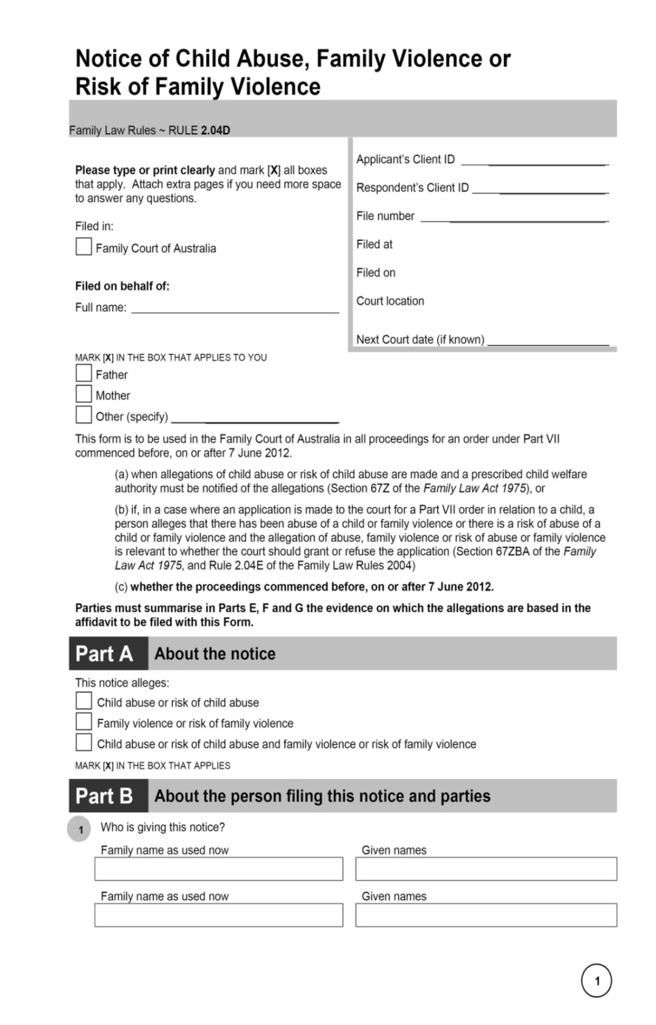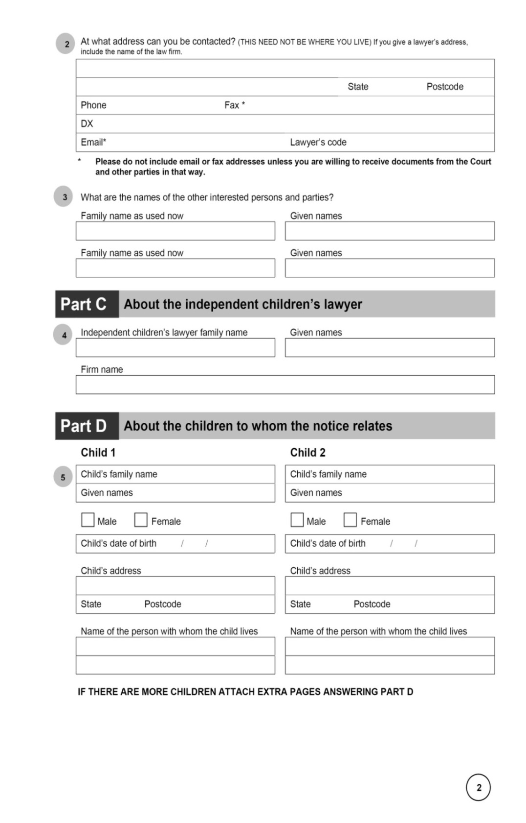

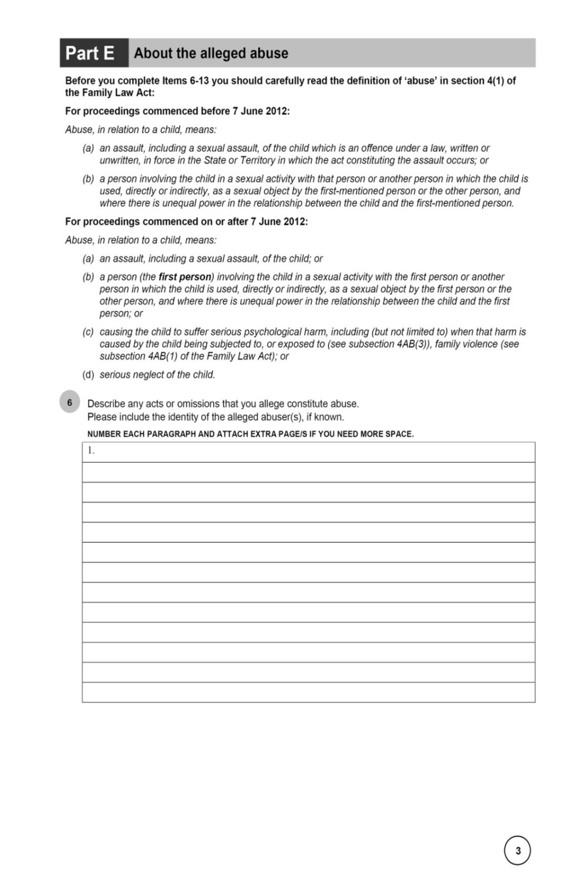

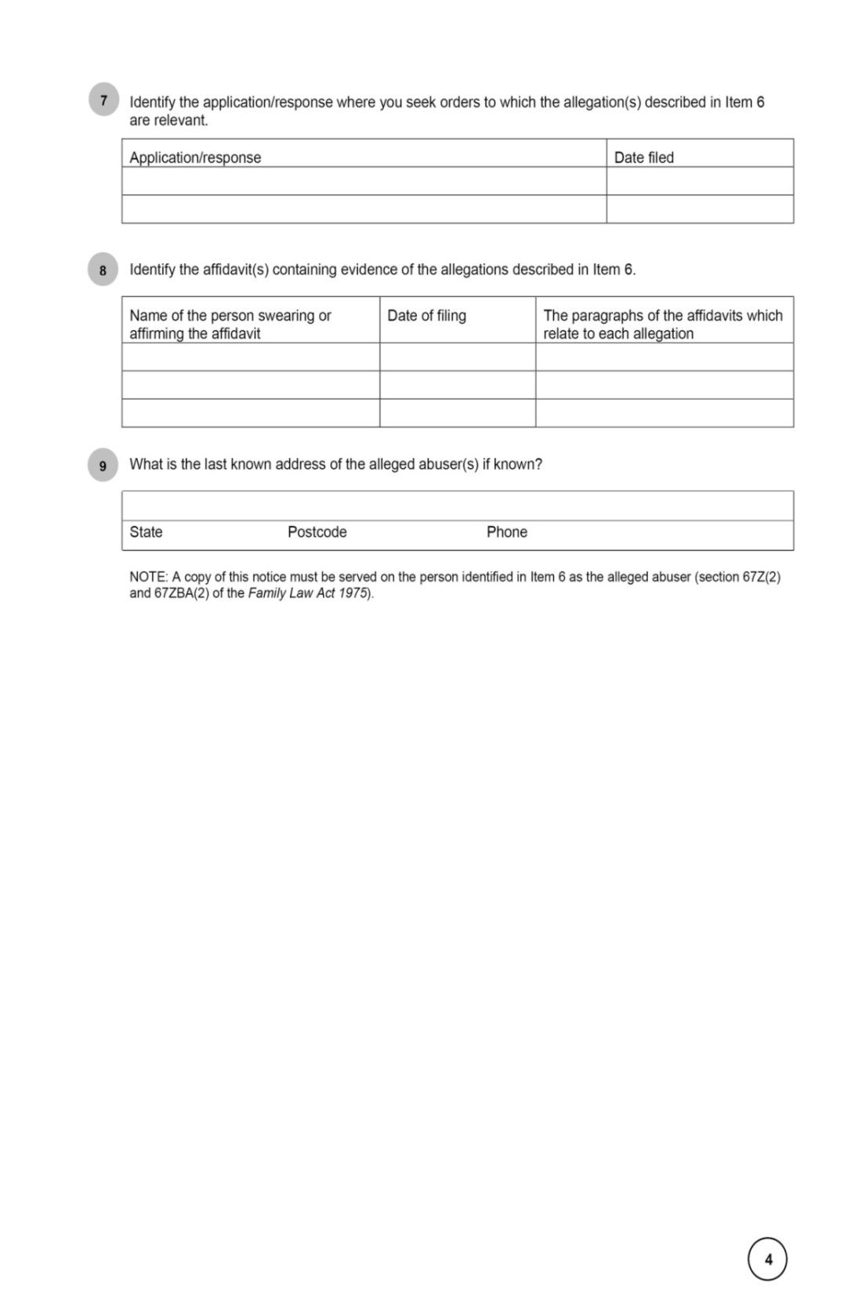

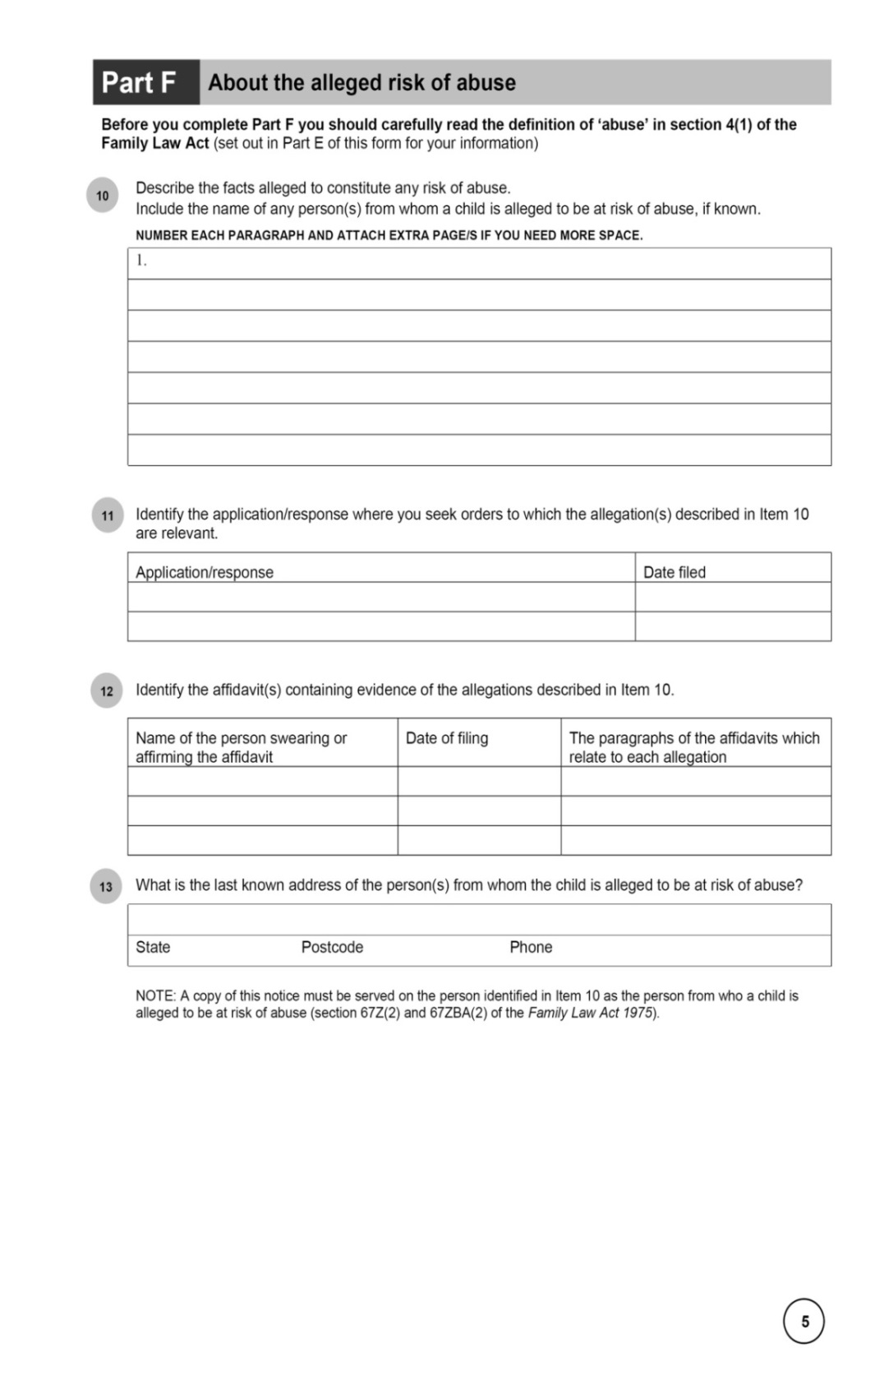

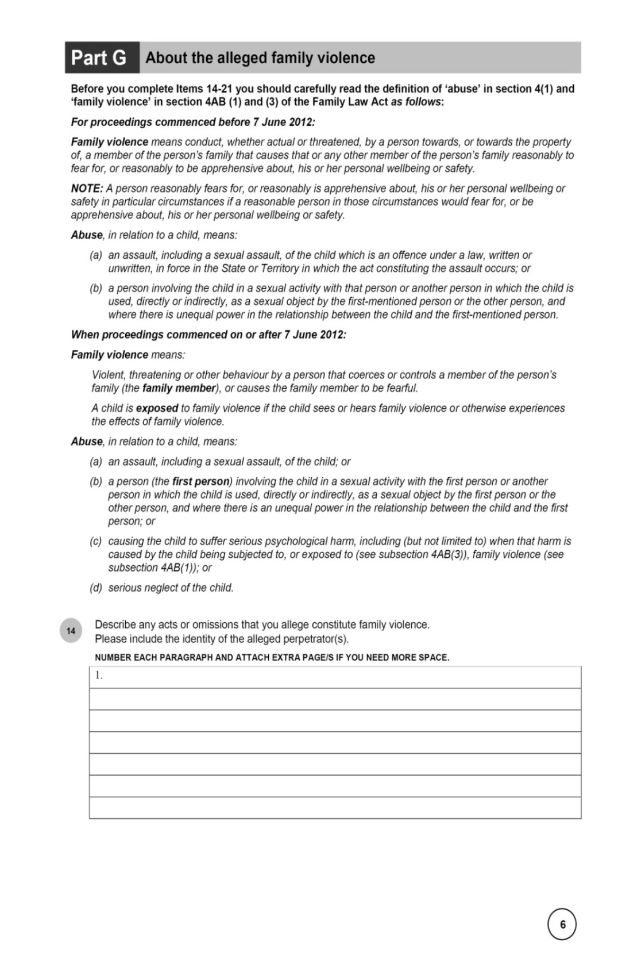

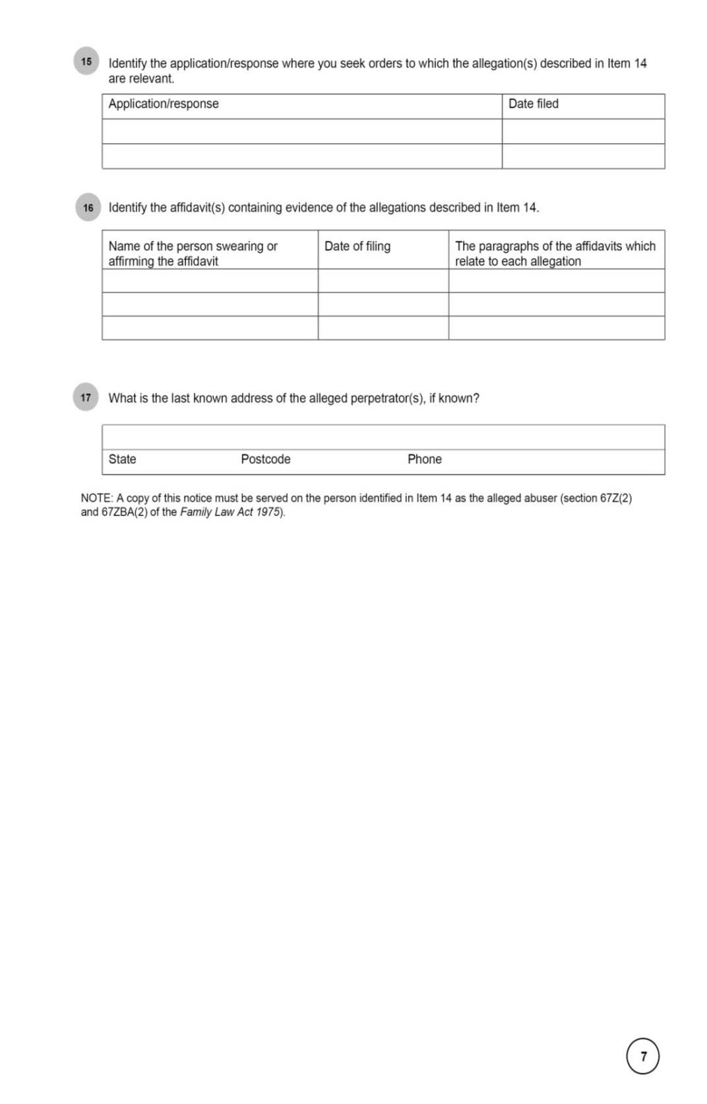

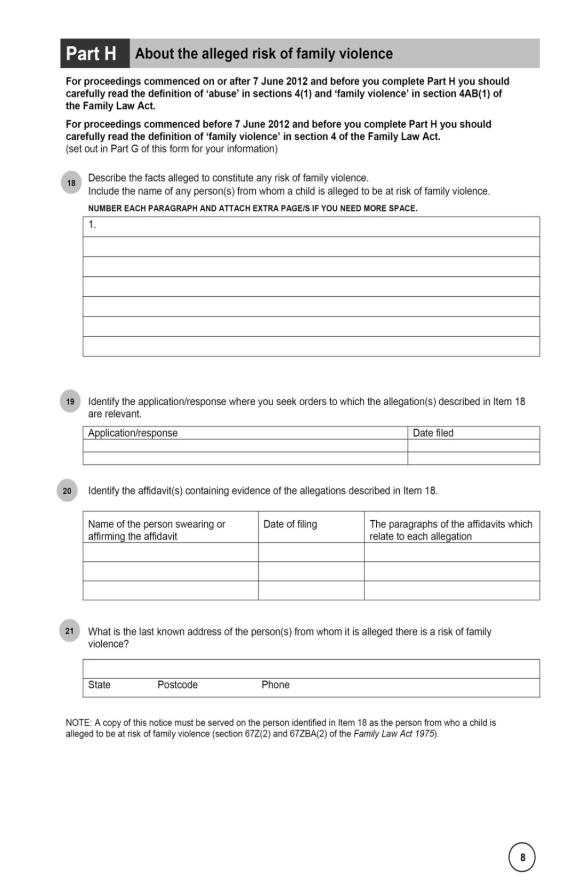

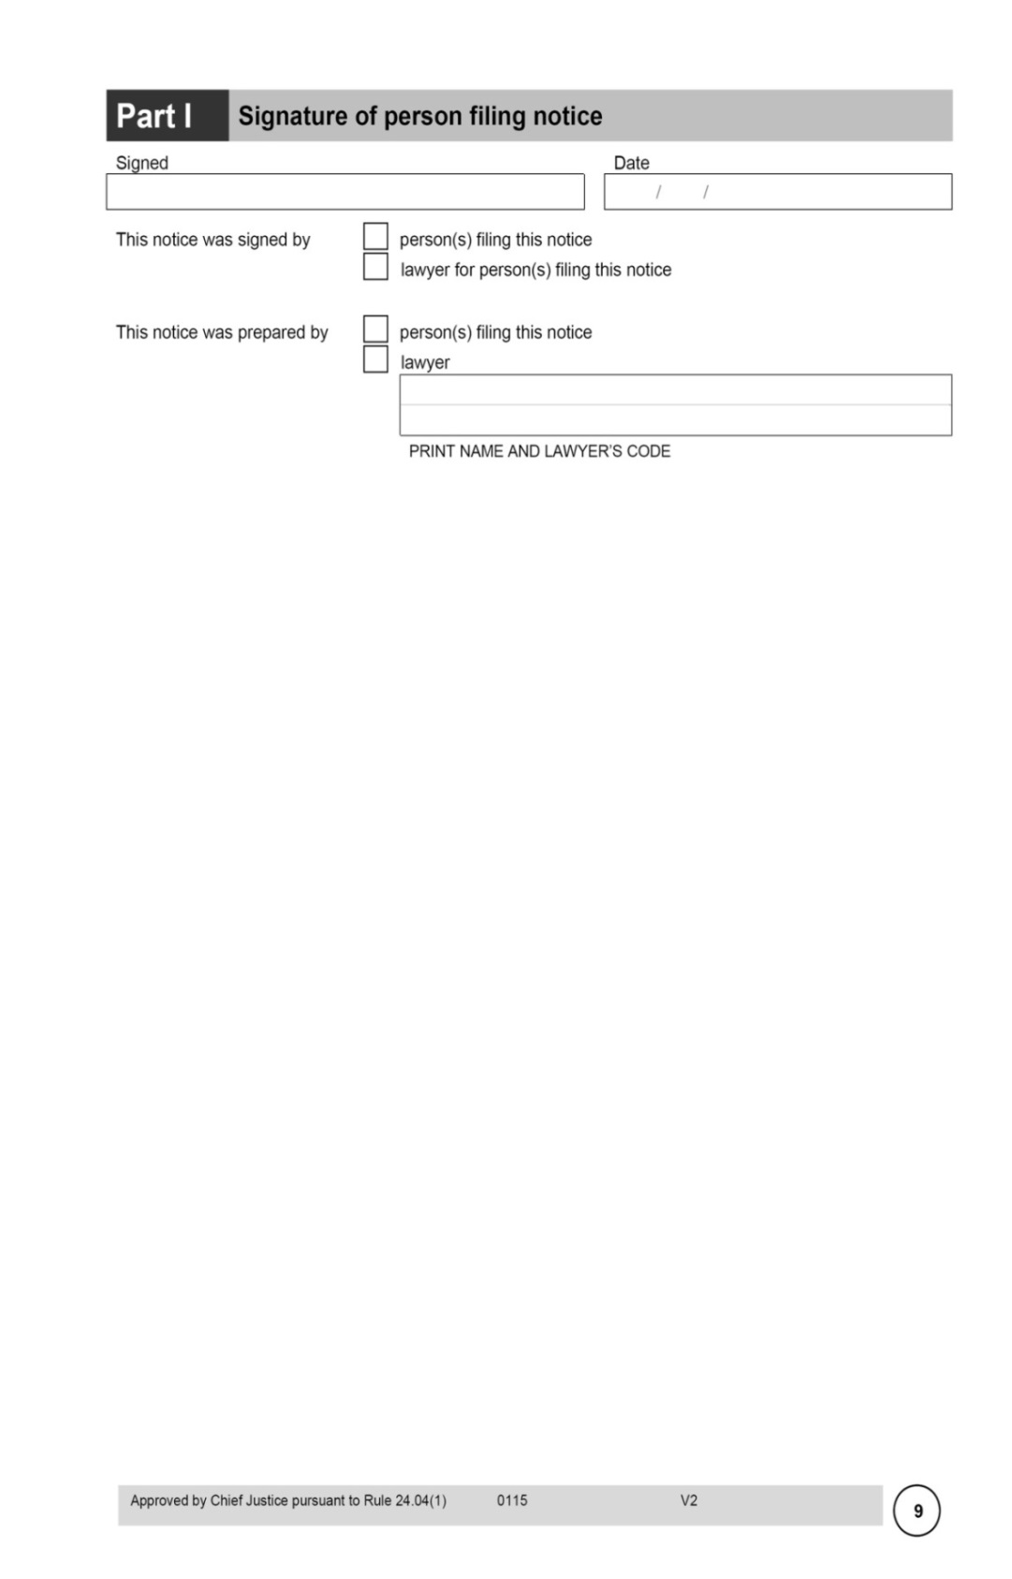

Schedule 6—Transitional provisions

Part 1—Transitional provisions commencing 1 January 2016

Family Law Rules 2004

1 Parts 1 and 2 of Chapter 27

Repeal the Parts, substitute:

Part 27.1—Transitional provisions relating to the Family Law Amendment (Arbitration and Other Measures) Rules 2015

27.01 Application of Schedule 3 (itemised scale of costs)

Schedule 3, as substituted by the *Family Law Amendment (Arbitration and Other Measures) Rules 2015*, applies to work done on or after 1 January 2016.

27.02 Application of amendments relating to subpoenas

(1) The amendments made by Schedule 2 to the *Family Law Amendment (Arbitration and Other Measures) Rules 2015* apply to subpoenas issued, or to be issued, on or after the commencement of that Schedule.

(2) This rule is repealed at the start of 1 February 2016.

Part 2—Transitional provisions commencing 1 April 2016

Family Law Rules 2004

2 At the end of Part 27.1

Add:

27.02 Application of Chapter 26B (Arbitration)

(1) Chapter 26B, as inserted by the *Family Law Amendment (Arbitration and Other Measures) Rules 2015*, applies to:

(a) arbitrations that start after the commencement of those rules; and

(b) arbitrations that started, but have not ended, before the commencement of those rules.

(2) This rule is repealed at the start of 1 May 2016.