EXPLANATORY STATEMENT
Kakadu National Park Management Plan 2016-2026
Overview of the Legislative Instrument
The Director of National Parks prepares management plans for Commonwealth reserves in accordance with Section 368 of the Environment Protection and Biodiversity Conservation Act 1999 (EPBC Act). The purpose of this management plan is to describe the philosophy and direction of management for Kakadu National Park for the next 10 years in accordance with the EPBC Act. The plan enables management to proceed in an orderly way, helps to reconcile competing interests, and identifies priorities for the allocation of available resources.
The management plan for the park is an enabling document. It allows management activities to occur that would otherwise be restricted under EPBC legislation, and enables certain management, recreational and commercial activities to occur.
The fifth management plan for the park ceased to have effect on the 31 December 2013. Since that time Kakadu National Park has been managed under s.357 of the EPBC Act, effectively guiding the interim management of the park by the actions and principles of the previous management plan until the sixth plan comes into effect.
About the park
Kakadu National Park covers an area of 19,810 square kilometres within the Alligator Rivers Region of the Northern Territory. Kakadu is the largest terrestrial national park in Australia, extending from the coast in the north to the southern hills and basins 150 kilometres to the south, and 120 kilometres from the Arnhem Land sandstone plateau in the east, through savanna woodlands to the western boundary.
The majority of the Kakadu region is Aboriginal land under the Aboriginal Land Rights Act (NT 1976) and has been home to Aboriginal people for over 50,000 years. The Aboriginal people, Bininj in the north and Mungguy in the south, are the traditional custodians of the land.
There is an extensive network of rock art sites in the Kakadu region, recognised to be one of the greatest concentrations of rock art sites in the world. Some of the rock art is estimated to be up to 20,000 years old. This represents one of the longest historical records of any group of people in the world.
The Kakadu region includes a diverse range of landscape types, including lowland savanna woodlands, stone country, rainforest and floodplains and coastal zones. These landscapes dramatically change throughout the year in response to the six seasons recognised by Bininj people in the north and five seasons by Mungguy people in the south of the park. The park contains a diverse range of plants and animals, including high numbers of endemic species in the stone country.
Joint management arrangements
Kakadu National Park was primarily proclaimed in three stages between 1979 and 1991, and inscribed on the World Heritage list for its outstanding cultural and natural values in 1981. Bininj/Mungguy have leased their land to the Australian Government to be jointly managed as a national park. One of the most important features of Kakadu National Park is the ongoing custodianship of the region by Bininj/Mungguy who continue to live in and jointly manage the park.
The Lease arrangements for Aboriginal land in the park obligate the Director of National Parks to provide certain benefits to the traditional owners of park land, including assisting in the maintenance of cultural traditions, providing employment opportunities, training in administrative and management skills and the protection of areas and matters of significance to the Indigenous community. This plan strengthens these commitments.
Consultation
In February 2012 a notice was published inviting comments on the proposal to prepare a draft management plan. This initial opportunity for public comment closed on 13 April 2012 and
seven submissions were received.
Following consideration of these submissions, the Director and the Board then prepared a draft management plan in accordance with s.368 (1) (b) of the EPBC Act, which was released for public comment on 3 December 2014, allowing 74 days for public consideration of the draft plan.
There were 31 written submissions received on the draft management plan from a range of stakeholders.
The Board of Management met twice to discuss the submissions on the draft plan and held an additional one day out of session meeting to discuss remaining issues and to consider what adjustments were necessary to finalise the plan. The Board altered aspects of the plan in response to a range of comments provided on the draft plan.
Period of operation
This management plan will come into operation, following approval by the Minister for Cities and the Built Environment under s.370 of the EPBC Act, at the beginning of the day after it is registered under the Legislative Instruments Act 2003. The plan will cease to have effect ten years after commencement, unless revoked or amended earlier by another management plan.
Regulatory Impact
This management plan has been written to preserve the cultural heritage of the park and its traditional owners, to conserve the terrestrial and marine ecosystems of the park, and to provide rewarding and unique experiences for visitors. This management plan does not place any additional compliance burden on businesses, community organisations or individuals. Given there is no additional compliance burden no regulatory offset is required. The Office of Best Practice Regulation (OBPR) advised was not necessary to prepare a Regulatory Impact Statement for this management plan (OBPR reference: ID 2015/19719).

Sally Barnes
Director of National Parks
11 December 2015
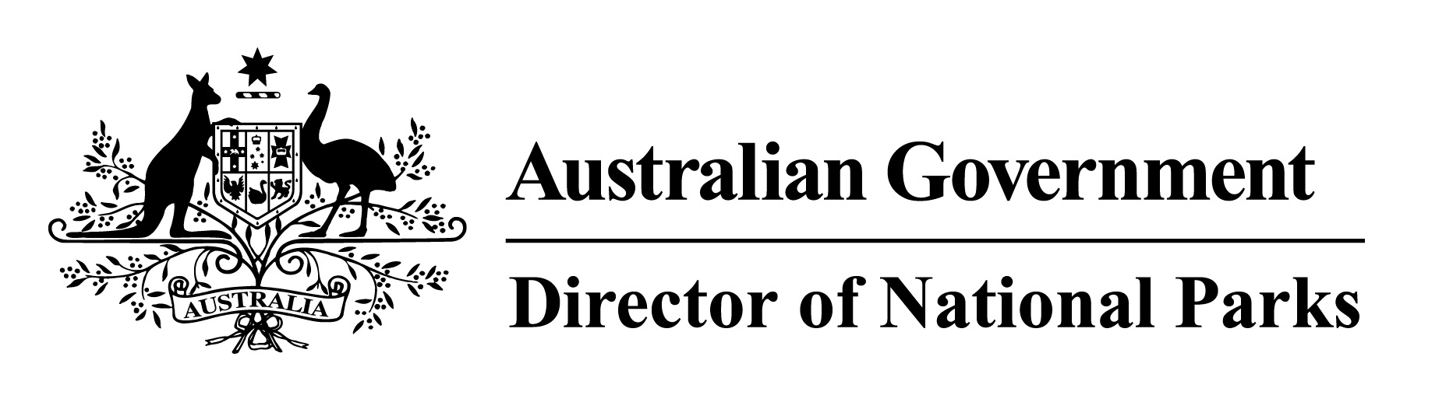
Statement of Compatibility with Human Rights
Prepared in accordance with Part 3 of the Human Rights (Parliamentary Scrutiny) Act 2011
Kakadu National Park Management Plan 2016-2026
This Legislative Instrument is compatible with the human rights and freedoms recognised or declared in the international instruments listed in section 3 of the Human Rights (Parliamentary Scrutiny) Act 2011.
Overview of the Legislative Instrument
The Director of National Parks prepares management plans for Commonwealth reserves in accordance with Section 368 of the Environment Protection and Biodiversity Conservation Act 1999 (EPBC Act). The purpose of this management plan is to describe the philosophy and direction of management for Kakadu National Park for the next ten years in accordance with the EPBC Act. The plan enables management to proceed in an orderly way, helps to reconcile competing interests, and identifies priorities for the allocation of available resources.
The EPBC Act and associated Regulations prohibit certain activities from occurring in Kakadu National Park and other Commonwealth reserves. The management plan for the park is an enabling document. It allows management activities to occur that would otherwise be restricted under EPBC legislation, and enables certain management, recreational and commercial activities to occur.
Human rights implications
This Legislative Instrument provides benefits to Indigenous Australians to address indigenous disadvantage, assisting their
- Right to self-determination
Through joint management of the park with traditional owners, traditional owner consultation and participation in decision making and the incorporation of traditional knowledge and practices in the management of the park.
- Right to equality and non-discrimination
Through encouraging the training and recruiting of Indigenous people for management and operational positions in the park.
Conclusion
This Legislative Instrument is compatible with human rights and provides benefits to Indigenous people, particularly the traditional owners of land in the park.

Sally Barnes
Director of National Parks
11 December 2015

