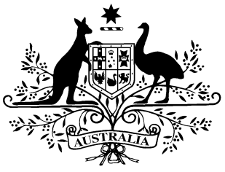

PB 17 of 2016

National Health (Remote Aboriginal Health Services Program) Special Arrangements Amendment Instrument 2016 (No. 1)

*National Health Act 1953*

I, JULIANNE QUAINE, Assistant Secretary, Pharmaceutical Access Branch, Pharmaceutical Benefits Division, Department of Health, delegate of the Minister for Health, make this Amendment Instrument under subsections 100(1) and 100(2) of the *National Health Act 1953*.

**Dated:** 23 February 2016

**JULIANNE QUAINE**

Assistant Secretary

Pharmaceutical Access Branch

Pharmaceutical Benefits Division

Department of Health

1 Name of Instrument

1. This Instrument is the *National Health (Remote Aboriginal Health Services Program) Special Arrangements Amendment Instrument 2016 (No. 1)*.
2. This Instrument may also be cited as PB 17 of 2016.

2 Commencement

This Instrument commences on 1 March 2016.

3 Amendment to PB 65 of 2010

Schedule 1 amends the *National Health (Remote Aboriginal Health Services Program) Special Arrangements Instrument**2010* (PB 65 of 2010).

Schedule 1 Amendments

[1] Section 9

*Omit 9 (b)*

*substitute*

(b) an amount equal to the administration, handling and infrastructure fee worked out under the determination under paragraph 98B(1)(a) of the Act; and