**EXPLANATORY STATEMENT**

Issued by the authority of the Attorney‑General

*Seas and Submerged Lands Act 1973*

*Seas and Submerged Lands (Historic Bays) Proclamation 2016*

Section 8 of the *Seas and Submerged Lands Act 1973* (the Act) provides that, where the Governor‑General is satisfied that a bay is an historic bay, he or she may, by proclamation, declare that bay to be an historic bay and shall, by the same or another proclamation, define the sea-ward limits of that bay. An historic bay is a bay which, by general acquiescence, has become part of the internal waters of Australia although the sea-ward limit exceeds that which would otherwise be permitted under the United Nations Convention on the Law of the Sea [Australian Treaty Series 1994 31].

The *Seas and Submerged Lands (Historic Bays) Proclamation 2016* (the Proclamation) repeals a previous proclamation made in 2006, which declared certain bays in South Australia – Anxious Bay, Encounter Bay, Lacepede Bay and Rivoli Bay – to be historic bays. That proclamation is scheduled to sunset in accordance with Part 6 of the *Legislation Act 2003*. The Proclamation again declares the four bays to be historic bays and specifies geographic coordinates of the baselines and sea-ward limits of those bays. The Proclamation replicates the substance of the previous proclamation and is not intended to change the definitions of the bays. The Proclamation uses the Geocentric Datum of Australia, which is the coordinate reference system currently used in Australia for all spatial information.

A map depicting the straight baselines drawn pursuant to the Proclamation and to the *Seas and Submerged Lands (Territorial Sea) Proclamation 2016*, so far as scale permits, is at Attachment A. Details of the Proclamation are set out in Attachment B.

The Proclamation is a legislative instrument for the purposes of the *Legislation Act 2003*.

No public consultation was undertaken in relation to the Proclamation, as it merely makes minor changes to the previous proclamation.

The Proclamation commences the day after it is registered in the Federal Register of Legislative Instruments.

**Attachment A**

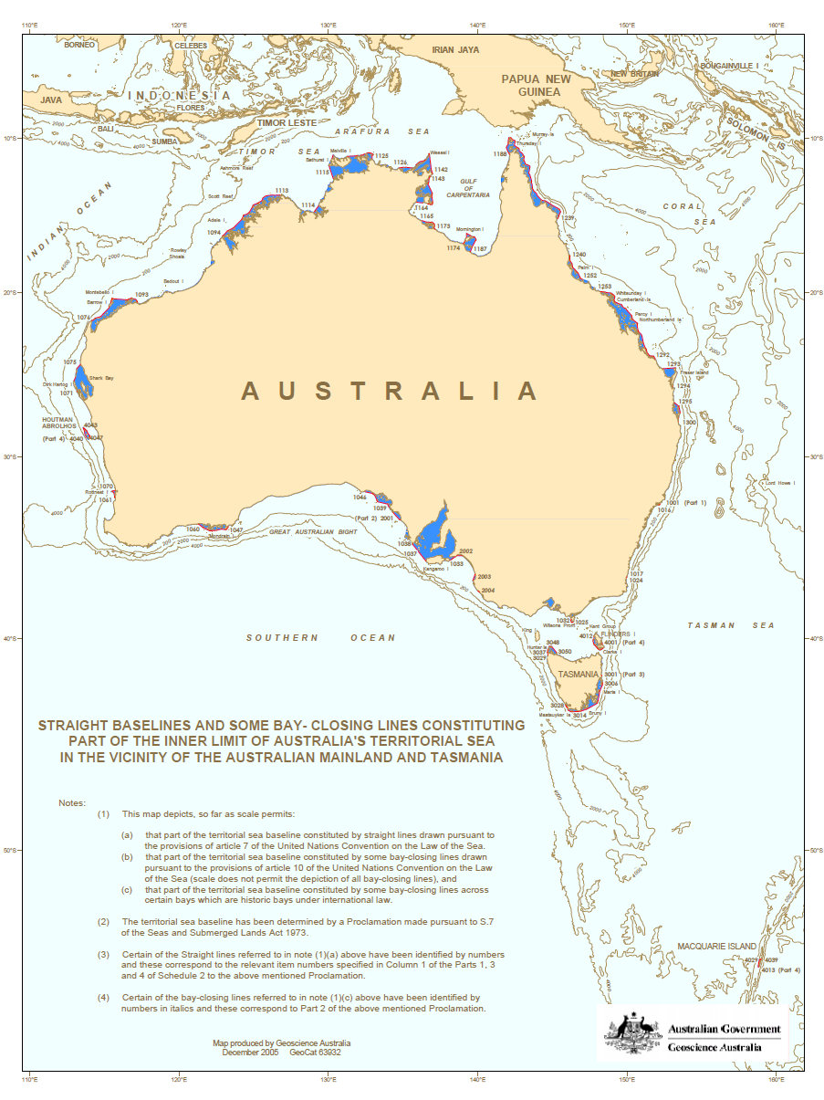

**Attachment B**

**Details of the *Seas and Submerged Lands (Historic Bays) Proclamation 2016***

Section 1 – Name

Section 1 gives the name of the Proclamation as the *Seas and Submerged Lands (Historic Bays) Proclamation 2016*.

Section 2 – Commencement

Section 2 provides that the Proclamation commences on the day after it is registered on the Federal Register of Legislative Instruments.

Section 3 – Authority

Section 3 confirms that the instrument is made under paragraph 8(a) of the *Seas and Submerged Lands Act 1973* (the Act).

Section 4 – Schedules

Section 4 has the effect of repealing the *Seas and Submerged Lands (Historic Bays) Proclamation 2006*, which is referred to in Schedule 3. Section 4 also clarifies that the other items in the Schedules have effect according to their terms.

Section 5 – Definitions

Subsection 5(1) defines particular terms that are used in the Proclamation as follows:

“Act”means the *Seas and Submerged Lands Act 1973*;

“Geocentric Datum of Australia” refers to the matters specified in Schedule 1;

“low-water” refers to lowest astronomical tide. Lowest astronomical tide is the lowest level to which the sea can be predicted to fall under normal meteorological conditions, and is usually estimated by reference to charts, geospatial imagery and other sources; and

“straight line” refers to a geodesic line, being the shortest possible line between two points on a curved surface.

Subsection 5(2) provides that the position on the surface of the Earth of a point, line or area is determined by reference to the Geocentric Datum of Australia (the GDA).

Section 6 – Declaration of historic bays

Article 10 of the United Nations Convention on the Law of the Sea [Australian Treaty Series 1994 31], which describes juridical bays for the purposes of international law, does not apply in relation to “historic bays”. The elements of an historic claim to waters under customary international law are the exercise of continuous sovereignty over a long period of time with the toleration or acquiescence of other States.

As part of the Offshore Constitutional Settlement, territorial sea baselines for Australia were proclaimed in 1983. In the area of South Australia, these baselines had the effect of enclosing, as Australian internal waters for the purposes of international law, Spencer Gulf, Gulf St Vincent, Investigator Strait and certain bays including Coffin Bay, Streaky Bay and Fowlers Bay. However, it was agreed between the Commonwealth and South Australia that a joint committee would be established to examine whether certain bays in South Australia were historic bays or historic waters. The Committee examined historical and other evidence and concluded that Encounter Bay, Lacepede Bay, Rivoli Bay and Anxious Bay met the criteria for being considered as historic bays, and recommended the making of a proclamation under the Act declaring these bays to be historic bays.

Section 6 again declares the specified bays to be historic bays.

Section 7 – Sea-ward limits – Anxious Bay

Subsection 7(1) specifies that the sea-ward limits of Anxious Bay are defined by straight lines joining the low-water line of the coast that are closest to the geographic coordinates specified in subsection 7(2).

Section 8 – Sea-ward limits – Encounter Bay

Subsection 8(1) specifies that the sea-ward limits of Encounter Bay are defined by straight lines joining the low-water lines of the coast that are closest to the geographic coordinates specified in subsection 8(2).

Section 9 – Sea-ward limits – Lacepede Bay

Subsection 9(1) specifies that the sea-ward limits of Lacepede Bay are defined by straight lines joining the low-water lines of the coast that are closest to the geographic coordinates specified in subsection 9(2).

Section 10 – Sea-ward limits – Rivoli Bay

Subsection 10(1) specifies that the sea-ward limits of Rivoli Bay are defined by straight lines joining the low-water lines of the coast that are closest to the geographic coordinates specified in subsection 10(2).

Section 11 – Low-water line of the same island

Section 11 makes provision for where a bay closing line provided for by any of sections 7, 8, 9 or 10 would pass through an island at two different points. In that case, the bay closing line is taken to be along the low‑water line of the island on the sea-ward side of the points of intersection of the straight line and the island’s coast.

Schedule 1 – Geocentric Datum of Australia

The GDA is the coordinate reference system currently used in Australia.

Item 1 – Reference ellipsoid

The item specifies the reference ellipsoid.

Item 2 – Reference frame

The item explains how the GDA is realised.

**Statement of Compatibility with Human Rights**

*Prepared in accordance with Part 3 of the Human Rights (Parliamentary Scrutiny) Act 2011*

**Seas and Submerged Lands (Historic Bays) Proclamation 2016**

This disallowable legislative instrument is compatible with the human rights and freedoms recognised or declared in the international instruments listed in section 3 of the *Human Rights (Parliamentary Scrutiny) Act 2011*.

**Overview of the disallowable legislative instrument**

The *Seas and Submerged Lands (Historic Bays) Proclamation 2016* declares certain bays in South Australia – Anxious Bay, Encounter Bay, Lacepede Bay and Rivoli Bay – to be historic bays, and defines the seaward limits of those bays.

The Proclamation is made under paragraph 8(a) of the *Seas and Submerged Lands Act 1973*. Paragraph 8(a) provides that, where the Governor-General is satisfied that a bay is an historic bay, he or she may, by proclamation, declare that bay to be an historic bay and shall define the seaward limits of that bay. Under international law, an historic bay is a bay which, by general acquiescence, has become part of Australia’s internal waters although the sea-ward limit of the bay exceeds that which would otherwise be permitted.

**Human rights implications**

This disallowable legislative instrument does not engage any of the applicable rights or freedoms.

**Conclusion**

This disallowable legislative instrument is compatible with human rights as it does not raise any human rights issues.