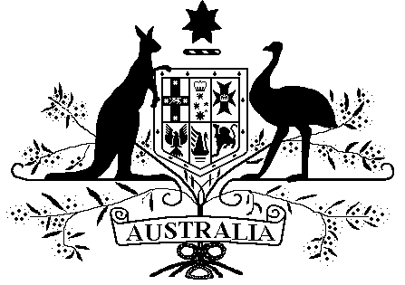

Veterans’ Entitlements Act 1986

Veterans’ Entitlements (Exempt Lump Sum – Life Insurance Payouts) Determination 2016

Instrument 2016 No. R15

I, MARK HARRIGAN, delegate of the Repatriation Commission, under paragraph 5H(12)(c) of the Veterans’ Entitlements Act 1986 (VEA), determine an amount specified in Part 2 of this instrument to be exempt lump sum for the purposes of the definition of “ordinary income” in subsection 5H(1) of the VEA.

Dated this 15th day of March 2016

Mark Harrigan
…………………………………………………………
MARK HARRIGAN
Part 1: Preliminary and Interpretation
1 Name of determination
This determination is the Veterans’ Entitlements (Exempt Lump Sum – Life Insurance Payouts) Determination 2016.
2 Commencement
This determination is taken to have commenced on 1 July 2015.
3 Definition
In this determination:

“income support supplement” means the payment called the income support supplement payable under Part IIIA of the VEA;

“life insurance payout” means a payment made to a person upon death or terminal illness of another person pursuant to a policy of insurance held by the first person;
“service pension” has the meaning given to service pension in subsection 5Q(1) of the VEA.

Part 2: Exempt Lump Sum
4 Life Insurance Payouts – exempt lump sums
If a person or a person’s partner receives a life insurance payout and the person is eligible for, or in receipt of a service pension or income support supplement, then the amount of the life insurance payout received by the person or the person’s partner is an exempt lump sum.

