**Work Health and Safety (Excavation Work) Code of Practice 2015**

made under the

***Work Health and Safety Act 2011*, section 274 (Approved Codes of Practice)**

**1 Name of instrument**

This instrument is the Work Health and Safety (Excavation Work) Code of Practice 2015.

**2 Commencement**

This instrument commences on the day after it is registered on the Federal Register of Legislative Instruments.

**3 Code of Practice Approval**

I approve the Excavation Work Code of Practice. I am satisfied that this code of practice was developed by a process described in section 274(2) of the *Work Health and Safety Act 2011*.

Michaelia Cash

Minister for Employment

17 December 2015

Date

**EXCAVATION WORK**

**Code of Practice**

**TABLE OF CONTENTS**

**FOREWORD 5**

**1 INTRODUCTION 6**

1.1 What is excavation work? 6

1.2 Who has health and safety duties in relation to excavation work? 6

1.3 What is required to manage risks associated with excavation work? 7

**2 THE RISK MANAGEMENT PROCESS 9**

2.1 Identifying the hazards 9

2.2 Assessing the risks 10

2.3 Controlling the risks 10

2.4 Reviewing control measures 11

**3 PLANNING THE EXCAVATION WORK 12**

3.1 Principal contractor 12

3.2 Designers 13

3.3 Safe Work Method Statements 13

3.4 Adjacent buildings or structures 14

3.5 Essential services 14

3.6 Securing the work area 15

3.7 Emergency plan 16

**4 CONTROLLING RISKS IN EXCAVATION WORK 17**

4.1 Excavated material and loads near excavations 17

4.2 Plant and equipment 20

4.3 Powered mobile plant 20

4.4 Falls 24

4.5 Using explosives 25

4.6 Atmospheric conditions and ventilation 26

4.7 Manual work 27

4.8 Information, training, instruction and supervision 27

**5 EXCAVATION METHODS 28**

5.1 Trenching 28

5.2 Tunnelling 28

5.3 Shafts 30

**6 PREVENTING GROUND COLLAPSE 32**

6.1 Benching and battering 34

6.2 Shoring 36

6.3 Removal of shoring supports 43

6.4 Shields and boxes 43

6.5 Other ground support methods 44

6.6 Regular inspection 45

**APPENDIX A – DEFINITIONS 46**

# FOREWORD

This Code of Practice for managing health and safety risks associated with excavation work is an approved code of practice under section 274 of the *Work Health and Safety Act* (the WHS Act).

An approved code of practice is a practical guide to achieving the standards of health, safety and welfare required under the *WHS Act and the* *Work Health and Safety Regulations* (the WHS Regulations).

A code of practice applies to anyone who has a duty of care in the circumstances described in the code. In most cases, following an approved code of practice would achieve compliance with the health and safety duties in the WHS Act, in relation to the subject matter of the code. Like regulations, codes of practice deal with particular issues and do not cover all hazards or risks that may arise. The health and safety duties require duty holders to consider all risks associated with work, not only those for which regulations and codes of practice exist.

Codes of practice are admissible in court proceedings under the WHS Act and Regulations. Courts may regard a code of practice as evidence of what is known about a hazard, risk or control and may rely on the code in determining what is reasonably practicable in the circumstances to which the code relates.

Compliance with the WHS Act and Regulations may be achieved by following another method, such as a technical or an industry standard, if it provides an equivalent or higher standard of work health and safety than the code.

An inspector may refer to an approved code of practice when issuing an improvement or prohibition notice.

This Code of Practice has been developed by Safe Work Australia as a model code of practice under the Council of Australian Governments’ *Inter-Governmental Agreement for Regulatory and Operational Reform in Occupational Health and Safety* for adoption by the Commonwealth, state and territory governments.

## Scope and application

This Code provides practical guidance for persons conducting a business or undertaking on how to manage the health and safety risks associated with excavation work. This Code applies to all types of excavation work including bulk excavations more than 1.5 metres deep, trenches, shafts and tunnels.

The guidance in this Code is relevant to excavation contractors as well as persons conducting   
a business or undertaking who have management or control of workplaces where excavation work is carried out, such as principal contractors.

Persons who have duties in relation to excavation work should also refer to the [Code of Practice: *Construction work*](http://www.safeworkaustralia.gov.au/sites/swa/about/publications/pages/construction-work)*.*

### How to use this code of practice

In providing guidance, the word ‘should’ is used in this Code to indicate a recommended course of action, while ‘may’ is used to indicate an optional course of action.

This Code also includes various references to provisions of the WHS Act and Regulations which set out the legal requirements. These references are not exhaustive. The words ‘must’, ‘requires’ or ‘mandatory’ indicate that a legal requirement exists and must be complied with.

# INTRODUCTION

Excavation failures are particularly dangerous because they may occur quickly, limiting the ability of workers (and in some cases others in the vicinity) to escape especially if the collapse is extensive.

The speed of an excavation collapse increases the risk associated with this type of work and the consequences are significant as the falling earth can bury or crush any person in its path. This can result in death by suffocation or internal crush injuries.

## What is excavation work?

Excavation work generallymeans work involving the removal of soil or rock from a site to form   
an open face, hole or cavity using tools, machinery or explosives.

A person conducting a business or undertaking must manage risks associated with all kinds   
of excavations at the workplace, no matter how deep.

Specific duties apply in relation to the higher-risk excavations such as trenches, shafts and tunnels. However these requirements do not apply to a mine, a bore to which a relevant water law applies or a trench used as a place of interment.

Any construction work (including any work connected with an ‘excavation’) that is carried out   
in or near:

* a shaft or trench with an excavated depth of greater than 1.5 metres, or
* a tunnel

is considered to be ‘high risk construction work’ for which a Safe Work Method Statement (SWMS) must be prepared.

Further guidance on the duties related to high risk construction work and SWMS is available in the[Code of Practice: *Construction work*](http://www.safeworkaustralia.gov.au/sites/swa/about/publications/pages/construction-work).

Other key terms relating to excavation work are listed in Appendix A.

## Who has health and safety duties in relation to excavation work?

A **person conducting a business or undertaking** has the primary duty to ensure, so far as is reasonably practicable, that workers and other persons are not exposed to health and safety risks arising from the business or undertaking.

The WHS Regulations include specific obligations for a person conducting a business or undertaking to manage the risks associated with excavation work including trenches.

**A person conducting a business or undertaking who has management or control of a workplace** where excavation work is being carried out must take all reasonable steps to obtain current underground essential services information relating to the part of a workplace where the excavation work is being carried out and areas adjacent to it before directing or allowing the excavation to commence. This information must be provided to any person engaged to carry out excavation work.

For the purpose of this Code, the person conducting a business or undertaking who carries out the excavation work is sometimes referred to as the ‘excavation contractor’.

A **principal contractor** for a construction project (for example where the cost of the construction work is $250 000 or more) has additional duties under the WHS Regulations (refer to section 3.1 of this Code).

**Designers** of structures must ensure, so far as is reasonably practicable, that the structure is without risks to health and safety, when used for a purpose for which it was designed. Designers must give the person who commissioned the design a written safety report that specifies the hazards relating to the design of the structure (refer to section 3.2 of this Code).

**Officers**, such as company directors, have a duty to exercise due diligence to ensure that the business or undertaking complies with the WHS Act and Regulations. This includes taking reasonable steps to ensure that the business or undertaking has and uses appropriate resources and processes to eliminate or minimise risks that arise from the excavation work.

**Workers** have a duty to take reasonable care for their own health and safety and that they do   
not adversely affect the health and safety of other persons. Workers must comply with any reasonable instruction and cooperate with any reasonable policy or procedure relating to health and safety at the workplace.

## What is required to manage risks associated with excavation work?

Regulation 305 A person conducting a business or undertaking must manage risks to health   
and safety associated with excavation work.

Regulation 34-38 In order to manage risks under the WHS Regulations, a duty holder must:

* identify reasonably foreseeable hazards that could give rise to the risk
* eliminate the risk so far as is reasonably practicable
* if it is not reasonably practicable to eliminate the risk – minimise the risk so far as is reasonably practicable by implementing control measures in accordance with the hierarchy   
  of control
* maintain the implemented control measure so that it remains effective, and
* review, and if necessary revise control measures so as to maintain, so far as is reasonably practicable, a work environment that is without risks to health and safety.

This Code provides guidance on managing the risks associated with excavation work by following a systematic process that involves:

* identifying hazards
* if necessary, assessing the risks associated with these hazards
* implementing control measures, and
* maintaining and reviewing the effectiveness of control measures.

Guidance on the general risk management process is available in the [Code of Practice*: How   
to manage work health and safety risks*](http://www.safeworkaustralia.gov.au/sites/swa/about/publications/pages/manage-whs-risks-cop)*.*

### Consulting your workers

Section 47 A person conducting a business or undertaking must consult, so far as is reasonably practicable, with workers who carry out work for them and who are (or are likely to be) directly affected by a work health and safety matter.

Section 48 If the workers are represented by a health and safety representative, the consultation must involve that representative.

Consultation with workers and their health and safety representatives is required at every step of the risk management process. In many cases, decisions about construction work and projects are made prior to engaging workers, therefore, it may not be possible to consult with workers in these early stages. However, it is important to consult with them as the excavation work progresses.

### Consulting, co-operating and co-ordinating activities with other duty holders

Section 46 A person conducting a business or undertaking must consult, co-operate and   
co-ordinate activities with all other persons who have a work health or safety duty in relation   
to the same matter, so far as is reasonably practicable.

A construction workplace will often be shared by various persons conducting a business or undertaking, such as civil engineers and contractors. Persons with overlapping duties should exchange information about the risks associated with the excavation work including any traffic and plant movements near the excavation area. They should work together in a co-operative and co-ordinated way so that all risks are eliminated or minimised so far as is reasonably practicable.

Further guidance on consultation is available in the [Code of Practice*: Work health and safety consultation, co-operation and co-ordination*](http://www.safeworkaustralia.gov.au/sites/swa/about/publications/pages/consultation-cooperation-coordination-cop)*.*

# THE RISK MANAGEMENT PROCESS

Regulation 305 A person conducting a business or undertaking must manage risks to health   
and safety associated with excavation work before the work commences including the risk of:

* a person falling into an excavation
* a person being trapped by the collapse of an excavation
* a person working in an excavation being struck by a falling thing
* a person working in an excavation being exposed to an airborne contaminant.

To manage the risks, all relevant matters must be considered including:

* the nature of the excavation
* the nature of the excavation work including the range of possible methods of carrying out the work, and
* the means of entry into and exit from the excavation (if applicable).

## Identifying the hazards

The first step in the risk management process is to identify the hazards associated with excavation work. Examples of excavation specific hazards include:

* underground essential services including gas, water, sewerage, telecommunications, electricity, chemicals and fuel or refrigerant in pipes or lines. Information about the location of these and other underground services, such as drainage pipes, soak wells and storage tanks, in and adjacent to the workplace, must be established before directing or allowing excavation work to commence
* the fall or dislodgement of earth or rock
* falls from one level to another
* falling objects
* inappropriate placement of excavated materials, plant or other loads
* the instability of any adjoining structure caused by the excavation
* any previous disturbance of the ground including previous excavation
* the instability of the excavation due to persons or plant working adjacent to the excavation
* the presence of or possible inrush of water or other liquid
* hazardous manual tasks
* hazardous chemicals (e.g. these may be present in the soil where excavation work is to be carried out)
* hazardous atmosphere in an excavation (e.g. using Methyl Ethyl Ketone (MEK) solvent for PVC pipes in poorly ventilated trenches)
* vibration and hazardous noise, and
* overhead essential services (powerlines) and ground mounted essential services (transformers, gas and water meters).

## Assessing the risks

Under the WHS Regulations, a risk assessment is not mandatory for excavation work however   
it is required for specific situations, for example when working with asbestos. In many circumstances a risk assessment will assist in determining the control measures that should be implemented. It will help to:

* identify which workers are at risk
* determine what sources and processes are causing that risk
* identify if and what kind of control measures should be implemented, and
* check the effectiveness of existing control measures.

When assessing the risks associated with excavation work you should consider things such as:

* local site conditions including access, ground slope, adjacent buildings and structures, water courses (including underground) and trees
* depth of the excavation
* soil properties including variable soil types, stability, shear strength, cohesion, presence of ground water, effect of exposure to the elements
* fractures or faults in rocks including joints, bedding planes, dip and strike directions and angles, clay seams
* any specialised plant or work methods required (e.g. ground support)
* the method(s) of transport, haul routes and disposal
* what exposures might occur, such as to noise, ultra violet rays or hazardous chemicals
* the number of people involved
* the possibility of unauthorised access to the work area
* local weather conditions, and
* the length of time that the excavation will be open.

## Controlling the risks

### The hierarchy of control measures

Some control measures are more effective than others. Control measures can be ranked from the highest level of protection and reliability to the lowest. This ranking is known as the *hierarchy of control*.

You must always aim to *eliminate a hazard*, which is the most effective control. If this is not reasonably practicable, you must minimise the risk by one or a combination of the following:

* *Substitution* – for example using an excavator with a rock breaker rather than manual method
* *Isolation* – for example using concrete barriers to separate pedestrians and powered mobile plant to reduce the risk of collision, and
* *Engineering Controls* – for example benching, battering or shoring the sides of the excavation to reduce the risk of ground collapse.

If risk remains, it must be minimised by implementing *administrative controls*, so far as is reasonably practicable, for example by installing warning signs near the excavation.

Any remaining risk must be minimised with suitable *personal protective equipment* (PPE), such as providing workers with hard hats, hearing protectors and high visibility vests.

Administrative control measures and PPE rely on human behaviour and supervision and used on their own tend to be the least effective in minimising risks.

Factors that should be considered when choosing suitable control measures include:

* excavating plant - when quantities are large, it may be effective to use different types of plant for the various materials to be excavated
* stockpiling arrangements - another site may need to be found for temporary stockpiling of materials
* material placement - the methods and plant used for excavating, transporting and compacting the material should be evaluated
* dewatering equipment, if required, and the system to be used
* transport of the excavated material - the type of plant used, the length of haul, the nature of the haul route, and the conditions of tipping and/or spreading.

Chapters 4-6 of this Code provide information on control measures for excavation work.

## Reviewing control measures

The control measures that are put in place to protect health and safety should be regularly reviewed to make sure they are effective.

Regulation 39 You must review your control measures and, if necessary, revise them:

* when the control measure is not effective in controlling the risk
* before a change at the workplace that is likely to give rise to a new or different health and safety risk that the control measure may not effectively control
* if a new hazard or risk is identified
* if the results of consultation indicate that a review is necessary, or
* if a health and safety representative requests a review.

Common review methods include workplace inspection, consultation, testing and analysing records and data. When reviewing control measures, a SWMS must also be reviewed and revised where necessary.

If problems are found, go back through the risk management steps, review your information and make further decisions about control measures.

# PLANNING THE EXCAVATION WORK

Excavation work should be carefully planned before work starts so it can be carried out safely. Planning involves identifying the hazards, assessing the risks and determining appropriate control measures in consultation with all relevant persons involved in the work including the principal contractor, excavation contractor, designers and mobile plant operators. Structural or geotechnical engineers may also need to be consulted at this stage.

Consultation should include discussions on the:

* nature and/or condition of the ground and/or working environment
* weather conditions
* nature of the work and other activities that may affect health and safety
* static and dynamic loads near the excavation
* interaction with other trades
* site access
* SWMS
* management of surrounding vehicular traffic and ground vibration
* type of equipment used for excavation work
* public safety
* existing services and their location
* the length of time the excavation is to remain open
* provision of adequate facilities, and
* procedures to deal with emergencies.

Further information on amenities and emergencies is available in the [Code of Practice: *Managing the work environment and facilities*](http://www.safeworkaustralia.gov.au/sites/swa/about/publications/pages/environment-facilities-cop)*.*

## Principal contractor

Where the value of construction work is $250 000 or more, the construction work is considered a ‘construction project’ for which additional duties apply to the principal contractor. There can only be one principal contractor for a construction project and this will be either the person commissioning the construction work or a person appointed as the principal contractor by the person commissioning the construction work.

The principal contractor has a range of duties in relation to a construction project including:

* preparing and reviewing a WHS management plan
* obtaining SWMS before any high risk construction work commences
* putting in place arrangements to manage the work environment including falls, facilities, first aid, an emergency plan and traffic management
* installing signs showing the principal contactor’s name, contact details and location of any site office, and
* securing the construction workplace.

Where significant excavation work is being carried out and building works have not commenced the person who commissions the construction work may appoint the excavation contractor as the principal contractor for the site preparation phase of the project and then replace them with a building expert after this phase is completed. If the excavation contractor is appointed as the principal contractor the contractor must comply with all principal contractor duties while undertaking this role.

For further guidance on how to calculate the cost of construction work and on principal contractor duties refer to the [Code of Practice: *Construction work*](http://www.safeworkaustralia.gov.au/sites/swa/about/publications/pages/construction-work)*.*

## Designers

Section 22 Designers must ensure, so far as is reasonably practicable, that the structure is designed to be without risks to the health and safety of persons who construct the structure   
at a workplace.

Regulation 295 The designer of a structure or any part of a structure that is to be constructed must give the person conducting a business or undertaking who commissioned the design a written report that specifies the hazards associated with the design of the structure that, so far   
as the designer is reasonably aware:

* create a risk to the health or safety of persons who are to carry out construction work on the structure or part, and
* are associated only with the particular design and not with other designs of the same type   
  of structure.

Designers of structures should consider possible excavation work methods and health and safety control measures when producing any final design documents and the safety report for the structure.

A person commissioning the construction work must consult, so far as is reasonably practicable, with the designer of the whole or any part of the structure about eliminating and controlling risks. If the person commissioning the construction work did not commission the design of the construction project, they must take all reasonable steps to obtain the designer’s safety report.

Where there is a principal contractor, the person commissioning the construction work must give the principal contractor any information they have about the hazards and risks associated with the work.

For further guidance on the duties of designers refer to the [Code of Practice: *Safe design   
of structures*](http://www.safeworkaustralia.gov.au/sites/swa/about/publications/pages/safe-design-of-structures).

## Safe Work Method Statements

If the excavation work is or involves high risk construction work, a person conducting a business or undertaking must prepare a SWMS before the high risk construction work starts. The SWMS must:

* identify the type of high risk construction work being done
* specify the health and safety hazards and risks arising from that work
* describe how the risks will be controlled
* describe how the control measures will be implemented, monitored and reviewed, and
* be developed in consultation with workers and their representatives who are carrying out the high risk construction work.

In some circumstances one SWMS can be prepared to cover more than one high risk construction work activity being carried out at the workplace by contractors and/or subcontractors. For example, where there is:

* a risk of a person falling more than 2 metres, and
* a trench with an excavated depth greater than 1.5 metres.

In this case, the contractors or subcontractors can consult and cooperate to prepare one SWMS. Alternatively they can prepare separate SWMS. If they choose to do this they must consult with each other to ensure all SWMS are consistent and they are not creating unintended additional risks at the workplace.

Further guidance on SWMS and an example SWMS template is available in the [Code of Practice: *Construction work*](http://www.safeworkaustralia.gov.au/sites/swa/about/publications/pages/construction-work)*.*

## Adjacent buildings or structures

Excavation work may seriously affect the security or stability of any part of a structure at   
or adjacent to the location of the proposed excavation which can lead to structural failure   
or collapse. Excavation work must not commence until steps are taken to prevent the collapse   
or partial collapse of any potentially affected building or structure.

Any excavation that is below the level of the footing of any structure including retaining walls that could affect the stability of the structure must be assessed by a competent person and secured by a suitable ground support system which has been designed by a competent person. Suitable supports to brace the structure may also be required and should be identified by a competent person.

It is also important that other buildings in and around the excavation site are not adversely affected by vibration or concussion during the excavation work. Special precautions may need to be taken in the vicinity of hospitals and other buildings containing equipment sensitive to shock and vibration.

Excavation work must be carried out in a way that does not cause flooding or water penetration   
to any adjacent building.

## Essential services

Essential services include the supply of gas, water, sewerage, telecommunications, electricity, chemicals, fuel and refrigerant in pipes or lines. The principal contractor must manage the risks associated with essential services at the workplace.

Specific control measures must be implemented before using excavators or other earthmoving machinery near overhead electric lines. The relevant authority should be consulted regarding approach distances and appropriate control measures implemented to prevent any part of the plant or any load carried on it from coming too close or contacting overhead electric lines.

### Underground essential services

Regulation 304 A person with management or control of the workplace must, before directing   
or allowing work to commence, take all reasonable steps to obtain current underground essential services information about the areas at the workplace where the excavation work is to be carried out. They must also obtain information about underground essential services in areas adjacent   
to the site of excavation and have regard for all of the information.

Information on the location of underground services may be obtained by contacting the Dial Before You Dig organisation in your state or territory. Any underground service plans that are obtained including information on underground essential services must be provided to the principal contractor and/or the excavation contractor. Other relevant parties including any subcontractors and plant operators carrying out the excavation work should also be provided   
with information about essential services and other plans so the information is considered when planning all work in the area.

Underground essential services information obtained must be:

* made available to any worker, principal contractor and subcontractors
* readily available for inspection, as required under the WHS Act, and
* retained until the excavation work is completed or, if there is a notifiable incident relating   
  to the excavation work, 2 years after the incident occurs.

Available information about existing underground essential services may not be accurate. Therefore it is important that excavation methods include an initial examination of the area to be excavated, for example sampling the area by exposing a short section of underground services usually using water pressure and a vacuum system to excavate or ‘pothole’ the area.

**Figure 1** Underground essential services exposed by ‘potholing’

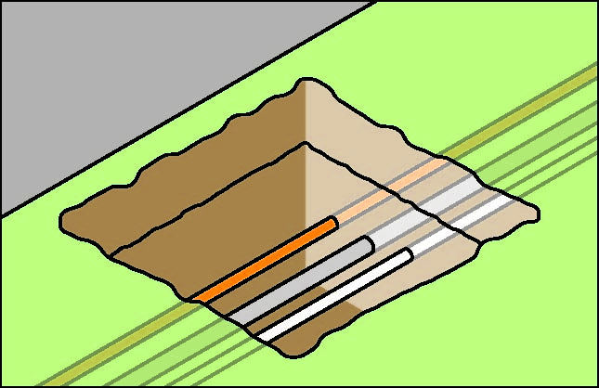

Further guidance on underground essential services and how to locate them is available in the [Code of Practice: *Construction work*](http://www.safeworkaustralia.gov.au/sites/swa/about/publications/pages/construction-work)*.*

## Securing the work area

Regulation 306 A person conducting a business or undertaking who proposes to excavate   
a trench at least 1.5 m deep, must ensure, so far as is reasonably practicable, that the work area is secured from unauthorised access (including inadvertent entry).

In securing the trench or excavation, you must consider:

* risks to health and safety arising from unauthorised access to the work area, and
* the likelihood of unauthorised access occurring.

This requirement aims to protect other workers on site who may be at risk by restricting access to the excavation area. It applies in addition to the duty that the person with management or control of the construction site has to ensure, so far as is reasonably practicable, that the site is secured from unauthorised access from members of the public, for example when the site is near schools, parks, shops or other public places.

## Emergency plan

Regulation 43 A person conducting a business or undertaking must ensure that an emergency plan is prepared for the workplace.

The excavation contractor must ensure that the emergency plan deals with unexpected incidents, such as ground slip, flooding, gas leaks and the rescue of workers from an excavation.

To ensure a co-ordinated response to an emergency, the plan should be incorporated as part   
of the broader construction project emergency plan prepared by the principal contractor.

# CONTROLLING RISKS IN EXCAVATION WORK

The following table lists common hazards associated with excavation work and examples   
of control measures:

| **Potential hazards** | **Examples of control measures** |
| --- | --- |
| Ground collapse | the use of benching or the installation of ground support (e.g. shoring) |
| Water inrush | pumps or other dewatering systems to remove water and prevent build-up |
| Falls | ramps, steps or other appropriate access into the excavation |
| Hazardous manual tasks | rotating tasks between workers |
| Airborne contaminants | mechanical ventilation to remove airborne contaminants |
| Buried contaminants (e.g. asbestos) | training to identify buried contaminants and what action to take |
| Underground services | obtain information from the relevant authorities on the location  of underground services |

## Excavated material and loads near excavations

Mechanical plant, vehicles, storage of materials (including excavated material) or any other heavy loads should not be located in the ‘zone of influence’ of an excavation unless the ground support system installed has been designed by a competent person, for example a geotechnical engineer, to carry such loads.

The zone of influence will depend on the ground conditions. It is the zone in which there may   
be an influence on the excavation including possible ground collapse (see Figure 2).

**Figure 2** Excavated material and loads near excavations

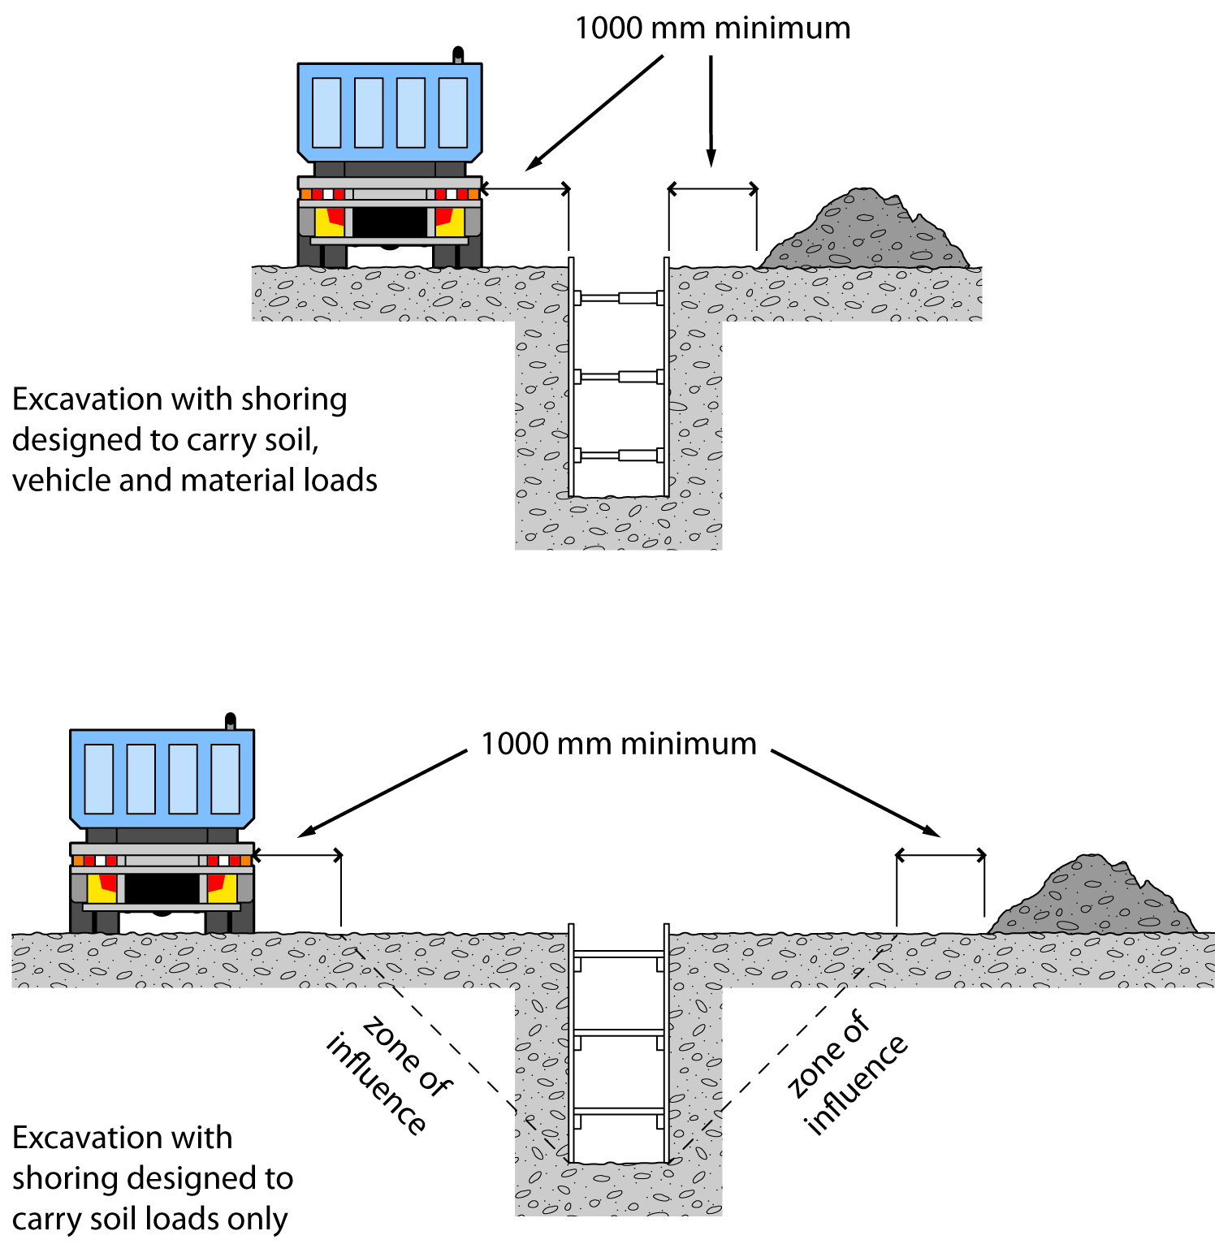

Figure 2 shows an example of:

* an excavation with shoring that has been designed to carry vehicle and material loads – this may be required where there is limited space around the excavation for vehicle movement and/or material storage, and
* an excavation with shoring that has been designed only to carry the load of the excavated faces and the related zone of influence.

Any material will add a load to the area where it is placed. It is important that materials are not placed or stacked near the edge of any excavation as this would put persons working in the excavation at risk. For example, the placement of material near the edge of an excavation may cause a collapse of the side of the excavation.

To reduce the risk of ground collapse, excavated or loose material should be stored away from the excavation. Excavated material should be placed outside the zone of influence. Alternatively, a ground support system should be designed and installed to carry the additional loads including any ground water pressures, saturated soil conditions and saturated materials.

If excavating in sloping ground decide which side of the excavation to place the excavated material. Things to consider include:

* ground conditions
* access to the excavation
* existing underground services
* the need for earthmoving machinery or vehicles to work or move along beside the excavation
* service installation and backfilling requirements, and
* any manual work being undertaken in the excavation.

Placing material on the lower side of the excavation will reduce the effective height of the excavation (see Figure 3) and the risk of material falling or being washed into the excavation.

**Figure 3** Excavated material impact on effective excavation depth

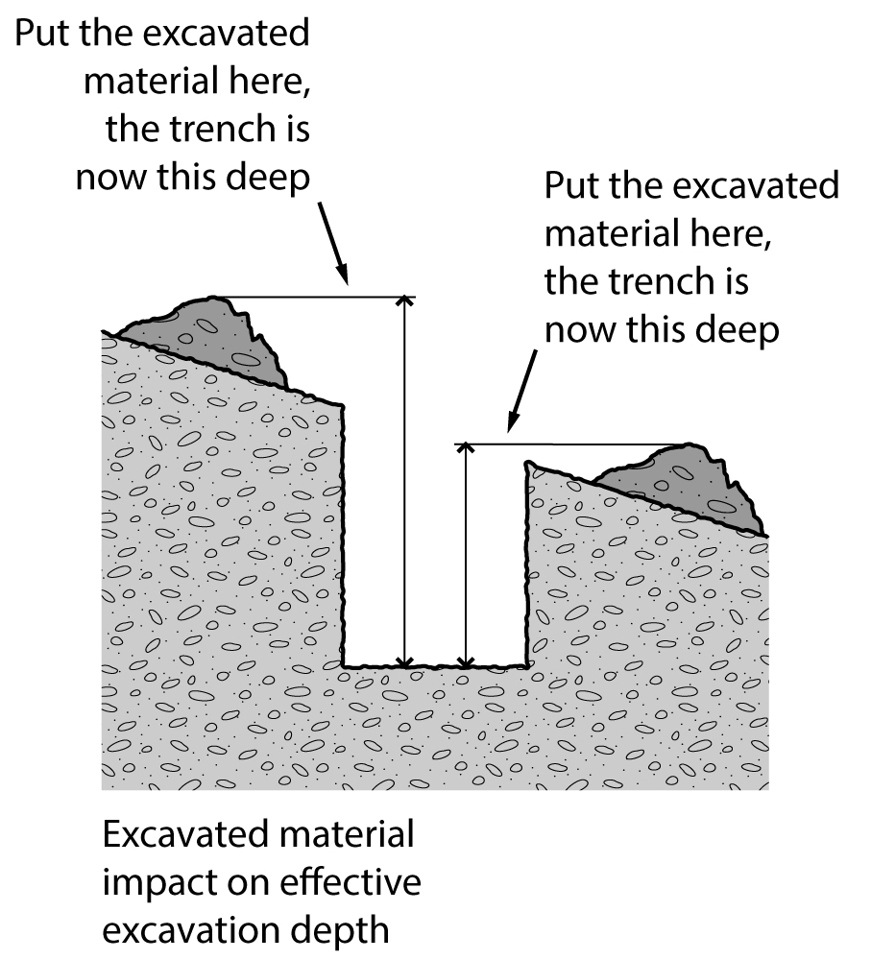

Care should be taken to ensure that material placed on the high side of the excavation does   
not increase the risk of ground collapse, or flooding by ponding or holding back runoff water. Excavated material should be placed so that it channels rainwater and other run-off water away from the excavation.

When a trench is being excavated beside an old service line, the excavated material should   
be placed on the side opposite the old service line to prevent excessive loading on previously weakened ground.

If excavated material is placed close to a trench due to obstructions such as fences, buildings   
or trees, the weight of the excavated material may overload the sides of a trench. In this case,   
the ground support system should be strengthened at these locations and barriers such as toeboards may need to be provided to prevent the material falling into the excavation.

Different soils when dumped in heaps, will assume a characteristic shape and settle naturally   
at different slopes. The angle which a sloping face of loose earth makes with the horizontal is sometimes referred to as the angle of repose. However, it is poor practice to relate the safe slope of an excavation to the angle of repose, even though the safe slope may be similar in some types of soil to the angle of repose.

## Plant and equipment

Excavation work cannot be carried out safely unless the plant being used is appropriate for the work and maintained in good condition. A range of plant and equipment may be used for excavation work including:

* powered mobile plant (see section 4.3)
* air compressors
* electric generators
* jack hammers
* hydraulic jacks
* oxy-acetylene (gas cutting/welding)
* scaffolding
* ladders, and
* many types of handheld plant such as shovels, picks, hammers, hydraulic jacks   
  and pinch/lever bars.

You should ensure:

* plant is used and operated by a competent person
* that appropriate guards and operator protective devices are fitted
* that the safe working load is displayed and any load measurement devices are operating correctly, and
* plant is maintained in accordance with the manufacturer/supplier’s instructions or relevant Australian Standards.

Further general guidance on plant can be found in the [Code of Practice: *Managing risks of plant in the workplace*](http://www.safeworkaustralia.gov.au/sites/swa/about/publications/pages/managing-the-risks-of-plant-in-the-workplace)*.*

### Lasers

Lasers must be designed, constructed and installed so that no person is exposed to accidental irradiation. Lasers that are capable of producing hazardous diffuse reflections or that may constitute a fire hazard, being laser classes 3B and 4, must not be used in construction work.

Any worker operating lasers must be trained in the use of the equipment. Further information on the safe use of lasers is available in AS 2397: *Safe use of lasers in the building and construction industry.*

## Powered mobile plant

A wide range of powered mobile plant including earthmoving machinery, may be used for excavation work. To select plant that is suitable for the task, you should consider:

* site access and restrictions
* site hazards such as overhead powerlines and underground services
* the ground conditions
* the type and depth of excavation
* the volume of material to be excavated and transported, and
* where the excavated material is to be located and/or stored.

A high risk work licence is required to operate some types of powered mobile plant. However in most cases earthmoving machinery does not require a licensed operator if it is being used for the purpose for which it was originally designed. Earthmoving machinery operators must be able to demonstrate they are competent to operate the specific type of plant being used and any attachments fitted to the plant.

Traffic management arrangements must be implemented at the workplace when powered mobile plant is to be used for excavation work to prevent collision with pedestrians or other mobile plant.

### Earthmoving machinery

Bulldozers and scrapers are often used to prepare a work area for further specific excavation.

Bulldozers typically excavate and move large amounts of material short distances. Bulldozers   
can be equipped with hydraulically operated rippers at the back of the machine which are capable of loosening the hardest of sedimentary rocks. This material may then be bulldozed away.   
This method frequently proves more economical than drilling and blasting softer rock.

Self-propelled rubber tyred scrapers enable very large quantities of material to be excavated and hauled economically over long distances at relatively high speed. Because of the large potential output and speeds of modern scrapers, careful attention should be given to job layout, haul roads, vehicle pathways and overall traffic management to achieve a healthy and safe workplace.

Temporary haul roads should be well constructed and maintained to enable plant operators   
to complete the work safely.

Large earthmoving machinery such as bulldozers should not operate close to an overhang   
or a deep excavation as the weight may collapse the sides. Equipment should always approach embankments or trenches from across the line of a trench rather than parallel to it.

Excavation work exceeding 1.5 metres deep is typically done by excavators or specialised   
plant such as tunnelling machines and raise-bores. Most of these types of plant have an element of mobility, although tunnelling machines typically have restricted movement.

Other plant used in excavation work includes backhoes, rubber tyred loaders, skid steer loaders (for example bobcat), trench diggers, graders and tip trucks.

### Blind spots

Operators of powered mobile plant can often have severely restricted visibility of ground workers or nearby pedestrians, particularly those close to the plant. Figure 4 shows some of the blind spots for operators of typical excavation equipment.

Figure 4 Mobile plant operator blind spots

Figure 4 shows mobile plant operator blind spots.

Powered mobile plant operating near ground personnel or other powered mobile plant should be equipped with warning devices (for example reversing alarm and a revolving light).

An effective system of communication based on two way acknowledgement between mobile plant operators and ground workers should be established before work commences. Relevant workers should also be trained in the procedures involved prior to the work commencing. The system should stop ground workers from approaching mobile plant until the operator has agreed to their request to approach. Similarly the system should stop operators from moving plant closer than   
a set distance from ground workers until the operator has been advised by ground workers that they are aware of the proposed movement.

Mobile plant operators and ground workers should be made familiar with the blind spots of particular items of plant being used. Induction training programs should emphasise the dangers of workers working in close proximity to mobile plant, and adequate supervision should be provided.

Mobile plant operators and ground workers should be provided with and required to wear high-visibility clothing.

### Operator protection

Powered mobile plant should be equipped with appropriate combination of operator protection devices, for example enclosed cabin and seat belts, to prevent the ejection of the operator or   
the operator being struck by falling objects.

Any earthmoving machinery weighing more than 1500 kgs, not including attachments, and designed to have a seated operator must have an appropriate operator protective structure fitted. These are either in the form of roll-over protective structures (ROPS) or falling object protective structures (FOPS) or both, depending on the application.

### Operating near excavations

Powered mobile plant should not operate or travel near the edge of an excavation unless the ground support system installed has been designed by a competent person to carry such loads. Physical barriers, such as wheel stoppers, can be one way of restricting plant movement near   
an excavation (see Figure 5).

**Figure 5** Preventingplant operation near excavations

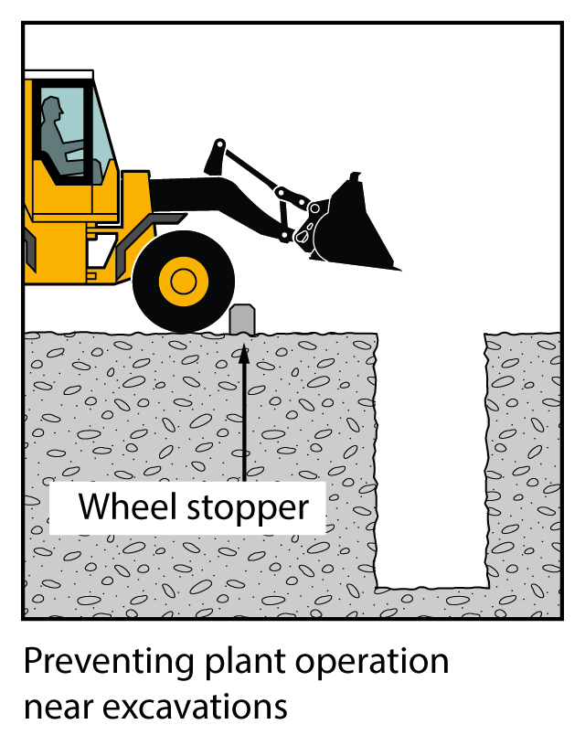

### Inspection and maintenance

Regular planned inspection and adequate maintenance must be carried out in accordance   
with the manufacturer’s recommendations to ensure safe operation of mobile plant used   
on excavation work, whether leased, hired or owned. Both mechanical and electrical testing should be done. The following checks should also be carried out:

* daily pre-start checks by the plant operator on the general condition and maintenance   
  of the plant, and
* regular inspections of the plant by a competent person in accordance with the manufacturer/supplier’s specifications or relevant Australian Standards.

Any plant defects should be reported immediately to the person conducting business   
or undertaking. Where a defect is likely to pose an immediate risk to health and safety   
the plant should be removed from service until the defect is rectified.

Owners of plant should keep logbooks and inspection check sheets containing a full service and repair history. These records should include any reported defects, kept current and retained for the life of the plant. If the plant is sold, the records should form part of the documentation forwarded to the purchaser of the plant upon its sale.

## Falls

Regulation 78 A person conducting a business or undertaking must manage the risk of a fall from one level to another that is reasonably likely to cause injury to the person or another person.

In managing the risks of falls, the WHS Regulations require the following specific control measures to be implemented where it is reasonably practicable to do so:

* carry out the work on solid construction that includes a safe means of access and egress
* if a fall risk cannot be eliminated, minimise the risk of fall by providing and maintaining a safe system of work including
  + using fall prevention devices (e.g. temporary work platforms and guard rails) or
  + work positioning systems (e.g. industrial rope access systems), or
  + fall arrest systems such as catch platforms.

Control measures include:

* the support system itself, for example using trench box extensions or trench sheets longer than the trench depth (see Figure 6)
* installing guard rails or covers on trench shields (see Figure 7)
* inserting guard rails and toe boards into the ground immediately next to the supported excavation side
* installing landing platforms or scaffold towers inside deep excavations
* securing ladders to trench shields
* installing effective barriers or barricades
* providing clearly defined pedestrian detours
* provision of alternative access and egress points to the excavation for emergency use, and
* backfilling the excavation as work progresses.

**Figure 6** Extending trench shields above the excavation

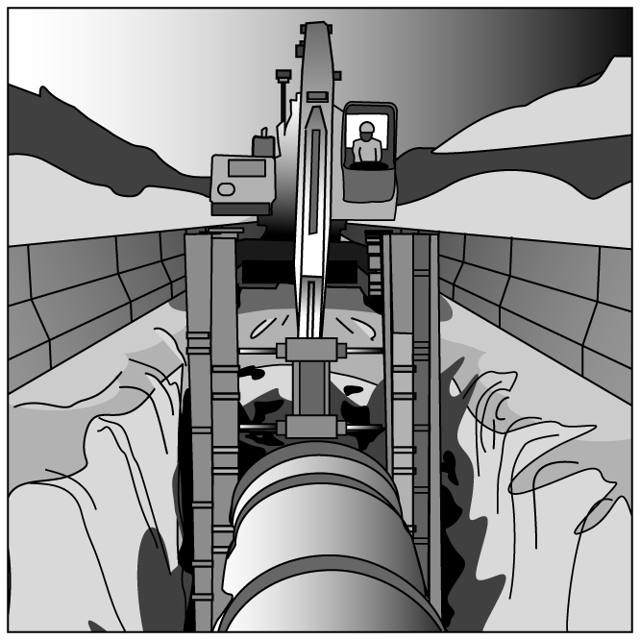

**Figure 7** Steel mesh covers over trench shields

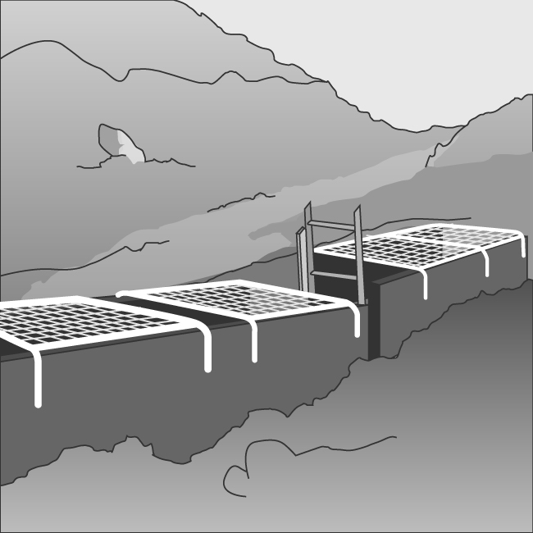

A SWMS must be prepared for excavation work that involves a risk of a person falling more than 2 metres.

Further guidance on controlling the risk of falls is available in the Code of Practice: *How to prevent falls at workplaces.*

## Using explosives

Construction work that involves the use of explosives is defined by the WHS Regulations as high risk construction workand a SWMS must be prepared before this work commences.

A competent person experienced in the controlled application of explosives for the purpose   
of carrying out the excavation work should be consulted before deciding whether explosives   
may be used for the excavation.

All possession, storage, handling and use of explosives must be carried out in compliance   
with the relevant dangerous substances/goods or explosives legislation applicable in your state   
or territory.

The transport of explosives must be in accordance with the [*Australian Code for the Transport   
of Explosives by Road and Rail*](http://www.safeworkaustralia.gov.au/sites/swa/about/publications/pages/cp2009actransportofexplosivesbyroadandrail3rdedition)*.*

Explosives must only be used by a competent person who is licensed in the use of explosives and has experience in the work to be undertaken. If explosives are used in excavation work,   
a licensed competent person must develop the blast management plan and be responsible   
for all aspects of the use of explosives.

For further information on the use of explosives for excavation work, refer to AS 2187.2: *Explosives – Storage and Use - Use of Explosives*

## Atmospheric conditions and ventilation

The risk of atmospheric contamination through a build up of gases and fumes must be controlled in excavation work. Gases and fumes heavier than air can collect in tunnels and excavations for example: gases (such as sulphur dioxide), engine fumes (such as carbon monoxide and carbon dioxide) and leakage from gas bottles, fuel tanks, sewers, drains, gas pipes and LPG tanks.

Plant that uses a combustion engine (for example air compressors, electrical generators) should never be used in a confined excavation such as a trench if workers are in the trench. The build-up of exhaust gases in the excavation, particularly carbon monoxide, can cause death.

Ventilation systems help to maintain adequate oxygen levels and dilute flammable gases, fumes and certain dusts, such as coal and sulphide which can ignite if in its explosive limits. The use of mechanical ventilation also reduces dust, fumes, hazardous contaminants and can control air temperature and humidity.

The ventilation system should be designed by a competent person to provide adequate ventilation levels through the excavation (for example a tunnel) during construction. This might include additional localised extraction ventilation to deal with the production of dust, heat or fumes from the excavation process and the operation of large plant or other activities like plant maintenance. The design should allow for the installation of ventilation equipment or ducting as the excavation progresses to maintain adequate air supply to the working face.

Other methods of controlling the risks associated with atmospheric contamination include:

* pre-start checks of atmospheric conditions
* using gas monitors including workers’ wearing personal monitors near their airways
* ensuring adequate ventilation (either natural or mechanical)
* working in pairs, with one person as a safety observer at the surface to monitor conditions
* ensuring familiarity with rescue procedures, and
* using PPE.

Further guidance on working in confined spaces is available in [Code of Practice: *Confined spaces.*](http://www.safeworkaustralia.gov.au/sites/swa/about/publications/pages/confined-spaces-cop)

## Manual work

Manual excavation methods are generally used for small, shallow excavations (for example less than 1.5 metres deep) in soft soils.

Regulation 60 A person conducting a business or undertaking must manage the risk of a musculoskeletal disorder associated with hazardous manual tasks.

When working in close proximity, workers should be kept sufficiently far apart to prevent injury from the use of picks or other hand tools. This applies particularly to work in trenches and small excavations.

Preparatory drilling activity and the use of hand drills may increase the risk of musculoskeletal disorders including disorders associated with exposure to vibration. For further guidance on controlling the risks of musculoskeletal disorders, refer to the [Code of Practice: *Hazardous manual tasks*](http://www.safeworkaustralia.gov.au/sites/swa/about/publications/pages/hazardous-manual-tasks-cop)*.*

## Information, training, instruction and supervision

Section 19 A person conducting a business or undertaking must ensure, so far as is reasonably practicable, the provision of any information, training, instruction and supervision that is necessary to protect all persons from risks to their health and safety arising from the work carried out.

Regulation 39 A person conducting a business or undertaking must ensure that information, training and instruction provided to a worker is suitable and adequate having regard to:

* the nature of the work carried out by the worker
* the nature of the risks associated with the work at the time of the information, training and instruction, and
* the control measures implemented.

The training provided must be readily understandable by any person to whom it is provided.

Regulation 317 A person conducting a business or undertaking must not direct or allow a worker to carry out construction work unless the worker has successfully completed general construction induction training.

Training specific to the excavation work and to the site should also be provided to workers by   
a competent person. Workers operating certain types of plant at the workplace must possess   
a valid licence to operate that plant.

Workers in a supervisory role (for example leading hand or foreman) should be experienced   
and trained in excavation work to ensure the work is carried out in accordance with SWMS.

Further information on general construction induction training and other training is available   
in Chapter 6 of the [Code of Practice: *Construction work*](http://www.safeworkaustralia.gov.au/sites/swa/about/publications/pages/construction-work)*.*