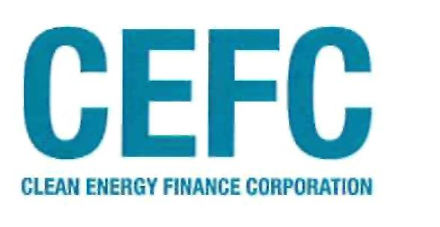
The Hon Greg Hunt MP
Minister for the Environment
Senator the Hon Mathias Cormann
Minister for Finance
3 May 2016
Dear Ministers
Thank you for your correspondence of 2 May 2016 enclosing a consultation draft direction (Investment Mandate) for consideration of the CEFC Board, as required under section 66 of the Clean Energy Finance Corporation Act 2012 (the CEFC Act). The Board welcomes the opportunity to be consulted and has asked that I respond on its behalf.
Clean Energy Innovation Fund
The Board acknowledges and welcomes the Government's direction to make available funding to support innovation in the clean energy sector through the Clean Energy Innovation Fund (the CEIF). The Board views the CEIF as a natural part of the CEFC's activities and is pleased to see the Government's recognition that the level of risk in such a fund will be significantly higher than that found in the CEFC's core portfolio.
We note the Government's intention that the Australian Renewable Energy Agency (ARENA) provide assistance with the delivery of the CEIF. The Board acknowledges ARENA'S expertise in analysing the technical merits of technology and we look forward to working with ARENA to support the Government's policy objectives.
Consistent with the object of the CEFC Act, the CEFC has pursued its investment function applying commercial rigour, investing responsibly and managing risk prudently, utilising a robust, commercial risk management approach. Recognising the need to accept a higher level of risk with respect to investments in the CEIF, we will continue to apply this same approach to the activities of the CEIF. The Board considers it important to emphasise that, as the investments made in the CEIF are ultimately held by the CEFC and funded with monies allocated to the CEFC under the CEFC Act, the final decision-making authority, responsibility, and management in relation to investments in the CEIF remains with the CEFC.
Benchmark returns
The Board notes that the Government has amended the Portfolio Benchmark Return for the CEFC's core portfolio (i.e. investments other than those in the CEIF) to 3% to 4% over the 5-year Australian Government bond rate. While this is a minor reduction in the Portfolio Benchmark Return from the target set out in the two most recent Investment Mandates issued to the CEFC (in February 2015 and December 2015), the Board is of the view that this is still an unrealistically high return target for this market. It does not reflect the CEFC's approach to risk and the proportion of public sector counterparties (universities and councils) within the current investment portfolio.
Clean Energy Finance Corporation  Suite 1702, 1 align street  Sydney, NSW 2000 Australia  ABN 43 669 904 352 | e info@cleanenergyfinancecorp.com.au  t 1300 002 332  i +61 2 8039 0800

As participants in the financial markets are aware, global equity risk premiums as well as both credit and duration spreads on debt instruments are compressed and are at or close to long term lows. These market pressures, when coupled with the CEFC's narrow investment universe of clean energy technologies in Australia, mean that the CEFC has limited ability to access higher yielding transactions. Consequently, as expressed in my responses to the last two Investment Mandates issued to the CEFC, the Board's view remains that targeting such a high rate of return will require the CEFC to seek out-of-market returns, which will be difficult to achieve.
In relation to the benchmark return of 1% over the 5-year Australian Government bond rate set for the CEIF, the Board would also like to highlight to the Ministers that there is a very wide range of potential returns on the early stage long term investments anticipated for the CEIF. As the portfolio will be both concentrated within a single industry sector, and involve technologies that are not yet fully commercially established, the return outcome of the CEIF investments will range from full loss of the investment to a return of a multiple of the investment. This variability in investment returns will be more pronounced in the CEIF than in the core portfolio and while the benchmark return set for CEIF is lower than that set for the core portfolio, the Government should expect high volatility on a year-to-year basis from this developing portfolio of early stage assets.
Investment stages
Finally, with the creation of the CEIF, there are now various sections of the Investment Mandate and the accompanying Explanatory Statement that describe technologies by reference to certain stages of their evolution - for example, research and development stage, beyond research and development stage but not yet sufficiently established or mature, commercially developed, etc. While the CEIF is indeed intended to make investments in technologies at earlier stages of development, it is important to understand that there is rarely a clear delineation between these various stages. Consequently, the CEFC Board will make decisions as to the appropriate vehicle (i.e. CEFC core business or the CEIF) for a particular investment based on their considered judgment of the technology, the commercial risk, and the maturity of the business involved in the investment opportunity.
Conclusion
The Board's view is that, subject to the comments noted above, the approach adopted in this consultation draft Investment Mandate represents an appropriate approach to allow the CEFC to support Australian Government policy priorities. We believe it provides a measure of investment flexibility necessary to build a portfolio that has an acceptable level of risk appropriate to the sector and allows the CEFC to continue to achieve the public policy objectives that underpin the CEFC Act.
We thank you again for consultation and the constructive and positive engagement that you and your offices have offered on the Investment Mandate. The Board acknowledges this direction and, once given will undertake all reasonable steps to ensure that the CEFC complies with the Investment Mandate and the CEFC Act.
Yours sincerely
Jillian Broadbent AO
Chair
Clean Energy Finance Corporation

