***Australian Film, Television and Radio School Act 1973***

# **DETERMINATION OF DEGREES, DIPLOMAS AND CERTIFICATES No. 2016/2**

I, **Julianne Schultz**, Chair of the Council of the Australian Film, Television and Radio School, on behalf of the Australian Film, Television and Radio School, make a determination under section 6A of the *Australian Film, Television and Radio School Act 1973* (AFTRS Act) specifying the following degrees, diplomas and certificates for the purposes of paragraph 5(1)(g) of the Act.

That Council approve the creation of the following courses by legislative instrument:

Diploma in Editing

Diploma in Camera

Diploma in Production Management

Diploma in Screen Business

Diploma in Screen Design

Diploma in Social Video

Advanced Diploma in Editing

Advanced Diploma in Production Sound

Advanced Diploma in Screenwriting - Feature Film

Advanced Diploma in Screenwriting - Series Television

Advanced Diploma in Script Editing and Development

Advanced Diploma in Visual Effects

Bachelor of Arts Screen – Production

Graduate Certificate Screen - Business

Graduate Certificate Screen - Cinematography

Graduate Certificate Screen - Documentary

Graduate Certificate Screen - Creative Producing

Graduate Certificate Screen - Directing

Graduate Certificate Screen - Editing

Graduate Certificate Screen - Music

Graduate Certificate Screen – Screenwriting

Graduate Diploma in Radio

Master of Arts Screen

Master of Arts Screen - Business and Leadership

This Determination comes into effect on the day after it is registered on the Federal Register of Legislative Instruments.

Dated: 30 June 2016

Signed:

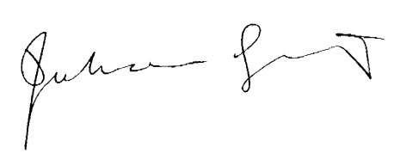

Professor Julianne Schultz AM FAHA  
Chair of Council

Australian Film, Television and Radio School